Project I

Nicholas S.Y. Ngo

*Student, Department of Aerospace Engineering, Daytona Beach, Florida, 32114, USA*

1. **Nomenclature**

*Cmax* = Maximum Camber

*Clocation* = Camber Location

*Tmax* = Maximum Thickness

*c* = chord length

*Cl* = Lift Coefficient

Cp = Pressure Coefficient

*L/D* = Lift to Drag Ratio

α = Angle of Attack

Re = Reynolds Number

*x/c* = Location on Chord

1. **Introduction**

Analyze flow over NACA 0012 symmetrical and NACA 4412 airfoils by using XFLR5, classical solutions and experimental data.

1. **NACA 0012 (Symmetrical Airfoil)**

* Cmax = 0.00c
* Clocation = 0.00c
* Tmax = 0.12c

1. **α = 0 (NACA 0012)**

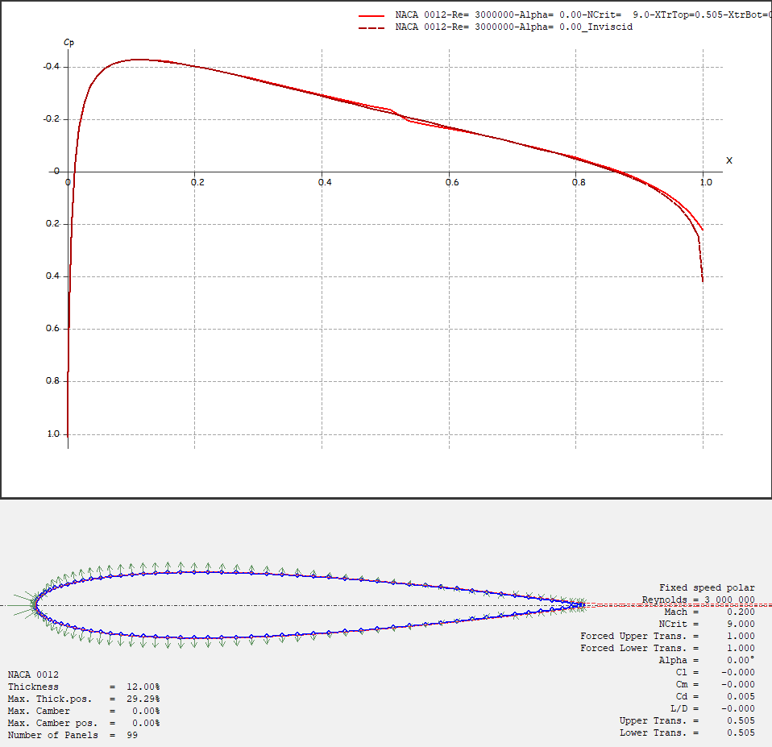

By analyzing the pressuredistributions (green arrows) from the airfoil plot, we can conclude that the pressure distributions are the same on the upper and lower surfaces. Another way to analyze equal pressure distributions is by observing the results of Cl, and L/D values, which in this case both are 0.

From the Cp vs X graph, the Cp value of front stagnation point is 1.01. The result is correct because for an airfoil experiencing freestream flow, the Cp value for front stagnation point should be at least 1.

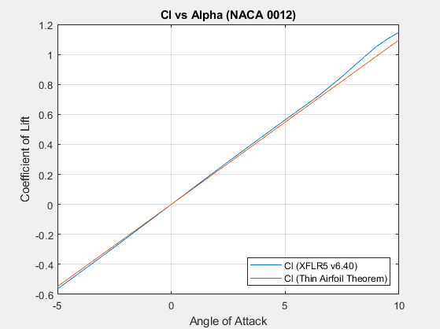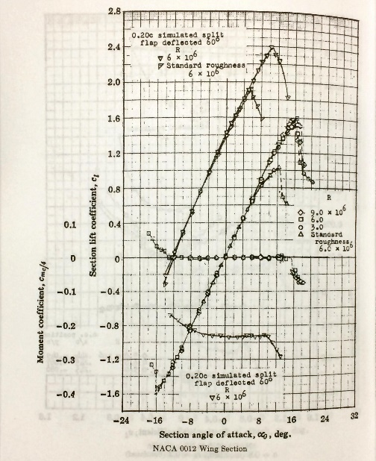

For both results obtained from XFLR5 and thin airfoil theorem, at α = 0, Cl = 0. When a symmetrical airfoil is in a zero angle of attack flight, pressure distribution for both upper and lower surfaces are equal (discussed previously), thus no lift is resulted.

The curve obtained from XFLR5 and thin airfoil theorem has a less steep slope compared to Abbott & Doenhoff. From experimental results obtain from Abbott & Doenhoff, the flow separation is around α = 10.5. Cl from thin airfoil theorem is governed by Cl = 2πα, thus the result of the slope increases linearly as α increases. Thus, we can conclude that thin airfoil theorem does not take flow separation into consideration.

1. **α = 9 (NACA 0012)**

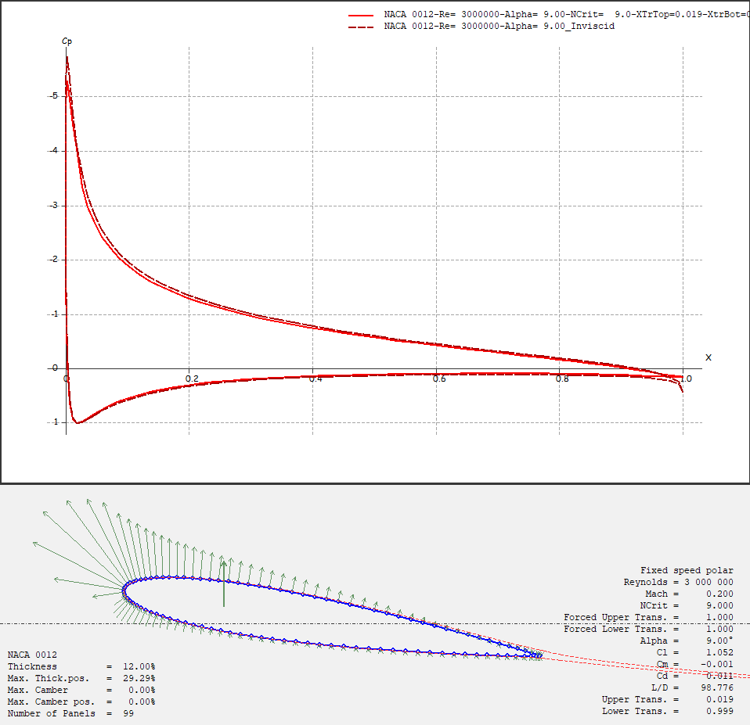

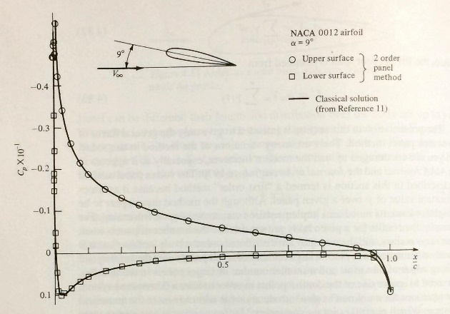

Results obtained from XFLR5 matches closely with the results by NACA and Anderson’s 2nd order panel method.

1. **NACA 4412 (Cambered Airfoil)**

* Cmax = 0.04c
* Clocation = 0.40c
* Tmax = 0.12c

## NACA 0012 vs NACA 4412

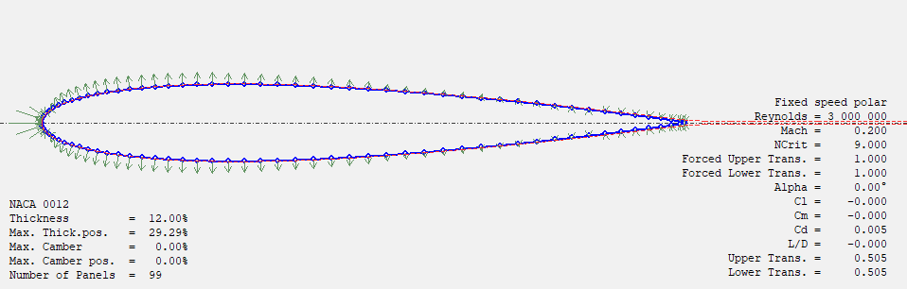

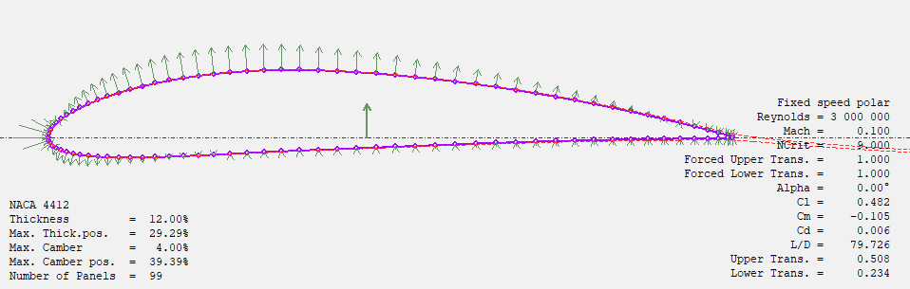

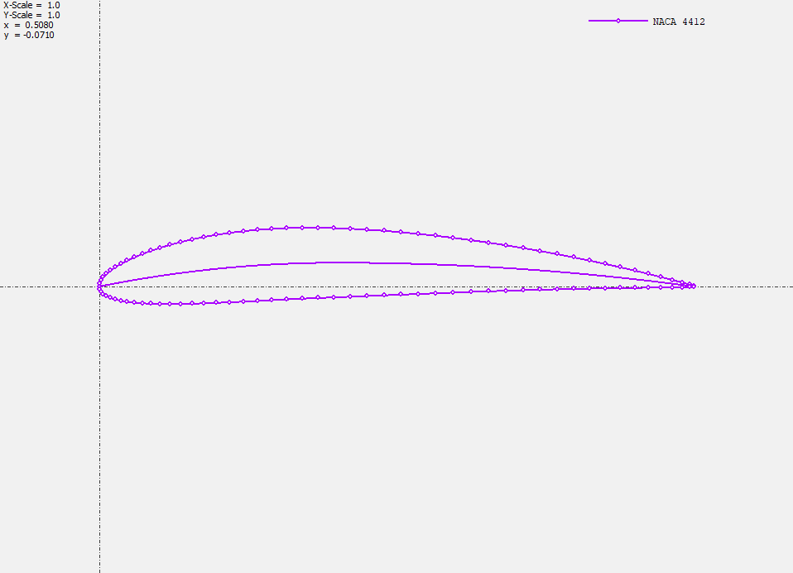

From NACA number system designation, we can determine the geometry of a NACA 4412 cambered airfoil. The maximum camber is 4% of the chord and located 40% of the chord with 12% thickness. For a NACA 0012 symmetrical airfoil, there is no camber and maximum thickness of 12%. The results obtain from XFLR5 agrees closely with the NACA number system designation. Interestingly for both airfoil which have the same maximum thickness, have the same maximum thickness location.

1. **Zero Lift Angle (αZL)**

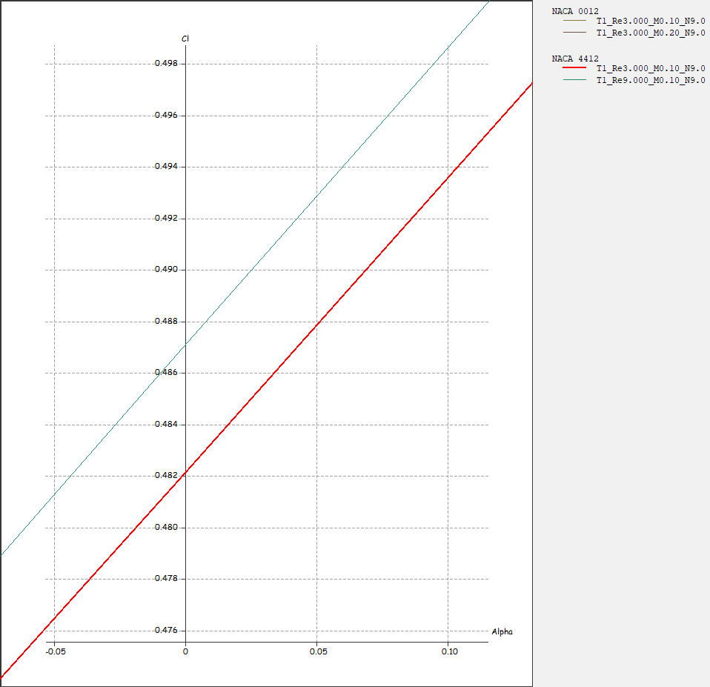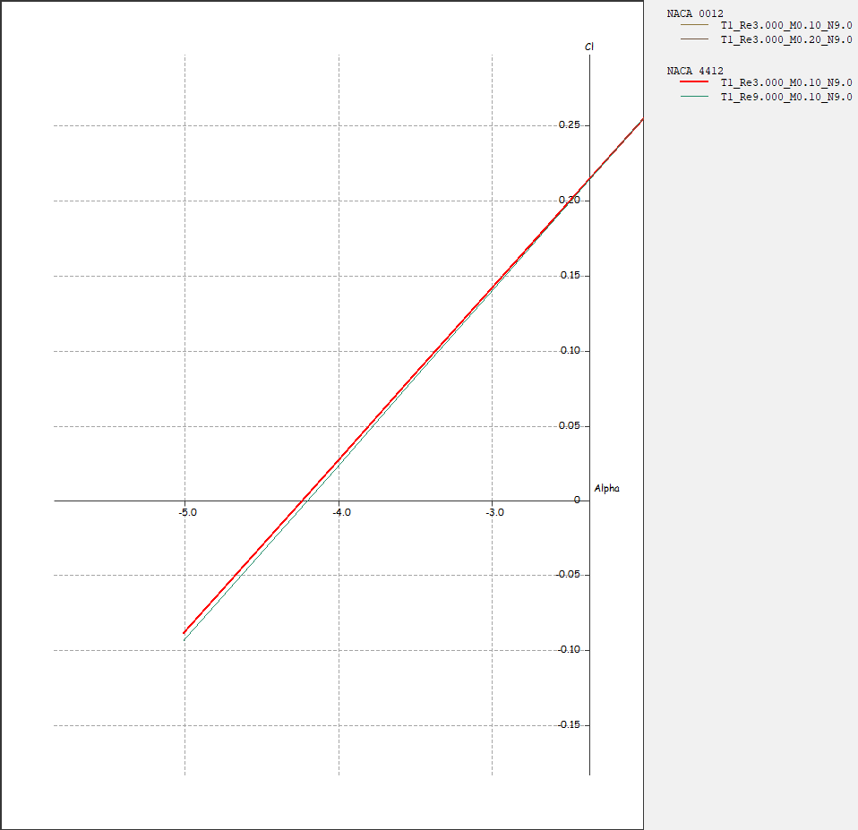

From the Cl vs α plot, we can use linear interpolation to determine the zero-lift angle (αZL). First, we will choose two points to obtain the slope of the curve. Second, we will determine an arbitrary Cl to find its corresponding α. Finally, we will use linear interpolation to determine the zero-lift angle.

|  |  |
| --- | --- |
| **Angle of Attack** | **Coefficient of Lift** |
| α | -0.200 |
| αZL | 0.000 |
| 0 | 0.482 |
| 0.05 | 0.488 |

=> =>

=>

1. **α = 0 (NACA 4412)**

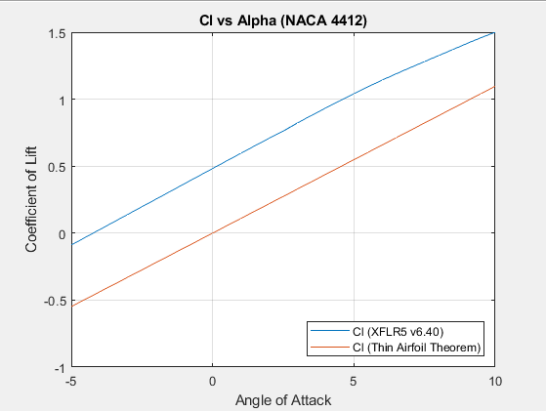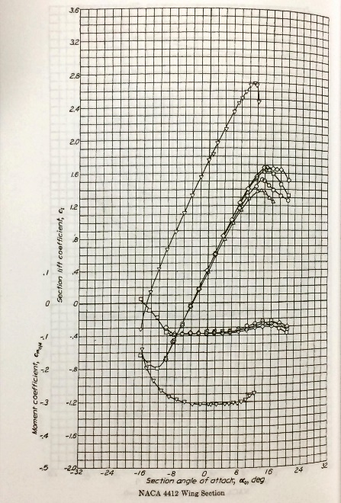

Results obtained between XFLR5 and thin airfoil theorem contain deltas. The camber resulted a difference in thickness between and throughout the chord line which alters the Cl, thus the difference in results. Cl from thin airfoil theorem is governed by Cl = 2πα and does not take camber into account. Thus, we can conclude that thin airfoil theorem is not suitable for cambered airfoil calculations.

The curve obtained from XFLR5 has a much higher magnitude compared to results obtained from Abbott & Doenhoff. Take α = 0 for instance, XFLR5 has an α of 0.5 and Abbott & Doenhoff has an α of 0.4. That is a delta of 0.1.

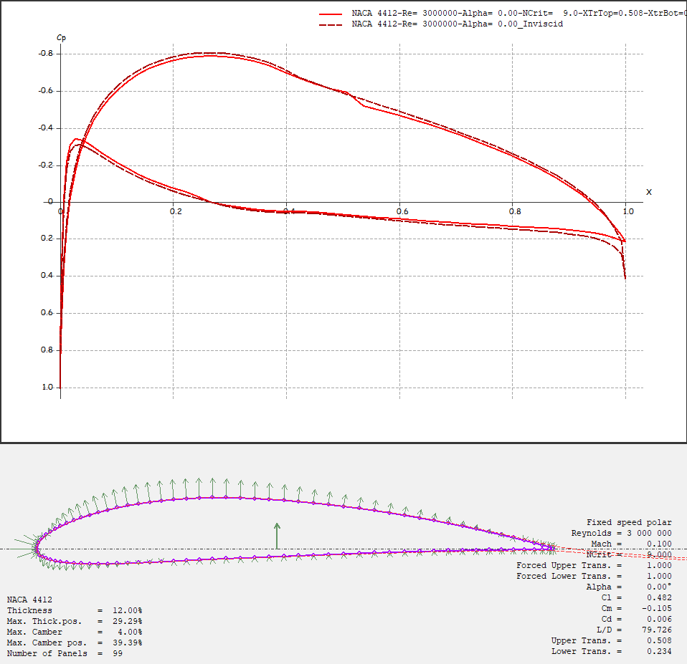

By analyzing the pressuredistributions (green arrows) from the airfoil plot, we can conclude that the pressure distributions on the upper surface have a smaller magnitude compare to the lower surface. Now if we observed both the Cp and Cl of the lower surface, we can conclude that when Cp increases, Cl increases.

By comparing both NACA 0012 and NACA 4412 at α = 0, there is significant difference in the Cp distribution throughout the airfoils. We can conclude that the effect of cambered has a play in altering both the Cl and Cp.

1. **α = 9 (NACA 4412)**

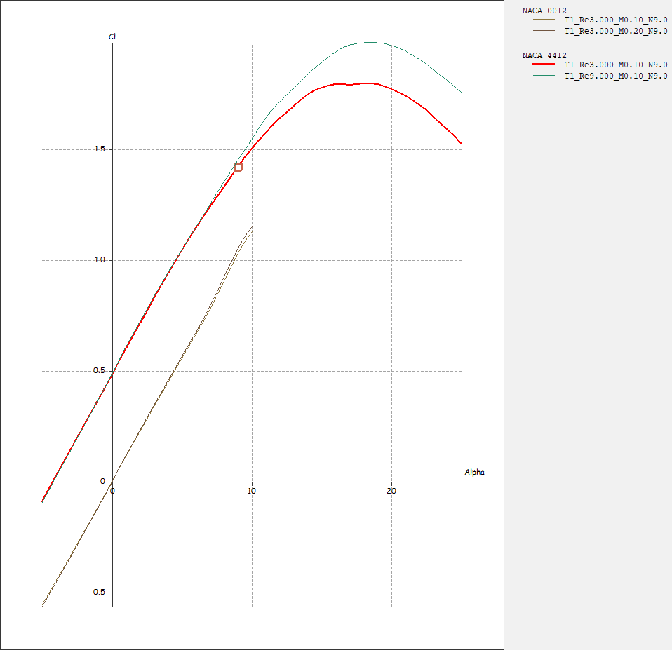

Cl obtained from XFLR5 is 1.42. As for Abott & Doenhoff is 1.25. Delta total of 0.17.

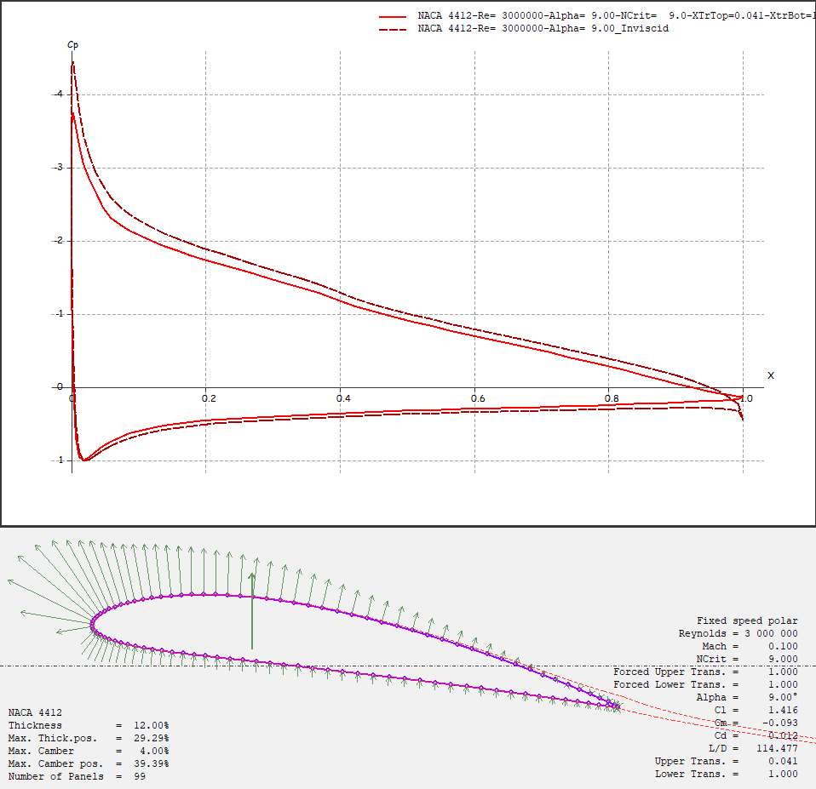

Cl of NACA 4412 transitions smoothly before and after the ¼ chord of the airfoil. Cl of NACA 0012 transitions abruptly before the ¼ chord of the airfoil. Comparing both airfoils at α = 9, NACA 0012 has a higher delta Cl at around ¼ chord compared to NACA 4412. This can be visualized by observing the green Cp arrows in the diagram. We can also conclude that a cambered airfoil has a higher lift (green bold arrow) compared to a symmetrical airfoil at the same α.

1. **NACA 4412 Viscous Analysis**

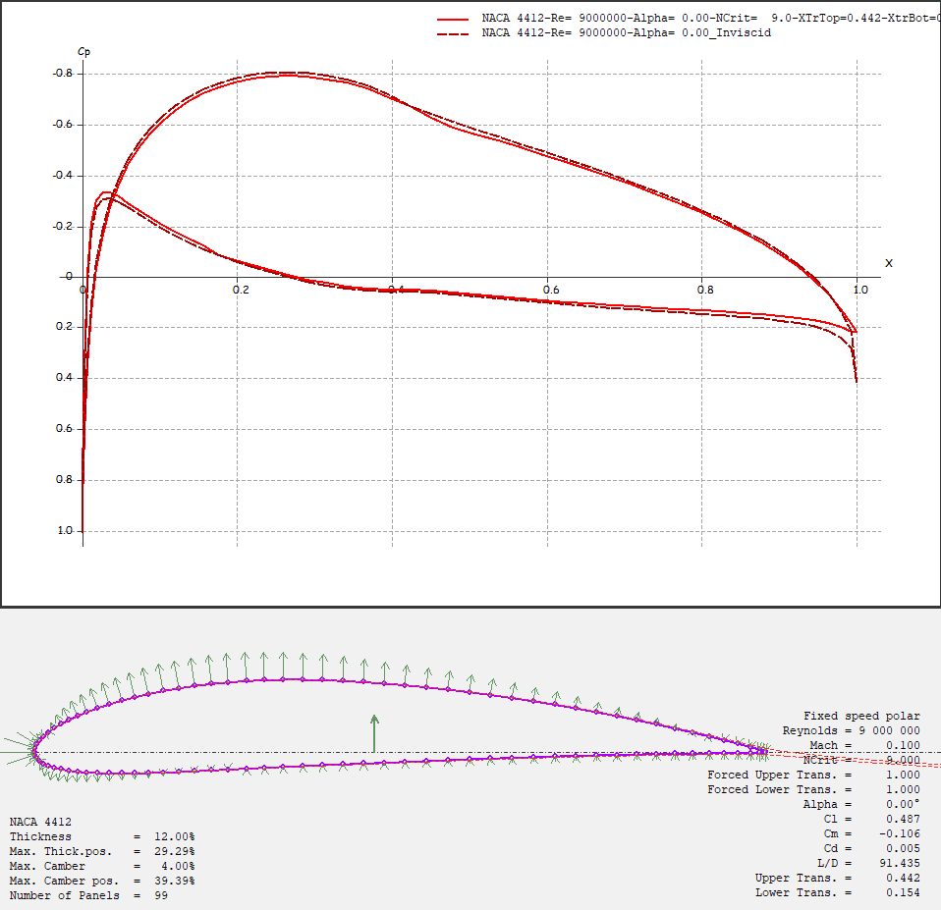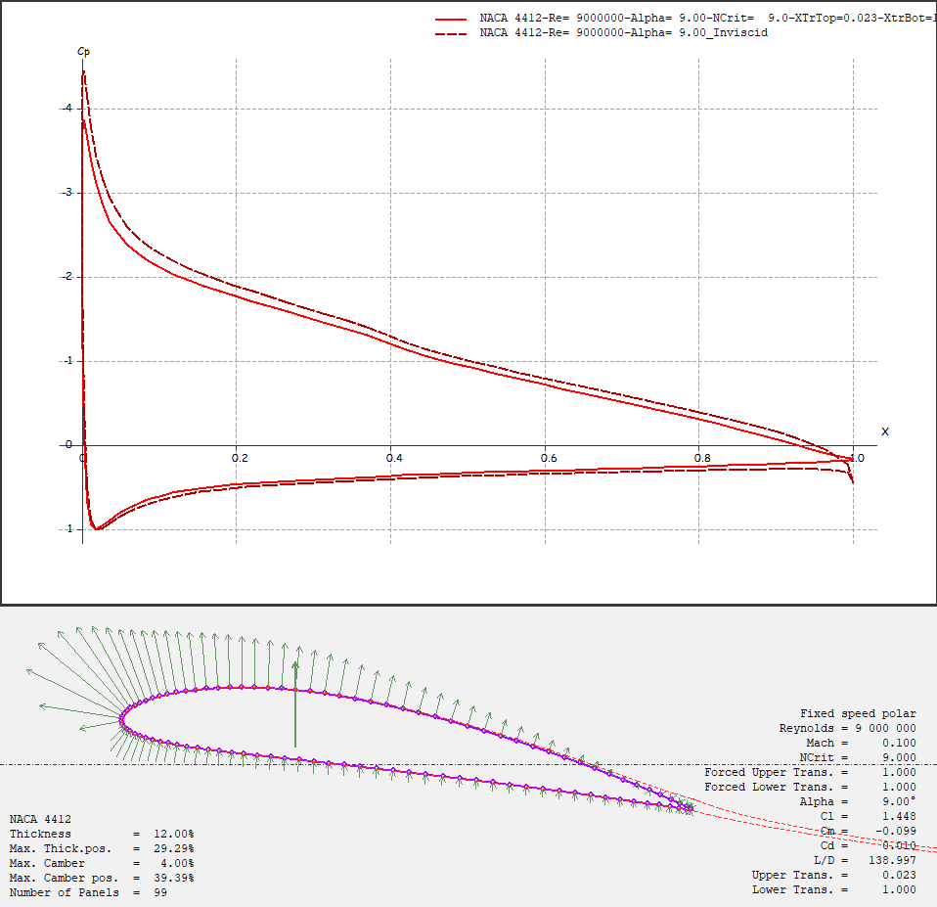

## Cp for α = 0 & α = 9

By analyzing the curves for both α **=** 0 and α **=** 9, the viscous distribution on the upper surface have consistent lower pressure. The inviscid distribution predicts a lower minimum value of pressure. The viscous distribution on the lower surface have consistent highest pressure. The inviscid solution shows the largest pressure between the upper and lower surface.

Since the lift is mostly determined by, we can conclude that the inviscid solution has a larger lift coefficient by observing the area under the graph from both plots.

## Cl for α = 0 & α = 9

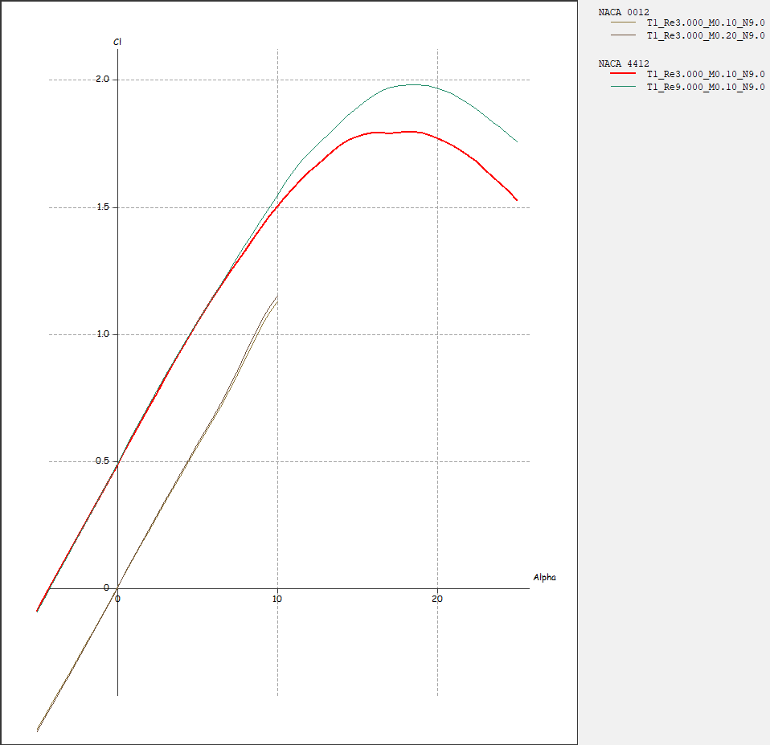

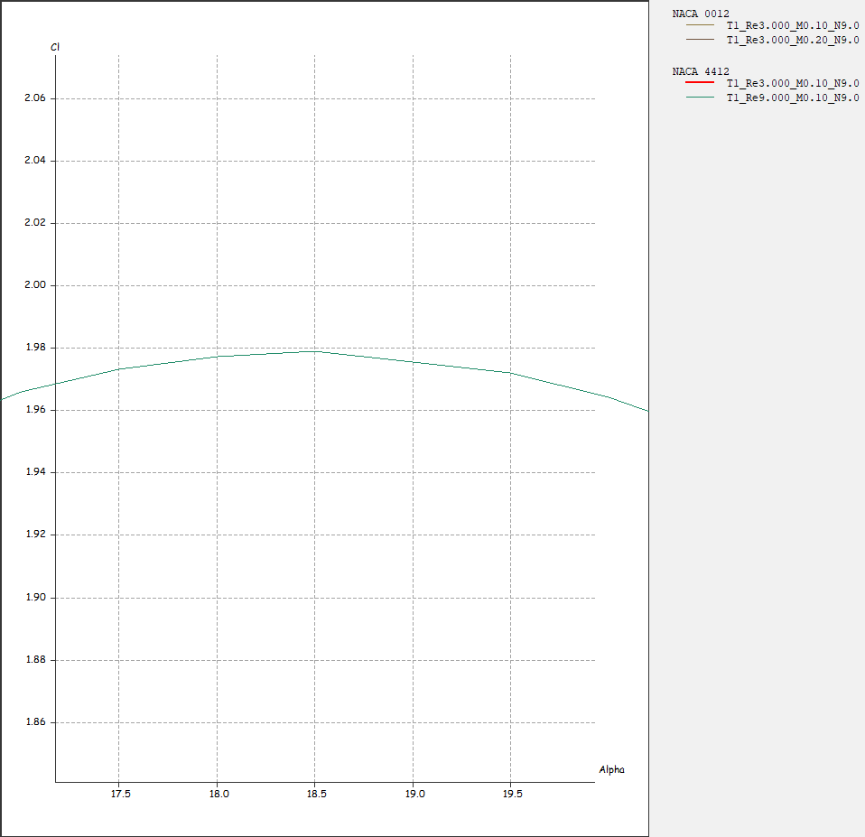

Cl increases when α increases. Reaching a certain large α, Cl will decrease abruptly, there is when flow separation occurs. For NACA 4412 results obtained from XFLR5, the maximum lift coefficient for Re at 9x10­6 is 1.98 at an α of 18.5. As for the results obtained from Abbott & Doenhoff, the maximum lift coefficient for Re at 9x10­6 is 1.65 at an α of 14. That’s a delta Cl of 0.35 and a delta α of 4.5.

1. **Drag Polar**

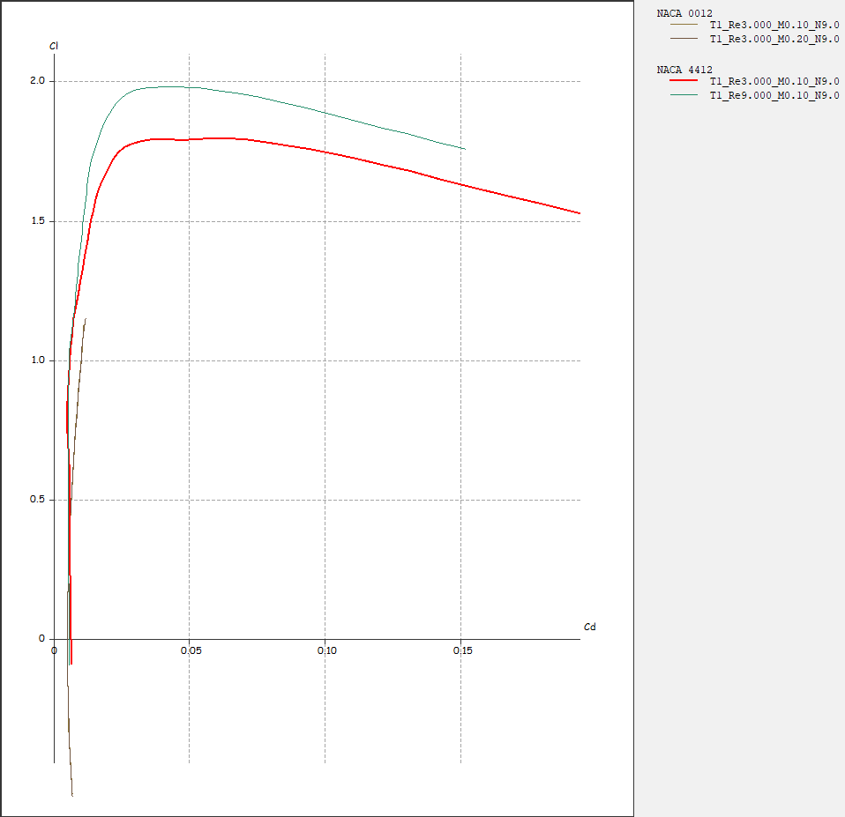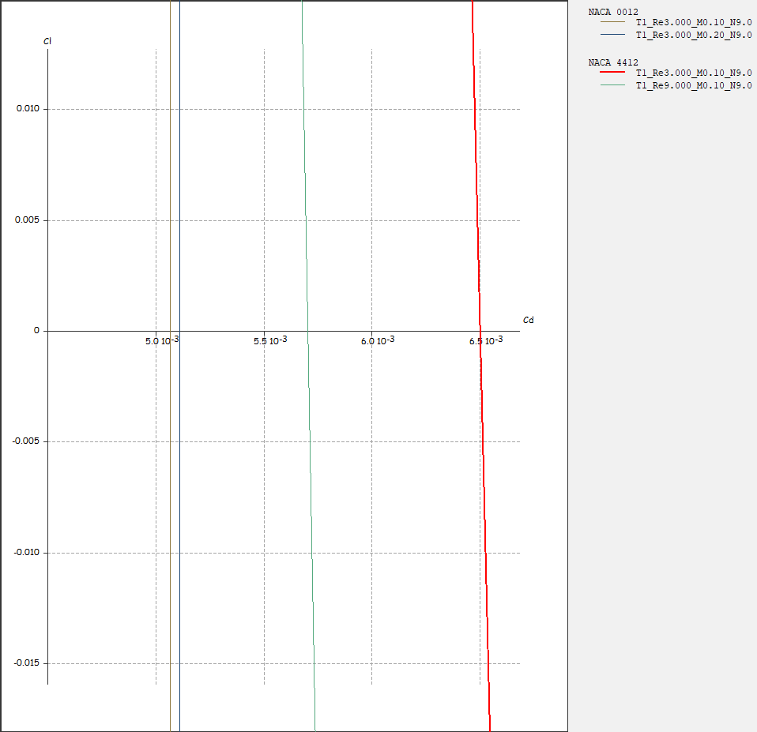

From previous discussion, we know that when an airfoil is in αzl, Cp = 0. From the drag polar plot, we can observe that when Cp = 0, Cd is approximately 5.5x103. When we increase α, Cl will increase dramatically while the increment of Cd is subtle. Thus, the Cd increases at small α, but not after the airfoil achieve maximum Cl. If α keeps increasing after the maximum Cl is achieved, the airfoil will experience stall. This is when Cl will decrease and Cd will increase as shown in the drag polar plot.

1. **Skin Friction Coefficient (α = 0)**

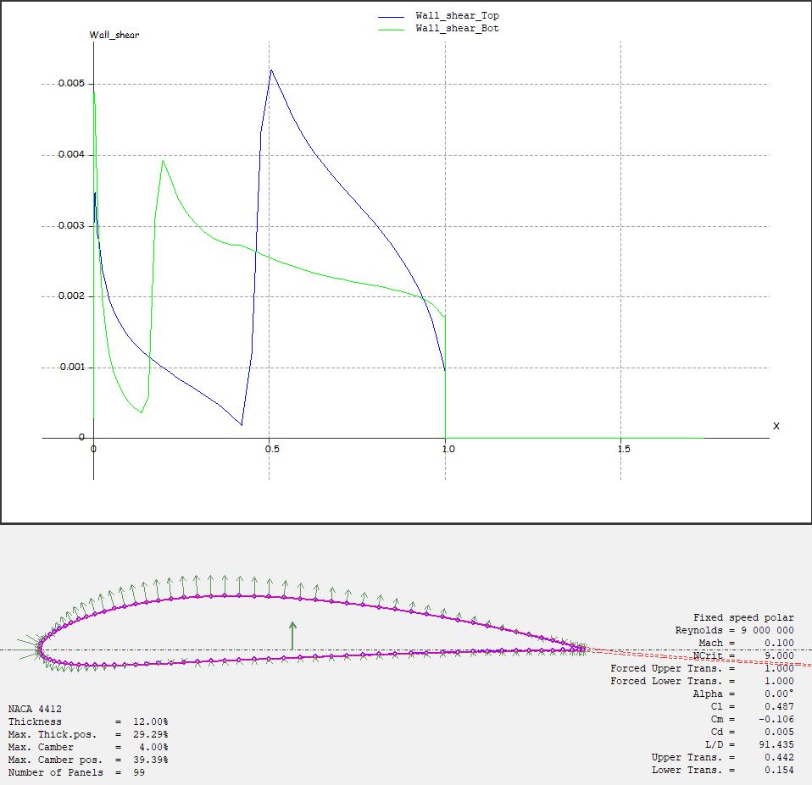

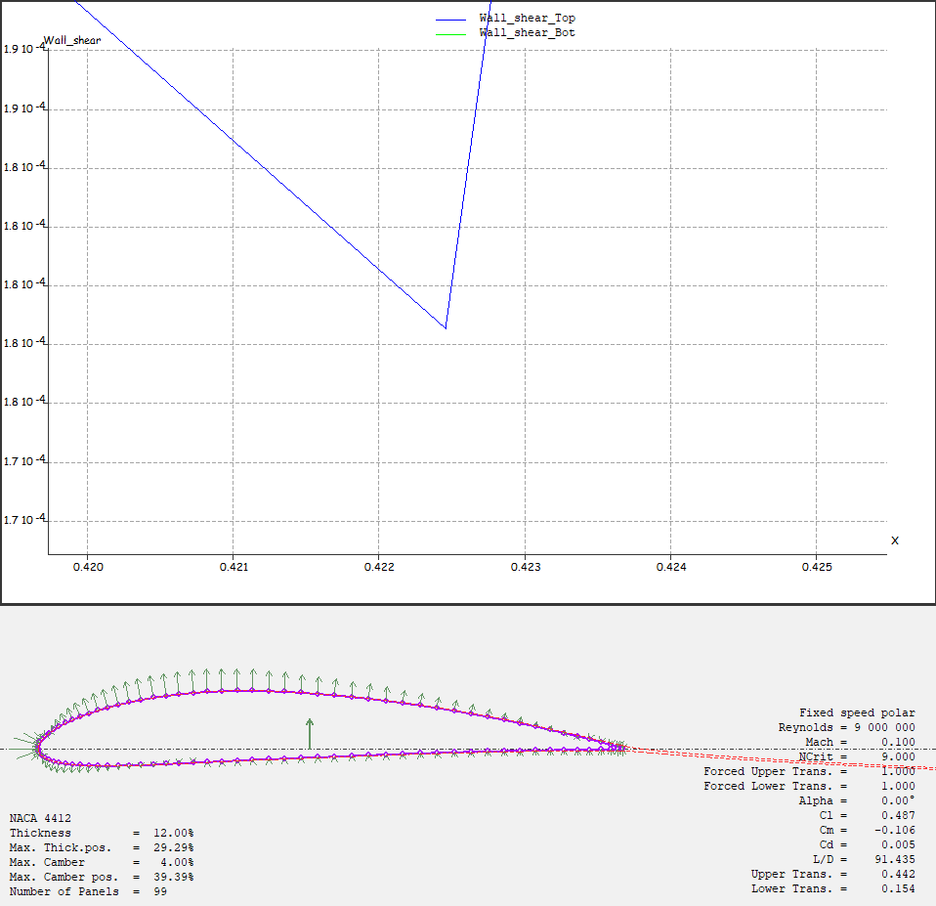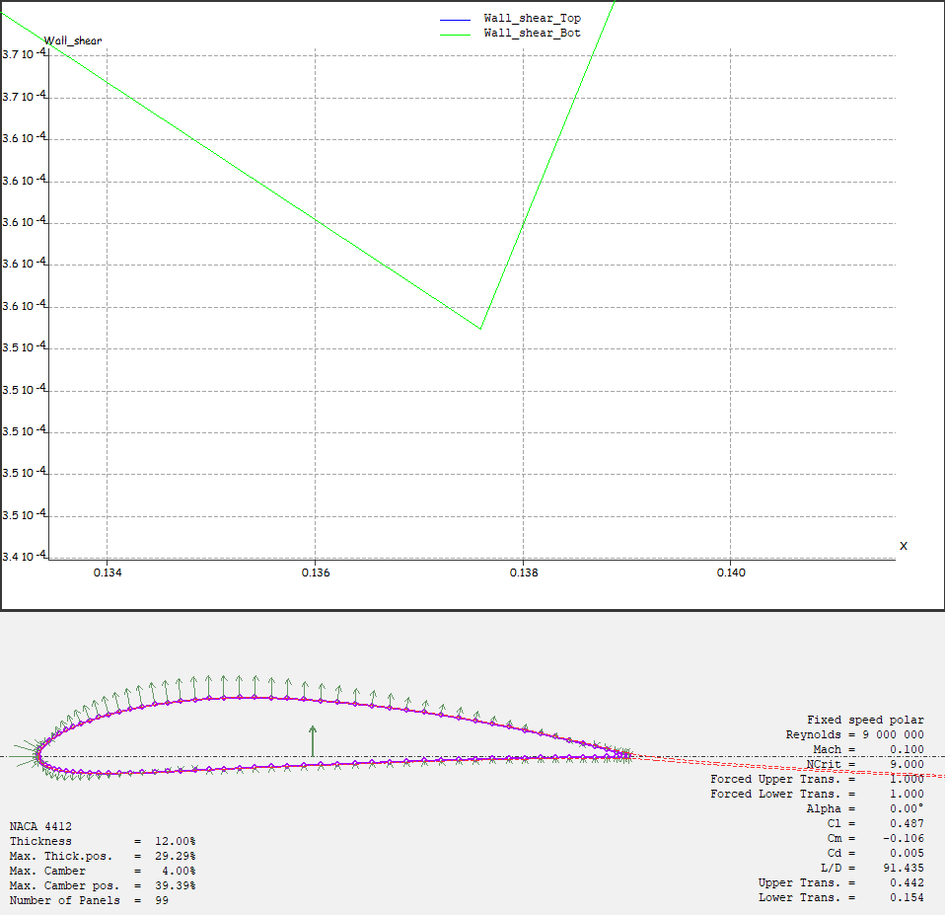

By observing both detailed plots, the top transition point is around x/c = 0.422. and the lower transition point is around x/c = 0.138. From the bottom left of the graphs, XFLR5 tabulated exact values for upper and lower transition points which are x/c = 0.442 for the top and x/c = 0.154 for the lower surfaces. Comparing both values obtained from the plots and the exact XFLR5 values, top surface has a delta x/c = 0.020 and bottom surface has a delta x/c = 0.016.

1. **Skin Friction Coefficient (α = 15)**

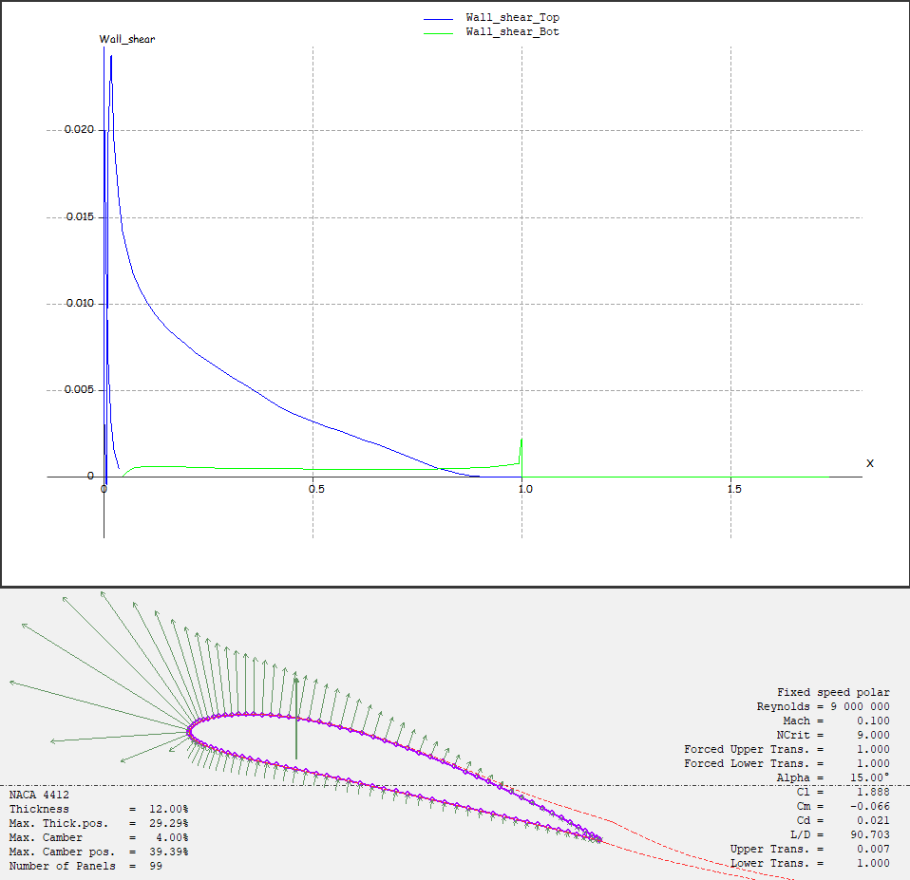

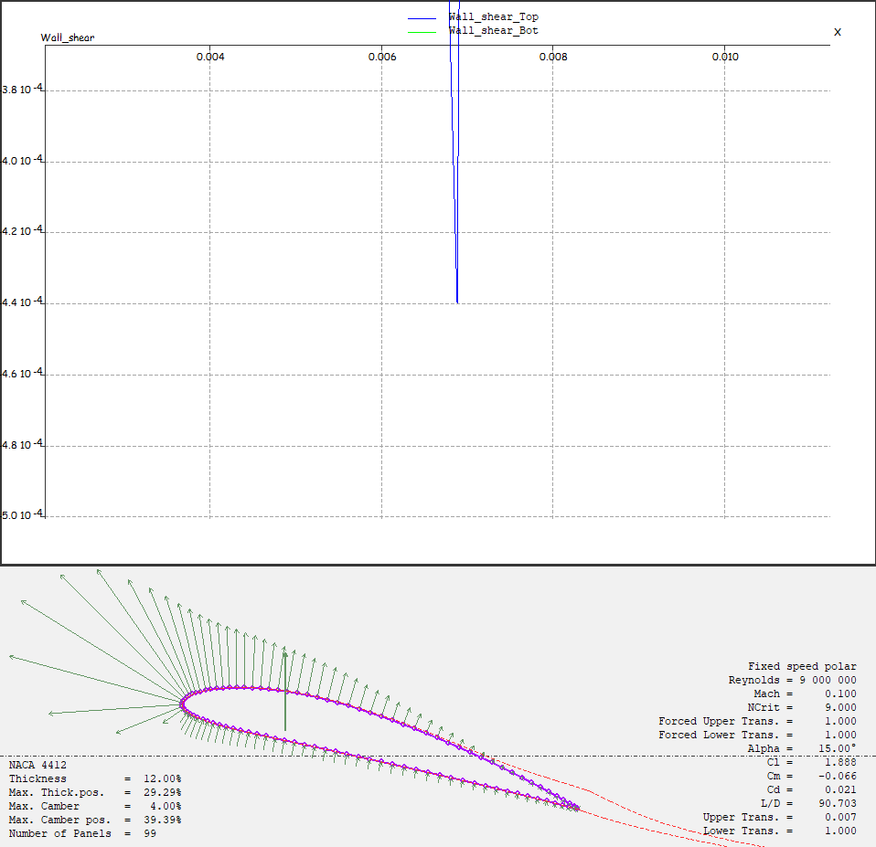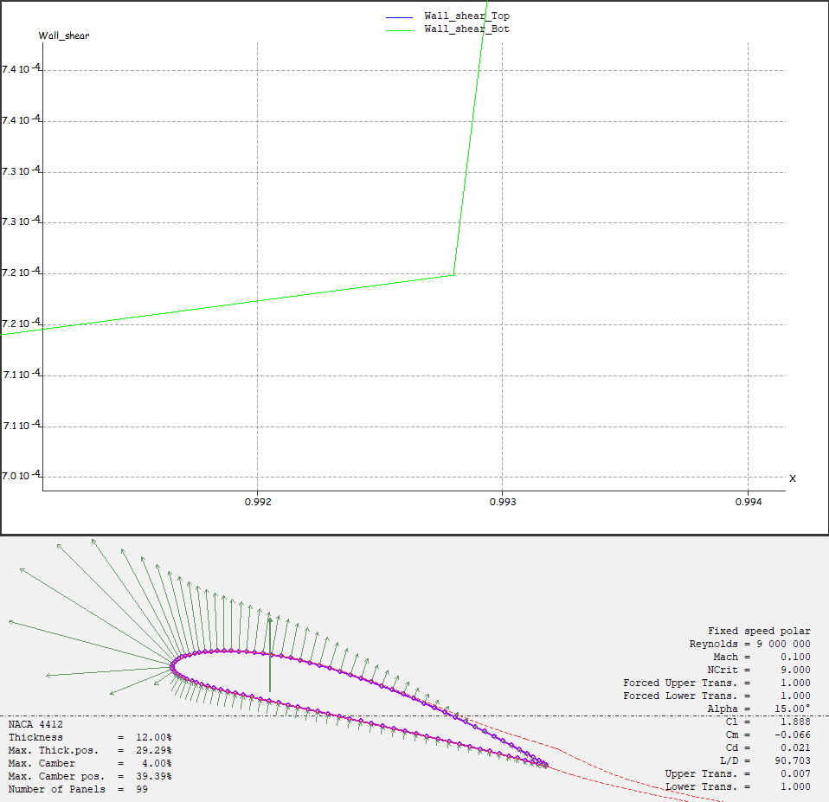

Both boundary layer on the top and lower surfaces will encounter boundary separation. By observing the plot, the approximate x/c for boundary layer to separate on top surface is around 0.007 and 0.993 for the lower surface. We can also observe that the top boundary layer increases more throughout the upper surface compared to the lower surface.

1. **Skin Friction Coefficient (α = 18)**

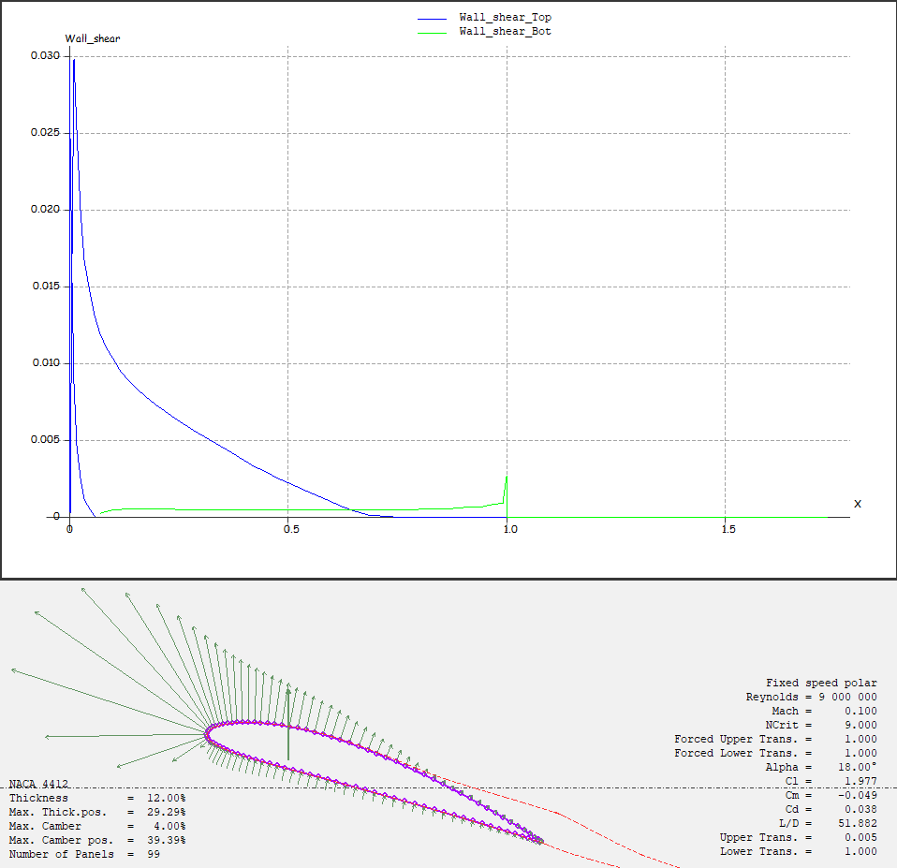

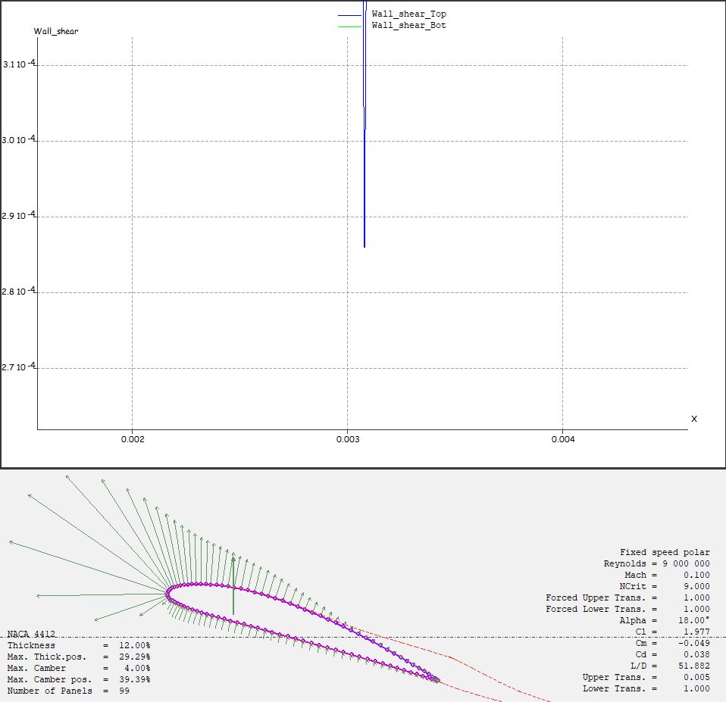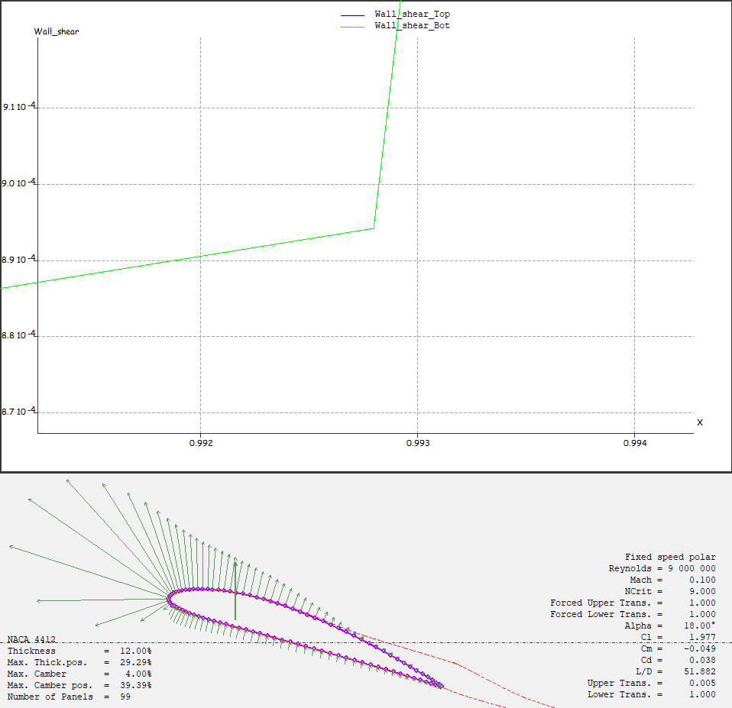

Now, when the α is increased, x/c upper surface transition approaches close to 0.003. The upper surface transition point moved forward as the α increases. When the α increases, the boundary layer thickness on the upper surface increases much earlier than in lower α.

1. **Effects of Reynolds Number on Max Cl and α**

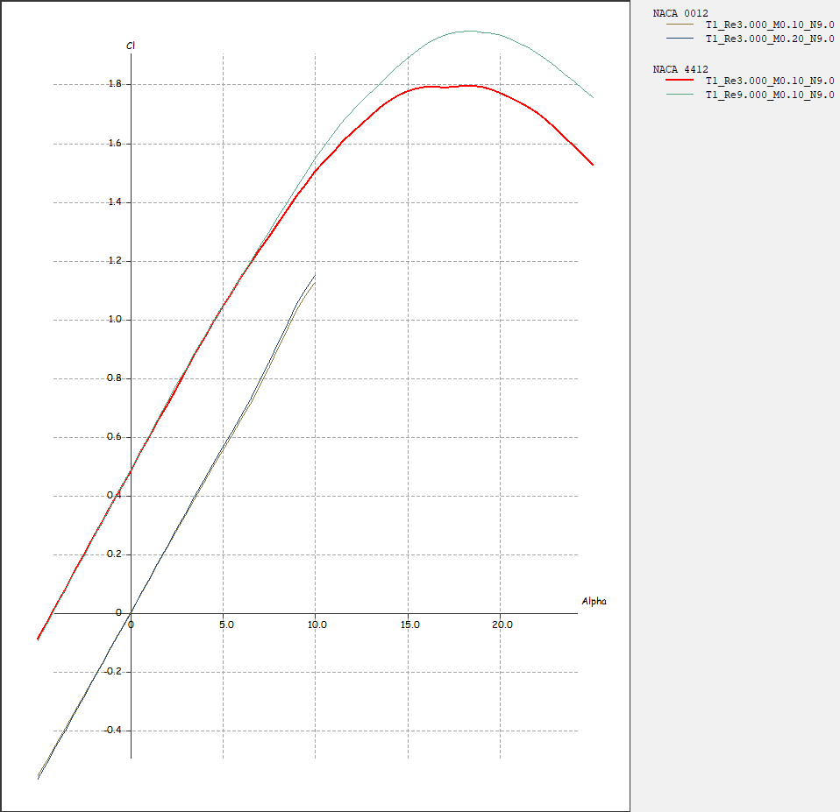

When the Re increases, the max Cl increases. Comparison between results from XFLR5 to experimental data by Abbott and Doenhoff is tabulated below.

|  |  |  |  |  |
| --- | --- | --- | --- | --- |
| **Data** | **XFLR5** | | **Abbott & Doenhoff** | |
| **Reynolds Number** | 3x106 | 9x106 | 3x106 | 9x106 |
| **Max Lift Coefficient** | 1.7927 | 1.9787 | 1.5 | 1.65 |
| **Angle of Attack** | 18.5deg | 18.5deg | 13deg | 14deg |

1. **Effects of Reynolds Number on Transition Location**

Now, let us analyze the effect of Re on the transition locations at α = 0.

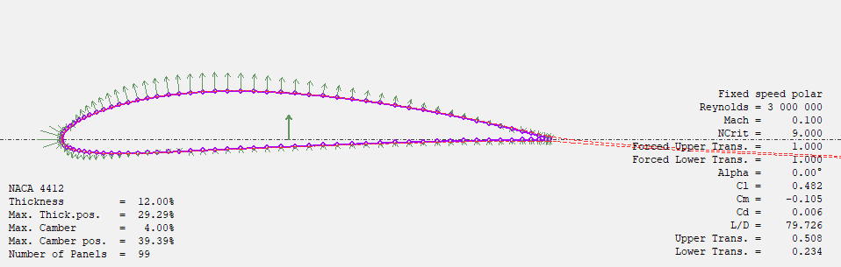

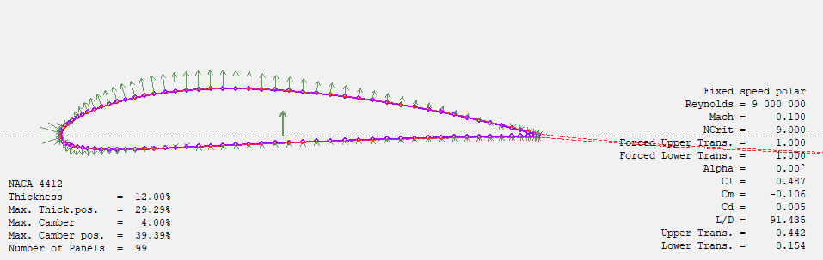

|  |  |  |
| --- | --- | --- |
| **Data** | **XFLR5** | |
| **Reynolds Number** | | 3x106 | 9x106 |
| **Upper Transition Location** | | 0.508 | 0.442 |
| **Lower Transition Location** | | 0.234 | 0.154 |

From the tabulated results, we can observe that when Re increases, both upper and lower transition location moves forward.

1. **Effects of Reynolds Number Location of Boundary Separation.**

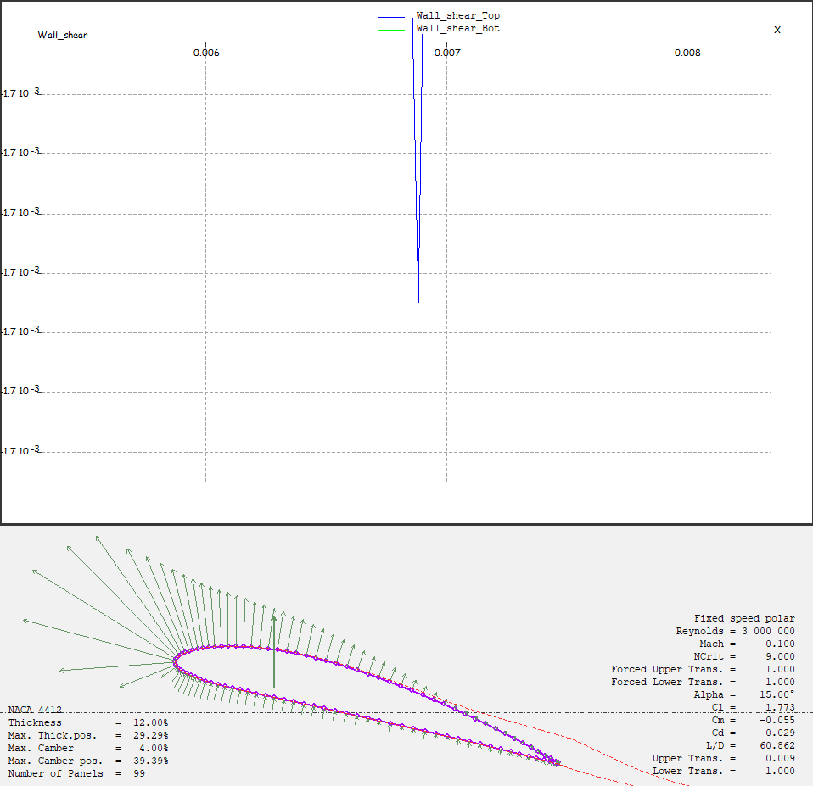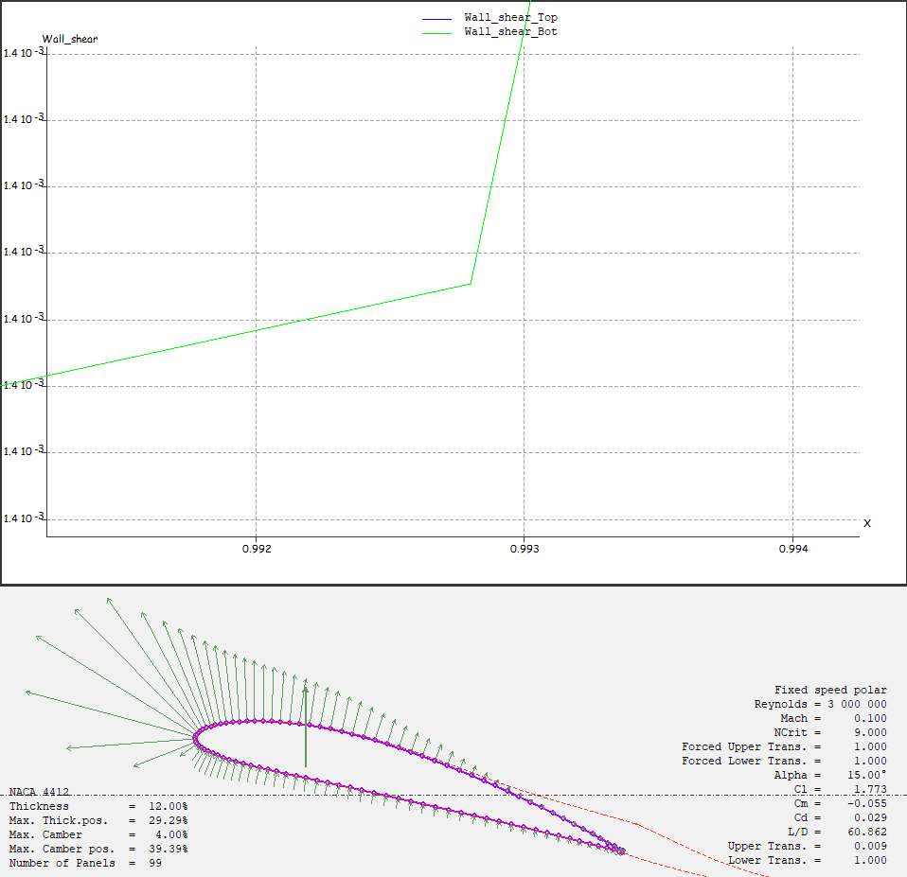



|  |  |  |
| --- | --- | --- |
| **Data** | **XFLR5** | |
| **Reynolds Number** | | 3x106 | 9x106 |
| **Upper Boundary Layer Separation Location** | | 0.007 | 0.993 |
| **Lower Boundary Layer Separation Location** | | 0.007 | 0.993 |

1. **Conclusion**

A conclusion section is not required, though it is preferred. Although a conclusion may review the main points of the paper, do not replicate the abstract as the conclusion. A conclusion might elaborate on the importance of the work or suggest applications and extensions. *Note that the conclusion section is the last section of the paper that should be numbered. The appendix (if present), acknowledgment, and references should be listed without numbers.*

**Appendix**

Matlab Codes

**Acknowledgments**

An Acknowledgments section, if used, **immediately precedes** the References. Sponsorship and financial support acknowledgments should be included here. The preferred spelling of the word “acknowledgment” in American English is without the “e” after the “g.” Avoid expressions such as “One of us (S.B.A.) would like to thank…” Instead, write “F. A. Author thanks…” *Sponsor and financial support acknowledgments are also to be listed in the “acknowledgments” section.*

**References**