<html>

<head>

<title>Home Page</title>

</head>

<body bgcolor=’’aquablue”>

<center>

<br><br>

<b>Home Page</b>

<br><br>

<form method=”post”action=”eminsertform.html”>

<input type=”submit”value=”Insert employee’’name=”submit’’></form>

<form method=”post”action=”emformdelete1.php”>

<input type=”submit”value=”Delete employee’’name=”submit’’></form>

</form>

</center>

</body>

</html>



<?php

$servername='localhost';

$username='root';

$password='';

$dbname="employee";

$conn=mysqli_connect($servername,$username,$password,$dbname);

if(!$conn){

die('could not connect

My Sql:'.mysql-error());

}

else

{echo"Database connected";

}

?>



<html>

<head>

<title>Employee form</title>

</head>

<body bgcolor="lightblue">

<form method="post"action="eminsertform.php">

<center>

<br><br>

<b>Employee Form</b>

<br><br><br>

<table>

<tr>

<td>Employee Id:</td>

<td>input type="employee"name="employee"></td>

</tr>

<tr>

<td>Name:</td>

<td>input type="name"name="name"></td>

</tr>

<tr>

<td>Designation:</td>

<td>input type="designation"name="designation"></td>

</tr>

<tr>

<td>Salary:</td>

<td>input type="salary"name="salary"></td>

</tr>

<tr>

<td>

<input type="submit"value="submit"name="submit">

</td>

</tr>

</table>

</form>

</body>

</html>

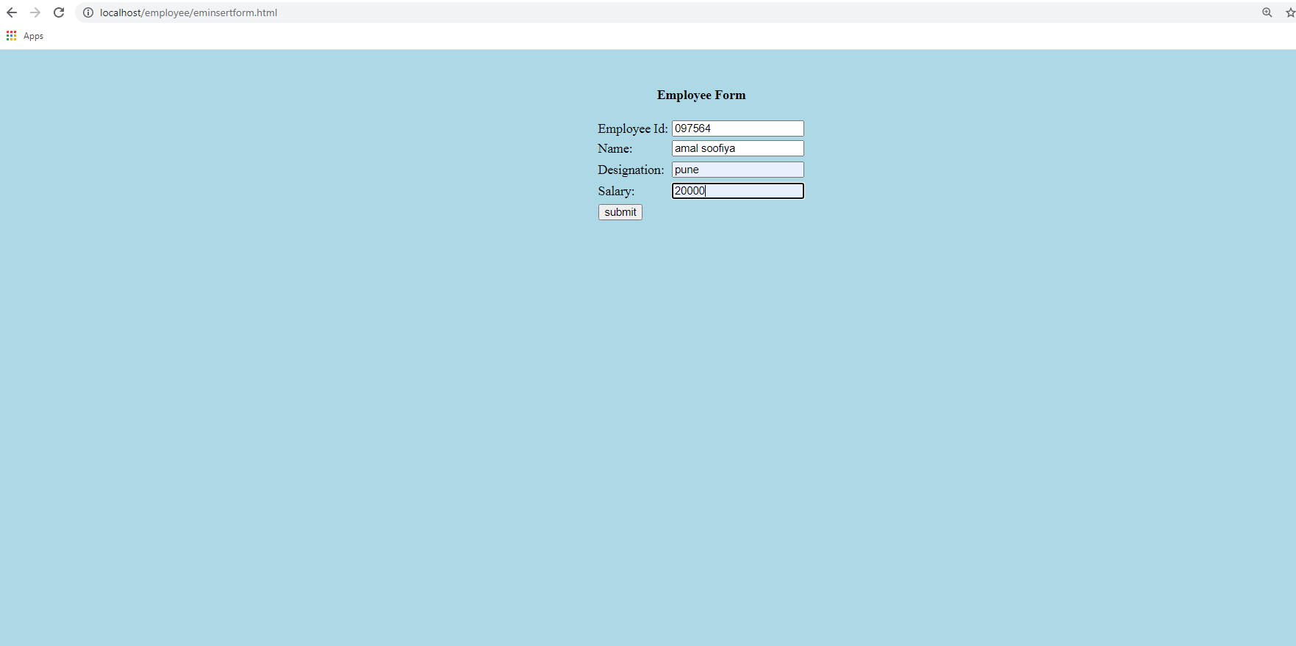

<html>

<body bgcolor="Yellowgreen">

<form action="emmain.html"method="post">

<center>

<br><br>

<?php

include_once'emconn.php';

if(isset($_POST['submit']))

{

$nam=$_POST['name'];

$desig=$_POST['designation'];

$sal=$_POST['salary'];

$sql="INSERT INTO buck(Name,Designation,Salary)

VALUES('$nam','$desig','$sal')";

if(mysqli_query($conn,$sql)){

echo"New employee added successfully!<br>";

}

else

{

echo"Error:". $sql ."". mysqli_error($conn);

}

mysqli_close($conn);

}

?>

<br><br><input type="submit"value="Back to home page"name="submit">

</center>

</body>

</html>

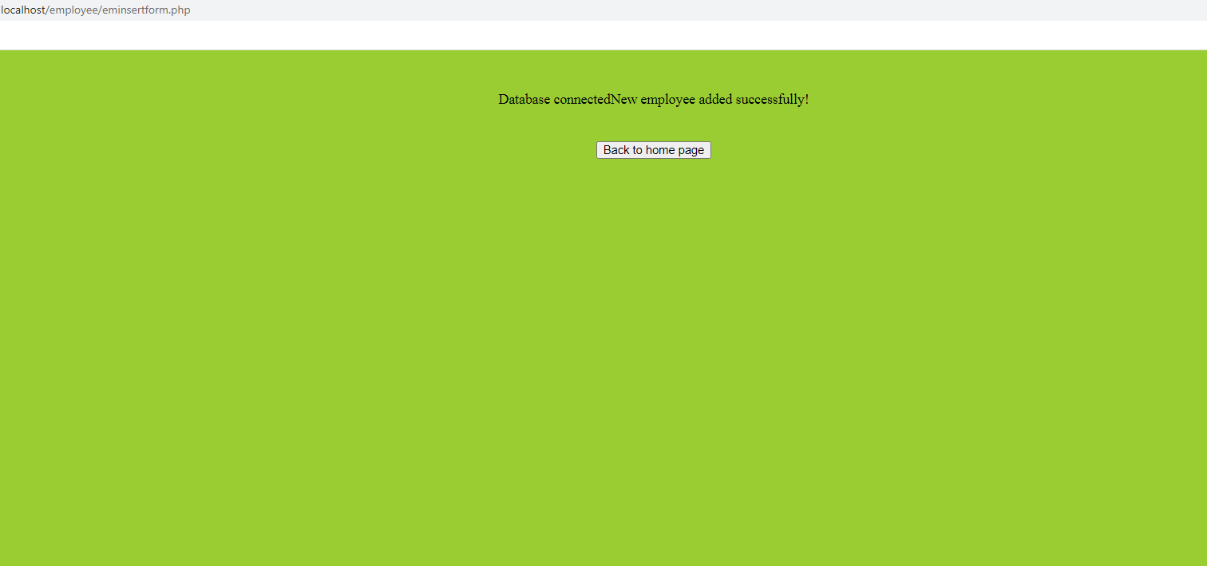

<html>

<head>

<title>Retrieve data</title>

</head>

<body bgcolor="lightpink">

<form method="post"action="emformdelete2.php">

<center>

<?php

include_once'emconn.php';

$sql="SELECT * FROM buck";

$result=mysqli_query($conn,$sql);

if(mysqli_num_rows($result)>0)

{

?>

<br><br>

<table border="2">

<tr>

<th>Employee Id</th>

<th>Name</th>

<th>Designation</th>

<th>Salary</th>

</tr>

<?php

$i=0;

while($row=mysqli_fetch_assoc($result)){

?>

<tr>

<td><?php echo $row["EmployeeId"];?></td>

<td><?php echo $row["Name"];?></td>

<td><?php echo $row["Designation"];?></td>

<td><?php echo $row["Salary"];?></td>

<?php

$i++;

}

?>

</table>

</tr>

<br><br><br.

<form method="post"action="emformdelete2.php">

Enter the Employee Id to delete:&nbsp&nbsp

<input type="text"name="id">

<br><br><br>

<input type="submit"name="Submit"value="submit">

</form>

<?php

}

else{

echo"No result found";

}

mysqli_close($conn);

?>

</center></form>

</body></html>

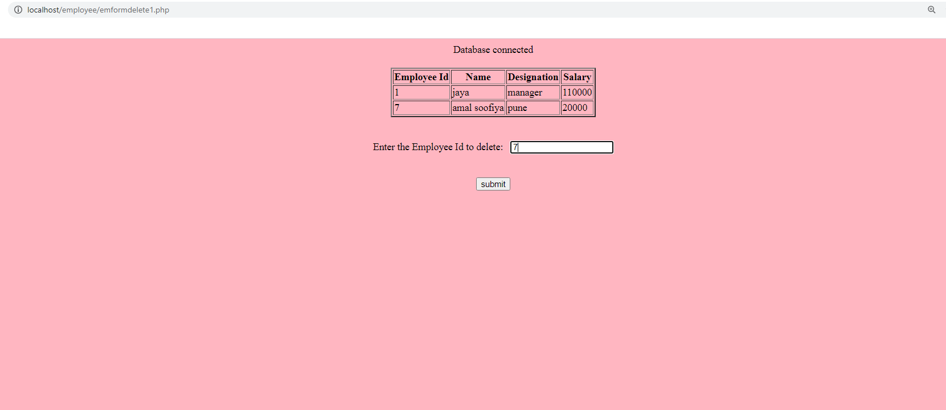

<html>

<body bgcolor="Yellow">

<form action="emmain.html"method="post">

<center>

<?php

include_once 'emconn.php';

$rid=$_POST['id'];

$sql="DELETE FROM buck WHERE EmployeeId='$rid'";

if(mysqli_query($conn,$sql))

{

echo"Record deleted successfully";

}

else{

echo"Error deleting record:".mysqli_error($conn);

}

mysqli_close($conn);?>

<br><br>

<input type="submit"value="Back to home page"name="submit">

</center>

</body>

</html>

