DS-471 Project
Deadline: Day 30/11/2026 @ 23:59
[Total Mark for this Assignment is 14]

Machine Learning
DS471

Instructions:
- You must submit two separate copies (one Word file and one PDF file) using the Assignment Template on Blackboard via the allocated folder. These files must not be in compressed format.
- It is your responsibility to check and make sure that you have uploaded both the correct files.
- Zero mark will be given if you try to bypass the SafeAssign (e.g. misspell words, remove spaces between words, hide characters, use different character sets, convert text into image or languages other than English or any kind of manipulation).
- Email submission will not be accepted.
- You are advised to make your work clear and well-presented. This includes filling in your information on the cover page.
- You must use this template, failing which will result in zero marks.
- You MUST show all your work, and text must not be converted into an image, unless specified otherwise by the question.
- Late submission will result in ZERO mark.
- The work should be your own, copying from students or other resources will result in ZERO mark.
- Use Times New Roman font for all your answers.

Name: Thamer Bander Almutairi  Name: Abdullah Mutlaq Albugami  Name: Khalid Alhamalawi  Name: Khalid Alqarni  Name: Mashaal M Alghamdi  CRN: 10700 |  | ID: S230006300  ID: S220014331  ID: S220016917  ID: S220022107  ID: S220012786

DS-471 Machine Learning Project Report
Credit Card Default Prediction
Predicting which credit-card clients will default on their next payment, using four traditional machine-learning models and a neural network.
Dataset: UCI Default of Credit Card Clients — 30,000 clients of a bank in Taiwan, 23 features (April–September 2005).
GitHub repository: https://github.com/Alhelfi1/DS471-Credit-Card-Default-Prediction

Contents
Learning Outcome(s):
Instructors: State the Learning Outcome(s) that match this question

Summary 2
1. Introduction 3
1.1 Problem definition 3
1.2 Objectives 4
1.3 Tools and reproducibility 5
2. Stage 1: Data Cleaning, Preparation and Exploration (2 Marks) 5
2.1 Dataset description 5
2.2 Target variable and class imbalance 7
2.3 Missing values and duplicates 8
2.4 Inconsistent data 8
2.5 Outliers 11
2.6 Transformation, scaling and encoding 12
2.7 Feature engineering 15
2.8 Correlation and multicollinearity 18
2.9 Exploratory analysis: the most relevant features 19
2.10 Summary of the data-preparation decisions 21
3. Stage 2: Data Splitting (1 Mark) 21
4. Stage 3: Model Selection and Development (3 Marks) 23
4.1 Selected models 23
4.2 Neural network architecture 23
4.3 Implementation and baseline results 24
4.4 Validating the preparation choices with cross-validation 25
5. Stage 4: Model Training and Hyperparameter Optimization (3 Marks) 26
5.1 Optimisation strategy 26
5.2 Hyperparameter grids 27
5.3 Selected hyperparameters 27
5.4 Monitoring over- and under-fitting: validation curves 28
5.5 Learning curves 31
5.6 Neural network: training and validation curves 32
5.7 Diagnosing and fixing over- and under-fitting in the neural network 34
5.8 Training vs validation performance of the final models 37
5.9 Choosing the decision threshold 37
6. Stage 5: Model Final Evaluation and Comparison (3 Marks) 39
6.1 Choice of evaluation metrics 39
6.2 Test-set results 39
6.3 How certain are the differences? 43
6.4 Are the predicted probabilities reliable? 45
6.5 Which features drive the predictions? 46
6.6 Final comparison and model selection 47
7. Discussion (1 Mark) 48
7.1 Interpretation of the results 48
7.2 Neural network vs traditional machine-learning models 49
7.3 Ethical considerations 50
7.4 Limitations 50
8. Conclusion (1 Mark) 51
8.1 Main findings 51
8.2 Possible future improvements 51
References 52
Appendix A: Reproducibility and Repository Structure 52

Summary
This project predicts whether a credit-card client will default on the next monthly payment. The data are the UCI Default of Credit Card Clients dataset: 30,000 clients of a Taiwanese bank, with six months of billing and repayment history and basic personal information. 22.1% of the clients defaulted, so the problem is imbalanced.
Data preparation.
- Cleaning: removed 35 exact duplicate rows and merged undocumented category codes into the documented "others" groups.
- Outliers and scale: kept all outliers, mostly reliable clients with large payments, and compressed the heavy-tailed amounts with a signed log or Yeo-Johnson transformation.
- Feature engineering: added nine features describing credit utilisation, repayment ratio and payment delays. The engineered number of delayed months became the single most correlated feature.
Modelling. The data were split 70/15/15 with stratification. Five models were tuned with 5-fold cross-validation (selection metric ROC-AUC): Logistic Regression, a Decision Tree, a Random Forest, Gradient Boosting and a Neural Network (multilayer perceptron, 128-64-32 neurons). The network's training and validation curves were monitored, and early stopping kept the weights of the best epoch (28). For every model, the decision threshold was then tuned on the validation set.
Results. On the untouched test set (4,495 clients), Gradient Boosting performed best:
- ROC-AUC 0.777 and PR-AUC 0.567;
- F1 0.541, catching 56% of defaulters with 52% precision;
- the best-calibrated probabilities (Brier score 0.135).
The Random Forest (ROC-AUC 0.776) and the Neural Network (0.772) followed. The network beat Logistic Regression and the Decision Tree on PR-AUC, but was significantly behind Gradient Boosting on PR-AUC and F1.
Recommendation: Gradient Boosting, with a decision threshold of 0.29 chosen on the validation data.

1. Introduction

1.1 Problem definition
Banks issue credit cards with a credit limit and expect clients to repay their monthly bills. When a client stops paying (defaults), the bank loses the outstanding amount. Predicting default in advance lets a lender act early, for example by reducing the credit limit, contacting the client or offering a payment plan. This is the task of credit scoring.
The data come from a bank in Taiwan in 2005, a period when card debt there grew quickly and many card holders were unable to repay [2]. For each of 30,000 clients the dataset contains:
- the credit limit;
- sex, education, marital status and age;
- for each month from April to September 2005: the repayment status, the bill amount and the amount paid.
The target states whether the client defaulted on the payment due in October 2005.
The machine-learning task is supervised binary classification: predict default (1) or no default (0) from the 23 input features. The two possible errors have different costs:
- A missed defaulter (false negative) costs the bank the money it lends.
- A false alarm (false positive) may cost a good customer through an unnecessary limit reduction.
Models are therefore judged on how well they rank clients by risk, and on how many defaulters they catch at a reasonable precision.

1.2 Objectives
- Prepare the data (Stage 1): understand the features; handle missing values, duplicates, inconsistent codes and outliers; justify encoding, transformation, scaling and feature engineering; explore the data and identify the most relevant features.
- Split the data into training, validation and test sets with a justified ratio (Stage 2).
- Develop suitable models (Stage 3): Logistic Regression, a Decision Tree, a Random Forest, Gradient Boosting and the mandatory Neural Network.
- Optimise the hyperparameters with cross-validation; monitor and correct over- and under-fitting, including training/validation curves for the neural network; choose decision thresholds (Stage 4).
- Evaluate all models once on the test set, compare them with suitable metrics and identify the most suitable model (Stage 5).

1.3 Tools and reproducibility
The complete workflow is in the notebook DS471_Credit_Card_Default_Prediction.ipynb in the project's GitHub repository (link at the top of this report). It uses Python with scikit-learn [3], pandas, NumPy, SciPy, Matplotlib and seaborn. It runs from top to bottom in Google Colab in about 25 minutes on a standard 2-core CPU.
The repository includes the data file. If that file is missing, the notebook downloads the original file from the UCI repository [1]. A single random seed (42) is used for every random step, so all numbers in this report can be reproduced exactly. All figures and tables were produced by the notebook.

2. Stage 1: Data Cleaning, Preparation and Exploration (2 Marks)
Data-leakage policy. The checks and plots in this stage use all clients, because they do not fit anything that is later used for prediction. Every step that learns from data — transformers, scalers, models, hyperparameters and decision thresholds — is fitted on the training data only (Stages 2–4), inside scikit-learn Pipelines. The engineered features (Section 2.7) use only each client's own row, so computing them before the split leaks nothing.

2.1 Dataset description
The dataset has 30,000 rows (clients) and 25 columns: an identifier, 23 features and the target (Table 1). There are no missing entries and all values are integers.
Table 1. Variables of the dataset (UCI documentation).
Column(s) | Description | Type
ID | Client identifier | identifier
LIMIT_BAL | Amount of credit given (individual and family/supplementary credit), NT$ | numeric
SEX | 1 = male, 2 = female | binary
EDUCATION | 1 = graduate school, 2 = university, 3 = high school, 4 = others | categorical
MARRIAGE | 1 = married, 2 = single, 3 = others | categorical
AGE | Age in years | numeric
PAY_0, PAY_2 … PAY_6 | Repayment status in Sep 2005 (PAY_0) back to Apr 2005 (PAY_6): −1 = paid duly; 1–9 = payment delay in months | ordinal
BILL_AMT1 … BILL_AMT6 | Bill statement amount, Sep 2005 (1) back to Apr 2005 (6), NT$ | numeric
PAY_AMT1 … PAY_AMT6 | Amount paid, Sep 2005 (1) back to Apr 2005 (6), NT$ | numeric
default payment next month | Target: 1 = default in Oct 2005, 0 = no default | binary

Data types and scales.
- SEX, EDUCATION and MARRIAGE are nominal codes; the six PAY columns are ordinal status codes; the other 14 features are numeric.
- The scales differ enormously. AGE runs from 21 to 79. The credit limit runs from NT$10,000 to NT$1,000,000. Bills reach NT$1.66 million, payments NT$1.68 million, and some bills are negative.
- The monetary columns are strongly right-skewed: their means lie far above their medians.
Renaming. In the original file the repayment-status columns are called PAY_0, PAY_2 … PAY_6 — there is no PAY_1. This naming is inconsistent with BILL_AMT1–6 and PAY_AMT1–6. They were renamed PAY_1 … PAY_6 (1 = September … 6 = April), and the target was renamed DEFAULT.

2.2 Target variable and class imbalance
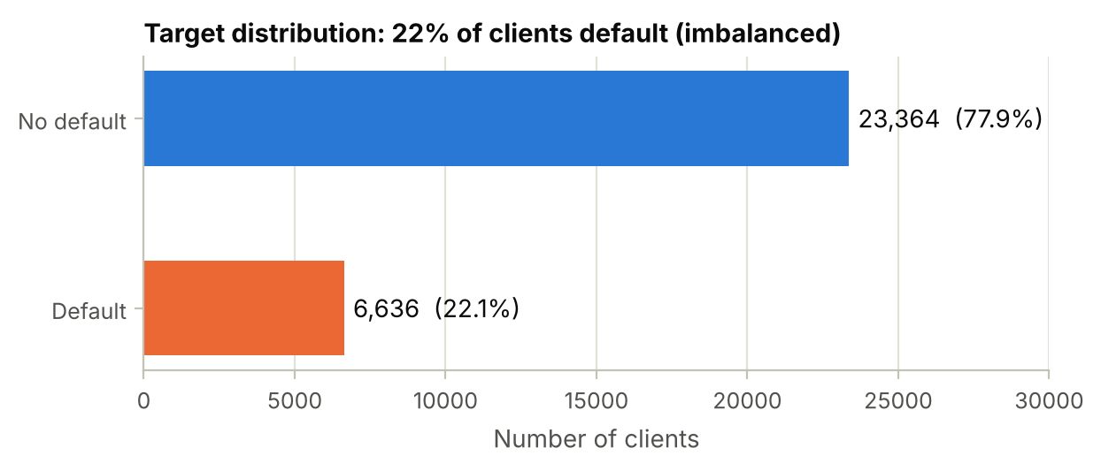
Figure 1. Distribution of the target variable (all 30,000 clients).
Finding. 6,636 of the 30,000 clients (22.1%) defaulted (Figure 1). This is a 3.52 : 1 imbalance. A model that always predicts "no default" is 77.9% accurate yet catches no defaulter at all.
Decisions.
- Metrics: accuracy alone is misleading, so the models are evaluated with ROC-AUC, PR-AUC, recall, precision and F1 for the default class (Stage 5).
- Stratified splits keep the default rate equal in all subsets (Stage 2).
- No synthetic over-sampling (SMOTE). SMOTE would create artificial clients. The imbalance is handled in two other ways:
  - class_weight='balanced' is offered to Logistic Regression, the Decision Tree and the Random Forest as a hyperparameter, and kept only when cross-validation prefers it;
  - the decision threshold is tuned on the validation set for every model (Section 5.9).
- Encoding of the target: it is already numeric with 1 = default (the positive class), so precision, recall and F1 directly describe how well defaulters are detected.

2.3 Missing values and duplicates
Missing values. None of the 750,000 entries is empty. However, EDUCATION and MARRIAGE contain codes that the documentation does not define. These are a hidden form of missing information and are handled as inconsistent data in Section 2.4.
Duplicates. Every ID is unique, but after removing the ID the rows were compared on all features (Table 2).
Table 2. Duplicate analysis (ID excluded).
Check | Result | Decision
Rows identical to another row in all 23 features and the target | 35 | remove
Rows identical to another row in the 23 features | 56 | —
Groups with identical features but different targets | 21 | keep
Duplicated rows that are inactive accounts (all six bills = 0) | 86% | —

Decisions.
- Remove the 35 exact duplicates (0.12% of the data). An identical copy adds no information. If one copy ended up in the training set and the other in the test set, the test result would be slightly optimistic.
- Keep the 21 groups with identical features but different targets. Different outcomes prove that these are different clients, most of them inactive accounts with no bills at all. Such cases are genuine noise that no model can resolve.
- Drop ID, which has no predictive meaning.
29,965 clients remain, with a default rate of 22.13%.

2.4 Inconsistent data
(a) Undocumented category codes. EDUCATION contains the codes 0, 5 and 6 and MARRIAGE the code 0, none of which is defined in the documentation (Table 3).
Table 3. Undocumented codes in EDUCATION and MARRIAGE (after removing duplicates).
Code | Meaning | Clients | Default rate
EDUCATION = 0 | undocumented | 14 | 0.0%
EDUCATION = 5 | undocumented | 280 | 6.4%
EDUCATION = 6 | undocumented | 51 | 15.7%
EDUCATION = 4 | others (documented) | 123 | 5.7%
MARRIAGE = 0 | undocumented | 54 | 9.3%
MARRIAGE = 3 | others (documented) | 323 | 26.0%

Decision: merge the undocumented codes into the documented "others" category (EDUCATION = 4, MARRIAGE = 3):
- They cover 399 clients, so dropping them would lose data.
- As separate categories they would be too small to estimate reliably.
- For EDUCATION, their default rates (0–16%) resemble the documented "others" group (5.7%). MARRIAGE = 0 (9.3%) is lower than "others" (26.0%), but 54 clients are too few for a separate group, and "others" is the documented catch-all.
After merging, EDUCATION has four categories (others: 468 clients) and MARRIAGE three (others: 377 clients).
(b) Repayment-status codes. The documentation defines only −1 ("paid duly") and 1–9 (months of delay). The data also contain the codes −2 and 0, and 0 is the most common value. Table 4 shows what these codes mean in practice.
Table 4. Share of clients whose bill in the same month is zero or negative, by repayment-status code.
Status code | Sep | Aug | Jul | Jun | May | Apr
-2 | 32.5% | 55.3% | 61.2% | 66.5% | 68.0% | 70.6%
-1 | 0.1% | 11.6% | 9.5% | 10.2% | 10.8% | 10.4%
0 | 0.0% | 1.8% | 2.0% | 1.8% | 2.4% | 3.8%

With status −2, 33–71% of clients have a bill ≤ 0 in the same month, compared with 0–12% for −1 and 0–4% for 0. This supports the interpretation commonly used for this dataset:
- −2 = no credit used (nothing to pay);
- −1 = paid in full;
- 0 = revolving credit (the minimum payment was made and the rest carried over).
A second inconsistency is that a one-month delay (code 1) occurs 3,667 times in September but almost never in the other months (28, 4, 2, 0, 0). The source evidently coded the months differently. This cannot be corrected without the bank's documentation.
Decision:
- Keep the codes as ordinal values (≤ 0 = no delay, k = k months of delay).
- Add status indicators for the most recent month (Section 2.7), because the codes −2, −1 and 0 are not ordered by risk.
(c) Other checks.
- 1,930 clients have at least one negative bill. This is a credit balance, e.g. after an overpayment or a refund. It is valid and was kept; the transformation in Section 2.6 preserves the sign.
- 3,931 clients have a bill above their credit limit. This is possible through interest, fees or tolerated over-limit spending, so it was kept.
- There are no negative payments or limits, and all ages (21–79) and limits are plausible.
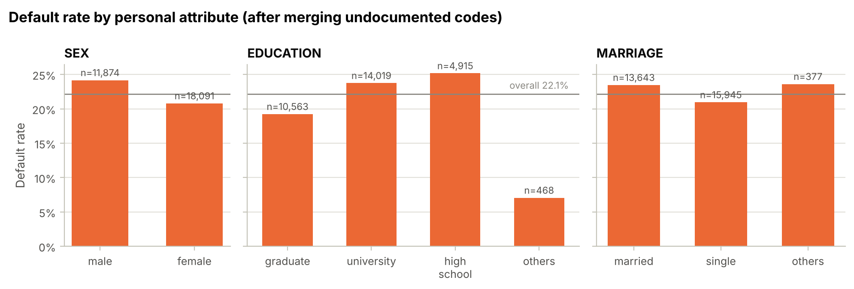
Figure 2. Default rate by sex, education and marital status after merging the undocumented codes; the grey line is the overall default rate.
The personal attributes are only weakly related to default (Figure 2):
- men 24.2% vs women 20.8%;
- graduate school 19.2% vs high school 25.2%;
- married 23.5% vs single 20.9%.

2.5 Outliers
The 1.5 × IQR rule was applied to the 13 monetary columns and AGE. It flags 32,670 values, and 10,452 clients (34.9%) have at least one outlying value (Table 5, Figure 3).
Table 5. Outliers by the 1.5 × IQR rule (ten columns with the most outliers).
Feature | Outliers | % of clients | Upper fence (NT$) | Maximum (NT$) | Default rate of outliers
PAY_AMT4 | 2,993 | 10.0% | 9,590 | 621,000 | 13.5%
PAY_AMT6 | 2,960 | 9.9% | 9,804 | 528,666 | 12.4%
PAY_AMT5 | 2,944 | 9.8% | 9,714 | 426,529 | 12.7%
PAY_AMT1 | 2,742 | 9.2% | 11,020 | 873,552 | 12.3%
BILL_AMT5 | 2,724 | 9.1% | 122,937 | 927,171 | 20.6%
PAY_AMT2 | 2,723 | 9.1% | 11,225 | 1,684,259 | 10.4%
BILL_AMT6 | 2,688 | 9.0% | 121,237 | 961,664 | 20.3%
BILL_AMT4 | 2,616 | 8.7% | 132,963 | 891,586 | 20.5%
PAY_AMT3 | 2,596 | 8.7% | 10,695 | 896,040 | 12.5%
BILL_AMT3 | 2,469 | 8.2% | 146,436 | 1,664,089 | 20.4%

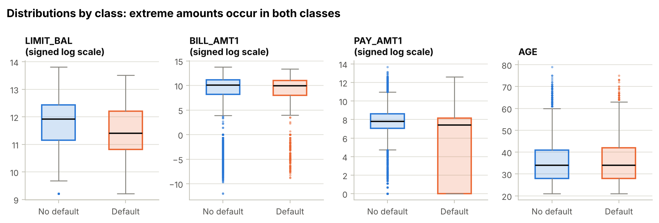
Figure 3. Distributions by class. The monetary features are shown on the signed log scale used later for the neural network.
Finding. The flagged clients mostly have large payments or high credit limits, and they default less often than average (15.2% vs 22.1%). The IQR rule is not meaningful for such data: monetary amounts are naturally heavy-tailed, and up to 24% of the payments are exactly zero, which makes the quartiles small.
Decision: keep all outliers.
- The values are real and plausible (Section 2.4).
- They carry information. Large payments signal low risk.
- Deleting them would bias the data. Removing a third of the clients, mostly reliable ones, would push the data towards risky clients.
- Their influence can be reduced without deleting anyone. For the scale-sensitive models, a transformation compresses the extreme amounts (Section 2.6). Tree-based models are insensitive to extreme values because they only use split thresholds.

2.6 Transformation, scaling and encoding
The monetary columns are extremely skewed (Table 6). The largest payment lies 72.8 standard deviations above the mean. Values like this would dominate the coefficients of a linear model and the gradient updates of a neural network.
Table 6. Skewness and largest standardised value (|z|) of the monetary columns before and after the signed log transform.
Feature | Skewness (raw) | Skewness (signed log) | Max |z| (raw) | Max |z| (signed log) | % zeros
PAY_AMT2 | 30.44 | -1.24 | 72.8 | 2.4 | 17.9%
PAY_AMT3 | 17.21 | -1.08 | 50.6 | 2.2 | 19.8%
PAY_AMT1 | 14.66 | -1.30 | 52.4 | 2.2 | 17.4%
PAY_AMT4 | 12.90 | -0.97 | 39.3 | 2.1 | 21.3%
PAY_AMT5 | 11.12 | -0.94 | 27.6 | 2.0 | 22.3%
PAY_AMT6 | 10.64 | -0.86 | 29.4 | 2.1 | 23.8%
BILL_AMT3 | 3.09 | -1.86 | 23.3 | 5.3 | 9.5%
BILL_AMT5 | 2.87 | -1.69 | 14.6 | 4.8 | 11.6%
BILL_AMT6 | 2.85 | -1.56 | 15.5 | 4.9 | 13.3%
BILL_AMT4 | 2.82 | -1.78 | 13.2 | 5.1 | 10.6%
BILL_AMT2 | 2.70 | -1.95 | 13.1 | 5.2 | 8.3%
BILL_AMT1 | 2.66 | -2.09 | 12.4 | 5.9 | 6.6%
LIMIT_BAL | 0.99 | -0.51 | 6.4 | 2.6 | 0.0%

The signed log transform, sign(x) · log(1 + |x|), was designed for this kind of data:
- It compresses the long tails: the largest |z| falls from 72.8 to 5.9, and the median |skewness| from 3.09 to 1.30 (Figure 4).
- It keeps zero at zero and keeps the sign of negative bills.
- It has no fitted parameters, so it cannot leak information.
The shapes are still not symmetric because of the spike of zero payments. That is acceptable: the aim is to remove extreme leverage, not to force normality.
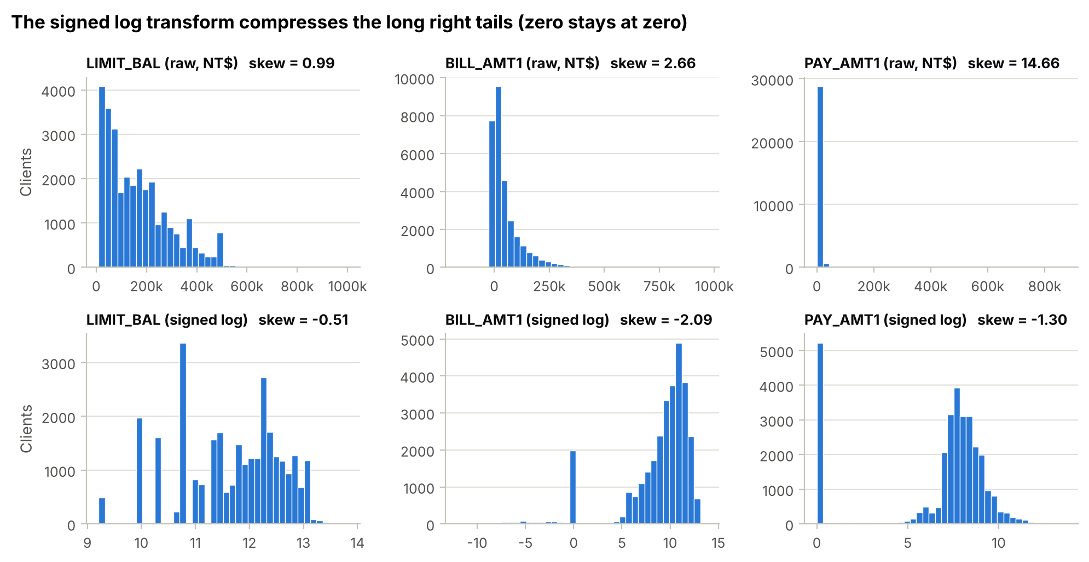
Figure 4. Three monetary features before (top) and after (bottom) the signed log transform.
Decision — preprocessing per algorithm (Table 7). The choice of transformation was confirmed by cross-validation in Section 4.4:
- Neural network: signed log on the 13 monetary columns, then standardisation (zero mean, unit variance) of all numeric inputs. Gradient-based training converges best when inputs share a similar scale.
- Logistic regression: the Yeo-Johnson power transformation [4] plus standardisation of all numeric inputs. It fits one exponent per feature, which also makes the relationship of features such as PAY_k with the log-odds more linear — something a linear model cannot learn itself. Cross-validation preferred it for this model.
- Trees: a decision tree only compares one feature with a threshold, so monotonic transformations change nothing. The three tree-based models use the raw values.
Table 7. Encoding and scaling used by each model (all steps are fitted inside the model pipeline on training data only).
Feature group | Logistic Regression | Neural Network | Decision Tree, Random Forest, Gradient Boosting
13 monetary columns | Yeo-Johnson + standardisation | signed log + standardisation | raw
AGE, PAY_1–6, engineered features | Yeo-Johnson + standardisation | standardisation | raw
EDUCATION, MARRIAGE (nominal) | one-hot | one-hot | one-hot
SEX | binary FEMALE (1 = female) | binary FEMALE | binary FEMALE

Encoding.
- EDUCATION (4 categories) and MARRIAGE (3) are nominal, so they are one-hot encoded. An integer code would wrongly suggest an order and equal spacing.
- SEX becomes the binary feature FEMALE.
- The repayment statuses PAY_1–PAY_6 stay numeric because they are ordinal (months of delay).
After encoding, the 32 feature columns give 37 model inputs.

2.7 Feature engineering
Nine features were added, based on how lenders assess credit risk (Table 8). Each one is computed from the client's own row only, so it cannot leak information between clients or between data splits. Utilisation and debt change were clipped to fixed, plausible ranges, which changed only 69 values.
Table 8. Engineered features (FEMALE only re-encodes SEX, so it is not counted among the nine new features).
Feature | Definition | Rationale
UTIL_LATEST | BILL_AMT1 / LIMIT_BAL, clipped to [−1, 2] | Credit utilisation in September
UTIL_AVG | mean(BILL_AMT1–6) / LIMIT_BAL, clipped to [−1, 2] | Average utilisation; a bill means little without the limit
REPAY_RATIO | Σ PAY_AMT1–5 / Σ positive BILL_AMT2–6, capped at 1 | Share of the billed debt actually repaid (a payment in month k settles the bill of month k + 1)
N_MONTHS_DELAYED | number of months (of 6) with PAY_k ≥ 1 | Persistence of payment problems
MAX_DELAY | max(PAY_1–6), floored at 0 | Severity of payment problems
BILL_CHANGE | (BILL_AMT1 − BILL_AMT6) / LIMIT_BAL, clipped to [−2, 2] | Is the debt growing?
PAY_1_NO_USE, PAY_1_PAID_FULL, PAY_1_REVOLVING | indicators for status −2, −1 and 0 in September | Lets linear models use the unordered status codes
FEMALE | 1 if SEX = 2 | Binary encoding of SEX

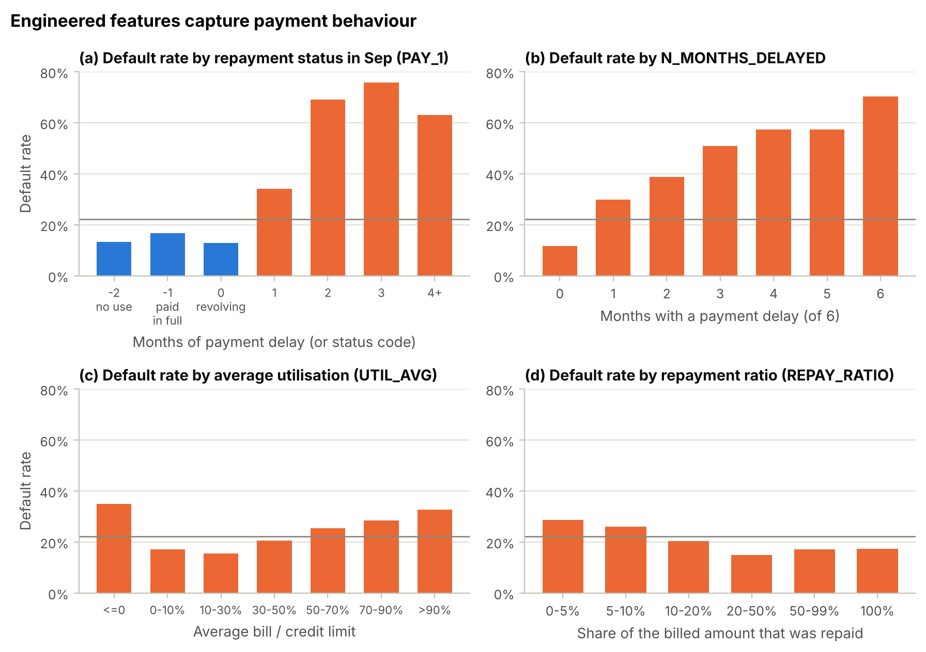
Figure 5. Default rate by (a) the September repayment status, (b) the number of delayed months, (c) average utilisation and (d) repayment ratio; the grey line is the overall default rate.
Patterns (Figure 5).
- (a) The September status is non-monotonic. Paid in full (−1) has a higher default rate (16.8%) than no use (−2, 13.2%) or revolving credit (0, 12.8%). Any delay raises the risk sharply: 34% for one month and 69% for two. One numeric column cannot express this to a linear model, hence the three indicators.
- (b) N_MONTHS_DELAYED increases steadily, from 11.7% default with no delay to 70.3% with six delayed months. Its correlation with DEFAULT (r = 0.398) is the highest of all features, higher than any original column (PAY_1: r = 0.325).
- (c) Utilisation shows a U-shape. Very high utilisation is risky, and so is a zero or negative average bill: 1,041 clients, 34.9% default.
- (d) Clients who repay a larger share of their bills default less.
Several of these patterns are non-linear, which is a first hint that flexible models will outperform a purely linear one.

2.8 Correlation and multicollinearity
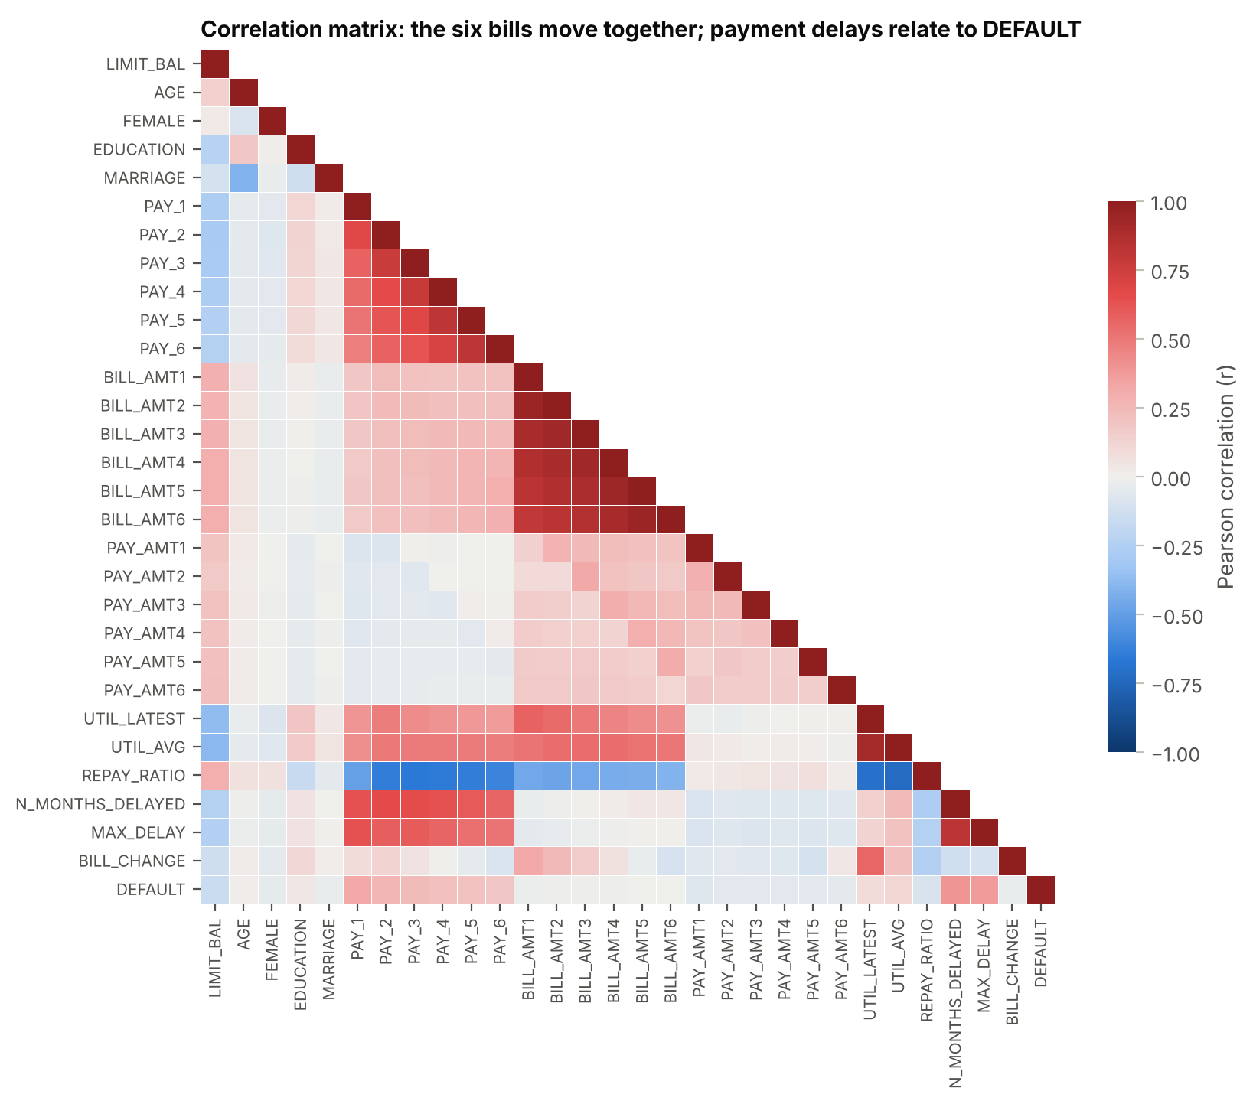
Figure 6. Pearson correlation matrix of the numeric features, the engineered features and the target.
Findings (Figure 6).
- The six monthly bills are strongly correlated (r = 0.80–0.95).
- The repayment statuses are moderately correlated (r = 0.48–0.82).
- Payments are only weakly correlated (r = 0.15–0.29).
Variance inflation factors were computed on the log scale used by the models. The median VIF is 5.7, and only the two utilisation features exceed 10 (maximum 36). That is expected, because they are ratios of amounts that are also in the model.
Decision: keep all features.
- With 20,975 training clients and 37 inputs there is ample data per parameter.
- Logistic Regression and the network use L2 regularisation, which stabilises correlated coefficients.
- Tree models are unaffected by collinearity.
- Cross-validation shows that the engineered features improve every model (Section 4.4).

2.9 Exploratory analysis: the most relevant features
Every feature was ranked by two measures of its relationship with the target (Figure 7):
- mutual information, which captures any dependence, including non-linear;
- the absolute correlation with DEFAULT, which measures linear association.
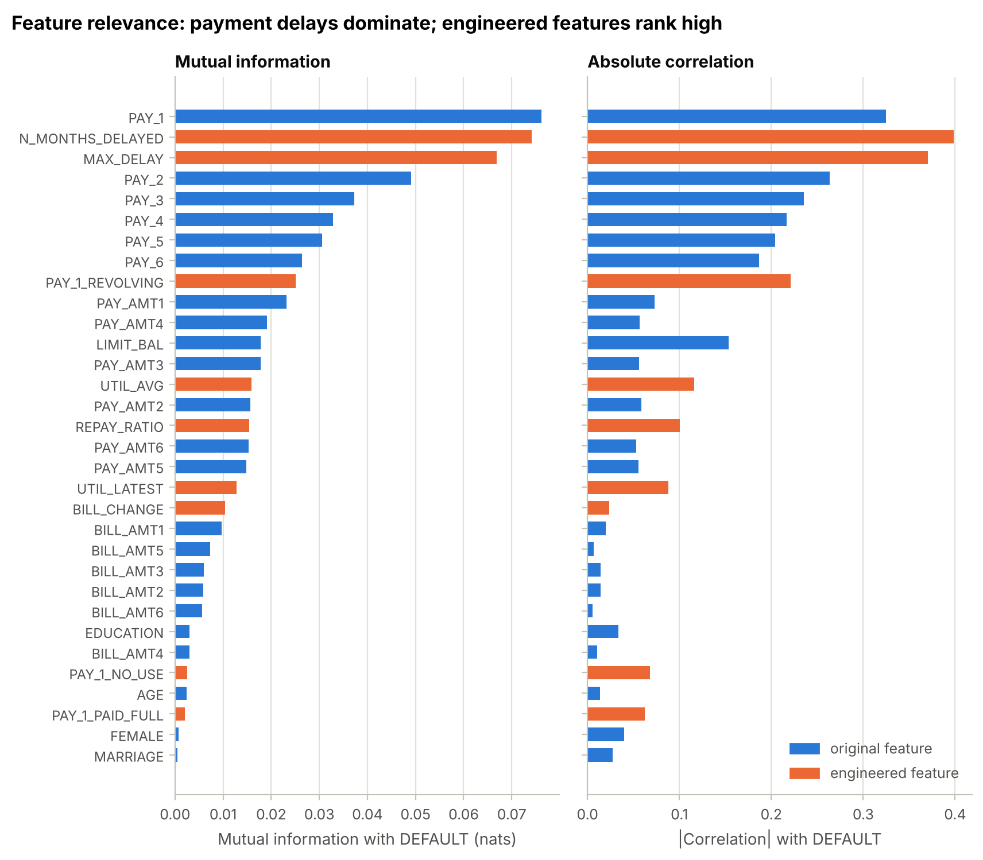
Figure 7. Relevance of every feature for DEFAULT: mutual information (left) and absolute correlation (right). Orange bars are engineered features.
Most relevant features.
- Payment behaviour dominates. The top features are PAY_1, N_MONTHS_DELAYED and MAX_DELAY, followed by the earlier statuses PAY_2–PAY_6, PAY_1_REVOLVING, the recent payment amounts and LIMIT_BAL. A higher limit means lower risk (r = -0.154).
- Bill amounts alone are almost unrelated to default (|r| < 0.02). They become informative only relative to the limit, as utilisation.
- Personal attributes carry very little information. Sex, marital status and age have mutual information below 0.003.
All features were kept: none is harmful, and the effect of removing the personal attributes is tested in Section 4.4.

2.10 Summary of the data-preparation decisions
Table 9. Data-preparation findings and decisions.
Step | Finding | Decision and justification
Missing values | none; undocumented codes | treated as inconsistent data
Duplicates | 35 exact duplicate rows; 21 same-feature groups with different targets | remove the 35 copies (leakage risk, no information); keep the rest; drop ID
Inconsistent data | EDUCATION 0/5/6, MARRIAGE 0, PAY codes −2/0, PAY_0 naming | merge into "others"; interpret and keep the PAY codes; rename PAY_1–PAY_6
Outliers | 34.9% of clients; mostly reliable high payers | keep; reduce their leverage by transformation
Target | 22.1% default (3.52 : 1) | stratified splits; class weights tested; threshold tuned on validation data
Encoding | 2 nominal features, 1 binary | one-hot EDUCATION / MARRIAGE; binary FEMALE; ordinal PAY codes
Scaling | skewness up to 30; values up to 73 SD | NN: signed log + standardisation; LR: Yeo-Johnson + standardisation; trees: none
Feature engineering | utilisation, repayment and delay patterns | 9 new features → 32 columns, 37 model inputs
Relevance | payment history dominates; personal attributes weak | keep all features; test removing the personal attributes

3. Stage 2: Data Splitting (1 Mark)
The 29,965 clients were divided into 70% training, 15% validation and 15% test, stratified by the target, in two steps:
- 15% was held out as the test set.
- 15/85 of the remainder became the validation set.
Table 10. Training, validation and test sets.
Set | Clients | % of data | Defaults | No default | % default
Training | 20,975 | 70.0% | 4,641 | 16,334 | 22.13%
Validation | 4,495 | 15.0% | 994 | 3,501 | 22.11%
Test | 4,495 | 15.0% | 995 | 3,500 | 22.14%
Total | 29,965 | 100.0% | 6,630 | 23,335 | 22.13%

Justification of the ratio.
- Large dataset, so a 15% evaluation set is enough. Each evaluation set contains about 995 defaulters, which gives precise estimates: the bootstrap 95% interval of the test ROC-AUC is only about ±0.018 (Section 6.3).
- The validation set has two jobs. It early-stops the neural network and sets each model's decision threshold. Both need enough defaulters, which argues against a smaller set — an 80/10/10 split would leave only about 660.
- Enough training data. 20,975 clients (70%) is plenty for 5-fold cross-validation, in which each fold still trains on 16,780 clients. The learning curves (Section 5.5) are almost flat at this size, so a larger training share would add little.
- Stratification keeps the default rate identical (22.1%) in all three sets, so each set represents the same population.
Roles of the three sets (no leakage).
- Training set — fit the models; tune the hyperparameters with 5-fold cross-validation inside this set.
- Validation set — check over- and under-fitting, early-stop the network and choose the decision thresholds. It never updates any model's parameters.
- Test set — used once, for the final evaluation and comparison.
The split was made before any transformer or model was fitted, with a fixed seed (42). An assertion in the notebook confirms that the three sets share no client.

4. Stage 3: Model Selection and Development (3 Marks)

4.1 Selected models
The target is binary, so this is a classification problem and Linear Regression, which predicts continuous values, is not appropriate. Five models of increasing flexibility were selected (Table 11). They cover the main families listed in the assignment, including two ensemble methods.
Table 11. Selected models and why each suits this problem.
Model | Family | Why it is appropriate
Logistic Regression | linear, probabilistic | The standard model in credit scoring: interpretable coefficients (log-odds) and probability outputs. A strong, transparent baseline.
Decision Tree | rule-based | Produces human-readable rules (e.g. "delayed 2+ months and utilisation > 90%"), captures interactions and needs no scaling. Also a high-variance reference for the over-fitting analysis.
Random Forest | ensemble — bagging | Averages hundreds of decorrelated trees [6]. Non-linear, robust to outliers and correlated features, with less variance than a single tree.
Gradient Boosting | ensemble — boosting | HistGradientBoostingClassifier [7]: adds shallow trees that correct the previous errors. Usually the strongest model family for tabular data [9]; fast on 21,000 rows.
Neural Network (MLP) | feed-forward network | Mandatory. Learns non-linear combinations of features. Regularised with L2 and early stopping.

Why not an SVM? A kernel SVM needs roughly O(n²) memory and O(n²)–O(n³) training time, which is impractical for a grid search on 21,000 clients. It also produces no probabilities without extra calibration. The tree ensembles already provide flexible non-linear decision boundaries at a fraction of the cost.

4.2 Neural network architecture
The mandatory network is a fully connected feed-forward multilayer perceptron (scikit-learn MLPClassifier):
- Input layer: 37 inputs (the 32 feature columns after one-hot encoding). The monetary columns are signed-log transformed and all numeric inputs are standardised (Table 7).
- Hidden layers: fully connected with ReLU activation. The number of layers and neurons was tuned (Stage 4); the final network has three hidden layers with 128, 64 and 32 neurons.
- Output layer: one sigmoid neuron giving P(default).
- Training: binary cross-entropy loss, minimised with the Adam optimiser [5] (learning rate 0.001) in mini-batches of 256 clients.
- Regularisation: an L2 weight penalty (alpha, tuned) and early stopping on the validation loss.
The final network has 37×128 + 128 + 128×64 + 64 + 64×32 + 32 + 32×1 + 1 = 15,233 trainable parameters. That is fewer than the 20,975 training clients, but enough capacity to memorise noise if it is not regularised (Section 5.7).

4.3 Implementation and baseline results
Each model is a scikit-learn Pipeline that chains its preprocessing (Table 7) and the classifier. Cross-validation therefore re-fits the preprocessing inside every fold. All models were first evaluated with default hyperparameters using stratified 5-fold cross-validation on the training set (Table 12).
Table 12. Baseline performance with default hyperparameters (training set, 5-fold CV).
Model | CV ROC-AUC | CV PR-AUC | Training ROC-AUC | Gap (train − CV)
Logistic Regression | 0.7808 ± 0.004 | 0.5363 | 0.7830 | 0.0022
Decision Tree | 0.6181 ± 0.012 | 0.2945 | 1.0000 | 0.3819
Random Forest | 0.7714 ± 0.005 | 0.5416 | 1.0000 | 0.2286
Gradient Boosting | 0.7864 ± 0.005 | 0.5580 | 0.8634 | 0.0770
Neural Network | 0.7483 ± 0.006 | 0.5003 | 0.8792 | 0.1309

Observations.
- Severe over-fitting in the flexible models. The default decision tree reaches a perfect training ROC-AUC (1.000) but only 0.618 in cross-validation. The default random forest (1.000 vs 0.771) and the default neural network (100 neurons, weak L2, no early stopping: 0.879 vs 0.748) also memorise the training clients.
- Logistic Regression shows almost no gap (0.783 vs 0.781). It is limited by its linear form (bias), not by variance.
- Default Gradient Boosting is already the best (0.786).
Stage 4 removes the over-fitting by tuning and regularisation.

4.4 Validating the preparation choices with cross-validation
Table 13 tests the Stage 1 decisions on the training set (5-fold CV). It compares the three feature sets and the three scaling options for the two scale-sensitive models, and the three feature sets for Gradient Boosting.
Table 13. Cross-validated ROC-AUC for each feature set and scaling option (training set, 5-fold CV). Final choices are highlighted.
Model — scaling | Original features (23) | + engineered (29) | + engineered + PAY_1 status (32)
LR — standardisation | 0.7274 | 0.7655 | 0.7733
LR — Yeo-Johnson | 0.7490 | 0.7641 | 0.7808
LR — signed log | 0.7500 | 0.7635 | 0.7750
NN — standardisation | 0.7753 | 0.7784 | 0.7784
NN — Yeo-Johnson | 0.7760 | 0.7803 | 0.7820
NN — signed log | 0.7750 | 0.7822 | 0.7829
GB — none (trees) | 0.7805 | 0.7866 | 0.7864

- Engineered features help every model: Logistic Regression gains +0.013 to +0.038 ROC-AUC, the network +0.003 to +0.007 and Gradient Boosting +0.006.
- The PAY_1 status indicators add a further +0.008 to +0.017 for Logistic Regression, which cannot learn the non-monotonic status pattern by itself. Gradient Boosting and the network learn it from the raw codes, so the indicators change little for them.
- Transformation (final feature set): Logistic Regression is best with Yeo-Johnson (0.7808 vs 0.7750 with the signed log and 0.7733 with plain standardisation). The network is best with the signed log (0.7829 vs 0.7820 and 0.7784). These are the choices used in the pipelines (Table 7).
Personal attributes. Sex, age and marital status are protected attributes in many lending regulations, so it is worth knowing what they contribute (Table 14).
Table 14. Effect of removing sex, age and marital status (training set, 5-fold CV, default hyperparameters).
Model | All 32 features | Without sex, age, marital status | Difference
Logistic Regression | 0.7808 | 0.7794 | -0.0014
Gradient Boosting | 0.7864 | 0.7862 | -0.0002

Removing them costs almost nothing (-0.0014 for LR and -0.0002 for GB). The main models keep the full dataset, as the assignment asks; the implications are discussed in Section 7.3.

5. Stage 4: Model Training and Hyperparameter Optimization (3 Marks)

5.1 Optimisation strategy
- Search method: exhaustive grid search (GridSearchCV) over the grids in Table 15. In total 191 configurations were tested.
- Validation scheme: stratified 5-fold cross-validation on the training set. Each candidate is trained five times on 16,780 clients and evaluated on the remaining 4,195, so the score is not the luck of a single split.
- Selection metric: ROC-AUC.
  - It measures how well a model ranks defaulters above non-defaulters, independently of the decision threshold, which is tuned separately (Section 5.9).
  - It does not depend on the class ratio.
  - It is the standard in credit scoring, where Gini = 2·AUC − 1.
  - PR-AUC was recorded for every candidate as well.
- Refit: the best configuration of each model was refitted on the full training set. Inside the search, the network used early stopping on an internal 10% split, and Gradient Boosting stopped adding trees when an internal 10% split stopped improving.

5.2 Hyperparameter grids
Table 15. Hyperparameter grids.
Model | Hyperparameters searched | Configs
Logistic Regression | C: 10⁻⁴, 10⁻³, 10⁻², 0.1, 1, 10, 100  class_weight: None, balanced | 14
Decision Tree | max_depth: 4, 6, 8, 10, 12, None  min_samples_leaf: 1, 50, 100, 200, 400, 800  class_weight: None, balanced | 72
Random Forest | 200 trees, max_features = √p  max_depth: 12, None; min_samples_leaf: 5, 15, 30, 60  class_weight: None, balanced_subsample | 16
Gradient Boosting | learning_rate: 0.03, 0.1; max_leaf_nodes: 7, 15, 31  min_samples_leaf: 50, 200, 800; l2_regularization: 0, 10, 100  up to 1,000 rounds with early stopping | 54
Neural Network | hidden layers: (32), (64, 32), (128, 64), (128, 64, 32), (256, 128, 64)  alpha: 10⁻⁴, 10⁻³, 10⁻², 0.1, 1, 3, 10  fixed: ReLU, Adam (lr 0.001), batch 256, early stopping | 35

5.3 Selected hyperparameters
Table 16. Selected hyperparameters and cross-validated performance (training set, 5-fold CV, mean ± SD).
Model | Selected hyperparameters | CV ROC-AUC | CV PR-AUC | Tuning time
Logistic Regression | C = 100; class_weight = balanced | 0.7833 ± 0.004 | 0.5373 | 46 s
Decision Tree | max_depth = 10; min_samples_leaf = 400; class_weight = balanced | 0.7777 ± 0.007 | 0.5333 | 40 s
Random Forest | 200 trees; max_depth = 12; min_samples_leaf = 30; balanced_subsample | 0.7909 ± 0.005 | 0.5631 | 278 s
Gradient Boosting | learning_rate = 0.03; max_leaf_nodes = 31; min_samples_leaf = 200; l2 = 100; 194 rounds | 0.7909 ± 0.004 | 0.5618 | 124 s
Neural Network | 128-64-32 ReLU; alpha = 1.0; Adam (lr 0.001); batch 256 | 0.7844 ± 0.006 | 0.5469 | 209 s

Justification of the selected values.
- Logistic Regression — C = 100, balanced weights. The CV score is flat for C ≥ 1 (0.7832–0.7833). With 20,975 clients and 37 inputs, the model cannot over-fit, so it needs little regularisation; strong regularisation under-fits (Figure 8). Balanced class weights improved the ROC-AUC slightly.
- Decision Tree — max_depth = 10, min_samples_leaf = 400, balanced. Requiring at least 400 clients per leaf is the key regularisation (Figure 8). Deeper limits tie, because the leaf size already stops the growth.
- Random Forest — leaves of 30 clients, max_depth = 12, balanced_subsample. Slightly smoothed trees generalise best. The five best configurations are within 0.0004 ROC-AUC.
- Gradient Boosting — learning_rate = 0.03, 31 leaves, min_samples_leaf = 200, L2 = 100, 194 rounds. A small learning rate with early stopping. The five best configurations are within 0.0002.
- Neural Network — 128-64-32 neurons, alpha = 1.0. Strong L2 regularisation wins. The five best networks, from 2 to 3 hidden layers, are within 0.0008.
For every model, the best configurations differ by much less than the fold-to-fold standard deviation (about 0.004–0.007). The tuned performance is therefore robust rather than the result of a lucky grid point.

5.4 Monitoring over- and under-fitting: validation curves
Figure 8 varies one key hyperparameter of each tuned model, keeping the others fixed, and plots the training and cross-validated ROC-AUC. A wide gap means over-fitting (high variance); both curves low means under-fitting (high bias). For Gradient Boosting the x-axis is the number of boosting rounds, read from staged predictions without early stopping.
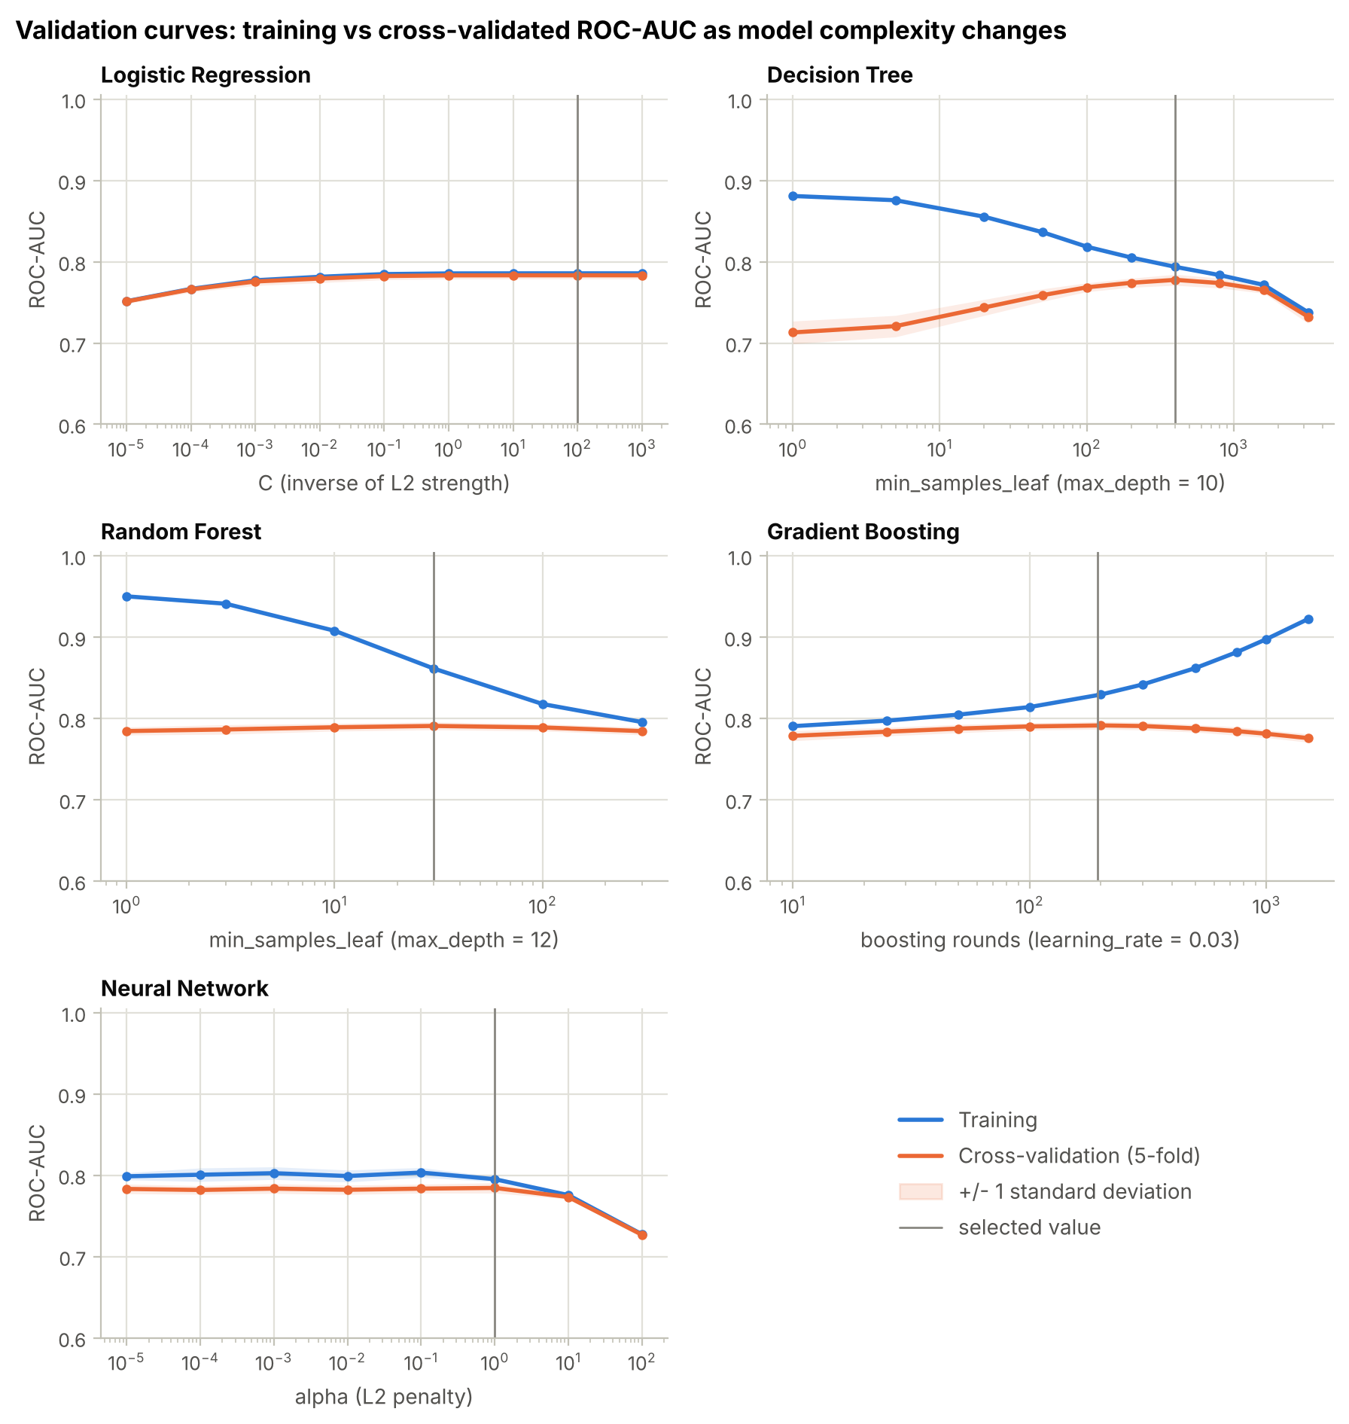
Figure 8. Validation curves: training vs 5-fold cross-validated ROC-AUC (mean ± 1 SD). The grey line marks the selected value.
- Logistic Regression: very strong regularisation (C = 10⁻⁵) under-fits (0.751 / 0.751). From C ≈ 1 both curves are flat with a gap of only 0.002: this simple model cannot over-fit 20,975 clients.
- Decision Tree: with one client per leaf it over-fits (training 0.881 vs CV 0.713). The CV score peaks at 400 clients per leaf (0.778); at 3,200 per leaf the tree under-fits (0.738 / 0.732).
- Random Forest: small leaves over-fit (0.950 vs 0.785), although averaging keeps the CV score reasonable. Leaves of 30 give the best CV score (0.791).
- Gradient Boosting: the training score keeps rising with more rounds (0.922 after 1,500). The CV score peaks at about 200 rounds (0.7915) and then declines (0.776) — over-fitting through too many trees. Early stopping chose 194 rounds.
- Neural Network: below alpha ≈ 1 the training–CV gap is about 0.015–0.02 even with early stopping. At alpha = 1 the CV score is highest (0.784). Larger penalties under-fit: 0.773 at alpha = 10 and 0.727 at alpha = 100.

5.5 Learning curves
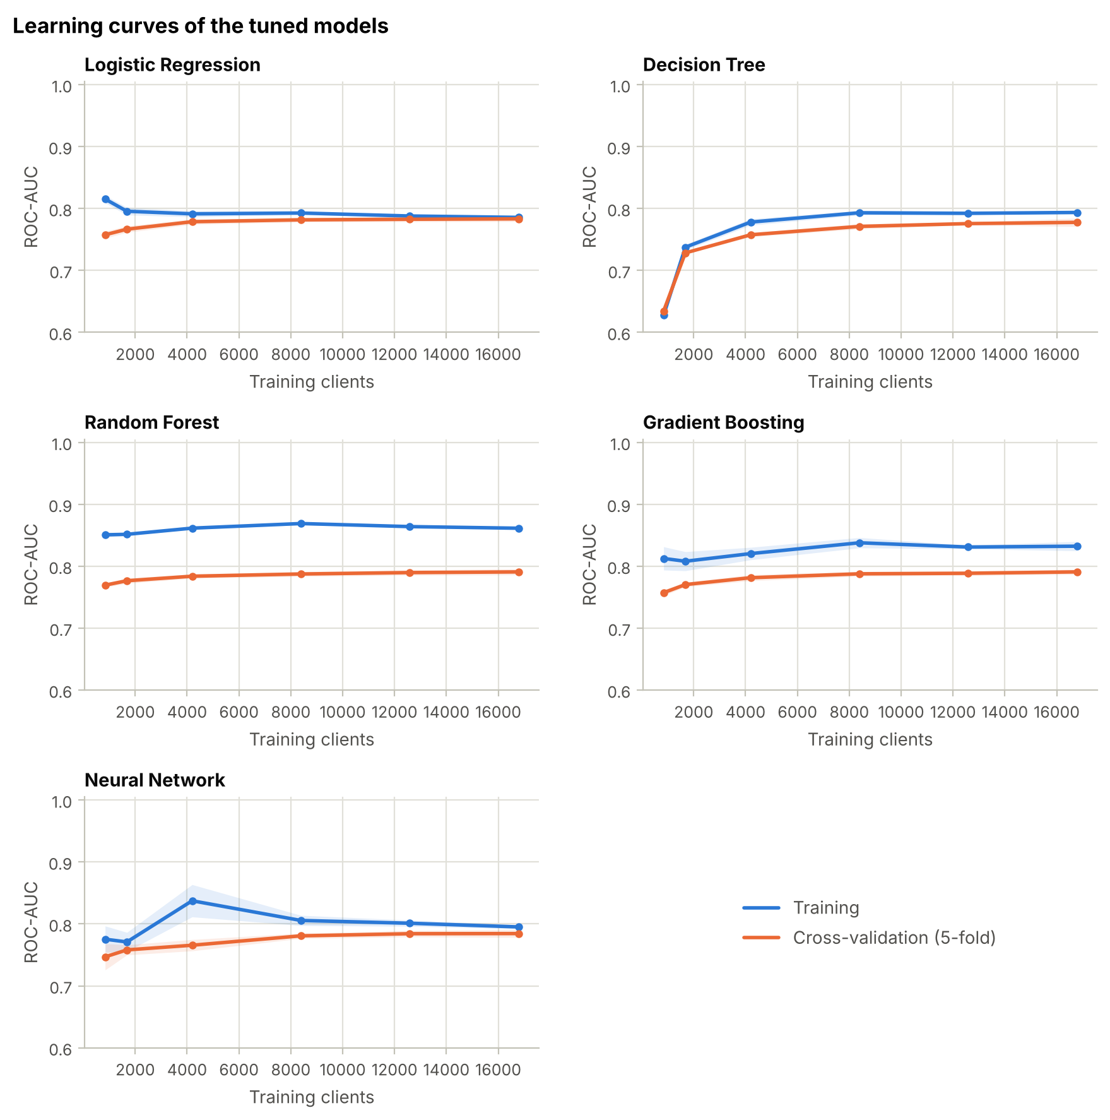
Figure 9. Learning curves of the tuned models (5-fold cross-validation on the training set).
Figure 9 shows performance against the number of training clients. With the full training folds (16,780 clients):
- Logistic Regression (gap 0.002) and the network (gap 0.011) generalise almost perfectly.
- The tree ensembles keep larger gaps (Random Forest 0.071, Gradient Boosting 0.041), which is typical of flexible models. Yet they reach the highest CV scores (0.791).
- All CV curves are nearly flat over the last 8,000 clients, so more data of the same kind would bring only small gains.

5.6 Neural network: training and validation curves
Training procedure. The network was trained one epoch at a time with partial_fit (one pass over the 20,975 training clients in mini-batches of 256). After every epoch, the binary cross-entropy loss, the accuracy and the ROC-AUC were computed on both the training and the validation set.
Early stopping. When the validation loss had not improved by at least 10⁻⁴ for 20 consecutive epochs, training stopped and the weights of the best epoch were restored. The validation data were used only to decide when to stop, never to update the weights.
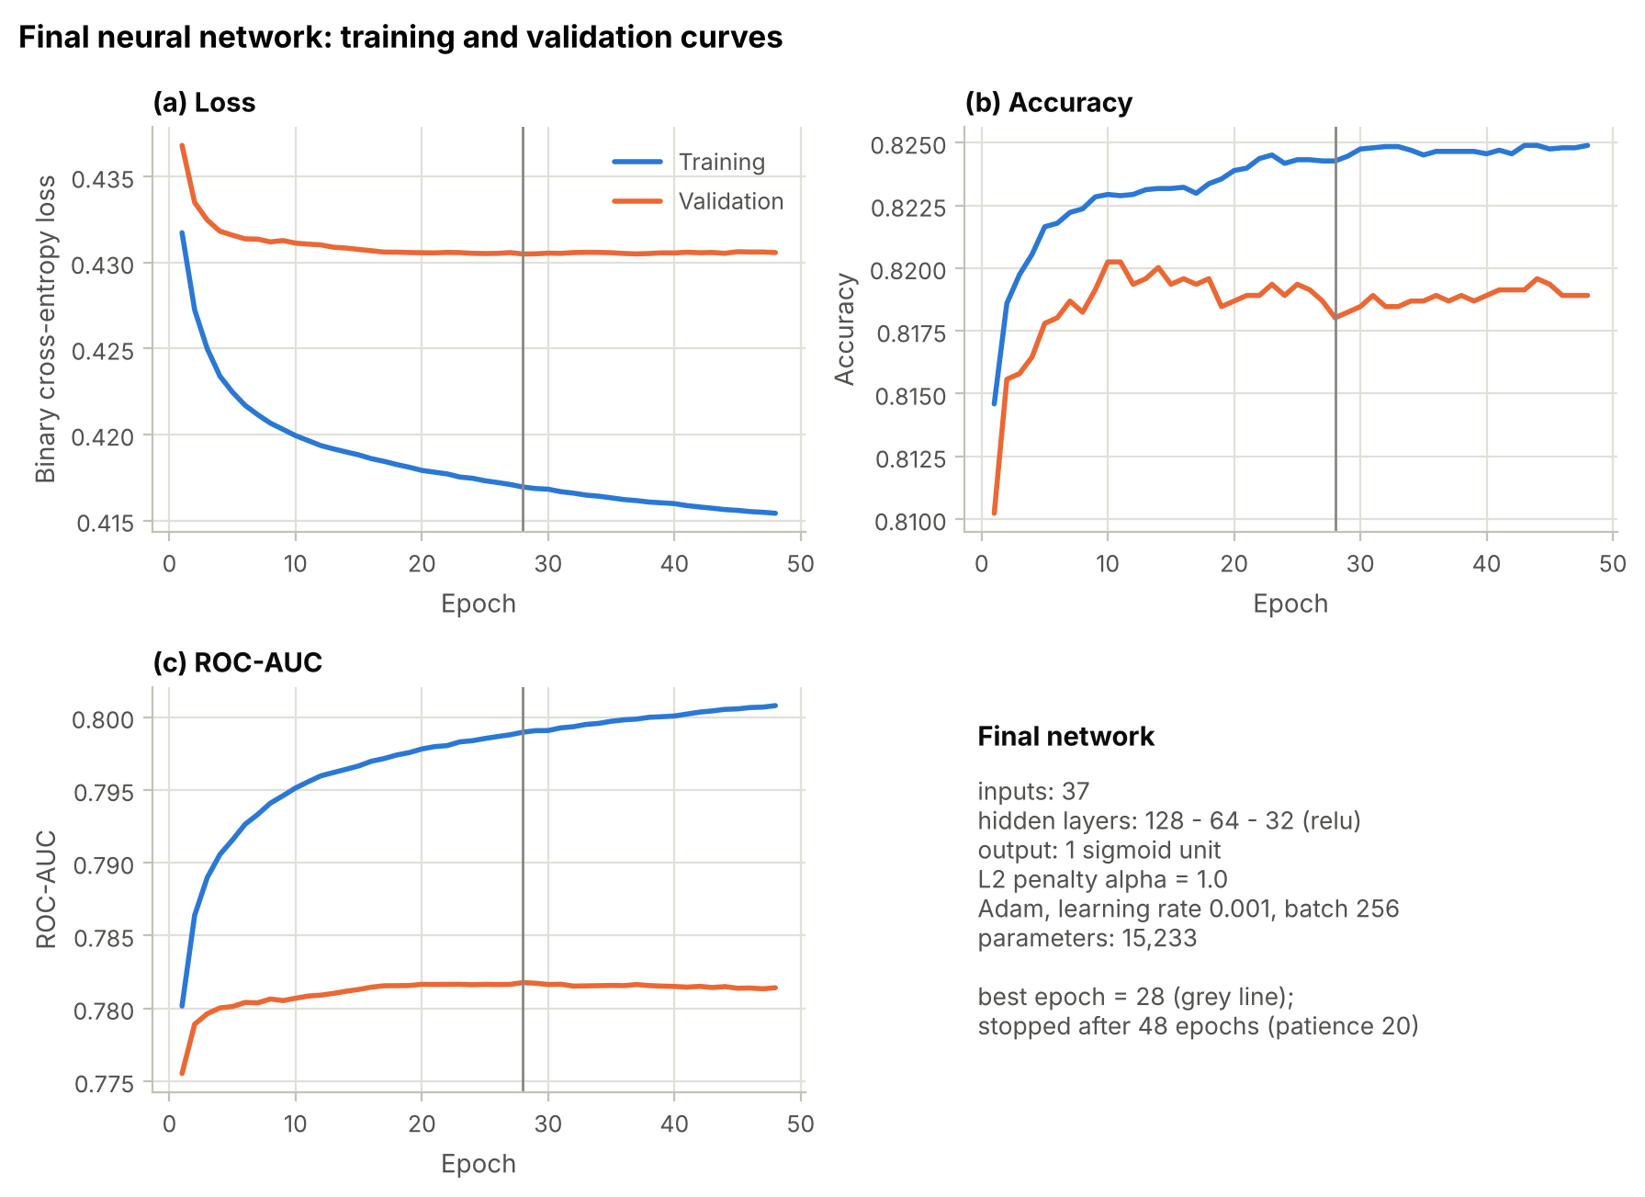
Figure 10. Training and validation curves of the final neural network: (a) loss, (b) accuracy and (c) ROC-AUC per epoch. The grey line marks the best epoch (28), whose weights were restored.
Interpretation (Figure 10).
- Both losses fall quickly during the first ~10 epochs.
- From about epoch 20, the validation loss stops improving while the training loss keeps falling — the network starts to learn noise that is specific to the training clients.
- Early stopping caught this. At the best epoch (28):
  - loss 0.417 (training) vs 0.4305 (validation);
  - accuracy 82.4% vs 81.8%;
  - ROC-AUC 0.799 vs 0.782.
- Training ended at epoch 48, and the epoch-28 weights were restored.
- The remaining gap is small (0.014 in loss). The network shows no under-fitting (its scores match the best tuned models in cross-validation), and its over-fitting was stopped in time.
The small loss differences in Figure 10 look large only because the y-axis is zoomed in. Section 5.7 shows real over-fitting.

5.7 Diagnosing and fixing over- and under-fitting in the neural network
To show what the curves look like when a network does not generalise, two deliberately badly configured networks were trained with the same data and procedure (Figure 11, Table 17).
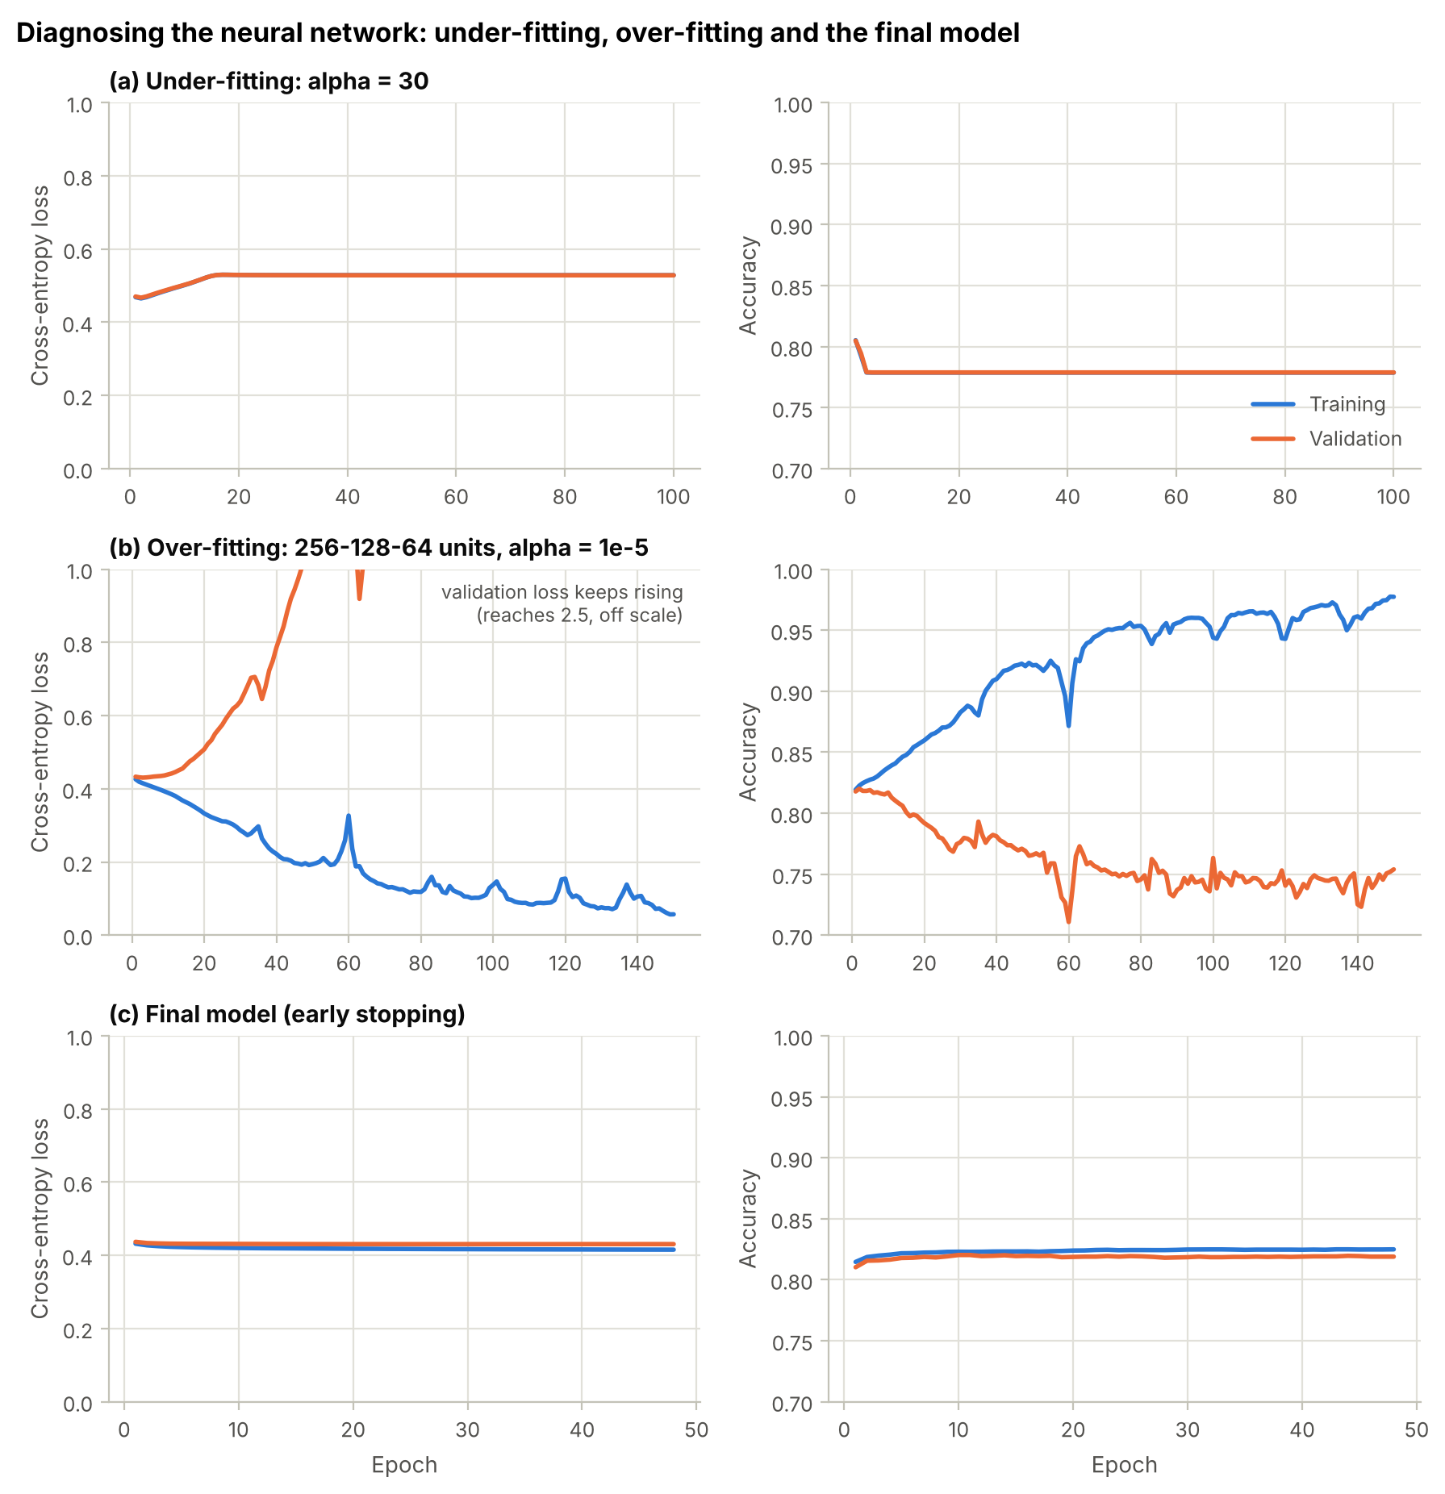
Figure 11. Loss (left) and accuracy (right) per epoch for (a) an over-regularised network, (b) a large network without regularisation or early stopping, and (c) the final model.
Table 17. Neural-network fit diagnostics (training and validation sets). The "final" columns are the values at the last epoch run; the final model itself keeps the weights of its best epoch (Section 5.6).
Scenario | Epochs | Best epoch | Val. loss at best | Final train loss | Final val. loss | Final train acc. | Final val. acc.
Under-fitting | 100 | 2 | 0.467 | 0.529 | 0.528 | 77.9% | 77.9%
Over-fitting | 150 | 3 | 0.430 | 0.057 | 2.474 | 97.7% | 75.4%
Final model | 48 | 28 | 0.431 | 0.415 | 0.431 | 82.5% | 81.9%

- (a) Under-fitting (alpha = 30). The penalty forces all weights towards zero. Both losses rise to 0.529 — the loss of always predicting the overall default rate — and both accuracies fall to 77.9%, the share of non-defaulters. The network predicts "no default" for every client: high bias.
  - Fix: a weaker penalty. Cross-validation selected alpha = 1.
- (b) Over-fitting (256-128-64 neurons, alpha = 10⁻⁵, 150 epochs, no early stopping). The validation loss is lowest at epoch 3 (0.430). After that it rises steadily, to 2.47 at epoch 150, while the training loss falls to 0.057 and the training accuracy reaches 97.7%. Validation accuracy drops to 75.4% and validation ROC-AUC to 0.664. The network memorises the training clients and becomes over-confident on new ones: high variance.
  - Fixes used in the final model: (1) an L2 penalty of alpha = 1; (2) an architecture chosen by cross-validation; (3) early stopping on the validation loss, with the best weights restored.
- (c) Final model. Training and validation curves stay close (Section 5.6).
Robustness to random initialisation. Networks start from random weights, so the final architecture was retrained with ten different seeds, using only the training and validation sets. The results were stable:
- validation ROC-AUC 0.781 ± 0.002 (range 0.775–0.783);
- validation loss 0.432 ± 0.002.
The early-stopping epoch varied (9–137), but the performance did not. The reported network is not a lucky draw.

5.8 Training vs validation performance of the final models
Table 18 compares the final models on the training and validation sets, together with two untuned reference models.
Table 18. Training vs validation performance (AUC = ROC-AUC).
Model | Train AUC | Val. AUC | Gap | Train PR-AUC | Val. PR-AUC | Val. log-loss
Decision Tree (default, unpruned) | 1.0000 | 0.6114 | 0.3886 | 1.0000 | 0.2882 | 9.879
Neural Network (default, no early stopping) | 0.8701 | 0.7531 | 0.1169 | 0.7112 | 0.4935 | 0.484
Logistic Regression | 0.7855 | 0.7759 | 0.0095 | 0.5395 | 0.5253 | 0.564
Decision Tree | 0.7958 | 0.7678 | 0.0279 | 0.5544 | 0.5272 | 0.556
Random Forest | 0.8600 | 0.7791 | 0.0808 | 0.6590 | 0.5532 | 0.522
Gradient Boosting | 0.8233 | 0.7777 | 0.0455 | 0.6089 | 0.5517 | 0.431
Neural Network | 0.7990 | 0.7818 | 0.0172 | 0.5673 | 0.5449 | 0.431

- Regularisation was essential. The unpruned tree falls from 1.000 to 0.611 on the validation set, with a log-loss of 9.9: it is confidently wrong. The default network falls from 0.870 to 0.753.
- After tuning, all validation scores lie between 0.768 and 0.782. The gaps are small for Logistic Regression (0.010), the network (0.017) and the tree (0.028), and moderate for Gradient Boosting (0.046) and the Random Forest (0.081). The forest's leaves of 30 clients still fit the training data closely, but its cross-validated performance is among the best (Table 16).
- The network has the highest validation ROC-AUC (0.782). This value is slightly optimistic, because the same validation set chose the network's stopping epoch; the test set gives the unbiased comparison (Section 6).

5.9 Choosing the decision threshold
A probability threshold of 0.5 is arbitrary for an imbalanced problem. For each model, the threshold that maximises F1 on the validation set was chosen (Table 19, Figure 12) and then applied unchanged to the test set.
Table 19. Decision thresholds chosen on the validation set.
Model | Threshold | Val. precision | Val. recall | Val. F1 | Val. F1 at 0.5 | Val. recall at 0.5
Logistic Regression | 0.62 | 0.545 | 0.535 | 0.540 | 0.521 | 0.630
Decision Tree | 0.59 | 0.513 | 0.563 | 0.537 | 0.514 | 0.664
Random Forest | 0.61 | 0.568 | 0.523 | 0.545 | 0.534 | 0.606
Gradient Boosting | 0.29 | 0.518 | 0.569 | 0.543 | 0.453 | 0.342
Neural Network | 0.33 | 0.556 | 0.532 | 0.544 | 0.470 | 0.364

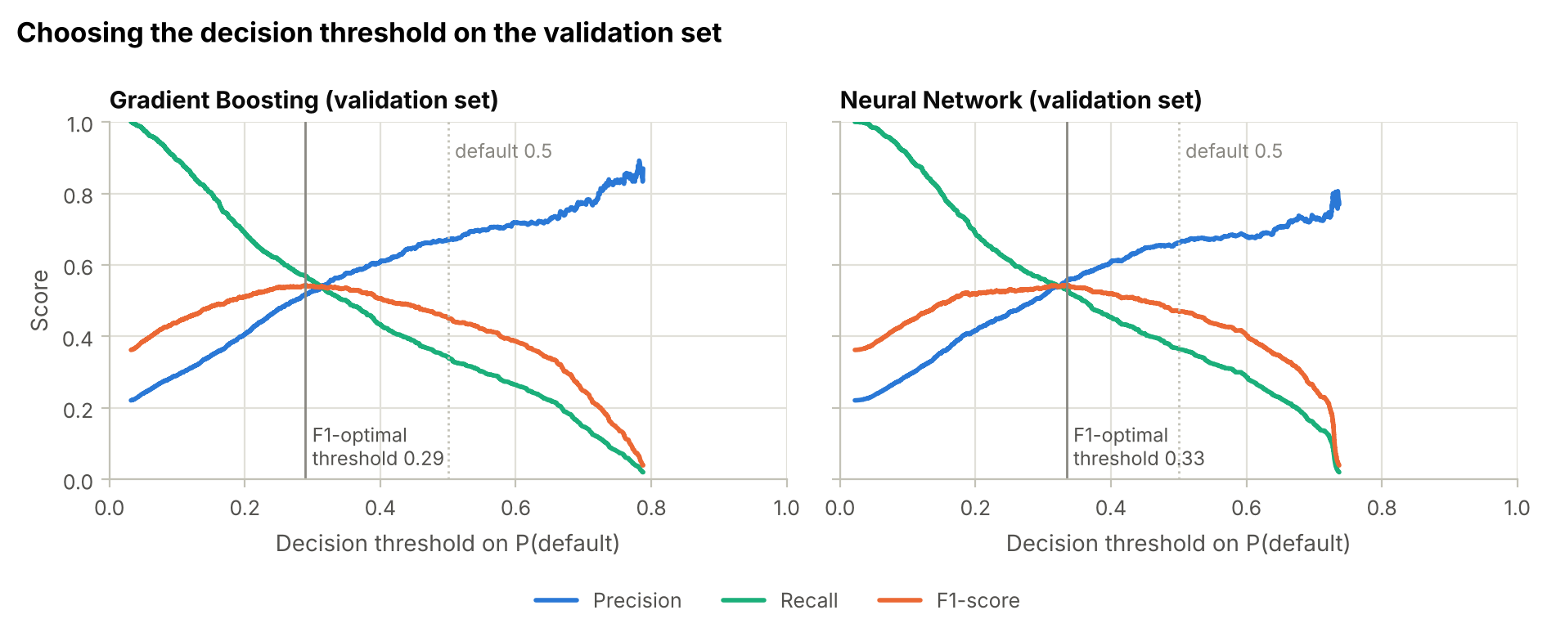
Figure 12. Precision, recall and F1 against the decision threshold on the validation set for Gradient Boosting and the Neural Network; the grey line marks the F1-optimal threshold.
- The unweighted models need a lower threshold (Gradient Boosting 0.29, network 0.33). At 0.5 they flag too few clients and catch only 34%–36% of the validation defaulters.
- The class-weighted models need a higher threshold (0.59–0.62), because class weighting already inflates their probabilities.
- Threshold tuning raises the validation F1 of Gradient Boosting from 0.453 to 0.543 and of the network from 0.470 to 0.544.

6. Stage 5: Model Final Evaluation and Comparison (3 Marks)

6.1 Choice of evaluation metrics
The positive class is default. Table 20 lists the metrics and why each matters here.
Table 20. Evaluation metrics and their role.
Metric | Definition | Why it matters for credit default
ROC-AUC (and Gini, KS) | area under the ROC curve; Gini = 2·AUC − 1; KS = max(TPR − FPR) | Primary ranking metric. Banks rank clients by risk; independent of the threshold and of the class ratio. Gini and KS are the usual credit-scoring statistics.
PR-AUC (average precision) | area under the precision–recall curve | Focuses on the minority (default) class; more informative than ROC-AUC when positives are rare [8].
Recall | TP / (TP + FN) | Share of defaulters caught. A missed defaulter costs the money lent.
Precision | TP / (TP + FP) | Share of flagged clients who really default. False alarms cost good customers.
F1-score | harmonic mean of precision and recall | One balanced number for the default class; used to choose the threshold.
Specificity, accuracy | TN / (TN + FP); (TP + TN) / N | Reported for completeness. Accuracy alone is misleading (77.9% for "always no default").
Brier score | mean squared error of the predicted probability | Quality (calibration) of the probabilities, relevant if scores are used as default probabilities.
Confusion matrix | counts of TP, FN, FP, TN | Shows the actual numbers of each type of error.

6.2 Test-set results
The final models were evaluated once on the 4,495 test clients (995 defaulters), at the thresholds chosen on the validation set (Tables 21 and 22).
Table 21. Test-set results at the validation-tuned threshold t (Acc. = accuracy, Prec. = precision, Spec. = specificity).
Model | t | Acc. | Prec. | Recall | Spec. | F1 | TP | FN | FP
Logistic Regression | 0.62 | 0.793 | 0.534 | 0.512 | 0.873 | 0.522 | 509 | 486 | 445
Decision Tree | 0.59 | 0.781 | 0.504 | 0.556 | 0.845 | 0.529 | 553 | 442 | 544
Random Forest | 0.61 | 0.798 | 0.547 | 0.508 | 0.881 | 0.527 | 505 | 490 | 418
Gradient Boosting | 0.29 | 0.788 | 0.520 | 0.564 | 0.852 | 0.541 | 561 | 434 | 518
Neural Network | 0.33 | 0.793 | 0.533 | 0.510 | 0.873 | 0.521 | 507 | 488 | 444

Table 22. Threshold-independent ranking and probability quality on the test set.
Model | ROC-AUC | Gini | KS | PR-AUC | Brier score
Logistic Regression | 0.7680 | 0.536 | 0.412 | 0.5345 | 0.1859
Decision Tree | 0.7634 | 0.527 | 0.411 | 0.5337 | 0.1873
Random Forest | 0.7756 | 0.551 | 0.419 | 0.5588 | 0.1723
Gradient Boosting | 0.7766 | 0.553 | 0.418 | 0.5666 | 0.1347
Neural Network | 0.7717 | 0.543 | 0.425 | 0.5500 | 0.1361

Results.
- Gradient Boosting is the best model on all three main metrics: ROC-AUC 0.777, PR-AUC 0.567 and F1 0.541. It catches 561 of the 995 defaulters (recall 56.4%) with a precision of 52.0%.
- The Random Forest (ROC-AUC 0.776, PR-AUC 0.559) and the Neural Network (0.772, 0.550) follow. Behind them are Logistic Regression (0.768, 0.535) and the Decision Tree (0.763, 0.534).
- The network has the highest KS statistic (0.425).
- Every model's test ROC-AUC is about 0.014 below its cross-validated score. This is normal sampling variation of a single test set; the ranking of the models is unchanged.
Table 23. Effect of the decision threshold on the test set: default 0.5 vs the validation-tuned threshold.
Model | Recall at 0.5 | Recall at tuned t | Precision at 0.5 | Precision at tuned t | F1 at 0.5 | F1 at tuned t
Logistic Regression | 0.625 | 0.512 | 0.450 | 0.534 | 0.524 | 0.522
Decision Tree | 0.653 | 0.556 | 0.412 | 0.504 | 0.505 | 0.529
Random Forest | 0.595 | 0.508 | 0.483 | 0.547 | 0.533 | 0.527
Gradient Boosting | 0.361 | 0.564 | 0.690 | 0.520 | 0.474 | 0.541
Neural Network | 0.388 | 0.510 | 0.664 | 0.533 | 0.490 | 0.521

The threshold matters (Table 23).
- At 0.5, Gradient Boosting has the highest accuracy of all models (82.3%) but catches only 36% of the defaulters — a clear illustration of why accuracy misleads.
- The validation-tuned threshold raises its recall to 56% and its F1 from 0.474 to 0.541. For the network, F1 rises from 0.490 to 0.521.
- For the class-weighted Logistic Regression and Random Forest, 0.5 was already near-optimal (test F1 changes by less than 0.01). For the Decision Tree, the tuned threshold adds +0.023.
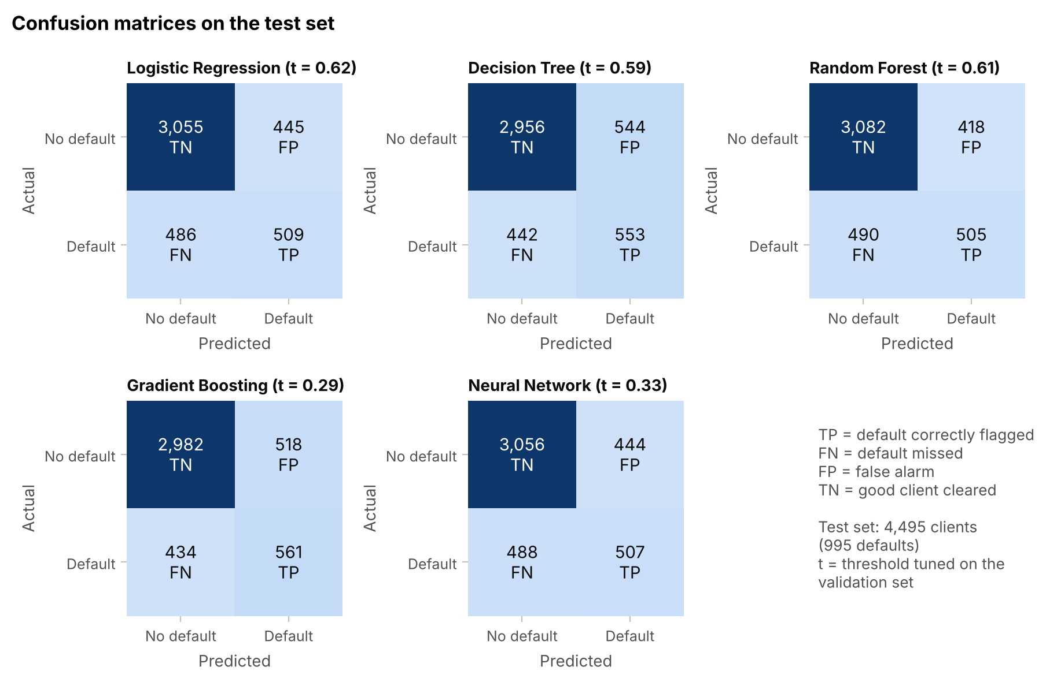
Figure 13. Confusion matrices on the test set at the validation-tuned thresholds (t).
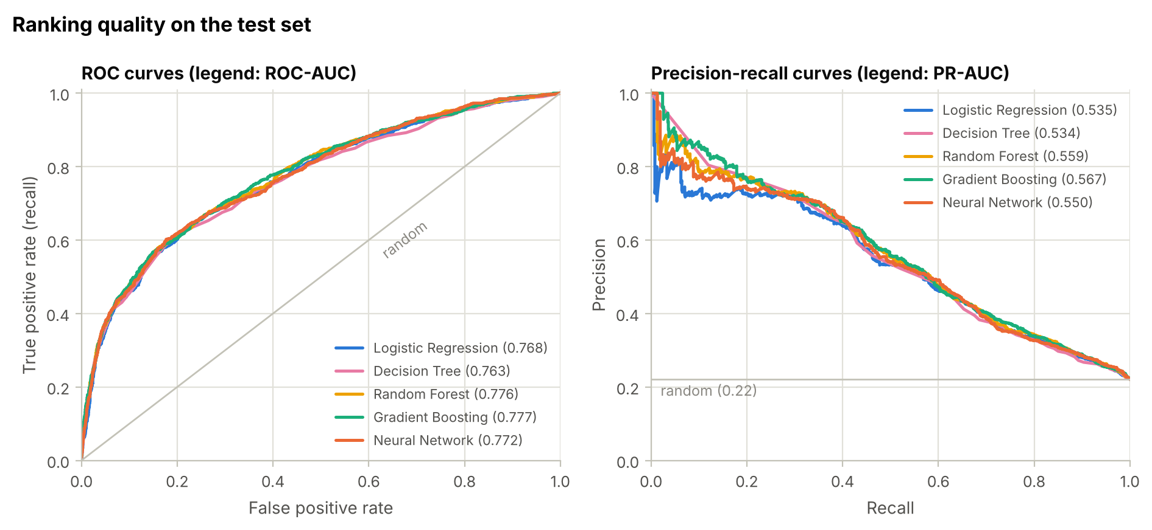
Figure 14. ROC curves (left) and precision–recall curves (right) on the test set.
The ROC curves of all models are close together (Figure 14). The tree ensembles lie slightly above the others in the middle of the curve. The precision–recall curves separate the models more clearly at low recall: among the clients with the highest predicted risk, Gradient Boosting and the Random Forest flag defaulters with the highest precision.

6.3 How certain are the differences?
A single test set gives a single number per model. To quantify the uncertainty, 2,000 paired bootstrap resamples of the test set were drawn. Each resample re-evaluates all models on the same clients, giving 95% confidence intervals (Figure 15) and confidence intervals for the differences between the Neural Network and each traditional model (Table 24).
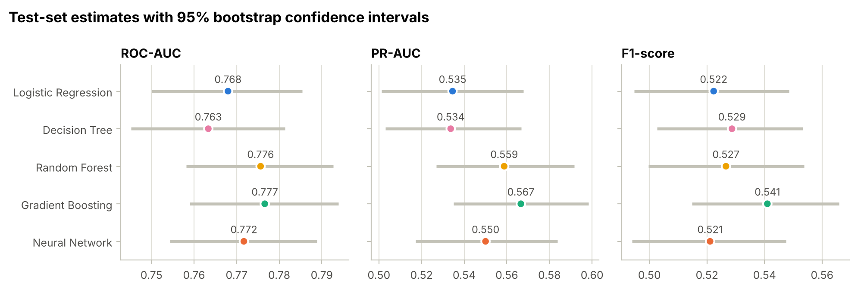
Figure 15. Test-set ROC-AUC, PR-AUC and F1 with 95% bootstrap confidence intervals.
Table 24. Paired bootstrap differences: Neural Network minus each traditional model (95% CI). Bold rows: the interval excludes zero.
Comparison | Metric | Difference | 95% CI
NN − LR | ROC-AUC | +0.0037 | [-0.0011, 0.0088]
NN − LR | PR-AUC | +0.0155 | [0.0043, 0.0263]
NN − LR | F1-score | -0.0013 | [-0.0146, 0.0117]
NN − DT | ROC-AUC | +0.0084 | [0.0007, 0.0162]
NN − DT | PR-AUC | +0.0163 | [0.0021, 0.0302]
NN − DT | F1-score | -0.0076 | [-0.0219, 0.0066]
NN − RF | ROC-AUC | -0.0039 | [-0.0093, 0.0017]
NN − RF | PR-AUC | -0.0087 | [-0.0234, 0.0051]
NN − RF | F1-score | -0.0055 | [-0.0164, 0.0058]
NN − GB | ROC-AUC | -0.0049 | [-0.0105, 0.0005]
NN − GB | PR-AUC | -0.0166 | [-0.0296, -0.0030]
NN − GB | F1-score | -0.0199 | [-0.0333, -0.0073]

- All five models overlap in ROC-AUC (each interval about ±0.018): ranking quality is similar across the models.
- Network vs Gradient Boosting: Gradient Boosting is significantly better in PR-AUC (by 0.017, 95% CI 0.003–0.030) and in F1 (by 0.020, CI 0.007–0.033). For ROC-AUC it is better in 96% of the resamples, just short of significance.
- Network vs Logistic Regression and Decision Tree: the network is significantly better in PR-AUC (+0.015 and +0.016) and, against the tree, in ROC-AUC.
- Network vs Random Forest: no significant difference on any metric.

6.4 Are the predicted probabilities reliable?
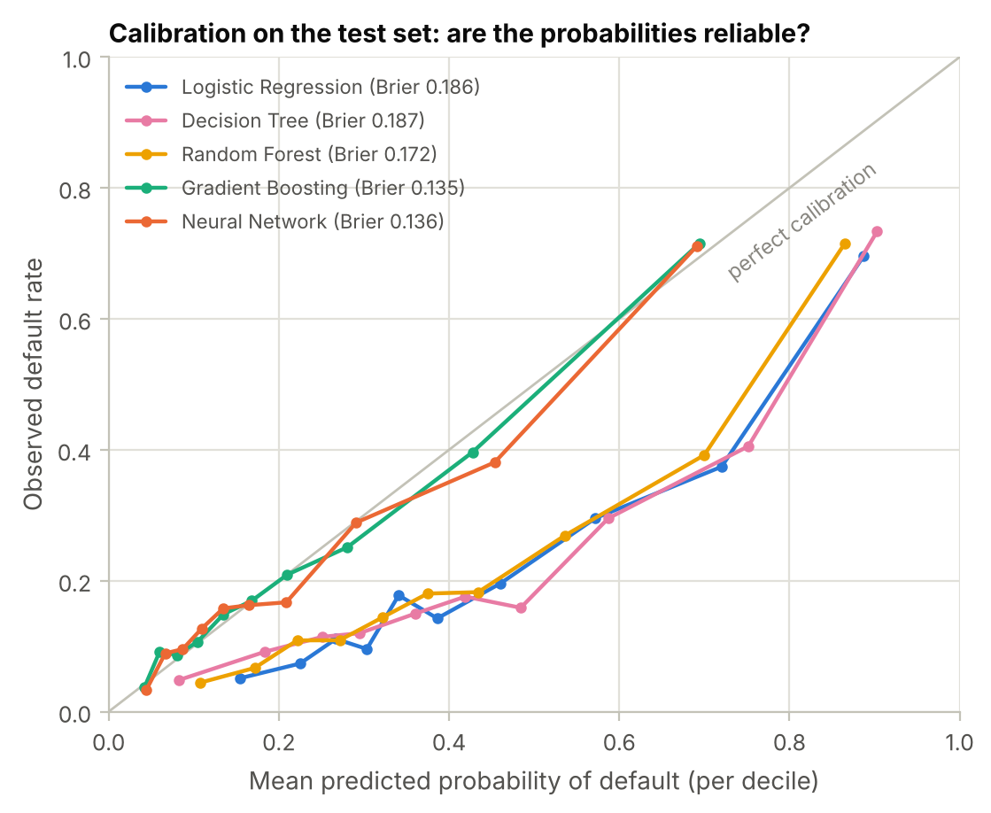
Figure 16. Calibration curves on the test set (observed default rate against the mean predicted probability, per decile of predicted risk) with Brier scores.
Calibration (Figure 16).
- Gradient Boosting and the network produce well-calibrated probabilities (Brier 0.135 and 0.136): when they predict a 30% risk, about 30% of those clients default.
- The class-weighted models systematically over-estimate the risk (Logistic Regression, Decision Tree, Random Forest; Brier 0.172–0.187). This is the known side effect of re-weighting the classes.
Over-estimation does not harm the ranking or the thresholded decisions, because the threshold was tuned for each model. It does matter if the scores are used directly as default probabilities, for example for pricing or loan-loss provisions. Gradient Boosting therefore also wins on this criterion.

6.5 Which features drive the predictions?
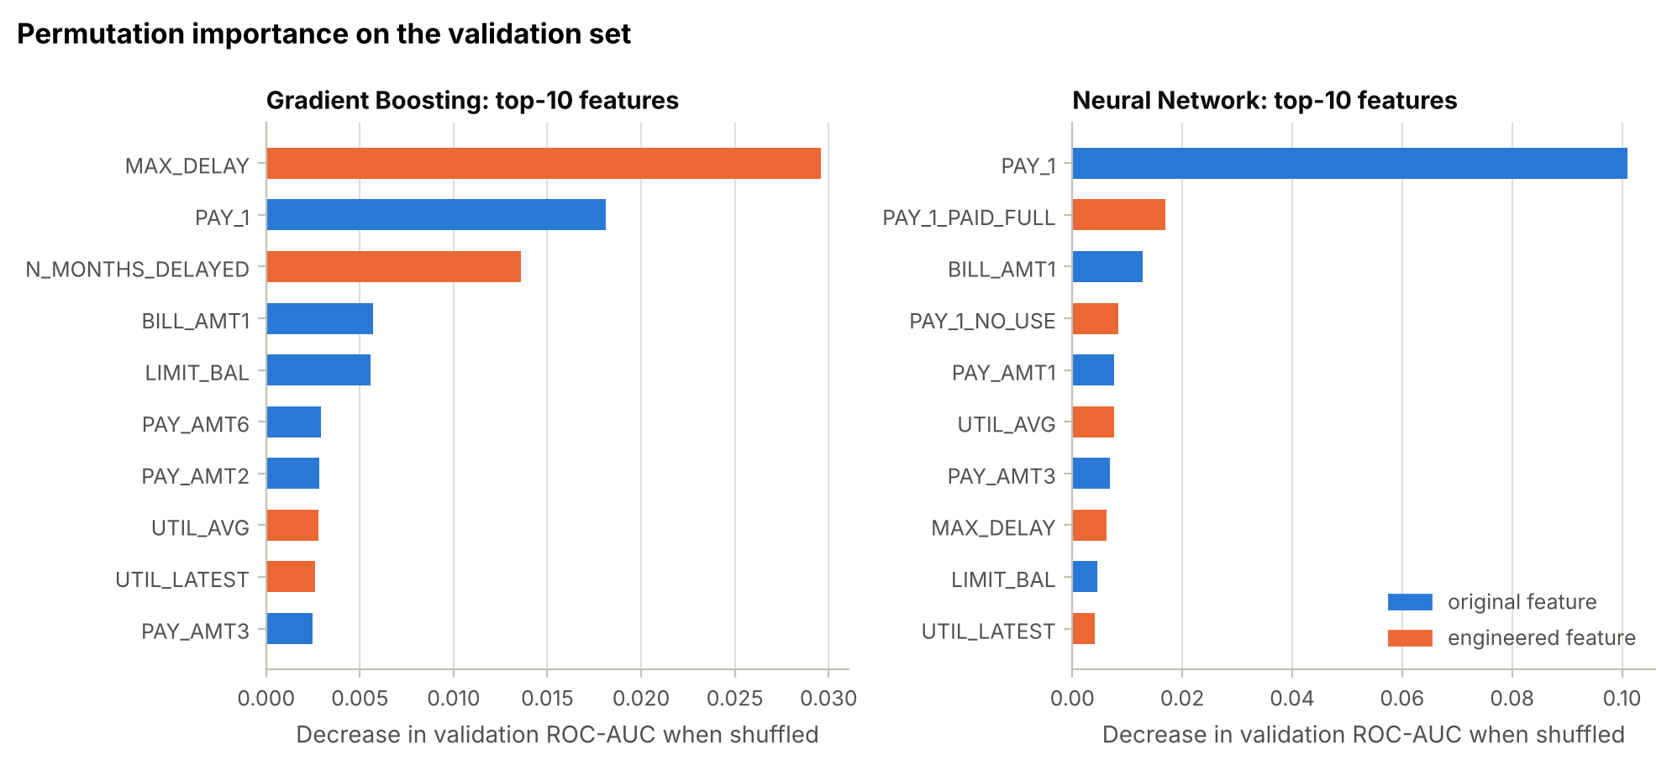
Figure 17. Permutation importance on the validation set: decrease in ROC-AUC when a feature is randomly shuffled (top 10 features).
Permutation importance measures how much the validation ROC-AUC drops when one feature is randomly shuffled. It works for any model (Figure 17).
- Gradient Boosting relies most on the engineered MAX_DELAY (drop 0.030), then PAY_1 (0.018) and the engineered N_MONTHS_DELAYED (0.014).
- The network relies mainly on PAY_1 (0.101) and the PAY_1 status indicators.
- Both then use the latest bill, the credit limit, utilisation and recent payment amounts.
- The personal attributes play almost no role.
This agrees with the relevance analysis of Stage 1: recent repayment behaviour is what predicts default. The engineered features are among the most useful inputs. Correlated features share importance (e.g. PAY_1 and MAX_DELAY), so the individual values should be read as a group pattern.

6.6 Final comparison and model selection
Table 25. Final comparison: cross-validation (training set), validation set and test set (AUC = ROC-AUC; prec. = precision).
Model | CV AUC | Val. AUC | Test AUC | Test PR-AUC | Test F1 | Test recall | Test prec. | Brier
Logistic Regression | 0.7833 | 0.7759 | 0.7680 | 0.5345 | 0.522 | 0.512 | 0.534 | 0.186
Decision Tree | 0.7777 | 0.7678 | 0.7634 | 0.5337 | 0.529 | 0.556 | 0.504 | 0.187
Random Forest | 0.7909 | 0.7791 | 0.7756 | 0.5588 | 0.527 | 0.508 | 0.547 | 0.172
Gradient Boosting | 0.7909 | 0.7777 | 0.7766 | 0.5666 | 0.541 | 0.564 | 0.520 | 0.135
Neural Network | 0.7844 | 0.7818 | 0.7717 | 0.5500 | 0.521 | 0.510 | 0.533 | 0.136

The decision combines the test results, the larger cross-validation evidence, the statistical comparisons and practical criteria (Table 26).
Table 26. Ranking of the models for this dataset and problem.
Rank | Model | Evidence
1 | Gradient Boosting | Joint-best CV ROC-AUC (0.7909); best test ROC-AUC (0.777), PR-AUC (0.567) and F1 (0.541, significantly better than the network); best-calibrated probabilities (Brier 0.135); fast to train and predict.
2 | Random Forest | Joint-best CV ROC-AUC (0.7909) and close on the test set (0.776); but its class-weighted probabilities are poorly calibrated (Brier 0.172) and it was the slowest to tune.
3 | Neural Network | Best validation ROC-AUC (0.782), highest KS (0.425) and well calibrated; significantly behind Gradient Boosting in test PR-AUC and F1; needed the most careful regularisation; least interpretable.
4 | Logistic Regression | Transparent and stable (no over-fitting), but limited by its linear form (test ROC-AUC 0.768).
5 | Decision Tree | Readable rules, but the weakest ranking (test ROC-AUC 0.763, CV 0.778).

Recommendation. Gradient Boosting (HistGradientBoostingClassifier: 31 leaves, learning rate 0.03, 194 rounds, decision threshold 0.29) is the most suitable model for this dataset and problem. On clients it has never seen, it catches 56% of the defaulters with 52% precision, ranks clients best and gives reliable default probabilities.

7. Discussion (1 Mark)

7.1 Interpretation of the results
- Predicting default is hard. Even the best model reaches a test ROC-AUC of about 0.78 and catches about half of the defaulters at about 50% precision. Default depends on events the data cannot see, such as job loss or illness, and 21 groups of clients have identical features but different outcomes. The models are therefore limited by noise in the data rather than by their capacity — the learning curves are already flat.
- The differences between the models are small but systematic. Every model's tuned CV ROC-AUC lies between 0.778 and 0.791, and the order is the same in cross-validation and on the test set: the tree ensembles first, then the network, Logistic Regression and the Decision Tree (only on the smaller validation set did the network come first). The tree ensembles lead because default risk depends on thresholds and interactions — "delayed two or more months", the U-shaped utilisation — which trees model directly.
- Data preparation mattered as much as model choice. The engineered delay and utilisation features improved every model and were the most important inputs of the best model. Keeping and transforming the outliers instead of deleting them kept the reliable high-payment clients in the data.
- For imbalanced data, the decision rule is part of the model. Threshold tuning on the validation set raised the recall of the best model from 36% to 56%.

7.2 Neural network vs traditional machine-learning models
Table 27. The neural network compared with the traditional models in this project.
Aspect | Neural Network (MLP) | Traditional models
Ranking performance | CV ROC-AUC 0.784; test ROC-AUC 0.772, PR-AUC 0.550 | GB 0.791 / 0.777 / 0.567 (best); RF 0.791; LR 0.783; DT 0.778
Statistical comparison (test) | Better than LR and DT in PR-AUC; equal to RF | GB significantly better than the NN in PR-AUC and F1
Probability calibration | Good (Brier 0.136) | GB good (0.135); class-weighted LR, DT, RF over-estimate risk
Tuning effort | 35 configurations (209 s), plus early stopping and curve monitoring | LR 46 s, DT 40 s, GB 124 s, RF 278 s
Sensitivity to settings | High: tiny L2 → over-fitting (val. loss up to 2.47); large L2 → collapse to "no default" | Low near the optimum: the five best configurations are within 0.003
Interpretability | Black box; needs post-hoc explanations | LR coefficients, tree rules, feature importances
Best use | Large or unstructured data (text, images, transaction sequences) | Medium-sized tabular data like this dataset

Findings.
- The network was a strong model. It had the best validation ROC-AUC and the highest KS, gave well-calibrated probabilities, and was significantly better than Logistic Regression and the single tree on PR-AUC.
- It did not beat the gradient-boosted trees, which is consistent with large benchmark studies of tabular data [9]. Two reasons:
  - Tabular features such as "months delayed" have sharp, irregular effects at thresholds; trees model these directly, while a network must approximate them with smooth functions.
  - The network's extra capacity had to be tamed: it reached its best performance only with strong L2 regularisation and early stopping. Without them it either memorised the training clients (validation loss rising to 2.47) or collapsed to always predicting "no default".
- Comparison with the original study. Yeh and Lien [2] compared six classical techniques on this dataset and found that the artificial neural network gave the most accurate estimates of the probability of default. Our results agree that the network beats Logistic Regression and a single decision tree, but modern tree ensembles, which were not part of their comparison, do better still.
- Interpretability matters in lending. Customers can ask why they were refused, so a bank would favour Gradient Boosting with feature-importance explanations, or even Logistic Regression, over a network with similar accuracy.

7.3 Ethical considerations
The dataset contains sex, age and marital status. Lending laws in many countries forbid or restrict their use in credit decisions, and models can turn historical patterns into unfair treatment. In this project these attributes carried very little information:
- mutual information below 0.003;
- negligible permutation importance;
- removing them changed the cross-validated ROC-AUC by only -0.0002 for Gradient Boosting.
A deployed model should therefore exclude them and be checked for equal error rates across groups.

7.4 Limitations
- One bank, one period. The data come from a single Taiwanese bank in 2005 with six months of history. Performance on today's clients or other markets is unknown.
- The F1-optimal threshold assumes equal weight for precision and recall. A real lender would use its actual costs: a missed default usually costs far more than a false alarm, which would favour a lower threshold.
- Unexplained coding. Some codes remain unexplained by the data owner (statuses −2 and 0; the near-absence of one-month delays after September).

8. Conclusion (1 Mark)

8.1 Main findings
- Data preparation. The data needed real cleaning: 35 duplicate rows, undocumented category and status codes, and extremely heavy-tailed amounts. Outliers were kept and transformed rather than deleted. Nine engineered features — delays, utilisation and repayment ratio — improved every model.
- Model performance. After tuning with 5-fold cross-validation, the ranking was Gradient Boosting ≈ Random Forest > Neural Network > Logistic Regression > Decision Tree, both in cross-validation and on the test set.
- Over-fitting control. Regularisation was essential for every flexible model: large leaves for the tree, leaf size and averaging for the forest, a small learning rate and early stopping for boosting, and L2 with early stopping for the network. The network's training and validation curves show a well-controlled fit.
- Decision threshold. Tuning the threshold on validation data is essential for imbalanced classes; it raised the recall of the best model from 36% to 56%.
- Recommended model. Gradient Boosting is the most suitable model: test ROC-AUC 0.777, PR-AUC 0.567, F1 0.541, with well-calibrated probabilities.

8.2 Possible future improvements
- Cost-sensitive decisions: choose the threshold by minimising the expected cost of false negatives and false positives, using the bank's real figures.
- Better models and tuning: LightGBM, XGBoost or CatBoost with Bayesian hyperparameter search; a stacked ensemble of Gradient Boosting and the network.
- Explainability: SHAP values to explain each individual decision to clients and regulators.
- Fairness: remove sex, age and marital status, and audit error rates across groups.
- Calibration: calibrate the class-weighted models (Platt or isotonic) if their probabilities are needed.
- More information: longer payment histories, macro-economic indicators, and retraining the final model on training + validation data before deployment.

References
[1] I.-C. Yeh, "Default of Credit Card Clients," UCI Machine Learning Repository, 2009. doi:10.24432/C55S3H.
[2] I.-C. Yeh and C.-H. Lien, "The comparisons of data mining techniques for the predictive accuracy of probability of default of credit card clients," Expert Systems with Applications, vol. 36, no. 2, pp. 2473–2480, 2009.
[3] F. Pedregosa et al., "Scikit-learn: Machine learning in Python," Journal of Machine Learning Research, vol. 12, pp. 2825–2830, 2011.
[4] I.-K. Yeo and R. A. Johnson, "A new family of power transformations to improve normality or symmetry," Biometrika, vol. 87, no. 4, pp. 954–959, 2000.
[5] D. P. Kingma and J. Ba, "Adam: A method for stochastic optimization," in Proc. International Conference on Learning Representations (ICLR), 2015.
[6] L. Breiman, "Random forests," Machine Learning, vol. 45, no. 1, pp. 5–32, 2001.
[7] J. H. Friedman, "Greedy function approximation: A gradient boosting machine," Annals of Statistics, vol. 29, no. 5, pp. 1189–1232, 2001.
[8] T. Saito and M. Rehmsmeier, "The precision-recall plot is more informative than the ROC plot when evaluating binary classifiers on imbalanced datasets," PLoS ONE, vol. 10, no. 3, e0118432, 2015.
[9] L. Grinsztajn, E. Oyallon and G. Varoquaux, "Why do tree-based models still outperform deep learning on typical tabular data?," in Advances in Neural Information Processing Systems (NeurIPS), Datasets and Benchmarks Track, 2022.

Appendix A: Reproducibility and Repository Structure
Software. Python 3.13 with numpy 2.5.3, pandas 3.0.5, scikit-learn 1.9.1, scipy 1.18.1, matplotlib 3.11.2 and seaborn 0.13.2. The notebook also runs with the library versions pre-installed in Google Colab; very small numerical differences between library versions are possible.
How to run. Open DS471_Credit_Card_Default_Prediction.ipynb in Google Colab or Jupyter and run all cells (about 25 minutes on a 2-core CPU). The data file is included in the repository. If it is missing, the notebook downloads the original file from the UCI repository. All random steps use the seed 42.
Repository link: https://github.com/Alhelfi1/DS471-Credit-Card-Default-Prediction
Table 28. Contents of the GitHub repository.
Path | Content
DS471_Credit_Card_Default_Prediction.ipynb | Complete, executed notebook: Stages 1–5, discussion and conclusion
data/default_of_credit_card_clients.csv | The dataset (exact CSV copy of the UCI file)
report/DS471_Project_Report.docx | This report
figures/ | The 17 figures used in this report (PNG, 200 dpi)
results/ | All results tables (CSV/JSON): split, baseline, ablation, tuning, curves, NN history and diagnostics, thresholds, test metrics, bootstrap intervals, final comparison
requirements.txt | Python dependencies
README.md | Project overview, key results and instructions

