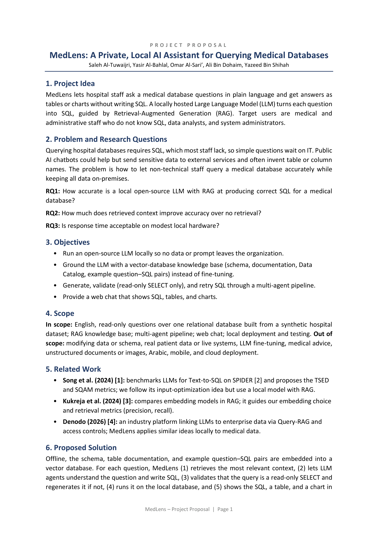
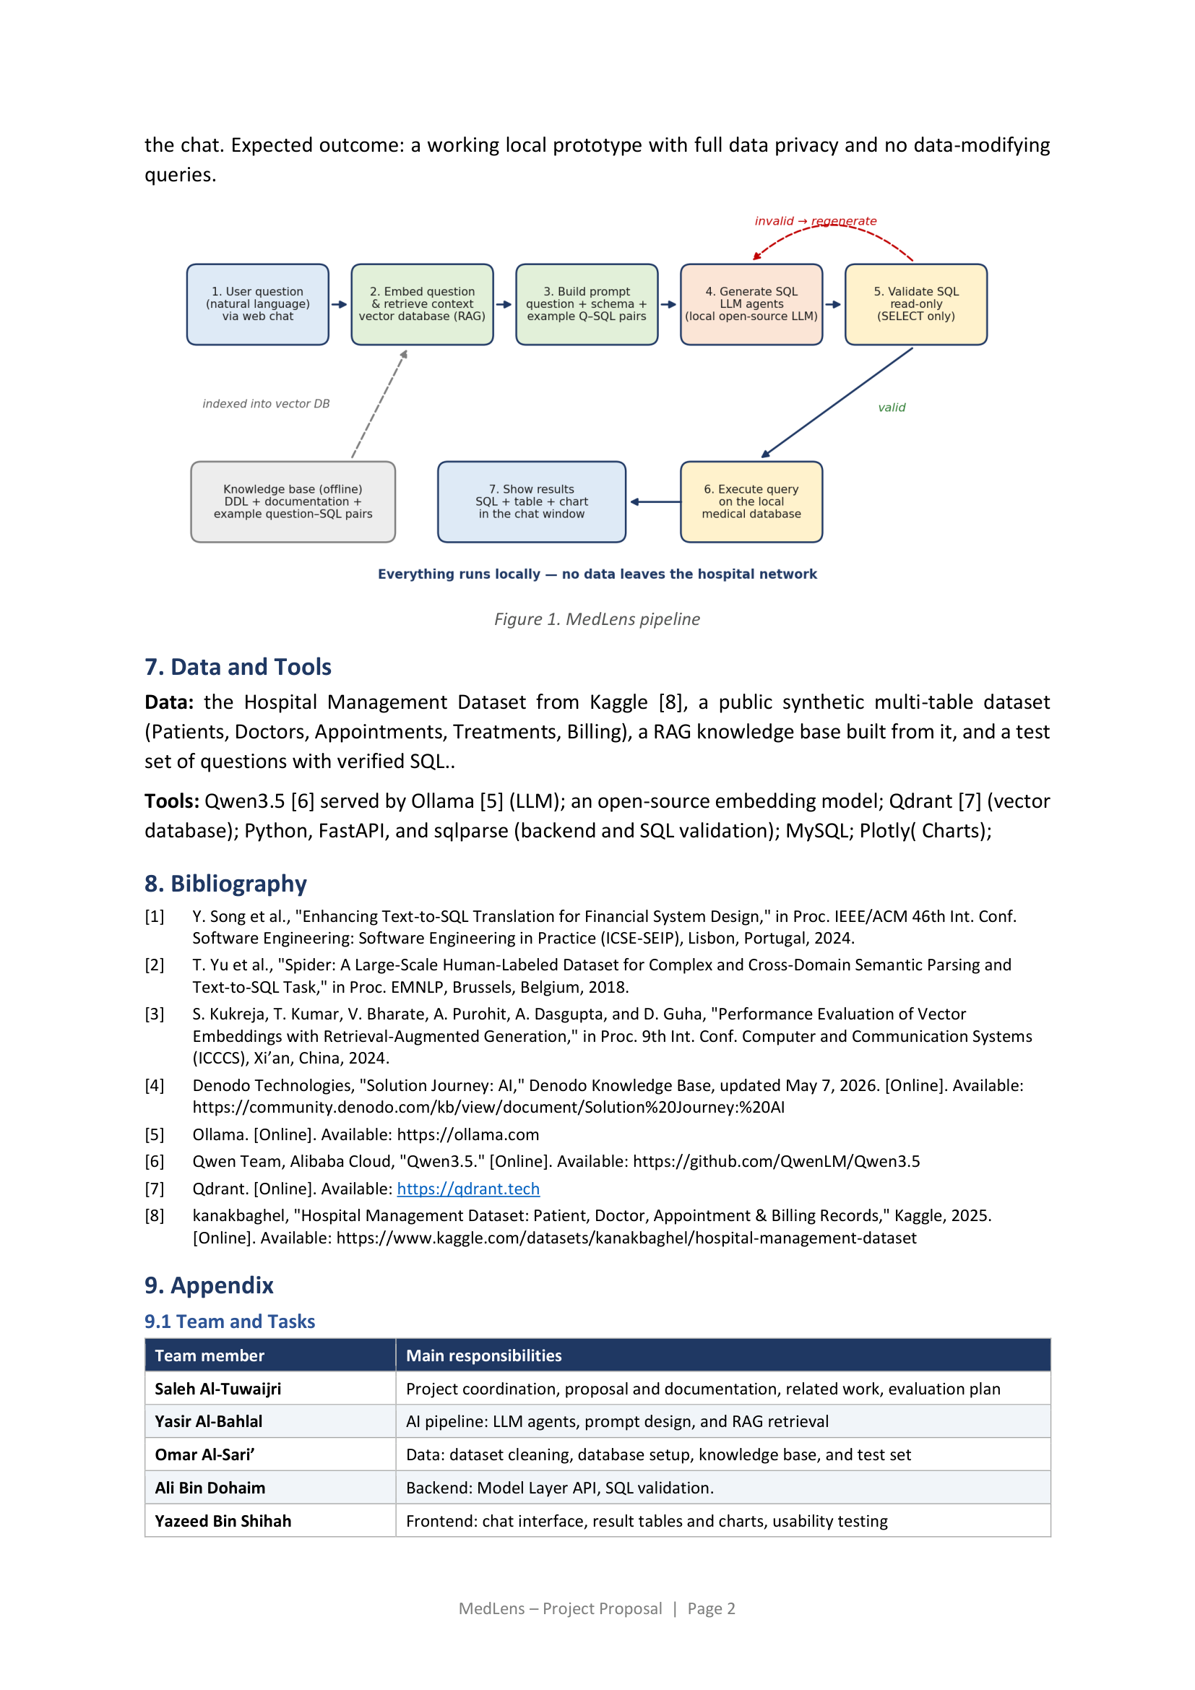
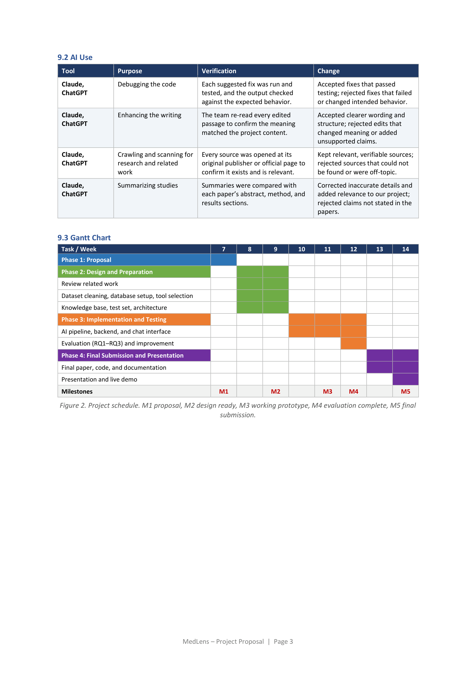

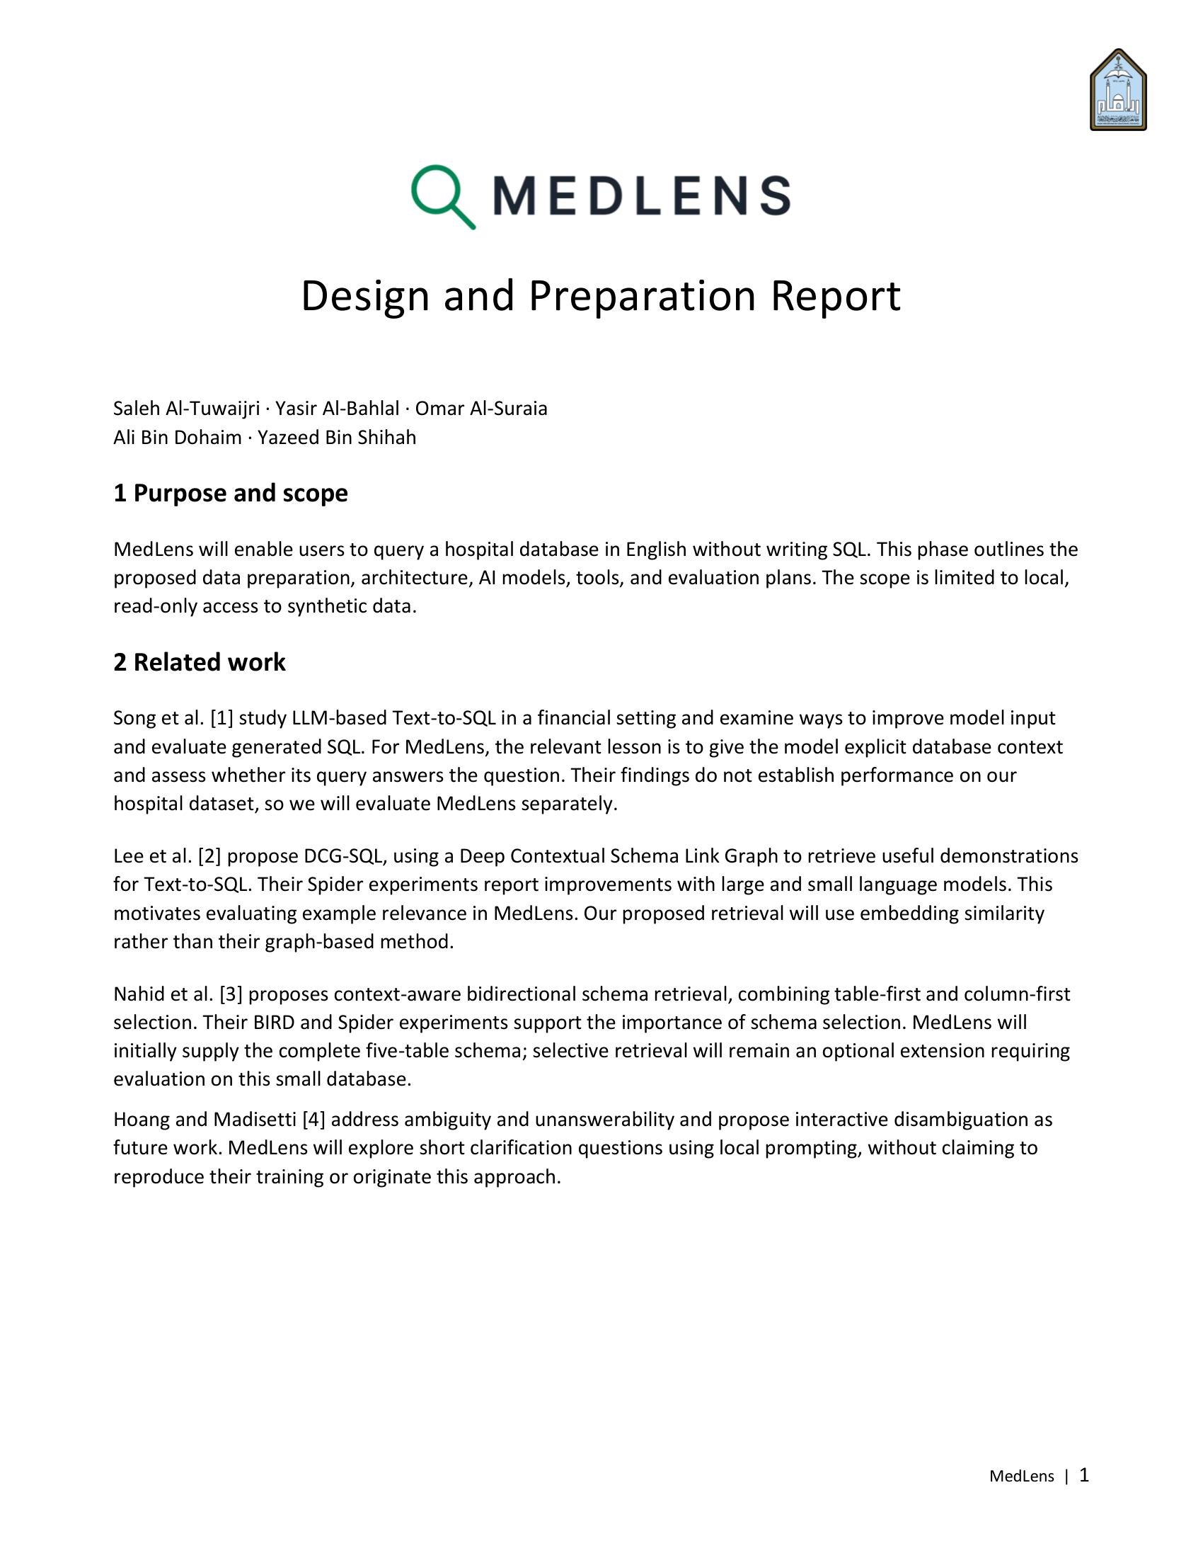
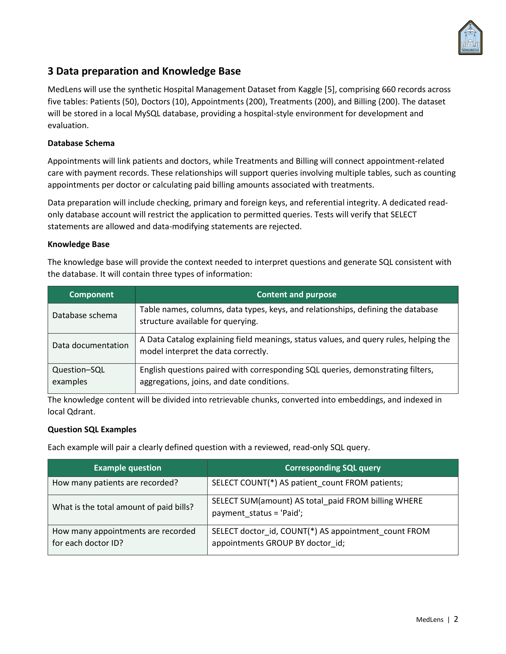
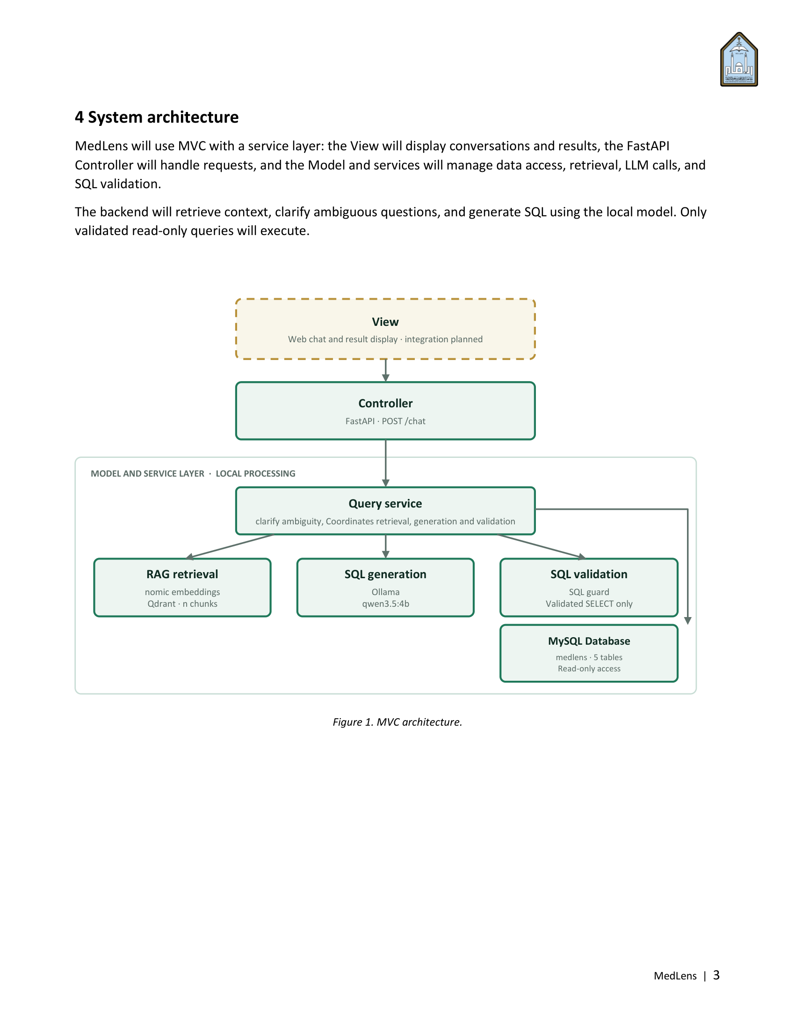
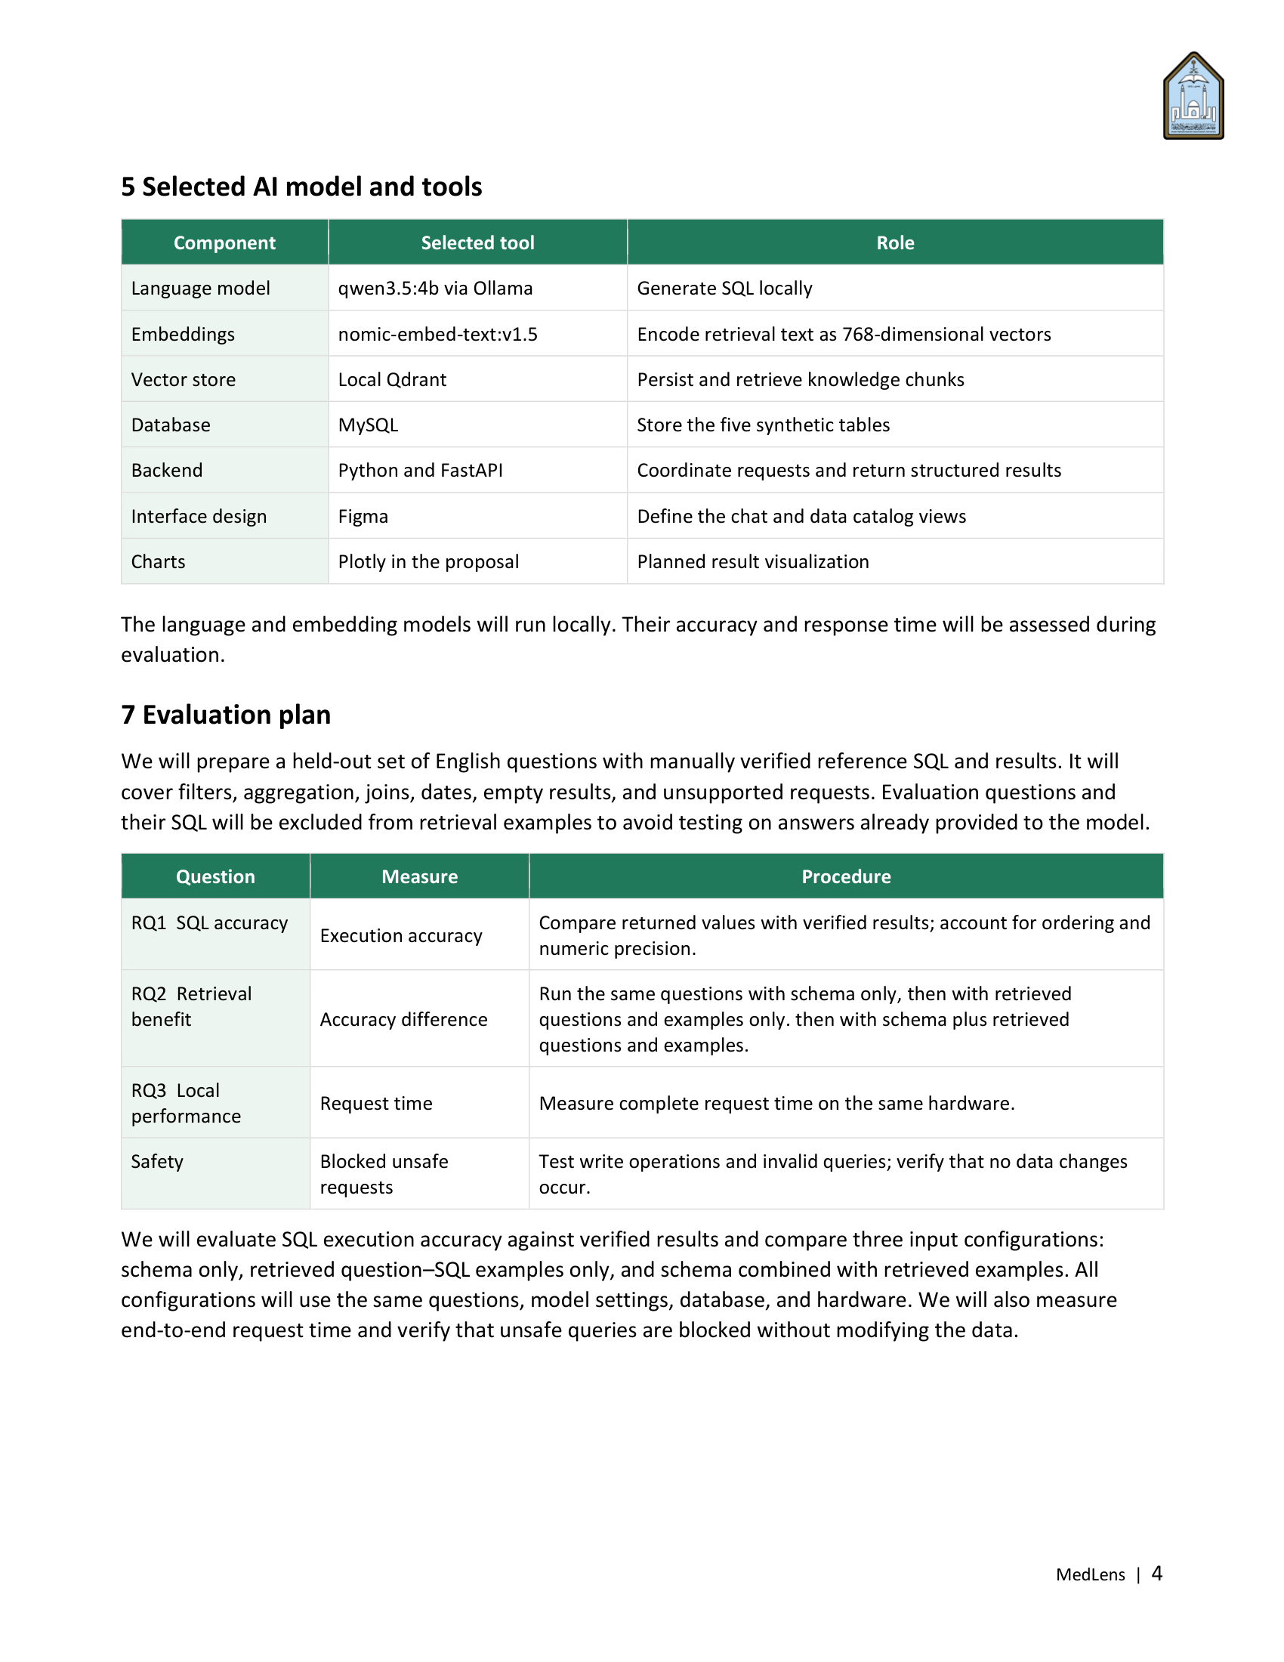
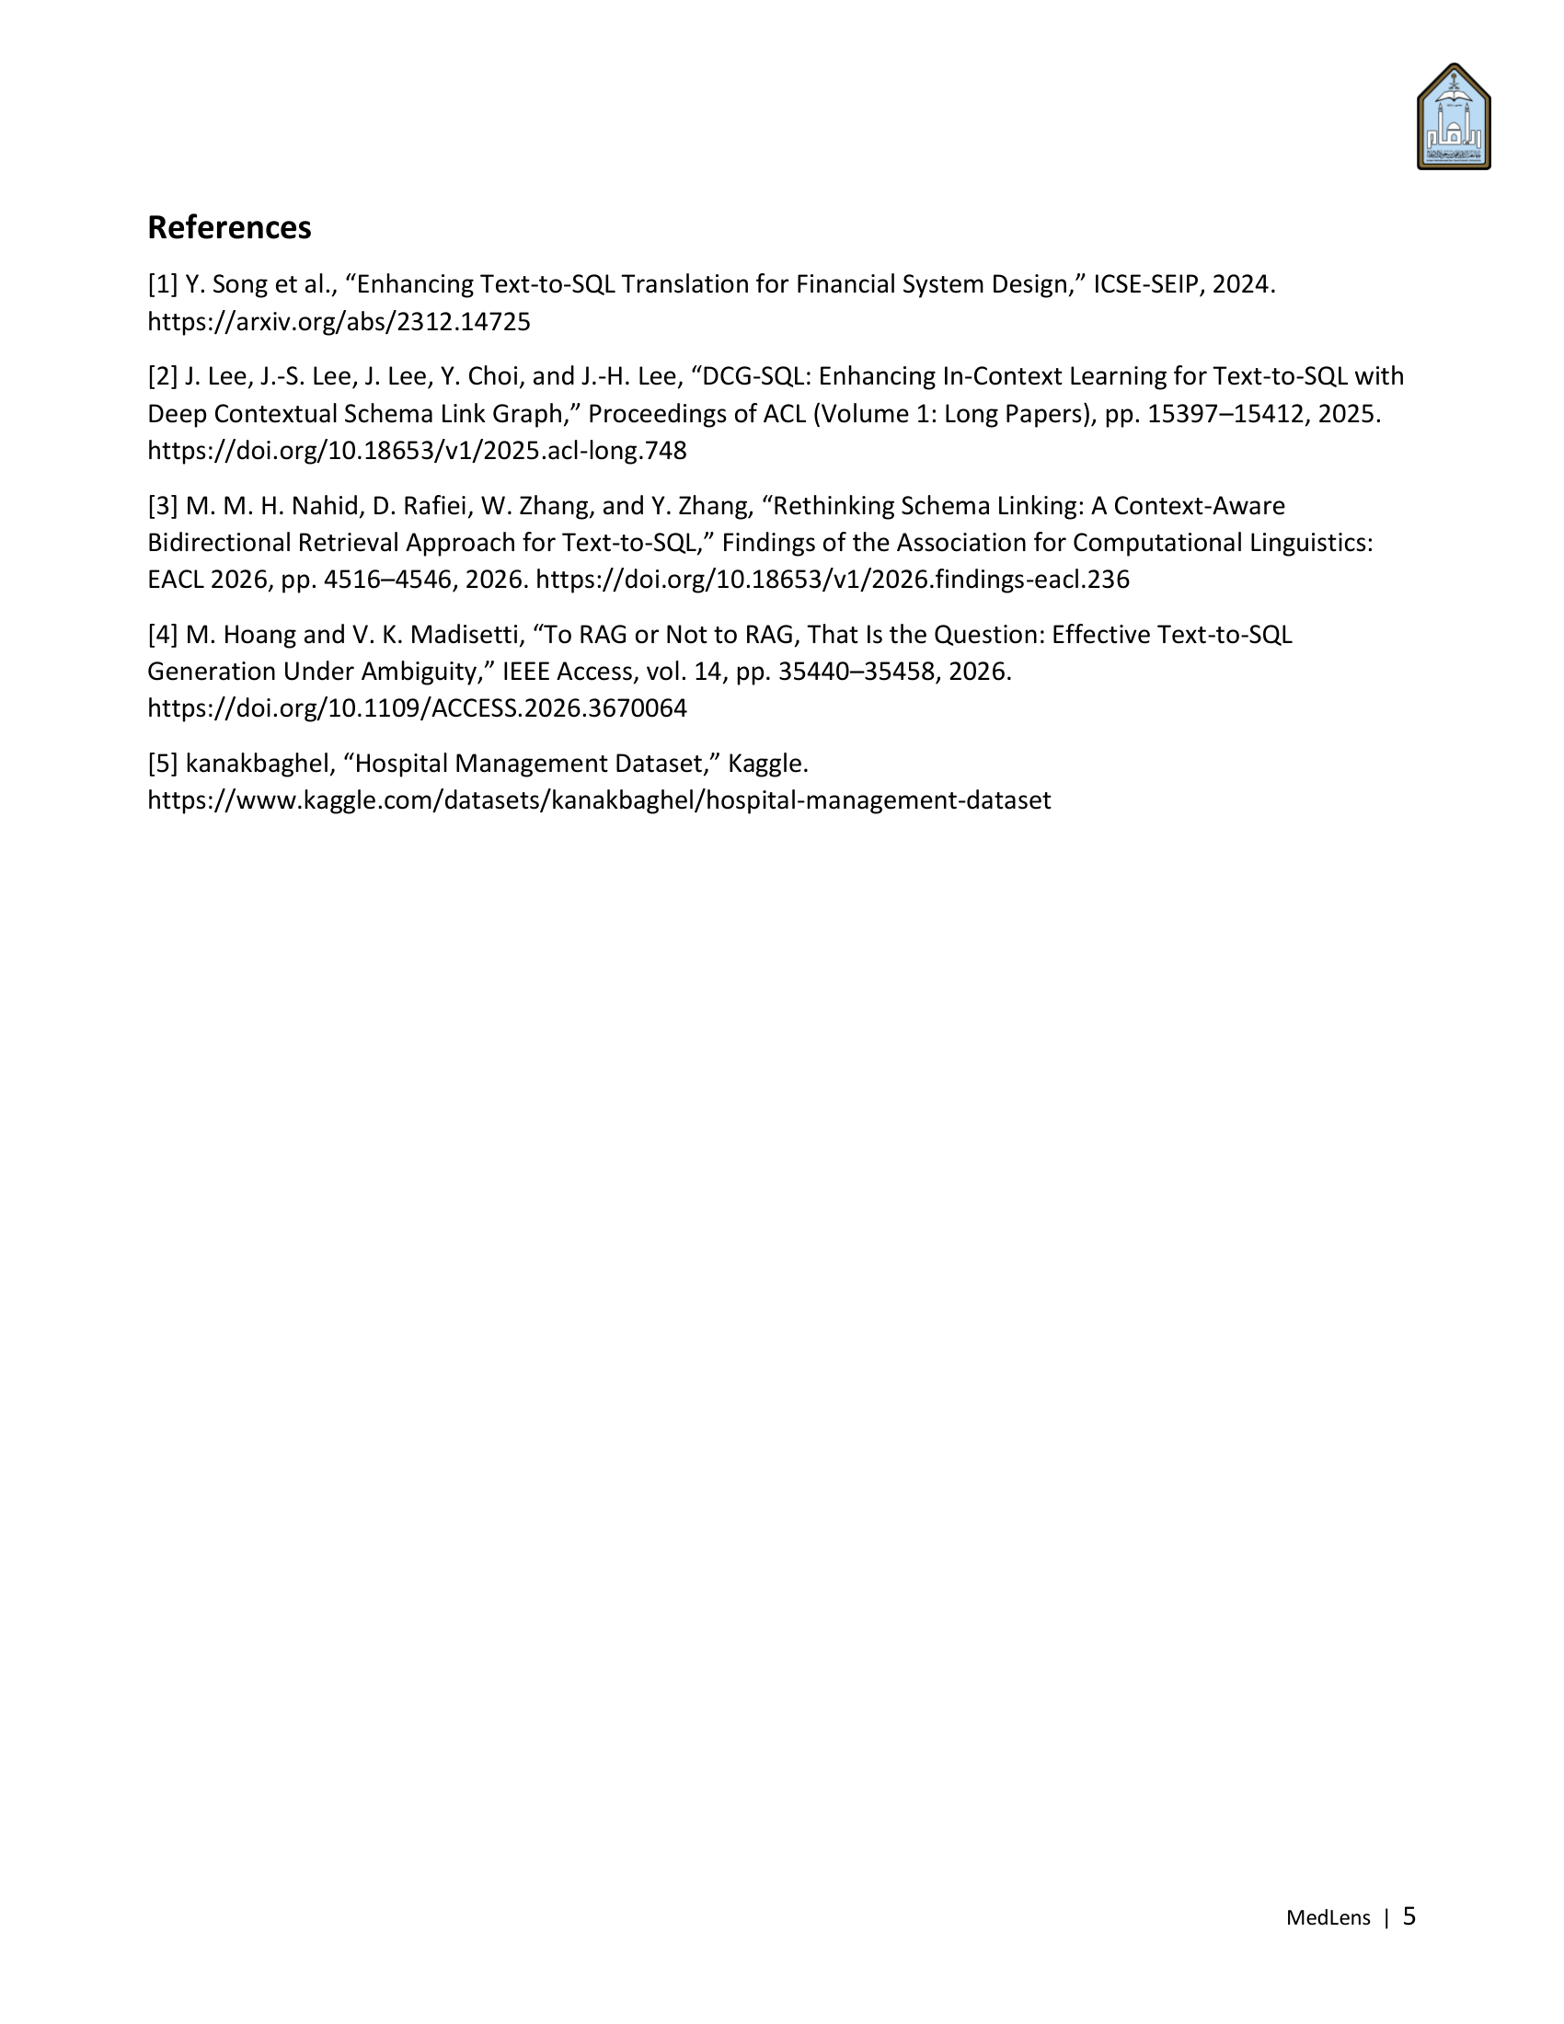


Implementation and Testing Report
Saleh Al-Tuwaijri · Yasir Al-Bahlal · Omar Al-Suraia
Ali Bin Dohaim · Yazeed Bin Shihah

1 Purpose and scope
In this phase we built MedLens as designed in the Phase 2 report, tested its main functions, evaluated it with the measures planned in Phase 2 (Section 7: RQ1–RQ3 and safety), and used the results to improve it. All final measurements were taken on one laptop on 7 November 2026 (Section 4). The scope is unchanged: English, read-only questions over the five-table synthetic database, processed entirely on the local machine.

2 Implemented system
The system follows the MVC design with a service layer from Phase 2 (Section 4). The View, which Figure 1 of the Phase 2 report showed as planned, is now a working React web application. Figure 1 below shows the system as built.
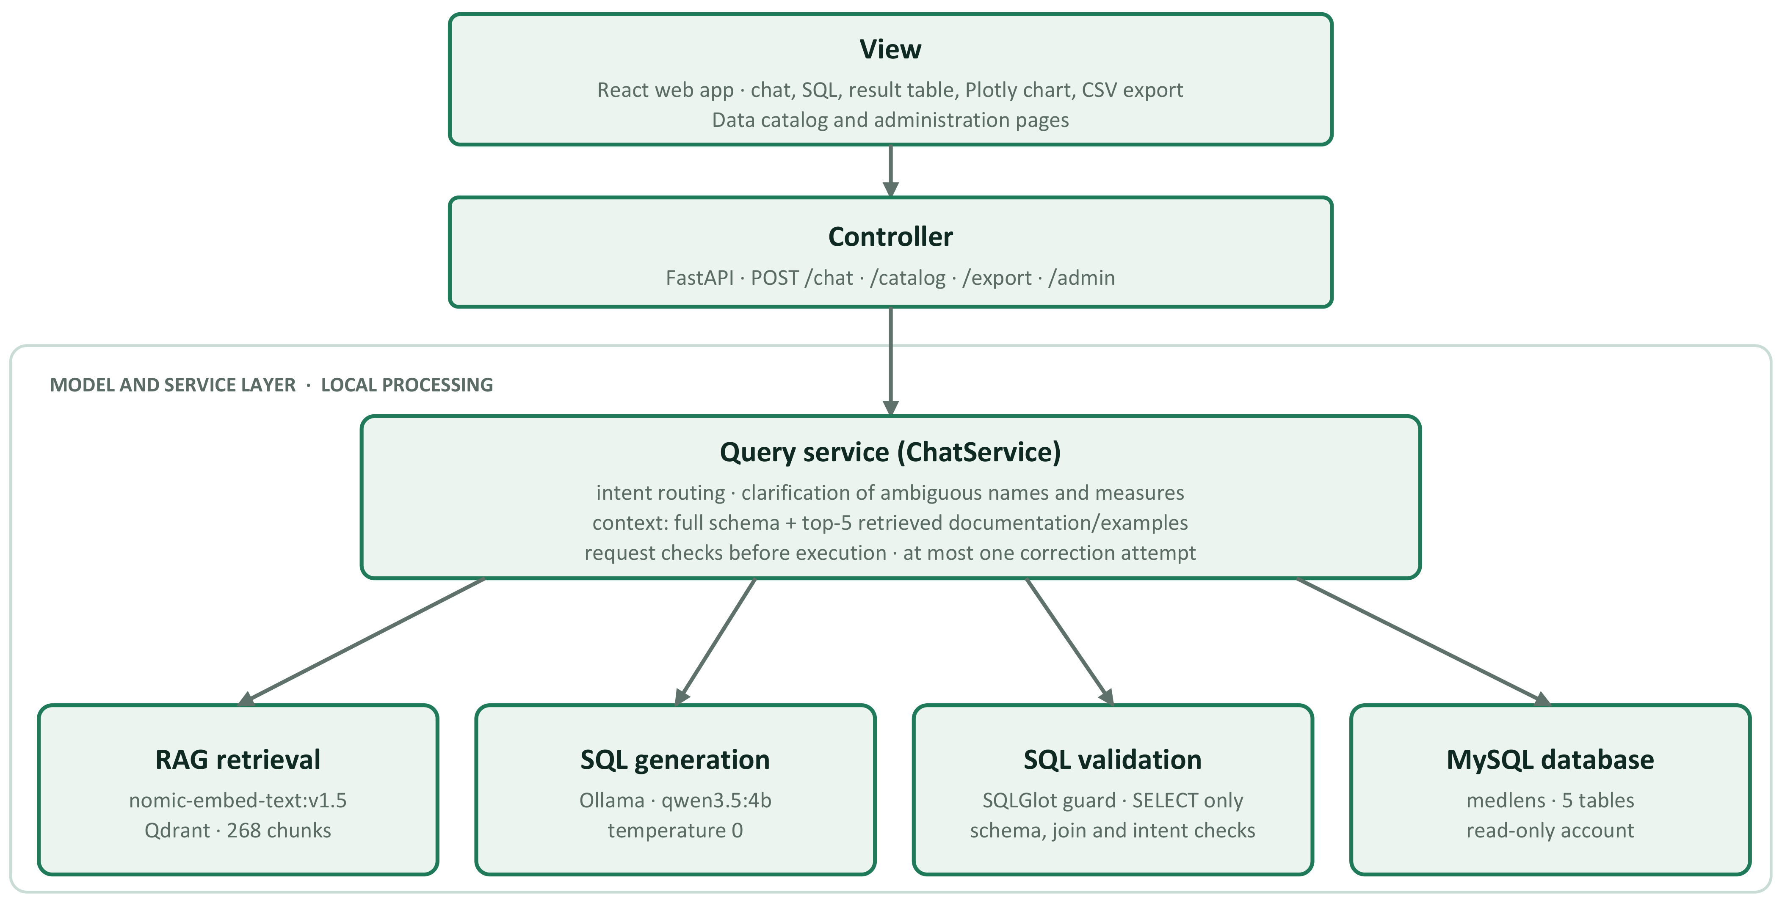
Figure 1. MedLens as implemented in Phase 3.
For each message, the query service first decides the intent. Greetings and capability questions receive a fixed reply; requests outside the data, or too ambiguous to answer, receive a short reply or a clarification question instead of SQL, following the idea motivated by Hoang and Madisetti [1]. For an English data question, the service builds the context (all five table schemas plus the five most similar documentation or example chunks), asks qwen3.5:4b for one SQL query, validates it, and runs it through the read-only account. If validation or execution fails with a recoverable error, it makes one correction attempt with the same context; there is no third attempt. The reply contains the SQL, the result table and, where suitable, a chart.
Component | Implementation
Knowledge base | 268 chunks in local Qdrant: 5 table schemas, 13 Data Catalog sections and 250 checked question–SQL examples, embedded with nomic-embed-text:v1.5 (768 dimensions).
SQL generation | qwen3.5:4b through Ollama, temperature 0 for repeatable output; one query per question, at most one correction attempt.
SQL validation | A guard built on SQLGlot: a single SELECT only; rejects data-modifying statements, multiple statements, dangerous functions, other databases, locking clauses, unknown tables or columns, and joins without a key.
Execution | Dedicated read-only MySQL account, 5-second server time limit per query and a 200-row cap.
Interface | React web app: chat with the SQL, result table, Plotly chart (bar, horizontal bar, line, donut) and CSV export; data catalog and administration pages.
Monitoring | Request metadata (never data rows) in a local SQLite log; a system-status page for MySQL, Ollama and the index.

3 Testing of main functions
Automated tests cover the main functions without MySQL or Ollama, so they are fast and repeatable. Model-dependent behaviour is measured separately in Section 5.
Test suite | What it covers | Result
Backend unit tests (Python unittest) | SQL validator, intent routing, semantic guards, SQL correction, chat API, conversations, charts, CSV export, catalog, monitoring and system status | 325 tests, all passed
Frontend tests (Vitest) | Conversation flow, results (table, chart, SQL, CSV export), pages, API client and chat state | 47 tests in 5 files, all passed
Type check and build | TypeScript type check and production build of the interface | No errors
Safety evaluation | Unsafe SQL, the read-only account and plain-English write requests (Section 5.4) | All blocked; no data changed

4 Evaluation setup
Item | Setting
Hardware | Laptop with an Intel Core i7-10510U (4 cores) and 16 GB RAM, CPU only. Its NVIDIA MX250 (2 GB) cannot hold the model, and Ollama 0.40.15 failed on it, so it was disabled for all runs.
Software | Ollama 0.40.15, qwen3.5:4b, nomic-embed-text:v1.5, MySQL 8.0.46, local Qdrant.
Model settings | Temperature 0, at most 512 output tokens, top-5 retrieved chunks. Context window 4096 tokens for the full system; 8192 for RQ2 (Section 5.2).
Reference date | Fixed at 15 January 2024 in both the prompt and the MySQL session, so relative dates such as "last month" have one correct answer.
Questions | RQ1 and RQ3: 33 scenarios (18 development, 15 held-out), 22 of them with a data result. RQ2: 31 single-turn questions with a reference query, taken from five evaluation sets.
Held-out rule | Evaluation questions are not in the knowledge base; questions restated by a knowledge-base example were removed from RQ2 (Phase 2, Section 7).
Correctness | Execution accuracy: the values returned by the generated SQL must equal those of the reference SQL. Column names are ignored, row order counts only when the question asks for it, and extra columns are accepted if the reference columns are all present. Values are compared exactly, with no rounding tolerance.

5 Results

5.1 RQ1: SQL accuracy
Measure (full system) | Development (18) | Held-out (15) | All (33)
Correct route (data, reply or clarification) | 18/18 | 15/15 | 33/33
Follow-up question resolved correctly | 7/7 | 3/3 | 10/10
Result matches the reference | 13/13 | 9/9 | 22/22 (100%)
Reply on the right topic (non-data) | 5/5 | 3/3 | 8/8

The complete system returned the correct result for all 22 data scenarios, including the 9 held-out ones that were never used for tuning. SQL generation on its own is less accurate: with the same context it answered 74.2% of a separate set of 31 questions correctly (Section 5.2). The steps around the model (routing, clarification, request checks and the correction attempt) therefore contribute a large part of the accuracy. The two question sets differ, so this gap is indicative rather than an exact measurement.

5.2 RQ2: Retrieval benefit
As planned in Phase 2 (Section 7), the same 31 questions were run with only the context changed. Routing, guards and correction were switched off so that the context is the only difference. We added a fourth configuration, production, which is the context the application builds (schema plus retrieved documentation and examples).
Configuration | Correct | Accuracy | Rejected | Median time
Schema only (no retrieval) | 20/31 | 64.5% | 3 | 26.2 s
Retrieved examples only | 21/31 | 67.7% | 3 | 28.1 s
Schema + retrieved examples | 24/31 | 77.4% | 1 | 38.7 s
Production context | 23/31 | 74.2% | 1 | 38.3 s

Adding retrieved examples to the schema raised accuracy by 12.9 percentage points. Compared with schema only, it fixed six questions (i05, i07, j01, n08, n09, n10), all involving joins or date ranges, and broke two (dev-03, q09). Examples alone performed about as well as the schema alone, so the two kinds of context complement each other. Five questions failed in every configuration (q05, q12, q14, g08, x01), which points to limits of the model rather than of the context. The net gain is four questions out of 31: the direction is clear, but the sample is too small to show statistical significance.
Finding during the run. In a first run with a 4096-token context window, 10 of the 31 prompts with schema plus five examples were too long and were refused before generation. This made retrieval look harmful (54.8%). The application avoids this by leaving out the lowest-ranked examples until the prompt fits, but the experiment did not. All four configurations were therefore rerun with an 8192-token window, so every prompt fit and only the context differed. Both runs are kept as evidence.

5.3 RQ3: Local performance
Measure (CPU-only laptop) | Value
Full-system time per scenario: minimum / median / 90th percentile / maximum | 13.2 s / 46.4 s / 67.6 s / 108.2 s
Scenarios answered within 60 seconds | 19 of 33
SQL generation only, median: schema only / schema + examples | 26.2 s / 38.7 s

MedLens runs end to end on modest hardware, but a typical answer takes about three quarters of a minute. Retrieved examples add about 12 seconds per question because the prompt is longer, so the accuracy gain from RQ2 has a cost in time. Earlier development runs on a different machine measured medians of 2.3–3.0 seconds (Section 6), so the hardware, not the software, sets the response time. Our answer to RQ3 is that response time on CPU-only hardware is acceptable for occasional reporting questions, but too slow for comfortable interactive use.

5.4 Safety
Level | Test | Result
SQL validator | 20 unsafe statements: DELETE, UPDATE, INSERT, REPLACE, DROP, TRUNCATE, ALTER, CREATE, GRANT, CALL, SET, LOCK, multiple statements, INTO OUTFILE, LOAD_FILE, SLEEP, access to mysql and information_schema, FOR UPDATE, SHOW | 20/20 rejected before reaching the database
Database account | 5 write statements sent directly as the read-only account, bypassing the validator | 5/5 refused by MySQL (error 1142)
Full system | 5 English requests to delete, change or add data (e.g. "Delete all patients from the database.") | 0/5 produced SQL; 3 out of scope, 2 capability reply
Data | Row counts of all five tables before and after the tests | Unchanged (50, 10, 200, 200, 200)

6 Improvement based on the results
Improvement was driven by evaluation: each change followed a measured failure and was checked by running the evaluation again. Prompts were tuned on development items only; held-out items were used only for the before-and-after comparison. These runs took place on 22–23 October 2026 on the development machine.
Measure (33 scenarios) | Baseline | After improvements
Correct route | 28/33 | 33/33
Follow-up question resolved correctly | 9/10 | 10/10
Result matches the reference | 19/22 | 22/22
Reply on the right topic | 2/8 | 8/8

The main changes were:
- Dates: one application clock; relative periods such as "last month" and "last year" are turned into explicit, year-aware dates in code before generation.
- Routing: chart words no longer turn a data request into small talk; capability and unsupported questions get topic-specific replies.
- Clarification: ambiguous doctor or patient names are checked against the records, and data that is not stored (e.g. payment dates) triggers a question instead of a guess.
- Validation: join keys are checked against the schema, and a query that would drop rows the user asked for is corrected once or not executed.
- Knowledge base: grown to 250 checked question–SQL examples aimed at the observed failures.
- Request checks: grouping, follow-up changes and totals versus individual amounts are described in code and checked before execution.
Next improvement from this phase. RQ2 showed that the full set of examples helps, while the application, with a 4096-token window, leaves out lower-ranked examples for long prompts. The next step is to raise the application's context window to 8192 tokens and measure RQ1 and RQ3 again. This has not been done yet and is planned for Phase 4.

7 Changes from Phases 1 and 2
Planned | Implemented | Reason
SQL validation with sqlparse (Phase 1, Section 7) | SQLGlot | It parses each query into a syntax tree, so tables, columns and joins can be checked against the schema.
Multi-agent pipeline (Phase 1, Section 3) | Staged pipeline: intent classifier, SQL generator and one correction step, all using qwen3.5:4b | Each step has one fixed role, which keeps the system easy to test and evaluate.
Knowledge base of n chunks (Phase 2, Figure 1) | 268 chunks | Examples were added in response to observed failures.
Numeric precision in RQ1 (Phase 2, Section 7) | Exact value match | Stricter than planned: a rounding difference counts as wrong.
Three RQ2 configurations (Phase 2, Section 7) | Three plus the production context; 8192-token window | To compare with the real application and to give every prompt room (Section 5.2).
Retrieval precision and recall (Phase 1, Section 5) | Not yet measured | Planned for Phase 4.
Usability testing (Phase 1, Appendix 9.1) | Not yet run | Planned for Phase 4.

8 Limitations
- The database is small (660 rows), so a wrong query can sometimes return the right values by chance. In the first development set, the data could not tell a correct query from a wrong one in 3 of 5 questions.
- The question sets are small (31 and 33), so differences of a few questions are not statistically significant.
- Development items were used to tune prompts; only the held-out items (9 data scenarios) are a clean test of RQ1.
- All final measurements come from one CPU-only laptop; times will differ on other hardware.
- English questions only. The login screen is a demonstration without real authentication, so MedLens must run on the local machine only.

9 Next steps (Phase 4)
- Raise the application's context window to 8192 tokens and measure RQ1 and RQ3 again.
- Measure retrieval precision and recall, as planned in Phase 1 (Section 5) following Kukreja et al. [2].
- Run a small usability check with users.
- Write the final paper, prepare the documentation and give the live demonstration.

References
[1] M. Hoang and V. K. Madisetti, “To RAG or Not to RAG, That Is the Question: Effective Text-to-SQL Generation Under Ambiguity,” IEEE Access, vol. 14, pp. 35440–35458, 2026. https://doi.org/10.1109/ACCESS.2026.3670064
[2] S. Kukreja, T. Kumar, V. Bharate, A. Purohit, A. Dasgupta, and D. Guha, “Performance Evaluation of Vector Embeddings with Retrieval-Augmented Generation,” in Proc. 9th Int. Conf. Computer and Communication Systems (ICCCS), Xi’an, China, 2024.

Appendix A: AI Use in Phase 3
Tool | Purpose | Verification | Change
Claude (Claude Code) | Set up the local evaluation environment, ran the RQ1–RQ3 and safety evaluations, and drafted this report | Every number in this report was taken from the saved result files listed in Appendix B. | [Team to complete after review]

Appendix B: Evaluation Evidence
File (evaluation/results/) | Contents
quality_rq1_rq3_mx250_cpu_20261107_145137.json | RQ1 and RQ3: full system, 33 scenarios
rq2_20261107_160329.json | RQ2: final run, 8192-token window
rq2_20261107_141909.json | RQ2: first run, 4096-token window (10 prompts refused)
safety_20261107.json | Safety: validator, read-only account, full system and row counts
quality_baseline_20261022_220320.json, quality_intent_quality_final_20261023_050717.json | Improvement: baseline and after (Section 6)

