

**North South University**

**Project Report for CSE- 215**

**INTRODUCTION TO PROGRAMMING LANGUAGE- II**

**SECTION- 19**

**Project Name : Telecom Operator**

|  |  |
| --- | --- |
| **Name** | **ID** |
| **ALIF AL RAZI** | **2011358042** |
| **SAYAM MIA** | **2011558642** |
| **MD. SHARIAR FAHIM** | **2012611642** |
| **ZAWWAD UL SAMI** | **2014254642** |

**Objective/ Vision :**

This is a Telecom Package Operating system for a user to receive multiple services starting from balance check to buying internet packages from different telecom operators from a single application.

**Users of the System :**

1. General public.

**System Functions :**

1. Can check details
2. Can check balance
3. Can buy internet packages
4. Can buy social packages
5. Can buy minute packages
6. Can take emergency loan
7. Can check their offers
8. Can check FnF offers

**Tools used & required:**

1. Use any IDE to develop the project. It may be Eclipse /Myeclipse / Netbeans/ VS Code etc.
2. Java Swing for Graphical User Interface (GUI).

**How project works?**

Upon running the code the system will initially start with a window showing 3 operators ( Robi, Airtel & Banglalink ) to choose from.

Unique codes required for each operator to proceed are given below :

* Robi : *121#
* Airtel : *5000#
* Banglalink : *500#

With a similar process, upon choosing the operator 10 unique options will be given to the user to choose from. To proceed further the user will have to type in the unique numbering codes given with each options.

In case of insufficient balance, user may go back and choose to take emergency loan or exit the system.

*Some screenshots are given below for further understanding:*

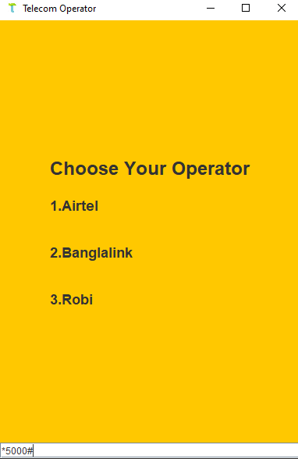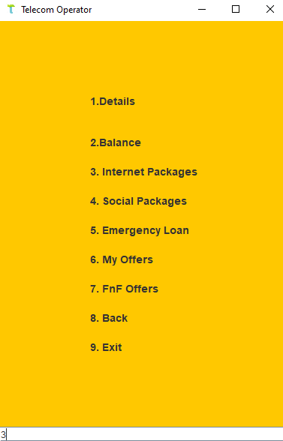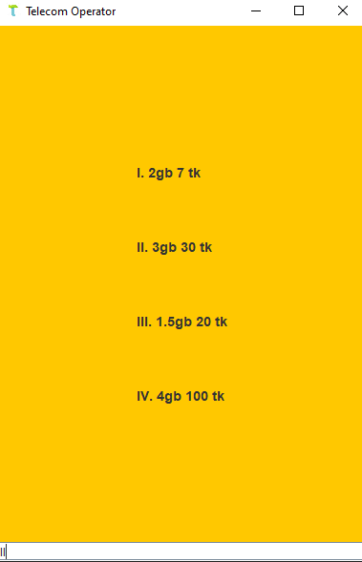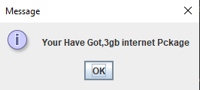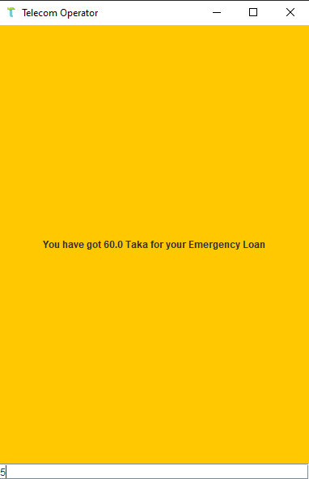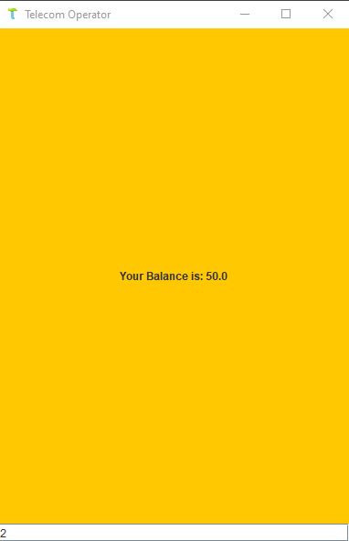

**UML:**





