NAME :ALISHBA ZAINAB

ROLL NO :23-BSE-006

SECTION :A

SUBMITTED TO :SIR WAQAS

ASSIGNMENT 2

Link:

https://github.com/ALISHBAZAINAB/cc_assign_2

PART 1&2
In Part 1, the environment was prepared using Terraform. The project included configuration files such as variables.tf and terraform.tfvars, along with modules for networking and security. The networking module handled the creation of the VPC, subnets, route tables, and an internet gateway, while the security module defined security groups for SSH, HTTP, and HTTPS traffic. Part 2 webserver modules main,output and variables are created

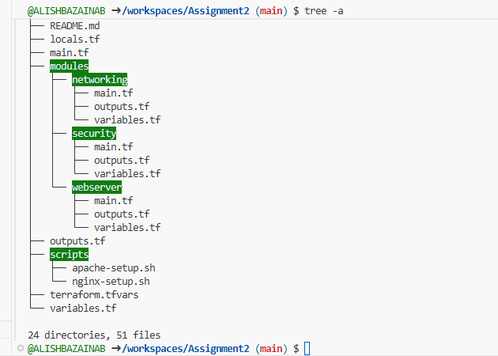

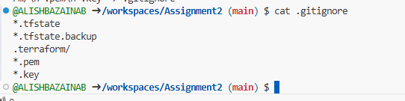

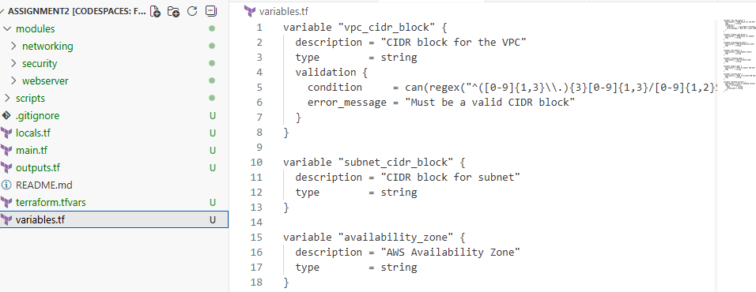

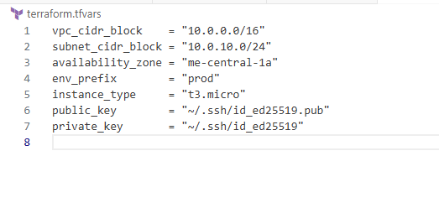
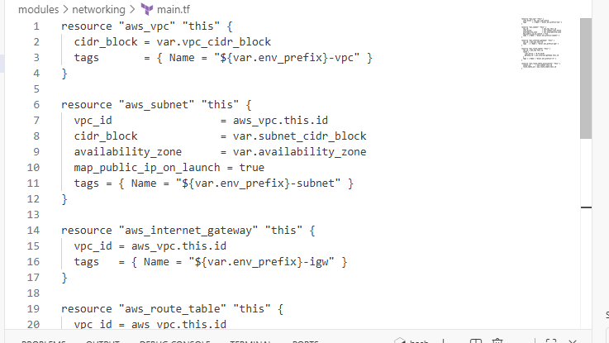

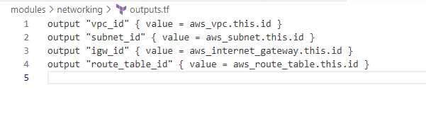
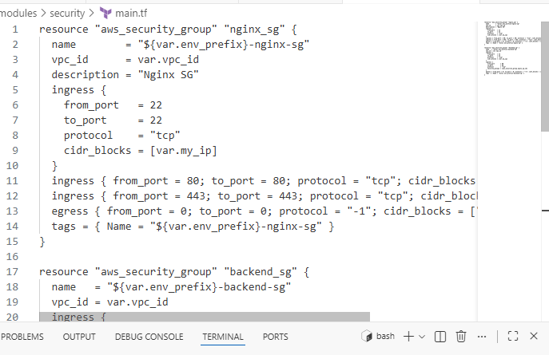

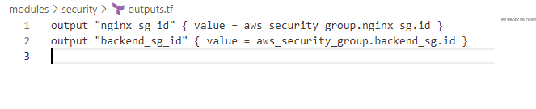

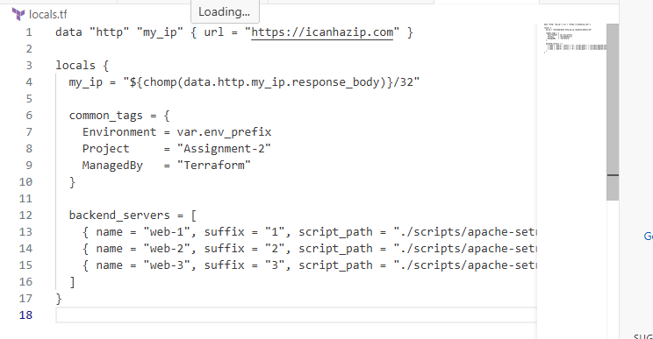
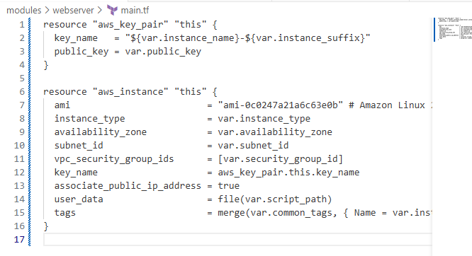

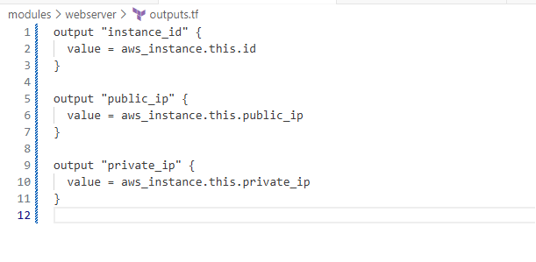
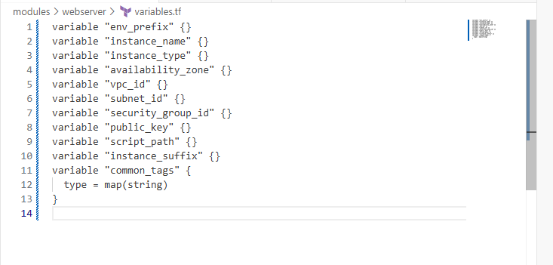
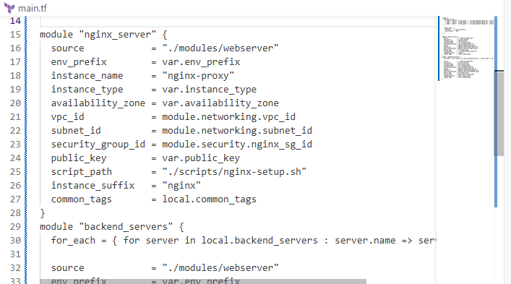

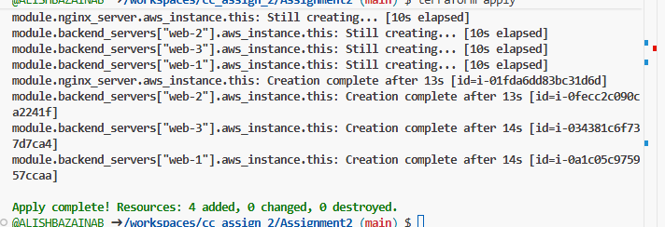

Task 3
Server Configuration Scripts
In Part 3, server configuration scripts were used to install and configure services on both the backend and proxy servers. Apache was installed on the backend web servers to serve content, while Nginx was installed on the proxy server to act as a reverse proxy. SSL self-signed certificates were generated and applied to Nginx for HTTPS connections.

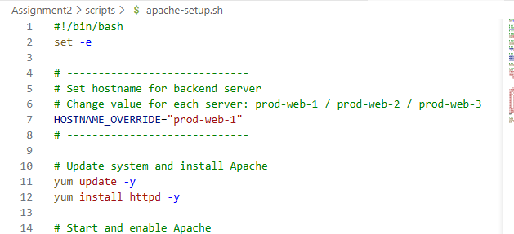

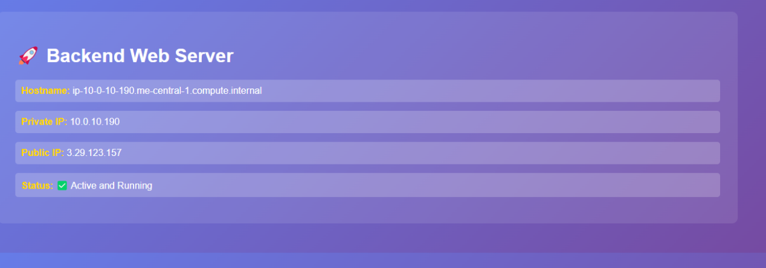

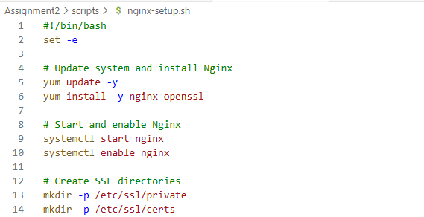
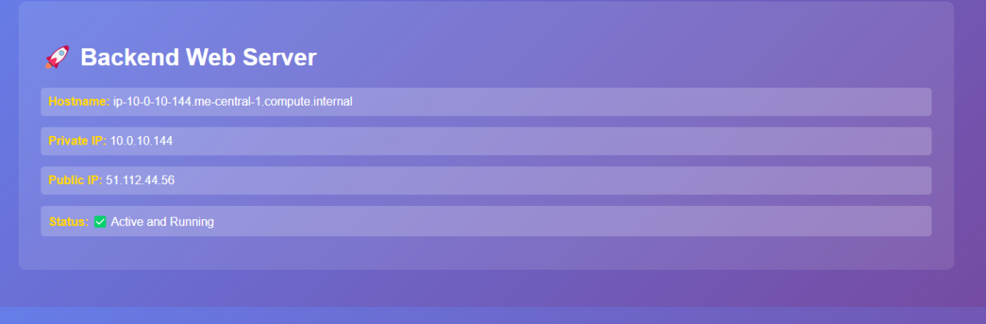

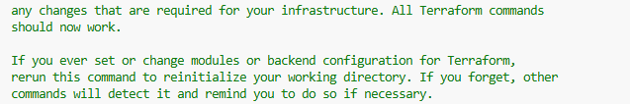

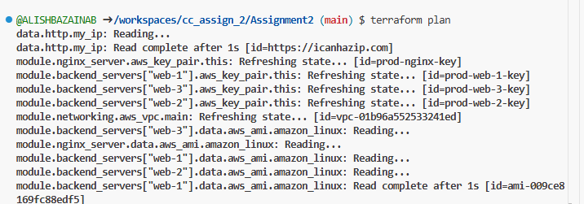
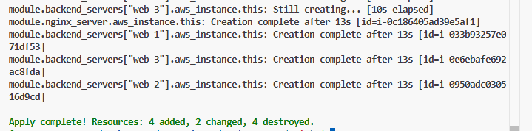

Task 4
Infrastructure Deployment
Part 4 involved deploying the complete infrastructure using Terraform. After applying the Terraform configuration, public IPs were verified for the Nginx proxy and backend servers. Nginx was configured as a reverse proxy and load balancer, distributing traffic between Web1 and Web2 while keeping Web3 as a backup. The deployment also included testing cache functionality, verifying that the X-Cache-Status header showed MISS on the first request and HIT on subsequent requests

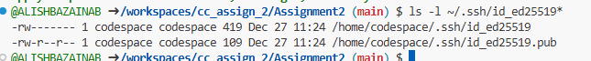
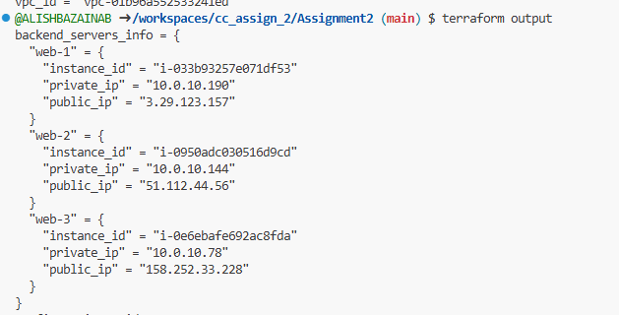
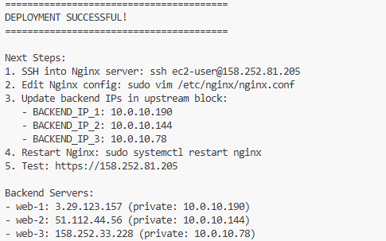

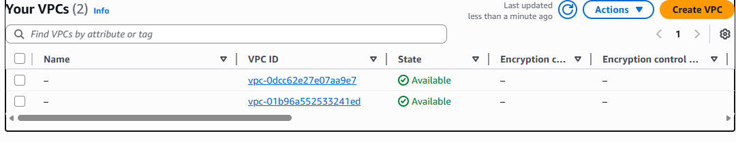
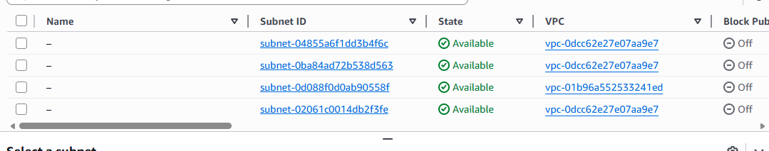

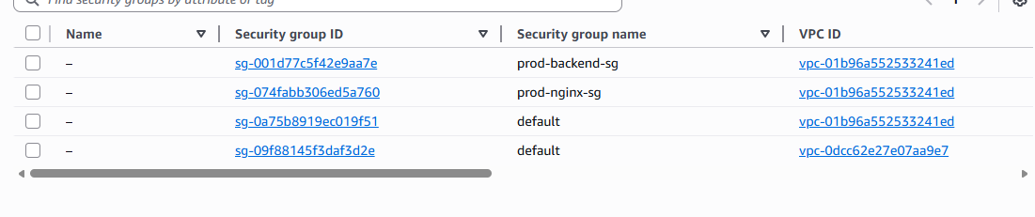

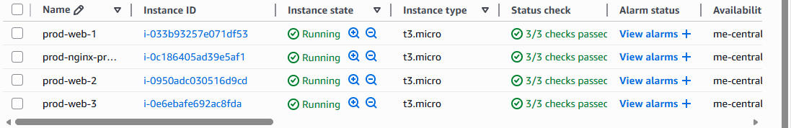

Task 5
In Part 5, the focus was on configuring and testing Nginx for load balancing and high availability. Nginx was configured to listen on both HTTP and HTTPS, with SSL applied. Load balancing was verified by refreshing the Nginx page multiple times and observing traffic alternating between Web1 and Web2, while Web3 remained as a backup. High availability was tested by stopping Apache on Web1 and Web2 sequentially and observing that traffic automatically switched to the backup server. Logs were monitored to confirm the caching and backend responses. Screenshots were captured for SSL warnings, web responses, load balancing behavior, and cache functionality to provide evidence of proper configuration.
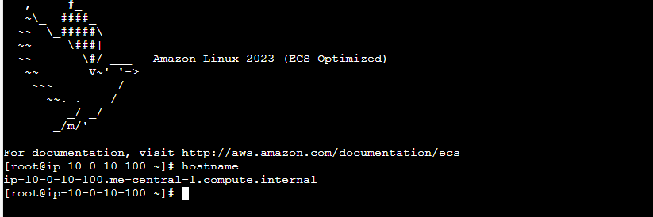

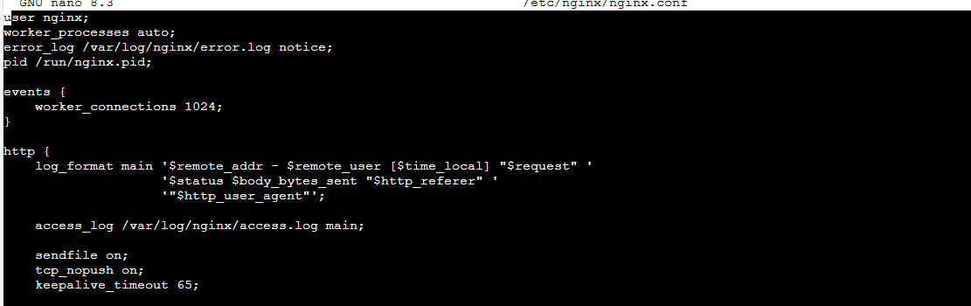

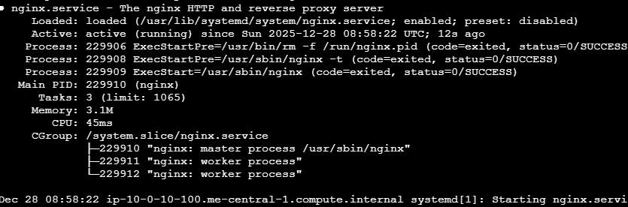

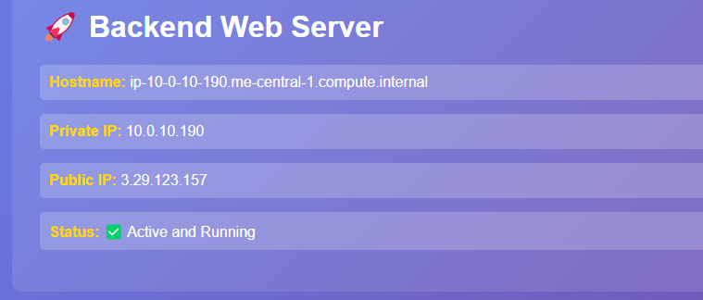

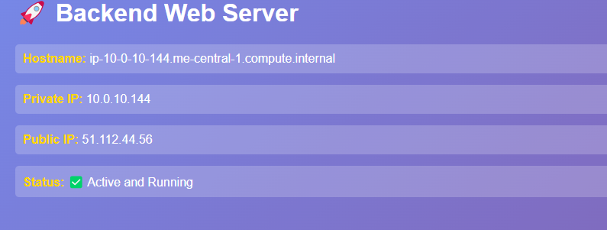

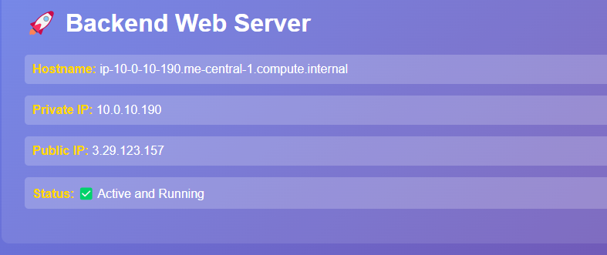

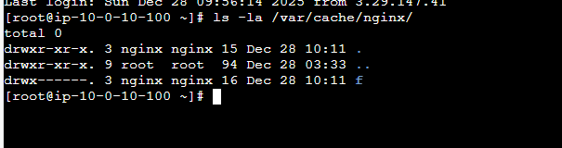

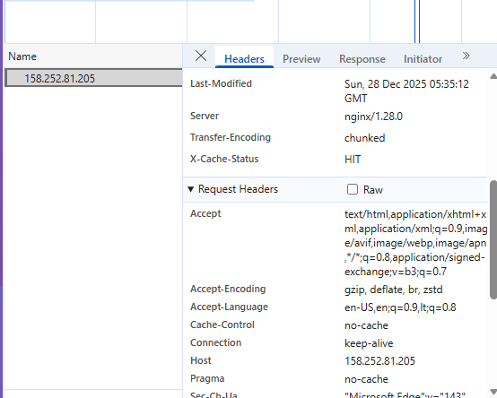

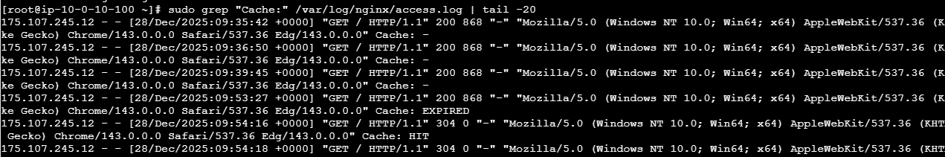

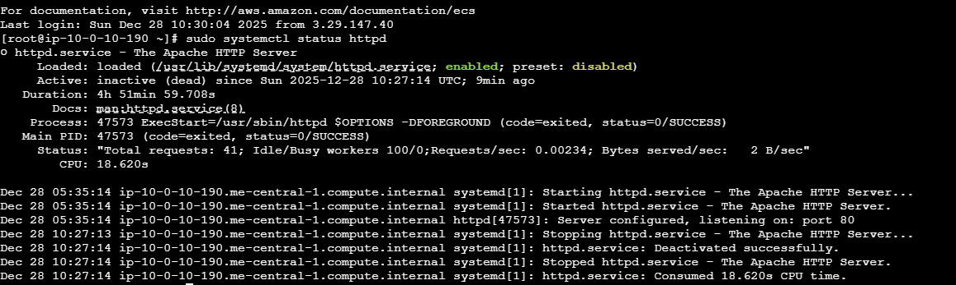

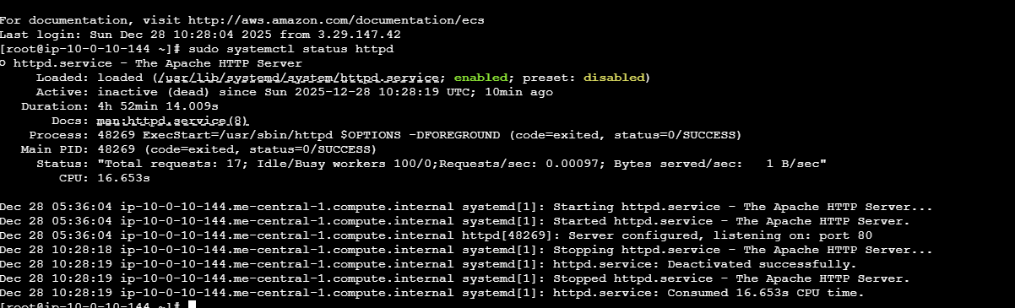

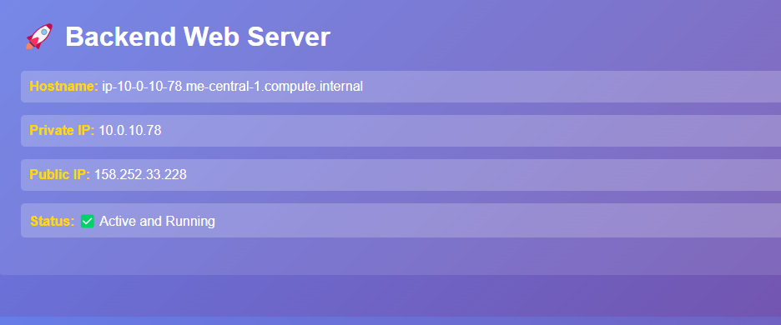

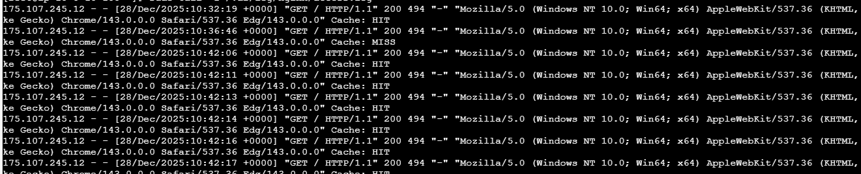

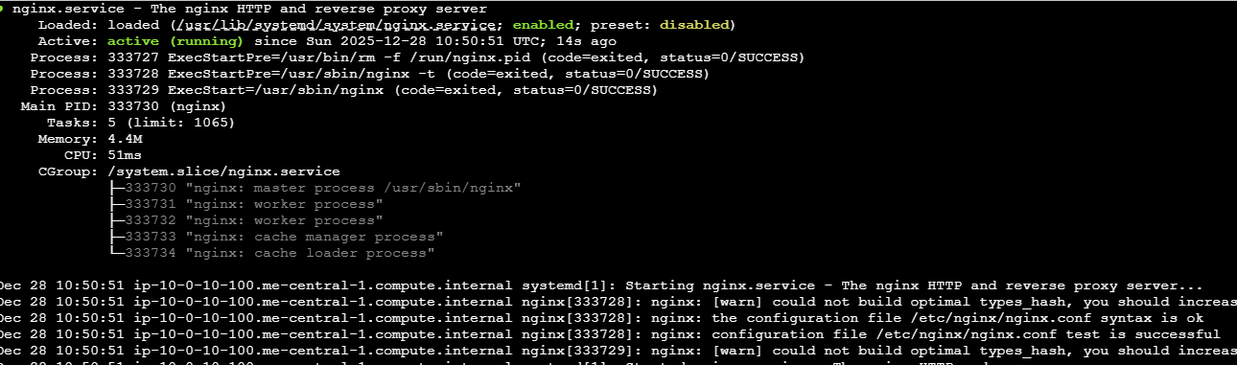

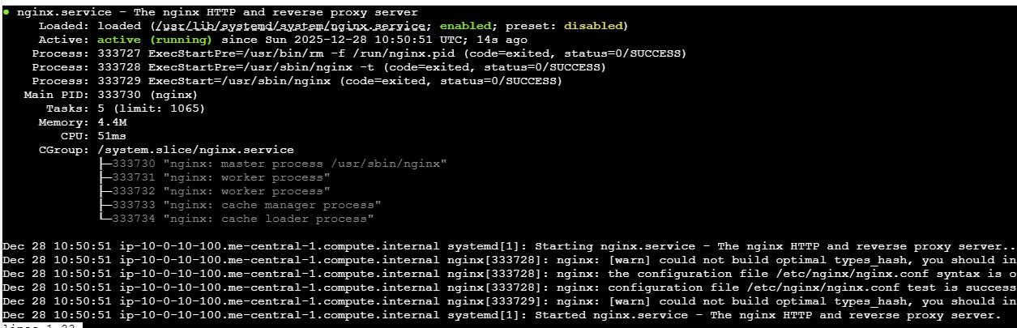

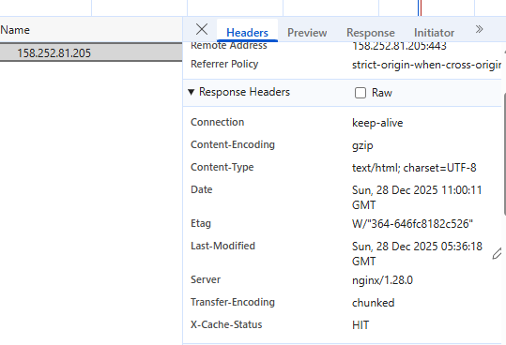

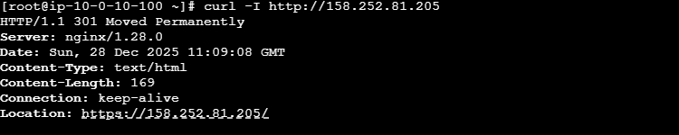

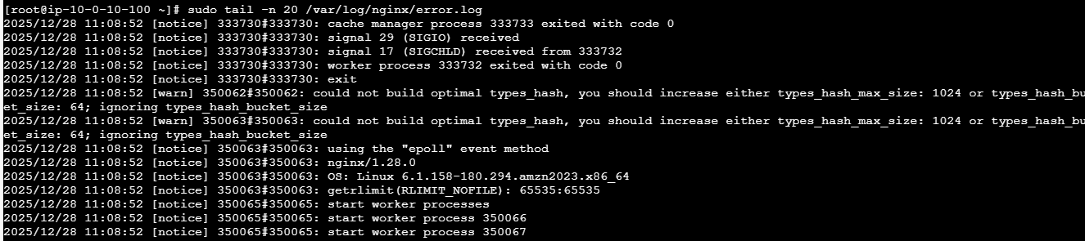

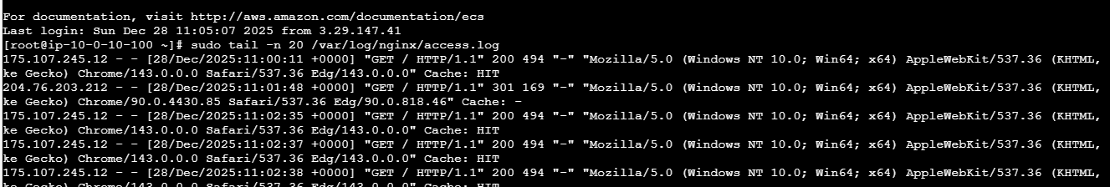

Task 6
Part 6 focused on cleaning up all deployed resources to prevent further AWS charges. Terraform destroy was used to remove all EC2 instances, networking components, and security groups. Manual verification in the AWS console confirmed that all resources were terminated.

