FATIMA JINNAH WOMEN UNIVERSITY


NAME:ALISHBA ZAINAB
ROLLNO:23-BSE-006
SECTION:A
SUBMITTED TO:SIR SHOAIB

LAB 7
Task 1
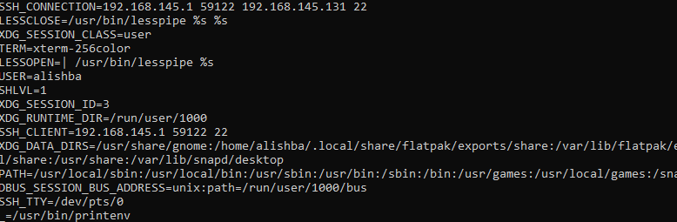

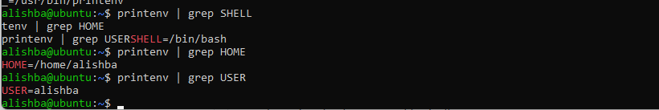

Task 2

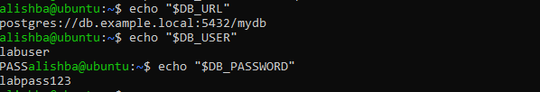

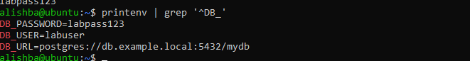

Task 3
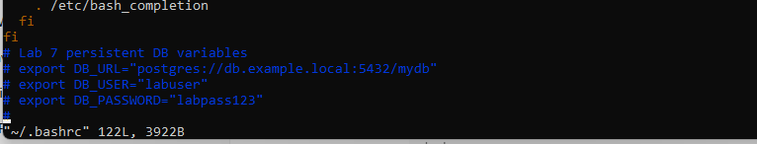
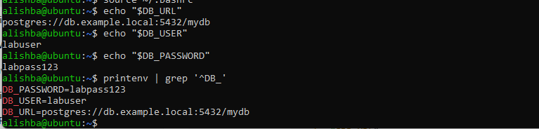

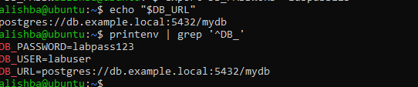

Task 4

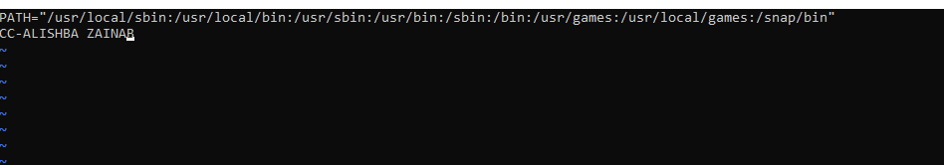





Task 5
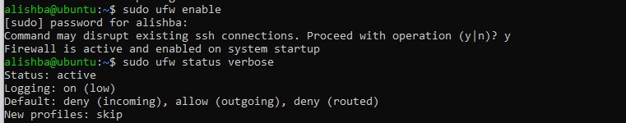

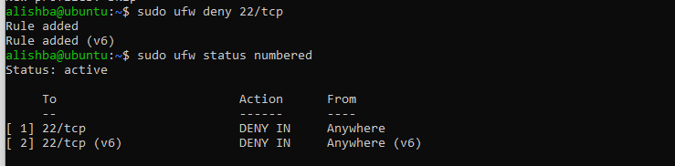



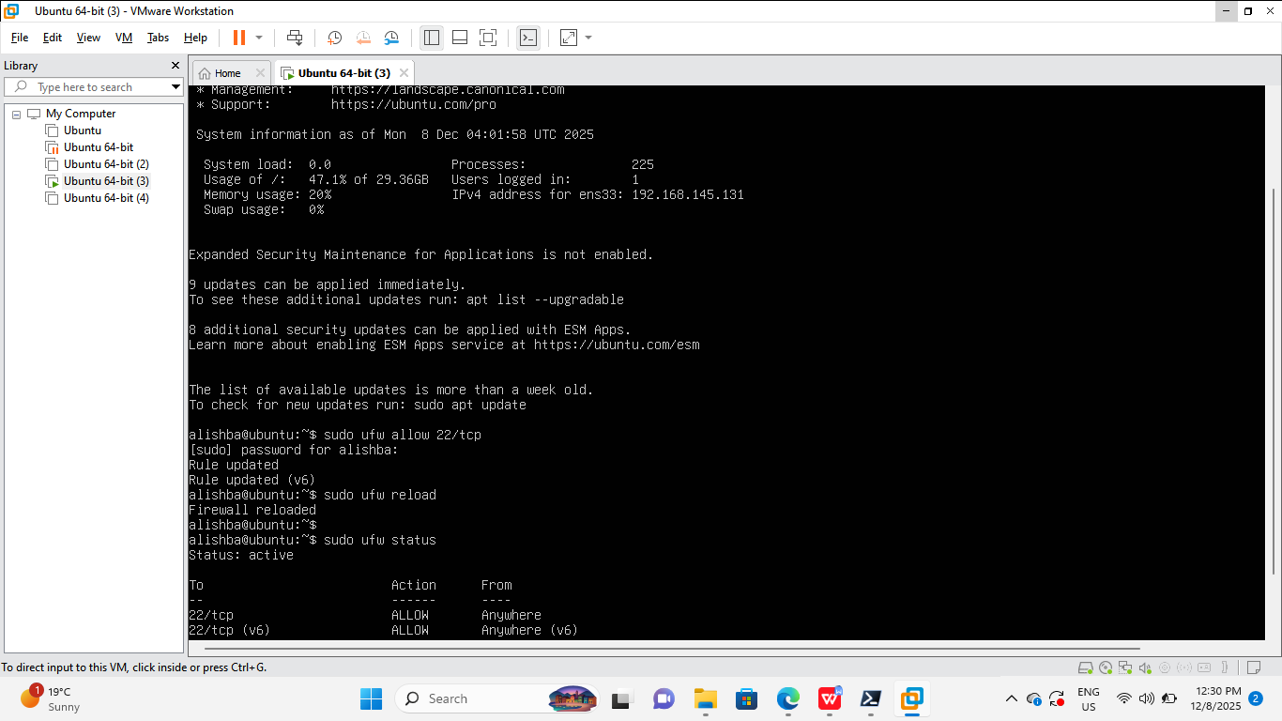

Task 6
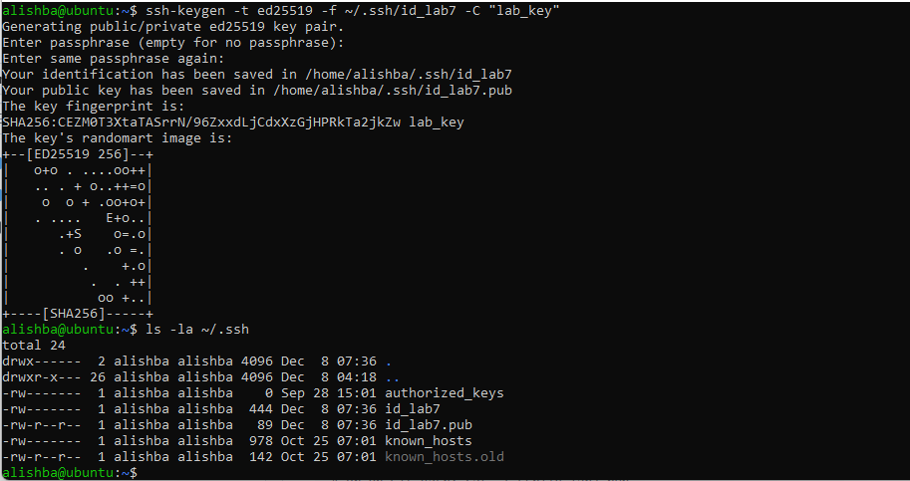

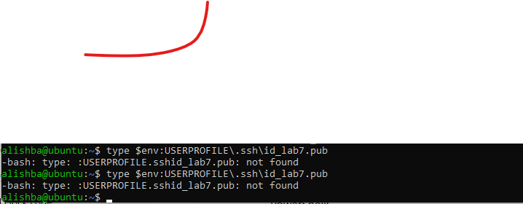

Task 6


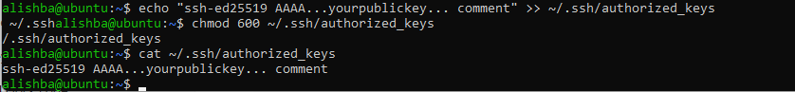

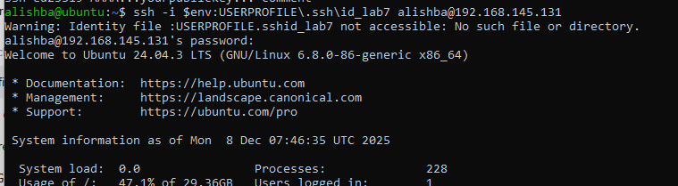

Evaluation question
