AGRICULTURAL SATELLITE INTELLIGENCE
Imagery Time Series Report
Source: AgroCloud Satellite Intelligence · Period 2026-01-01 to 2026-07-07 · 10 observations
AOI: Drawn AOI · 99.53 ha · Sentinel-2 (Sentinel Hub)

Field Summary
AOI / Field Name | Drawn AOI
Total Field Area | 99.53 ha
Analysis Period | 2026-01-01 to 2026-04-25 (10 observations)
Satellite Source | Sentinel-2 (Sentinel Hub)
Latest Acquisition | 2026-07-07
Vegetation Indices | NDVI, NDMI, NDWI, SAVI
Vegetation Health Summary | Moderate vigor
Data Completeness | 10 of 10 periods

Executive Summary
The dataset covers 10 satellite observations from 2026-01-01 to 2026-04-25. Vegetation condition is improving, with moderate vigor (NDVI 0.50) recorded on the latest acquisition date of 2026-04-23. Stress-related classes cover roughly 51% of the monitored area. Canopy moisture remains constrained (NDMI 0.06), and the soil-adjusted index (SAVI) tracks closely with NDVI. Together, the four indices point to a field that is photosynthetically active but under mild-to-moderate water stress in localized zones.
Vegetation Vigor (NDVI / SAVI)
Moderate vigor with localized variability across the field, based on NDVI. The NDVI trend is improving across the monitoring period, with a latest mean of 0.50.
Moisture Status (NDMI / NDWI)
NDMI (0.06) and NDWI (-0.55) both indicate water-limited canopy conditions in parts of the field.
Vegetation Health Summary
About 51% of the AOI falls in stressed or critical vegetation classes (risk level: moderate). The dominant class is healthy vegetation (~37.0 ha, 37%), but combined stress and bare-cover classes account for over a third of the AOI. NDVI alone would read this field as moderate vigor; cross-checking against NDMI and NDWI shows that vigor is being held back by canopy water limitation rather than structural or soil factors, since SAVI tracks closely with NDVI rather than diverging from it. Suggested workflow: use NDVI for a first-pass vigor screen, NDMI/NDWI to separate water stress from other stress causes, and SAVI to sanity-check NDVI in sparsely vegetated or early-growth zones where exposed soil can distort the raw NDVI signal.

Period Statistics
Metric | NDVI | NDMI | NDWI | SAVI
Mean | 0.3985 | -0.1081 | -0.4669 | 0.3976
Min | 0.3113 | -0.3365 | -0.6242 | 0.3138
Max | 0.5231 | 0.1379 | -0.3317 | 0.5172
Std Dev | 0.0767 | 0.1483 | 0.0838 | 0.0736
Latest (2026-07-07) | 0.5021 | 0.0588 | -0.5490 | 0.4970
Trend (slope/period) | +0.0180 | +0.0385 | -0.0046 | +0.0173
Flags
Vigor Flag: Moderate · Moisture Flag: Water-Limited · NDVI Trend (last 4 weeks): Increasing

Imagery Timeline — Vegetation & Moisture Trends
The charts below plot each vegetation index across all acquisition dates in the monitoring period, aligned by scene date.
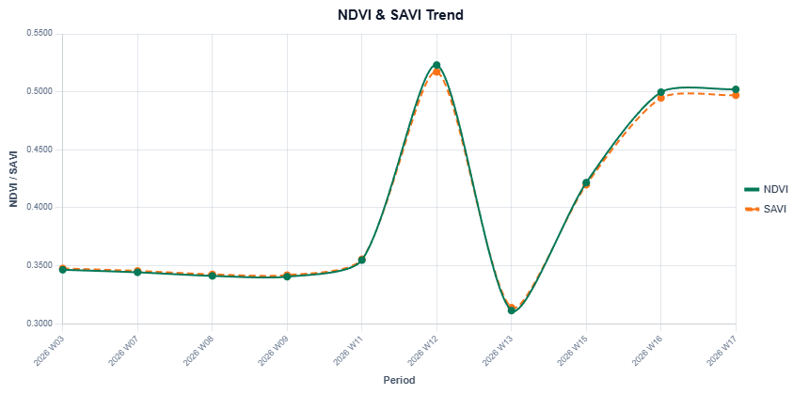
NDVI & SAVI Trend
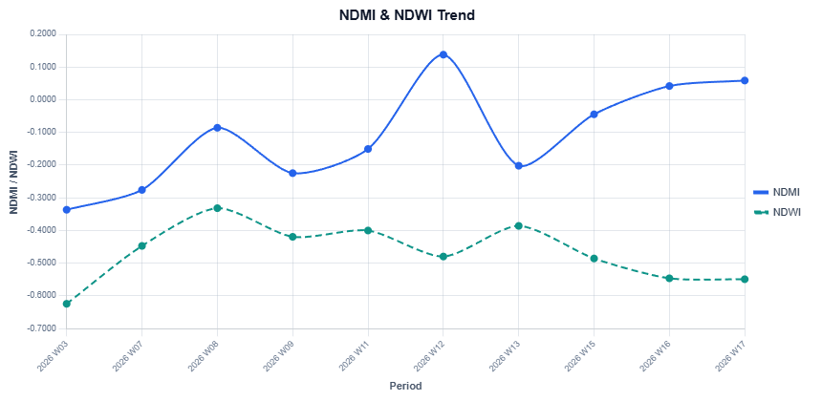
NDMI & NDWI Trend

Vegetation Coverage Timeline
Coverage is calculated independently for each acquisition date. NDVI classification: Healthy / Moderate / Stress = Vegetation; Critical = Bare.
Date | NDVI Mean | Veg. Coverage % | Veg. Area (ha) | Dominant Class
2026-01-18 | 0.3465 | 99.7% | 99.23 | Moderate vigor
2026-02-12 | 0.3443 | 99.9% | 99.41 | Stressed vegetation
2026-02-22 | 0.3412 | 100.0% | 99.53 | Stressed vegetation
2026-02-27 | 0.3405 | 99.8% | 99.38 | Stressed vegetation
2026-03-11 | 0.3548 | 99.7% | 99.22 | Stressed vegetation
2026-03-19 | 0.5231 | 99.3% | 98.86 | Healthy vegetation
2026-04-24 | 0.3113 | 100.0% | 99.53 | Stressed vegetation
2026-05-08 | 0.4217 | 100.0% | 99.53 | Moderate vigor
2026-06-18 | 0.4997 | 99.9% | 99.47 | Stressed vegetation
2026-07-07 | 0.5021 | 99.8% | 99.29 | Stressed vegetation

Map Snapshots — Full Time Series
AOI index maps for every acquisition date, organized by analysis layer. Data source: Sentinel-2 L2A (Sentinel Hub WMS).
NDVI — Vegetation Vigor — All Acquisition Dates
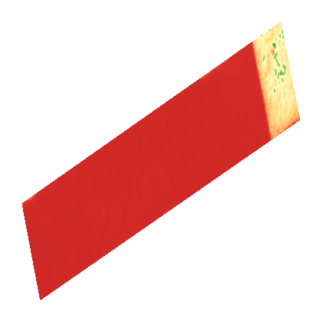  2026-01-18  NDVI 0.3465 | 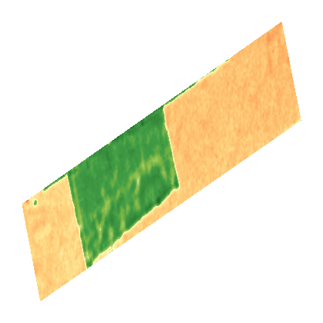  2026-02-12  NDVI 0.3443 | 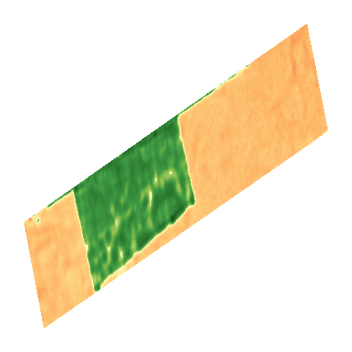  2026-02-27  NDVI 0.3405 | 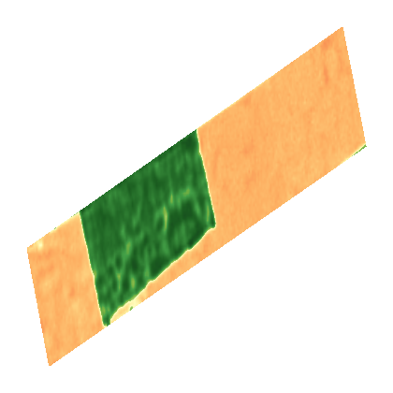  2026-03-11  NDVI 0.3548
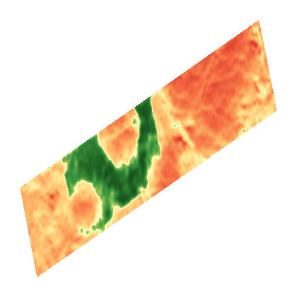  2026-04-19  NDVI 0.5231 | 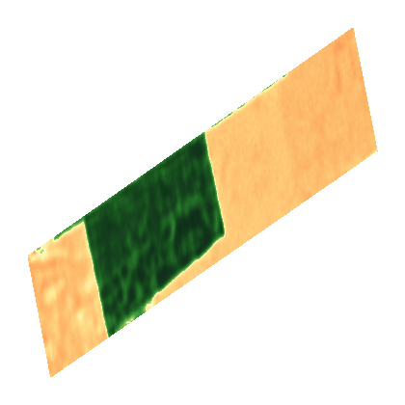  2026-05-24  NDVI 0.3113 | 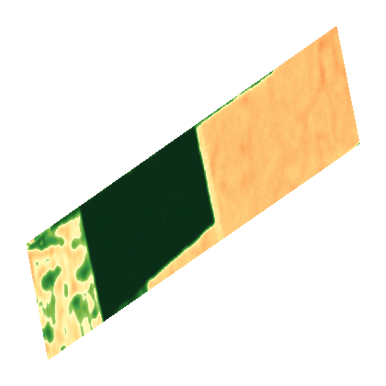  2026-06-18  NDVI 0.4997 | 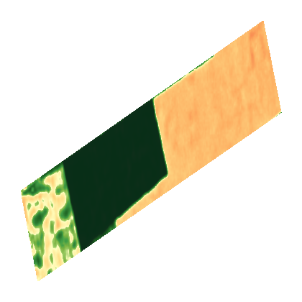  2026-07-07  NDVI 0.5021
Legend: Water/No veg (< -0.08) · Very low vigor (-0.08–0.02) · High stress (0.02–0.10) · Crop stress (0.10–0.18) · Early watch (0.18–0.26) · Watch (0.26–0.34)
Vigor climbs from stress-dominated readings in Jan–Mar toward moderate vigor by late April. Dominant class on 2026-04-23: stressed vegetation (~50.5 ha, 51%). Inspect irrigation uniformity; monitor nutrient availability.
NDMI — Canopy Moisture — All Acquisition Dates
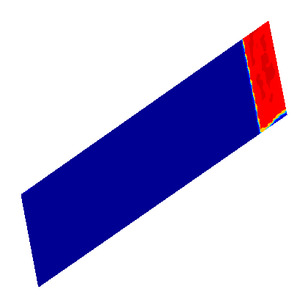  2026-01-18  NDMI -0.3365 | 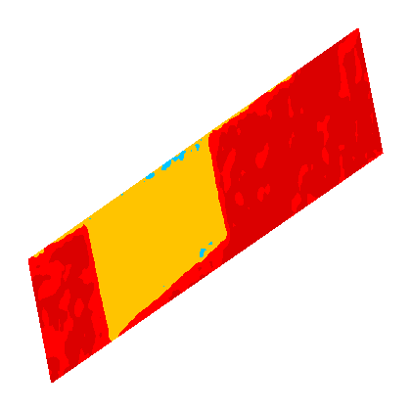  2026-02-12  NDMI -0.2758 | 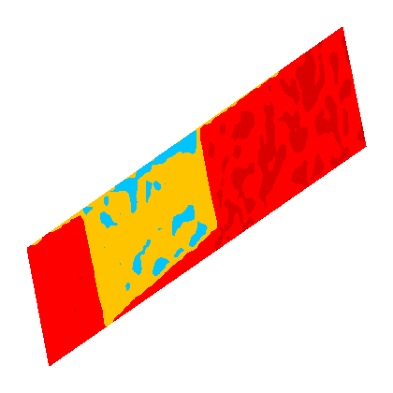  2026-02-27  NDMI -0.2245 | 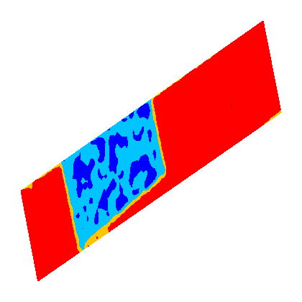  2026-03-11  NDMI -0.1506
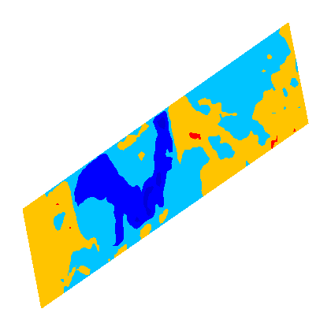  2026-04-19  NDMI 0.1379 | 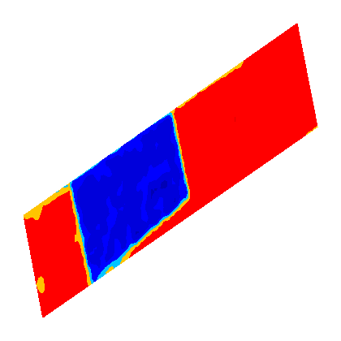  2026-05-24  NDMI -0.2019 | 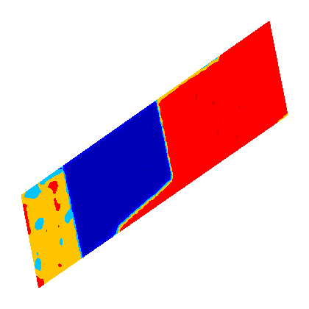  2026-06-18  NDMI 0.0420 | 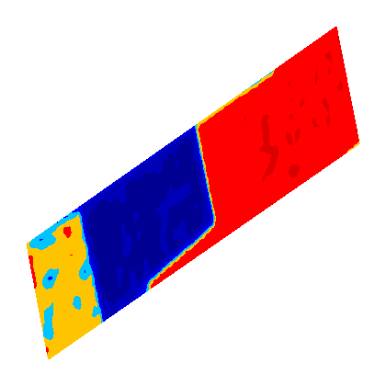  2026-07-07  NDMI 0.0588
Legend: Severe stress (< -0.64) · High stress (-0.64–-0.48) · Moderate stress (-0.48–-0.32) · Low stress (-0.32–-0.16) · Dry canopy (-0.16–0.00) · Moist canopy (0.00–0.16)
Canopy moisture stays negative (dry) through most of the period, briefly recovering around week 12, and closes near-neutral (mean NDMI 0.06) on 2026-04-23. Inspect irrigation uniformity; schedule moisture checks in drier zones.

NDWI — Surface Water / Moisture — All Acquisition Dates
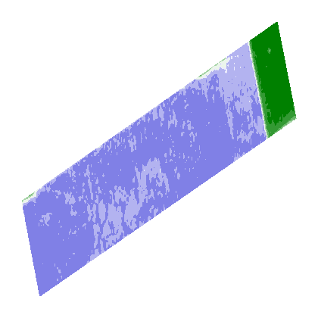  2026-01-18  NDWI -0.6242 |   2026-02-12  NDWI -0.4471 |   2026-02-27  NDWI -0.4193 |   2026-03-11  NDWI -0.4000
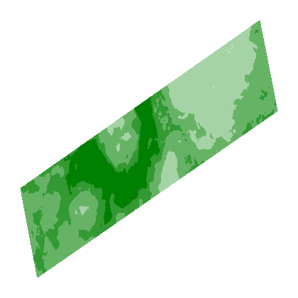  2026-04-19  NDWI -0.4796 |   2026-05-24  NDWI -0.3859 |   2026-06-18  NDWI -0.5462 |   2026-07-07  NDWI -0.5490
Legend: Very dry (< -0.45) · Dry (-0.45–-0.28) · Moderate dry (-0.28–-0.14) · Slightly dry (-0.14–-0.05) · Bare transition (-0.05–0.00) · Low moisture (0.00–0.004)
Surface moisture remains in the dry-to-very-dry range across all scenes, with the latest reading (-0.55) still classified very dry (~99.5 ha, 100%). Immediate field inspection recommended; verify irrigation, drainage, and crop establishment.
SAVI — Soil-Adjusted Vegetation — All Acquisition Dates
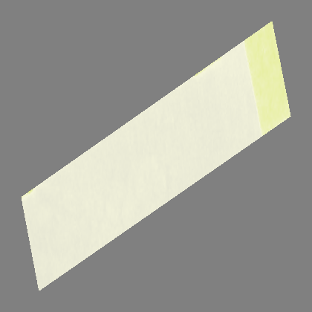  2026-01-18  SAVI 0.3476 | 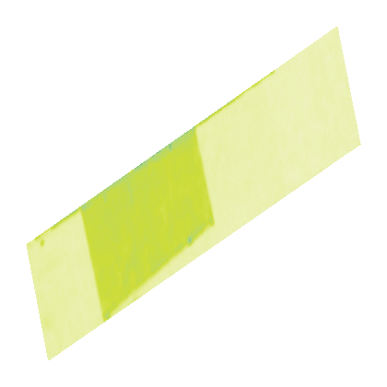  2026-02-12  SAVI 0.3455 | 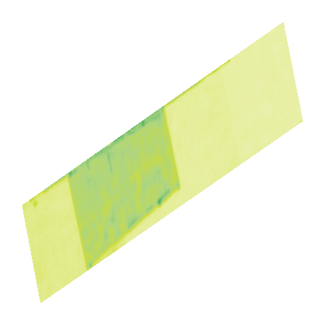  2026-02-27  SAVI 0.3419 | 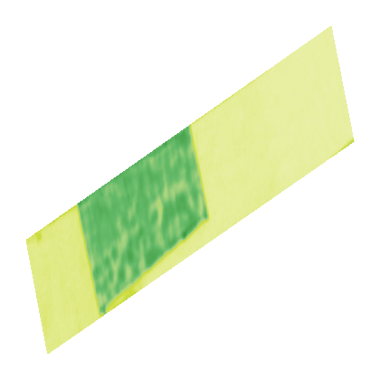  2026-03-11  SAVI 0.3556
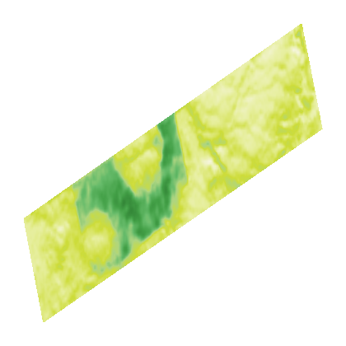  2026-04-19  SAVI 0.5172 | 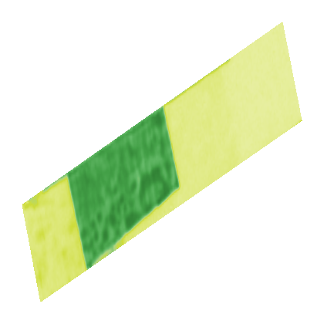  2026-05-24  SAVI 0.3138 | 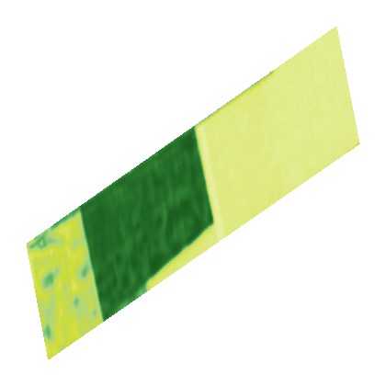  2026-06-28  SAVI 0.4947 | 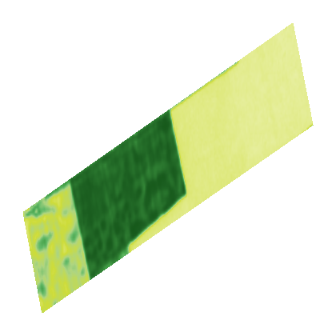  2026-07-07  SAVI 0.4970
Legend: Bare/non-veg (< -0.35) · Very sparse cover (-0.35–-0.20) · Sparse cover (-0.20–-0.05) · Low cover (-0.05–0.10) · Low-moderate cover (0.10–0.25) · Moderate cover (0.25–0.40)
SAVI tracks NDVI closely throughout, confirming vigor changes are vegetation-driven rather than soil-background artifacts. Moderate density with limited soil influence by 2026-04-23; inspect irrigation uniformity and monitor nutrient availability.

Data Quality Notes
Analysis uses NDVI, NDMI, NDWI, and SAVI indices derived from Sentinel Hub statistics. All index values are derived from source imagery statistics. Week numbers are ISO week labels parsed from the period column; gaps indicate weeks with no available scene or observation.

Recommendations
- Inspect irrigation uniformity, prioritizing zones flagged as stressed or critical.
- Monitor nutrient availability where moderate-vigor and stress classes overlap.
- Ground-truth stressed zones identified on the classification map before intervention.
- Schedule follow-up moisture checks in drier zones identified by NDMI/NDWI.
- Verify irrigation, drainage, and crop establishment in areas with persistent low NDWI.
Generated 2026-07-08 09:32:02 UTC by AgroCloud Satellite Intelligence. Analytics Summary and Time Series Data summarize AOI statistics; Map Snapshots shows per-index timeline maps aligned with the chart.

