

Contents

The exam on one page 3
Your coverage checklist 4
THE TEN KNOWLEDGE AREAS
1. Conceptual Foundations 10% 5
2. Geospatial Data Fundamentals 15% 12
3. Cartography & Visualization 10% 20
4. Data Acquisition 11% 26
5. Data Manipulation 11% 34
6. Analytical Methods 11% 40
7. Database Design & Management 10% 48
8. Application Development 7% 54
9. Systems Design & Management 7% 60
10. Professional Practice 8% 65
REVIEW & PRACTICE
Pairs people mix up 71
Numbers & formulas 72
The night before: 40 facts 73
150 practice questions 74
Answer key 91
Glossary 94

How to use this book
- Each area follows the same order: big idea → concept cards (definition, example, picture, exam question) → memory tricks → keywords → traps → test yourself.
- First pass: read every definition and example. Second pass: cover the answers and do the exam questions.
- Finish with the 150 questions and the night-before page.
The exam on one page

What | GISCI Geospatial Core Technical Knowledge Exam (needed for the GISP)
Questions | 100 scored + up to 60 unscored test questions. You can't tell which, so treat all as real
Time | 4 hours: about 1.5 minutes per question
Pass mark | Scaled score of 73 (pass / fail)
Content | 2019 blueprint: 10 knowledge areas, 45 skills (KSAs)
Style | Concepts, not software buttons. Scenarios, formulas, NOT/EXCEPT, select-all, pseudocode
Where the marks are
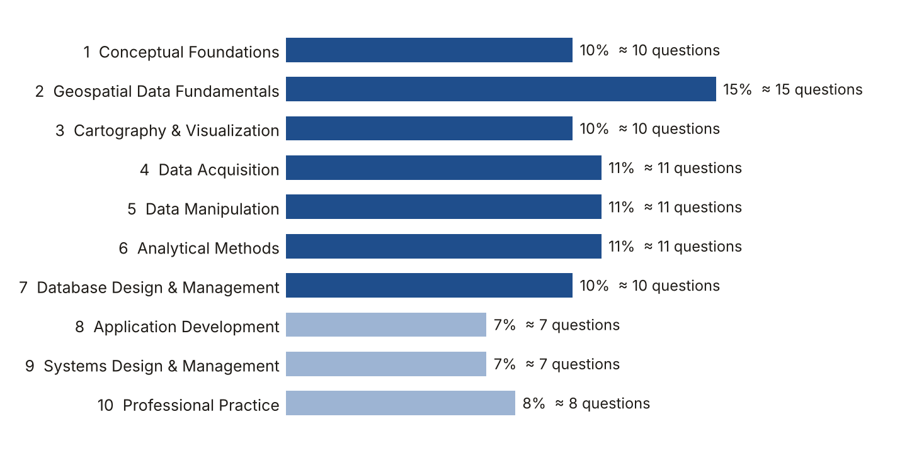
Areas 1–7 give 78% of the marks. Learn them first.
How to remember it all
- Read one area a day. Start with the big idea, then the bullets.
- Say the memory tricks out loud. Saying beats re-reading.
- Cover the answers and do the Test yourself questions. Retrieval is what makes facts stick.
- Come back to the same area after 1 day, 3 days and 7 days (spaced repetition).
- Read the Night before page every day of the last week.
Your coverage checklist

These are all 45 skills (KSAs) on the official 2019 blueprint. Every one is covered in this guide. Tick a box when you can explain the skill without looking.
KSA | Skill | Where | Progress
101 | Datums, coordinate systems & projections | Area 1 | ☐ Read ☐ Know it
102 | Discrete features vs continuous phenomena | Area 1 | ☐ Read ☐ Know it
103 | Earth geometry & its approximations | Area 1 | ☐ Read ☐ Know it
104 | Basic geomatics & its relationship to GIS | Area 1 | ☐ Read ☐ Know it
201 | Spatial data models & planar geometries | Area 2 | ☐ Read ☐ Know it
202 | Spatial data relationships | Area 2 | ☐ Read ☐ Know it
203 | Data quality | Area 2 | ☐ Read ☐ Know it
204 | Data resolution | Area 2 | ☐ Read ☐ Know it
205 | Data validation & uncertainty | Area 2 | ☐ Read ☐ Know it
206 | Metadata | Area 2 | ☐ Read ☐ Know it
207 | Temporal data | Area 2 | ☐ Read ☐ Know it
208 | Standards: ISO, FGDC, OGC | Area 2 | ☐ Read ☐ Know it
301 | Graphic representation techniques | Area 3 | ☐ Read ☐ Know it
302 | Map design principles & map elements | Area 3 | ☐ Read ☐ Know it
303 | Surface interpretation & representation | Area 3 | ☐ Read ☐ Know it
304 | 2D and 3D visualization | Area 3 | ☐ Read ☐ Know it
401 | Digitising & manual collection/conversion | Area 4 | ☐ Read ☐ Know it
402 | Field data collection | Area 4 | ☐ Read ☐ Know it
403 | Automated collection & conversion | Area 4 | ☐ Read ☐ Know it
404 | Remotely sensed data | Area 4 | ☐ Read ☐ Know it
405 | Crowdsourced & open-source data and services | Area 4 | ☐ Read ☐ Know it
501 | Georeferencing, format conversion & transformation | Area 5 | ☐ Read ☐ Know it
502 | Generalisation operations & methods | Area 5 | ☐ Read ☐ Know it
503 | Spatial file types, uses & limits | Area 5 | ☐ Read ☐ Know it
504 | Data integration | Area 5 | ☐ Read ☐ Know it
601 | Data selection queries & views | Area 6 | ☐ Read ☐ Know it
602 | Data classification | Area 6 | ☐ Read ☐ Know it
603 | Analytical operations & methods | Area 6 | ☐ Read ☐ Know it
604 | Map algebra | Area 6 | ☐ Read ☐ Know it
605 | Descriptive & spatial statistics | Area 6 | ☐ Read ☐ Know it
701 | Relationships among database objects | Area 7 | ☐ Read ☐ Know it
702 | Database design | Area 7 | ☐ Read ☐ Know it
703 | Database management & administration | Area 7 | ☐ Read ☐ Know it
704 | Data security | Area 7 | ☐ Read ☐ Know it
801 | Data transfer protocols | Area 8 | ☐ Read ☐ Know it
802 | Coding, scripting & modelling basics | Area 8 | ☐ Read ☐ Know it
803 | Basic application development methods | Area 8 | ☐ Read ☐ Know it
901 | Systems architecture & design (software, platforms, environments) | Area 9 | ☐ Read ☐ Know it
902 | Systems & application security | Area 9 | ☐ Read ☐ Know it
903 | Trends in geospatial technology | Area 9 | ☐ Read ☐ Know it
1001 | Work-related policies & procedures | Area 10 | ☐ Read ☐ Know it
1002 | Ethics in technical GIS work | Area 10 | ☐ Read ☐ Know it
1003 | Managing, documenting & communicating GIS work | Area 10 | ☐ Read ☐ Know it
1004 | How GIS is used in other professions | Area 10 | ☐ Read ☐ Know it
1005 | GIS professional organisations & certification | Area 10 | ☐ Read ☐ Know it

AREA 1  Conceptual Foundations | 10%  ≈ 10 of 100 questions

The big idea
Every coordinate depends on a model of the Earth (the datum) and on how that round Earth is drawn flat (the projection).
Learn it: 10 concepts, one by one
Each concept: definition → example → picture → exam question
1.1 Datum
DEFINITION The reference model of the Earth plus its fixed starting point. All coordinates are measured from it.
EXAMPLE The same fire hydrant has different coordinates in NAD27 and in NAD83: the point did not move, the datum changed.
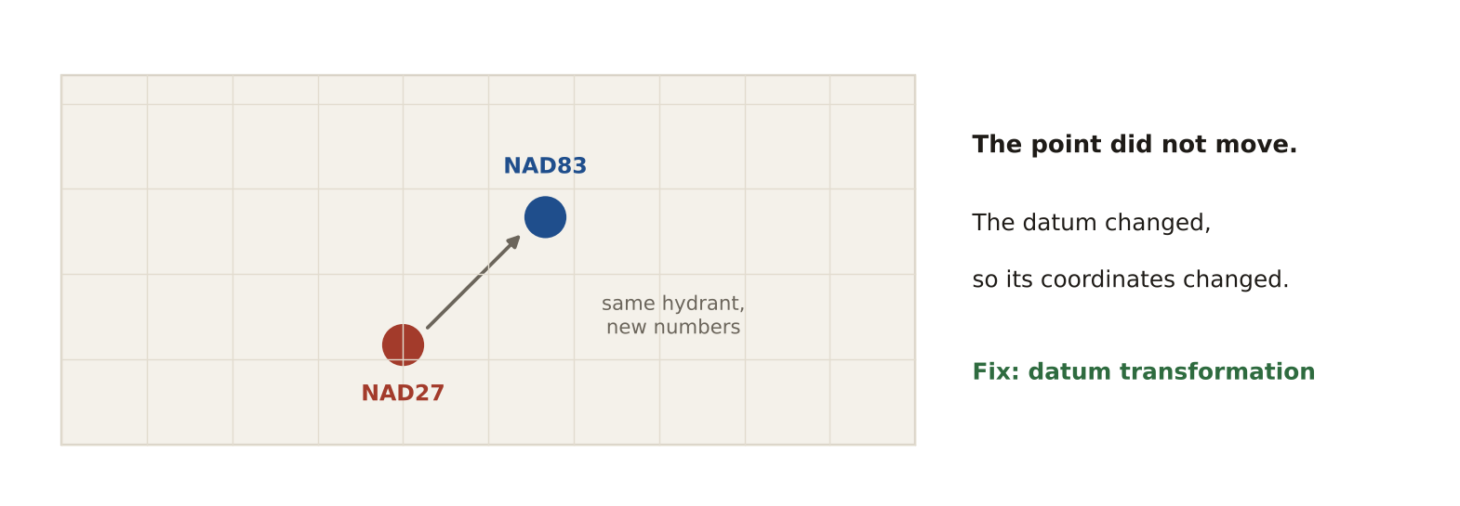
LIKELY EXAM QUESTION
A layer in NAD27 does not line up with a layer in NAD83. What is needed?
A) A new symbol
B) A datum (geographic) transformation
C) Generalisation
D) A topology rule
✔ Answer: B · Different datums give different coordinates for the same place.

1.2 Earth models
DEFINITION Three ways to describe the Earth's shape: sphere (simple), ellipsoid (smooth, flattened at the poles), geoid (lumpy gravity surface ≈ mean sea level).
EXAMPLE WGS 84 and GRS 80 are ellipsoids. EGM2008 is a geoid model.
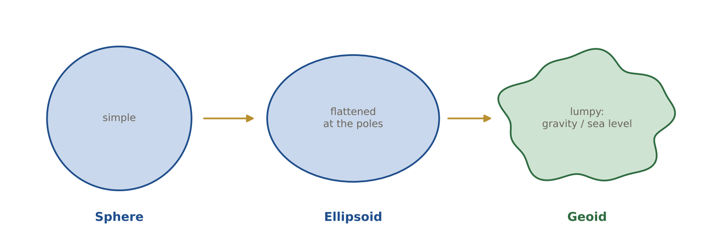
LIKELY EXAM QUESTION
Which surface best matches mean sea level?
A) Sphere
B) Ellipsoid
C) Geoid
D) Datum plane
✔ Answer: C · The geoid follows gravity, so it matches mean sea level.

1.3 Heights: h, H and N
DEFINITION h = height above the ellipsoid (from GPS). H = height above the geoid (map / sea-level height). N = geoid height. H = h − N.
EXAMPLE GPS shows h = 60 m. The geoid here is N = −30 m. Map height H = 60 − (−30) = 90 m.
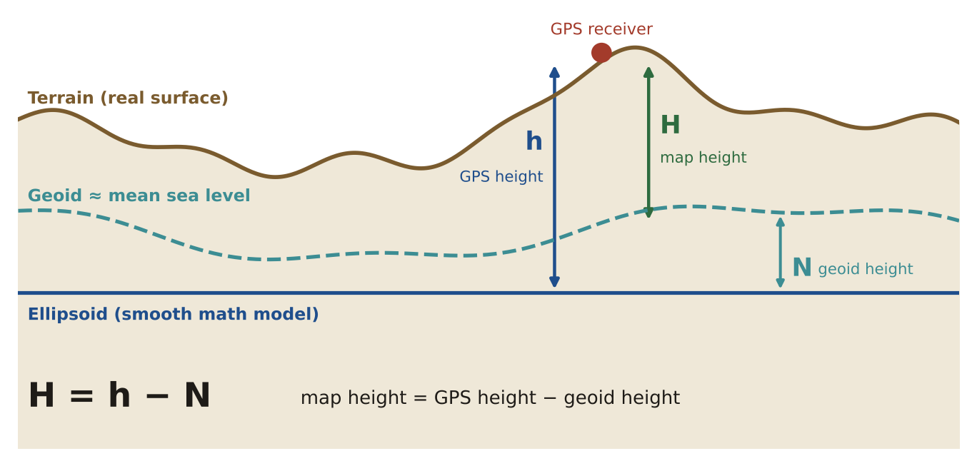
LIKELY EXAM QUESTION
GPS gives h = 120 m and N = 20 m. What is the orthometric height H?
A) 140 m
B) 100 m
C) 120 m
D) 6 m
✔ Answer: B · H = h − N = 120 − 20 = 100 m.

1.4 Geographic vs projected coordinates
DEFINITION Geographic = latitude and longitude in degrees on a round Earth. Projected = flat x and y in metres or feet.
EXAMPLE Dubai airport: 25.25° N, 55.36° E (geographic) or about 336,000 E, 2,793,000 N in UTM zone 40 (metres).
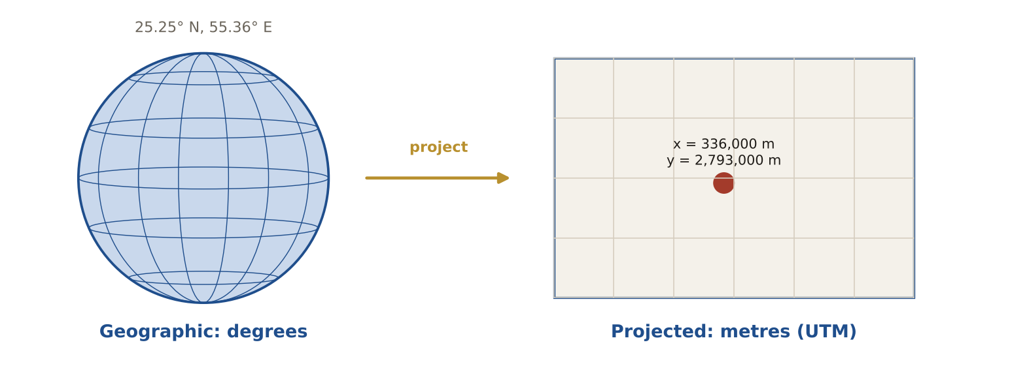
LIKELY EXAM QUESTION
You need to measure distances in metres. Which system should the data use?
A) Geographic WGS 84
B) A projected system such as UTM
C) Any datum
D) Decimal degrees
✔ Answer: B · Projected systems use linear units, so distance and area are easy to measure.

1.5 Map projections
DEFINITION A method of flattening the round Earth onto a cylinder, a cone or a plane.
EXAMPLE Mercator uses a cylinder. Lambert Conformal Conic uses a cone. Polar stereographic uses a plane.
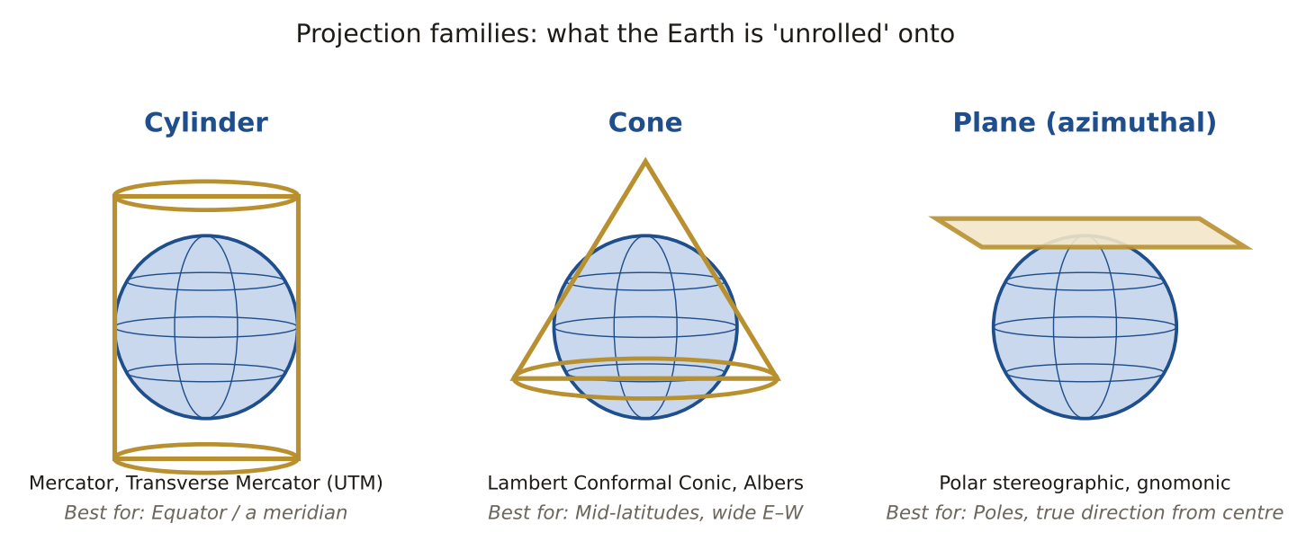
LIKELY EXAM QUESTION
Which projection surface suits a mid-latitude country wide from east to west?
A) Cylinder
B) Cone
C) Plane
D) Sphere
✔ Answer: B · A cone touches the globe along a mid-latitude line, where distortion is lowest.

1.6 What a projection keeps
DEFINITION No flat map keeps everything. Conformal keeps shape, equal-area keeps area, equidistant keeps distance, azimuthal keeps direction.
EXAMPLE On Mercator (conformal) Greenland looks as big as Africa, but Africa is 14 times bigger.
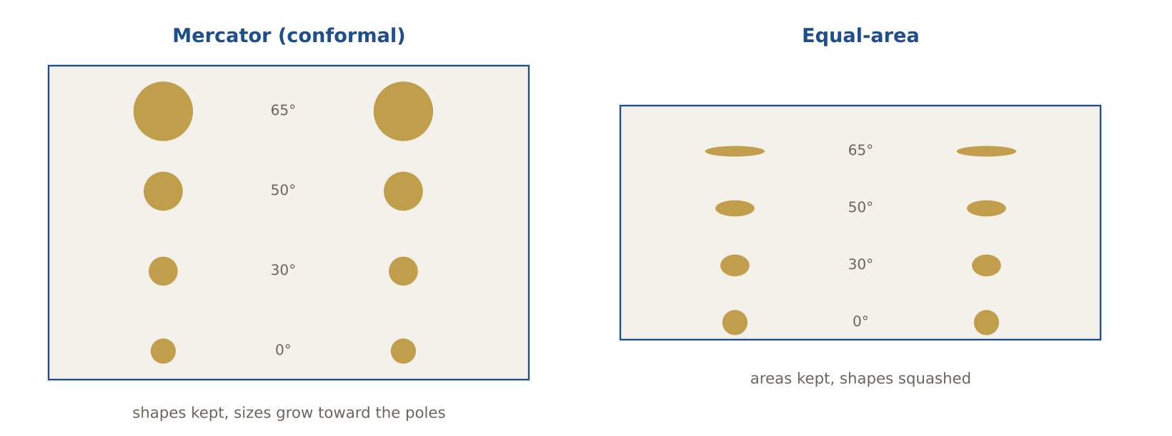
LIKELY EXAM QUESTION
You must compare the forest area of two countries. Which projection type?
A) Conformal
B) Equal-area
C) Gnomonic
D) Mercator
✔ Answer: B · Area comparisons need an equal-area projection, such as Albers.

1.7 UTM
DEFINITION Universal Transverse Mercator: 60 zones, each 6° wide, in metres. False easting 500,000 m. Scale 0.9996 on the central meridian.
EXAMPLE Abu Dhabi (54.4° E) is in zone 40: floor((54.4 + 180) ÷ 6) + 1 = 40.
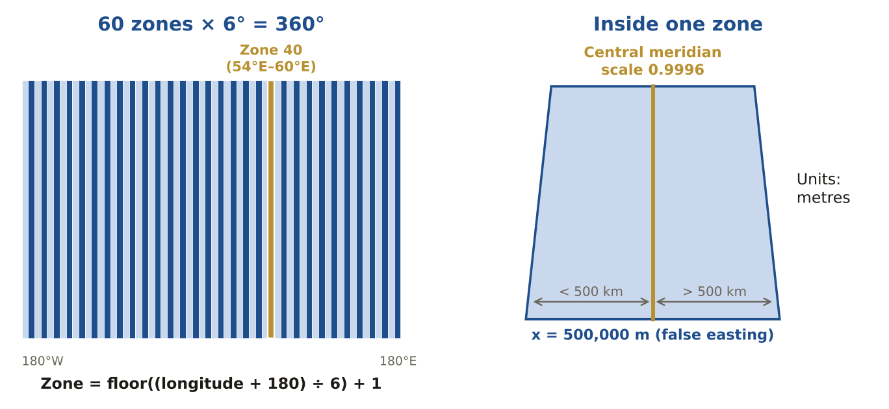
LIKELY EXAM QUESTION
What is the false easting of every UTM zone?
A) 0 m
B) 100,000 m
C) 500,000 m
D) 1,000,000 m
✔ Answer: C · 500,000 m keeps all x values positive inside a zone.

1.8 State Plane (SPCS)
DEFINITION US coordinate zones made for states. Zones long north–south use Transverse Mercator; zones long east–west use Lambert Conformal Conic.
EXAMPLE Tennessee is long east–west, so its zone uses Lambert Conformal Conic.
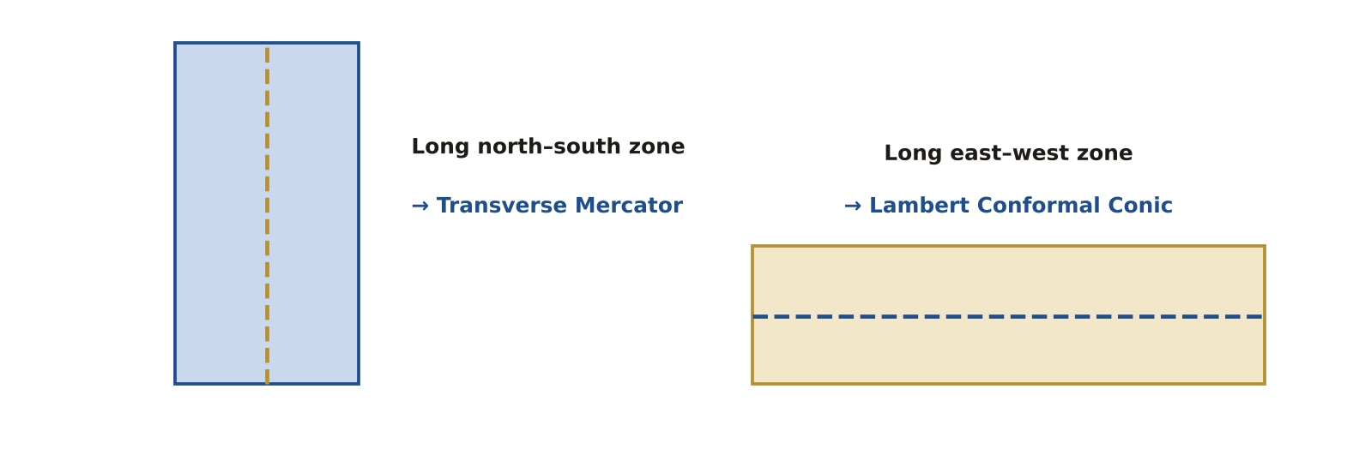
LIKELY EXAM QUESTION
A State Plane zone that is long north–south uses which projection?
A) Lambert Conformal Conic
B) Transverse Mercator
C) Albers
D) Mercator
✔ Answer: B · Transverse Mercator has low distortion along a north–south strip.

1.9 Discrete vs continuous
DEFINITION Discrete features have clear edges (parcels, roads). Continuous phenomena have a value everywhere (elevation, temperature).
EXAMPLE A parcel map is discrete (vector). A rainfall surface is continuous (raster).
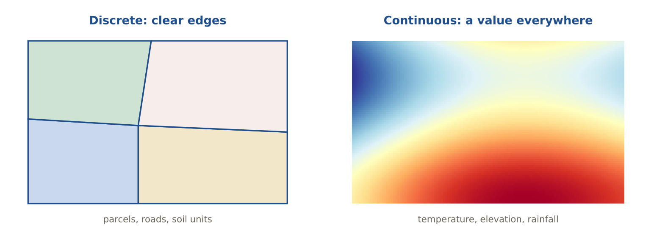
LIKELY EXAM QUESTION
Which is a continuous phenomenon?
A) Building footprints
B) Soil sample sites
C) Air pressure
D) Fire stations
✔ Answer: C · Air pressure has a value at every location.

1.10 Geomatics
DEFINITION The family of sciences that collect, manage and present location data: surveying, GNSS, photogrammetry, remote sensing, cartography and GIS.
EXAMPLE A city project uses surveying for control points, drones for imagery and GIS for analysis: all are geomatics.
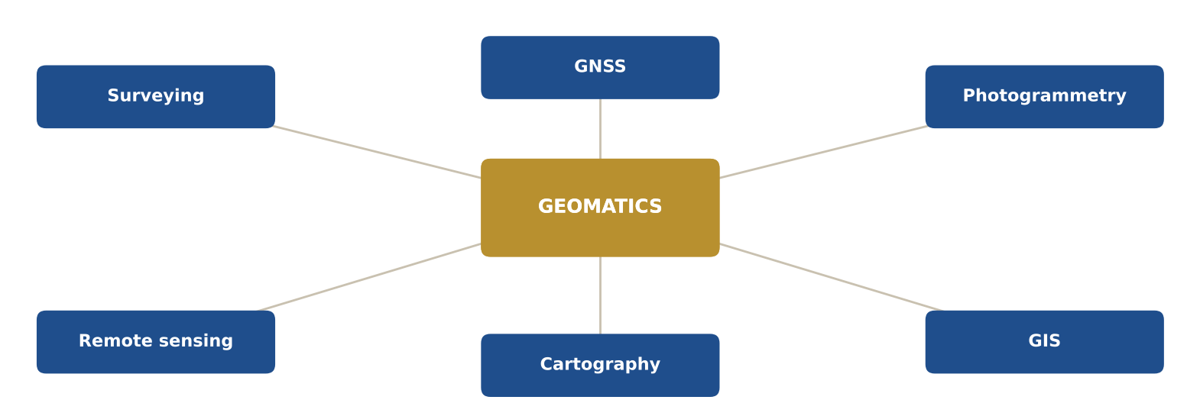
LIKELY EXAM QUESTION
Which of these is NOT part of geomatics?
A) Photogrammetry
B) Remote sensing
C) Surveying
D) Payroll accounting
✔ Answer: D · Geomatics is about measuring and mapping the Earth.

Memory tricks
★ S-E-G Earth models from simple to real: Sphere → Ellipsoid → Geoid.
★ "Map height = GPS minus Geoid" H = h − N.
★ C-E-E-A = Shape, Area, Distance, Direction Conformal keeps Shape · Equal-area keeps Area · Equidistant keeps Distance · Azimuthal keeps Direction.
★ UTM: 60 × 6 = 360 60 zones of 6° cover the whole globe. Zone = floor((longitude + 180) ÷ 6) + 1.
If the question says… think…
If the question says… | …think
"UTM", "State Plane" | units are metres / feet
"lat/long", "WGS 84 geographic" | units are decimal degrees
"NAD27 to NAD83" | coordinates change → datum transformation
"compare area", "density" | equal-area projection (Albers)
"navigation", "angles", "shapes" | conformal projection (Mercator, LCC)
"Greenland looks huge" | Mercator stretches scale toward the poles (k = sec φ)
Don't fall for it
- UTM is in METRES, not degrees. Lat/long is in DEGREES, not metres.
- Changing the datum changes coordinate values — never assume NAD27 = NAD83 = WGS84.
- Elevation and temperature are continuous; soils and zoning are discrete.

Test yourself (cover the answers)
1. Dubai is at longitude 55.3° E. Which UTM zone?
Answer: Zone 40: floor((55.3 + 180) ÷ 6) + 1 = 40.
2. GPS reads h = 60 m and the geoid height N = −30 m. What is the height above sea level?
Answer: H = h − N = 60 − (−30) = 90 m.
3. Convert 35°15′ to decimal degrees.
Answer: 35 + 15/60 = 35.25°.

AREA 2  Geospatial Data Fundamentals | 15%  ≈ 15 of 100 questions

The big idea
Good GIS data has the right model (vector, raster or TIN), clean topology, known quality and metadata that tells others what it is.
Learn it: 12 concepts, one by one
Each concept: definition → example → picture → exam question
2.1 Data models: vector, raster, TIN
DEFINITION Vector stores points, lines and polygons. Raster stores a grid of cells. A TIN stores triangles between irregular points.
EXAMPLE Wells = points, roads = lines, lakes = polygons. A satellite image = raster. A terrain model from survey points = TIN.
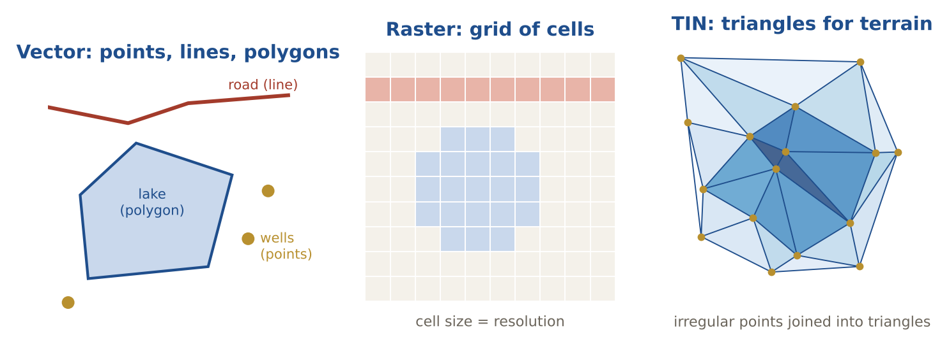
LIKELY EXAM QUESTION
Which model uses irregularly spaced points joined by triangles?
A) Raster
B) TIN
C) Shapefile
D) Grid
✔ Answer: B · TIN = Triangulated Irregular Network.

2.2 Topology
DEFINITION Rules about how shapes share space: no overlaps, no gaps, lines must connect.
EXAMPLE Two parcels must not overlap, and a road line must touch the next road line with no small gap (dangle).
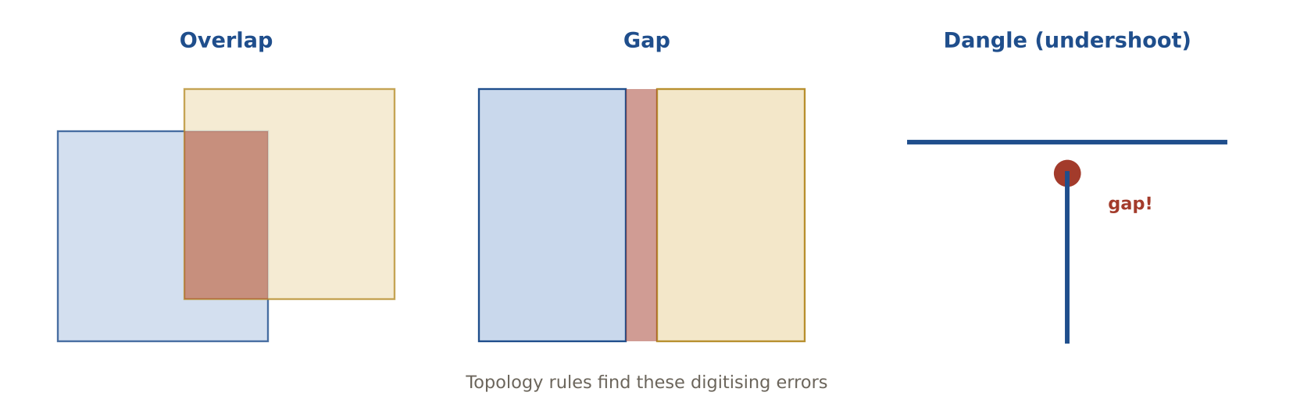
LIKELY EXAM QUESTION
A line ends just before it reaches another line. This error is called a:
A) Sliver
B) Dangle (undershoot)
C) Overlap
D) Gap
✔ Answer: B · A dangling end that stops short is an undershoot.

2.3 Spatial relationships
DEFINITION How two features relate in space: contains, within, touches (adjacent), intersects, disjoint.
EXAMPLE A school point is WITHIN a district. Two districts that share a border TOUCH each other.
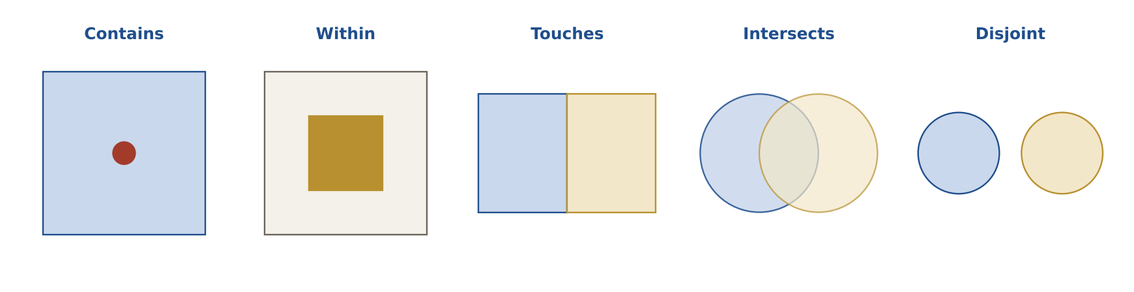
LIKELY EXAM QUESTION
Two polygons share only a boundary. What is the relationship?
A) Contains
B) Touches (adjacent)
C) Disjoint
D) Within
✔ Answer: B · Sharing an edge without overlapping = touches.

2.4 Data quality elements
DEFINITION Six ways to judge data: positional accuracy, attribute accuracy, completeness, temporal accuracy, logical consistency, lineage.
EXAMPLE A road layer missing 10% of roads has poor completeness. A wrong speed limit is an attribute accuracy problem.
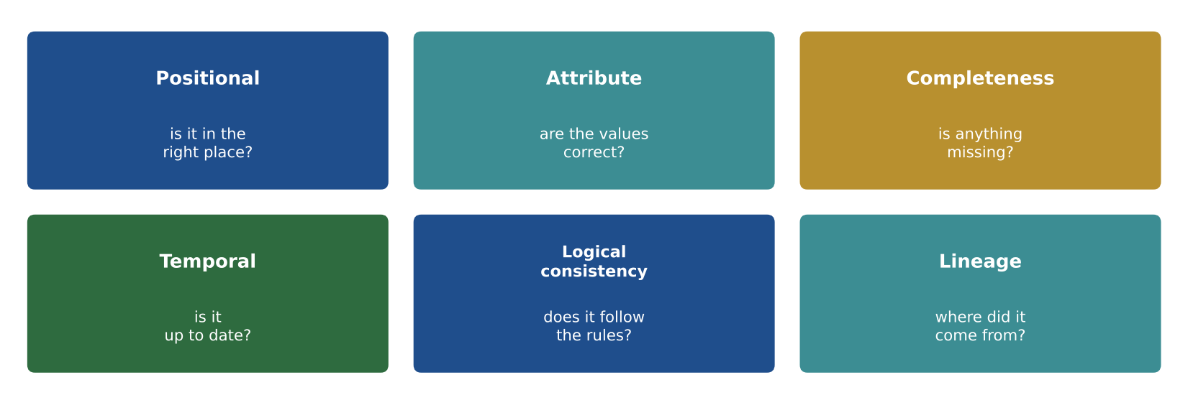
LIKELY EXAM QUESTION
Records of where data came from and how it was processed are called:
A) Completeness
B) Lineage
C) Logical consistency
D) Precision
✔ Answer: B · Lineage = the history of the data.

2.5 Accuracy vs precision
DEFINITION Accuracy = how close to the true value. Precision = how close repeated values are to each other (or how fine the detail).
EXAMPLE A GPS gives 5 readings all within 10 cm of each other, but 3 m from the true point: precise, not accurate.
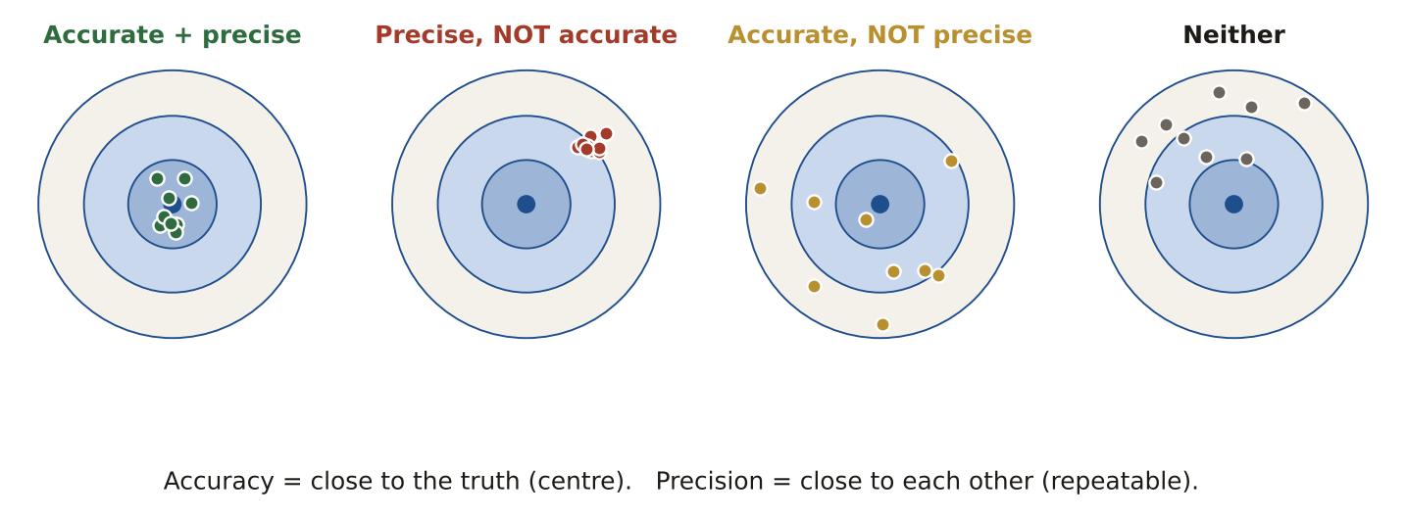
LIKELY EXAM QUESTION
Repeated measurements are tightly grouped but far from the truth. They are:
A) Accurate and precise
B) Precise but not accurate
C) Accurate but not precise
D) Neither
✔ Answer: B · Tight group = precise; far from truth = not accurate.

2.6 QA vs QC
DEFINITION QA (quality assurance) prevents errors before and during work. QC (quality control) checks the finished product.
EXAMPLE QA: writing a field manual and training staff. QC: running topology checks on the delivered data.
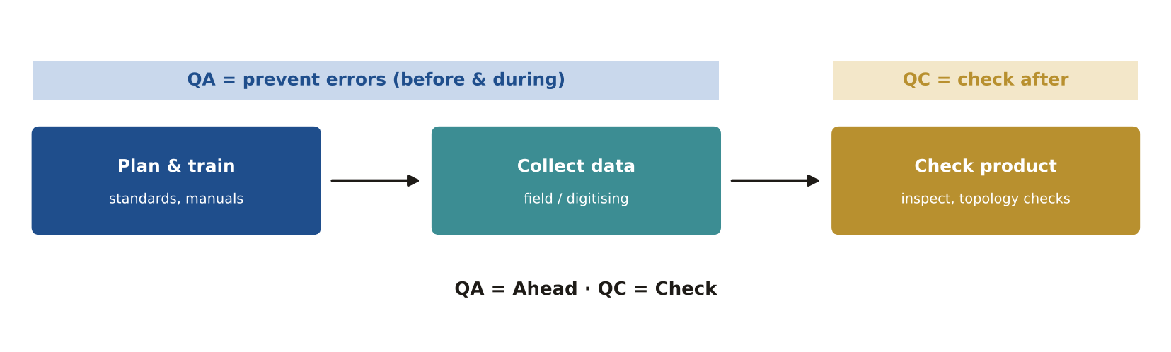
LIKELY EXAM QUESTION
Training data collectors before fieldwork is:
A) QC
B) QA
C) Lineage
D) Validation
✔ Answer: B · Prevention before the work = QA.

2.7 RMSE and NSSDA
DEFINITION RMSE = √(sum of squared errors ÷ number of points). NSSDA reports accuracy at 95% confidence (horizontal = 1.7308 × RMSEr).
EXAMPLE Errors 3, 4, 0 and 5 m → (9 + 16 + 0 + 25) ÷ 4 = 12.5 → √12.5 ≈ 3.54 m.
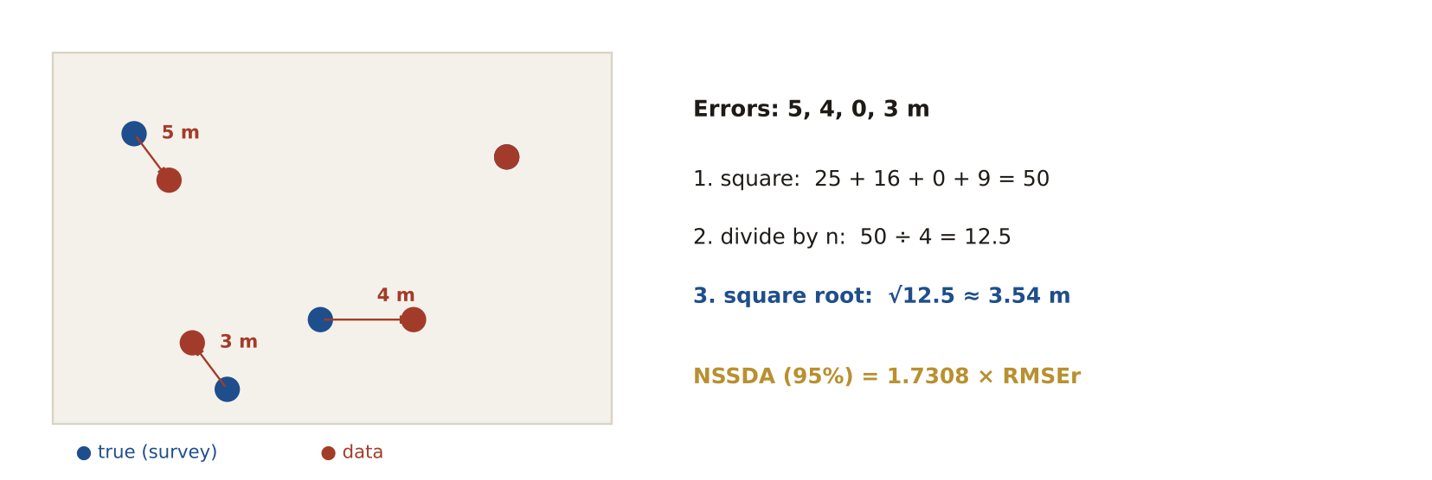
LIKELY EXAM QUESTION
Errors at 4 check points are 2, 2, 2 and 2 m. What is the RMSE?
A) 1 m
B) 2 m
C) 4 m
D) 8 m
✔ Answer: B · √((4 + 4 + 4 + 4) ÷ 4) = √4 = 2 m.

2.8 Scale and resolution
DEFINITION Large scale (1:1,200) = small area with lots of detail. Small scale (1:1,000,000) = big area with little detail. Raster resolution = cell size.
EXAMPLE A city parcel map is 1:1,200 (large scale). A world map is 1:50,000,000 (small scale).
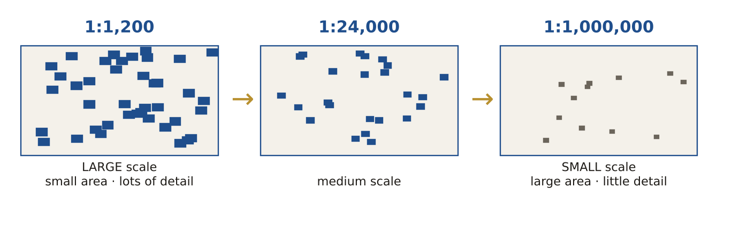
LIKELY EXAM QUESTION
Which map shows the MOST detail?
A) 1:1,000,000
B) 1:250,000
C) 1:24,000
D) 1:1,200
✔ Answer: D · The largest fraction (1/1,200) = largest scale = most detail.

2.9 Metadata
DEFINITION Data about data: who made it, what it contains, when, where, how, its coordinate system and its accuracy.
EXAMPLE A road layer's metadata says: made by the city in 2024, UTM zone 40, accuracy 1 m, contact: GIS office.
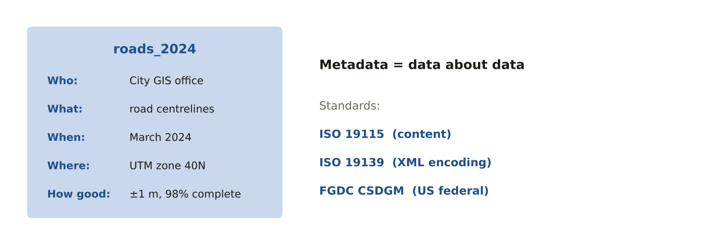
LIKELY EXAM QUESTION
Which is the ISO standard for geographic metadata content?
A) ISO 9001
B) ISO 19115
C) ISO 14001
D) ISO 27001
✔ Answer: B · ISO 19115 defines metadata content (ISO 19139 is its XML).

2.10 Temporal data
DEFINITION Data that records WHEN something was true, so you can study change over time.
EXAMPLE Land-cover maps of 2000, 2010 and 2020 show how a city grew into farmland.
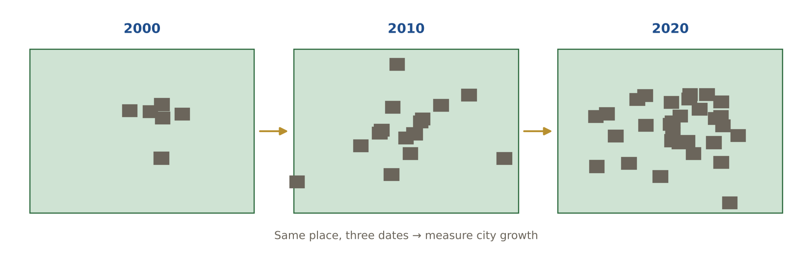
LIKELY EXAM QUESTION
Storing hourly air-quality readings needs which field type for the time?
A) Text
B) Date / time
C) Short integer
D) Blob
✔ Answer: B · A date/time field allows time queries and animation.

2.11 Standards bodies
DEFINITION ISO/TC 211 makes the ISO 19100 geographic standards. OGC makes open web and data standards. FGDC sets US federal standards.
EXAMPLE WMS and GeoPackage come from OGC. ISO 19115 comes from ISO/TC 211. CSDGM metadata comes from FGDC.
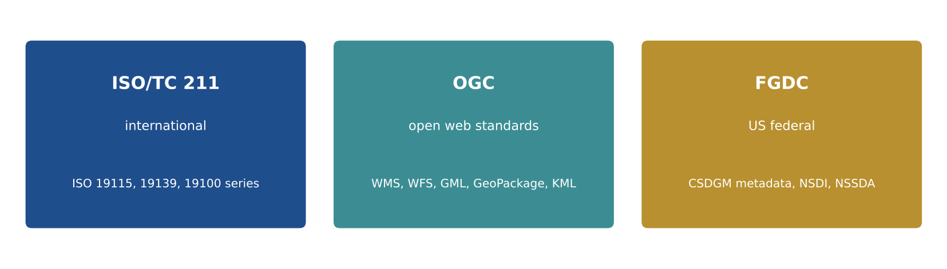
LIKELY EXAM QUESTION
WMS, WFS and GML are standards from:
A) FGDC
B) OGC
C) ISO/TC 211
D) IEEE
✔ Answer: B · The Open Geospatial Consortium publishes the web service standards.

2.12 Validation and uncertainty
DEFINITION Validation = checking data against rules and better data. Uncertainty = how sure we are about a value or boundary.
EXAMPLE A soil boundary drawn as a sharp line is really a gradual change: its position is uncertain by tens of metres.
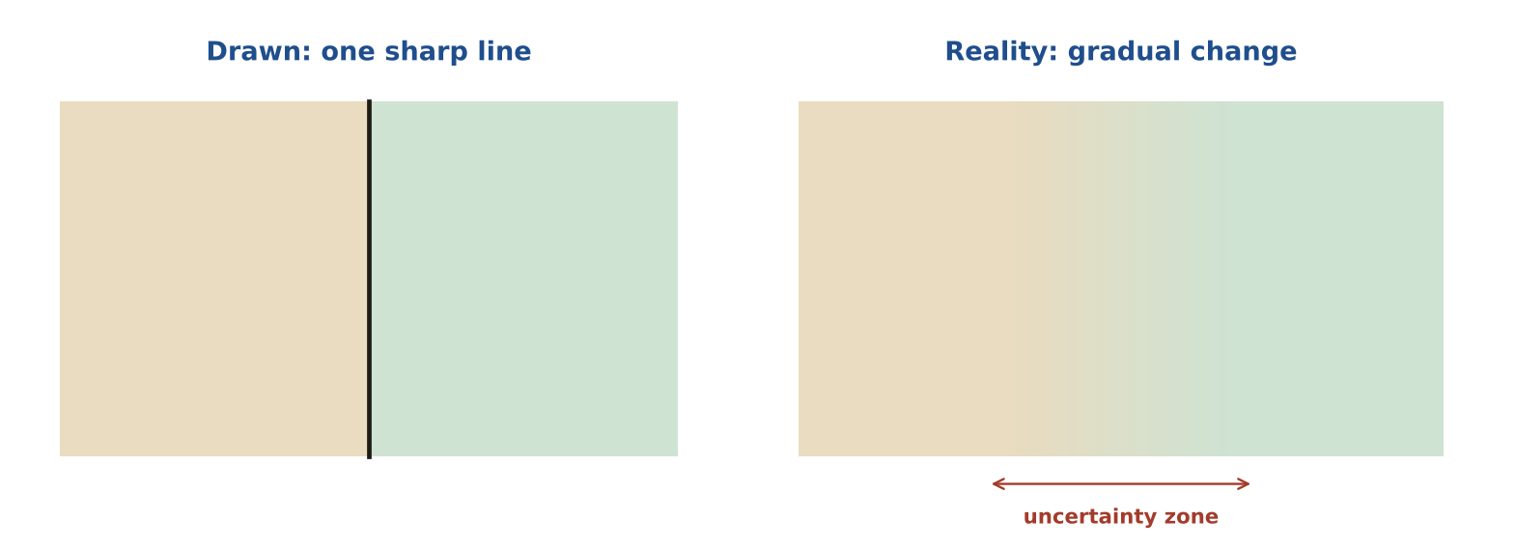
LIKELY EXAM QUESTION
Combining a 1 m accurate layer with a 30 m accurate layer gives a result that is about:
A) 1 m accurate
B) 30 m accurate or worse
C) 15 m accurate
D) Perfectly accurate
✔ Answer: B · The result is never better than the weakest input.

Memory tricks
★ "Please Always Check The Logical Lineage" Positional · Attribute · Completeness · Temporal · Logical consistency · Lineage (the six quality elements).
★ QA = Ahead, QC = Check QA happens before (process). QC happens after (product).
★ Large scale = Large detail 1:1,200 is a large fraction, so it shows a small area in large detail.
★ TIN = Triangles In Nature Irregular points joined by triangles, used for terrain.
If the question says… think…
If the question says… | …think
"standards, procedures, training" | QA
"inspect / check finished data" | QC
"irregularly spaced points" | TIN
"lines that don't meet" | dangle (topology error)
"thin unwanted polygons" | slivers
"95% confidence" | NSSDA
Don't fall for it
- A TIN uses IRREGULARLY spaced points; a raster uses a regular grid.
- Writing standards and procedures = QA. Running checks on finished data = QC.
- Smaller scale → larger error. A 1:100,000 source cannot support parcel-level accuracy.
- If 95% of errors are below 20 m, then 5% of errors are above 20 m.

Test yourself (cover the answers)
1. Errors at 4 check points are 3, 4, 0 and 5 m. What is the RMSE?
Answer: √((9 + 16 + 0 + 25) ÷ 4) = √12.5 ≈ 3.54 m.
2. Writing a field-collection manual is QA or QC?
Answer: QA: it prevents errors before they happen.
3. Which is larger scale: 1:24,000 or 1:250,000?
Answer: 1:24,000 (bigger fraction, more detail).

AREA 3  Cartography & Visualization | 10%  ≈ 10 of 100 questions

The big idea
A good map matches the right symbol to the right kind of data and leads the eye to what matters most.
Learn it: 9 concepts, one by one
Each concept: definition → example → picture → exam question
3.1 Levels of measurement (NOIR)
DEFINITION Nominal = names. Ordinal = ranks. Interval = numbers without a true zero. Ratio = numbers with a true zero.
EXAMPLE Land-use type = nominal. Road class (minor, major) = ordinal. Temperature °C = interval. Population = ratio.
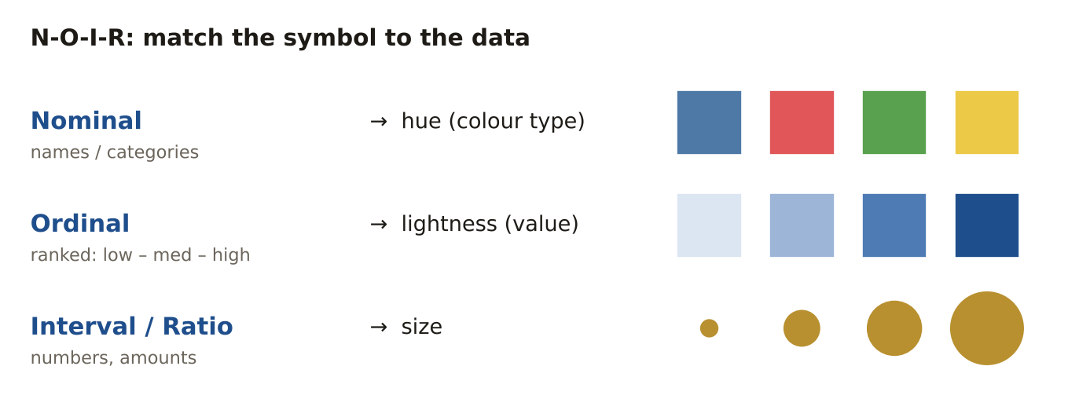
LIKELY EXAM QUESTION
Population density is which level of measurement?
A) Nominal
B) Ordinal
C) Interval
D) Ratio
✔ Answer: D · It has a true zero (no people).

3.2 Choropleth vs proportional symbols
DEFINITION Choropleth = areas shaded by a RATE. Proportional symbols = circles sized by a TOTAL count.
EXAMPLE Unemployment % by district → choropleth. Number of unemployed people by district → proportional circles.
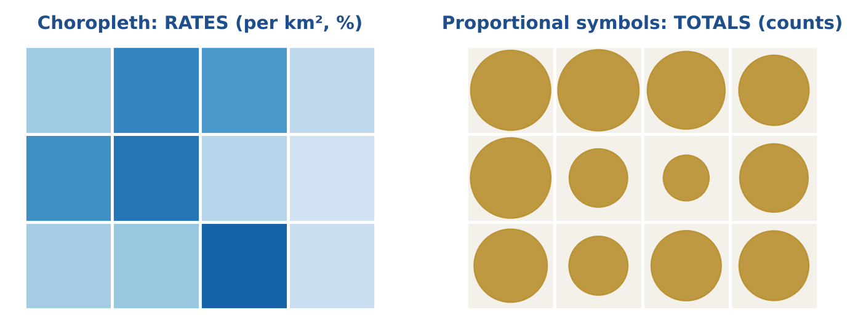
LIKELY EXAM QUESTION
Which data is right for a choropleth map?
A) Total crimes
B) Crimes per 1,000 people
C) Number of schools
D) Total population
✔ Answer: B · Choropleths need normalised data (rates).

3.3 Colour schemes
DEFINITION Sequential = light to dark for low to high. Diverging = two colours from a middle value. Qualitative = different hues for categories.
EXAMPLE Income → sequential blues. Change since 2010 (−/+) → red–white–blue. Land use → qualitative hues.
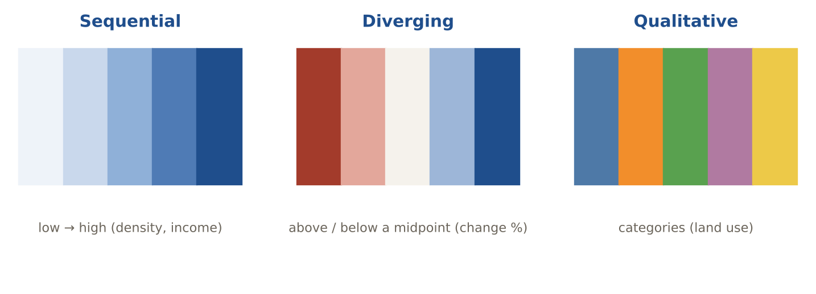
LIKELY EXAM QUESTION
Population change from −20% to +20% is best shown with:
A) Sequential
B) Diverging
C) Qualitative
D) One colour
✔ Answer: B · Diverging schemes show values below and above a midpoint.

3.4 Map elements
DEFINITION Parts a reader needs: title, legend, scale, north arrow, data source, date, projection, inset map.
EXAMPLE A flood map without a legend cannot be read; without a date, nobody knows if it is current.
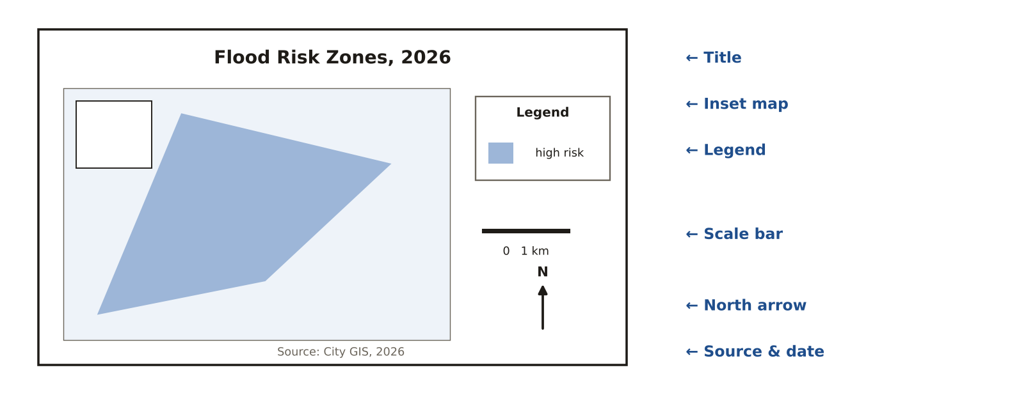
LIKELY EXAM QUESTION
Which element explains what the map symbols mean?
A) Neatline
B) Legend
C) Inset
D) Scale bar
✔ Answer: B · The legend is the key to the symbols.

3.5 Visual hierarchy
DEFINITION The most important information should stand out most; background information should be quiet.
EXAMPLE On an evacuation map the routes are bold red; streets and buildings are light grey.
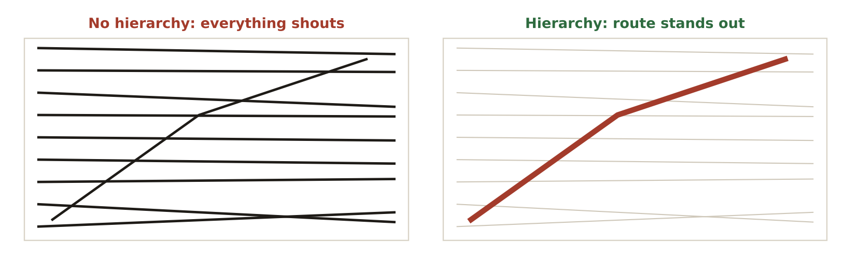
LIKELY EXAM QUESTION
Making the main subject stand out from the background is called:
A) Figure–ground
B) Generalisation
C) Classification
D) Projection
✔ Answer: A · Figure–ground makes the subject (figure) separate from the background.

3.6 Typography
DEFINITION Label rules that readers expect: water in blue italics, bigger places in bigger text, spread letters across areas.
EXAMPLE "Nile" in blue italics along the river; "CAIRO" in bold capitals; "S A H A R A" spaced across the desert.
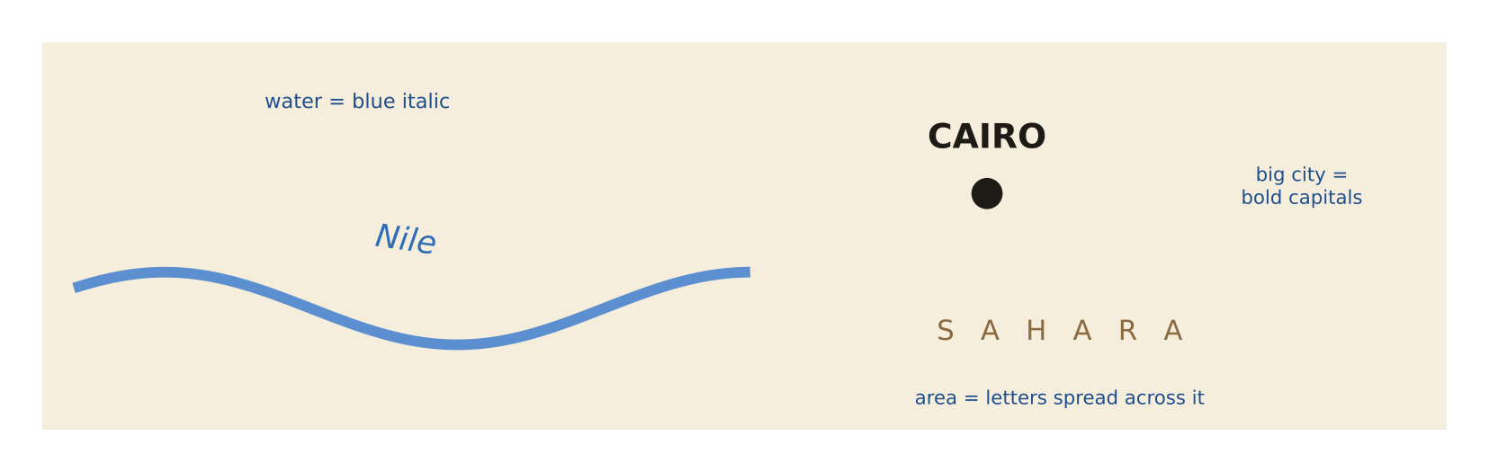
LIKELY EXAM QUESTION
By convention, labels for rivers and lakes are:
A) Red bold
B) Blue italic
C) Black capitals
D) Green underline
✔ Answer: B · Hydrographic labels are blue and italic.

3.7 Surfaces: contours, hillshade, profile
DEFINITION Contours join equal heights. Hillshade shows relief with light from 315°, 45°. A profile shows height along a line.
EXAMPLE Contours packed close together on a map mean a steep slope.
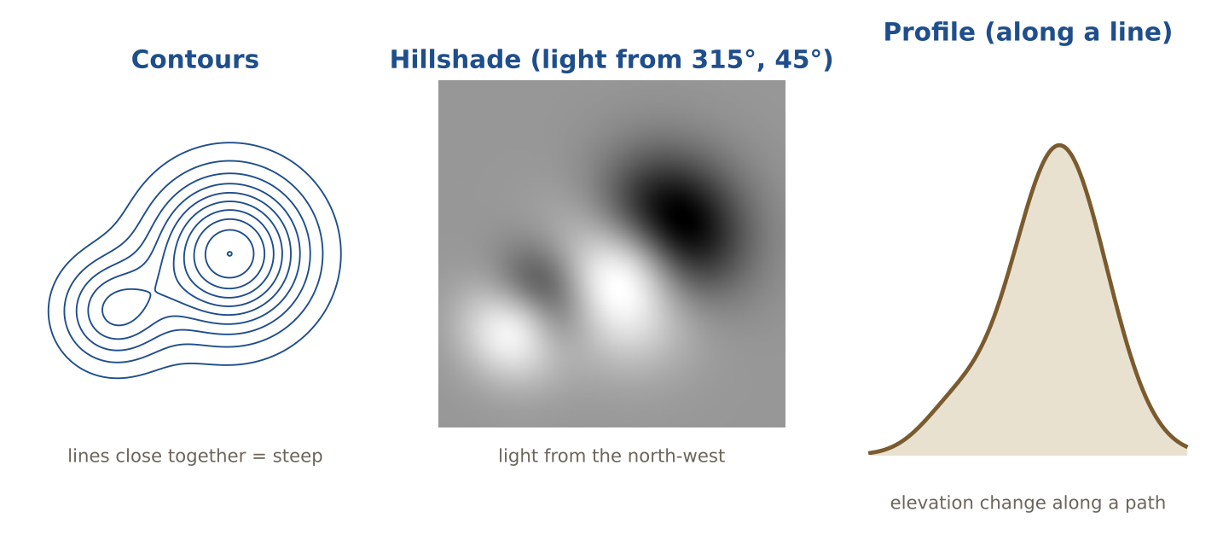
LIKELY EXAM QUESTION
Closely spaced contour lines show:
A) Flat land
B) Steep slope
C) Water
D) A valley floor only
✔ Answer: B · Height changes fast over a short distance.

3.8 Slope, aspect and viewshed
DEFINITION Slope = steepness. Aspect = the compass direction a slope faces. Viewshed = the area visible from a point.
EXAMPLE A planner uses a viewshed to see which homes can see a new wind turbine.
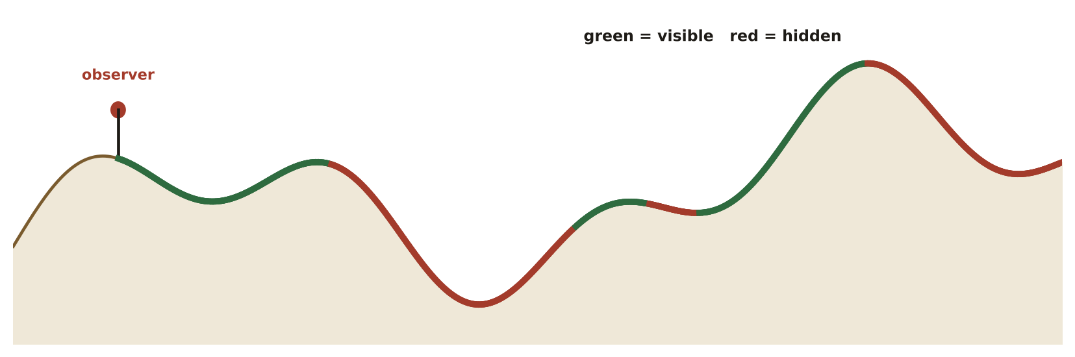
LIKELY EXAM QUESTION
Which analysis finds every place visible from a watchtower?
A) Aspect
B) Viewshed
C) Buffer
D) Hillshade
✔ Answer: B · Viewshed = line-of-sight analysis from an observer.

3.9 DEM vs DSM, 2D vs 3D
DEFINITION DEM (DTM) = bare ground. DSM = top surface including buildings and trees. 3D views add height; vertical exaggeration makes relief easier to see.
EXAMPLE A flood model uses the DEM (ground). A telecom planner uses the DSM (roofs and trees block signals).
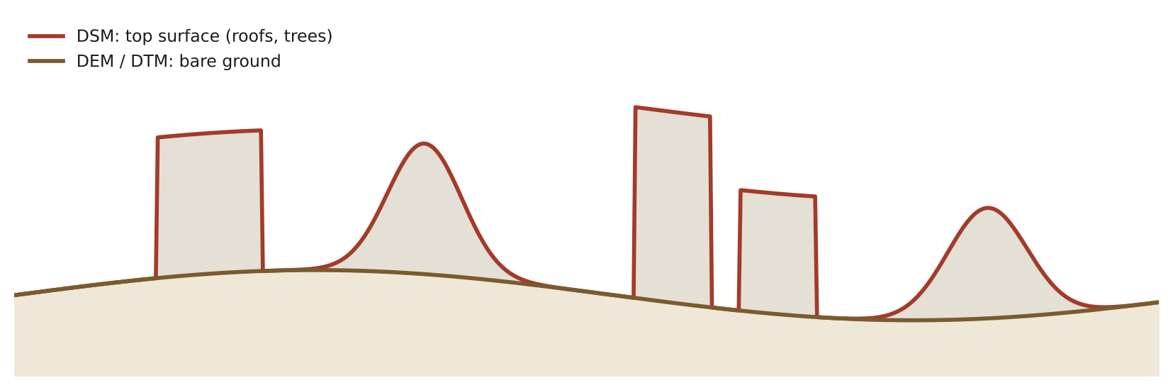
LIKELY EXAM QUESTION
Which surface includes buildings and tree tops?
A) DEM
B) DTM
C) DSM
D) Geoid
✔ Answer: C · Digital Surface Model = the top surface.

Memory tricks
★ N-O-I-R Nominal · Ordinal · Interval · Ratio, from least to most information.
★ "Choropleth = rates, not raw" Normalise first (per person, per km², %).
★ RGB = light adds, CMYK = ink subtracts Screens add light; printers subtract with ink.
★ Hillshade 315 / 45 Light from the north-west, 45° above the horizon.
If the question says… think…
If the question says… | …think
"total number of …" on a map | graduated / proportional symbols
"rate", "per capita", "density" | choropleth
"categories", "land-use types" | qualitative colours (hue)
"above and below average" | diverging colour scheme
"elevation change along a line" | profile
"what can be seen from a point" | viewshed
Don't fall for it
- Never make a choropleth of raw totals (e.g., total crimes) — normalise first.
- 'Network' is NOT a surface representation; contour, shaded relief, wireframe are.
- Use a PROFILE to see elevation change along a line, not aspect.

Test yourself (cover the answers)
1. Is temperature in °C interval or ratio data?
Answer: Interval: 0 °C is not 'no temperature'.
2. You must map total population by county. Which map type?
Answer: Proportional or graduated symbols.
3. Which is NOT a surface representation: contours, hillshade, network, wireframe?
Answer: Network.

AREA 4  Data Acquisition | 11%  ≈ 11 of 100 questions

The big idea
Data comes from digitising, surveys, GNSS, imagery, lidar and the crowd, and each source has its own errors and limits.
Learn it: 12 concepts, one by one
Each concept: definition → example → picture → exam question
4.1 Digitising and its errors
DEFINITION Tracing features from imagery or scanned maps. Common errors: overshoots, undershoots (dangles) and slivers. Snapping prevents them.
EXAMPLE With a 1 m snapping tolerance, a road end automatically joins the road it touches.
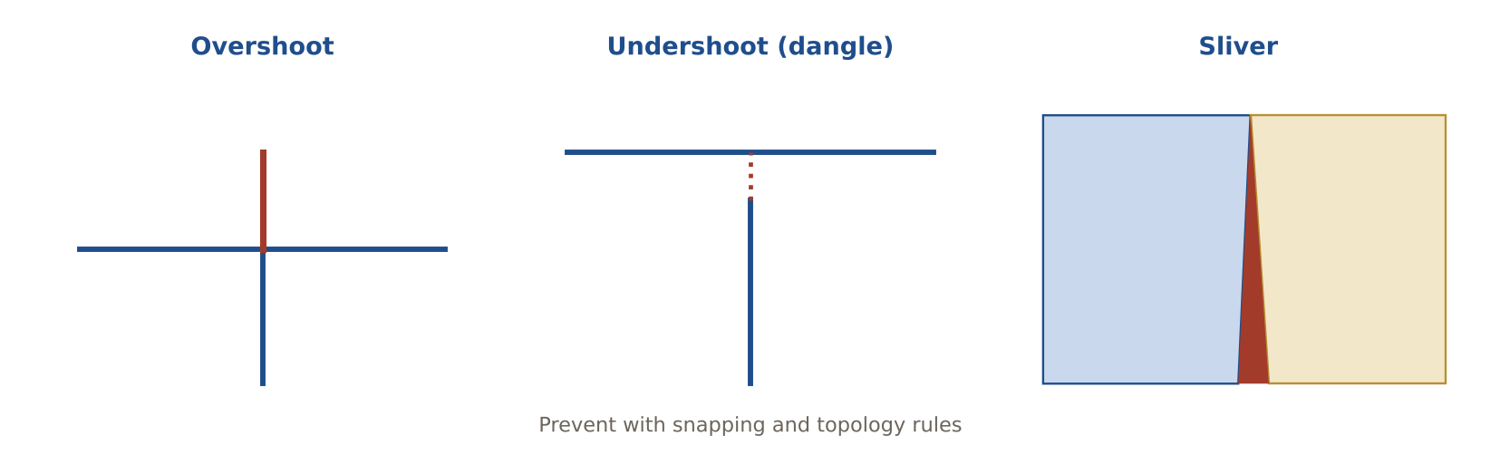
LIKELY EXAM QUESTION
A line that goes past the line it should stop at is a(n):
A) Undershoot
B) Overshoot
C) Sliver
D) Gap
✔ Answer: B · It shoots over the target line.

4.2 COGO
DEFINITION Coordinate geometry: building features from survey bearings and distances.
EXAMPLE A deed says: N 45° E, 120 m; then S 30° E, 80 m … COGO turns this into the exact parcel shape.
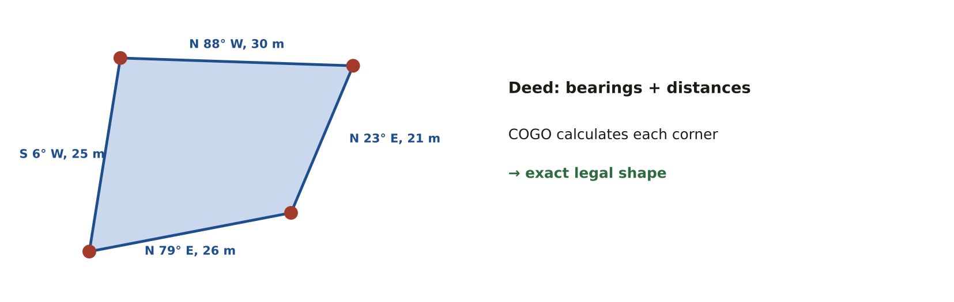
LIKELY EXAM QUESTION
A parcel must be entered from its legal description. Best method?
A) Heads-up digitising
B) COGO
C) Geocoding
D) Scanning
✔ Answer: B · Bearings and distances are entered with COGO.

4.3 Geocoding
DEFINITION Turning an address into a point on the map using reference streets with address ranges.
EXAMPLE On a street segment numbered 100–198, address 150 is placed about halfway along.
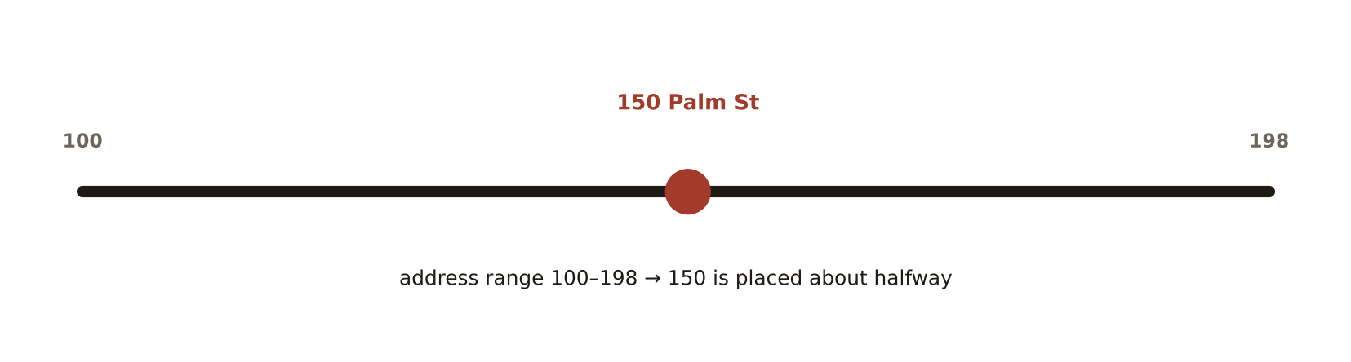
LIKELY EXAM QUESTION
Which factor most affects geocoding match rate?
A) Map colours
B) Quality of the reference street data
C) Screen size
D) Projection
✔ Answer: B · Bad or old reference data gives unmatched or wrong points.

4.4 GNSS basics
DEFINITION Satellites (GPS, GLONASS, Galileo, BeiDou) give positions. You need 4 satellites for 3D. Low PDOP = good satellite geometry.
EXAMPLE In a city street, buildings block satellites and cause multipath, so accuracy drops.
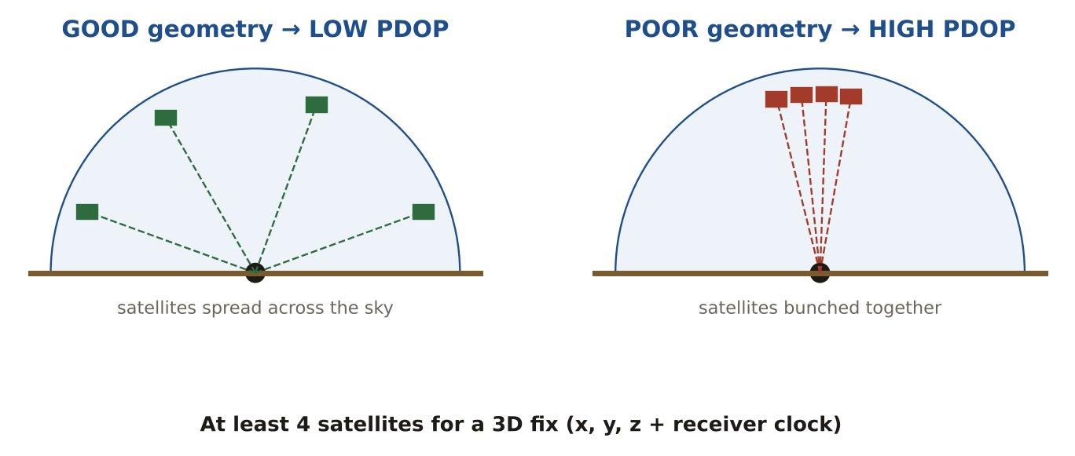
LIKELY EXAM QUESTION
Minimum number of satellites for a 3D position?
A) 2
B) 3
C) 4
D) 6
✔ Answer: C · x, y, z and the receiver clock = 4 unknowns.

4.5 Differential GNSS and RTK
DEFINITION A base station at a known point measures the error and sends corrections to the rover. RTK does this in real time for centimetre accuracy.
EXAMPLE A utility crew uses RTK to locate valve covers to 2 cm.
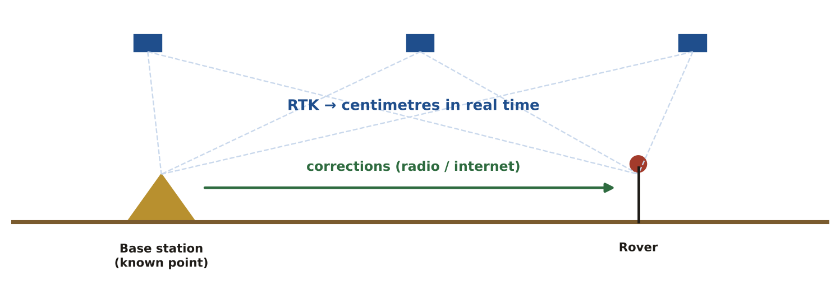
LIKELY EXAM QUESTION
Centimetre accuracy in real time with a base station is:
A) Autonomous GPS
B) WAAS
C) RTK
D) Multipath
✔ Answer: C · Real-Time Kinematic uses carrier-phase corrections.

4.6 Passive vs active sensors
DEFINITION Passive sensors record reflected sunlight. Active sensors send their own energy and record the return.
EXAMPLE Landsat and Sentinel-2 cameras are passive. Radar (SAR) and lidar are active and work at night.
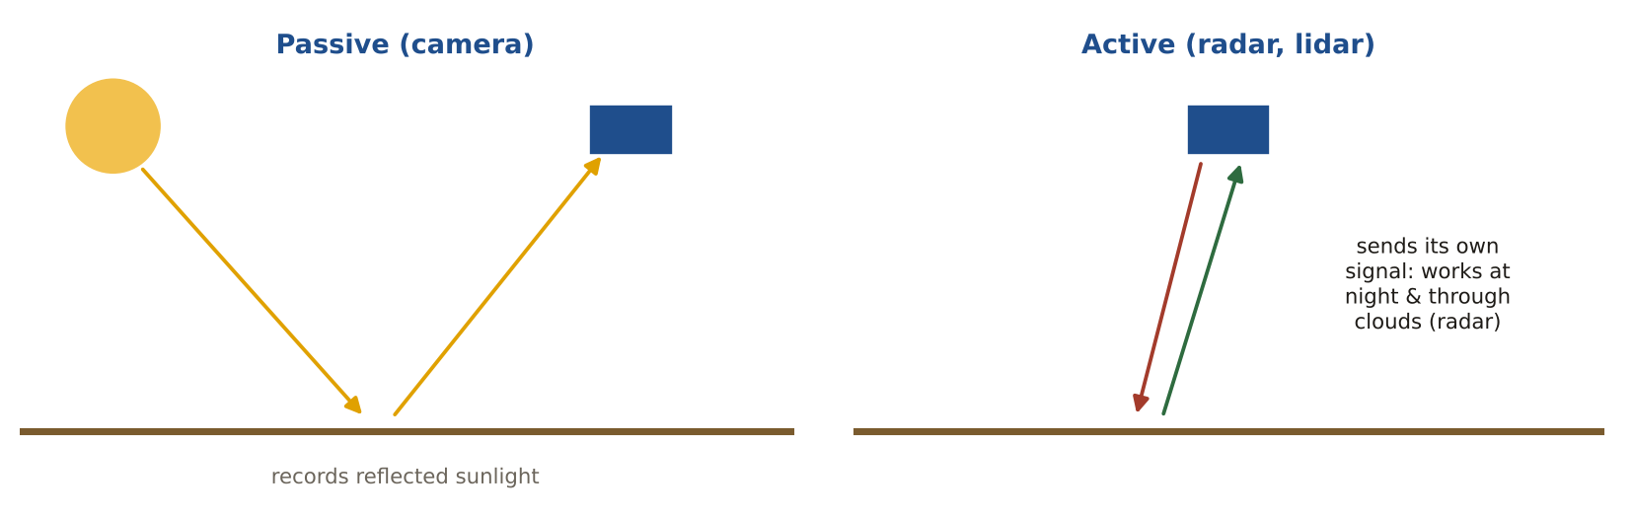
LIKELY EXAM QUESTION
Which sensor can image through clouds at night?
A) Multispectral camera
B) SAR radar
C) Panchromatic camera
D) Human eye
✔ Answer: B · Radar is active and microwaves pass through clouds.

4.7 The four resolutions
DEFINITION Spatial = cell size. Spectral = number and width of bands. Radiometric = number of grey levels (bits). Temporal = revisit time.
EXAMPLE Sentinel-2: 10 m spatial, 13 bands, 12-bit, revisit every 5 days.
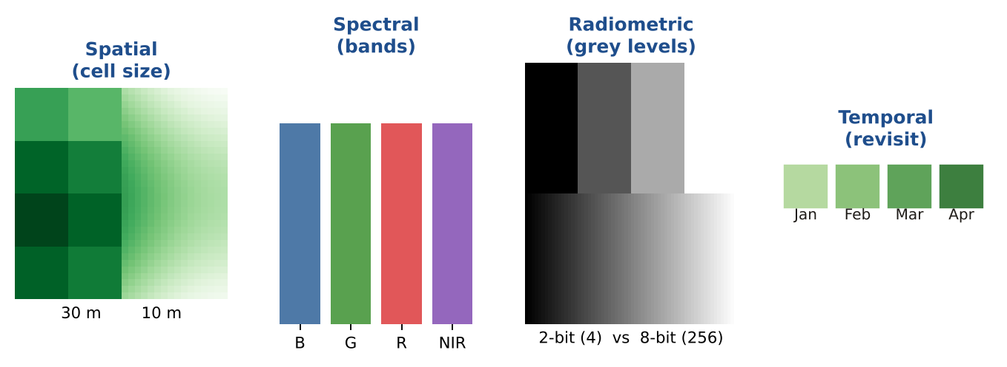
LIKELY EXAM QUESTION
An 8-bit sensor records how many brightness levels?
A) 8
B) 64
C) 256
D) 1,024
✔ Answer: C · 2⁸ = 256 levels (radiometric resolution).

4.8 NDVI
DEFINITION A vegetation index: NDVI = (NIR − Red) ÷ (NIR + Red). Values near +1 mean healthy plants.
EXAMPLE NIR = 0.5 and Red = 0.1 → (0.4) ÷ (0.6) ≈ 0.67: healthy vegetation.
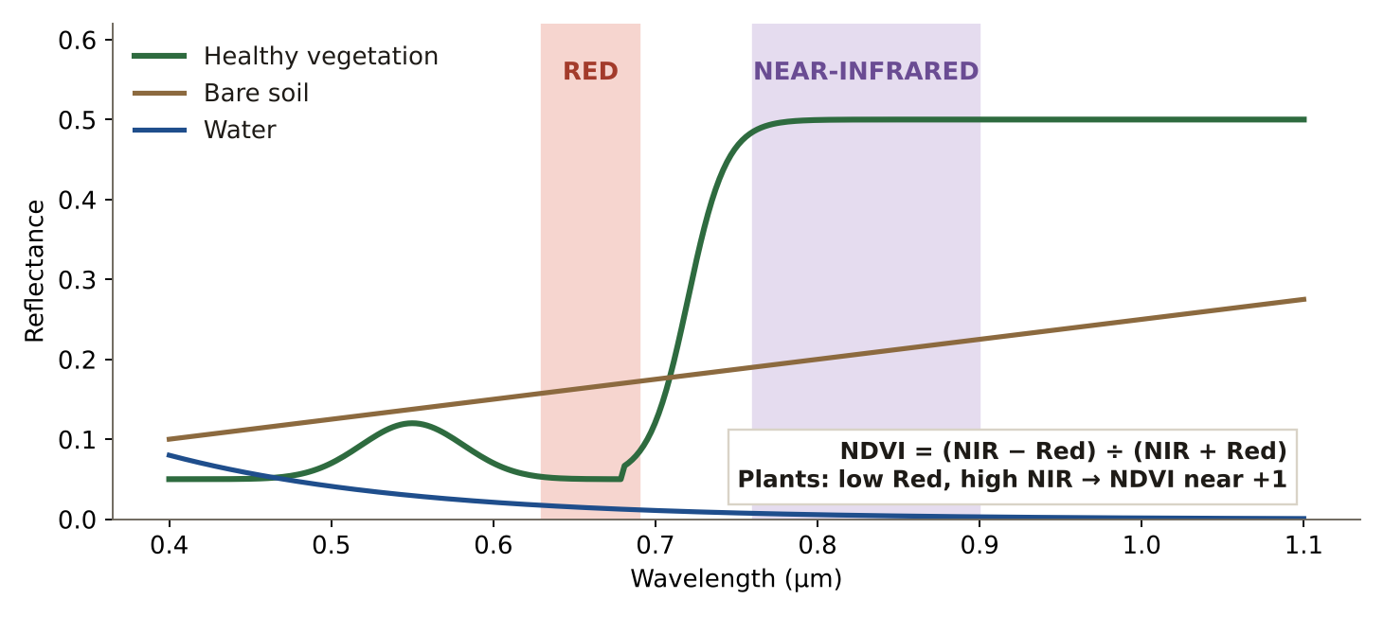
LIKELY EXAM QUESTION
Which two bands are used in NDVI?
A) Blue and green
B) Red and near-infrared
C) Thermal and red
D) Green and SWIR
✔ Answer: B · Plants absorb red and reflect near-infrared.

4.9 Orthophoto, oblique photo and drones
DEFINITION An orthophoto is corrected for tilt and terrain, so it has one scale you can measure on. Oblique photos show building sides. Drones (UAS) collect both cheaply.
EXAMPLE A drone survey of a site produces an orthomosaic and a 3D model in one day.
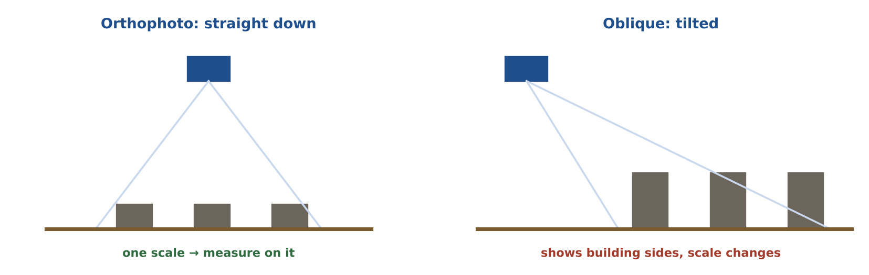
LIKELY EXAM QUESTION
Which image can be used to measure distances directly?
A) Oblique photo
B) Orthophoto
C) Raw aerial frame
D) Street photo
✔ Answer: B · Orthorectification removes tilt and relief displacement.

4.10 Lidar
DEFINITION A laser scanner that measures millions of points. First returns hit treetops and roofs; last returns often reach the ground.
EXAMPLE Last-return ground points make a bare-earth DEM even under a forest.
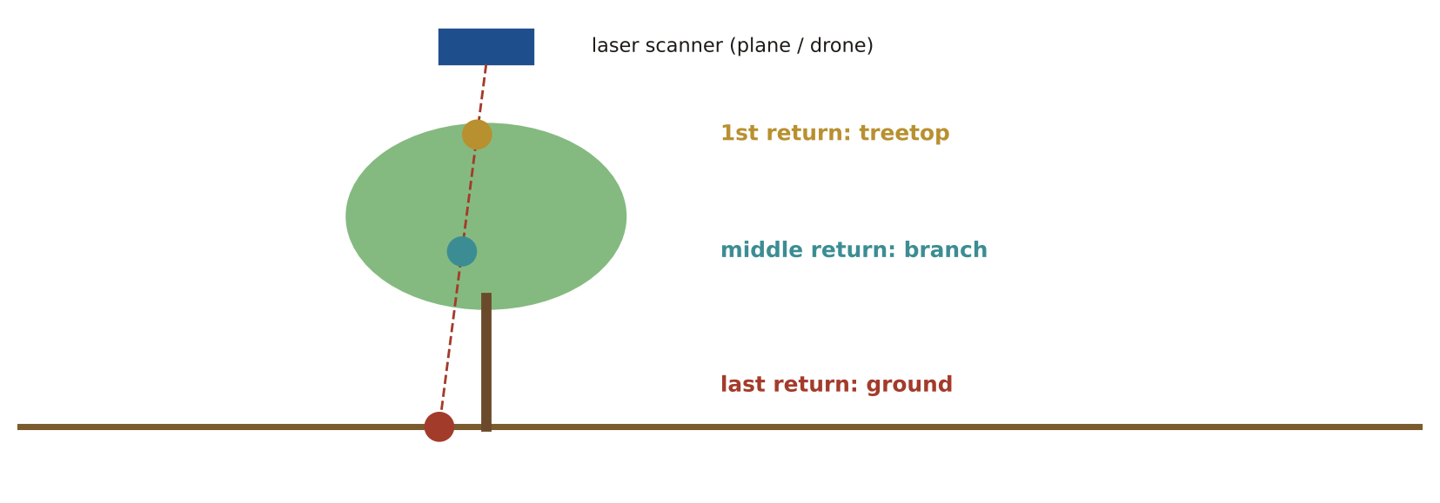
LIKELY EXAM QUESTION
Which lidar return is best for a bare-earth DEM?
A) First return
B) Last (ground) return
C) Intensity
D) Any return
✔ Answer: B · Last returns pass through gaps in the canopy to the ground.

4.11 Image classification and accuracy
DEFINITION Supervised = you give training samples. Unsupervised = the computer finds clusters. Accuracy is checked with a confusion matrix.
EXAMPLE In the matrix, 115 of 130 check pixels are correct → overall accuracy 88%.
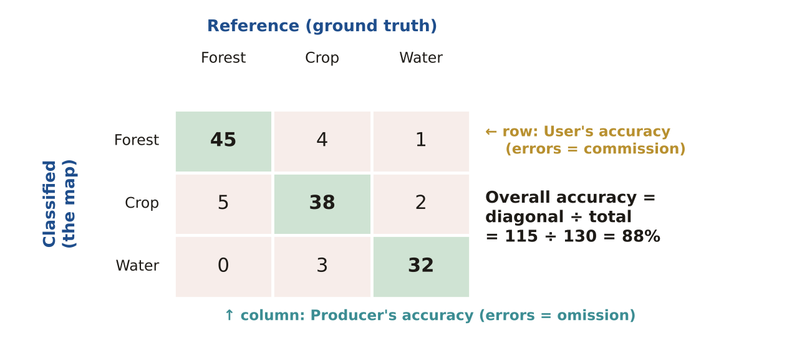
LIKELY EXAM QUESTION
Producer's accuracy is linked to which error?
A) Commission
B) Omission
C) Systematic
D) Blunder
✔ Answer: B · Producer Omits, User Commits.

4.12 Crowdsourced and open data (VGI)
DEFINITION Data collected by volunteers or shared openly. Quality varies, and licences usually require attribution.
EXAMPLE OpenStreetMap roads are free to use but you must credit the contributors (ODbL licence).
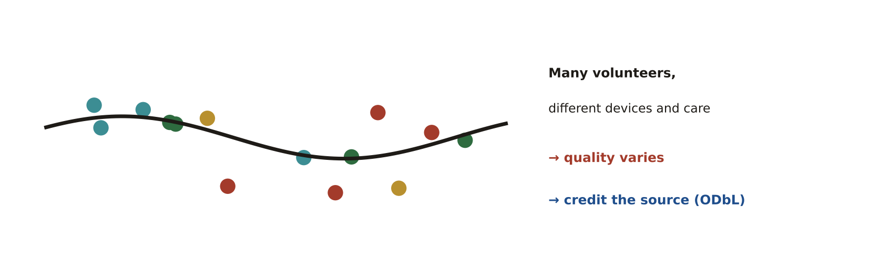
LIKELY EXAM QUESTION
The main concern when using volunteered data is:
A) It is never free
B) Variable quality
C) It has no coordinates
D) It cannot be mapped
✔ Answer: B · Different volunteers collect with different care and tools.

Memory tricks
★ "4 to fix" x, y, z and the receiver clock need 4 satellites.
★ S-S-R-T Spatial · Spectral · Radiometric · Temporal resolution.
★ "Plants love near-infrared" NDVI = (NIR − Red) ÷ (NIR + Red); healthy vegetation is close to +1.
★ "Producer Omits, User Commits" Producer's accuracy ↔ omission error; user's accuracy ↔ commission error.
If the question says… think…
If the question says… | …think
"bearings and distances", "legal description" | COGO
"PDOP" | satellite geometry (lower is better)
"centimetre accuracy", "base station" | RTK
"sends its own energy" | active sensor (lidar, radar)
"healthy vegetation" | NDVI / near-infrared
"OpenStreetMap", "VGI" | variable quality, attribution required
Don't fall for it
- 4 satellites (not 3) for a 3D GPS fix.
- Oblique images are NOT easy to measure and do NOT have uniform scale.
- The main limit of open data is usually ATTRIBUTION requirements.
- Integration with GIS software is NOT a real UAS limitation; range, permissions, storage and processing cost are.

Test yourself (cover the answers)
1. How many satellites for a 3D GNSS position?
Answer: Four.
2. NIR = 0.5 and Red = 0.1. What is NDVI?
Answer: (0.5 − 0.1) ÷ (0.5 + 0.1) ≈ 0.67.
3. Which image type has a uniform scale you can measure on?
Answer: An orthophoto.

AREA 5  Data Manipulation | 11%  ≈ 11 of 100 questions

The big idea
Before analysis, data must be put in the right place (georeferencing), the right shape (conversion, generalisation) and the right format.
Learn it: 9 concepts, one by one
Each concept: definition → example → picture → exam question
5.1 Georeferencing
DEFINITION Giving a scanned map or image real-world coordinates by linking control points to known locations.
EXAMPLE Four road intersections on an old scanned map are matched to the same intersections on today's street layer.
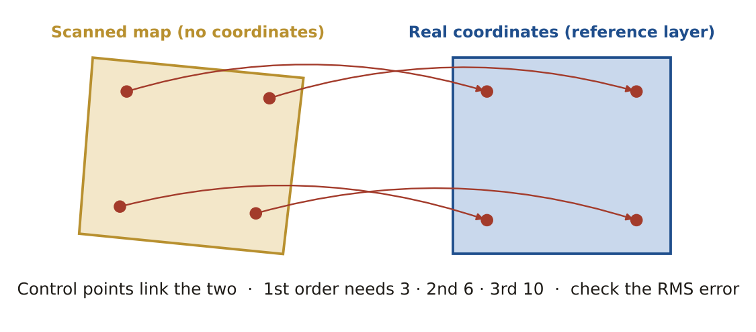
LIKELY EXAM QUESTION
After georeferencing, which value tells you how well the control points fit?
A) NDVI
B) RMS error
C) PDOP
D) Kappa
✔ Answer: B · Lower RMS error = better fit.

5.2 Transformation order
DEFINITION 1st order (affine) shifts, rotates and scales: needs 3 points. 2nd order bends: needs 6. 3rd order bends more: needs 10.
EXAMPLE A flat scanned map → 1st order. A warped old map → 2nd order.
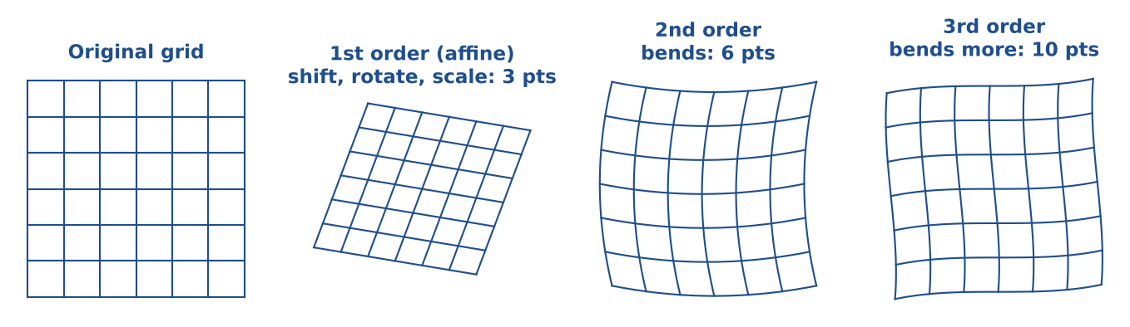
LIKELY EXAM QUESTION
Minimum control points for a 2nd-order transformation?
A) 3
B) 4
C) 6
D) 10
✔ Answer: C · 3 – 6 – 10 for 1st, 2nd and 3rd order.

5.3 Resampling
DEFINITION Choosing new cell values when a raster is moved or resized. Nearest neighbour keeps original values; bilinear and cubic average them.
EXAMPLE Land-cover classes → nearest neighbour. Elevation → bilinear.
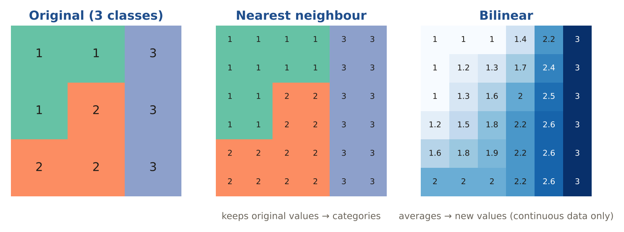
LIKELY EXAM QUESTION
Which method for a soil-type raster?
A) Bilinear
B) Cubic
C) Nearest neighbour
D) Kriging
✔ Answer: C · Categories must not be averaged into new values.

5.4 Vector ↔ raster conversion
DEFINITION Rasterising turns features into cells; the cell size is the first choice. Vectorising turns cells into lines or polygons.
EXAMPLE A lake polygon rasterised at 100 m loses its small bays; at 10 m it keeps them.
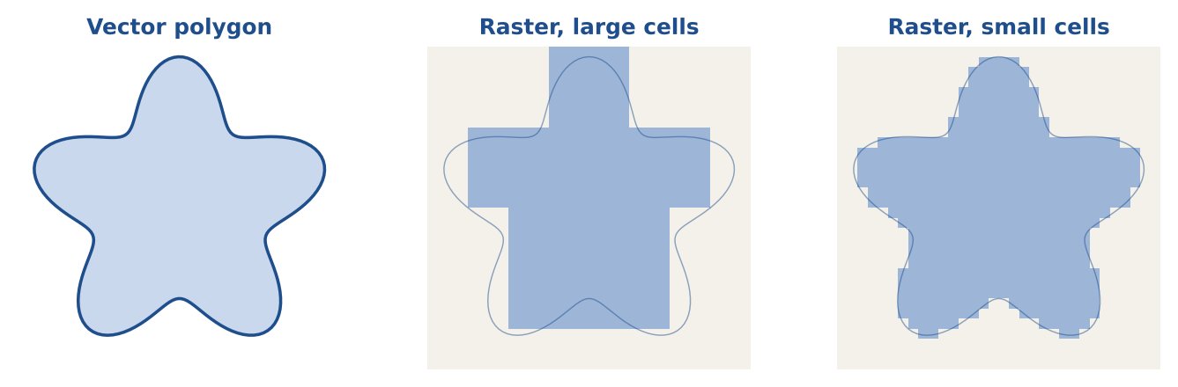
LIKELY EXAM QUESTION
The first decision when converting vector to raster is:
A) Colour
B) Cell size
C) Projection name
D) Font
✔ Answer: B · Cell size controls detail and file size.

5.5 Reprojection
DEFINITION Changing data from one coordinate system to another. If the datum changes too, a datum transformation is also needed.
EXAMPLE Converting GPS points from WGS 84 lat/long to UTM zone 40 metres before measuring distances.
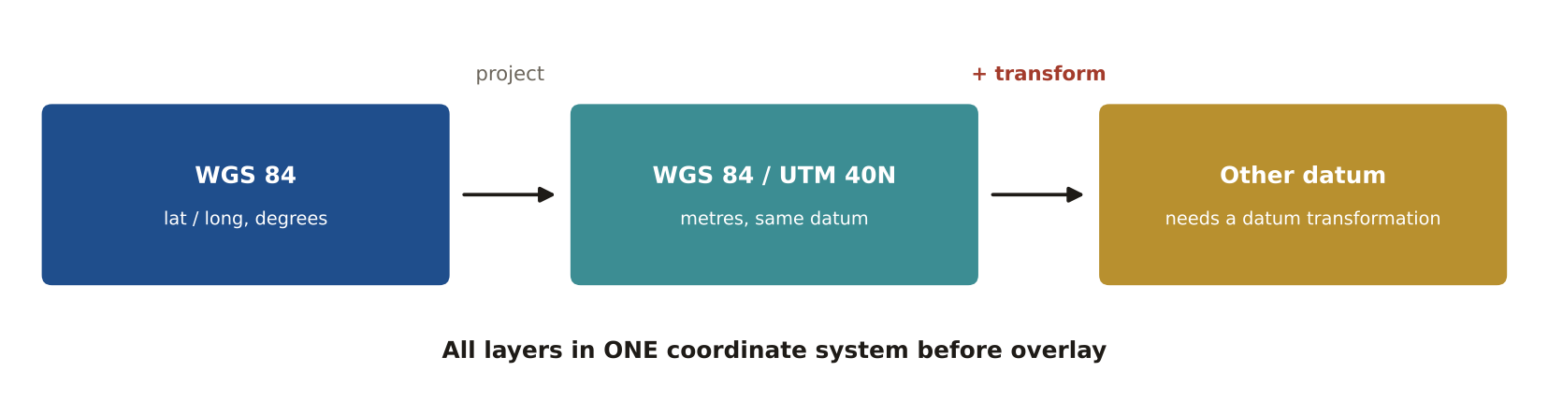
LIKELY EXAM QUESTION
Before overlaying layers from different sources you must first:
A) Generalise them
B) Put them in the same coordinate system
C) Delete metadata
D) Rasterise them
✔ Answer: B · Layers line up only in a common coordinate system.

5.6 Rubber-sheeting and edge-matching
DEFINITION Rubber-sheeting stretches data to fit better data. Edge-matching joins features across the edges of map sheets. Conflation merges the best of two datasets.
EXAMPLE Roads on sheet A stop 5 m short of the same roads on sheet B: edge-matching connects them.
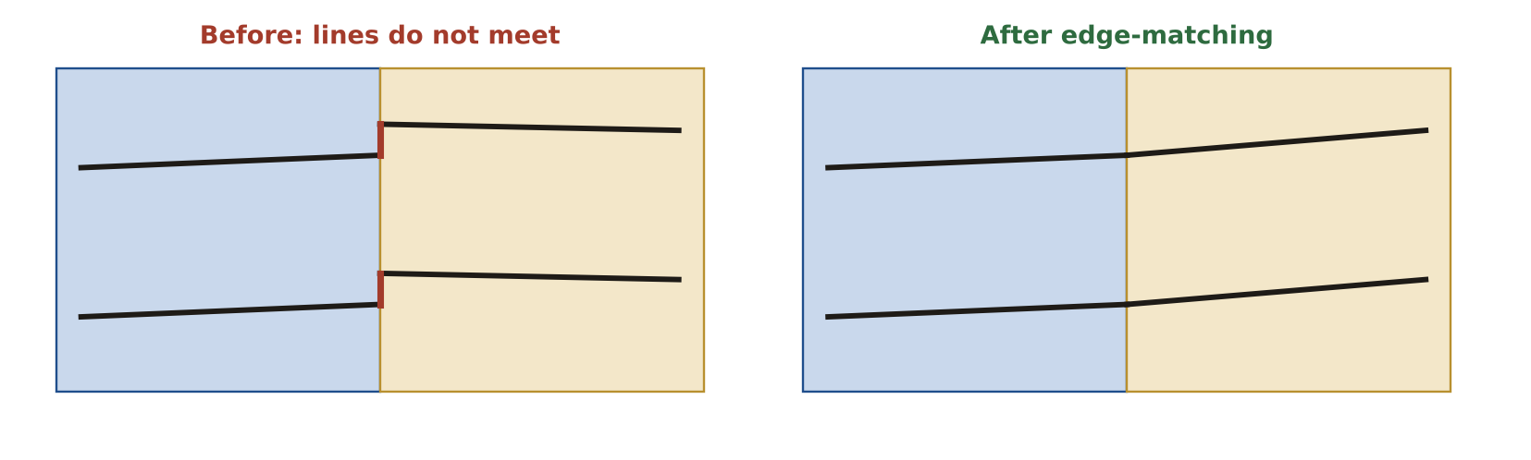
LIKELY EXAM QUESTION
Joining features across the boundary of two adjacent map sheets is:
A) Conflation
B) Edge-matching
C) Rubber-sheeting
D) Dissolve
✔ Answer: B · Edge-matching aligns features at sheet edges.

5.7 Generalisation
DEFINITION Making data simpler for a smaller scale: simplify, smooth, aggregate, collapse, displace, select.
EXAMPLE At world scale a city polygon collapses into a point, and close buildings aggregate into one block.
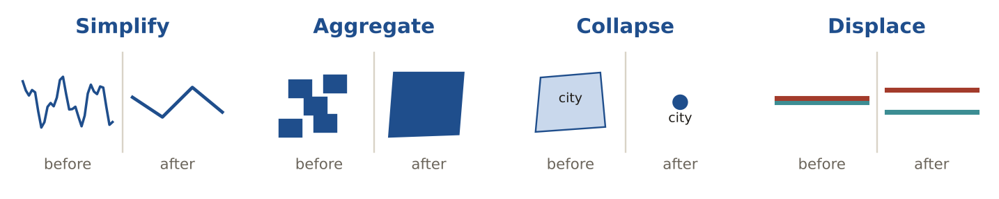
LIKELY EXAM QUESTION
Showing a city as a point at small scale is called:
A) Displace
B) Collapse
C) Exaggerate
D) Smooth
✔ Answer: B · Collapse reduces dimension (area → point).

5.8 File formats
DEFINITION Shapefile (2 GB limit, 10-character field names, no topology), geodatabase, GeoPackage (open SQLite), GeoJSON and KML (WGS 84), GeoTIFF, LAS/LAZ (lidar).
EXAMPLE Field name "POPULATION_2020" is cut to "POPULATION" in a shapefile.
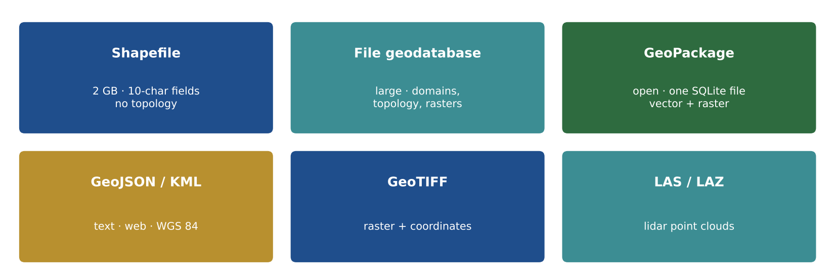
LIKELY EXAM QUESTION
Which is an open, single-file format based on SQLite?
A) Shapefile
B) GeoPackage
C) KML
D) DWG
✔ Answer: B · GeoPackage is an OGC standard built on SQLite.

5.9 Data integration (ETL)
DEFINITION Bringing data from different sources together: Extract, Transform (coordinate system, fields, formats), Load.
EXAMPLE Combining county parcels from 5 offices: each uses different field names, so fields are mapped to one schema.
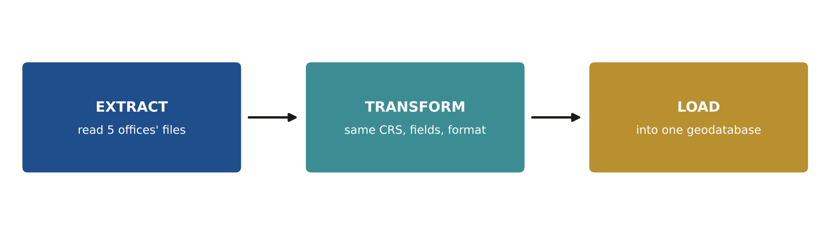
LIKELY EXAM QUESTION
ETL stands for:
A) Edit, Test, Load
B) Extract, Transform, Load
C) Export, Translate, Link
D) Enter, Track, Log
✔ Answer: B · The standard name for moving and reshaping data.

Memory tricks
★ "Nearest for Names" Categories keep their values with nearest neighbour; bilinear/cubic for smooth surfaces.
★ 3 – 6 – 10 Minimum control points for 1st-, 2nd- and 3rd-order transformations.
★ "Cell size first" The first decision in any vector-to-raster conversion.
★ "Weakest link" Integrated data is only as accurate as the worst layer.
If the question says… think…
If the question says… | …think
"land cover / soils raster" + resample | nearest neighbour
"scanned paper map" | georeferencing with control points
"stretch to fit" | rubber-sheeting
"remove vertices" | simplification (Douglas–Peucker)
"open, single-file, SQLite" | GeoPackage
"CAD", "DXF" | limited attribute data
Don't fall for it
- Land cover / soils raster → NEAREST NEIGHBOUR resampling.
- Vector → raster: think about CELL SIZE first.
- DXF's main GIS limitation = limited attribute data (it CAN be projected and drawn over rasters).
- When national roads are offset from local high-res imagery, fix (adjust/digitise) the ROADS — the imagery-derived buildings are more accurate.

Test yourself (cover the answers)
1. Which resampling for a land-cover raster?
Answer: Nearest neighbour (it never invents new class values).
2. Minimum control points for an affine (1st-order) transformation?
Answer: Three.
3. Two shapefile limits?
Answer: 2 GB file size and 10-character field names (also no topology).

AREA 6  Analytical Methods | 11%  ≈ 11 of 100 questions

The big idea
Analysis asks where, how much and why: queries, overlays, classification, interpolation, map algebra and spatial statistics.
Learn it: 12 concepts, one by one
Each concept: definition → example → picture → exam question
6.1 Attribute query vs spatial query
DEFINITION An attribute query selects by values in the table (SQL WHERE). A spatial query selects by location (inside, near, touching).
EXAMPLE Attribute: POP > 50000. Spatial: all schools within 1 km of a river.
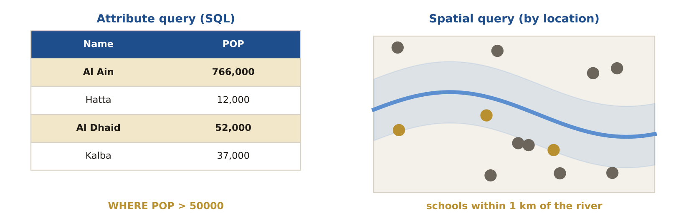
LIKELY EXAM QUESTION
Which SQL finds every name that starts with 'Al'?
A) NAME = 'Al'
B) NAME LIKE 'Al%'
C) NAME LIKE '%Al'
D) NAME IN 'Al'
✔ Answer: B · % means any characters after 'Al'.

6.2 Classification methods
DEFINITION Equal interval = same class width. Quantile = same number of features per class. Natural breaks (Jenks) = groups at natural gaps.
EXAMPLE 100 districts in 4 quantile classes → 25 districts in each class.
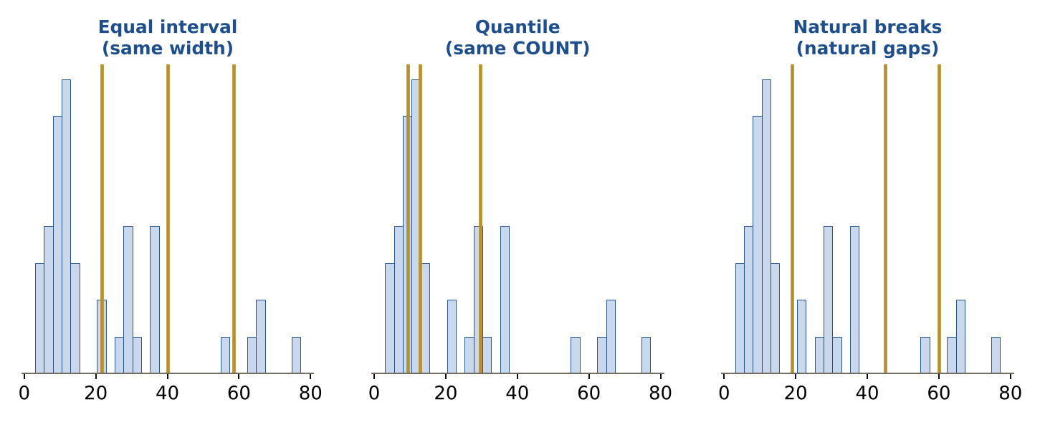
LIKELY EXAM QUESTION
Which method puts the SAME NUMBER of features in each class?
A) Equal interval
B) Quantile
C) Natural breaks
D) Standard deviation
✔ Answer: B · Quantile = same quantity per class.

6.3 Overlay
DEFINITION Combining layers: intersect keeps the shared area, union keeps everything, clip cuts one layer to another's outline, erase removes it.
EXAMPLE Clip roads to a city boundary to get only the city's roads.
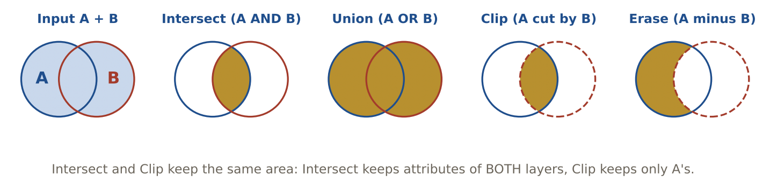
LIKELY EXAM QUESTION
Which overlay keeps only the area common to both layers, with attributes from both?
A) Union
B) Intersect
C) Erase
D) Clip
✔ Answer: B · Intersect = A AND B.

6.4 Buffer and dissolve
DEFINITION A buffer makes a zone at a set distance around features. Dissolve merges features that share the same value.
EXAMPLE A 100 m buffer around a river shows the no-build zone; dissolve merges overlapping buffers into one.
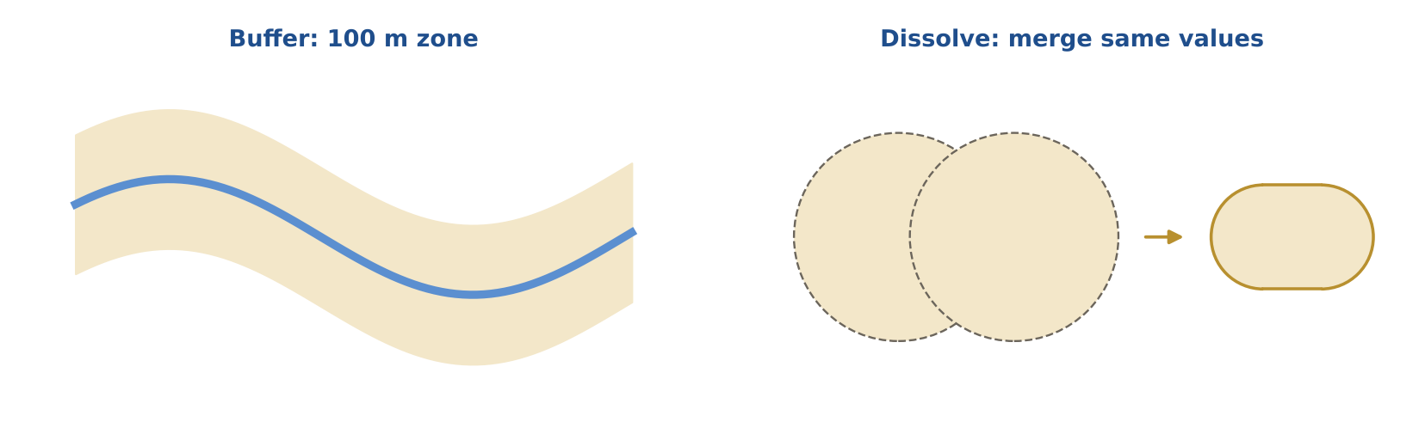
LIKELY EXAM QUESTION
Which tool creates a 500 m zone around each school?
A) Clip
B) Buffer
C) Dissolve
D) Union
✔ Answer: B · Buffers create distance zones.

6.5 Spatial join and Thiessen polygons
DEFINITION A spatial join copies attributes from one layer to another by location. Thiessen (Voronoi) polygons give each point the area closest to it.
EXAMPLE Thiessen polygons around rain gauges show which area each gauge represents.
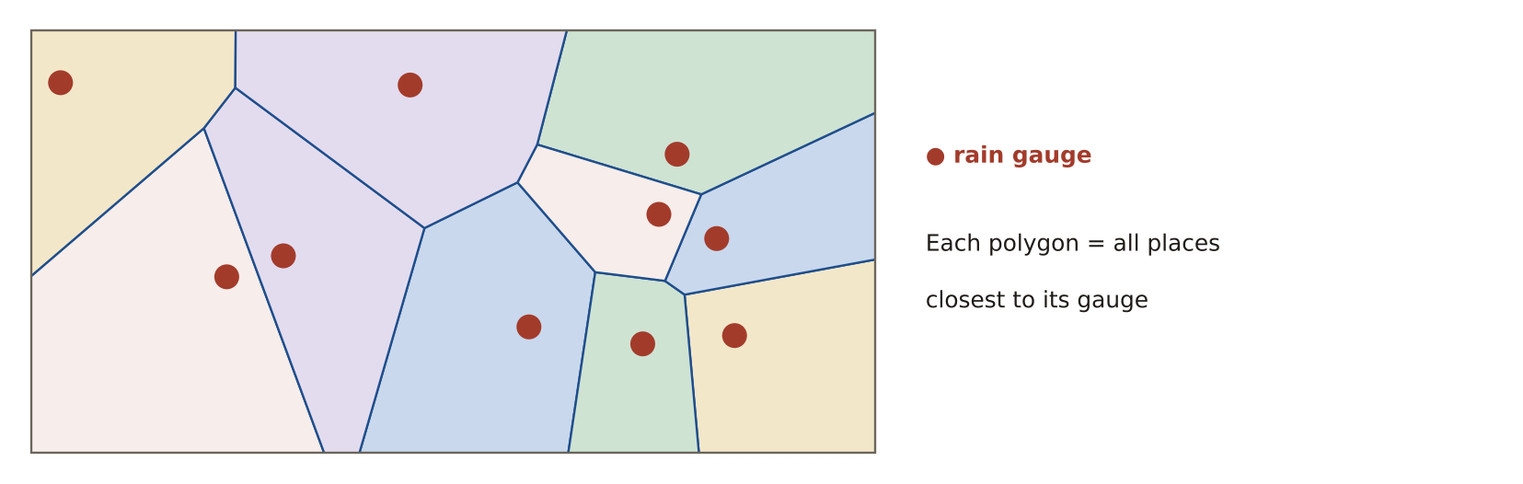
LIKELY EXAM QUESTION
Thiessen polygons define:
A) Equal-area zones
B) The area closest to each point
C) Watersheds
D) Buffers
✔ Answer: B · Every place in a polygon is nearest to its point.

6.6 Network analysis
DEFINITION Analysis along connected lines with a cost (time or distance): best route, closest facility, service area, location–allocation.
EXAMPLE Service area: all streets an ambulance can reach within 8 minutes.
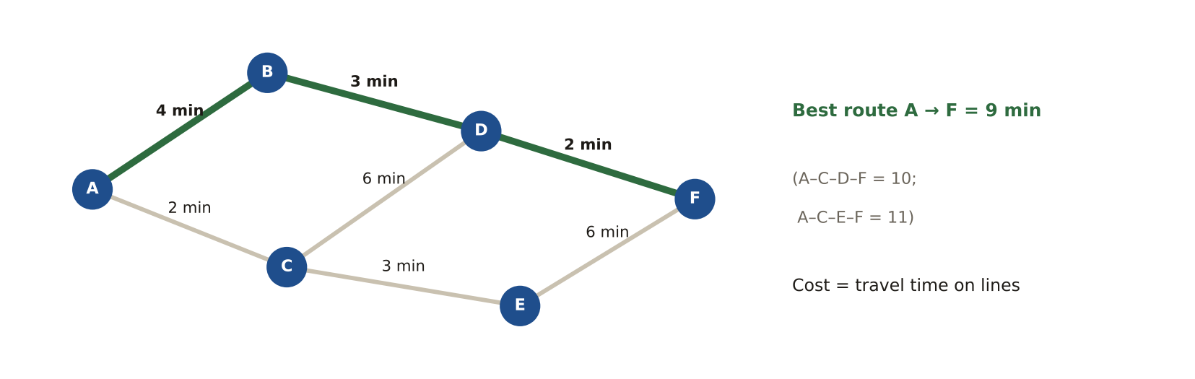
LIKELY EXAM QUESTION
Which analysis shows the area reachable within 10 minutes of a station?
A) Route
B) Service area
C) Closest facility
D) Buffer
✔ Answer: B · Service area uses network travel time, not straight-line distance.

6.7 Interpolation
DEFINITION Estimating values between sample points. IDW: near points count more. Kriging: uses statistics (a semivariogram) and gives an error surface. Spline: smooth surface.
EXAMPLE From 30 rain gauges, kriging creates a rainfall surface plus a map of how uncertain it is.
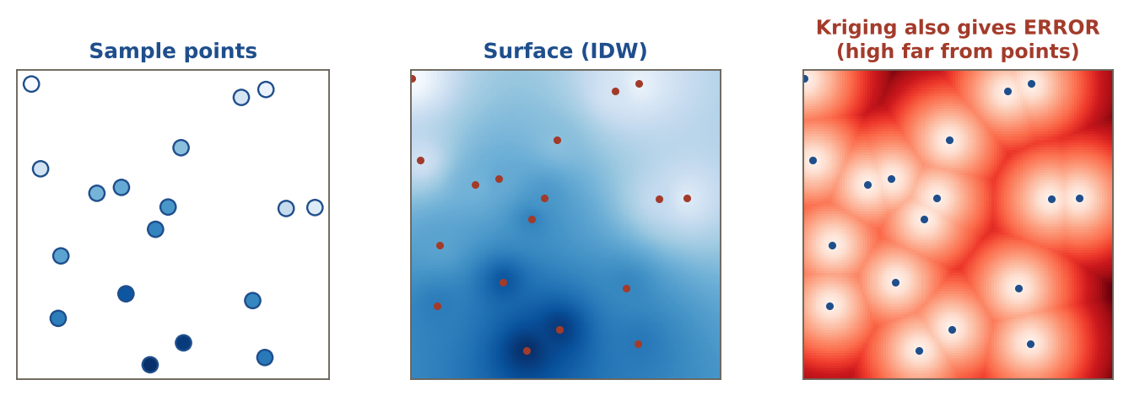
LIKELY EXAM QUESTION
Which method gives a prediction-error surface?
A) IDW
B) Spline
C) Kriging
D) Nearest neighbour
✔ Answer: C · Kriging is geostatistical, so it estimates its own error.

6.8 Map algebra
DEFINITION Raster math. Local = cell by cell. Focal = a cell and its neighbours. Zonal = per zone. Global = the whole raster.
EXAMPLE Slope from a DEM is focal (it uses the 3×3 window around each cell).
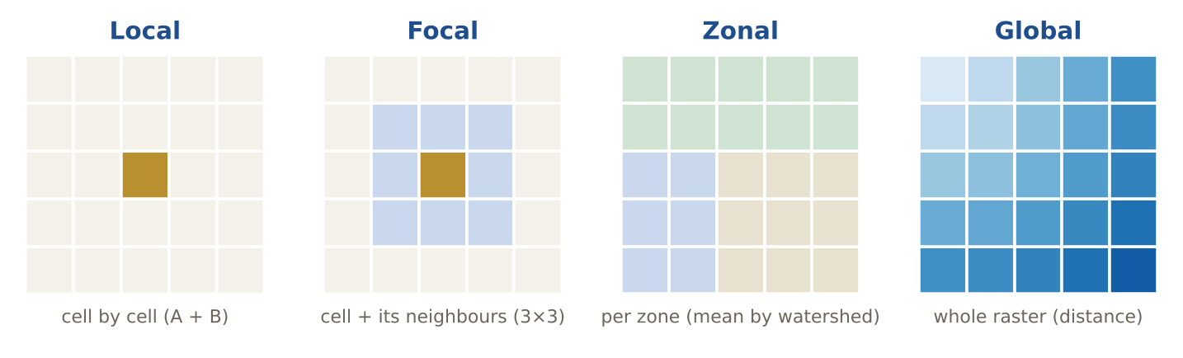
LIKELY EXAM QUESTION
Mean elevation for each watershed is which operation?
A) Local
B) Focal
C) Zonal
D) Global
✔ Answer: C · Statistics per zone = zonal.

6.9 Hydrology
DEFINITION Order of steps: fill sinks → flow direction → flow accumulation → stream network and watersheds.
EXAMPLE Cells with high flow accumulation become the stream lines.
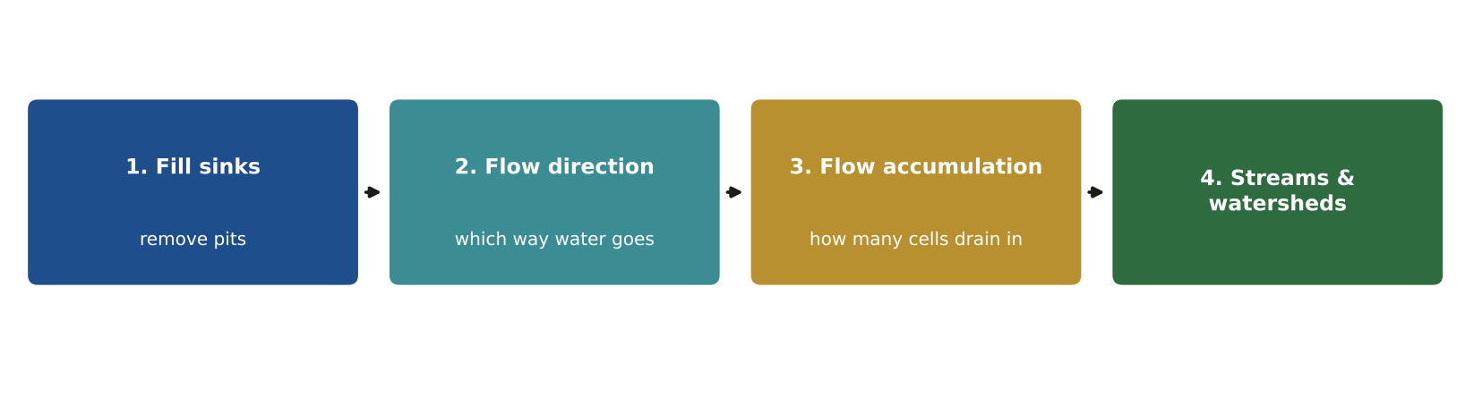
LIKELY EXAM QUESTION
Which step comes right before flow accumulation?
A) Fill sinks
B) Flow direction
C) Watershed
D) Hillshade
✔ Answer: B · Accumulation counts cells flowing in, so it needs directions first.

6.10 Spatial patterns
DEFINITION Points can be clustered, random or dispersed. Nearest-neighbour index R < 1 = clustered. Moran's I > 0 = similar values cluster.
EXAMPLE Crime points with R = 0.4 are strongly clustered.
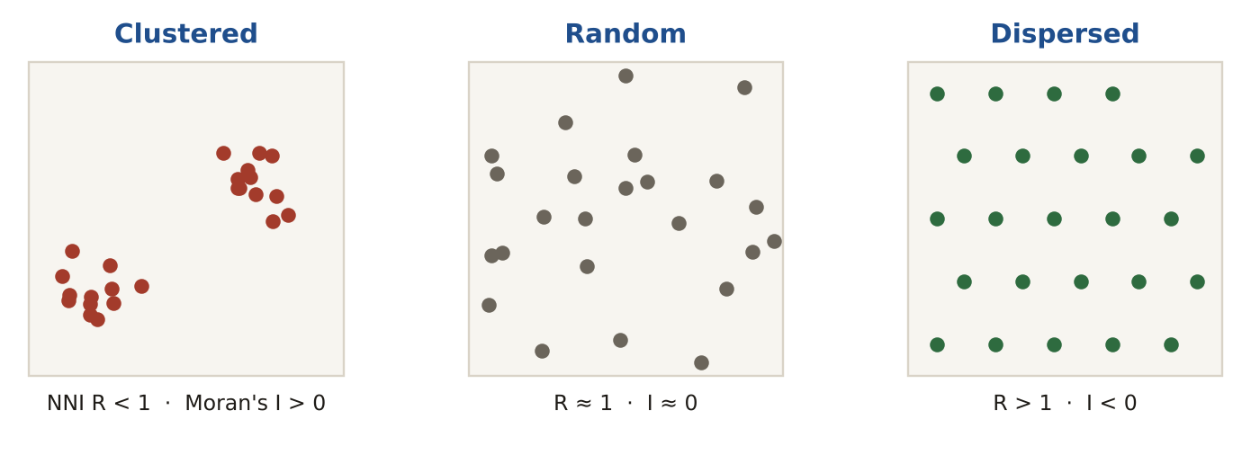
LIKELY EXAM QUESTION
Moran's I close to −1 means:
A) Clustered
B) Random
C) Dispersed
D) No data
✔ Answer: C · Negative I = neighbours are unlike each other (dispersed).

6.11 Hot-spot analysis
DEFINITION Getis-Ord Gi* finds statistically significant clusters of high values (hot spots) and low values (cold spots) using z-scores.
EXAMPLE z = +2.8 at a junction: a significant hot spot of accidents (|z| > 1.96 = 95%).
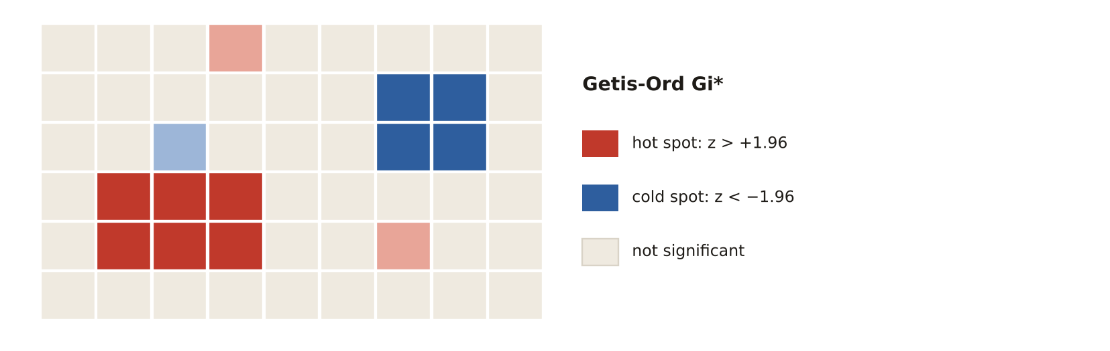
LIKELY EXAM QUESTION
A Gi* z-score of −2.5 indicates:
A) Hot spot
B) Cold spot
C) Random
D) Error
✔ Answer: B · Significant negative z = cluster of low values.

6.12 Descriptive spatial statistics
DEFINITION Mean centre = average x and y. Standard distance = how spread out points are. Standard deviational ellipse = spread plus direction.
EXAMPLE The mean centre of all customers shows the best place for a new shop.
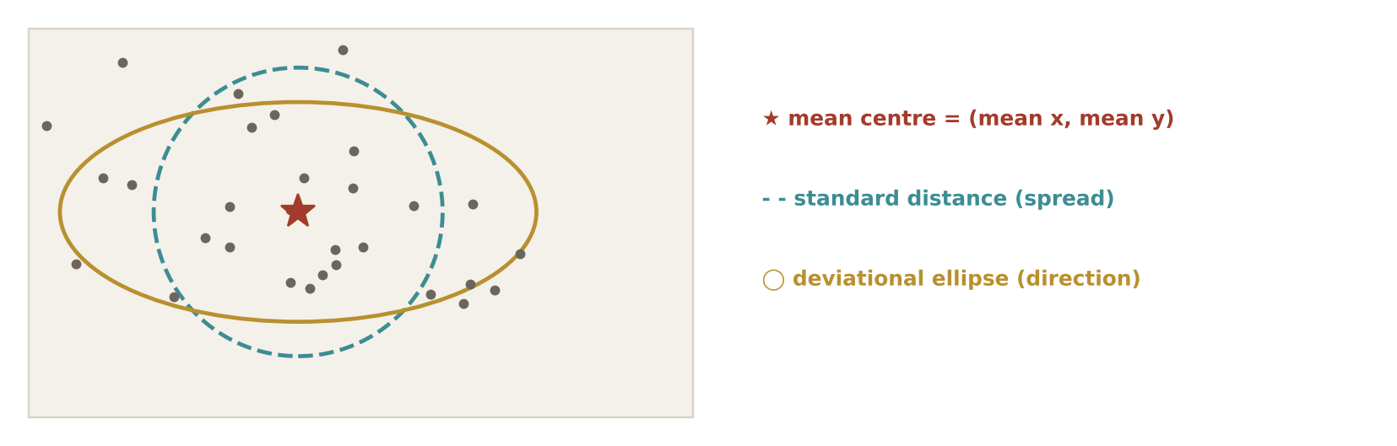
LIKELY EXAM QUESTION
The mean centre of points is:
A) The median attribute
B) The average x and average y
C) The largest point
D) The densest cell
✔ Answer: B · Mean centre = (mean x, mean y).

Memory tricks
★ "Intersect = AND, Union = OR" Intersect keeps what is in both layers; union keeps what is in either.
★ L-F-Z-G Local = one cell · Focal = its neighbours · Zonal = a zone · Global = everything.
★ "Quantile = same Quantity" Each class gets the same number of features.
★ "Kriging = statistics" Only kriging uses a semivariogram and gives a prediction-error surface.
If the question says… think…
If the question says… | …think
"starts with", "contains" | LIKE 'Text%' / '%Text%'
"same number of features per class" | quantile
"3×3 window", "slope" | focal operation
"semivariogram", "error surface" | kriging
"hot spots" | Getis-Ord Gi*
"clustered or dispersed?" | nearest-neighbour index / Moran's I
Don't fall for it
- In SQL, the wildcard is % with LIKE (not = and not *).
- Relational (>, <) and Boolean (AND/OR) map algebra output 1/0 rasters.
- Lower RMSE = MORE accurate. Compute it: √(sum of squares ÷ n).
- Overlay results are only as good as the input layers and the business accuracy need.

Test yourself (cover the answers)
1. SQL for names starting with 'Best'?
Answer: NAME LIKE 'Best%'.
2. Moran's I = +0.8. Clustered, random or dispersed?
Answer: Clustered.
3. Slope from a DEM is which map-algebra type?
Answer: Focal (it uses each cell's neighbours).

AREA 7  Database Design & Management | 10%  ≈ 10 of 100 questions

The big idea
A geodatabase stores data in related tables, protects it with rules and keys, and lets many people edit it safely.
Learn it: 9 concepts, one by one
Each concept: definition → example → picture → exam question
7.1 Keys: primary and foreign
DEFINITION A primary key (PK) uniquely identifies each row and is never empty. A foreign key (FK) points to a primary key in another table.
EXAMPLE PARCEL.ParcelID is a PK. OWNERSHIP.ParcelID is an FK that refers to it.
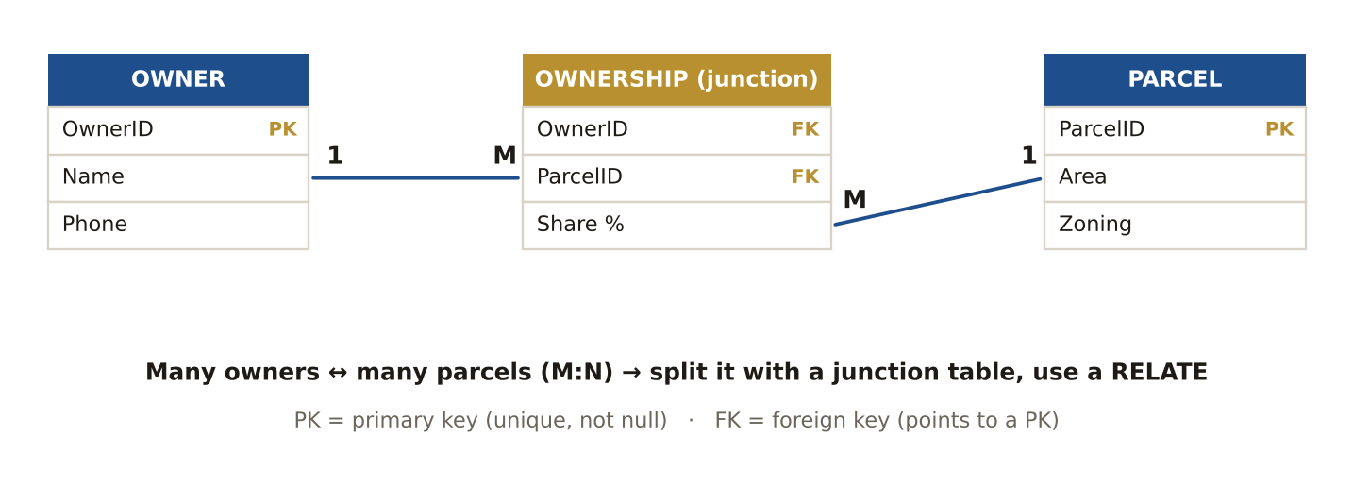
LIKELY EXAM QUESTION
A primary key must be:
A) Unique and not null
B) Text only
C) Repeated
D) Optional
✔ Answer: A · Each record needs one unique, non-empty ID.

7.2 Cardinality
DEFINITION How many records relate: one-to-one (1:1), one-to-many (1:M), many-to-many (M:N). M:N needs a junction table.
EXAMPLE One parcel has many inspections (1:M). Many students take many classes (M:N).
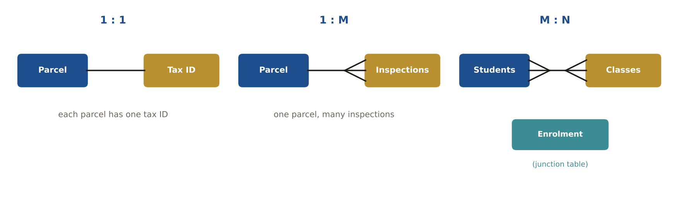
LIKELY EXAM QUESTION
Students and classes (each student has many classes, each class many students) is:
A) 1:1
B) 1:M
C) M:N
D) M:1
✔ Answer: C · Many on both sides = many-to-many.

7.3 Join vs relate
DEFINITION A join copies fields into one table (1:1 or M:1). A relate keeps tables separate and links them (1:M or M:N).
EXAMPLE Join a zoning table to parcels. Relate parcels to their many inspection records.
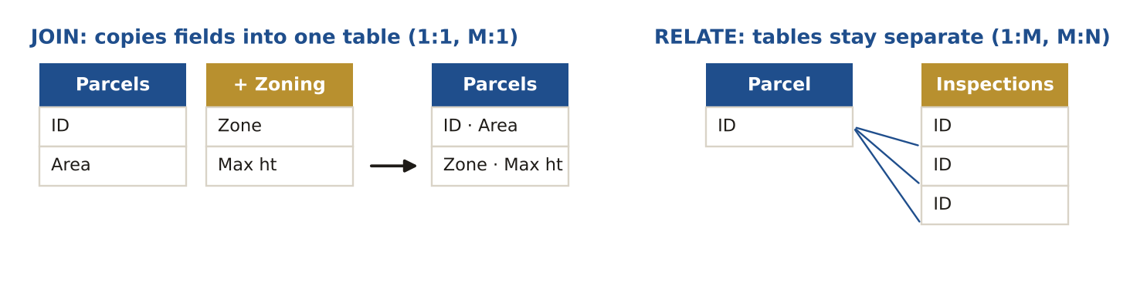
LIKELY EXAM QUESTION
Parcels have many inspection records. Which link?
A) Join
B) Relate
C) Spatial join
D) Append
✔ Answer: B · One-to-many needs a relate.

7.4 Database design stages
DEFINITION Conceptual (what entities and relationships, E-R diagram) → logical (tables, keys, normalisation) → physical (real software, data types, indexes).
EXAMPLE Choosing 'Long integer' for ParcelID and adding an index happens in the physical stage.
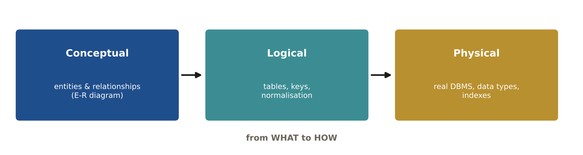
LIKELY EXAM QUESTION
An entity-relationship diagram belongs to which stage?
A) Conceptual
B) Logical
C) Physical
D) Testing
✔ Answer: A · The conceptual model shows entities and how they relate.

7.5 Normalisation
DEFINITION Organising tables to avoid repeated data. 1NF: one value per cell. 2NF: depends on the whole key. 3NF: depends on nothing but the key.
EXAMPLE Phone1, Phone2, Phone3 columns break 1NF → move phones to their own table.
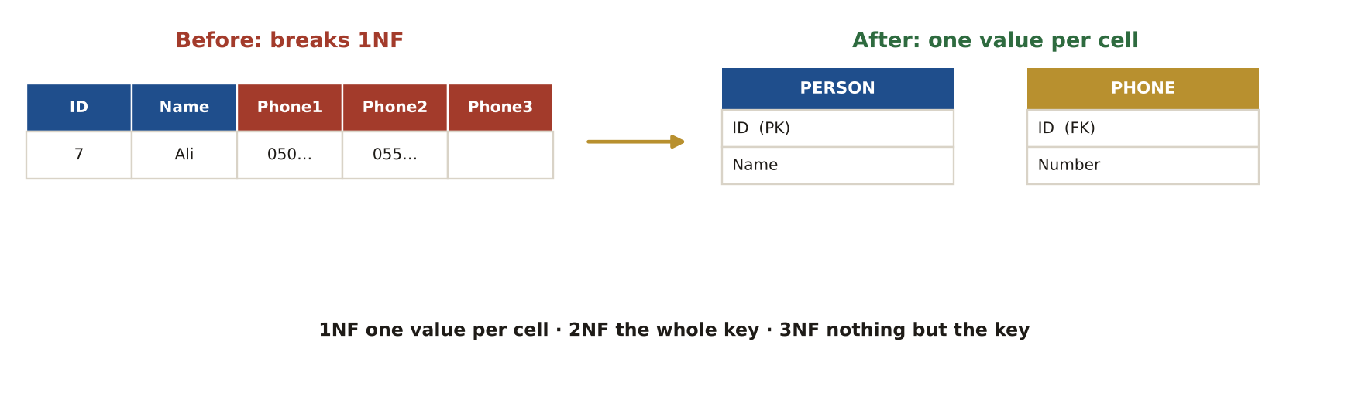
LIKELY EXAM QUESTION
Repeating columns such as Phone1, Phone2, Phone3 break:
A) 1NF
B) 3NF only
C) Topology
D) Indexing
✔ Answer: A · Repeating groups violate first normal form.

7.6 Domains and subtypes
DEFINITION A domain limits a field to allowed values (a list or range). Subtypes group features of one class with their own defaults.
EXAMPLE Pipe material domain: PVC, Steel, Copper. Nobody can type "Stell".
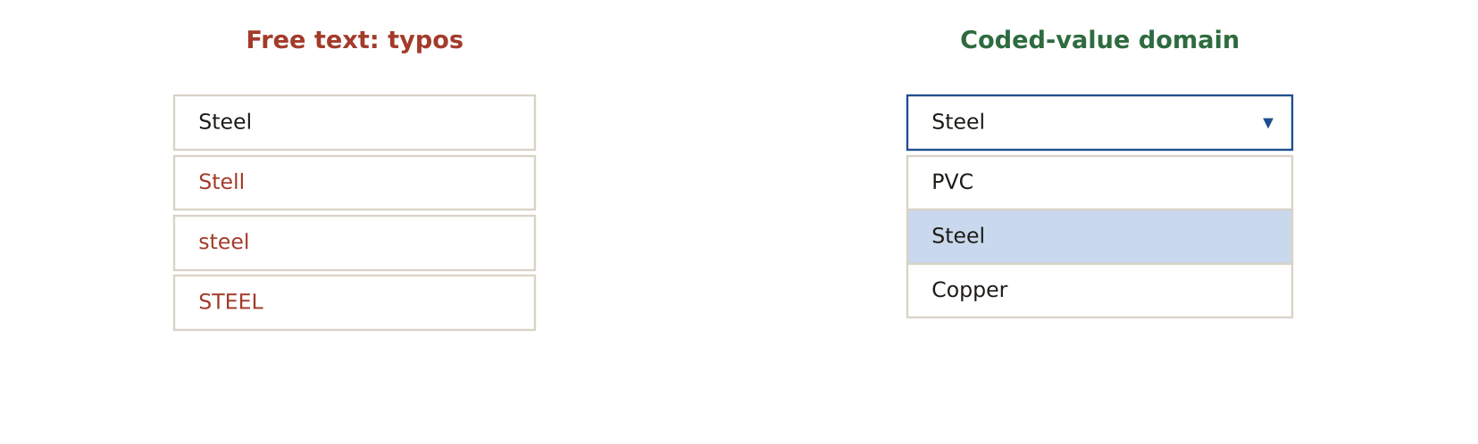
LIKELY EXAM QUESTION
The best way to stop spelling errors in a 'Zoning' field is:
A) An index
B) A coded-value domain
C) A relate
D) A buffer
✔ Answer: B · Users pick from a list instead of typing.

7.7 Versioning and replication
DEFINITION Versioning lets many editors work at once, then reconcile and post. Replication copies the database to another office and syncs changes.
EXAMPLE Field office with a slow link works on a replica and syncs every night.
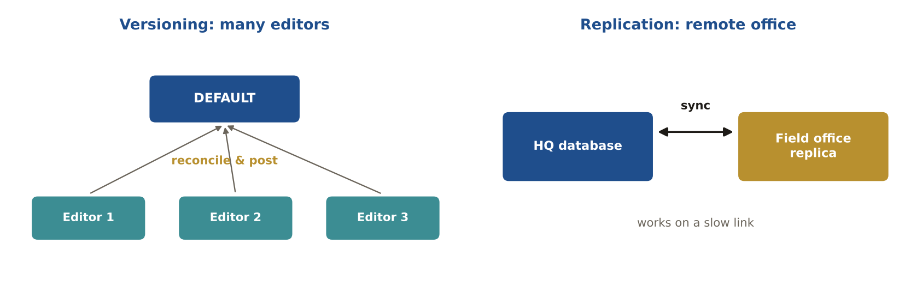
LIKELY EXAM QUESTION
Ten editors edit the same geodatabase at once. What do you use?
A) Replication
B) Versioning
C) Backup
D) Domain
✔ Answer: B · Versioning manages simultaneous edits.

7.8 SQL families
DEFINITION DDL builds structure (CREATE, ALTER, DROP). DML handles data (SELECT, INSERT, UPDATE, DELETE). DCL controls access (GRANT, REVOKE).
EXAMPLE GRANT SELECT ON parcels TO viewer; → DCL.
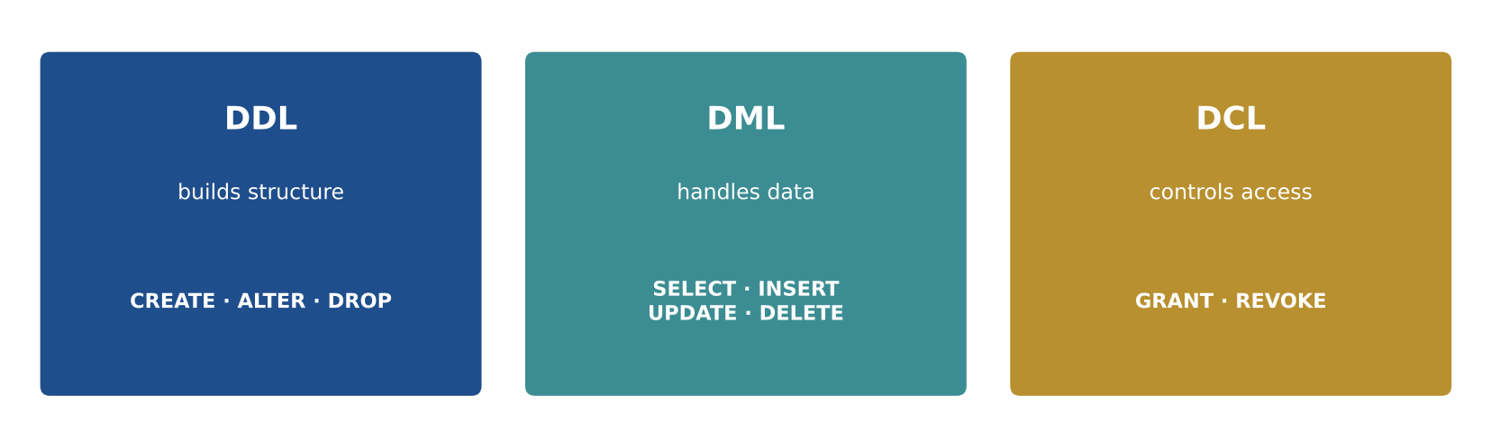
LIKELY EXAM QUESTION
UPDATE parcels SET zone = 'R1' is which type?
A) DDL
B) DML
C) DCL
D) TCL
✔ Answer: B · It changes data values.

7.9 Database security (CIA)
DEFINITION Confidentiality = only the right people see data. Integrity = data is not changed wrongly. Availability = data is there when needed.
EXAMPLE Least privilege: viewers get read-only access; only editors can change parcels.
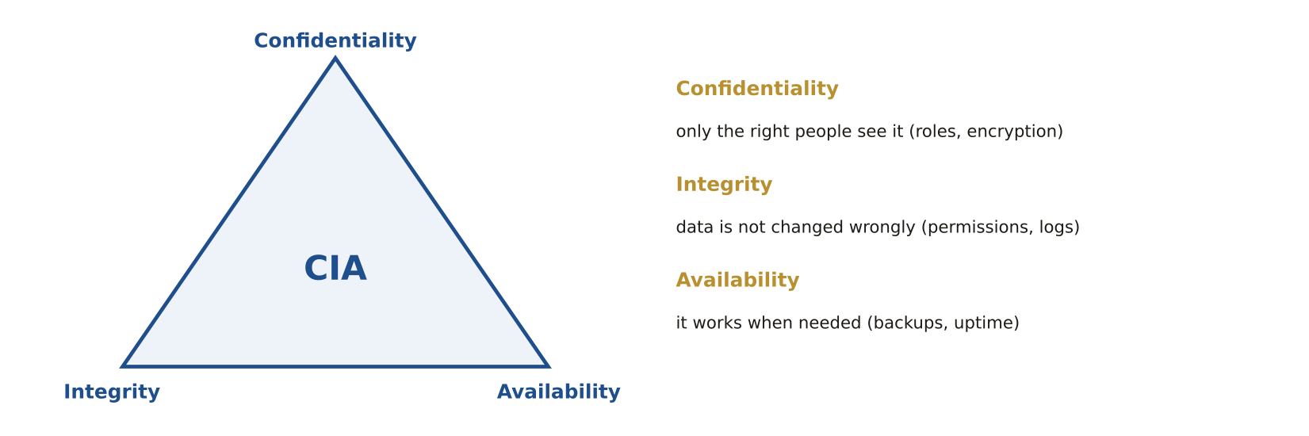
LIKELY EXAM QUESTION
Protecting data from unauthorised changes is:
A) Confidentiality
B) Integrity
C) Availability
D) Scalability
✔ Answer: B · Integrity = correctness of the data.

Memory tricks
★ "The key, the whole key, and nothing but the key" 1NF, 2NF and 3NF in one sentence.
★ "Many-to-many → Relate" Joins can't hold M:N; relates can.
★ "Domain stops typos" A coded-value list makes misspelling impossible.
★ D-D-D: DDL Defines, DML Does, DCL Decides Structure · Data · Permissions.
If the question says… think…
If the question says… | …think
"spelling mistakes in a field" | attribute domain
"many editors at once" | versioning
"slow satellite office" | replication
"GRANT", "REVOKE" | DCL
"repeating groups" | violates 1NF
"owners ↔ parcels, both many" | many-to-many → junction table / relate
Don't fall for it
- Many-to-many = RELATE (not join).
- To stop spelling mistakes in an attribute → DOMAIN (not spell check, not default value).
- Slow access from a satellite office → database REPLICATION.
- Data-type constraints live in the FIELDS.

Test yourself (cover the answers)
1. A parcel has many owners and an owner has many parcels. What do you need?
Answer: A junction (associative) table, used with a relate.
2. Is SELECT DDL or DML?
Answer: DML.
3. Best way to stop 'Residental' typos in a zoning field?
Answer: A coded-value domain.

AREA 8  Application Development | 7%  ≈ 7 of 100 questions

The big idea
GIS apps talk over web protocols and services, and are built with code, tested often and managed with version control.
Learn it: 8 concepts, one by one
Each concept: definition → example → picture → exam question
8.1 Protocols
DEFINITION Rules for sending data across networks: HTTP (web), HTTPS (encrypted web), FTP/SFTP (files), SSH (secure login), SMTP (email).
EXAMPLE A public web map uses HTTPS so data is encrypted and still works in every browser.
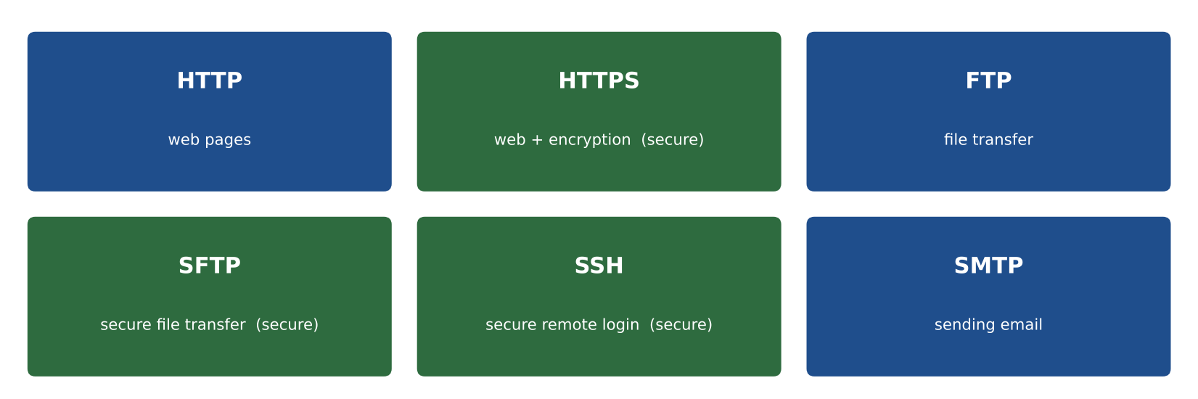
LIKELY EXAM QUESTION
Which protocol is secure AND widely accessible for a web map?
A) FTP
B) HTTP
C) HTTPS
D) Telnet
✔ Answer: C · HTTPS = HTTP plus encryption.

8.2 REST web services
DEFINITION A simple web service style: a URL plus an HTTP verb (GET, POST, PUT, DELETE). Answers are often JSON.
EXAMPLE GET …/parcels/query?where=zone='R1'&f=json returns matching parcels as JSON.
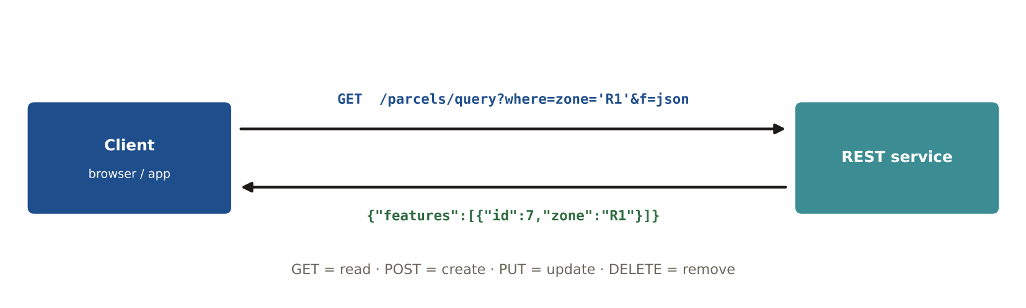
LIKELY EXAM QUESTION
Which HTTP verb READS data in a REST service?
A) POST
B) GET
C) PUT
D) DELETE
✔ Answer: B · GET retrieves a resource.

8.3 OGC web services
DEFINITION WMS = map pictures. WFS = vector features (WFS-T edits). WCS = raster values. WMTS = cached tiles. WPS = processing.
EXAMPLE A browser basemap uses WMTS tiles; field editors use WFS-T to edit hydrants.
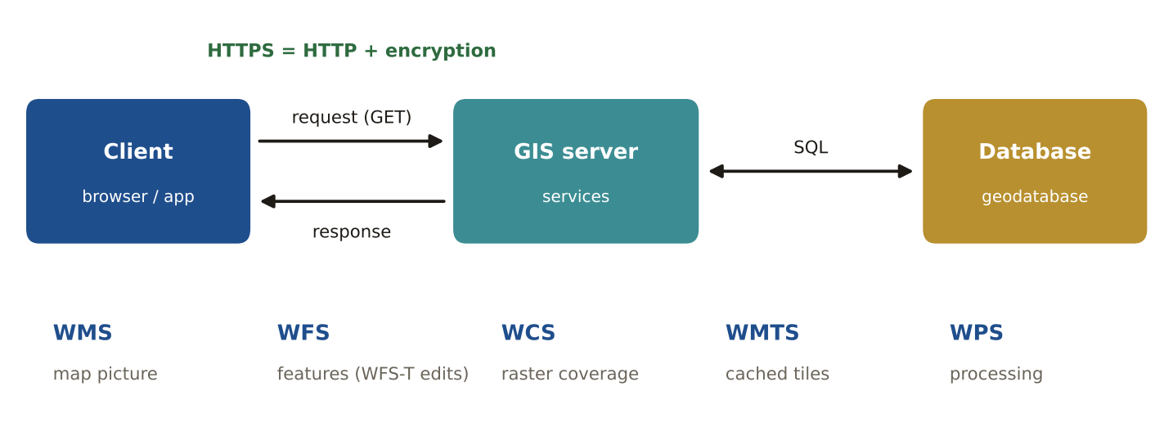
LIKELY EXAM QUESTION
Which service returns only a picture of the map?
A) WFS
B) WMS
C) WCS
D) WPS
✔ Answer: B · Web Map Service returns images.

8.4 Data exchange formats: JSON and XML
DEFINITION Text formats for sending data between systems. JSON is light and common on the web; XML uses tags and is used by GML and metadata.
EXAMPLE The same hydrant as GeoJSON: {"type":"Point","coordinates":[55.3,25.2]}
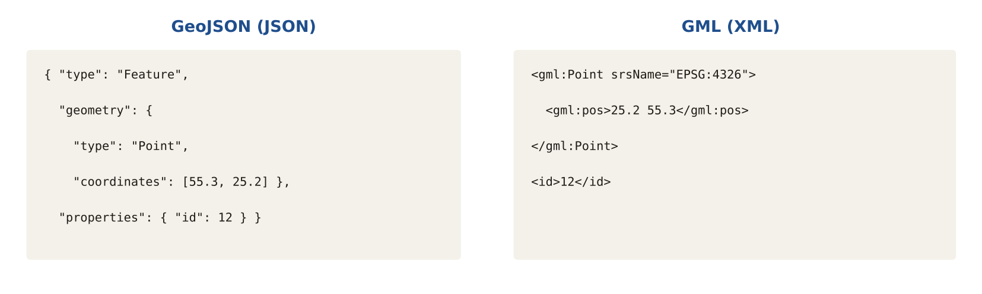
LIKELY EXAM QUESTION
GML is based on:
A) JSON
B) XML
C) CSV
D) SQL
✔ Answer: B · Geography Markup Language is an XML encoding.

8.5 Coding basics and pseudocode
DEFINITION Variables store values, if/else chooses, loops repeat, functions package code. Read pseudocode line by line and track each variable.
EXAMPLE x = 1; repeat 3 times: x = x × 2 → x = 2, 4, 8.
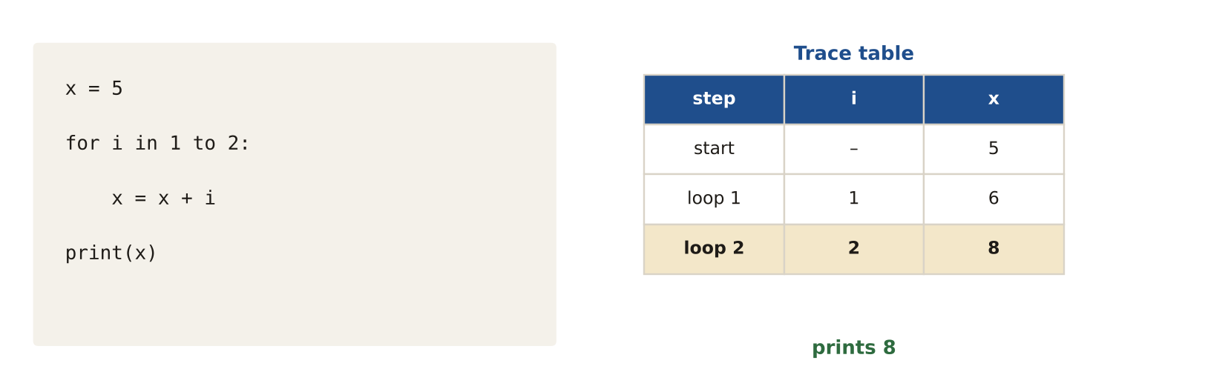
LIKELY EXAM QUESTION
x = 5; for i in 1..2: x = x + i. What is x?
A) 6
B) 7
C) 8
D) 10
✔ Answer: C · 5 + 1 = 6, then 6 + 2 = 8.

8.6 Development methods
DEFINITION Waterfall finishes each stage before the next. Agile (Scrum) works in short sprints with constant testing and user feedback.
EXAMPLE A field app is built in 2-week sprints and users test each new version.
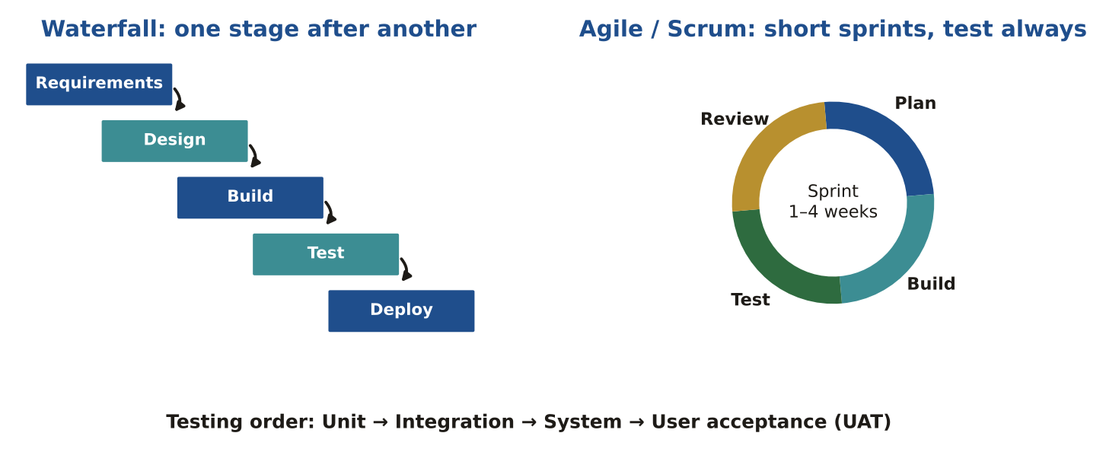
LIKELY EXAM QUESTION
Which is NOT an Agile practice?
A) Sprints
B) User stories
C) Limited testing
D) Frequent delivery
✔ Answer: C · Agile tests continuously.

8.7 Testing order
DEFINITION Unit (one piece) → integration (pieces together) → system (whole app) → user acceptance (users approve).
EXAMPLE The users of the permit app sign off in UAT before go-live.
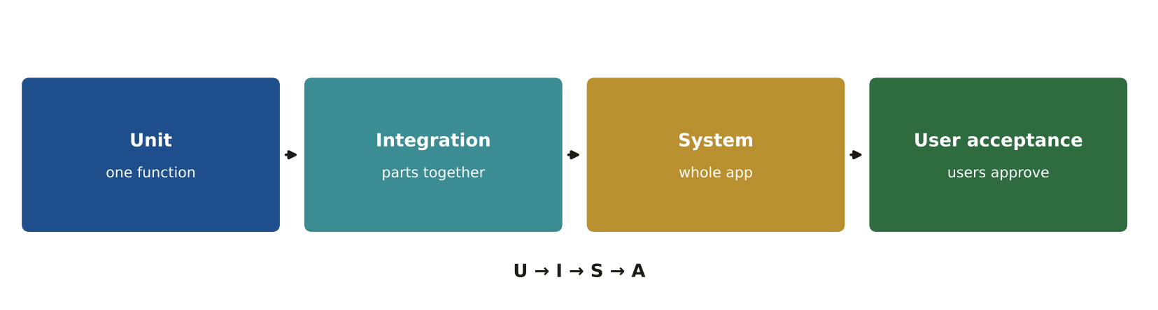
LIKELY EXAM QUESTION
The final testing stage, done by end users, is:
A) Unit
B) Integration
C) System
D) User acceptance
✔ Answer: D · UAT confirms the app meets business needs.

8.8 Version control (Git)
DEFINITION Tracks every change to code, lets people work on branches and merge, and lets you go back to older versions.
EXAMPLE A developer makes a branch for a new tool, then merges it after review.
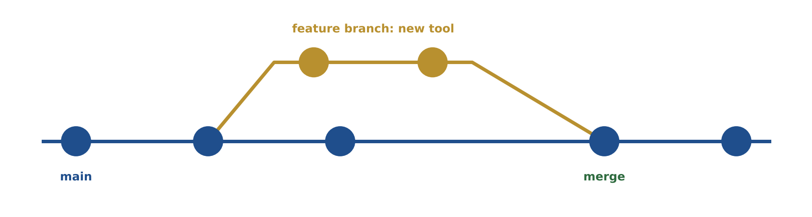
LIKELY EXAM QUESTION
Git is mainly used to:
A) Project data
B) Track code changes and collaborate
C) Encrypt files
D) Classify images
✔ Answer: B · Version control keeps the history of code.

Memory tricks
★ "Map-Feature-Coverage" WMS = Map picture · WFS = Features · WCS = Coverage (raster).
★ "S for Secure" HTTPS is HTTP plus encryption.
★ U-I-S-A Unit → Integration → System → Acceptance.
★ "Agile = test always" Limited testing is never Agile.
If the question says… think…
If the question says… | …think
"secure and widely accessible" | HTTPS
"edit features over the web" | WFS-T
"picture of a map" | WMS
"sprints", "user stories" | Agile / Scrum
"end users approve" | UAT
read pseudocode | track each variable line by line
Don't fall for it
- 'Limited testing' is NOT part of Agile — Agile tests continuously.
- Most secure yet widely accessible web protocol → HTTPS.
- Read pseudocode slowly: track each variable step by step.

Test yourself (cover the answers)
1. Which OGC service returns editable vector features?
Answer: WFS-T.
2. Which is NOT Agile: sprints, user stories, limited testing, continuous delivery?
Answer: Limited testing.
3. Last stage of testing?
Answer: User acceptance testing (UAT).

AREA 9  Systems Design & Management | 7%  ≈ 7 of 100 questions

The big idea
A GIS system is planned from real needs, built on the right architecture (desktop, server, cloud) and kept secure.
Learn it: 7 concepts, one by one
Each concept: definition → example → picture → exam question
9.1 Client–server and tiers
DEFINITION A client asks, a server answers. Three tiers: presentation (interface) → logic (GIS/app server) → data (database).
EXAMPLE A browser (thin client) asks a GIS server for a map; the server reads the database.
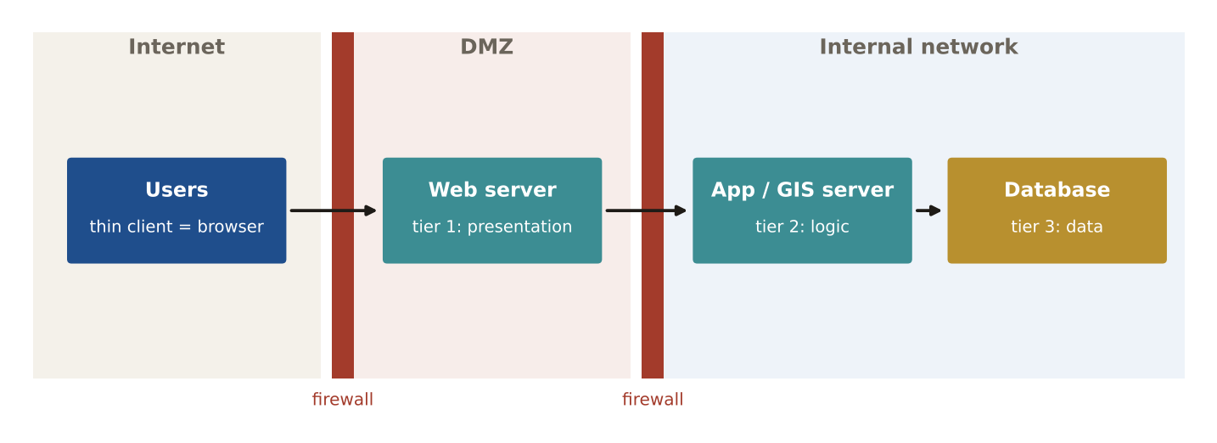
LIKELY EXAM QUESTION
In three-tier architecture, the middle tier holds:
A) The user interface
B) Business logic / application server
C) Raw data files
D) Network cables
✔ Answer: B · Presentation → logic → data.

9.2 Cloud models
DEFINITION IaaS = rent servers. PaaS = rent a platform to build on. SaaS = use ready software in the browser.
EXAMPLE Renting a virtual machine to install GIS Server = IaaS. ArcGIS Online = SaaS.
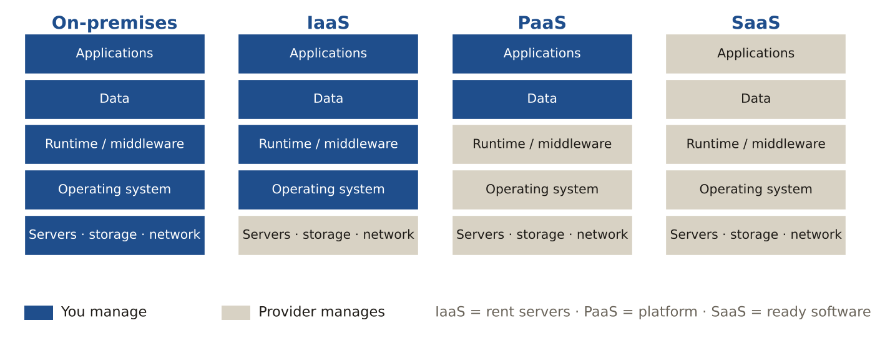
LIKELY EXAM QUESTION
Ready-to-use web mapping software you just log into is:
A) IaaS
B) PaaS
C) SaaS
D) On-premises
✔ Answer: C · Software as a Service.

9.3 Planning a GIS (needs assessment)
DEFINITION Start with users' needs, then requirements, design, pilot, implementation and maintenance.
EXAMPLE Interviews show planners need parcel search; that becomes a requirement before buying software.
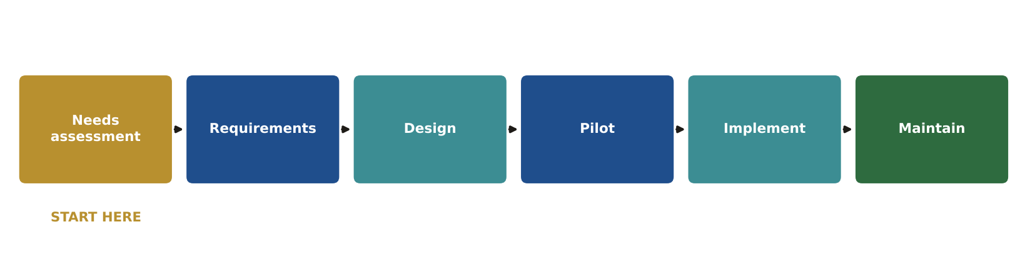
LIKELY EXAM QUESTION
The FIRST step in planning an enterprise GIS is:
A) Buy software
B) Needs assessment
C) Load data
D) Write code
✔ Answer: B · Needs come before tools.

9.4 Functional vs non-functional requirements
DEFINITION Functional = WHAT the system does. Non-functional = HOW WELL it does it (speed, security, uptime).
EXAMPLE "Users can search by parcel ID" = functional. "Search returns in 2 seconds" = non-functional.
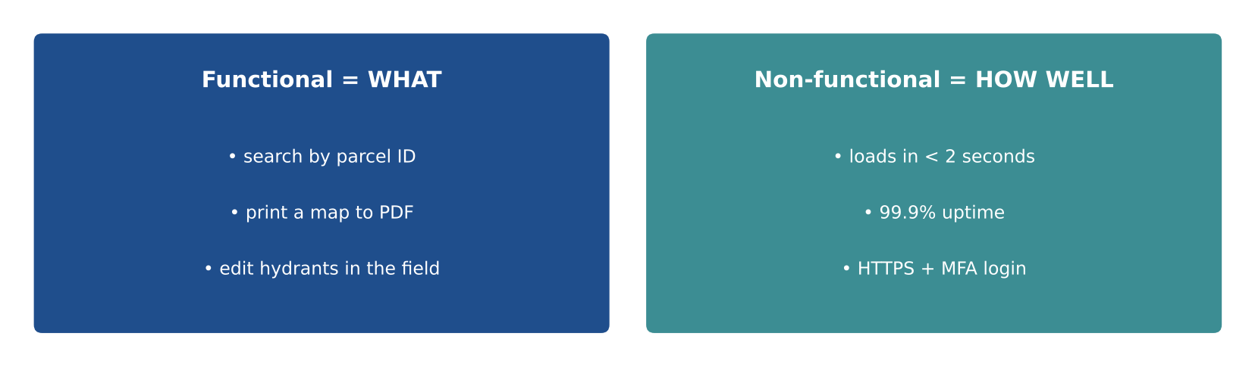
LIKELY EXAM QUESTION
'The map loads in under 3 seconds' is:
A) Functional
B) Non-functional
C) Optional
D) A test case
✔ Answer: B · It describes performance, not a feature.

9.5 Security layers
DEFINITION Firewall and DMZ protect the network, HTTPS encrypts, MFA and roles control who gets in. Threats: phishing, SQL injection, ransomware.
EXAMPLE Public web servers sit in the DMZ; the database stays inside the internal network.
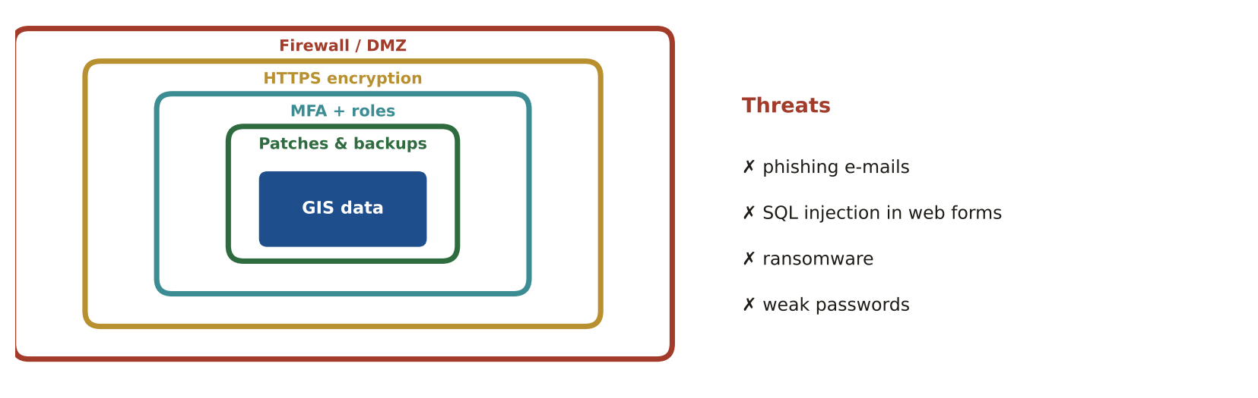
LIKELY EXAM QUESTION
Password plus a code from your phone is:
A) Single sign-on
B) Multi-factor authentication
C) Encryption
D) Firewall
✔ Answer: B · Two different factors = MFA.

9.6 Software options
DEFINITION Commercial (COTS) has vendor support and licence costs. Open source (QGIS, PostGIS, GeoServer) has no licence fee but needs in-house skills.
EXAMPLE A small team without developers may prefer commercial support; a skilled team may choose open source.
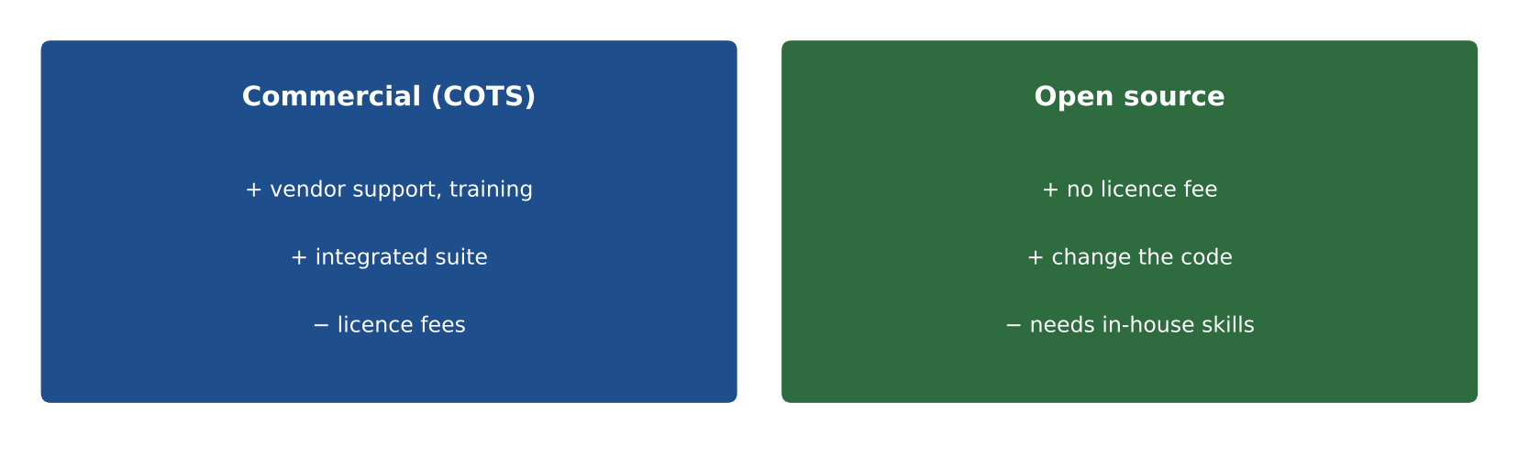
LIKELY EXAM QUESTION
A main cost of open-source GIS is usually:
A) Licence fees
B) Staff skills and support
C) Per-user fees
D) Mandatory hardware
✔ Answer: B · No licence fee, but you need people who can run it.

9.7 Trends: AR, VR and digital twins
DEFINITION AR adds digital information on the real view. VR is a fully computer-made world. A digital twin is a live digital copy of a real place.
EXAMPLE A tablet showing buried pipes over the real street is AR.
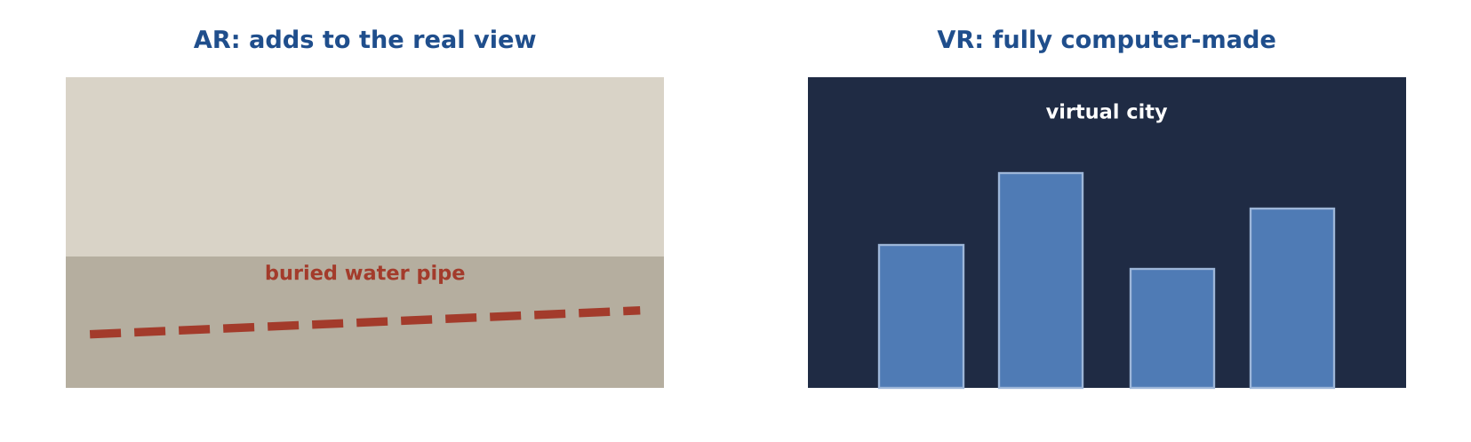
LIKELY EXAM QUESTION
A headset that overlays underground utilities on the street view is:
A) VR
B) AR
C) Digital elevation
D) Cartogram
✔ Answer: B · AR augments (adds to) reality.

Memory tricks
★ "Pizza as a service" IaaS = you rent the kitchen · PaaS = take-and-bake · SaaS = pizza delivered.
★ "AR Adds to Reality" A headset showing buried pipes on the real street is augmented reality.
★ "Needs before tools" Every system starts with a needs assessment.
★ "Functional = What, Non-functional = How well" Features vs speed, security and uptime.
If the question says… think…
If the question says… | …think
"requests a service" | client
"ready-to-use web software" | SaaS
"scale up and down quickly" | cloud elasticity
"speed", "uptime", "security" requirements | non-functional
"buried utilities shown in a headset" | augmented reality
"first step of a new system" | needs assessment
Don't fall for it
- Cloud does NOT guarantee security, and it removes (not creates) collaboration barriers.
- Headset overlaying underground utilities on the real world → AUGMENTED reality.

Test yourself (cover the answers)
1. Does moving to the cloud guarantee security?
Answer: No.
2. 'The system must respond in 2 seconds' is functional or non-functional?
Answer: Non-functional.
3. A browser map app is a thin or thick client?
Answer: Thin client.

AREA 10  Professional Practice | 8%  ≈ 8 of 100 questions

The big idea
A GIS professional is honest, follows policy and law, knows the limits of the job and manages projects well.
Learn it: 9 concepts, one by one
Each concept: definition → example → picture → exam question
10.1 Policies, licences and privacy
DEFINITION Follow your organisation's rules for sharing data, licences, copyright and personal information (PII).
EXAMPLE A records request asks for parcel data: share public fields, remove owners' phone numbers if policy says they are private.
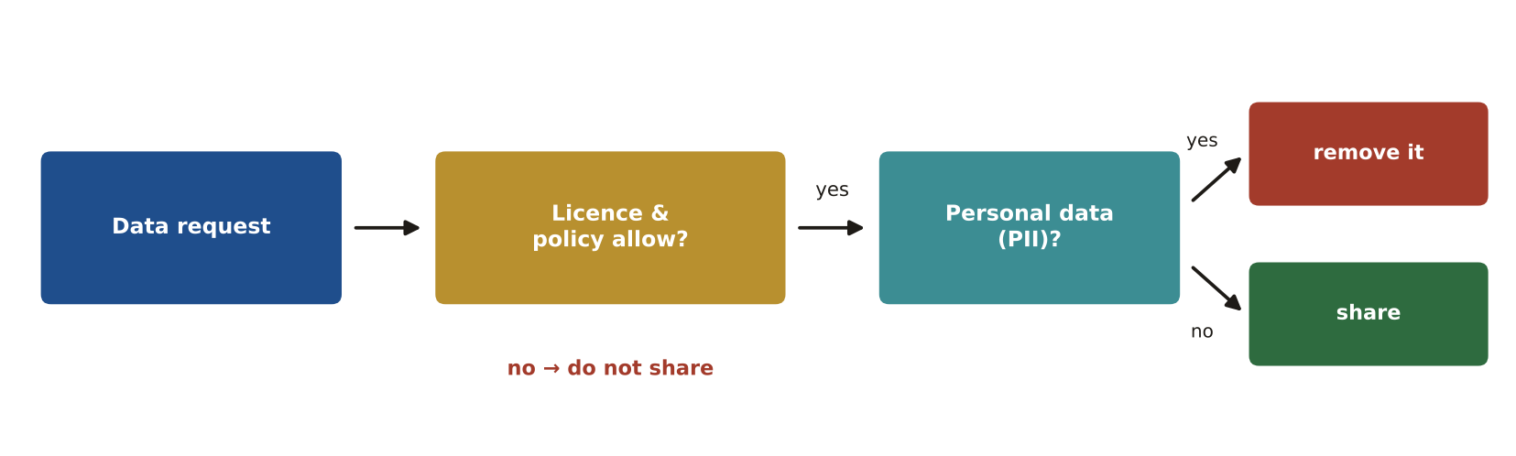
LIKELY EXAM QUESTION
Before sharing a dataset outside your organisation, first check:
A) Its colours
B) Its licence and sharing policy
C) Its file size
D) Its software version
✔ Answer: B · Licences and policies decide what may be shared.

10.2 GISCI Code of Ethics
DEFINITION A GISP has obligations to society, to employers and funders, to colleagues and the profession, and to individuals. Honesty first.
EXAMPLE Your boss wants to hide a data error from a client: you must disclose it.
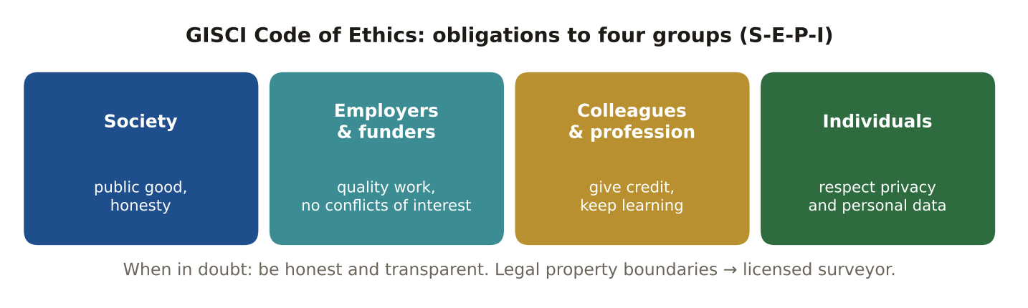
LIKELY EXAM QUESTION
A client asks you to change results to favour their site. You should:
A) Agree quietly
B) Refuse and report results honestly
C) Delete the data
D) Change only the colours
✔ Answer: B · Honesty and integrity come before client wishes.

10.3 Know your limits
DEFINITION GIS maps parcels, but deciding a legal boundary is licensed surveying.
EXAMPLE Two neighbours dispute a fence line: send them to a licensed surveyor, not the GIS parcel map.
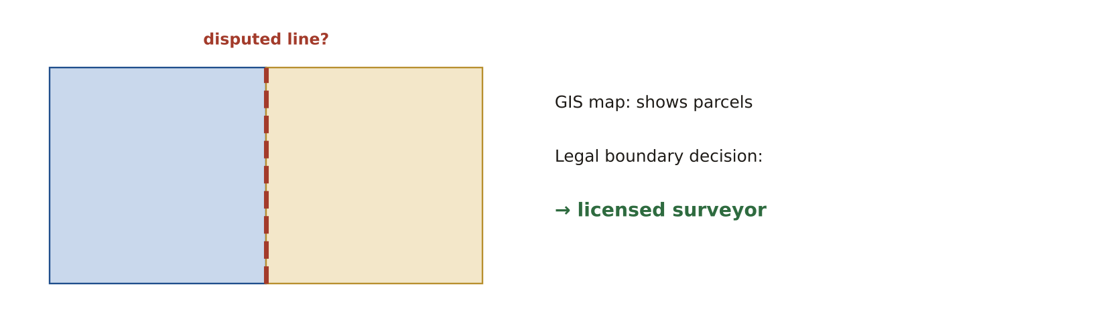
LIKELY EXAM QUESTION
Who determines a legal property boundary?
A) GIS analyst
B) Licensed surveyor
C) Map designer
D) Database admin
✔ Answer: B · Legal boundaries are surveying work.

10.4 Project phases and triple constraint
DEFINITION Initiate → plan → execute → close, with monitoring all the time. Scope, time and cost are linked: change one and the others move.
EXAMPLE The client adds 3 new layers (scope) → the deadline or the budget must grow.
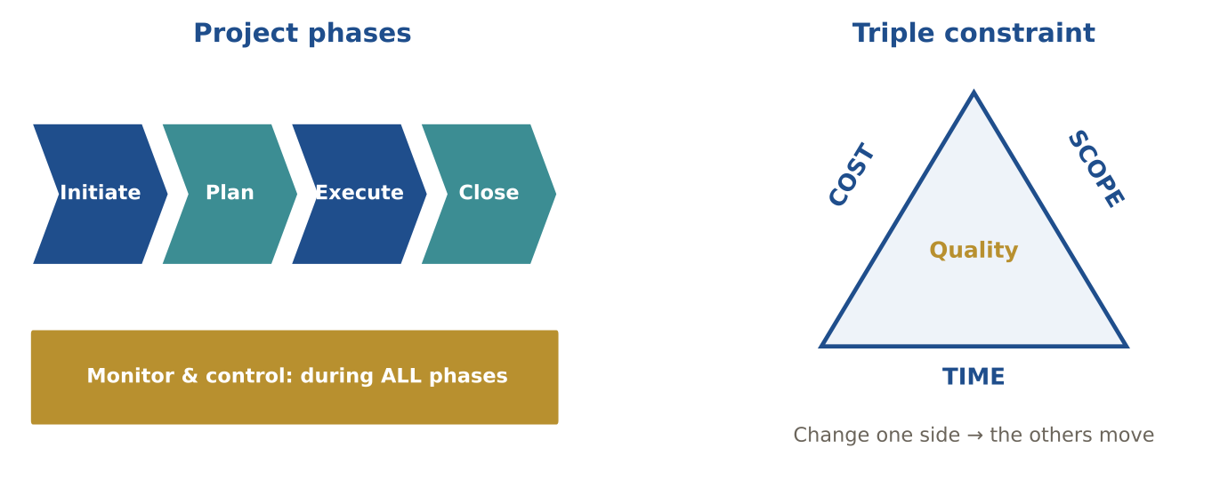
LIKELY EXAM QUESTION
When does monitoring and control happen?
A) Only at the end
B) Only in planning
C) Throughout all phases
D) Never
✔ Answer: C · It runs alongside every phase.

10.5 Project tools: WBS, Gantt, critical path
DEFINITION WBS breaks work into tasks. A Gantt chart shows tasks on a timeline. The critical path is the longest chain of dependent tasks.
EXAMPLE If a task on the critical path is 3 days late, the whole project is 3 days late.
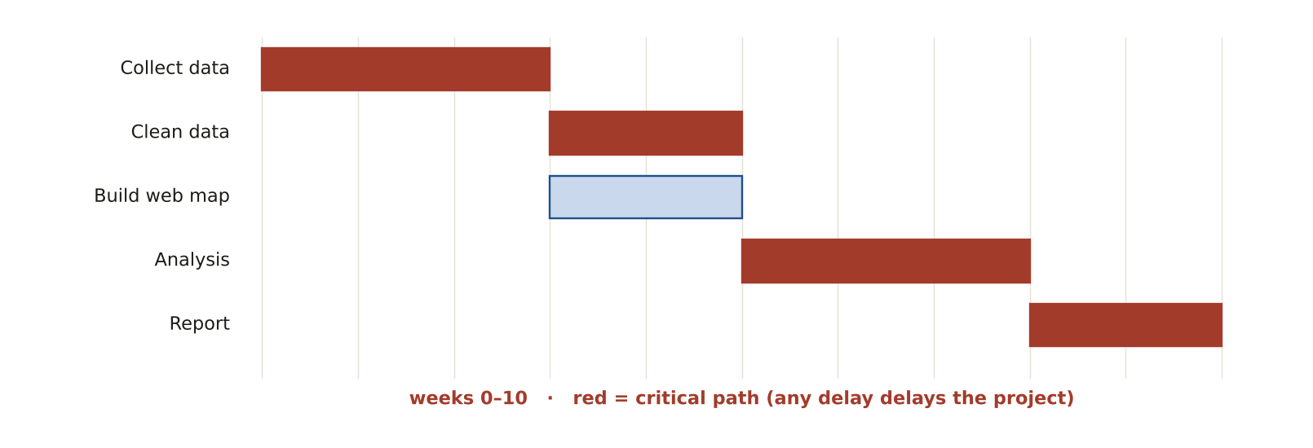
LIKELY EXAM QUESTION
The longest chain of dependent tasks is the:
A) WBS
B) Critical path
C) Baseline
D) Risk register
✔ Answer: B · It sets the earliest finish date.

10.6 Documenting and communicating
DEFINITION Record methods, sources, assumptions and limits. Match the message to the audience.
EXAMPLE Council members get a one-page map and decision; the technical team gets the full method report.
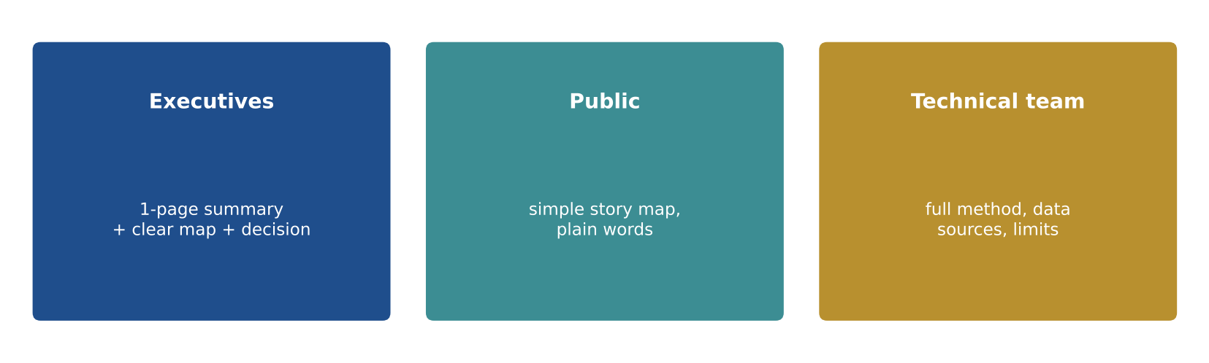
LIKELY EXAM QUESTION
The best way to present results to executives is:
A) Full code listing
B) Short summary with clear maps
C) Raw tables
D) Metadata XML
✔ Answer: B · Executives need results and decisions, not methods.

10.7 GIS in other fields
DEFINITION GIS supports many professions: planning, utilities, agriculture, health, emergency services, environment, transport, business.
EXAMPLE Health officials map disease cases to find clusters; farmers use GIS for variable-rate fertiliser.
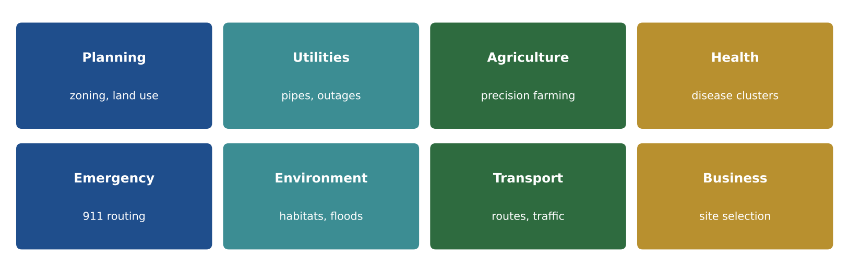
LIKELY EXAM QUESTION
Variable-rate fertiliser with GNSS and GIS is used in:
A) Precision agriculture
B) Law
C) Accounting
D) Linguistics
✔ Answer: A · Farm machines change rates by location.

10.8 Professional organisations
DEFINITION GISCI (GISP certification), URISA (urban and regional IS), ASPRS (photogrammetry and remote sensing), UCGIS (education, GIS&T Body of Knowledge), OGC (standards).
EXAMPLE The GIS&T Body of Knowledge, which the exam follows, is published by UCGIS.
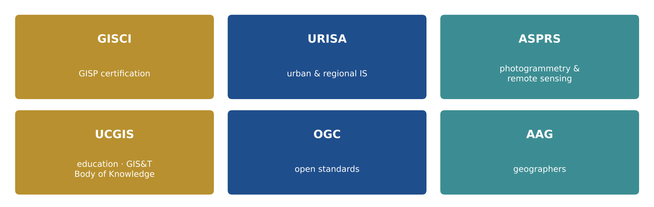
LIKELY EXAM QUESTION
Which organisation focuses on photogrammetry and remote sensing?
A) URISA
B) ASPRS
C) GISCI
D) UCGIS
✔ Answer: B · American Society for Photogrammetry and Remote Sensing.

10.9 GISP requirements
DEFINITION Education, at least 4 years of experience and contributions (portfolio), sign the Code of Ethics, pass the exam, recertify every 3 years.
EXAMPLE Passing in December 2026 means the first recertification is due around December 2029.
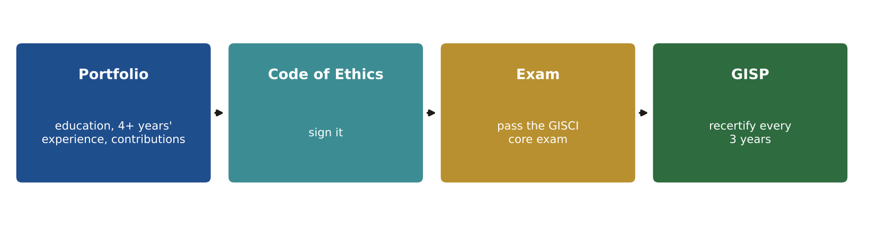
LIKELY EXAM QUESTION
How often must a GISP recertify?
A) Every year
B) Every 3 years
C) Every 5 years
D) Never
✔ Answer: B · Every three years.

Memory tricks
★ S-E-P-I The four ethical obligations: Society · Employers/funders · Profession/colleagues · Individuals.
★ "Monitor always" Monitoring and control run through every project phase.
★ "Boundaries belong to surveyors" GIS maps parcels; licensed surveyors decide legal lines.
★ 4 – 3 At least 4 years' experience to apply; recertify every 3 years.
If the question says… think…
If the question says… | …think
ethics question with pressure from a boss | choose honesty and transparency
"legal boundary" | licensed surveyor, not GIS
"when does monitoring happen?" | throughout all phases
"scope, time, cost" | triple constraint
"best data for a model" | authoritative data from the source
"personal information" | protect PII, follow privacy policy
Don't fall for it
- Project monitoring happens during ALL stages, not only at delivery.
- For suitability models, identify AUTHORITATIVE data and get it from the source — do not just collect 'everything available'.
- Ethics answers: choose honesty and transparency, even when a client or boss prefers another result.

Test yourself (cover the answers)
1. Your manager asks you to hide a data error from a client. What does the Code of Ethics say?
Answer: Be honest: disclose the error.
2. Name the triple constraint.
Answer: Scope, time and cost.
3. Who determines a disputed legal property line?
Answer: A licensed surveyor.
Pairs people mix up

The exam loves to test the difference. Read across each row.
This | vs this | The difference
Datum | Projection | Datum = where the coordinates are anchored (Earth model). Projection = how the round Earth is drawn flat.
Geographic CS | Projected CS | Degrees on a globe vs metres/feet on a flat plane.
Ellipsoid | Geoid | Smooth math shape vs gravity surface (≈ sea level).
Conformal | Equal-area | Keeps shape/angles vs keeps area.
Large scale | Small scale | 1:1,000 (detailed, small area) vs 1:1,000,000 (general, big area).
Accuracy | Precision | Close to truth vs repeatable/detailed.
QA | QC | Prevent errors (process) vs find errors (product).
Vector | Raster | Points/lines/polygons vs grid of cells.
Raster | TIN | Regular cells vs irregular triangles.
DEM / DTM | DSM | Bare-earth vs top surface including trees and buildings.
Passive sensor | Active sensor | Uses sun/emitted energy vs sends its own (lidar, radar).
Vertical photo | Oblique photo | Straight down, measurable vs angled, distorted, shows facades.
Supervised | Unsupervised | Classification with training samples vs computer clustering.
Producer's accuracy | User's accuracy | Omission error (map maker view) vs commission error (map user view).
Nearest neighbour | Bilinear/cubic | Categorical data vs continuous data resampling.
Clip | Intersect | Cut to a boundary (input attributes only) vs keep common area with attributes of both.
Union | Intersect | Everything from both vs only the overlap.
Join | Relate | Merge attributes into one table (1:1, M:1) vs keep linked (1:M, M:N).
Append | Merge | Add rows into an existing dataset vs create a new combined dataset.
Equal interval | Quantile | Equal value ranges vs equal number of features.
Local | Focal | Cell by cell vs moving neighbourhood window.
Zonal | Global | Statistics per zone vs operation using the whole raster.
Authentication | Authorisation | Who you are vs what you may do.
Waterfall | Agile | Sequential phases vs short iterative sprints.
WMS | WFS | Map images vs actual vector features.
AR | VR | Digital layer on the real view vs fully virtual world.
Numbers & formulas

Every number the exam can ask you to use or calculate.
DMS → decimal degrees | DD = D + M/60 + S/3600 (35°15′ = 35.25°)
1° of latitude | ≈ 111 km (69 miles). Longitude degrees shrink toward the poles (× cos latitude).
UTM | 60 zones × 6° • metres • scale factor 0.9996 • false easting 500,000 m
GPS 3D position | Minimum 4 satellites (x, y, z + receiver clock)
Orthometric height | H = h − N (ellipsoid height minus geoid height)
Distance | d = √((x₂ − x₁)² + (y₂ − y₁)²)
RMSE | √( Σ error² ÷ n )
NSSDA (95%) | Horizontal = 1.7308 × RMSEr • Vertical = 1.9600 × RMSEz
NMAS (1947) | 90% of points within 1/30 inch (> 1:20,000) or 1/50 inch (≤ 1:20,000)
NDVI | (NIR − Red) ÷ (NIR + Red); range −1 to +1, healthy vegetation high
Photo scale | f ÷ (H − h) (focal length ÷ flying height above ground)
Polynomial control points | 1st order ≥ 3 • 2nd order ≥ 6 • 3rd order ≥ 10
Hillshade default | Sun azimuth 315° (NW), altitude 45°
Stereo imagery | ≈ 60% forward overlap, ≈ 30% side overlap
PLSS | Township 6 × 6 mi = 36 sections • section = 640 acres
Nearest-neighbour index | R < 1 clustered • R ≈ 1 random • R > 1 dispersed
Moran's I | + clustered • ~0 random • − dispersed
Shapefile limits | 2 GB per file • 10-character field names
Choropleth classes | Usually 5–7 classes
GISP | 4 yrs experience • exam + portfolio + ethics • recertify every 3 yrs
The night before: 40 facts

If you remember only one page, make it this one.
1. UTM: 60 zones × 6°, metres, false easting 500,000 m, k = 0.9996  2. Zone formula: floor((longitude + 180) ÷ 6) + 1  3. Heights: H = h − N (map height = GPS height − geoid height)  4. DMS → DD: D + M/60 + S/3600  5. Projections: Conformal = shape · Equal-area = area · Equidistant = distance · Azimuthal = direction  6. Mercator: Scale k = sec φ (2× at 60°): Greenland looks huge  7. RMSE: √(Σ error² ÷ n); lower = more accurate  8. NSSDA 95%: Horizontal 1.7308 × RMSEr · Vertical 1.9600 × RMSEz  9. Quality elements: Positional, attribute, completeness, temporal, logical consistency, lineage  10. QA / QC: QA = before (process) · QC = after (product)  11. Scale: Large scale = small area, more detail  12. Measurement: Nominal, ordinal, interval, ratio (NOIR)  13. Choropleth: Rates and densities only, never raw totals  14. GNSS: 4 satellites for 3D; low PDOP = good; RTK = cm  15. NDVI: (NIR − Red) ÷ (NIR + Red), −1 to +1  16. Resolutions: Spatial, spectral, radiometric, temporal  17. Confusion matrix: Producer's = omission · User's = commission  18. Resampling: Nearest for categories · bilinear/cubic for continuous  19. Georeferencing: 1st order 3 points · 2nd 6 · 3rd 10  20. Shapefile: 2 GB, 10-character field names, no topology | 21. SQL wildcards: % any characters · _ one character (with LIKE)  22. Overlay: Intersect = both · Union = either · Clip = cut to boundary  23. Map algebra: Local · Focal · Zonal · Global  24. Statistics: NNI R < 1 clustered · Moran's I + clustered · Gi* hot spots  25. Kriging: Semivariogram + error surface  26. Normal forms: The key (1NF), the whole key (2NF), nothing but the key (3NF)  27. Many-to-many: Junction table + relate  28. Domain: Stops spelling errors in attributes  29. Versioning / replication: Many editors / remote offices  30. SQL families: DDL structure · DML data · DCL permissions  31. OGC: WMS map · WFS features · WCS raster · WPS processing  32. HTTPS: Secure and widely accessible  33. Testing: Unit → integration → system → UAT  34. Cloud: IaaS · PaaS · SaaS; scalable, not automatically secure  35. AR vs VR: AR adds to the real view · VR replaces it  36. Ethics: Society, employers, profession, individuals; always honest  37. Legal boundaries: Licensed surveyors, not GIS  38. Projects: Monitoring in all phases; scope–time–cost  39. GISP: 4+ years' experience, Code of Ethics, exam, renew every 3 years  40. Exam: 100 scored questions, 4 hours, pass = scaled 73

On exam day
- Arrive 30 minutes early with the ID that matches your Pearson VUE booking.
- Read NOT / EXCEPT and "select all" questions twice.
- Remove two wrong answers first, then pick the one that is true in every case.
- Flag hard questions and move on. Answer everything: no penalty for guessing.
150 practice questions

Original questions in the exam's style, grouped by knowledge area in proportion to the blueprint weights (not official GISCI items).
Are you ready?
- Answer all questions without looking, then mark them with the key.
- 80% or more in every area: you are in good shape. Below 70% in an area: re-read its concept cards.
- Redo every question you got wrong after 3 days.
Area 1 · Conceptual Foundations
1. A dataset is stored in WGS 84 geographic coordinates. What are its units?
A) Metres
B) Feet
C) Decimal degrees
D) US survey feet
2. Convert 24°30′36″ to decimal degrees.
A) 24.36
B) 24.51
C) 24.3036
D) 24.50
3. Which projection property does the Albers projection preserve?
A) Shape
B) Area
C) Direction from centre
D) True distance everywhere
4. A GPS gives an ellipsoid height of 50 m. The geoid height (N) is −30 m. What is the orthometric height?
A) 20 m
B) 50 m
C) 80 m
D) −80 m
5. How wide is each UTM zone?
A) 3° longitude
B) 6° longitude
C) 8° latitude
D) 10° longitude
6. Which phenomena are continuous? (Select all that apply)
A) Precipitation
B) Land parcels
C) Elevation
D) School districts
7. Which surface is used as the reference for orthometric heights (heights above mean sea level)?
A) Geoid
B) Datum plane
C) Sphere
D) Ellipsoid
8. Which datum is the realisation used by GPS?
A) NAVD88
B) NAD83
C) WGS 84
D) NAD27
9. A city stores parcels in a projected coordinate system. Which is the most likely unit?
A) Decimal degrees
B) Grads
C) Feet or metres
D) Radians
10. Which projection family is best for a country that is long in the east–west direction in the mid-latitudes?
A) Transverse Mercator
B) Lambert Conformal Conic
C) Gnomonic
D) Polar stereographic
11. Which is a CONTINUOUS phenomenon?
A) Road centrelines
B) Air temperature
C) Parcel boundaries
D) Fire hydrants
12. Convert 24.5° to degrees and minutes.
A) 24°30′
B) 24°05′
C) 24°15′
D) 24°50′
13. Which line on a map crosses every meridian at the same angle?
A) Great circle
B) Small circle
C) Rhumb line (loxodrome)
D) Geodesic
14. Which shortest-path line between two points on the globe is called a great circle?
A) A line of constant bearing
B) A line whose plane passes through the Earth's centre
C) Any parallel of latitude
D) A contour line
15. Which discipline is NOT usually considered part of geomatics?
A) Surveying
B) Photogrammetry
C) Remote sensing
D) Accounting
Area 2 · Geospatial Data Fundamentals
16. Two polygons share a common boundary. Which topological relationship is this?
A) Connectivity
B) Adjacency
C) Containment
D) Disjoint
17. Which activity is quality CONTROL rather than quality assurance?
A) Writing a digitising standard
B) Training field crews
C) Running topology checks on the delivered data
D) Defining a data model before collection
18. Which map scale is the LARGEST scale?
A) 1:1,000,000
B) 1:250,000
C) 1:100,000
D) 1:24,000
19. Which standard defines geographic metadata content internationally?
A) ISO 19115
B) ISO 9001
C) OGC WMS
D) ISO 14001
20. Which statement about accuracy and precision is TRUE?
A) Precise data is always accurate
B) Accurate data is always precise
C) Data can be precise but inaccurate
D) They mean the same thing
21. Which is a core element of data quality in ISO/FGDC? (Select all that apply)
A) Completeness
B) Software vendor
C) Positional accuracy
D) Lineage
22. Which OGC standard returns map IMAGES?
A) WFS
B) WMS
C) WCS
D) GML
23. Which vector geometry best represents a lake for calculating its area?
A) Point
B) Line
C) Node
D) Polygon
24. What is the main advantage of the raster model?
A) Exact boundaries
B) Simple overlay and analysis of continuous surfaces
C) Built-in topology
D) Small file size always
25. Halving the cell size of a raster (e.g., 30 m to 15 m) multiplies the number of cells by about:
A) 0.5
B) 8
C) 2
D) 4
26. Two polygons that share an edge are described as:
A) Contained
B) Disjoint
C) Connected
D) Adjacent
27. A dataset is missing 15% of the buildings in its area. Which quality element is weak?
A) Positional accuracy
B) Completeness
C) Lineage
D) Temporal accuracy
28. Records of where the data came from and how it was processed are called:
A) Precision
B) Logical consistency
C) Topology
D) Lineage
29. Which statement about accuracy is TRUE?
A) Accuracy only applies to rasters
B) Accuracy can never be measured
C) Accuracy compares data with a more accurate reference
D) Accuracy means many decimal places
30. Which metadata standard is the international ISO standard?
A) ISO 19115
B) OGC KML
C) FGDC CSDGM
D) ISO 9001
31. Which organisation develops open standards such as WMS, WFS and GML?
A) ISO
B) FGDC
C) ANSI
D) OGC
32. Storing the date when each feature was valid allows:
A) Topology
B) Generalisation
C) Temporal analysis
D) Projection
33. Error that is consistent in one direction (e.g., every point shifted 5 m east) is:
A) Blunder
B) Random error
C) Precision
D) Systematic error
34. A large mistake such as a typed coordinate with a missing digit is called a:
A) Blunder (gross error)
B) Systematic error
C) Bias
D) Random error
35. A 1:24,000 map is printed with a 0.5 mm line. About how wide is the line on the ground?
A) 12 m
B) 0.12 m
C) 120 m
D) 1.2 m
36. Which data model stores elevation as connected triangular faces?
A) Raster
B) Shapefile
C) TIN
D) Point cloud only
37. Which topology rule finds polygons that overlap when they should not?
A) Must not have gaps
B) Must be single part
C) Must not overlap
D) Must not have dangles
Area 3 · Cartography & Visualization
38. You want to map TOTAL population by county. Which map type is best?
A) Choropleth
B) Proportional symbol
C) Isarithmic
D) Dot density with no legend
39. The data shows % change from last year (−20% to +20%). Which colour scheme fits?
A) Sequential
B) Qualitative
C) Diverging
D) Single hue random
40. What does closely spaced contour lines indicate?
A) Flat land
B) Steep slope
C) Water body
D) Data error
41. Which visual variable is best for showing CATEGORIES (land-use types)?
A) Size
B) Colour value (lightness)
C) Colour hue
D) Graduated symbols
42. Which colour scheme best shows population density from low to high?
A) Qualitative
B) Diverging
C) Sequential
D) Random
43. Which map element tells the reader what the symbols mean?
A) Neatline
B) Scale bar
C) North arrow
D) Legend
44. Which visual variable is best for showing ORDERED data such as low, medium, high?
A) Hue
B) Lightness (value)
C) Orientation
D) Shape
45. A dot-density map shows:
A) Only categories
B) Quantities by placing dots that each represent a set number
C) Exact locations of every person
D) Elevation
46. An isarithmic map uses:
A) Shaded areas by unit
B) Flow arrows
C) Proportional circles
D) Lines of equal value
47. Which projection should a world choropleth map of population density use?
A) An equal-area projection
B) Any conformal projection
C) Gnomonic
D) Mercator
48. A cartogram:
A) Resizes areas by a variable such as population
B) Shows elevation
C) Shows true shapes
D) Is only for navigation
49. Where is the light source in a standard hillshade?
A) North (0°), 90°
B) North-west (315°), 45° altitude
C) South-east, 15°
D) Directly overhead
50. Which surface layer shows the downhill direction each cell faces?
A) Slope
B) Aspect
C) Hillshade
D) Curvature
51. Vertical exaggeration in a 3D scene is used to:
A) Make subtle relief easier to see
B) Correct projection errors
C) Reduce file size
D) Change the datum
52. Which typographic convention is standard for water features?
A) Blue italic
B) Black all-caps
C) Green underlined
D) Bold red upright
Area 4 · Data Acquisition
53. NDVI is calculated from which bands?
A) Blue and green
B) Red and near-infrared
C) Thermal and red
D) Green and SWIR
54. Which sensors are ACTIVE? (Select all that apply)
A) Lidar
B) Landsat multispectral
C) Synthetic aperture radar
D) Aerial camera
55. A digitised line stops short of the line it should meet. This is a(n):
A) Overshoot
B) Undershoot
C) Sliver
D) Spike
56. Which GPS technique gives centimetre accuracy in real time using a base station?
A) Autonomous GPS
B) WAAS
C) RTK
D) Assisted GPS
57. For a supervised classification, what must the analyst provide?
A) Number of clusters only
B) Training samples
C) A DEM
D) Nothing
58. Which GNSS term describes the quality of the satellite geometry?
A) RTK
B) WAAS
C) DOP
D) SNR
59. Signals bouncing off buildings before reaching the receiver cause:
A) Multipath error
B) Selective availability
C) Ionospheric delay only
D) Clock drift
60. Differential GNSS improves accuracy by:
A) Using corrections from a base station at a known location
B) Recording longer attribute lists
C) Using a larger antenna only
D) Using more satellites
61. Which sensor works through clouds and at night?
A) Thermal camera only
B) Multispectral optical
C) Synthetic aperture radar (SAR)
D) Panchromatic camera
62. A satellite with 11-bit data has which radiometric resolution?
A) 1,024 levels
B) 256 levels
C) 11 grey levels
D) 2,048 levels
63. Which classification needs training samples from the analyst?
A) Supervised
B) Unsupervised
C) Random
D) ISODATA only
64. In a confusion matrix, overall accuracy equals:
A) The kappa value
B) Producer's accuracy × user's accuracy
C) Correct pixels on the diagonal ÷ total pixels
D) Total pixels ÷ classes
65. Which lidar return is most useful for building a bare-earth DEM?
A) Last (ground-classified) return
B) First return
C) Any return
D) Intensity only
66. Which data source is collected by volunteers and needs careful quality checks?
A) Ortho imagery from a contractor
B) Volunteered Geographic Information (VGI)
C) Census TIGER files
D) Survey-grade GNSS
67. Scanning a paper map produces:
A) A geodatabase
B) Raster data
C) A TIN
D) Vector data
68. Converting a scanned raster map into lines automatically is called:
A) Mosaicking
B) Rasterisation
C) Vectorisation
D) Orthorectification
69. Which is TRUE about OpenStreetMap data?
A) It is open but requires attribution under its licence
B) It cannot be downloaded
C) It is always survey-accurate
D) It has no licence
Area 5 · Data Manipulation
70. You are resampling a LAND-COVER raster. Which method should you use?
A) Bilinear
B) Cubic convolution
C) Nearest neighbour
D) Spline
71. Minimum number of control points for a 1st-order (affine) transformation?
A) 2
B) 3
C) 6
D) 10
72. At small scale, a city polygon is shown as a dot. Which generalisation operator?
A) Displacement
B) Collapse
C) Smoothing
D) Exaggeration
73. Which are shapefile limitations? (Select all that apply)
A) 10-character field names
B) 2 GB file size limit
C) Cannot store a coordinate system
D) Does not store topology
74. Which format is a web-friendly JSON format that normally uses WGS 84 lon/lat?
A) GML
B) GeoJSON
C) DWG
D) MrSID
75. Which transformation keeps shapes but can scale, rotate and shift data?
A) Rubber-sheeting
B) Similarity (conformal)
C) Spline
D) Polynomial 3rd order
76. A high RMS error after georeferencing most likely means:
A) The control points are well matched
B) Some control points are wrong or poorly placed
C) The projection is equal-area
D) The raster is too small
77. Which resampling method is best for a DEM?
A) Bilinear or cubic convolution
B) Nearest neighbour
C) Majority
D) Mode
78. Reprojecting data from one coordinate system to another that uses a different datum requires:
A) A topology rule
B) Only changing the units
C) Generalisation
D) A geographic (datum) transformation
79. Matching features across the boundary of two adjacent map sheets is:
A) Snapping
B) Rubber-sheeting
C) Conflation
D) Edge-matching
80. Which generalisation operator merges several small building polygons into one built-up area?
A) Displace
B) Simplify
C) Aggregate
D) Exaggerate
81. Moving a road symbol slightly so it does not touch a river symbol at small scale is:
A) Collapse
B) Displacement
C) Selection
D) Smoothing
82. Which format is a single open file based on SQLite that can hold vectors and rasters?
A) DWG
B) Shapefile
C) GeoPackage
D) KML
83. Which shapefile component stores the coordinate system?
A) .shp
B) .shx
C) .prj
D) .dbf
84. Which format is used to store lidar point clouds?
A) GeoTIFF
B) LAS / LAZ
C) CSV only
D) GPX
85. ETL in data integration stands for:
A) Export, Translate, Link
B) Enter, Track, Log
C) Extract, Transform, Load
D) Edit, Test, Load
86. Before overlaying layers from different sources, you should first:
A) Generalise all layers
B) Delete the metadata
C) Convert them to KML
D) Put them in the same coordinate system
Area 6 · Analytical Methods
87. Which SQL finds every name CONTAINING 'Park'?
A) Name = 'Park'
B) Name LIKE 'Park%'
C) Name LIKE '%Park%'
D) Name LIKE 'Park'
88. Which overlay keeps ONLY the area common to both layers?
A) Union
B) Intersect
C) Erase
D) Identity
89. A Moran's I value near +1 means:
A) Random pattern
B) Dispersed pattern
C) Clustered pattern
D) No data
90. Calculating slope from a DEM using a 3×3 window is which map-algebra type?
A) Local
B) Focal
C) Zonal
D) Global
91. Mean elevation for each watershed is which map-algebra type?
A) Local
B) Focal
C) Zonal
D) Global
92. Errors at 4 check points are 3, 4, 0 and 5 m. RMSE ≈ ?
A) 3.0 m
B) 3.5 m
C) 12.5 m
D) 4.0 m
93. Which interpolation uses a semivariogram and gives a prediction-error surface?
A) IDW
B) Spline
C) Kriging
D) Natural neighbour
94. The classification that puts the SAME NUMBER of features in each class is:
A) Equal interval
B) Quantile
C) Natural breaks
D) Standard deviation
95. Which tool creates zones at a set distance around features?
A) Dissolve
B) Clip
C) Buffer
D) Union
96. Which tool removes boundaries between polygons that share the same attribute value?
A) Merge
B) Split
C) Dissolve
D) Erase
97. Which tool attaches the attributes of a polygon to the points that fall inside it?
A) Spatial join
B) Buffer
C) Append
D) Erase
98. Thiessen (Voronoi) polygons define:
A) Areas closest to each point
B) Watersheds
C) Equal-area zones
D) Buffers of equal size
99. Which hydrology step must come BEFORE flow accumulation?
A) Kriging
B) Hillshade
C) Viewshed
D) Flow direction
100. A z-score of +2.8 for a hot-spot result means:
A) A statistically significant high cluster
B) Dispersion
C) A cold spot
D) Not significant
101. Which network analysis finds the area reachable within 10 minutes of a fire station?
A) Route
B) OD cost matrix
C) Service area
D) Closest facility
102. The mean centre of a set of points is:
A) The largest cluster
B) The average x and average y
C) The median of the attribute
D) The point closest to all others by network distance
103. Weighted overlay is used mainly for:
A) Suitability analysis
B) Georeferencing
C) Topology checks
D) Map projections
Area 7 · Database Design & Management
104. Students and classes (each student takes many classes; each class has many students) is:
A) 1:1
B) 1:M
C) M:N
D) M:1
105. Removing transitive dependencies brings a table to:
A) 1NF
B) 2NF
C) 3NF
D) Denormalised form
106. Multiple editors work at the same time and later 'reconcile and post'. This is:
A) Replication
B) Versioning
C) Archiving
D) Indexing
107. Which SQL command gives a user permission to read a table?
A) CREATE
B) UPDATE
C) GRANT
D) SELECT
108. A primary key must be:
A) Repeated in every row
B) A text field
C) Unique and not null
D) Optional
109. A field in one table that refers to the primary key of another table is a:
A) Foreign key
B) Composite key
C) Domain
D) Index
110. Which design stage produces an entity-relationship (E-R) diagram?
A) Conceptual
B) Implementation
C) Maintenance
D) Physical
111. Choosing data types, field lengths and indexes for a specific DBMS happens in which design stage?
A) Logical
B) Physical
C) Requirements
D) Conceptual
112. A table stores 'Phone1, Phone2, Phone3' columns for each person. This breaks:
A) 3NF only
B) 1NF (repeating groups)
C) Topology
D) Referential integrity
113. Which SQL statement creates a new table?
A) UPDATE
B) CREATE TABLE
C) GRANT
D) SELECT
114. Which SQL statement changes values in existing records?
A) DROP
B) INSERT
C) UPDATE
D) ALTER
115. An index on a field mainly:
A) Speeds up searches
B) Creates backups
C) Stops typing errors
D) Encrypts the data
116. The 'A' in ACID transactions stands for:
A) Availability
B) Accuracy
C) Access
D) Atomicity
117. Which security principle protects data from unauthorised CHANGE?
A) Scalability
B) Integrity
C) Availability
D) Confidentiality
118. Restoring a geodatabase after a server failure depends mostly on:
A) A new projection
B) More domains
C) Larger field names
D) A tested backup plan
Area 8 · Application Development
119. Which OGC service lets a client EDIT vector features over the web?
A) WMS
B) WMTS
C) WFS-T
D) WCS
120. Short iterations called sprints, with continuous testing, describe:
A) Waterfall
B) Agile/Scrum
C) Big-bang
D) Spiral only
121. Which protocol is used to transfer files securely?
A) HTTP
B) SFTP
C) SMTP
D) FTP
122. In a REST web service, which HTTP verb is used to READ data?
A) GET
B) DELETE
C) PUT
D) POST
123. Which data format is lightweight, text-based and common in web maps?
A) E00
B) GeoJSON
C) DWG
D) MrSID
124. Which OGC service returns raster coverage data such as elevation values?
A) WFS
B) WCS
C) WMS
D) CSW
125. What does this pseudocode print? x = 2; for i in 1 to 3: x = x * 2; print x
A) 12
B) 6
C) 8
D) 16
126. A reusable block of code that takes inputs and returns a result is a:
A) Comment
B) Variable
C) Loop
D) Function
127. Version control systems such as Git are used to:
A) Track changes to code and allow collaboration
B) Project data
C) Encrypt databases
D) Classify imagery
128. Which development approach completes each stage (requirements, design, build, test) before the next starts?
A) Agile
B) Kanban
C) Waterfall
D) Scrum
Area 9 · Systems Design & Management
129. Cloud model where the vendor delivers ready-to-use software through a browser:
A) IaaS
B) PaaS
C) SaaS
D) On-premises
130. Giving users only the minimum access they need is the principle of:
A) Least privilege
B) Single sign-on
C) Load balancing
D) Elasticity
131. A headset shows a fully computer-generated city that replaces the real view. This is:
A) Augmented reality
B) Virtual reality
C) Mixed reality
D) Remote sensing
132. In a three-tier architecture, the middle tier usually contains:
A) The user interface
B) The database files
C) The business logic / application server
D) The network cables
133. Which cloud model gives you virtual servers that you manage yourself?
A) IaaS
B) SaaS
C) On-premises
D) PaaS
134. A network zone that sits between the internet and the internal network to host public web servers is a:
A) VPN
B) LAN
C) Domain
D) DMZ
135. Requiring a password AND a code from a phone is:
A) Single sign-on
B) Role-based access
C) Multi-factor authentication
D) Encryption at rest
136. Which attack inserts malicious commands into a database query through a web form?
A) Phishing
B) SQL injection
C) Denial of service
D) Ransomware
137. A live 3D model of a city that is updated with sensor data is called a:
A) Digital twin
B) Thematic map
C) Mosaic
D) Cartogram
138. Which is the FIRST step when planning an enterprise GIS?
A) Write code
B) Buy software
C) Needs assessment with users
D) Load data
Area 10 · Professional Practice
139. A client asks you to adjust weights so their preferred site ranks first, without justification. You should:
A) Adjust quietly
B) Refuse and report results honestly with documented methods
C) Delete the analysis
D) Change the data source
140. Which organisation publishes the GIS&T Body of Knowledge?
A) GISCI
B) UCGIS
C) ASPRS
D) OGC
141. Which organisation awards the GISP certification?
A) URISA
B) OGC
C) ASPRS
D) GISCI
142. Which organisation focuses on photogrammetry and remote sensing professionals?
A) ASPRS
B) URISA
C) UCGIS
D) NSGIC
143. Which organisation is known for urban and regional information systems and GIS management?
A) IEEE
B) ASPRS
C) ISO
D) URISA
144. A public agency receives a request for GIS data under an open-records law. You should first:
A) Delete sensitive layers
B) Follow the agency's policy and check for restricted or private data
C) Refuse every request
D) Send all data immediately
145. You discover your published map contains an error that affects decisions. The ethical action is to:
A) Ignore it
B) Tell those affected and correct it
C) Wait until someone complains
D) Remove your name from it
146. Uncontrolled growth of a project's requirements is called:
A) Scope creep
B) Baseline
C) Lessons learned
D) Critical path
147. The longest chain of dependent tasks that sets the project finish date is the:
A) Gantt chart
B) Critical path
C) Work breakdown structure
D) Risk register
148. Which profession uses GIS mainly for crop monitoring and variable-rate application?
A) Law
B) Precision agriculture
C) Linguistics
D) Accounting
149. Before sharing a dataset outside your organisation you should check:
A) The software version
B) Only its file size
C) Its licence and sharing policy
D) Its colour scheme
150. GISP recertification is required every:
A) Year
B) 5 years
C) 3 years
D) 10 years
Answer key

Q | Answer | Area | Why
1 | C | 1 | Geographic coordinate systems use angular units.
2 | B | 1 | 24 + 30/60 + 36/3600 = 24 + 0.5 + 0.01 = 24.51.
3 | B | 1 | Albers is an equal-area conic projection.
4 | C | 1 | H = h − N = 50 − (−30) = 80 m.
5 | B | 1 | 60 zones × 6° = 360°.
6 | AC | 1 | They have a value at every location; parcels and districts are discrete.
7 | A | 1 | Orthometric heights are measured from the geoid, which approximates mean sea level.
8 | C | 1 | GPS broadcasts positions in WGS 84.
9 | C | 1 | Projected systems use linear units such as feet or metres.
10 | B | 1 | A conic projection fits mid-latitude areas with a large east–west extent.
11 | B | 1 | Temperature has a value everywhere, so it is continuous.
12 | A | 1 | 0.5 × 60 = 30 minutes.
13 | C | 1 | A rhumb line keeps a constant bearing and is straight on Mercator.
14 | B | 1 | Great circles lie on a plane through the Earth's centre; the equator and meridians are examples.
15 | D | 1 | Geomatics covers surveying, GNSS, photogrammetry, remote sensing, mapping and GIS.
16 | B | 2 | Adjacency = neighbours sharing an edge.
17 | C | 2 | QC checks the finished product; the others prevent errors (QA).
18 | D | 2 | Large scale = smallest denominator = most detail.
19 | A | 2 | ISO 19115 is the metadata standard (ISO 19139 is its XML encoding).
20 | C | 2 | Repeated measurements can cluster tightly around the wrong value.
21 | ACD | 2 | Vendor is not a data quality element.
22 | B | 2 | WMS = Web Map Service (pictures).
23 | D | 2 | Only polygons have area.
24 | B | 2 | Cell-by-cell math makes rasters ideal for continuous surfaces and overlay.
25 | D | 2 | Cells grow with the square: (30/15)² = 4.
26 | D | 2 | Adjacency means sharing a boundary.
27 | B | 2 | Completeness measures what is missing (omission) or extra (commission).
28 | D | 2 | Lineage is the history of the data.
29 | C | 2 | Accuracy is assessed against an independent source of higher accuracy.
30 | A | 2 | ISO 19115 defines geographic metadata content.
31 | D | 2 | The Open Geospatial Consortium (OGC) publishes these standards.
32 | C | 2 | Time attributes support change and temporal analysis.
33 | D | 2 | Systematic errors are biased in one direction and can often be corrected.
34 | A | 2 | Blunders are big mistakes found with validation checks.
35 | A | 2 | 0.5 mm × 24,000 = 12,000 mm = 12 m.
36 | C | 2 | A TIN stores triangles between irregular points.
37 | C | 2 | The 'must not overlap' rule flags overlaps.
38 | B | 3 | Raw counts suit proportional symbols; choropleths need normalised data.
39 | C | 3 | Diverging schemes show values above/below a meaningful midpoint (0%).
40 | B | 3 | Elevation changes quickly over a short distance.
41 | C | 3 | Hue suits nominal data; value/size imply order or quantity.
42 | C | 3 | Low-to-high data needs a sequential scheme.
43 | D | 3 | The legend explains the symbols.
44 | B | 3 | Lightness shows order; hue shows categories.
45 | B | 3 | Each dot stands for a fixed count, placed randomly within the area.
46 | D | 3 | Isolines (contours, isotherms) connect equal values.
47 | A | 3 | Density compares areas, so area must be kept true.
48 | A | 3 | Cartograms distort size to show a value.
49 | B | 3 | 315° azimuth and 45° altitude look natural to most readers.
50 | B | 3 | Aspect is the compass direction of the slope.
51 | A | 3 | Stretching z values makes small height differences visible.
52 | A | 3 | Hydrographic labels are blue and italic.
53 | B | 4 | NDVI = (NIR − Red)/(NIR + Red).
54 | AC | 4 | Active sensors emit their own energy.
55 | B | 4 | An undershoot leaves a dangle/gap.
56 | C | 4 | Real-Time Kinematic uses carrier-phase corrections from a base.
57 | B | 4 | Supervised = analyst-defined training areas.
58 | C | 4 | Dilution of precision; lower values mean better geometry.
59 | A | 4 | Multipath is common in urban canyons.
60 | A | 4 | The base station measures the error and sends corrections.
61 | C | 4 | Radar is active and uses microwaves that pass through clouds.
62 | D | 4 | 2¹¹ = 2,048 brightness levels.
63 | A | 4 | Supervised classification learns from analyst-defined training areas.
64 | C | 4 | Overall accuracy is the sum of the diagonal over the total.
65 | A | 4 | Last returns most often hit the ground.
66 | B | 4 | VGI quality varies between contributors.
67 | B | 4 | A scanner creates an image (raster).
68 | C | 4 | Vectorisation traces raster features into vectors.
69 | A | 4 | OSM uses the ODbL; you must credit the contributors.
70 | C | 5 | Nearest neighbour keeps the original class codes.
71 | B | 5 | 1st order ≥ 3, 2nd ≥ 6, 3rd ≥ 10.
72 | B | 5 | Collapse reduces dimension (area → point).
73 | ABD | 5 | The .prj file stores the coordinate system.
74 | B | 5 | GeoJSON (RFC 7946) uses WGS 84.
75 | B | 5 | A similarity transformation keeps shape.
76 | B | 5 | Check and remove control points with large residuals.
77 | A | 5 | Continuous data needs smooth resampling.
78 | D | 5 | A datum change needs a transformation such as NADCON or a grid method.
79 | D | 5 | Edge-matching joins features at sheet edges.
80 | C | 5 | Aggregation combines nearby features.
81 | B | 5 | Displacement separates crowded symbols.
82 | C | 5 | GeoPackage is an OGC standard using SQLite.
83 | C | 5 | The .prj file holds the projection definition.
84 | B | 5 | LAS is the standard lidar format; LAZ is compressed.
85 | C | 5 | ETL moves and reshapes data between systems.
86 | D | 5 | Layers must share a coordinate system to line up.
87 | C | 6 | % on both sides = any characters before and after.
88 | B | 6 | Intersect outputs only the overlapping area.
89 | C | 6 | Positive spatial autocorrelation = similar values cluster.
90 | B | 6 | It uses each cell's neighbourhood.
91 | C | 6 | Statistics per zone.
92 | B | 6 | (9+16+0+25)/4 = 12.5; √12.5 ≈ 3.54 m.
93 | C | 6 | Kriging is geostatistical.
94 | B | 6 | Quantile = equal count.
95 | C | 6 | Buffers create distance zones.
96 | C | 6 | Dissolve combines features with the same value.
97 | A | 6 | A spatial join transfers attributes by location.
98 | A | 6 | Every location inside a Thiessen polygon is nearest to its point.
99 | D | 6 | Fill sinks → flow direction → flow accumulation → watershed.
100 | A | 6 | |z| > 1.96 is significant at 95%; positive = hot spot.
101 | C | 6 | A service area shows reach within a time or distance limit.
102 | B | 6 | Mean centre = (mean x, mean y).
103 | A | 6 | Reclassified layers are weighted and added to rank sites.
104 | C | 7 | Many-to-many needs an associative table.
105 | C | 7 | 3NF = non-key fields depend only on the key.
106 | B | 7 | Versioning supports multi-user editing.
107 | C | 7 | GRANT is DCL (data control language).
108 | C | 7 | Each record needs a unique, non-empty identifier.
109 | A | 7 | Foreign keys build relationships.
110 | A | 7 | The conceptual model shows entities and relationships.
111 | B | 7 | The physical design targets the real software.
112 | B | 7 | Repeating groups violate first normal form.
113 | B | 7 | CREATE is a DDL statement.
114 | C | 7 | UPDATE changes data (DML); ALTER changes structure (DDL).
115 | A | 7 | Indexes make queries faster.
116 | D | 7 | Atomicity: a transaction completes fully or not at all.
117 | B | 7 | Integrity means data is not altered without permission.
118 | D | 7 | Regular, tested backups enable recovery.
119 | C | 8 | WFS-Transactional supports insert/update/delete.
120 | B | 8 | Agile works in sprints.
121 | B | 8 | SFTP runs file transfer over SSH (encrypted).
122 | A | 8 | GET retrieves a resource.
123 | B | 8 | GeoJSON is plain JSON for features.
124 | B | 8 | Web Coverage Service delivers raster values.
125 | D | 8 | 2 → 4 → 8 → 16 after three loops.
126 | D | 8 | Functions package reusable logic.
127 | A | 8 | Git records history and supports teamwork.
128 | C | 8 | Waterfall is sequential.
129 | C | 9 | Software as a Service.
130 | A | 9 | Least privilege limits damage from mistakes or attacks.
131 | B | 9 | VR replaces the real world; AR overlays it.
132 | C | 9 | Presentation → logic → data.
133 | A | 9 | Infrastructure as a Service = rented servers.
134 | D | 9 | The demilitarised zone isolates public-facing servers.
135 | C | 9 | MFA uses two or more factors.
136 | B | 9 | SQL injection abuses unvalidated input.
137 | A | 9 | Digital twins mirror the real asset with live data.
138 | C | 9 | Understand the business needs before choosing tools.
139 | B | 10 | GISCI ethics require honesty and transparency.
140 | B | 10 | UCGIS maintains the GIS&T BoK.
141 | D | 10 | The GIS Certification Institute awards the GISP.
142 | A | 10 | American Society for Photogrammetry and Remote Sensing.
143 | D | 10 | Urban and Regional Information Systems Association.
144 | B | 10 | Follow policy and protect confidential or personal data.
145 | B | 10 | Honesty and responsibility to the public come first.
146 | A | 10 | Scope creep adds work without control.
147 | B | 10 | Delays on the critical path delay the project.
148 | B | 10 | Agriculture uses GIS with GNSS and imagery for field management.
149 | C | 10 | Licences and policies decide what may be shared.
150 | C | 10 | GISPs recertify every three years.
Glossary

174 exam terms, A to Z. The number is the knowledge area.
Term | Area | Meaning
ACID | 7 | Atomicity, Consistency, Isolation, Durability of transactions.
Address locator | 4 | Reference data + rules used to geocode addresses.
Affine transformation | 5 | 1st-order: shift, rotate, scale, skew; needs 3+ points.
Aggregation | 5 | Grouping small features into a larger one.
Agile / Scrum / Sprint | 8 | Iterative method / framework / short work cycle.
API | 8 | Application Programming Interface: rules for programs to talk to each other.
Aspect | 3 | Compass direction a slope faces.
Associative table | 7 | Junction table that resolves a many-to-many link.
Authoritative data | 10 | Official data from the responsible source/agency.
Bilinear / cubic convolution | 5 | Resampling that averages values (continuous data).
Buffer | 6 | Zone at a set distance around features.
Cardinality | 7 | How many records relate to how many (1:1, 1:M, M:N).
Cartogram | 3 | Areas resized by a variable (e.g., population).
Central meridian | 1 | Line of longitude at the centre of a projection/zone.
Choropleth map | 3 | Areas shaded by a value; needs normalised data.
CI / CD | 8 | Continuous integration / continuous delivery.
Client | 9 | Computer/app that requests a service.
Cloud-Optimised GeoTIFF | 5 | GeoTIFF arranged for efficient web streaming.
COGO | 1 | Coordinate geometry: building features from bearings and distances.
Collapse | 5 | Reducing dimension: area → line or point.
Completeness | 2 | Nothing missing that should be there; no extra features.
Composite key | 7 | Primary key made of 2+ fields.
Conflation | 5 | Merging two datasets into one better dataset.
Conflict of interest | 10 | Personal interest that could bias professional work.
Confusion matrix | 4 | Table comparing classified vs reference classes.
Contour interval | 3 | Elevation difference between neighbouring contour lines.
Control points / links | 5 | Matching source and map locations used to georeference.
Critical path | 10 | Longest chain of dependent tasks; sets the finish date.
CSDGM | 2 | FGDC Content Standard for Digital Geospatial Metadata.
Dangle | 2 | Line end that does not connect to another line.
Dasymetric map | 3 | Refines a choropleth using ancillary data (e.g., only populated land).
Data dictionary | 7 | List of tables, fields, types and meanings.
Data-sharing agreement | 10 | Contract defining how data may be used and shared.
Datum transformation | 1 | Math to move coordinates between datums (e.g., NADCON, NTv2).
DBMS / RDBMS | 7 | Database management system (Oracle, SQL Server, PostgreSQL+PostGIS).
Decimal degrees (DD) | 1 | DD = D + M/60 + S/3600.
Definition query | 6 | Filter limiting which features a layer shows.
Developable surface | 1 | Cylinder, cone or plane used to flatten the globe.
DGPS | 4 | Differential GPS: corrections from a known base station.
Digital twin | 9 | Live digital copy of a real asset or city.
Displacement | 5 | Moving features apart so they do not overlap at small scale.
Dissolve | 6 | Merging features that share an attribute value.
DMZ | 9 | Network zone between internet and internal network.
Domain | 7 | Allowed values for a field (list or range).
Dot density | 3 | Each dot = a set number of items.
Douglas–Peucker | 5 | Classic line-simplification algorithm.
E-R diagram | 7 | Entity–Relationship model drawing.
Ecological fallacy | 2 | Wrongly applying group (area) statistics to individuals.
Edge-matching | 5 | Aligning features across adjacent map sheets/datasets.
Elasticity / scalability | 9 | Adding or removing resources as demand changes.
Ellipsoid (spheroid) | 1 | Smooth mathematical shape of the Earth (e.g., GRS80, WGS84, Clarke 1866).
EPSG / WKID | 1 | Numeric code that identifies a coordinate system.
ETL | 5 | Extract, Transform, Load workflow for data integration.
False easting / northing | 1 | Values added so coordinates stay positive.
Figure–ground | 3 | Making the subject stand out from the background.
Fitness for use | 2 | Is the data good enough for THIS purpose?
Focal (neighbourhood) | 6 | Operation using a moving window of cells.
FOIA / open records | 10 | Laws allowing the public to request government data.
Foreign key | 7 | Field that refers to a primary key in another table.
Function | 8 | Reusable named block of code.
Functional requirement | 9 | What the system must do.
Gantt chart | 10 | Bar chart schedule of tasks over time.
GeoAI | 9 | AI/machine learning applied to geospatial data.
Geoid | 1 | Gravity-based surface close to mean sea level; used for heights.
GeoPackage | 5 | Open OGC SQLite-based format for vector and raster.
Getis-Ord Gi* | 6 | Hot-spot / cold-spot statistic.
GIS&T Body of Knowledge | 10 | UCGIS outline of GIS knowledge; the exam is aligned to it.
GISP-E / PreGISP | 10 | Early-career GISCI credential and exam.
Graduated symbol | 3 | Symbols in size classes for quantities.
Graticule | 1 | Grid of latitude and longitude lines.
Great circle | 1 | Shortest route between two points on a sphere.
Ground control point (GCP) | 4 | Surveyed point used to correct or georeference imagery.
Heads-up digitising | 4 | Tracing features on screen over a background image.
Hillshade | 3 | Shaded relief from an imaginary light source.
Horizontal datum | 1 | Reference for lat/long: NAD27, NAD83, WGS84.
IaaS / PaaS / SaaS | 9 | Cloud service levels: infrastructure / platform / software.
IDW | 6 | Inverse distance weighted interpolation.
Index contour | 3 | Darker labelled contour every 4th or 5th line.
Inset / locator map | 3 | Small map showing detail or the wider location.
Isarithmic / isoline | 3 | Lines of equal value (contours, isotherms).
ISO 19115 / 19139 | 2 | ISO metadata standard / its XML implementation.
ISO 19157 | 2 | ISO standard for data quality.
JSON / GeoJSON | 8 | Lightweight data format / its geographic version.
Kernel density | 6 | Smooth surface showing concentration of points.
Kriging / semivariogram | 6 | Geostatistical interpolation / its spatial-correlation model.
Latency / bandwidth | 9 | Delay / data capacity of a network.
Least privilege | 7 | Give users only the access they need.
Lessons learned | 10 | Review at project end to improve future work.
Liability disclaimer | 10 | Statement limiting responsibility for misuse of data.
LIKE + % | 6 | Wildcard text match (any characters).
Lineage | 2 | History of the data: sources and processing steps.
Load balancer | 9 | Spreads traffic across servers.
Logical consistency | 2 | Data follows its rules (topology, valid values).
Loop | 8 | Repeats code (for each feature, while condition).
Lossless vs lossy | 5 | Compression that keeps / discards some data.
MAUP | 2 | Modifiable Areal Unit Problem: results change when zone boundaries/sizes change.
Metes and bounds | 1 | Legal description using bearings, distances and landmarks.
MFA | 9 | Multi-factor authentication (password + code/device).
Minimum mapping unit | 2 | Smallest area that is mapped as a separate feature.
Moran's I | 6 | Global measure of spatial autocorrelation.
Multi-tier architecture | 9 | Separated presentation, logic and data layers.
Multipath | 4 | GNSS signal bouncing off buildings/surfaces before reaching receiver.
Multispectral / hyperspectral | 4 | A few broad bands / hundreds of narrow bands.
Natural breaks (Jenks) | 6 | Classes at natural gaps in the data.
NDVI | 4 | Vegetation index from red and near-infrared bands.
Nearest neighbour | 5 | Resampling that keeps original values (categories).
Neatline | 3 | Border that frames the map.
Needs assessment | 9 | Study of what users need before designing a system.
Non-functional requirement | 9 | How well it must do it (speed, security, uptime).
Normalisation | 6 | Dividing by area or total to make fair comparisons.
NSDI | 2 | US National Spatial Data Infrastructure (led by FGDC).
NSSDA | 2 | US standard for reporting positional accuracy at 95%.
Object-oriented | 8 | Code organised as classes and objects.
Orthorectification | 4 | Removing tilt and terrain distortion from imagery.
Overshoot / undershoot | 4 | Line passes / stops short of where it should connect.
PDOP | 4 | Positional dilution of precision; lower = better satellite geometry.
PII | 10 | Personally Identifiable Information; must be protected.
Planar topology | 2 | Lines that cross must create a node (a problem for bridges/overpasses).
PLSS | 1 | US Public Land Survey System: township 6×6 miles = 36 sections; 1 section = 1 sq mile = 640 acres.
Point cloud | 4 | Millions of x,y,z points (lidar or photogrammetry).
Primary key | 7 | Field that uniquely identifies each record.
Profile | 3 | Cross-section graph of elevation along a line.
Proportional symbol | 3 | Symbol size directly proportional to the value.
Pseudocode | 8 | Plain-language outline of program logic.
Quantile | 6 | Equal number of features in each class.
Reconcile & post | 7 | Merge edits from a version back to the parent.
Relational / logical operator | 6 | Compare cells (>, <, =) or combine (AND, OR) → true/false output.
Relief displacement | 4 | Tall objects lean outward from the image centre.
Replication | 7 | Synchronised copies of a database in other places.
Representative fraction | 2 | Scale written as 1:24,000.
REST | 8 | Lightweight web-service style using URLs and HTTP verbs.
Rhumb line (loxodrome) | 1 | Line of constant compass bearing; straight on Mercator.
RMSE | 2 | Root mean square error: main measure of positional accuracy.
RTK | 4 | Real-Time Kinematic GNSS with a base station; centimetre accuracy.
Rubber-sheeting | 5 | Non-uniform stretching to fit known points.
SAR | 4 | Synthetic Aperture Radar; works through clouds and at night.
Schema | 7 | Structure of the database (tables, fields, rules).
Schema mapping | 5 | Matching fields from one data model to another.
Scope creep | 10 | Uncontrolled growth of project requirements.
SDK | 8 | Software Development Kit: tools/libraries to build apps.
Server | 9 | Computer that provides a service.
Simple Features | 2 | OGC/ISO standard geometry model (point, linestring, polygon).
Sliver polygon | 2 | Thin unwanted polygon from mismatched boundaries.
Snapping tolerance | 4 | Distance within which vertices join automatically.
Spatial index | 7 | Structure that speeds up location-based searches.
Spatial join | 6 | Transferring attributes based on location.
SSO | 9 | Single sign-on with one login for many systems.
Stakeholder | 10 | Anyone affected by or interested in the project.
Subtype | 7 | Sub-category within a feature class with its own defaults.
Tangent vs secant | 1 | Projection surface touches the globe at one line (tangent) or cuts it at two (secant, less distortion).
Thiessen / Voronoi | 6 | Polygons of area closest to each point.
Tissot's indicatrix | 1 | Circles drawn on a map to show projection distortion.
TLS / SSL | 8 | Encryption behind HTTPS.
UAT | 8 | User acceptance testing by real users before release.
Uncertainty / error propagation | 2 | Errors in inputs carry into, and can grow in, outputs.
Vectorisation | 4 | Converting scanned raster lines into vector features.
Version control (Git) | 8 | Tracks code changes and enables teamwork.
Versioning | 7 | Multi-user editing with separate versions.
Vertex / node | 2 | Vertex = any point on a line; node = start/end point or junction.
Vertical datum | 1 | Reference for heights: NGVD29, NAVD88.
Vertical exaggeration | 3 | Stretching z values so relief is easier to see.
VGI | 4 | Volunteered Geographic Information (e.g., OpenStreetMap).
View | 6 | Stored query that behaves like a table.
Viewshed | 3 | Area visible from an observer point.
Virtualisation / containers | 9 | Running many systems on shared hardware (VMs, Docker).
Visual hierarchy | 3 | Ordering map elements by importance through size, weight and contrast.
Waterfall | 8 | Step-by-step method; each phase finishes before the next.
WBS | 10 | Work Breakdown Structure: project split into tasks.
Web Mercator (EPSG:3857) | 1 | Projection used by web maps; bad for measuring area.
WHERE clause | 6 | Condition part of an SQL query.
WMS / WFS / WCS | 8 | OGC services for maps / features / coverages.
World file | 5 | Small text file (.tfw, .jgw) holding image georeferencing.
z-score / p-value | 6 | How unusual a result is / chance it is random.
Zonal | 6 | Operation summarising values within zones.
Independent study material based on the 2019 GISCI exam blueprint. Not affiliated with or endorsed by GISCI. Practice questions are original, not official exam items. Official information: gisci.org. © 2026 Mohamed Alkamel.



