**PROJECT REPORT**

NAME: ALKA

REGISTRATION NUMBER:17BCE2287

**QUES:2**. Create a GUI game in which whenever game starts , the game gives 10 randomly selected TV show names and jumbled , the user has to predict the correct name of the TV show and accordingly how many he guesses correct he gets 1 point. Remember the jumbled word should be different every time and also jumbled in a different way. Hint – use random library.

**ABSTRACT**: In this game whenever game starts ,the game gives us 10 randomly selected TV shows names and jumbled ,the user has to predict the correct name of of the TV show and accordingly how many he guesses coorrect he gets 1 point and the jumbled word will be different every time and will also be jumbled in a different way.For GUI we are using Python framework PyQt.Python offers multiple options for developing GUI (Graphical User Interface). Out of all the GUI methods, PyQt is most commonly used method. It is a standard Python interface to the Tk GUI toolkit shipped with Python. Python with tkinter outputs the fastest and easiest way to create the GUI applications.

**INTRODUCTION:** Python is used in GUI apps .The following game allow the user to play the as many times he wants to play and if he guesses the correct name of TV show he gets 1 point .we are using PyQt.It is a standard python interface to the Tk GUI toolkit shipped with python.

**METHODOLOGY:**

**1. CONCEPT BEING USED**: Firstly we will be Importing the module – PyQt and then we will create the main window (container) and we will add any number of widgets to the main window and at last we will apply the event Trigger on the widgets.

**2**.**BLOCK DIAGRAM OF EXECUTION:**

**3.CODE:**

# -- coding: utf-8 --

# Form implementation generated from reading ui file 'gui.ui'

#

# Created by: PyQt5 UI code generator 5.5.1

#

# WARNING! All changes made in this file will be lost!

from PyQt5 import QtCore, QtGui, QtWidgets

import sys

import random

import time

localScore = 0

cnt = 0

org = []

jum = []

class Ui_Game(object):

def _init_(self,parent=None):

super(Ui_Game,self)._init_()

global org, jum

i=0

a = ['sherlock', 'threshold', 'fame', 'friends', 'office', 'flash', 'Lost', 'bigbang', 'dexter', 'suits', 'madmen', 'breathe','atlanta','StrangerThings','haunting','homecoming','maniac','westworld','queereye','BigMouth','pose','AmericanVandal','JessicaJones','arrow','counterpart','WalkingDead','hatim','pokemon','ninja','doremon']

while(i<10):

pick = random.choice(a)

if pick not in org:

org.append(pick)

i+=1

for i in range(len(org)):

l_word = random.sample(org[i],len(org[i]))

jumbled = ''.join(l_word)

jum.append(jumbled)

def setupUi(self, Game):

Game.setObjectName("Game")

Game.resize(565, 287)

self.Heading = QtWidgets.QLabel(Game)

self.Heading.setGeometry(QtCore.QRect(190, 20, 181, 51))

self.Heading.setStyleSheet("font: 75 14pt \"Ubuntu\";")

self.Heading.setObjectName("Heading")

self.Score = QtWidgets.QLabel(Game)

self.Score.setGeometry(QtCore.QRect(220, 190, 131, 17))

self.Score.setObjectName("Score")

self.label_4 = QtWidgets.QLabel(Game)

self.label_4.setGeometry(QtCore.QRect(20, 110, 111, 71))

self.label_4.setObjectName("label_4")

self.label_5 = QtWidgets.QLabel(Game)

self.label_5.setGeometry(QtCore.QRect(20, 90, 111, 17))

self.label_5.setObjectName("label_5")

self.jum_word = QtWidgets.QLabel(Game)

self.jum_word.setGeometry(QtCore.QRect(160, 90, 151, 17))

self.jum_word.setObjectName("jum_word")

self.submit = QtWidgets.QPushButton(Game)

self.submit.setGeometry(QtCore.QRect(400, 130, 81, 27))

self.submit.setObjectName("submit")

self.plainTextEdit = QtWidgets.QPlainTextEdit(Game)

self.plainTextEdit.setGeometry(QtCore.QRect(160, 130, 221, 31))

self.plainTextEdit.setObjectName("plainTextEdit")

self.retranslateUi(Game)

QtCore.QMetaObject.connectSlotsByName(Game)

self.retranslateUi(Game)

QtCore.QMetaObject.connectSlotsByName(Game)

self.submit.clicked.connect(self.myfunc)

def retranslateUi(self, Game):

global jum

_translate = QtCore.QCoreApplication.translate

Game.setWindowTitle(_translate("Game", "Game"))

self.Heading.setText(_translate("Game", "Jumble Word Game"))

self.Score.setText(_translate("Game", ""))

self.label_4.setText(_translate("Game", "Original Word : "))

self.label_5.setText(_translate("Game", "Jumbled Word :"))

self.jum_word.setText(_translate("Game", "Null"))

self.submit.setText(_translate("Game", "Submit"))

self.jum_word.setText(jum[0])

def myfunc(self):

global cnt, jum, org, localScore

data = self.plainTextEdit.toPlainText()

if(data==org[cnt]):

localScore+=1

cnt+=1

if(cnt!=10):

self.jum_word.setText(jum[cnt])

self.plainTextEdit.setPlainText("")

else:

self.Score.setText("Your Score is " + str(localScore))

#time.sleep(5)

#sys.exit()

app = QtWidgets.QApplication(sys.argv)

MainWindow = QtWidgets.QMainWindow()

ui = Ui_Game()

ui.setupUi(MainWindow)

MainWindow.show()

sys.exit(app.exec_())

**RESULT:** Successfully Completed

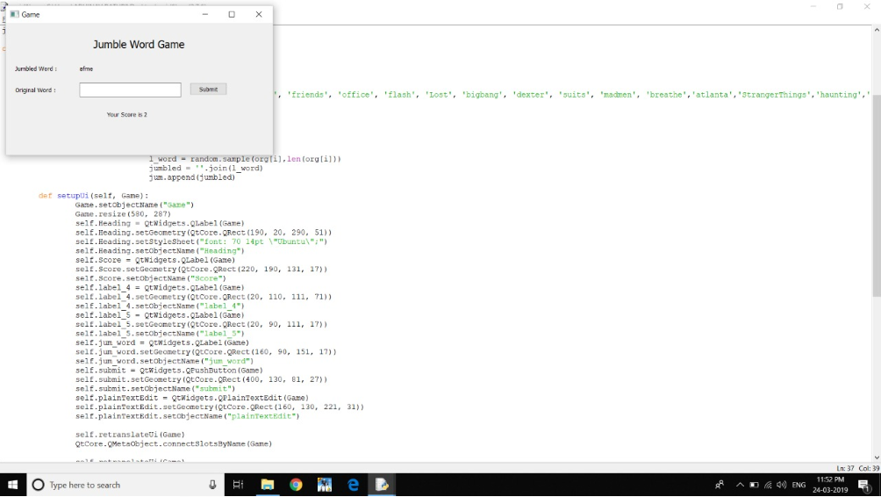

**CONCLUSION:** ­-The PyQt framework was used to implement the GUI.Python with PyQt outputs the fastest and easiest way to create the GUI applications .

**REFRENCES:** https://www.youtube.com/watchv=RJB1Ek2Ko_Y&list=PL6gx4Cwl9DGBwibXFtPtflztSNPGuIB_d

https://www.youtube.com/watch?v=whErCLh0-QU&t=510s

https://www.geeksforgeeks.org/python-gui-PyQt