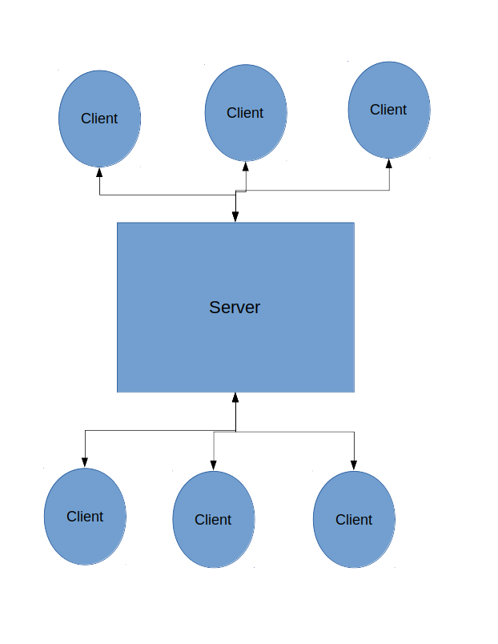
Design
Each client and the server will run in separate processes. The server will listen for a client and process its request, somehow handling multiple clients.
There will be a class for both the client and the server. There will also be a Chatroom class, representing a chat room, and a Message class, representing a message the client sends to the server, and a class for any other entity that needs to be represented in the code.

