ROCKWELL × NVIDIA PHYSICAL AI HACKATHON · FALL 2026

Dataset 2: Fluid Mixing Station
Project brief: problem, dataset, analysis and solution
Last updated: 2026-10-21 Status: Team plan reviewed by the organisers; resources granted (Brev $500, DGX Spark workspace). Next: study the problem and data, then project setup.
1. Hackathon Context 2
2. The Problem 2
3. How the Station Works 3
3.1 Tanks 3
3.2 Recipes and dispense order 3
3.3 Operating constraints (for any data collection on the line) 3
4. Colour Carryover 4
5. Why the Current Inspection Is Not Enough 4
6. Data Provided 4
6.1 Links 5
7. Organiser Guidance 6
7.1 First step 6
7.2 Starter approaches 6
7.3 Questions to narrow the first experiment 6
7.4 Testing requirements 6
8. Problem Understanding (Team Analysis) 6
9. Potential Pitfalls (Team Analysis) 7
10. Early Solution Sketch (Superseded) 7
11. Our Solution 8
11.1 Team Plan (Submitted 2026-10-14) 9
12. Business Case 9
13. Decision Log 10
14. Open Questions 10
15. Glossary 11
16. Change Log 12

1. Hackathon Context
The hackathon asks teams to pick one real process on the CSI testbed (UWM Connected Systems Institute), make it measurably better, and show it working. The testbed is a high-mix, low-volume (HMLV) demonstration plant built with Rockwell Automation hardware that produces vials of mixed-colour fluid from custom recipes.
Date | Milestone
Wed, Oct 14 | Team plan due, 11:59 PM CT. Submitted 2026-10-14 (see 11.1).
Sun, Nov 1 | Final submission due, 11:59 PM CT: about a 5-minute video, a one-page summary, the repository link, and references
Thu, Nov 5 | Finals at MSOE Diercks Hall, 5–8 PM

What judges expect:
- The solution running on real hardware (a supervised test on the CSI line).
- A specific problem and why it matters on this line.
- A business case for other manufacturers: cost today, savings, and what adoption takes.
- Measured results against a baseline, and honesty about where it still fails.
Briefing emphasis (verbal, from the pre-hackathon briefing; not yet in the written criteria): winning depends less on how good the solution is and more on whether it is scalable, works in real time, and has low latency.
Ground rule: real line data is for looking, not training. Training data must be generated with the digital twin, because on an HMLV line a new recipe has no real images before it runs, and collecting labelled faults is costly and repeats at every changeover.

2. The Problem
Four tanks feed the vial filling station. A recipe sets how many mL to draw from each tank, but the control system does not know the actual colour in each tank. Fluids mix upstream of a single shared nozzle, so fluid left from the previous fill can carry into the next recipe, especially when the colour changes.
Goal: build a system that detects colour or fill problems and explains the likely cause, linking what the cameras saw to the recipe order, the tank state, or colour carryover. Flagging that a vial looks different is not enough.
Analogy: a coffee machine makes a latte right after a hot chocolate. The first cup tastes chocolatey because the nozzle wasn't flushed. A good inspector doesn't just say "this latte tastes wrong"; they say "it tastes wrong because the hot chocolate ran just before it."

3. How the Station Works

3.1 Tanks
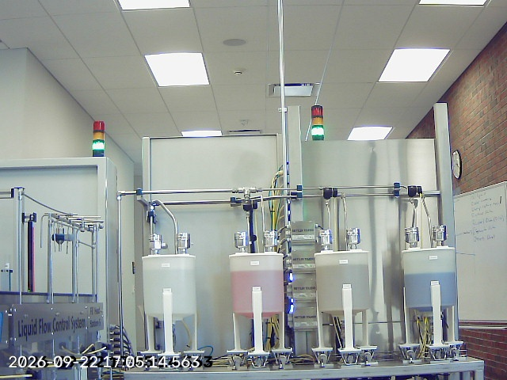
tank_level camera. Left to right: T-100, T-200, T-300, T-400. Tank colours look washed out through the translucent walls.
Tank | Position (tank_level view) | Fluid / appearance on camera
T-100 | Leftmost | Clear diluent; looks whitish
T-200 | Second | Orange; looks pink through the tank wall
T-300 | Third | Out of service. Looks greyish and appears to hold fluid, but is never used
T-400 | Rightmost | Blue; looks pale grey-blue

- Tanks are identified by number, not colour, because tank colours can change.
- The coloured band shows each tank's fill level (e.g. T-200 about half full, T-400 about two-thirds), which is useful for tank-state explanations.

3.2 Recipes and dispense order
- Fixed dispense order: T-200 → T-400 → T-100, skipping any tank the recipe doesn't use. This decides which fluid passes through the shared path last.
- Up to 3 recipes can be queued in the Batch Scheduler. The labelled data covers 10 recipes, swapped in and out of the queue during collection.

3.3 Operating constraints (for any data collection on the line)
- At most 80 mL per vial.
- A component can be set from 0–80 mL, but use at least 10 mL of any selected component.
- At most 50 mL from T-200 (more can fault the system and require a plant-manager reset).
- Never use T-300 (configuration issue that can require a reset).
- No recipe changes without the plant manager's guidance.

4. Colour Carryover
When the station switches recipes, residue from the previous recipe's mixture in the shared mixing path enters the first vial of the new batch, so it comes out discoloured. The second and third vials come out clean as the residue flushes through. The last vial of each recipe therefore reliably shows that recipe's true colour.
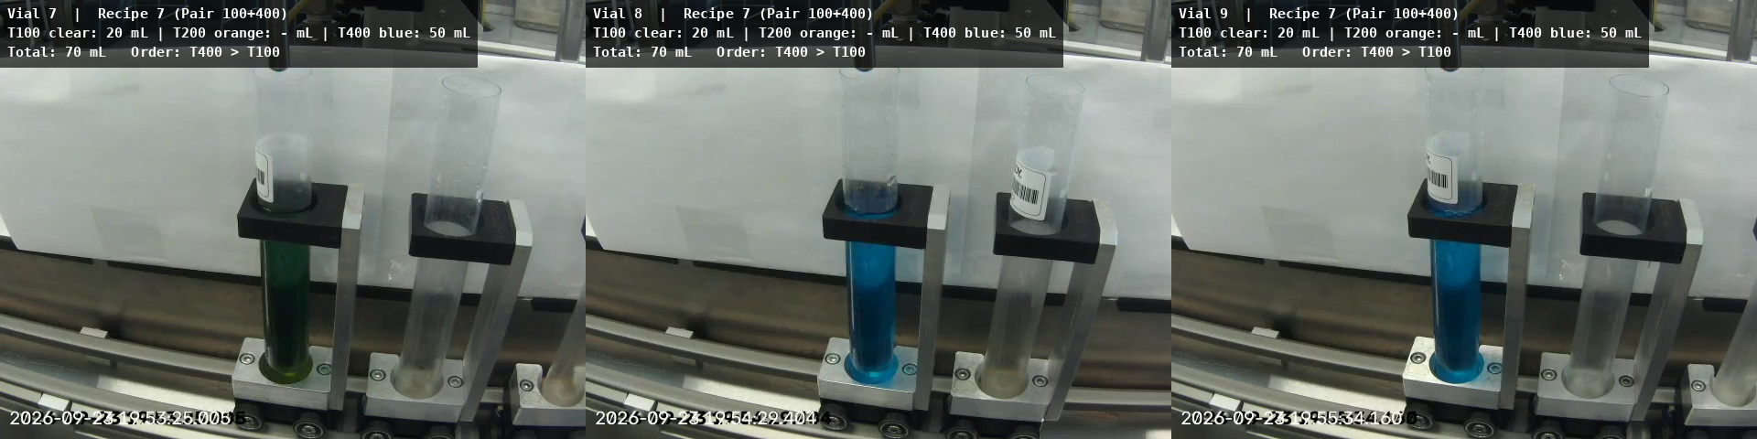
Recipe 7 (20 mL clear T-100 + 50 mL blue T-400). Vial 7, the first of the batch, is green; vials 8 and 9 are blue.
Example: Recipe 6 (30 mL clear T-100 + 10 mL orange T-200) ran just before Recipe 7. Blue mixing with leftover orange in the shared path explains the green tint of vial 7. The system should make exactly this kind of link: the odd vial traces back to the recipe that ran before it.

5. Why the Current Inspection Is Not Enough
A Teledyne vision system checks vial colour and weight before the final station. Because the control system doesn't know the tank colours, it compares the observed colour with a reference database: a known colour passes, an unknown one fails.
- It does not check whether the vial matches the intended recipe.
- It does not warn the operator that the next recipe is likely to be affected by residue in the shared path.

6. Data Provided
Source | Content | Labelled?
vial_fill camera | Side view of the vial-fill station | Only 30 vials (10 recipes × 3)
tank_level camera | The four tanks | No
cap_seal camera | The cap/seal station | No
5 synchronised videos (IDs 1–5) | All three cameras recorded together; cross-reference by timestamp | Labels cover the 30 vials only; videos 1–4 unlabelled
Digital twin (USD, Isaac Sim) | Fill and cap/seal stations with cameras matched to vial_fill and cap_seal, plus a render script | Labels come with rendered data; tanks not modelled, liquid colour approximate

- Cameras are 640×480; video at 30 fps; stills about every 2 s.
- Each labelled vial has: recipe ID; per-tank volumes (T-100 clear, T-200 orange, T-400 blue); total volume; dispense order; fill start and end times; per-frame "is filling" labels.
- T-300 is not used in any recipe.
- Barcodes and labels may be present on vials, in inconsistent orientations. Production does not rely on them.
- Organiser answer: all labels and details are already on the website. PLC, batch-scheduler and Teledyne data are not available; any extra data must be requested or collected by the team.
- Organiser answer: all videos and images were captured by a single computer, so there is no clock offset between vial_fill, tank_level and cap_seal.
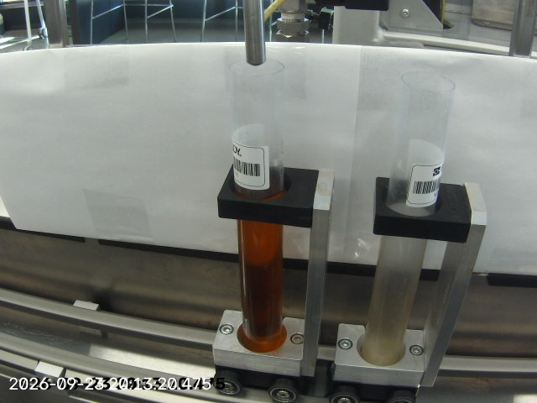
vial_fill camera: a vial filled with orange fluid. A neighbouring vial and a barcode label are also in frame.

6.1 Links
Dataset page: https://msoe-maic.com/library?article=Rockwell-NVIDIA-Fall-2026-Fluid-Mixing
Sample data from the line: https://drive.google.com/drive/folders/1qwV2BEz3ODX17kwNCr9M15DfkY8U_blQ?usp=sharing
Digital twin (datasets 1 and 2): https://drive.google.com/file/d/1nXRN_VZ_DKGS33jtELwn6z8WR8dbQfKe/view?usp=sharing
All Innovation Lab data: https://drive.google.com/drive/folders/1GWuHV2WUNLztq_Fga6xBH7qFzhxDaac8?usp=sharing
Collect and test your own data: https://msoe-maic.com/library?article=Rockwell-NVIDIA-Fall-2026-Data-Collection
Tools and resources: https://msoe-maic.com/library?article=Rockwell-NVIDIA-Fall-2026-Resources

7. Organiser Guidance

7.1 First step
Check that a vial_fill frame can be matched to the closest tank_level and cap_seal frames. Record any missing frames, clock offsets or timestamp drift before building a model.

7.2 Starter approaches
- Start simple: basic colour and fill-level measurements of the finished vial.
- Link the cameras: follow one moment across tanks, filling and cap/seal to reason about cause.
- Use the recipe sequence: the previous recipe and fluid order can explain what the camera sees.
- Cosmos Reason: a vision-language model reasoning over images or video plus recipe context, guided by examples of good and bad fills.
- Synthetic data from the twin: render fills, colours and lighting as training data.
- Grow the labelled test data: label videos 1–4 and the tank_level and cap_seal views, or collect new data on the line.

7.3 Questions to narrow the first experiment
- Can a simple colour measurement give a useful baseline before using a vision-language model?
- Can tank colours be inferred from camera views and the expected blend compared with the filled vial?
- How much does the prior recipe explain the next vial's colour?
- Can the system flag risky recipe transitions before the vial is filled?
- How will lighting changes and transparent vial material affect colour measurements?

7.4 Testing requirements
- Split by production run or time window so near-identical neighbouring frames don't land in both training and test sets.
- Leave-one-recipe-out evaluation: hold out all vials of one recipe, use the others as references, and repeat for each recipe.
- Report false alarms and missed defects separately.
- If the solution claims a likely cause, evaluate that explanation separately from detection.

8. Problem Understanding (Team Analysis)
The system must:
- Detect colour or fill problems in a vial.
- Explain the likely cause: carryover from the previous recipe, the wrong recipe, or tank state (e.g. a low level or an unexpected colour).
- Ideally, warn before filling that an upcoming recipe transition is risky.
Metric priority: treat "defect detected" as the positive class. A false negative (a defective vial passed as OK) is the costliest error, so aim for high recall on defects and report the false-alarm rate at the threshold that catches every known defect.

9. Potential Pitfalls (Team Analysis)
- No explicit defect label. Labels give the recipe and volumes, not good/bad. "Discoloured" has to be derived (first vial of a batch = likely contaminated; last vial = true colour). There are probably no labelled fill-level defects. Organisers: we define what counts as a defect (colour and fill deviations), as long as it is aligned with the physical system.
- Very little data. Only 2 clean references per recipe and about 10 carryover examples in total, so every metric will be noisy.
- Sim-to-real colour gap. We must train on the twin, but its liquid colour is approximate and the tanks aren't modelled. Colour, the main signal, is where the twin is weakest.
- Fragile colour measurement. The transparent vial shows the background (white curtain, black holder, metal track) through the liquid. Warm white balance and lighting changes shift colours. The visible liquid region is small at 640×480. Fill height changes apparent colour. Barcode labels can cover the liquid, and a neighbouring vial (sometimes with residue) is always in frame.
- Non-linear colour mixing. Dyes mix subtractively (blue + orange residue gives green), and dilution changes saturation non-linearly, so the expected colour isn't an RGB average of the recipe.
- Unknown carryover strength. The amount of residue may depend on the last-dispensed fluid, volumes and timing. With about 10 transitions, explanations will likely be qualitative.
- Tank colour inference. Colours seen through the translucent tank walls are washed out (orange looks pink). T-300 holds fluid but is unused.
- Timestamp sync. Organisers confirmed there is no clock offset (single recording computer). Burned-in timestamp overlays are garbled, so use filenames rather than OCR. Stills every 2 s can miss short events.
- Leakage. Neighbouring frames are near-identical. Use run, time-window or leave-one-recipe-out splits; 10 folds means high variance.
- Explanation is scored separately. We need a way to check the claimed cause (e.g. correct prior recipe or tank).
- Line safety constraints apply to any data collection (see 3.3).

10. Early Solution Sketch (Superseded)
Kept for reference. The proposed design is in section 11.
- Baseline: segment the vial's liquid region and measure its colour in a lighting-robust colour space (Lab or HSV), plus fill height. Compare with the recipe's reference colour (the last vial of each recipe).
- Context layer: combine the recipe sequence (previous recipe and dispense order) with tank state from tank_level to produce rule-based cause explanations.
- Reasoning layer: Cosmos Reason with example frames plus recipe context for human-readable explanations.
- Pre-fill warning: a carryover risk score for each upcoming recipe transition.
- Twin data: render with varied colours, fill levels and lighting for robustness; calibrate twin colours against the real reference vials.

11. Our Solution
Item | Detail
Problem statement | Right First Vial: Real-Time, GPU-Accelerated Prediction and Explanation of Color Carryover. Prevent, detect and explain colour carryover after recipe changes at Station 3, in real time, without retraining for new recipes.
Approach and architecture | 1) Warn before filling: a carryover risk score for each queued recipe transition. 2) Detect: a GPU segmentation model isolates the liquid in vial_fill frames; colour and fill height are compared with the expected colour; DeepStream processes the vial_fill, tank_level and cap_seal streams together on one edge GPU. 3) Explain: link the vial to the recipe sequence, dispense order and tank state; Cosmos Reason writes the explanation asynchronously, only for flagged vials. The expected colour comes from a mixing model plus the recipe, so new recipes need no retraining.  Constraint (organisers): equipment data (recipe queue, PLC) is not available to our application at runtime, so the recipe must come from another source, e.g. operator input. Open design question (see §14).
Synthetic data generation | Isaac Sim / Replicator renders of the vial-fill scene with varied colour, fill level and lighting. Twin camera and colours calibrated to real reference vials (the last vial of each recipe).
Model(s) | Segmentation model trained via the TAO Toolkit on twin images and optimised with TensorRT (a few ms per frame); DeepStream for multi-camera streams; mixing model for expected colour; Cosmos Reason for explanations (asynchronous).
Baseline | Simple CPU colour-measurement pipeline (fixed region plus colour rules). The GPU system must beat it on missed defects at similar latency.
Results vs baseline | TBD. Planned metrics: missed defects and false alarms (reported separately), explanation accuracy, latency per vial; leave-one-recipe-out evaluation.
Known failure cases and limits | TBD
Real-hardware test | TBD. A GB10 is already installed at CSI and connected to the cameras; we load our solution onto it for the supervised test (book through Shamar Webster in #data-and-testbed-requests).

11.1 Team Plan (Submitted 2026-10-14)
Item | Detail
Team | Monank Gajjar's team (4 members)
Roles | Monank (lead developer): integration, camera sync, colour measurement pipeline. Malhar: digital twin rendering and synthetic data (Isaac Sim / Replicator). Shubham: segmentation training (TAO) and TensorRT / DeepStream deployment. Ajay: evaluation, Cosmos Reason explanations, documentation.
Dataset | Dataset 2: Fluid Mixing Station 3
Compute requested | Brev and UWM DGX Spark. About $165 in Brev credits: Isaac Sim on L40S ~25 h (~$75); segmentation training on RTX PRO 6000 ~10 h (~$60); Cosmos Reason fallback ~5 h (~$15); small buffer. Free: our own laptops, DGX Spark, build.nvidia.com API.
AI agent plans | 1 × $100/month Claude (Monank); 2 × $20/month Claude (Malhar, Shubham); Ajay on free Gemini.
Mentor support | NVIDIA, Rockwell Automation, Emulate3D / CSI
Additional data requested | Recipe / PLC logs with timestamps for videos 1–4; a controlled transition set (4–5 recipe changes × 3 vials, all cameras); vial_fill camera settings; per-vial Teledyne colour and weight results; a held-out real test set.
Questions sent | See section 14.
Organiser feedback | Problem is aligned with the hackathon goals. Make sure the scenario, recipe overview and operator interactions match the processes in the current plant workflow.
Resources granted | Brev: $500 in credits; Monank is captain with admin access (invite teammates as Member or Maintainer; track spend under Billing). Isaac launchable on L40S costs $3.65/h; RTX PRO 6000 / 4500 instances support Start/Stop. YAAD GPU Lab: a private team workspace on a DGX Spark (root, GPU, Docker) plus batch jobs on any of the 8 Sparks at UWM CSI, over VPN (credentials kept private). build.nvidia.com usable now. Agent tools: pending.

12. Business Case
Item | Detail
Cost of the problem today (scrap, rework, downtime, labour) | TBD
What the solution saves or improves | TBD
Adoption requirements (hardware, setup time, changeovers, operator trust) | TBD

Context from the organisers: in the 2020 Annual Business Survey, only about 3% of manufacturers used AI for automated inspection. A NIST survey estimates defective products cost US discrete manufacturers $32–58B per year.

13. Decision Log
Date | Decision | Reason
2026-10-12 | Focus on Dataset 2 (Fluid Mixing) for now | Team decision
2026-10-14 | Committed to Dataset 2 (Fluid Mixing) | Data available now; the prevention-plus-explanation angle stands out; best fit for the scalable, real-time, low-latency emphasis. Dataset 3 data not yet released; Dataset 1 likely crowded.
2026-10-14 | GPU-based perception (segmentation + TensorRT + DeepStream); CPU pipeline kept as the baseline | Learned segmentation is robust to labels, glare and neighbouring vials; the GPU keeps neural models real-time and scales to many camera streams. A CPU is fast for simple maths but not robust.
2026-10-14 | Project title: Right First Vial: Real-Time, GPU-Accelerated Prediction and Explanation of Color Carryover | Names the problem (the first vial after a change) and signals prevention, real time and GPU acceleration.
2026-10-14 | Brev request of about $165 | Each item maps to a need: L40S for rendering, RTX PRO 6000 for training, free API for Cosmos Reason. Compared against $70 (too tight) and $175 (looked padded).
2026-10-14 | AI agent plans: 1 × $100 + 2 × $20 Claude; one member on free Gemini | Within the organisers' stated budget; paid plans go to the code-heavy GPU pipeline roles.

14. Open Questions
Answers received from the organisers after the team plan:
- Defect definition: colour and fill deviations are in scope; we define the defect, aligned with the physical system.
- Real reference vials: any calibration strategy is allowed if it aligns the result with the operating system.
- Recipe/PLC logs or Teledyne results for videos 1–4: not available; all labels and details are on the website.
- Held-out real test set: none from the organisers; we collect our own holdout, and judges evaluate on it.
- Camera clock offsets: none; everything was captured by a single computer.
- Reading the recipe queue during a live test: not possible; equipment data is not available to our application.
- Edge GPU for the live test: a GB10 at CSI is already connected to the cameras; we load our solution onto it.
Still open (team decisions):
- Where does the recipe come from at runtime (e.g. operator input), and how does that match the current operator workflow?
- Our exact defect definition (colour threshold vs expected colour; under- and over-fill).
- Holdout collection plan: what to record, how many vials and transitions, and when to book CSI.
- Compute split between the DGX Spark workspace and Brev.

15. Glossary
Term | Meaning
HMLV | High-mix, low-volume: many product variants in small batches, with frequent changeovers
Digital twin | A simulated copy of the physical station used to generate labelled training data
Vial | A small clear tube with a cap, filled with coloured fluid
Carryover | Residue from the previous recipe in the shared mixing path that discolours the next vial
Diluent | The clear fluid (T-100) used to dilute colours
Dispense order | The fixed sequence in which tanks release fluid: T-200 → T-400 → T-100
False negative (FN) | A missed defect; the costliest error
False positive (FP) | A false alarm; a good vial flagged as defective
Recall | Defects caught ÷ all real defects
Leave-one-recipe-out | Hold out all vials of one recipe for testing, use the rest as references, and repeat for each recipe
Cosmos Reason | NVIDIA vision-language model that reasons over images or video with a text prompt
Isaac Sim / Replicator | NVIDIA simulation platform and its synthetic data generation tool
Teledyne vision system | The line's existing camera check of vial colour and weight against a reference database
Segmentation | An AI model that labels every pixel in an image (e.g. liquid vs background)
TensorRT | NVIDIA tool that optimises a trained model to run much faster on a GPU
DeepStream | NVIDIA framework for running AI on several live video streams in real time
Edge GPU | A small GPU device installed at the machine (e.g. NVIDIA Jetson) instead of in the cloud
Brev | NVIDIA cloud service for renting GPU machines by the hour
DGX Spark | Compact NVIDIA GPU system; UWM has 10 for hackathon teams
GB10 | NVIDIA chip inside the DGX Spark; CSI has one connected to the station cameras for live tests
YAAD GPU Lab | 8 DGX Sparks at UWM CSI; our team has a private workspace and can send batch jobs

16. Change Log
Date | Change
2026-10-12 | Document created: Dataset 2 problem, station, carryover, data, organiser guidance, team problem analysis, pitfalls and candidate solution
2026-10-14 | Team plan submitted: status updated; briefing judging emphasis added (§1); proposed GPU-based solution (§11) and team plan summary (§11.1); decision log entries; questions sent to organisers (§14); glossary terms; §10 marked superseded.
2026-10-21 | Organiser feedback and answers recorded (§6, §9, §11, §11.1, §14); resources granted (Brev $500, DGX Spark workspace); runtime recipe constraint noted; new open team decisions; glossary terms.

