Experiment 3 initial trial review
Rockwell Automation × NVIDIA Hackathon
Prepared for Pablo and The A-Team
Evidence and repository checked October 22, 2026

What the recordings establish
The supplied archives show real robot manipulation: two blue-on-red stacks and several screw transfers. Some other completed-looking outcomes involved human help. The separate green-bin lift is unproven, and the reported yellow-cube pickup and drop has not been identified in these files.
Reviewed raw evidence | Count
Episodes / telemetry rows | 17 / 14,442
Camera streams / decoded frames | 51 / 43,326
Recorded closures / completed close-open cycles | 20 / 19
Stationary recordings / controller-fault endings | 2 / 6
Phone clips showing setup or human demonstrations | 7 clips / 98.62 seconds

Results worth showing the team
Robot-performed stacks remain standing after retreat in d41abe episode 2 and ecd8ec episode 3. In d41abe episode 0, both initial screws reach the yellow bin after earlier unsuccessful cycles. These examples can support stage-by-stage comparison of grasping, transport, release and final state.
Human handling contributes to the final stack in ecd8ec episode 1 and to screw completion in d41abe episode 4. Their final states must be labeled assisted. None observed means no human handling was seen; it does not prove autonomous policy control.

How to use this package
The workbook contains the episode inventory, individual grasp events, repository-only evidence, next-test plan, blank future attempts and a code/settings guide. It preserves original IDs and separates observations from metadata labels. No combined success rate is calculated for these different tasks.
The files were shared for Tuesday review. Run IDs are dated October 19–20; exact session mapping and team ownership of the showcase episodes remain unverified. The current SIDC dashboard identifies its example rows as organizers’ own runs. Sharing date alone does not establish who executed an archived run.

Evidence coverage and repository context
Source | What was checked | Role
lerobot-q77a4ef.rar | r20261020-52dbd4: 5 episodes, 6,946 rows, 15 videos | Green-bin lift attempt records.
showcase-runs.rar | 208189, d41abe, ecd8ec: 12 episodes, 7,496 rows, 36 videos | Reference robot behaviors; ownership not established.
VIDEO TO ANALYZE | Seven PXL_20261020 phone clips | One setup clip and six human demonstrations.
Main GitHub repository | Initial 68-file audit at 9c402f6; clone updated to 27e027a with seven website commits. | Code, reports, resources and website assets. New sample video duplicates reviewed evidence; no new raw trial logs.

The repository describes another physical run
Run r20261020-5fea53 is separate from the supplied r20261020-52dbd4 data. GitHub reports two recorded commissioning episodes and 670 frames. The raw files for that run are absent here, so its measurements and scores are source-reported context, not new independent measurements.
Repository-only episode | Duration / frames | What the repository reports
0 / t01 | 51.6 s / 517 | Official success; closest to A 2.531 mm; B not reached.
1 / t02 | 15.2 s / 153 | Official success; closest to A 2.540 mm; B not reached.

The official summary gives 2/2 recorded successes, zero faults and zero interventions. Trial t00 was cancelled, so only two of three planned trials were recorded. Both episodes stopped before the A-to-B leg: the original waypoint completion tolerance was 2 mm. The repository records a correction to 5 mm and calls for repeating the non-contact path before adding perception or grasping.

Which code was used is still a missing field
Main policy.py remains the commissioning waypoint policy. The adaptive bin candidate is separate code and implements lift-and-hold without automatic lowering/release. Its presence on main is not evidence that an archived trial ran that code. No source maps each supplied episode to an exact commit and effective settings.
The reported commissioning settings are TCP in UF0, 10 Hz, 2 mm/action translation, 1 degree/action rotation and an open gripper. They must not be copied into unrelated historical episodes. Preserve the actual launch command, commit, local changes, configuration and overrides for future runs.

Robot reference episodes in the first two runs
All times are seconds from episode start. The short IDs below expand to r20261019-208189 and r20261019-d41abe. End labels describe termination, not task success.
Run and episode | Task / duration / end label | Reviewed sequence and outcome
208189 / 0 | Red onto blue / 11.6 / fault | Approach; no recorded feedback closure. Cubes remain separate. A final command requests closure, which is not confirmed in feedback.
208189 / 1 | Red onto blue / 10.8 / fault | Another interrupted approach with no feedback closure. No stack established.
d41abe / 0 | Two screws to yellow bin / 118.4 / operator | Four cycles. First two do not clear the screws. Later releases at 80.1 and 105.7 deposit both initial screws. Wrist views show two in the bin; final tabletop region clear.
d41abe / 1 | One screw to yellow bin / 58.0 / operator | Close 15.2; open 25.6. Screw visible inside bin at 28–33. No human handling observed. Yellow cube stays on table.
d41abe / 2 | Blue onto red / 34.6 / operator | Close 15.7; open 24.9. Robot places blue on red; stack remains after retreat at 27–34.6. No human handling observed.
d41abe / 3 | Blue onto red / 16.1 / fault | No recorded closure. Cubes remain separate. Fault cause not identified.
d41abe / 4 | Four screws to yellow bin / 202.1 / operator | Six cycles. A screw remains on the rim; person moves it onto the table at 148–150. Robot repicks and releases at 181.9. Final completion is assisted.

What the screw examples teach us
Counting gripper closures overstates successful transfers. In one episode, four cycles clear two screws; in another, a rim deposit and human reset precede completion. Future records should identify the target screw, distinguish missed grasps from incomplete deposits and record intervention timestamps.

Find the exact footage
Inside showcase-runs.rar, open the run folder, then videos/observation.images.side/chunk-000/file-NNN.mp4. NNN is the episode index, such as file-002.mp4 for episode 2. Use observation.images.wrist for close screw-placement views. The three camera files are views of the same episode, not separate attempts.

Mixed task episodes and human demonstrations
Run r20261019-ecd8ec contains several task descriptions. Pre-existing objects and human corrections are separate from robot-performed outcomes.
Episode | Task / duration / end label | Reviewed sequence and outcome
0 / t00 | Blue onto red / 89.3 / operator | Two cycles. Person removes/repositions blue near gripper at 63–70. Final cubes separate. One repeated effort on the same stack target is identifiable.
1 / t01 | Blue onto red / 59.6 / stop | Close 14.9; open 26.7. Person handles/stacks cubes at 30–34; final stack follows intervention. Assisted outcome.
2 / t01 | Blue onto red then yellow / 42.1 / fault | One cycle, release 32.0. No final stack established; yellow pickup unconfirmed. No second recorded grasp.
3 / t02 | Blue onto red / 37.5 / operator | Close 14.2; open 26.0. Robot-performed, off-center stack remains after retreat at 28–37.5. No human handling observed.
4 / t03 | Screws to green bin / 68.3 / operator | Two transfer cycles, releases 34.8 and 54.9. Initial two screws leave tabletop area and contents appear inside bin. Yellow cube and existing blue/red stack are not new outcomes.

The seven phone clips demonstrate a different goal
The demonstrated task is to place four red cubes into a green bin, one at a time. The team clarified that these videos should become task instructions the robot can imitate. The clips alone do not supply robot coordinates, gripper force or executable motion paths. Some demonstrations steady the bin by hand.
PXL_20261020 suffix | Duration | Content
165145164 | 14.54 s | Setup/framing; no complete transfer sequence.
165201912 | 13.83 s | Overhead four-cube sequence.
165226075 | 9.08 s | Side four-cube sequence.
165240667 | 7.46 s | Close overhead; final four-cube state visible.
165311341 | 24.54 s | Narrated overhead arrangement and transfers.
165355671 | 13.67 s | Narrated side sequence.
165414567 | 15.50 s | Narrated close overhead and final state.

Green bin lift and camera failures
Run r20261020-52dbd4 asks the robot to grip one wall of an empty green bin, make an approved minimal vertical test lift, hold briefly and return it. The task text gives no numeric approved lift height. These recordings do not establish completion.
Episode | Seconds / end | Recorded behavior | Camera evidence
0 / t00 | 196.6 / stop | Pose and gripper constant. | Only first 4.9–5.5 s nonblack.
1 / t00 | 427.8 / stop | Pose and gripper constant. | All three views black.
2 / t00 | 14.1 / fault | Motion starts 0.5; no closure. | All three views black.
3 / t01 | 14.5 / fault | Visible approach; no closure. | All three views nonblack.
4 / t02 | 41.1 / stop | Closure 15.5; repeated height adjustments; no reopening. | Bin offset from tool; transport not established.

Episodes 0–1 contain 6,246 of 6,946 rows, about 90% of this run, without recorded motion. Only three episodes move; two end with a controller-fault label. No alarm code identifies a collision, limit violation or software fault as the cause.
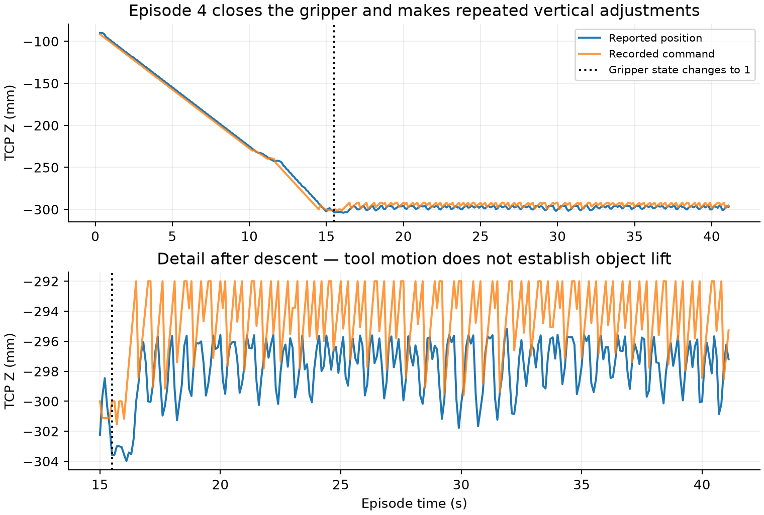
Episode 4 tool motion. The trace measures the tool, not movement of the bin.
At closure the reported tool XYZ is about (450.00, −21.25, −303.58) mm. Post-closure Z ranges from −303.98 to −295.18 mm. This is not a measured object-lift height. A future recording must show the wall between the fingers and the bin separating from and returning to the table.

What to test and record next
Confirm whether the corrected commissioning check has already passed. The sequence below reconciles the current repository runbook with the manipulation examples. Five repeats and a three-second final-state window are proposed starting rules to agree with the team, not existing results or statistical reliability thresholds.
Order and test | Why | What should count as completion
1 Map sources and check saved cameras | Archive ownership/code mapping missing; black streams in 52dbd4. | Every run tied to session, task, commit/config and usable saved video.
2 Verify commissioning status | Repository A-to-B task incomplete; correction recorded. | If not already repeated: both approved waypoints within 5 mm, gripper open, no fault/intervention, completed plan.
3 One cube into green bin | Human demonstration needs a repeatable robot baseline. | Propose 5 identical-layout trials; cube inside after release/retreat for 3 s without human repositioning.
4 Blue-on-red stacking | Two visible robot stacks; other attempts incomplete or assisted. | Propose 5 identical-layout trials; stack standing after retreat for 3 s without repositioning.
5 One screw into yellow bin | Misses and rim placements require separate labels. | Propose 5 single-screw trials; screw fully inside after release/retreat.
6 Diagnose bin lift | Approach faults and closure do not establish bin transport. | Operator reviews alarms; agrees lift/hold/return values and records visible object movement.
7 Four identified cubes | Multi-object sequences need per-target accounting. | After single-cube baseline, all four inside; record retries and help for each cube.

Data needed from the operator
Capture the actual robot-computer commit SHA, any uncommitted edits, exact launch command, policy name, config copy and effective settings. Record run/episode/target IDs, starting layout, attempt start/end times, outcome, failures, assistance and timestamps, alarm codes, all camera files and final object state.
If the adaptive candidate uses depth or prints verification JSON, retain that local depth and console output with timestamps. The official returned datasets do not record depth. Historical code/settings remain unknown unless the team supplies a mapping; current main is not a substitute.

Verification method and remaining gaps

Three checks completed
Source completeness: the initial audit matched all 68 tracked files at 9c402f6. The clone was subsequently fast-forwarded to main at 27e027a7548b61aa76efea019cc782b69af9690f. Seven additional commits add the showcase website, CAD assets and one sample video. The robot policy and trial evidence files did not change. The new video is an excerpt of an already reviewed episode, not another trial.
Raw evidence: both archive hashes and all seven phone hashes were rechecked. An independent pass reread all 17 telemetry files and decoded all 51 camera streams. Row/frame counts, 20 closures, 19 openings, timestamps and black-frame results reconcile with the analysis. The archives remain unchanged.
Interpretation and presentation: independent review rechecked the stacks, screw deposits and human interventions. Workbook totals and formulas reconcile, blank future rows remain blank, and the report and workbook use the same source boundaries. These checks do not replace official adjudication.

How visual conclusions were reached
Review used full-duration one-second timelines, denser samples around gripper changes, additional camera views and selected full-resolution frames. Every camera frame was decoded for quality/count checks. This is sampled visual interpretation, not continuous human viewing of every frame or calibrated object tracking.
A 0-to-1 gripper feedback change records closure, not grip force or object capture. Episode duration includes idle time; close-to-open time excludes approach and final verification. Original trial IDs repeat, so run ID plus episode is the record key. Stop/operator/fault labels describe termination, not successful task completion.

Gaps that remain visible in the package
Exact team/session ownership and executed commit/settings are not recovered for every archive episode. Raw r20261020-5fea53 files are missing. Controller alarm details, official outcomes for the 17 supplied episodes, calibrated object motion, and the reported yellow-cube pickup/drop clip are unavailable here. No overall success percentage is justified by this mixed set.

Key archive fingerprints
lerobot-q77a4ef.rar
82334151a7b9062b3e8a8b48b046b289d463166cc09389586ab772c3c114db3b
showcase-runs.rar
fddc5113628d4d7a3624020ed0181bcb0ece4248799ecc42f3c6e342cf681d00
The workbook Guide and sources tab retains the full nine-file inventory and hashes. File references use archive-relative paths so the package can be shared without personal machine paths.

Repository sources and official resource access
Sources below were checked on October 22, 2026. Main repository access used the connected GitHub account. Live resource checks establish page reachability, not downloaded archive integrity or permission to execute a physical trial.
Main repository at the verified revision
First supervised physical run report
Machine-readable commissioning evidence
Physical rollout runbook
Active policy and separate adaptive candidate
Resource | Current check and restriction
Official SIDC client and public dashboard | Repository/README and dashboard accessible. Individual team results/downloads require the private status link/key; those private records were not accessed.
Experiment 3 article | The msoe-maic.com library URL returned HTTP 404. Published Markdown mirror is accessible.
Experiment 3 digital twin | Google Drive preview accessible, titled fanuc_er4ia_hackathon_starter_v05.zip. Actual download permission and archive integrity not tested.
General hackathon Drive folder | Folder preview accessible. Not a substitute for raw team run records.

Official participant client
SIDC public dashboard
Experiment 3 published article mirror
Experiment 3 digital twin preview
General hackathon Drive folder
The digital twin is a separate planning/simulation resource. No new archive was downloaded or executed during this review. The raw local files remain the basis for the 17-episode analysis.

Website update and sample video provenance
Update checked October 22, 2026. The local clone now matches GitHub main at 27e027a. The seven new commits provide a team showcase website. They add no new measured robot trial results, and the 17-episode analysis remains unchanged.

Show the Job
The browser samples video frames, measures motion and detects color regions, then produces example instructions and waypoint exports. The step parser is simulated and the image-to-robot mapping is uncalibrated. Generated coordinates and confidence values are not validated robot instructions or measured trial outcomes.

Generate the Tool
Photo and video loading, the 3D viewer and STL export are implemented. Actual 3D reconstruction is not connected: the demo displays a stand-in gripper model even for an uploaded capture set.

Drag to Move
A browser workcell uses CAD models for cubes, a screw and a bin. Users can drag parts, view an animated pick-and-place and export a plan. The arm uses simplified kinematics without physics and is not connected to the physical robot.

Other website changes
The update adds website styling, a sample video and poster, a Node server with a passcode gate, and a GitHub workflow to sync website files to a separate hosting repository. The website repeats the previously documented commissioning results for r20261020-5fea53; these are not new runs.

The sample is an existing trial
ourwebsite/public/assets/testbed-demo.mp4 is a shortened, re-encoded copy of the first 30 seconds of showcase-runs/r20261019-d41abe/videos/observation.images.side/chunk-000/file-002.mp4. This is episode 2, trial t02: the robot stacks the blue cube on the red cube. The full source has 347 frames (about 34.7 seconds); the website copy has 300 frames at 10 fps.

How the match was checked
The sample had no exact file-hash match among the 58 reviewed videos. Frame comparison identified the source and then checked all 300 sample frames against the same frame positions in the original. Mean pixel difference after resizing to 320 by 180 was 1.39 on a 0–255 scale, consistent with re-encoding. Count it once under the existing episode; do not add an attempt or success to Excel.

What this means for our analysis
Use the website as a demonstration of the planned workflow. Our reviewed videos and attempt log can help evaluate whether generated steps identify the correct object, action order and final outcome. The workbook remains the historical trial record; its repository audit reference is the earlier 9c402f6 snapshot. This report records the subsequent website update.
GitHub comparison of the seven website commits

