We counted the number of health technicians per 10,000 people from 2003 to 2022 and found that the data had the following characteristics:

|  |  |  |  |  |
| --- | --- | --- | --- | --- |
| Variable name | average value | standard deviation | median | variance |
| Number of health technicians per 10,000 people | 53.55 | 16.22 | 51 | 263.103 |
| Number of urban health technicians per 10,000 people | 85.05 | 21.683 | 88.5 | 470.155 |
| Number of rural health technicians per 10,000 people | 37.65 | 12.546 | 35 | 157.397 |

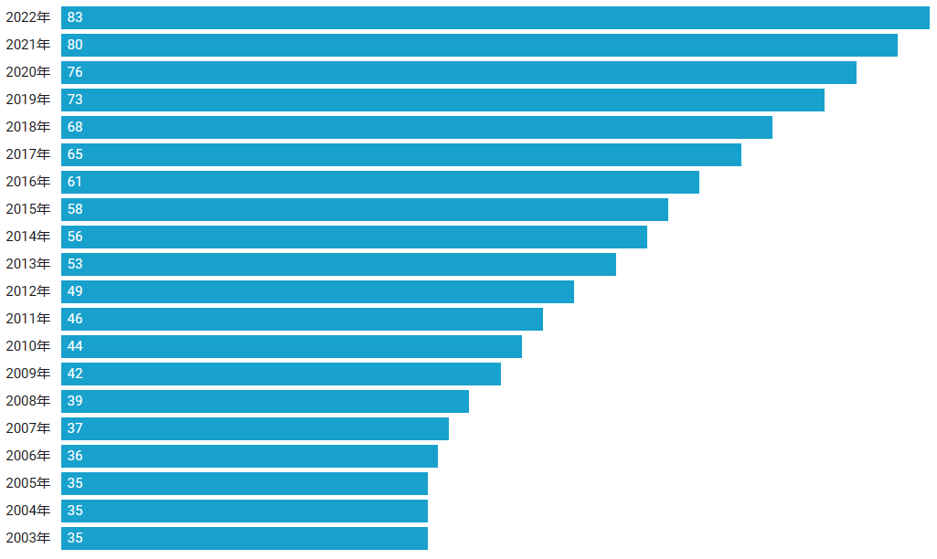The national average number of health technicians per 10,000 people is shown in the following chart:

Trend change: Data shows that the number of health technicians has increased year by year, from 35 in 2003 to 83 in 2022.

25% quantile: 37.500

Median: 51.000

75% quantile: 67.250

Maximum: 111.875

Maximum: 83.000

Minimum: 35.000

Mean and Quantile Values: The mean value is 51.000 and the median value is 51.000, indicating that the central trend of the data is relatively stable.

Explanation of differences: The large standard deviation and high dispersion of the overall number of health technicians reflect differences in health system management and resource allocation in different regions. Attention needs to be paid to the balanced allocation and management efficiency of health resources to ensure that all districts have access to appropriate health services and resource support。

The average number of health technicians per 10,000 people in cities across the country is shown in the following chart:

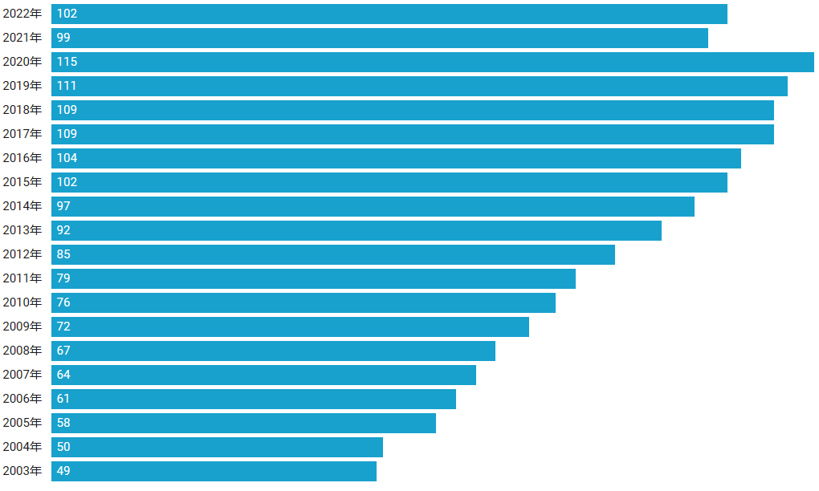

25% quantile: 64.750

Median: 88.500

75% quantile: 103.500

Maximum: 115.000

Minimum: 49.000

Trend change: Data shows that the number of urban health technicians has increased year by year, from 49 in 2003 to 115 in 2022.

Volatility: There are large differences in the number of health technicians in cities, indicating that some city residents spend more on health and others lower.

Mean and quantile: The mean value was 88.500 and the median was 88.500, indicating that the number of urban health technicians was on the rise overall, but the difference was large.

The average number of health technicians per 10,000 people in cities across the country is shown in the following chart:

Trend change: Data show that the number of rural health technicians has increased year by year, from 23 in 2003 to 52 in 2022.

25% quantile: 27.250

Median: 35.000

75% quantile: 45.250

Maximum: 66.000

Minimum: 22.000

Volatility: The number of rural health technicians is relatively concentrated and stable, indicating that the health expenditure of rural residents is generally more consistent.

Mean and quantile: The mean value is 35.000 and the median is 35.000, indicating that the number of rural health technicians is on the rise overall, but the volatility is relatively small.

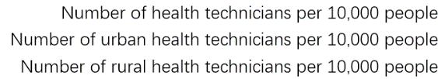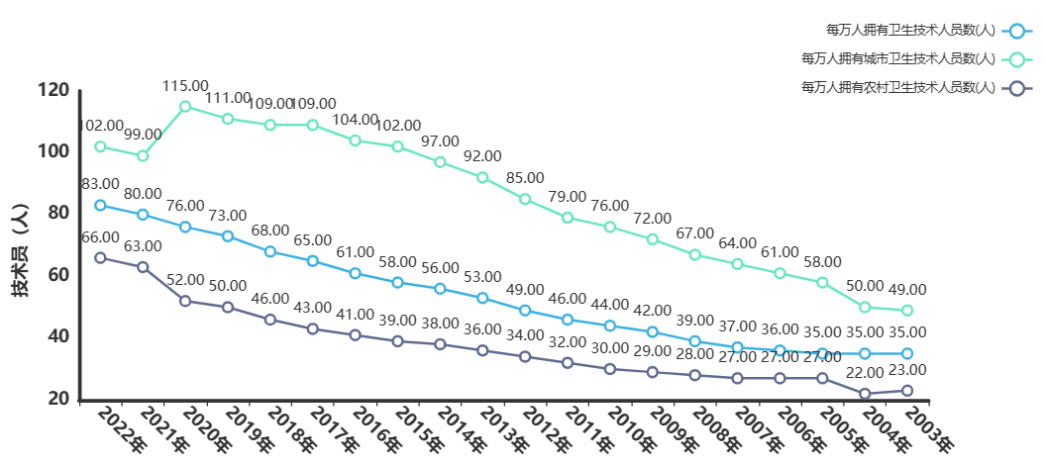Conclusion：

Overall, the number of health technicians is on the rise, with urban averages higher but more volatile, and rural averages relatively low and less volatile.

The data reflect the uneven distribution of health resources and services between urban and rural areas, which may be related to factors such as regional economic level, medical system, and population structure. Attention should be paid to the balanced development of urban and rural health resources. But the overall trend is upward.