The capital investment in healthcare has also increased greatly in our country, which further reflects the improvement of healthcare level.

* Below is an overview description of the results of funding for different areas of healthcare and a box diagram of its various areas

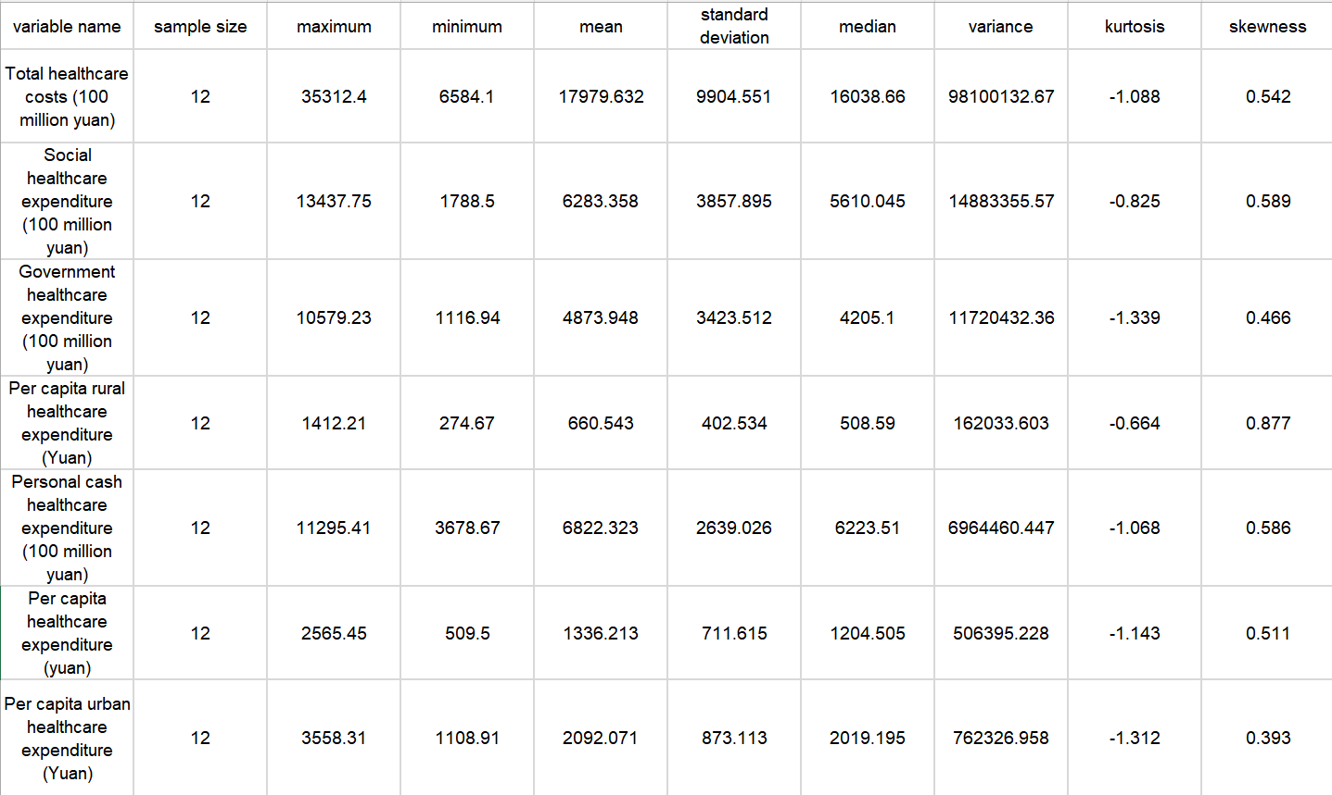

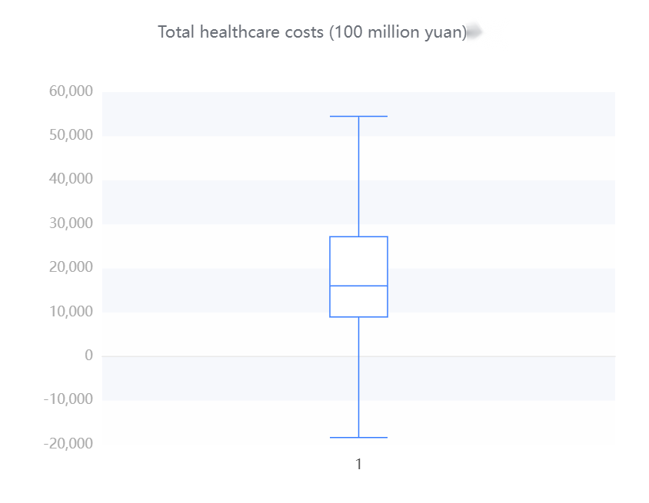 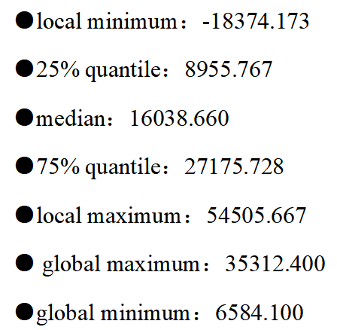

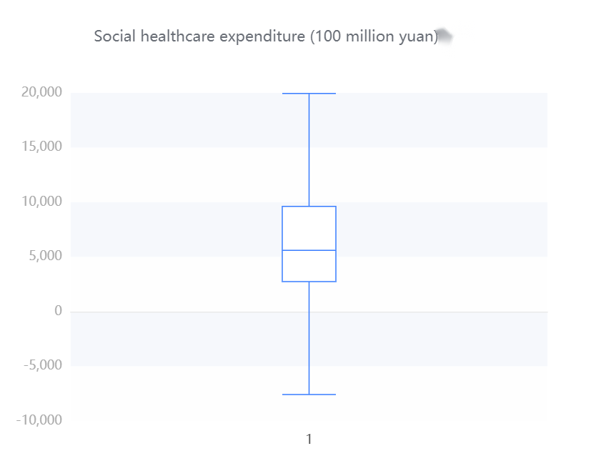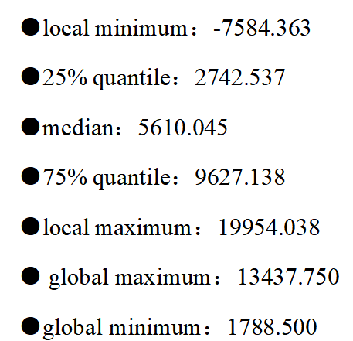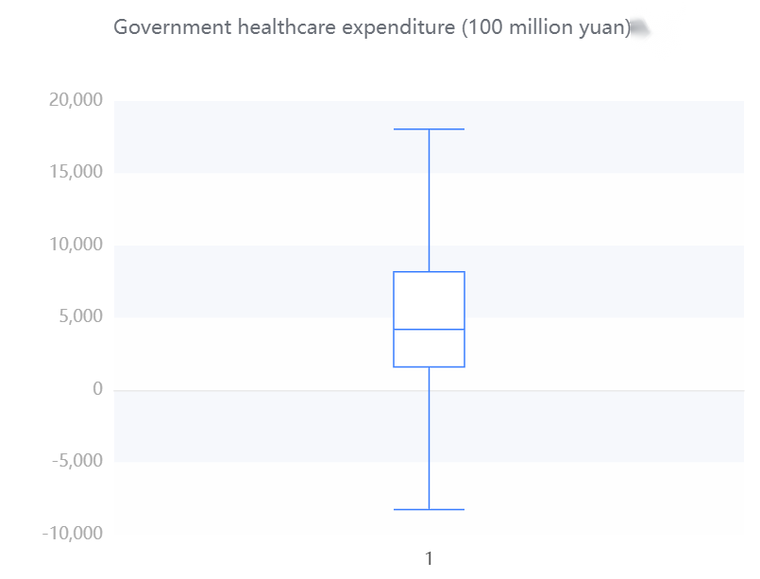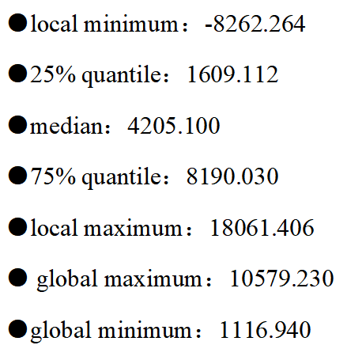

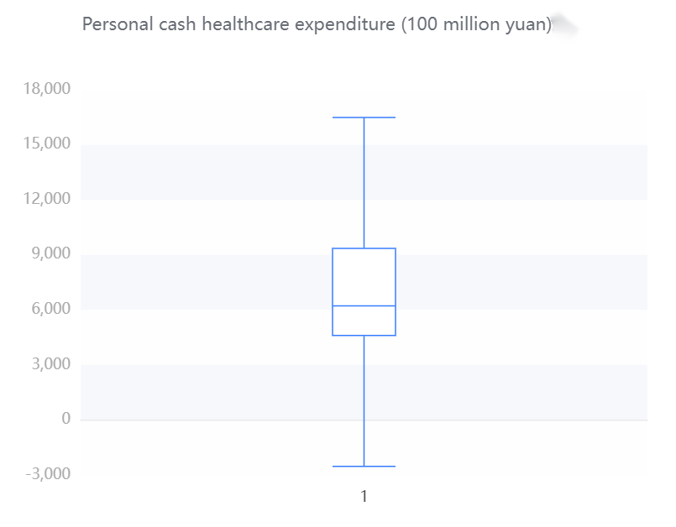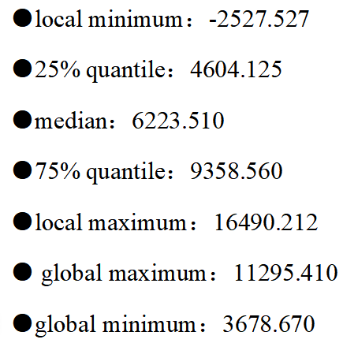

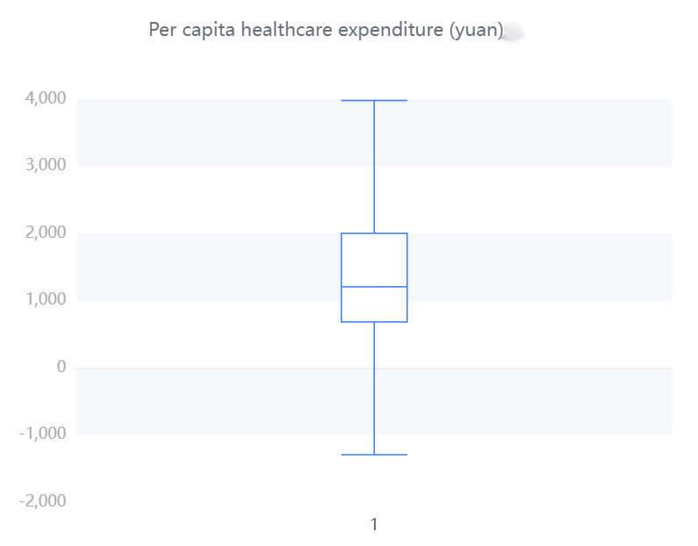 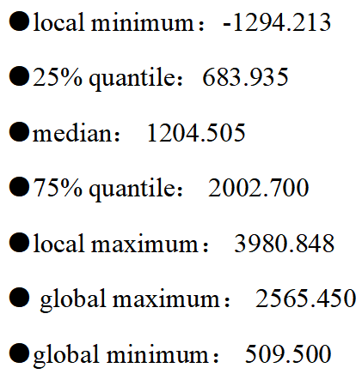

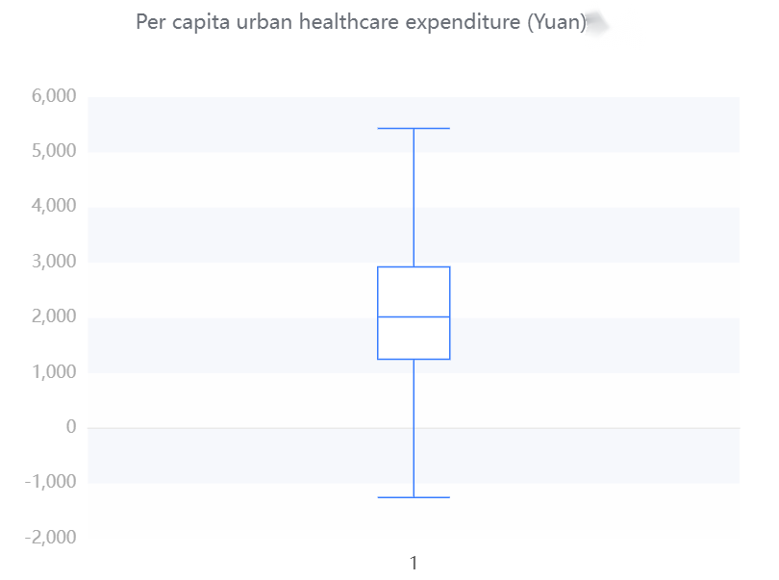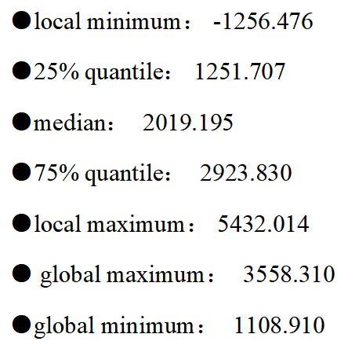

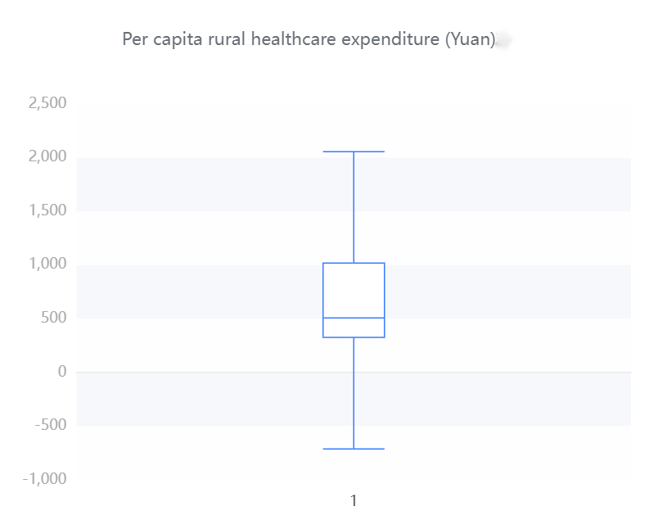 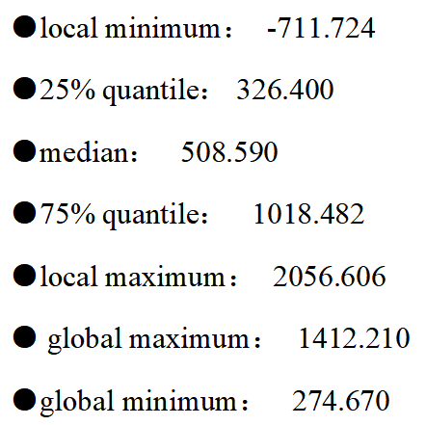

From these table, we can roughly know that the total healthcare expenditure is relatively high, and the government and social expenditure also occupy a considerable proportion. There is also a considerable difference between the government and social healthcare expenditure. The average government healthcare expenditure is 487.394.8 billion yuan, while the social healthcare expenditure is 628.335.8 billion yuan. The large standard deviation and high dispersion of the total healthcare cost reflect the differences in the management and resource allocation of the healthcare system in different places. It is necessary to pay attention to the balanced allocation and management efficiency of healthcare resources to ensure that all regions can obtain appropriate healthcare services and resource support.

Meanwhile, when looking at urban and rural health costs, there are some interesting findings. The average per capita health cost in urban areas (RMB 2,092.071) was significantly higher than that in rural areas (RMB 660.543), which may reflect that urban residents have easier access to more medical resources and services, and may also be related to the higher cost of living in cities.

In addition, the standard deviation of per capita health cost in cities is large (873.113 yuan), which means that there is a certain difference in health cost in cities. It may be that some urban residents spend more on health, while others spend less.

The standard deviation of per capita health expenditure in rural areas is small (402.534 yuan), indicating that the health expenditure of rural residents is relatively concentrated and stable on the whole.

Hence, there are significant differences in health costs between urban and rural areas, with higher average costs in cities, but also with large differences. These data may reflect the uneven distribution of rural and urban health resources and services.

* Next, the scatterplot shows the results of the central trend analysis of the frequency analysis of total healthcare expenditure (100 million yuan), government healthcare expenditure (100 million yuan), social healthcare expenditure (100 million yuan), individual cash healthcare expenditure (100 million yuan), per capita healthcare expenditure (yuan), urban healthcare expenditure (yuan) and rural healthcare expenditure (yuan). The abscissa is from 2022 to 2003.

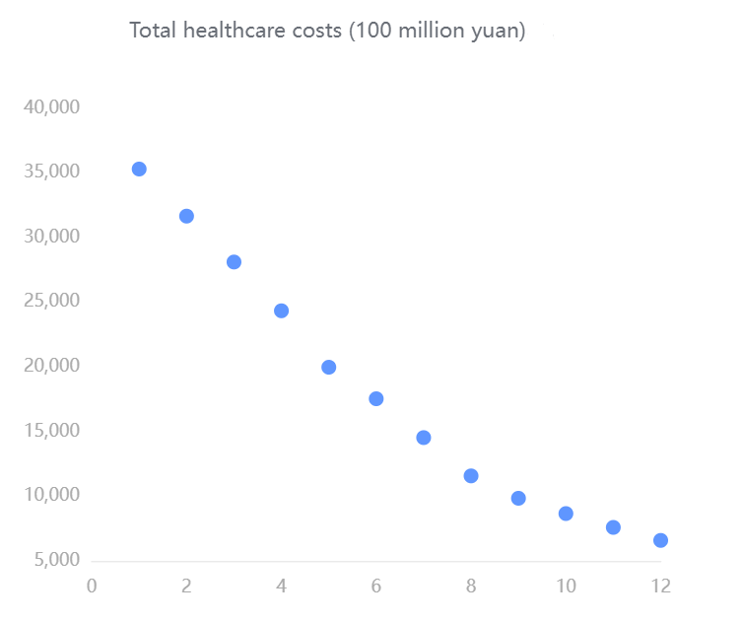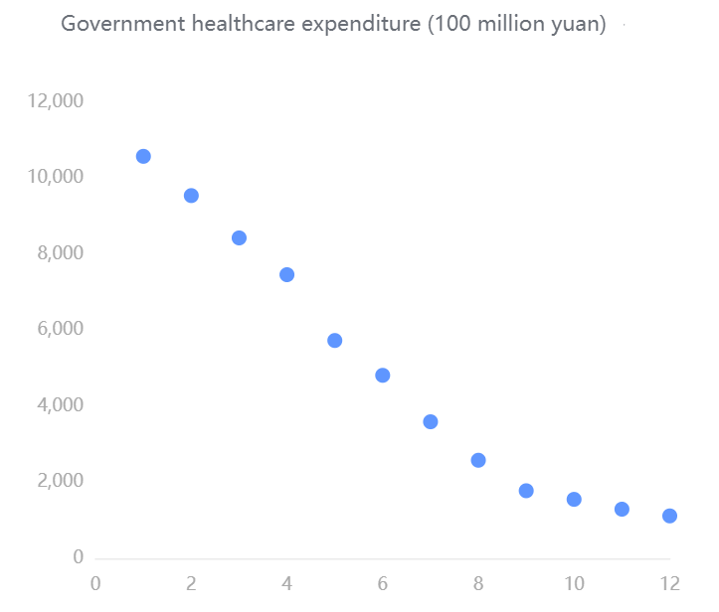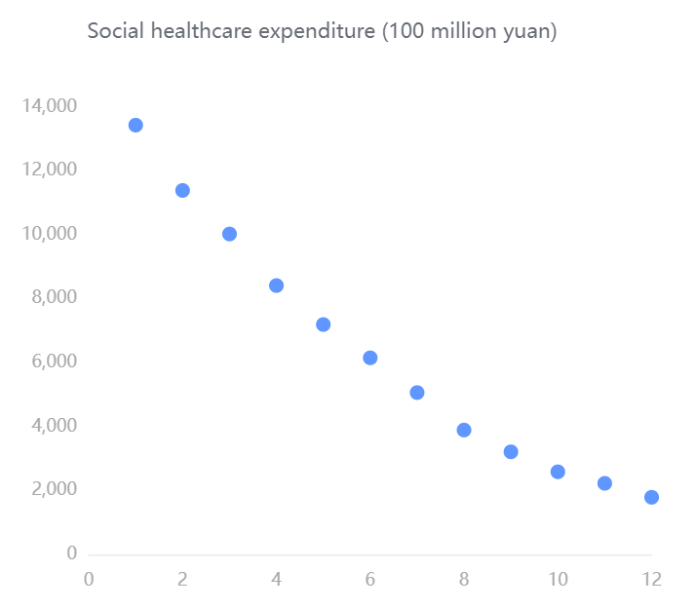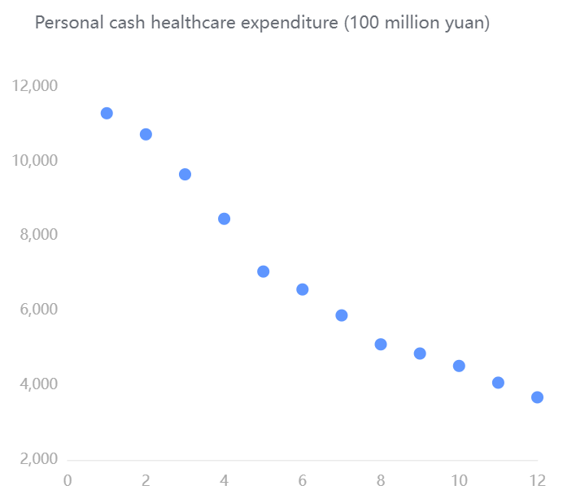

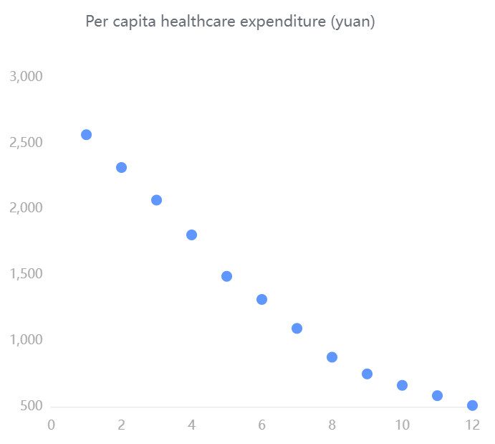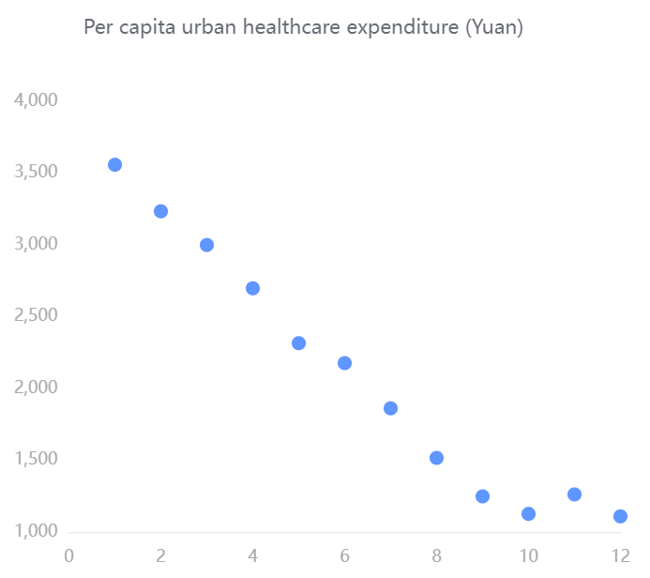

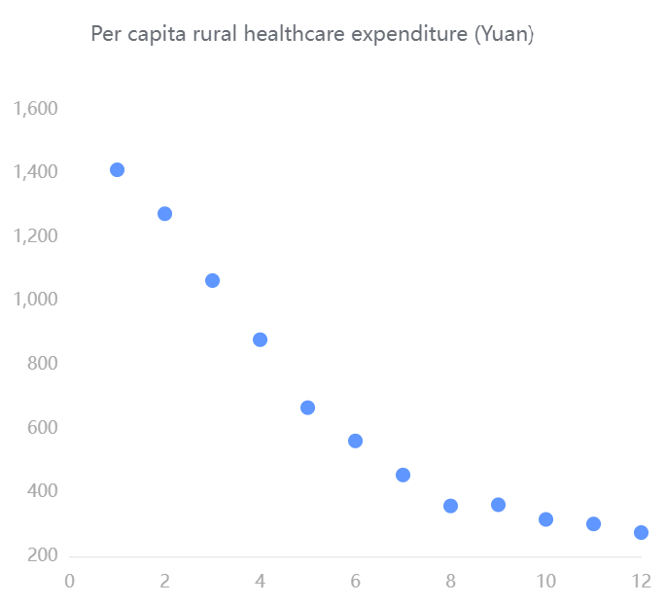

From these scatter diagrams, we can see that with the increase of the years, the funding for various aspects of healthcare is constantly increasing rapidly. The total cost of health care ranges from about 6,000 to 36,000. Government spending on healthcare ranges from about 1,800 to 10,800. Social healthcare expenditures ranged from about 2,200 to 13,500. Personal out-of-pocket healthcare expenditures ranged from about 4,000 to 11,500. Per capita healthcare expenditure ranges from about 260 to 500. Per capita urban health expenditure ranges from about 1,100 to 3,600. Per capita spending on healthcare in rural areas ranges from about 250 to 1400. It reflects the country's increasing emphasis on healthcare.