Since a stronger and more democratic country may have more budget for their public medical system, we may investigate the relationship between the year, budget, and number of medical personnel.

We may first depict the relationship between the year and budget to verify whether the two variables are in positive proportion over the recent 20 years.

For dataset “National Health Expenditures”, we want to estimate how much confidence we can conclude the budget is in an increasing trend over the past 20 years. Since the data collected is not in normal distribution, and our focus is to depict their trend, thus, we shall use linear regression for analysis. The null hypothesis shall be “there’s no relationship between the two variables”. Hence, we need to find the p-value and coefficients of all dependent variables with respect to the “year” attribute through R (Appendix 3.1).

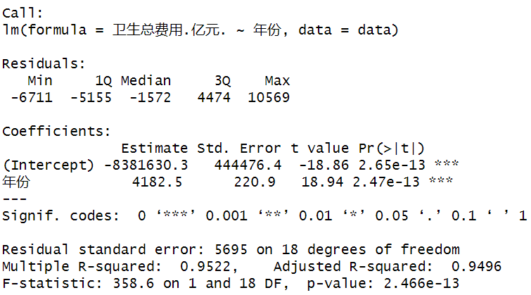

*Table 1: National healthcare expenditure over the years Table 2: Government healthcare expenditure over the years*

*Table 3: Society healthcare expenditure over the years Table 4: Individual healthcare expenditure over the years*

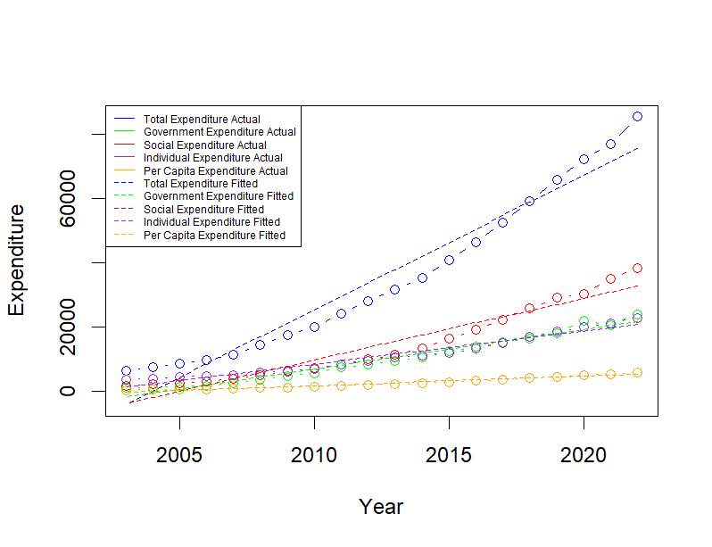

*Table 5: Per capita healthcare expenditure over the years Table 6: Regressed & actual data visualization*

By inspecting all output tables, we may notice that $pValue≤8.839×{10}^{-12}<0.05$ and all coefficients for the year (“年份”) is positive. Therefore, we may have strong evidence to reject the null hypothesis and can conclude that all health expenditures are positive correlated with the year.

Consequently, we may conclude that China’s government alongside with its citizens are getting wealthier and have increased its investments in the health of citizens over the past 20 years.

For National health expenditure, its average increment rate over the past 20 years may imply the degree of the government attaches to people’s health.

$$Average increment rate=\sum_{n=1}^{20}{\frac{{Val}_{n+1}-{Val}_{n}}{{Val}_{n}}}×100$$

By using this formula, we may get the average increment rate of the national health expenditure between years is 14.51581% (Appendix 3.2).

Therefore, in average, the health budget for each year shall be 14.5% higher comparing to the last year, which may indicate the fast progressing of China’s economy over the past 20 years, with better medical conditions and spare money, people are more aware of the importance to get better healthcare.

As we have confirmed that the national health expenditure keeps increasing over the past 20 years, the number of medical personnel per ten thousand people is another important measure of a country’s robustness of its medical system. Since big medical system needs huge amount of money, manpower, advanced equipment to support, it may reflect the degree of development of a country. Obviously, by observation, these data are all increasing by years, but whether the progression in rural area are in the same level with the urban area. By using the same strategy of the average increment rate, we may depict the increment trend of urban area and rural area by adding "每万人拥有城市卫生技术人员数.人.", "每万人拥有城市执业.助理.医师数.人.", "每万人拥有城市注册护士数.人." up for total medical personnel in urban area, and summing "每万人拥有农村卫生技术人员数.人.", "每万人拥有农村执业.助理.医师数.人.", "每万人拥有农村注册护士数.人." up for total medical personnel in rural area (Appendix 3.3).

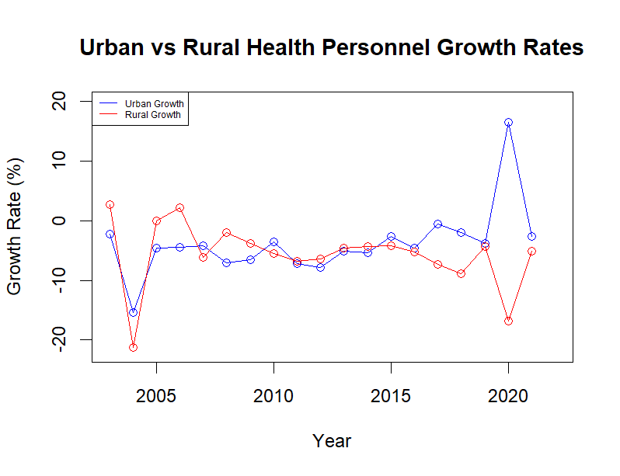

*Table 7: Urban vs rural health personnel growth rates*

Therefore, we may notice that the total increment rate per year in a city is not always equivalent to that rate in a county. This can be influenced by emergencies and various issues. For example, the corona virus pandemic in 2020, since the urban area needs more doctors than rural area, medical personnel in rural may became personnel in a city. However, the overall increase of the number of medical personnel per ten thousand people is much slower than the increment in healthcare budget. Which may indicate that China’s progression in cultivating medical personnel is not in a very fast speed comparing to other investments.