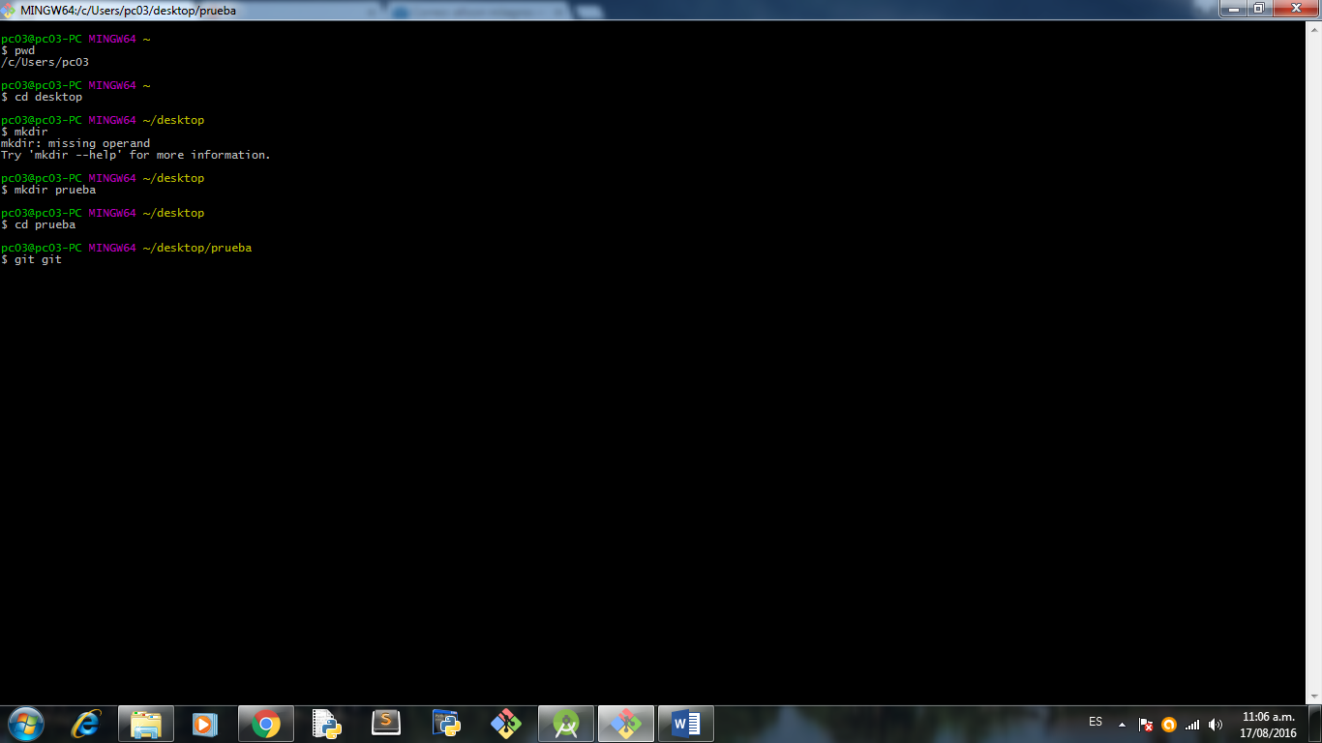

Ls .. para ver lo que hay en mi repositorio

Pwd .. para saber mi ubicación

Mkdir … para crear directorio

hu@cho23

pc03@pc03-PC MINGW64 ~

$ pwd

/c/Users/pc03

pc03@pc03-PC MINGW64 ~

$ cd desktop

pc03@pc03-PC MINGW64 ~/desktop

$ mkdir

mkdir: missing operand

Try 'mkdir --help' for more information.

pc03@pc03-PC MINGW64 ~/desktop

$ mkdir prueba

pc03@pc03-PC MINGW64 ~/desktop

$ cd prueba

pc03@pc03-PC MINGW64 ~/desktop/prueba

$ ls

pc03@pc03-PC MINGW64 ~/desktop/prueba

$ pwd

/c/Users/pc03/desktop/prueba

pc03@pc03-PC MINGW64 ~/desktop/prueba

$ ls

pc03@pc03-PC MINGW64 ~/desktop/prueba

$ cd test

bash: cd: test: No such file or directory

pc03@pc03-PC MINGW64 ~/desktop/prueba

$ cd prueba

bash: cd: prueba: No such file or directory

pc03@pc03-PC MINGW64 ~/desktop/prueba

$ git remove add origin https://github.com/ALLISON23/prueba.git

git: 'remove' is not a git command. See 'git --help'.

Did you mean this?

remote

pc03@pc03-PC MINGW64 ~/desktop/prueba

$ git init

Initialized empty Git repository in C:/Users/pc03/Desktop/prueba/.git/

pc03@pc03-PC MINGW64 ~/desktop/prueba (master)

$ git remote add origin https://github.com/ALLISON23/prueba.gi

pc03@pc03-PC MINGW64 ~/desktop/prueba (master)

$ git remote add origin https://github.com/ALLISON23/prueba.git

fatal: remote origin already exists.

pc03@pc03-PC MINGW64 ~/desktop/prueba (master)

$ git push -u origin master

error: src refspec master does not match any.

error: failed to push some refs to 'https://github.com/ALLISON23/prueba.gi'

pc03@pc03-PC MINGW64 ~/desktop/prueba (master)

$ cd ..

pc03@pc03-PC MINGW64 ~/desktop

$ rm -r prueba/

pc03@pc03-PC MINGW64 ~/desktop

$ ls

CodeBlocks.lnk\* 'Excel 2013.lnk'\* primerPhyton.py

desktop.ini 'Google Chrome.lnk'\* 'Word 2013.lnk'\*

,

pc03@pc03-PC MINGW64 ~/desktop

$ mkdir prueba

pc03@pc03-PC MINGW64 ~/desktop

$ cd prueba

pc03@pc03-PC MINGW64 ~/desktop/prueba

$ ls

index.html

pc03@pc03-PC MINGW64 ~/desktop/prueba

$ git init

Initialized empty Git repository in C:/Users/pc03/Desktop/prueba/.git/

pc03@pc03-PC MINGW64 ~/desktop/prueba (master)

$ git config --global user.name = "ALLISON23"

pc03@pc03-PC MINGW64 ~/desktop/prueba (master)

$ git config --global user.email = "alli\_mat@hotmail.com"

pc03@pc03-PC MINGW64 ~/desktop/prueba (master)

$ git config --global --list

user.name==

user.email==

pc03@pc03-PC MINGW64 ~/desktop/prueba (master)

$ git init

Reinitialized existing Git repository in C:/Users/pc03/Desktop/prueba/.git/

pc03@pc03-PC MINGW64 ~/desktop/prueba (master)

$ git remote add origin https://github.com/ALLISON23/prueba.git

pc03@pc03-PC MINGW64 ~/desktop/prueba (master)

$ git push -u origin master

error: src refspec master does not match any.

error: failed to push some refs to 'https://github.com/ALLISON23/prueba.git'

pc03@pc03-PC MINGW64 ~/desktop/prueba (master)

$ git status

On branch master

Initial commit

Untracked files:

(use "git add <file>..." to include in what will be committed)

index.html

nothing added to commit but untracked files present (use "git add" to track)

pc03@pc03-PC MINGW64 ~/desktop/prueba (master)

$ git add .

pc03@pc03-PC MINGW64 ~/desktop/prueba (master)

$ git status

On branch master

Initial commit

Changes to be committed:

(use "git rm --cached <file>..." to unstage)

new file: index.html

pc03@pc03-PC MINGW64 ~/desktop/prueba (master)

$

pc03@pc03-PC MINGW64 ~/desktop/prueba (master)

$ git commit -m "first commit"

[master (root-commit) fc04fd0] first commit

1 file changed, 11 insertions(+)

create mode 100644 index.html

pc03@pc03-PC MINGW64 ~/desktop/prueba (master)

$ git push -u origin master

Username for 'https://github.com': ALLISON23

remote: Invalid username or password.

fatal: Authentication failed for 'https://github.com/ALLISON23/prueba.git/'

pc03@pc03-PC MINGW64 ~/desktop/prueba (master)

$ git push -u origin master

Username for 'https://github.com': ALLISON23

remote: Invalid username or password.

fatal: Authentication failed for 'https://github.com/ALLISON23/prueba.git/'

pc03@pc03-PC MINGW64 ~/desktop/prueba (master)

$ git push -u origin master

Username for 'https://github.com': ALLISON23

remote: Invalid username or password.

fatal: Authentication failed for 'https://github.com/ALLISON23/prueba.git/'

pc03@pc03-PC MINGW64 ~/desktop/prueba (master)

$ git push -u origin master

Username for 'https://github.com': ALLISON23

Counting objects: 3, done.

Delta compression using up to 4 threads.

Compressing objects: 100% (2/2), done.

Writing objects: 100% (3/3), 276 bytes | 0 bytes/s, done.

Total 3 (delta 0), reused 0 (delta 0)

To https://github.com/ALLISON23/prueba.git

\* [new branch] master -> master

Branch master set up to track remote branch master from origin.