**Jenkins**

**Introduction** : Jenkins is one open source tool to perform continuous integration. The basic functionality of Jenkins is to monitor a version control system and to start and monitor a build system (for example, Apache Ant or Maven) if changes occur. Jenkins monitors the whole build process and provides reports and notifications to alert maintainers on success or errors.

**Installation :**

1. Download the jenkins.war file from <http://jenkins-ci.org/views/hudson-tutorials>

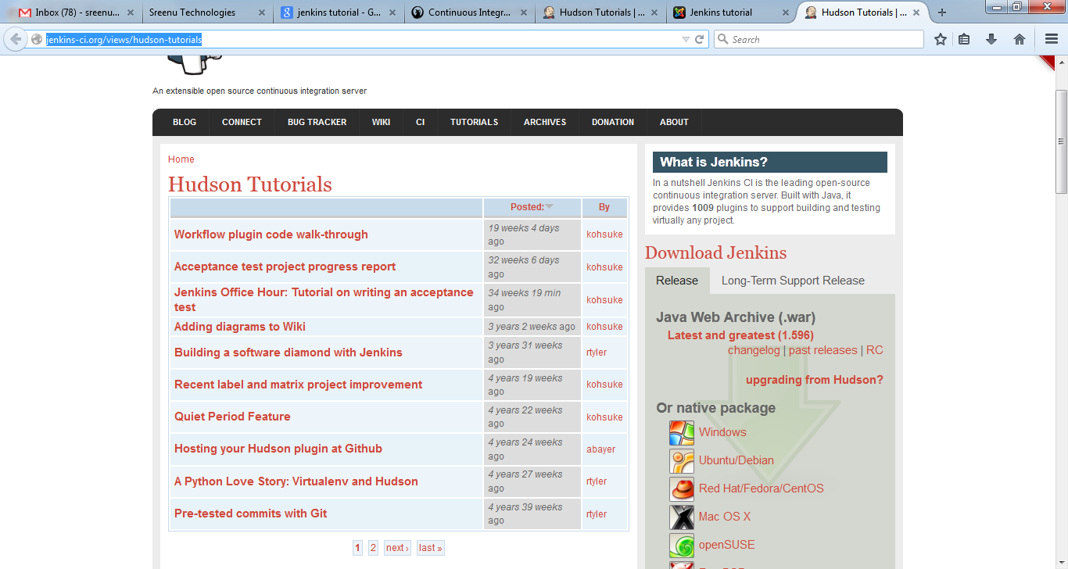

1. Download the war file

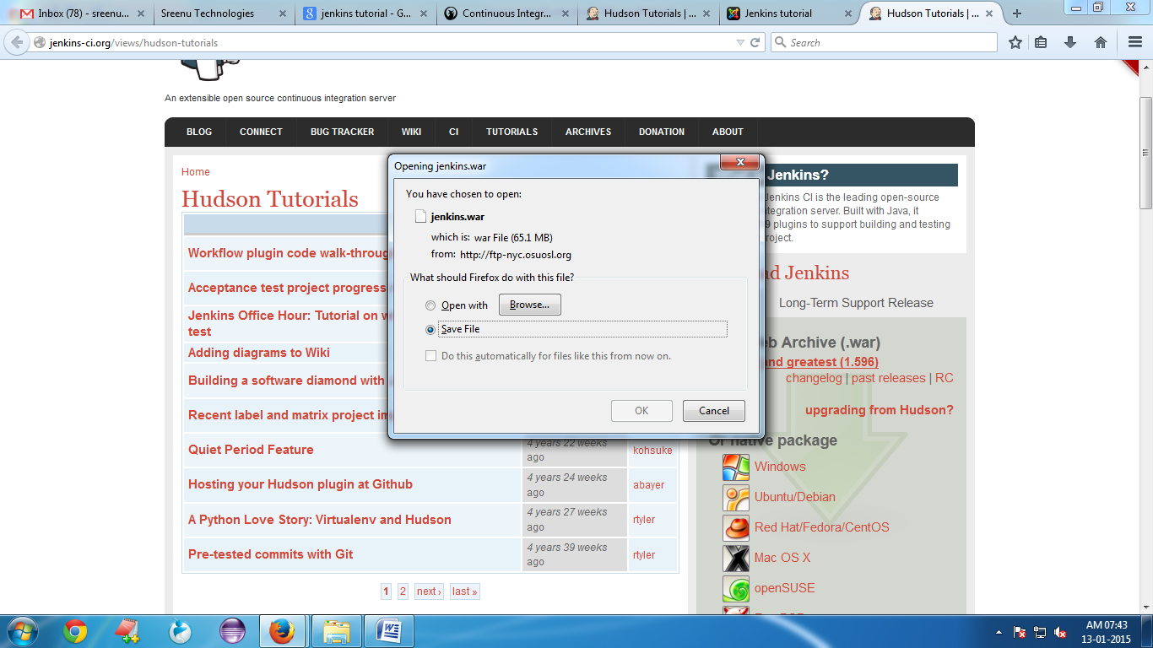

1. Deploy the Jenkins. war file into tomcat

Copy the Jenkins. War file into apache-tomcat-7.0.57\webapps folder.

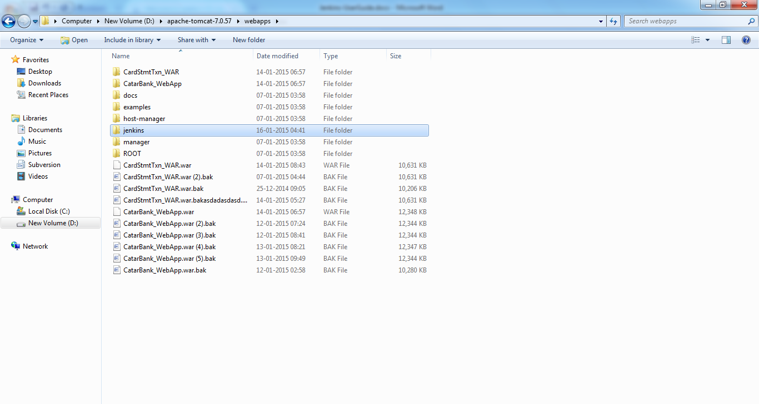4. Start the Tomcat Server

1. Open the Tomcat Admin Console . <http://localhost:2015/manager/html>

You will see the Jenkins application below

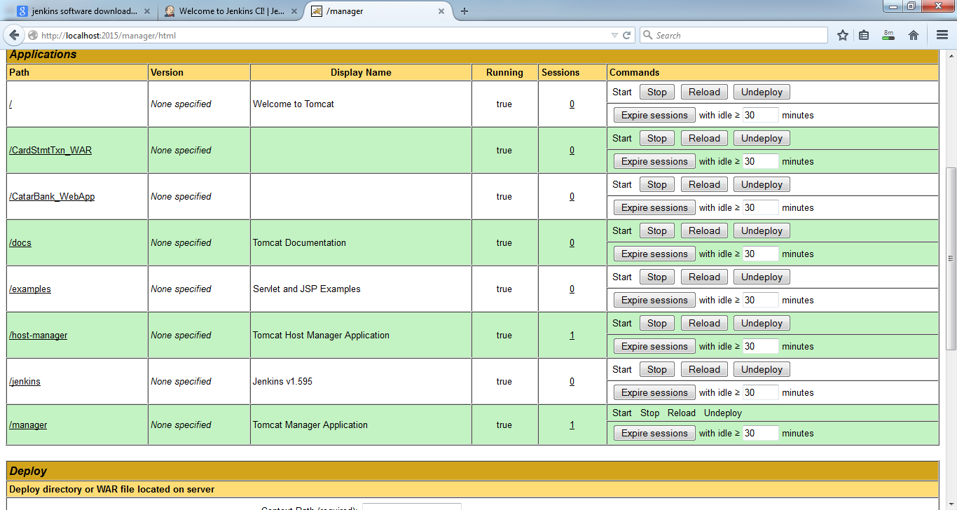

1. Click on Jenkins application then it will be redirecting to the Jenikins home page.

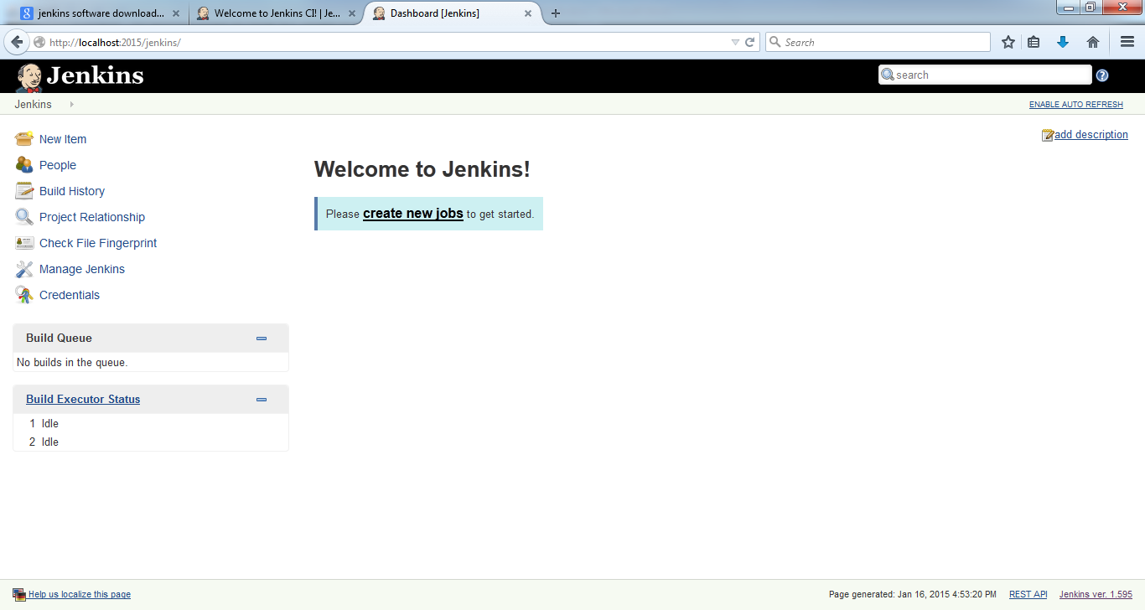

1. How to Add the jar/war/ear artefact to the Jenkins

Click On new Item🡪Item Name: Artfifact Name choose maven project and click on OK

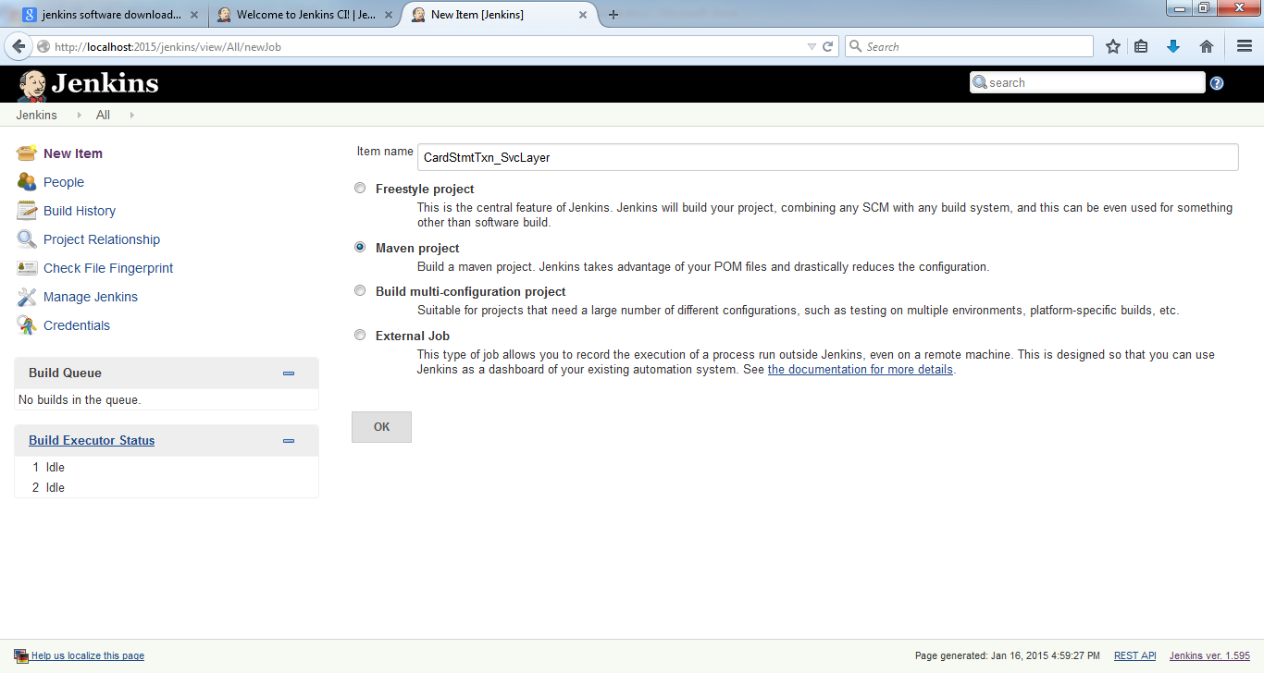

8.Build the jar file

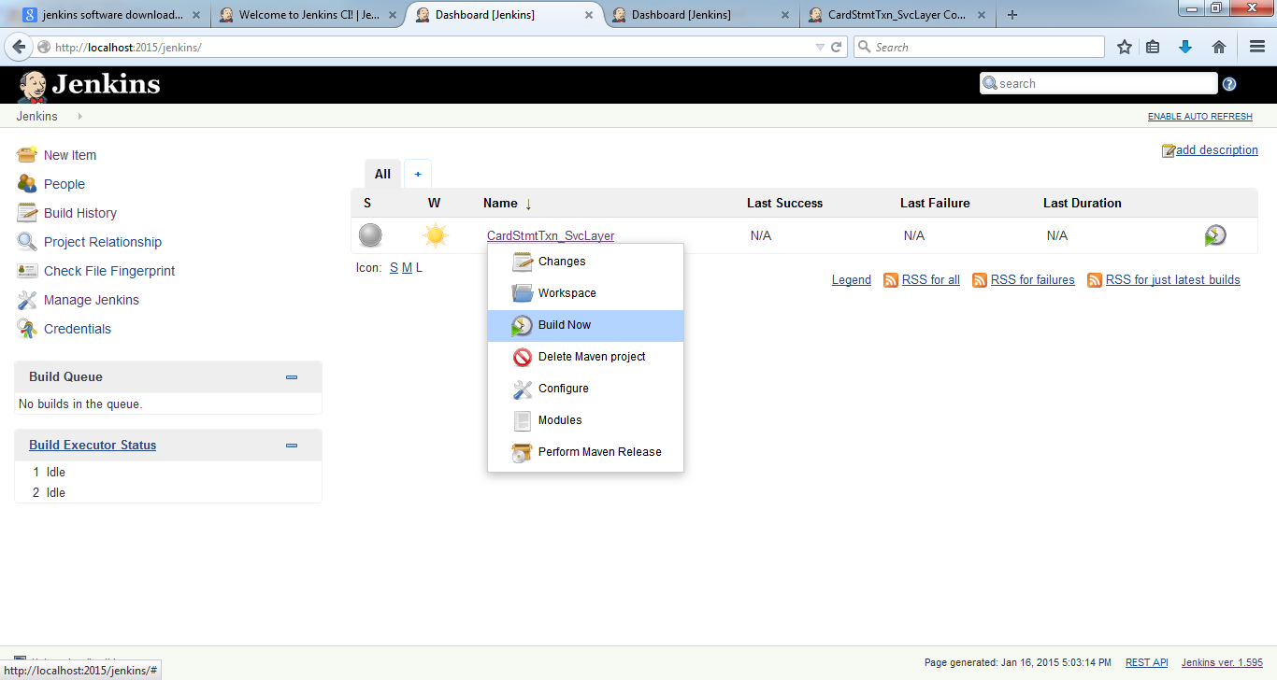

9 . I Have build the same jar in 6 times.here build history is showing times

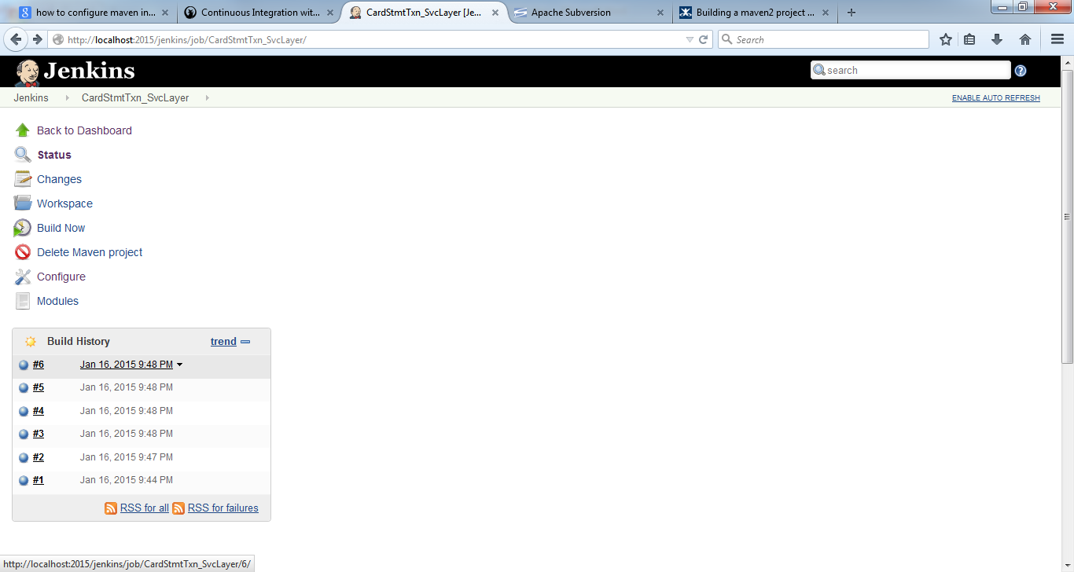

10. How to see build success message :

Click on build id( #6 or #5). Then click on Console Output button.

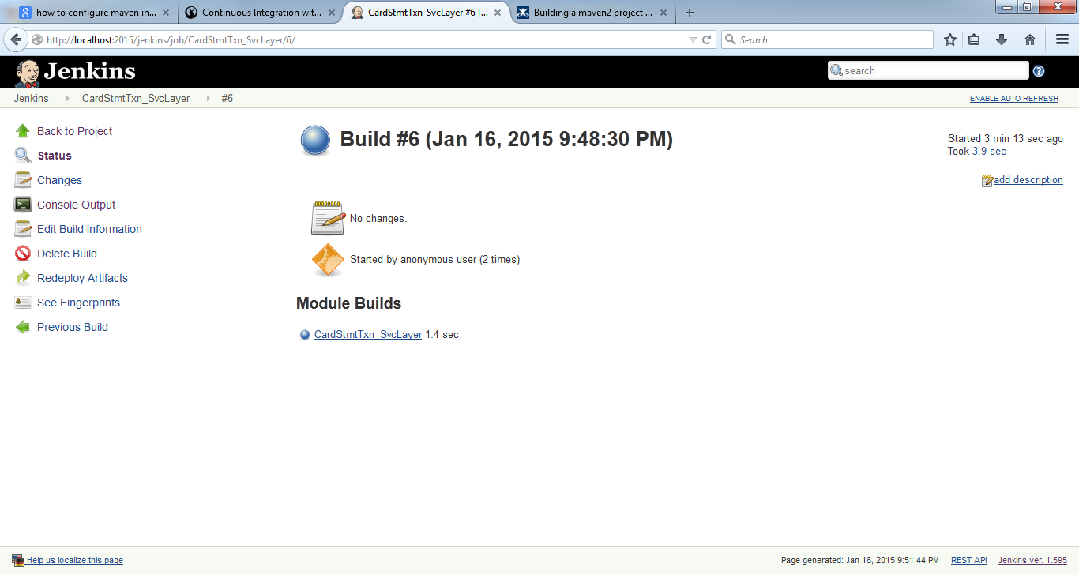

11. Click On Console OutPut on RightHandside.Then show the build success message.

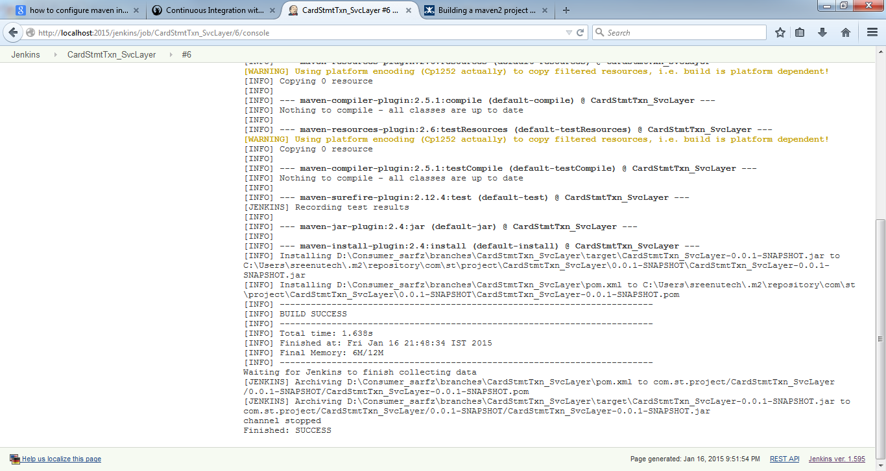

11. Where we can check in our local repository.

Build History Location :

C:\Users\sreenutech\.jenkins\jobs\CardStmtTxn_SvcLayer\modules\com.st.project$CardStmtTxn_SvcLayer\builds

How to release the Code :

Release the code means move your trunk code ( 1.0-SNAPSHOT.i.e. snapshot) to tags code( 1.0. i.e. without snapshot).

12. Choose the project .

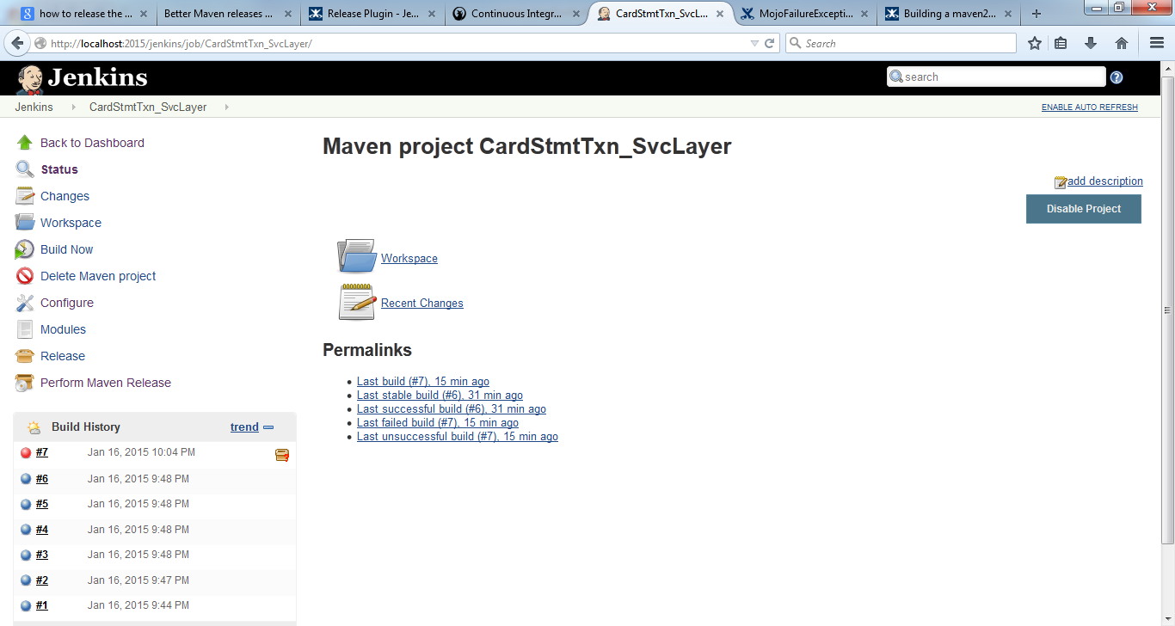

13. On Left Hand Side click on **“Perform Maven Release**” button.you will be redirectring to the below screen.

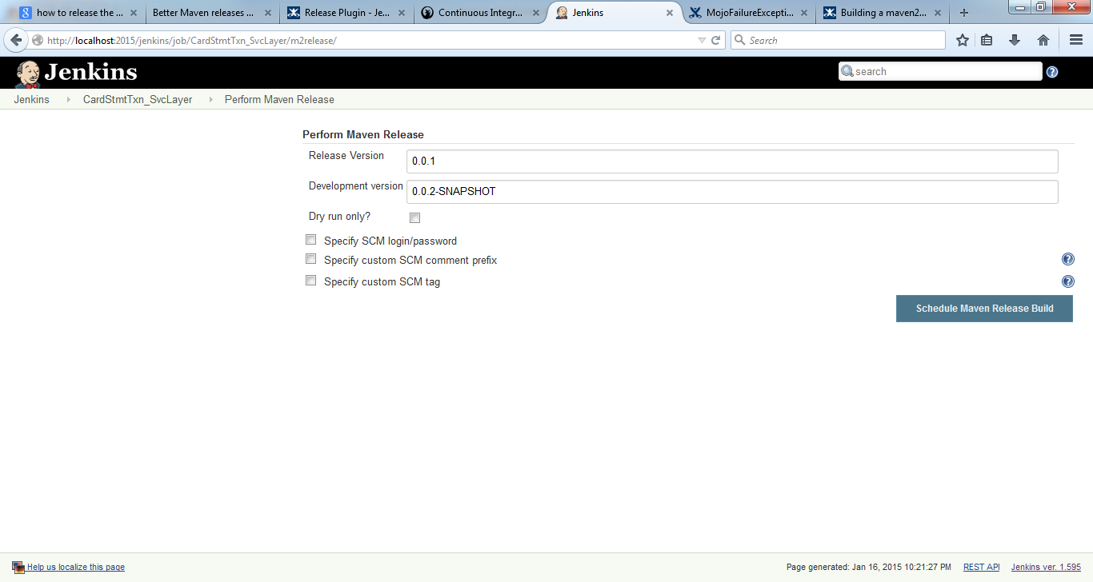

**Note : If you observe here,Release version has changed from 0.0.1.SNAPSHOT to 0.0.1**

14. Click on Schedule “Maven Release Build”.

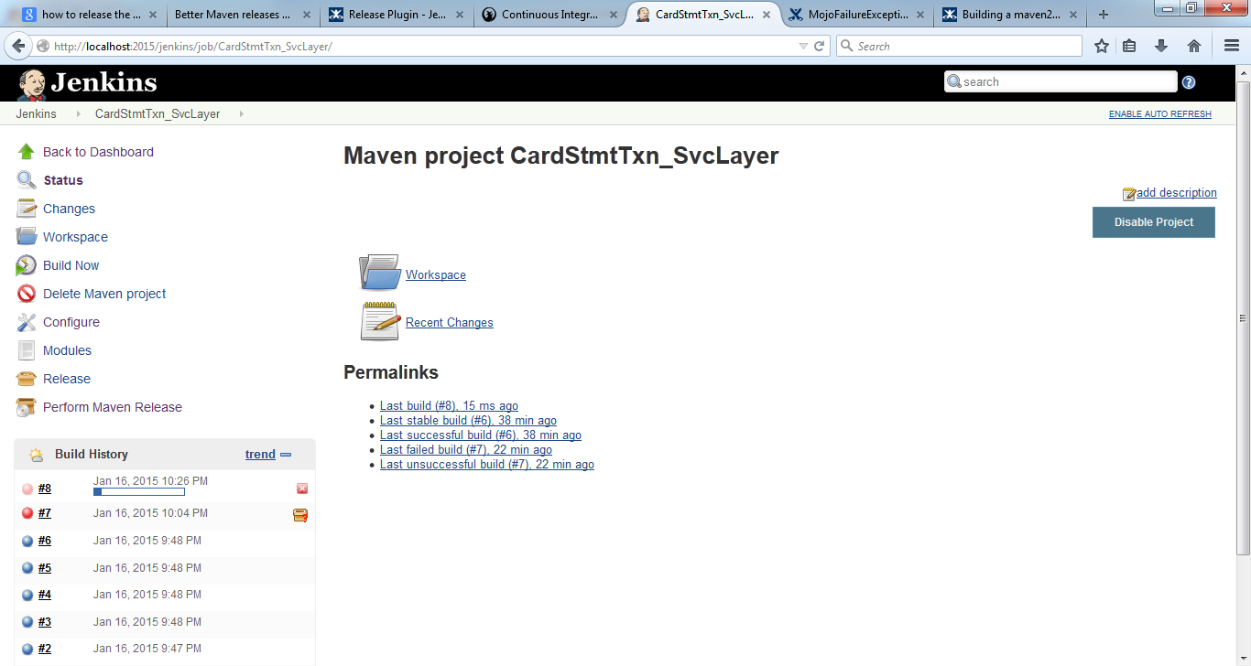

Now the released version updated to 0.0.1