**Generative AI in Research**

Generative AI- Refers to the class of AI that can generate new content based on patterns learned from existing data. Relies on Large Language Models

Large Language Models- Is a type of AI model trained on massive amounts of text data to understand and generate human like language. Example Chat GPT, Deepseek, Claude, Gemini.

Prompts- Refers to instructions we give to a large language model to tell it what to do.

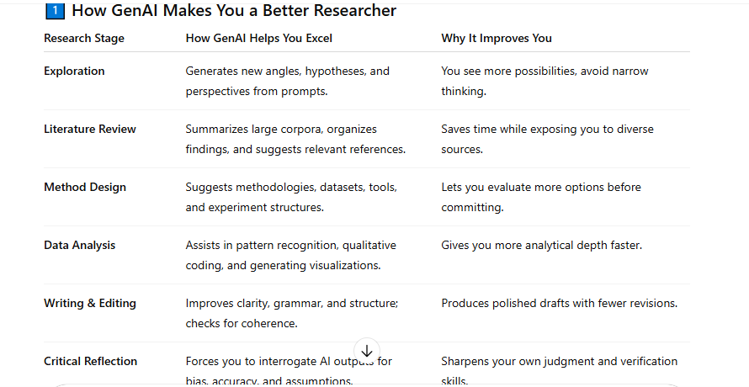

A key concept that we can build using Gen AI to help in research is Retrieval Augmented Generation.

**Retrieval-Augmented Generation (RAG)**

**RAG combines:**

•Retriever → Searches your custom database (papers, datasets, reports). Database can be made from pdf’s, text files or CSV files from our research.

•Generator → Uses GenAI (GPT) to answer your question only based on retrieved material from your database of PDFs.

**Why RAG?**

•Idea Generation from your own work.(Knowledge of the large language model Is based on all your work)   
•Chat GPT platform the large language model has been taught a lot of different things leading to for it to hallucinate information. Using RAG helps in reducing hallucination

and answer is real from the provided sources. (RAG system adds citations where it got the answer from all your documents )   
•Keeps unpublished research private and no sending sensitive data to external AI.

➢**N/B -**With RAG you have a personal AI research Assistant that reasons only from your chosen literature.

**Frameworks to build RAG include:**

NO-Code Tools:

1.N8N- Drag and drop automation tool, open-source and self-hostable. 2.Flowise AI   
3.LangFlow   
4.Zapier

How will you use Gen AI as a researcher?

**"I’ll use Generative AI to save time on routine parts of**

**research so I can focus on deeper thinking.**

It will help me quickly find and summarize relevant studies,

suggest new ideas, and improve the clarity of my writing. I’ll

always double-check the information it gives me and be open

about when I’ve used it. For me, AI is a support tool, not a

replacement for my own analysis and judgment."