WEBPAGE ASSIGNMENT: KITTENS
-NEEDS: header, body, button, picture, footer
***push code to GitHub and upload design to Dribbble.com (make sure to save design in 1600x1200 to avoid being cut off)
MESSAGE/EMOTION:
COLOR SCHEME:
PRIMARY: light gold/champagne
Medium Champagne
-CMYK (0,5,34,7)
-happiness
-elegance

SECONDARY: lilac
“Languid Lavender”
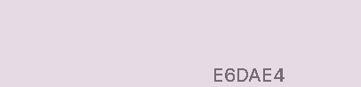
-CMYK (0,5,1,10)
-joy
ACCENT: gold

“Vegas Gold”
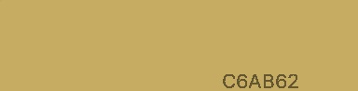
-CMYK (0,14,51,22)

-COORESPONDING PICTURE THAT WORKS WITH COLOR SCHEME
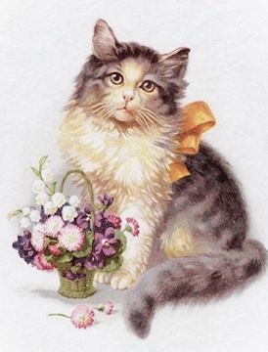

FONT FAMILY: Dancing Script
-HEADER FONT
-BODY FONT
-FOOTER FONT

BACKGROUND COLORS:
-HEADER:
-BODY:
-FOOTER:

FONT COLOR:
-HEADER:
-BODY:
-FOOTER:

