**GROUP PROJECT**

*CSCI 2170 Server Side Scripting*

*October 21, 2021*

Adam Melvin

Liam Osler

Sarah Pollock-Jordan

Rachel Woodside

**Table of Contents**

Nova Scotia Court News Website 2

Contributors: 2

Website Goals: 2

Technology Stack: 2

Documentation: 2

Key Features: 3

Website Users: 4

Administrators: 4

Moderators: 4

Verified Users (Law professionals, politicians, journalists, etc.) 4

Registered Users (general users or not yet verified users): 4

General Users (not logged in): 4

User Stories: 5

Casual Carl: 5

Registered Randy: 5

Verified Veronica: 5

Press Paige: 6

Moderator Molly: 6

Admin Adam: 6

Conceptual Images: 7

Homepage: 7

Login Modal: 7

Account Creation Modal: 7

User Profile: 7

Desktop Homepage: 8

User List Display: 9

Citations 10

# Nova Scotia Court News Website

## Contributors:

* Adam Melvin
* Liam Osler
* Sarah Pollock-Jordan
* Rachel Woodside

## Website Goals:

* Aggregate rulings from the Courts of Nova Scotia and present them in an accessible and easy to read fashion for users from a broad range of demographics.
* Index page "newsfeed" that aggregates sources such as the Courts of Nova Scotia's RSS Feed, CanLII's Nova Scotia RSS Feeds and other local news outlets for stories relevant to the court rulings and legislation in Nova Scotia.
* Means for users to add comments and/or reactions to the content on the Index page.
* Means for users to "follow" a certain topic, ruling, user, or other items.
* Provide a forum for discussions about Nova Scotia court rulings, legislation and legal affairs.

## Technology Stack:

* PHP
* MySQL
* JavaScript
* CSS
* Libraries:
* [Bootstrap 4.0](https://getbootstrap.com/docs/4.0/getting-started/introduction/)
* Git:
* <https://github.com/LiamOsler/CSCI2170Project-LegalNewsWebsite>

## Documentation:

* Documentation will be provided through the README.md document hosted in the Github repository.

# Key Features:

* Features common across all pages:
  + Navigation Bar
    - Website logo/name in the top left (will link to index.php)
    - Collapsing navigation button to these areas:
      * Advanced Search (search by user, article or outlet to access user, article or outlet pages)
      * Court Docket
      * Contact/Support
    - Login Area/Login Indication (logged in user shows profile icon in top right)
* Index page:
  + Feed of the most recent posts
  + A search bar:
    - AJAX used to display results live
  + If the user is logged in, display their customized results
* Advanced search page:
  + Allows user to set search filters
* User pages:
  + Feed of the most recent comments/reactions by the user
  + Feed of the most recent article posts (if user is verified)
  + If the user is logged in, allow them to edit the fields on their profile
* Admin/Moderator page:
  + Shows an overview of content that may require moderation (flagged by users)
  + Allows the administrator and moderators to change the visibility of posts
  + Can verify users/outlets
* Article pages:
  + The title of the article
  + The author/outlet of the article
  + The contents of the article
  + The reaction count/ratio of the article
  + The comments made by users on the article (in chronological order)
* Outlet pages
  + Map of location of the courtroom
  + Contact information
  + Feed of all articles posted by the outlet
* Court docket page:
  + Shows an interactive calendar with previous and upcoming court sessions
* Contact/Support page
  + Creates support ticket site administrator

# Website Users:

## Administrators:

* Elevated user privileges
* Manages other user accounts
* Manages moderators and users

## Moderators:

* Moderates discussion boards
* May hide content as deemed appropriate by the terms of acceptable behaviour outlined in the user agreement to terms and conditions.

## Verified Users (Law professionals, politicians, journalists, etc.)

* Must be verified by the website (akin to Twitter verification)
  + User icon shows a verification symbol
* Same features as registered users, but may also publish opinion pieces/articles/announcements

## Registered Users (general users or not yet verified users):

* Anyone can register for account
  + Must agree to terms and conditions during registration
  + User can upload a profile picture that creates their user icon
* Can follow a topic or a ruling
* Has a userpage that displays the user's activity feed
  + Items the user has commented on
  + Items the user has reacted to
  + Activity feed can be set to public/private according to user preference

## Users that are not logged in:

* Anyone can browse the public content on the website without having account or being logged in.
* Can see site content like the most recent posts, court dockets, user comments and can perform searches, but cannot post or interact with content.

# User Stories:

* Casual/Unregistered User (“Casual Carl”)
* Registered User (“Registered Randy”)
* Legal Professional (“Verified Veronica”)
* Reporter/Journalist (“Press Paige”)
* Administrator (“Admin Adam”)
* Moderator (“Moderator Molly”)

## Casual Carl:

Casual Carl is an example of an unregistered user. Casual Carl may find the Nova Scotia Legal News Website through various means. Perhaps he found a link to an article posted on Nova Scotia Legal News that was shared through social media, or perhaps he found an article while researching a topic of personal interest and was linked through a search engine to the website. Regardless of how Carl arrived on the site, he experiences the most basic level of access - essentially, he can view content, but can’t post content without registering. The website needs to present enough information to Carl to pique his interest in participating further and should nudge him towards registering an account.

## Registered Randy:

Randy is an example of a legal buff for whom Nova Scotia law is a personal interest. The Nova Scotia Legal News website provides Randy with up-to-date Nova Scotia court rulings, as well as articles posted by legal professionals and other verified users, which provide opinions and context to the rulings. As a registered user, he can comment on and react to (like/dislike) articles posted on the Nova Scotia Legal News community. Randy can also follow other registered users to build a network of friends and colleagues, as well as follow verified users to keep track of their published articles. While Randy may be registered, he is not verified so he does not have the authorization to post his own articles to the website.

## Verified Veronica:

Verified Veronica is an example of a legal professional whose credentials have been verified by the moderators and administrators of the website. She would use the Nova Scotia Legal News Website to keep track of recent court rulings and interact with her colleagues by following them. As a verified user, she is also able to post her own articles to the website. She can comment on and like/dislike articles to interact with other users on the Nova Scotia Legal News Website. Veronica can follow other registered users, such as her law colleagues, to see their profiles and their posted articles. The website provides Veronica with the means to communicate with the law community, as well as keep up to date on recent news in from the Nova Scotia Courts which could be relevant to her work.

## Press Paige:

Press Paige is an example of a law blogger who writes opinion articles on various cases. Press Paige will have been verified and approved to post articles on the Nova Scotia Legal News website. She will have all the permissions of a verified user, as well as the ability to upload and delete her own articles. Nova Scotia Legal News allows Paige to connect to a greater audience and share her opinions with the legal community. Reporters like Paige can use these opinion articles to filter the “legalese” out of case law and make the subject matter more accessible to the broader public.

## Moderator Molly:

Moderator Molly is one of the members of the team of designated moderators on Nova Scotia Legal News. Her primary responsibility is to moderate the comment sections under articles and make sure all content obeys the user agreement and the terms and conditions. Molly can remove any posts which do not follow these rules. Additionally, Molly may review articles posted by Press Paige or Verified Veronica and make sure they also follow the terms and conditions.

## Admin Adam:

Admin Adam is an example of a dutiful web-developer tasked with caring for the Nova Scotia Legal News Website. Admin Adam has the highest level of access on the website. The roles of the administrator are all-encompassing and include all the responsibilities of the moderators, but with a greater level of responsibility. They must maintain the website and may moderate content and appoint/remove moderators as required.

# Conceptual Images:

|  |  |
| --- | --- |
| Homepage: | Login Modal: |
| Account Creation Modal: | User Profile: |

## Desktop Homepage:

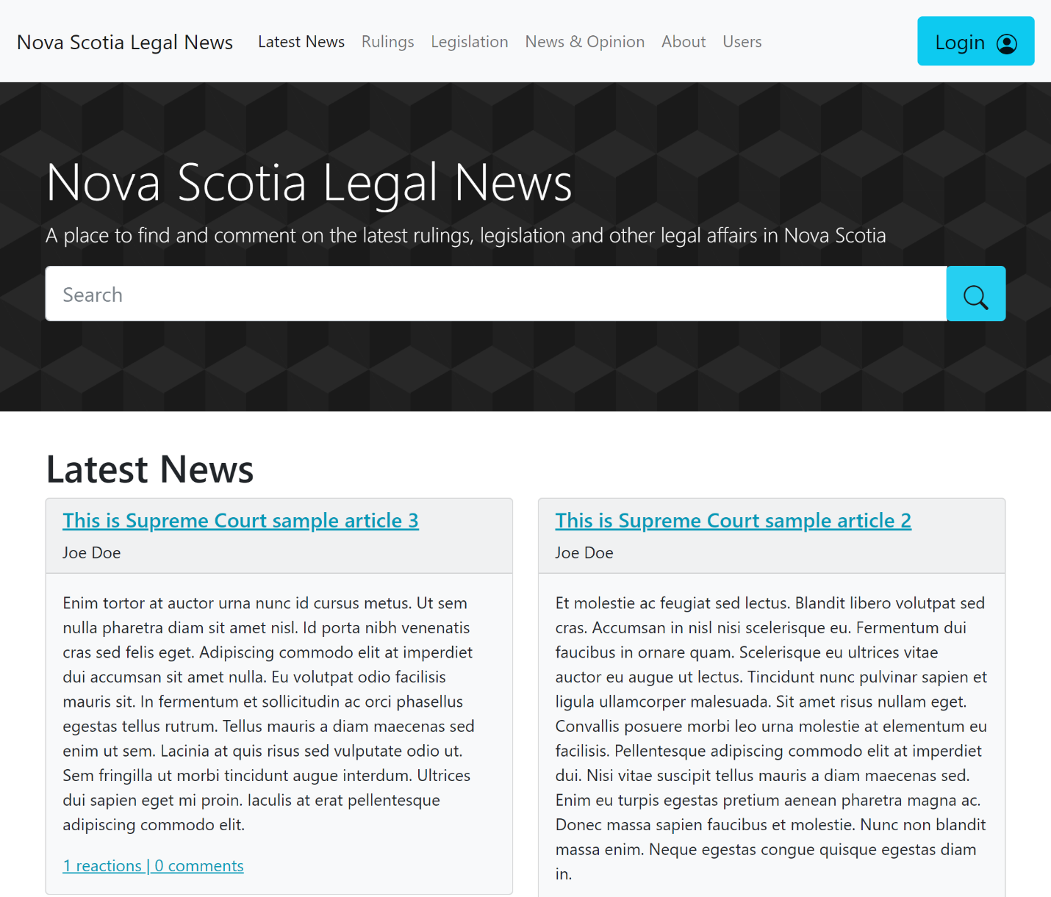

## User List Display:

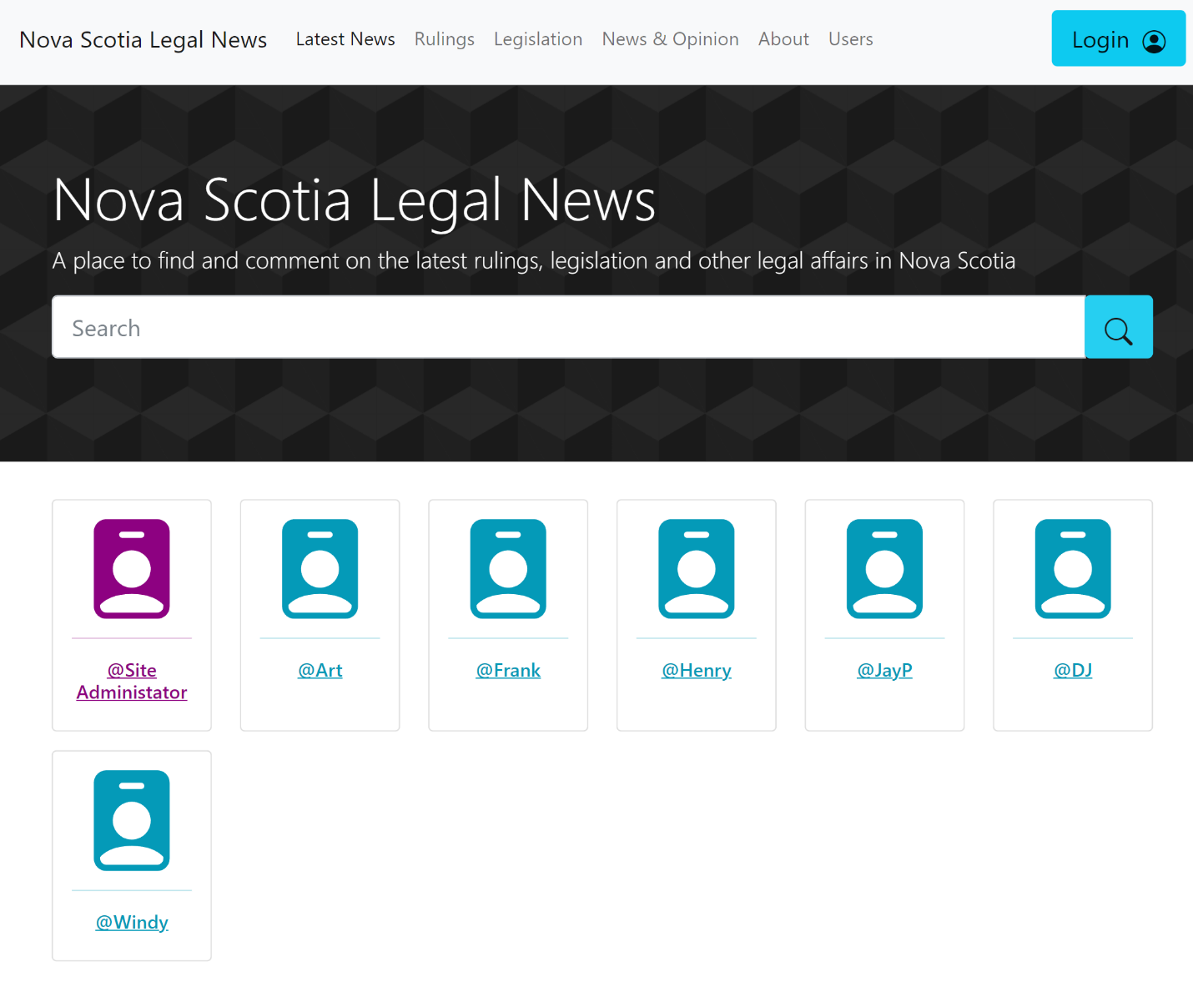

### Database Schema:

### 

# Citations

How To & Tools - Content Inventory

Author: U.S. General Services Administration Technology Transformation Services

URL: <https://www.usability.gov/how-to-and-tools/methods/content-inventory.html>

Date Accessed: 13 October 2021

Used as a reference for what basic content should be included in our plan.

Atlassian Agile Coach - User stories with examples and a template

Author: Max Rehkopf

URL: <https://www.atlassian.com/agile/project-management/user-stories>

Date Accessed: 18 October 2021

Used as a reference for the general content of user stories.