AI Product Review
Intelligence System
Complete Project Report
Multi-agent product review intelligence system
with fine-tuned DistilBERT, Streamlit, CrewAI, and Gemini API

Table des matières
1. Executive Summary 4
2. Project Context and Objective 4
3. Work Distribution 4
4. Project Requirements and Compliance 4
5. Global System Architecture 5
6. Part 1 - Machine Learning / Deep Learning Pipeline 5
6.1 Objective of the ML Part 5
6.2 Development Environment 6
6.3 Dataset Selection 6
6.4 Data Preprocessing 6
6.5 Train / Validation Split 6
6.6 Tokenization 6
6.7 Model Choice: DistilBERT 7
6.8 Fine-tuning Configuration 7
6.9 Evaluation Results 7
6.10 Saving the Model 7
6.11 Final Model API 7
7. Part 2 - Application, Streamlit, and Multi-agent Architecture 8
7.1 Objective of the Application Part 8
7.2 Streamlit Interface 8
7.3 Orchestrator 8
7.4 Collector Agent 8
7.5 Sentiment Agent 9
7.6 Insight Agent 9
7.7 Human-in-the-loop Checkpoint 9
7.8 Report Agent and Gemini API 9
7.9 JSON Logging System 10
7.10 Error Handling 10
8. Review Sources and Indexing 10
8.1 Manual Reviews 10
8.2 Demo CSV 10
8.3 HuggingFace Lightweight Reviews 10
8.4 Amazon Reviews 2023 Product-level Source 10
8.5 Local Reviews Index Improvement 11
9. Final Project Structure 11
10. Installation and Execution 12
10.1 Create the Virtual Environment 12
10.2 Install Dependencies 12
10.3 Configure Gemini 12
10.4 Place the Local Model 12
10.5 Run the Application 12
11. GitHub and Collaboration Workflow 12
12. Current Limitations and Possible Improvements 13
13. Project Strengths 13
14. Conclusion 13

1. Executive Summary
The AI Product Review Intelligence System is an artificial intelligence application designed to analyze product reviews automatically and produce a structured decision-making report. The system combines a Deep Learning sentiment model with a multi-agent architecture. The Deep Learning component uses a fine-tuned DistilBERT model for sentiment classification, while the application layer uses specialist agents to collect reviews, analyze sentiment, extract business insights, validate the analysis through a human checkpoint, and generate a final report.
The project satisfies the main academic requirements: a multi-agent architecture, at least two specialist agents plus one orchestrator, a fine-tuned Deep Learning model, Streamlit integration, a human-in-the-loop checkpoint, JSON logging, error handling, automated report generation, and GitHub collaboration.

2. Project Context and Objective
Customer reviews are an important source of information for understanding how users perceive a product. However, analyzing large volumes of reviews manually is slow, repetitive, and difficult to scale. The objective of this project is to transform raw product reviews into useful indicators such as sentiment distribution, recurring complaints, product strengths, and business recommendations.
The final system allows the user to enter a product name, collect or provide product reviews, analyze sentiment automatically, display key metrics, validate the results, and generate a structured final product intelligence report.

3. Work Distribution
Parts | Main Responsibility | Main Deliverables
Part 1 | Machine Learning / Deep Learning | Dataset preparation, preprocessing, DistilBERT fine-tuning, model evaluation, saved model, prediction API, evaluation artifacts, ML documentation
Part 2 | Application / Multi-agent / Integration | Streamlit app, CrewAI agents, orchestrator, review collectors, insight extraction, JSON logging, error handling, human checkpoint, Gemini report generation, application documentation

The ML part exposes a simple and stable API, while the application layer consumes this API without modifying the model training workflow.

4. Project Requirements and Compliance
Requirement | Implementation in the Project
Multi-agent architecture | Orchestrator + Collector Agent + Sentiment Agent + Insight Agent + Report Agent
At least 2 specialist agents | Four specialist agents were implemented
One fine-tuned Deep Learning model | DistilBERT fine-tuned on Amazon product review sentiment data
Human-in-the-loop checkpoint | User approval is required before final report generation
Logging | JSONL logs with timestamps and agent action details
Error handling | Centralized custom exceptions and safe fallbacks
Streamlit integration | Complete user interface implemented in app.py
CrewAI usage | Agents are defined and organized for CrewAI orchestration
Gemini API | Used for final report generation when configured
GitHub collaboration | Separate branches for ML and application work

5. Global System Architecture
The system follows a modular architecture. The user interacts with the Streamlit interface. Streamlit triggers the orchestrator, which then calls the specialist agents in the correct workflow order.
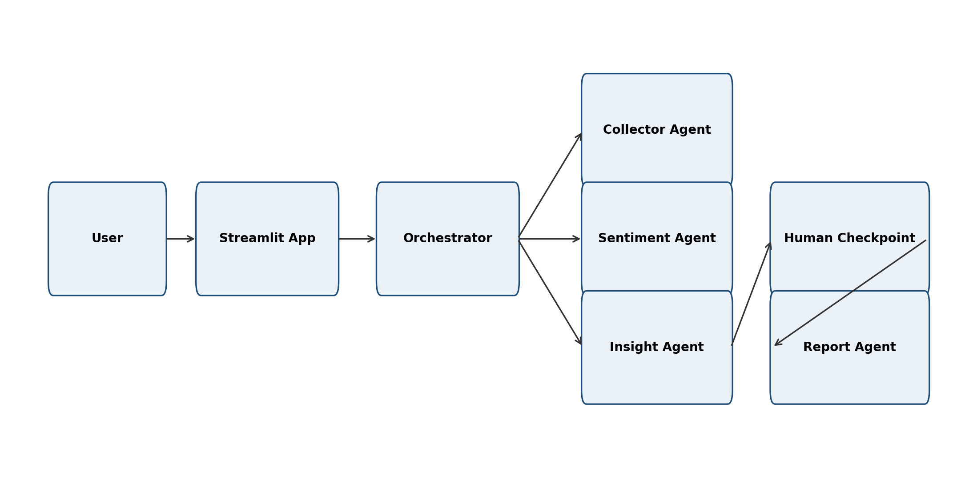
Figure 1 - Global architecture of the multi-agent product review intelligence system.

6. Part 1 - Machine Learning / Deep Learning Pipeline
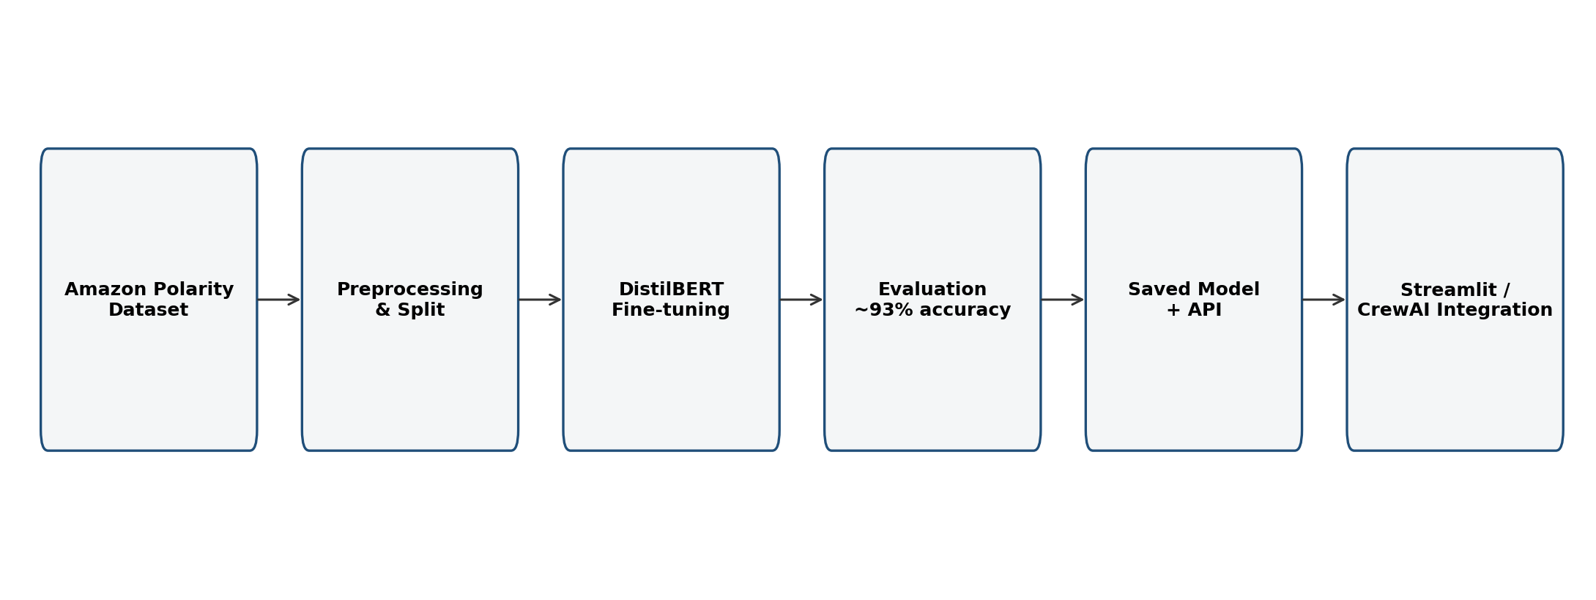
Figure 2 - ML pipeline from dataset preparation to application integration.

6.1 Objective of the ML Part
The objective of the ML part was to build a sentiment classifier able to classify product reviews as positive or negative. The final model had to be reusable by the application layer through a simple function:
predict_sentiment(text)
Expected output:
{
"label": "positive",
"score": 0.95
}
This interface makes the model easy to integrate into Streamlit, CrewAI tools, and the orchestrator.

6.2 Development Environment
The ML workflow was developed in Google Colab using GPU acceleration. After enabling the GPU runtime, the environment detected a Tesla T4 GPU. This was important because transformer fine-tuning is computationally expensive and significantly faster on GPU than CPU.

6.3 Dataset Selection
The first dataset considered was McAuley-Lab/Amazon-Reviews-2023. However, loading it through HuggingFace caused compatibility issues because dataset scripts are no longer supported in some cases. The final dataset selected for model training was amazon_polarity.
This dataset was appropriate because it is product-review based, already formatted for sentiment classification, compatible with HuggingFace, and simple enough to train.

6.4 Data Preprocessing
The original dataset contains the columns label, title, and content. The title and content fields were merged into a single text field called review_text, giving the model more context for each review.
Original Label | Meaning | Final Label
0 | Negative | 0
1 | Positive | 1

To reduce training time, a subset of 20,000 reviews was selected. The distribution was almost balanced, with approximately 10,257 positive reviews and 9,743 negative reviews.

6.5 Train / Validation Split
Split | Size
Training set | 16,000
Validation set | 4,000

The validation set was used to evaluate how well the model generalizes to unseen data.

6.6 Tokenization
The tokenizer used was distilbert-base-uncased. The main tokenization parameters were:
truncation=True
padding="max_length"
max_length=128
The maximum length of 128 tokens was a practical choice because product reviews are usually short or medium-length. This also reduces memory usage and speeds up training.

6.7 Model Choice: DistilBERT
The selected model was DistilBertForSequenceClassification with num_labels=2. DistilBERT is a lighter version of BERT. It keeps strong NLP performance while being faster and more efficient.

6.8 Fine-tuning Configuration
Parameter | Value
Epochs | 2
Learning rate | 2e-5
Batch size | 16
Weight decay | 0.01
Evaluation strategy | At each epoch

Only two epochs were used because DistilBERT is already pretrained, this also reduced the risk of overfitting.

6.9 Evaluation Results
Metric | Result
Validation accuracy after epoch 1 | 92.45%
Validation accuracy after epoch 2 | 92.98%
Final evaluation loss | 0.250581
Final accuracy | 92.975%

The classification report showed precision, recall, and F1-score around 0.93 for both positive and negative classes. This indicates that the model is balanced and performs well.

6.10 Saving the Model
The trained model and tokenizer were saved in:
model/sentiment_distilbert/
The folder contains files such as config.json, model.safetensors, tokenizer.json, tokenizer_config.json, and training_args.bin.

6.11 Final Model API
The ML part exposes the file:
src/sentiment_model.py
Example usage:
from src.sentiment_model import predict_sentiment
result = predict_sentiment("This product is amazing.")
print(result)
Example output:
{"label": "positive", "score": 0.9964}
This stable API allows the Streamlit and CrewAI application to use the model without needing to know the training details.

7. Part 2 - Application, Streamlit, and Multi-agent Architecture

7.1 Objective of the Application Part
The application part transforms the ML model into a complete usable system. It allows the user to enter a product, collect reviews, analyze sentiment, display insights, approve the analysis, and generate a final report.
It also implements the software engineering requirements of the project: agents, orchestrator, logs, error handling, Gemini API integration, and GitHub workflow.

7.2 Streamlit Interface
The main application file is:
app.py
The Streamlit interface includes:
- a product name input
- a review source selector
- an optional manual review input area
- an analysis button
- sentiment metrics
- a sentiment distribution chart
- a table of analyzed reviews
- a human approval checkbox
- a final report generation button
- a JSON log viewer

7.3 Orchestrator
The orchestrator is implemented in:
src/orchestration/orchestrator.py
Its role is to coordinate the complete workflow:
1. Collect reviews
2. Analyze sentiment
3. Generate insights
4. Wait for human approval
5. Generate the final report
The orchestrator guarantees that the final report cannot be generated before the user validates the analysis.

7.4 Collector Agent
The Collector Agent retrieves product reviews from different sources:
- manual reviews entered in Streamlit
- a demo CSV file
- a lightweight HuggingFace review dataset
- Amazon Reviews 2023 using a local product index

Main files:
src/app_tools/review_collector.py
src/app_tools/hf_review_collector.py
src/app_tools/amazon2023_collector.py
src/app_tools/product_index_search.py
The Collector Agent always returns a standardized list of reviews. This allows the next agents to work independently of the review source.

7.5 Sentiment Agent
The Sentiment Agent uses the ML prediction function:
from src.sentiment_model import predict_sentiment
It enriches each review with a sentiment label, a confidence score, and the model source used.
If the local trained model is missing, the system can use a temporary fallback based on:
from transformers import pipeline
pipeline("sentiment-analysis")
This fallback keeps the demo stable even if the trained model folder is not present locally.

7.6 Insight Agent
The Insight Agent transforms sentiment predictions into business indicators. It computes:
- total number of reviews
- positive, negative percentages
- recurring complaints
- product strengths
Main file:
src/app_tools/insight_tool.py

7.7 Human-in-the-loop Checkpoint
Before generating the final report, the user must approve the analysis in the Streamlit interface. If the checkbox is not validated, the workflow blocks report generation. This directly satisfies the human-in-the-loop requirement and makes the system safer.

7.8 Report Agent and Gemini API
The Report Agent generates a structured product intelligence report. Main file:
src/app_tools/report_tool.py
The generated report contains:
- Executive summary
- Sentiment distribution
- Main customer complaints
- Product strengths
- Business recommendations
- Risks and limitations
- Conclusion
When a Gemini API key is configured, Gemini is used to generate the final report. If the API key is missing, a Markdown fallback report is generated to prevent the demo from crashing.

7.9 JSON Logging System
The logging system is implemented in:
src/utils/logger.py
Logs are stored in:
logs/agent_actions.jsonl
Each log entry contains:
timestamp, agent, action, status, input, output, error
The logs can also be displayed inside Streamlit.

7.10 Error Handling
Error handling is centralized in:
src/utils/errors.py
Main custom errors:
ProductReviewError
ReviewCollectionError
SentimentAnalysisError
InsightGenerationError
HumanApprovalRequiredError
ReportGenerationError
This makes the code cleaner, more robust.

8. Review Sources and Indexing

8.1 Manual Reviews
The user can paste reviews directly into Streamlit. This is useful for fast tests and controlled demonstrations.

8.2 Demo CSV
The file data/sample_reviews.csv is used as a stable fallback. It allows the application to work even if external review sources are slow or unavailable.

8.3 HuggingFace Lightweight Reviews
This source retrieves reviews from a lightweight HuggingFace dataset. Its main limitation is that product matching is keyword-based.

8.4 Amazon Reviews 2023 Product-level Source
This is the most advanced review source. It uses a local SQLite product index to find the best products matching the user's query.
User query
-> Local SQLite product index
-> Best product candidates
-> parent_asin
-> Amazon Reviews 2023 reviews
-> Sentiment analysis
Database file:
data/amazon2023_product_index.db

8.5 Local Reviews Index Improvement
Because Amazon Reviews 2023 is very large, retrieving reviews remotely can be slow. A local reviews index script was prepared:
scripts/build_amazon2023_reviews_index.py
This is the main recommended improvement to make Amazon review retrieval faster inside Streamlit.

9. Final Project Structure
AI-Product-Review-Intelligence/
|
|-- app.py
|-- README.md
|-- README_APP.md
|-- requirements.txt
|-- requirements-app.txt
|-- .env.example
|-- .gitignore
|
|-- model/
| |-- sentiment_distilbert/
|
|-- src/
| |-- sentiment_model.py
| |
| |-- app_agents/
| | |-- crew_agents.py
| |
| |-- app_tools/
| | |-- review_collector.py
| | |-- sentiment_tool.py
| | |-- insight_tool.py
| | |-- report_tool.py
| | |-- hf_review_collector.py
| | |-- amazon2023_collector.py
| | |-- product_index_search.py
| |
| |-- orchestration/
| | |-- orchestrator.py
| |
| |-- utils/
| |-- logger.py
| |-- errors.py
|
|-- scripts/
| |-- save_results.py
| |-- build_amazon2023_index.py
| |-- build_amazon2023_reviews_index.py
|
|-- data/
| |-- sample_reviews.csv
|
|-- results/
| |-- classification_report.txt
| |-- confusion_matrix.png
| |-- evaluation_metrics.json
|
|-- logs/
| |-- agent_actions.jsonl

10. Installation and Execution

10.1 Create the Virtual Environment
python -m venv .venv
.venv\Scripts\activate

10.2 Install Dependencies
pip install -r requirements.txt
pip install -r requirements-app.txt

10.3 Configure Gemini
Create a .env file at the project root:
GEMINI_API_KEY= gemini_api_key
GEMINI_MODEL=gemini-2.5-flash
CREWAI_LLM_MODEL=gemini/gemini-2.5-flash
If Gemini is not configured, the Markdown fallback still allows report generation.

10.4 Place the Local Model
The trained model folder must be placed here:
AI-Product-Review-Intelligence/model/sentiment_distilbert/

10.5 Run the Application
streamlit run app.py

11. GitHub and Collaboration Workflow
The collaboration was organized using separate branches:
Branch | Content
model-part | ML workflow, trained model API, evaluation artifacts, ML documentation
app-part | Streamlit app, agents, orchestrator, logging, errors, report generation

12. Current Limitations and Possible Improvements
Limitation | Explanation | Possible Improvement
Model not pushed to GitHub | model.safetensors is larger than 100 MB | Share separately, use Git LFS, or use cloud storage
Amazon Reviews 2023 can be slow | The dataset is very large | Create a local review index
Model is mainly binary | Training dataset is positive/negative | Add a neutral class or neutral decision rules
Product matching can be approximate | Some sources use keyword matching | Add semantic search or embeddings

13. Project Strengths
- Clear and modular architecture
- Strong separation between ML and application responsibilities
- Fine-tuned DistilBERT model developed by the team
- Stable prediction API with predict_sentiment(text)
- Multiple review sources
- Streamlit interface ready for demonstration
- Human-in-the-loop checkpoint
- JSON logging for traceability
- Centralized error handling
- Automated report generation
- Merge-friendly GitHub workflow

14. Conclusion
The AI Product Review Intelligence System demonstrates how Deep Learning and multi-agent systems can be combined to transform raw customer reviews into structured, actionable business intelligence. By integrating a fine-tuned DistilBERT sentiment model with a modular application layer, the system is able to collect reviews, classify customer sentiment, extract key insights, and generate a final product analysis report through an interactive Streamlit interface.
A major strength of the project is its clear separation of responsibilities. The Machine Learning component focuses on training and deploying a reliable sentiment prediction model, while the application layer manages orchestration, agent collaboration, user interaction, logging, error handling, and report generation. This modular design makes the solution easier to maintain, easier to explain, and easier to extend in the future.
The multi-agent architecture also adds value by simulating a realistic AI workflow. Each agent has a specific role: collecting reviews, analyzing sentiment, extracting insights, and generating reports. The orchestrator coordinates these agents and ensures that the workflow remains structured and controlled. The human-in-the-loop checkpoint reinforces reliability by requiring user validation before the final report is generated, which is important in real-world AI systems where human supervision remains necessary.
From a technical perspective, the project successfully satisfies the main academic requirements: a fine-tuned Deep Learning model, a multi-agent architecture with an orchestrator, CrewAI organization, Gemini API integration, Streamlit deployment, logging, error handling, GitHub collaboration, and a clean modular structure. The system is also designed to remain stable during demonstration, with fallback mechanisms for missing APIs or unavailable external resources.
Overall, this project represents a complete and practical AI solution for product review intelligence. It goes beyond simple sentiment classification by converting customer opinions into business-oriented insights such as strengths, complaints, risks, and recommendations. The final system is simple enough to be defended clearly during the oral presentation, while still demonstrating strong technical value through its combination of Deep Learning, agent-based orchestration, human validation, and automated report generation.

