Top 10 Bangalore Residence area analysis for Realtors/Investors

Lakshmi Narayana A

3rd Nov 2019

1. **Introduction**
   1. **Background**

Bangalore, Capital city of Indian state, Karnataka. It has been attracting many people across the world with its vast growing investment options and easily adoptable lifestyles. Its population is more than 10 million and being one of the well-known metropolitan cities in India. Though Bangalore is vast and got good stay options near to all business needs. When it comes to permanent residence over here many parameters need to analyze. This Report takes ahead in that aspect.

* 1. **Problem**

Apart from business in Silicon Valley of India. One common question real estate team face is, ‘which is the best residence place in Bangalore’. Even investors need an overview of most happening places near the preferred residence. Evidences produced should be from authenticated sources. This is the biggest Challenge being faced by construction companies and real estate people Other way same challenge from investors.

* 1. **Focus Point**

Now we are going to focus on Top 10 Best residence places in Bangalore. Reporting the most happening events and best facilities available near to locality. Which intern helps investors to decide which is right place to proceed with.

* 1. **Target audience**

This analysis is meant to solve the problem of **Investors (Purchasers)** which helps with required facilities as per their expectation.

e.g.: If Purchasers are of age more than 50 then they would be expecting places with **more clam**, that means religious places, parks, Heath care centers etc.

If purchasers are of mid age (30 – 45) they would be expecting **sport places**, gyms, recreation places in nearby e.g. Golf, cricket stadium etc.

Indirect other beneficiaries are **Real Estate business People** who gets clear details about localities to support business

We usually don’t target less age people (age < 30) for residence suggestions.

1. **Data Acquisition**
   1. **Data collection**

Initial data for analysis has been considered from the link [Bangalore details](https://www.karnataka.com/bangalore/top-10-localities-to-live-in-bangalore/). This link helped to find Top 10 best places to reside in Bangalore. With the wiki help finally landed with required Geolocation details (latitude and longitude) for listed areas as below,

|  |  |  |  |
| --- | --- | --- | --- |
| SL No | Area | Lat | lang |
| **1** | **Indira Nagar** | 12.971891 | 77.641151 |
| **2** | **Marathahalli** | 12.951845 | 77.699577 |
| **3** | **Malleshwaram** | 13.005459 | 77.569199 |
| 4 | **Koramangala** | 12.934533 | 77.626579 |
| 5 | **Hebbal** | 13.035781 | 77.597008 |
| **6** | **Jayanagar** | 12.927501 | 77.582774 |
| **7** | **Banashankari** | 12.925453 | 77.546761 |
| **8** | **Ulsoor** | 12.9755 | 77.6182 |
| **9** | **Basavanagudi** | 12.942117 | 77.575361 |
| **10** | **Whitefield** | 12.971389 | 77.750130 |

* 1. **Feature selection**

Next data analysis is most dependent on Foursquare data over happening details around the locations.

We are mainly looking for 2 categories of places

1. Calm venues nearby residence
2. Sport/Restaurant kind of venues to enjoy bear to residence

For each area selected, we will be pulling top 100 Most active venues within range of 5 Km.

Based on the available data we will be pulling Top priority features and segregate the kind of places like Parks, temples, Hospitals, schools into Calm priority

Restaurants, Bars, sports clubs, stadiums etc. features into Recreation category. Based on the max feature availability. Areas will be rated as calm and sportive.

* 1. **Tool being used**

**Folium** maps for Categorical venue display

**Foursquare** for venue detail source.

1. **Methodology**
   1. **Required Data collection**

As a first step visualize defined areas on Map. For that folium map will be created for Bangalore (Latitude = 12.972442 and longitude = 77.580643) coordinates and Top 10 cities are plotted into map.

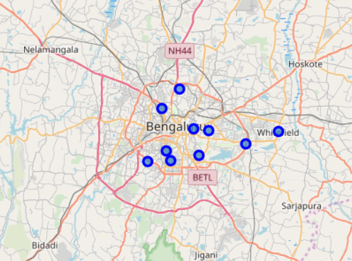

This analysis is quite complex to analyze as we can’t build Module quite easily with available foursquare data. Also, as here analysis being done on Top Cities and most happening places nearby.

* 1. **Data segregation**

Data from FS will be of different category and these data is being segregated into one level above category kind. So that data will be grouped into known categories.

As these are data based, Extra category created as “Others” that is for future observation. If any new category comes into picture that will be added into known category group

Final table of data looks like below,

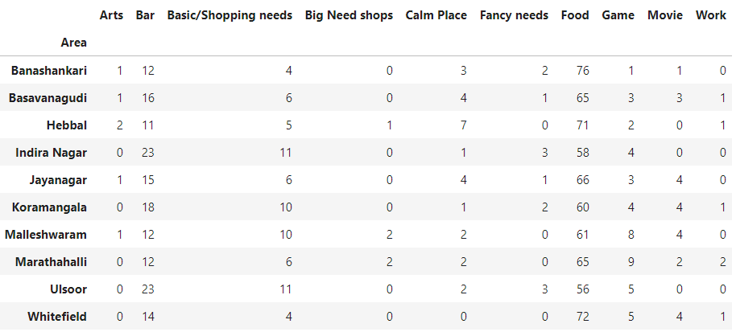

* 1. **Normalization:**

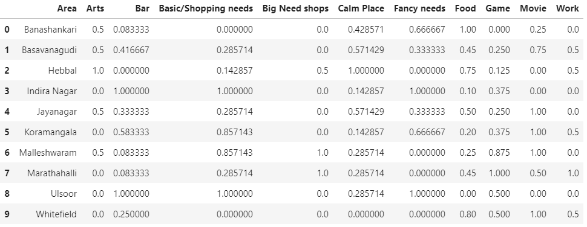

* 1. **ML Histogram Category analysis**

Histogram plots used to check how the tradeoff runs between two categories

e.g.: Graph plotted on Bar count in cam areas

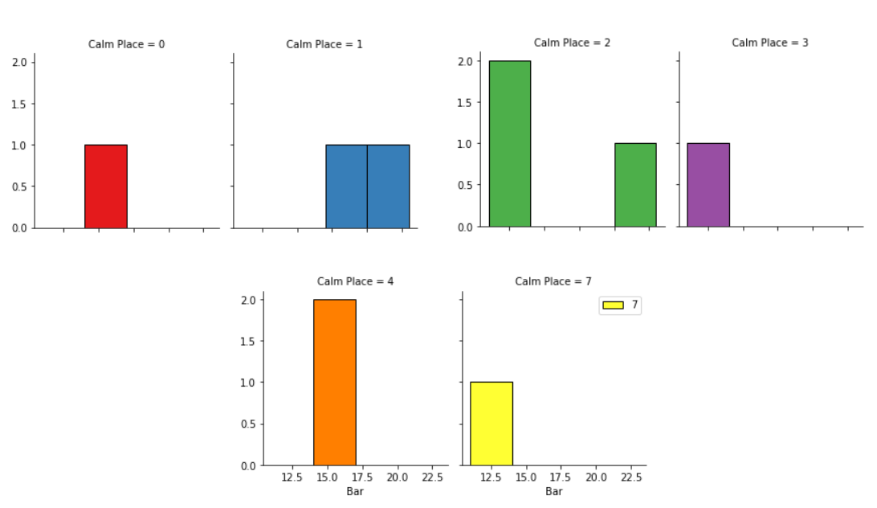

Here few observations can be made like highest calm place got a smaller number of bars as Happening places.

* 1. **Target category analysis**

Based on Interest Target category varies, here we are mainly looking for Residential area. Based on normalization and categorizing.

This module was tried with Decision tree module which finally didn’t fit well as we ae comparing all top ranked cities only,

1. **Results**
   1. **Clustering data**

As part of result we could segregate places with most happening places as below,

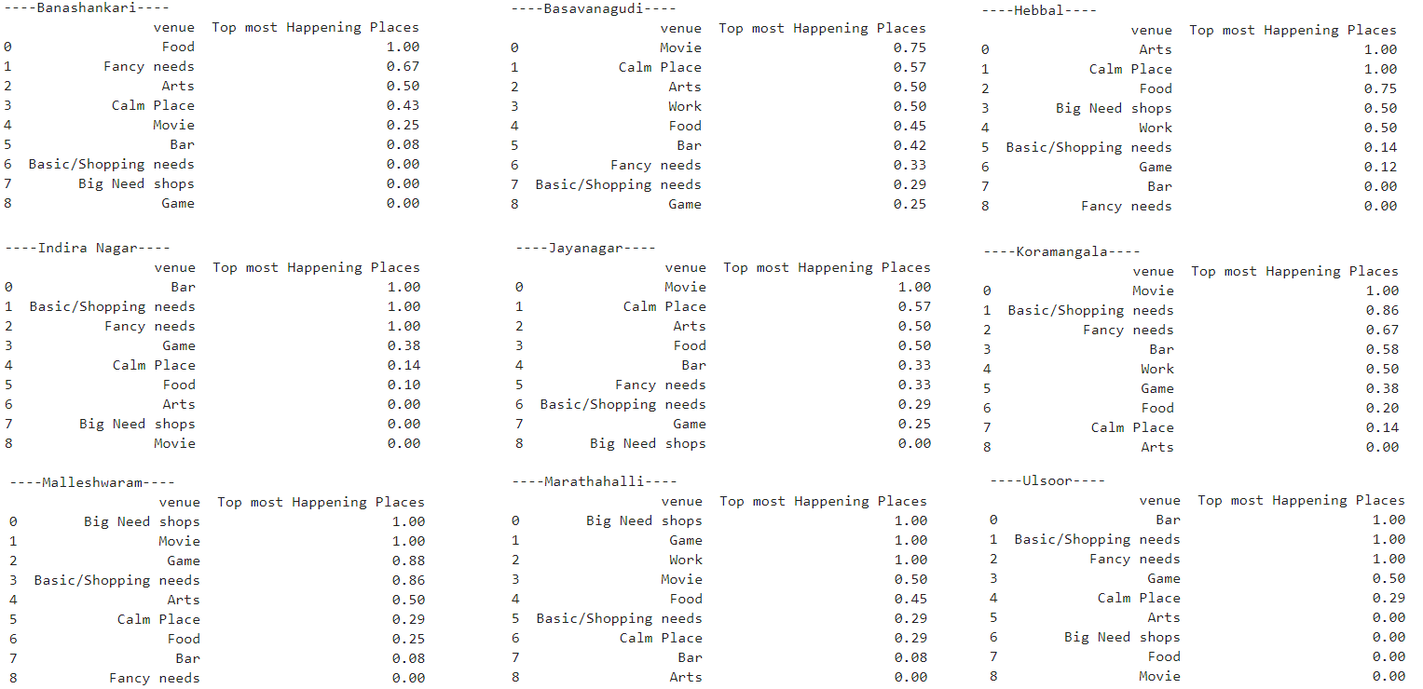

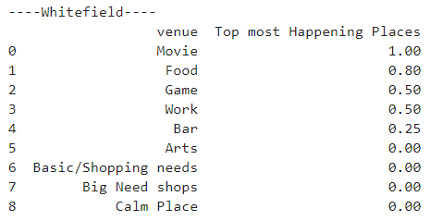

With this we can find few results as below findings,

Hotels or food corners Having great visibility in Banashankari and next in Whitefield.

Bar or Restaurants having good visibility in Ulsoor.

Movie/Auditoriums got more visibility in Basavangudi, Hebbal, Jayanagar,Kormangala , Malleshwaram and whitefield.

Big shopping needs got more visibility in Malleshwaram, Ulsoor, Indira Nagar.

As Far as nearby working location and good living Marathhalli and Whitefield stands on top.

1. **Discussions**

This analysis over top areas are very helpful to get lot of data in crisp way. As mentioned in introduction section, This analysis helps real estate people to max extend so that they can picturize the areas with most happening places in and around selected areas. This Data also helps different business bodies to concentrate on their new investment modes.

In this case building modules was a difficult task because we are analyzing areas and best methodology suited is decision tree. Other model developments fail as its entirely different to constitute an area with just available options. Whereas this can act as an important factor

1. **Conclusions**

In this study, I have analyzed the top 10 areas of Bangalore for the suitability of the selected areas as per the beneficiary interest. This will help mainly,

1. People who are targeting to Purchase plots/Flats in these areas.

2. Real Estate people to explain their customers nicely about most happening events across the interested areas.

3. This model will be flexible enough to expand the analysis to new Areas. By just adding Lat, Long of new area to list.

4. Foursquare API used to fetch required details about the areas.

5. Folium map shows the locality of areas in Bangalore.

1. **Further analysis**

This analysis can be later extended with new cities or locations.

As a further improvement , This category preferred to be Foursquare data.