
Assignment

Course Title : Structured Programming Language
Course Code : CSE 101
Assignment No : 01
Submitted By | Submitted To
MD. Abdulla Al-Noman | Sadman Sakib
Id: 20261203021 | Lecturer
Intake: 50 | Dept. of CSE
Section: 01
Department of CSE

Date of Submission: 17-02-2026

01. Program Name: Write a C program to enter the length and breadth of a rectangle and find

its area and perimeter.

Input:

#include <stdio.h>
int main(){
float length, breadth;
float area, perimeter;
printf("Enter the length of the rectangle: ");
scanf("%f", &length);
printf("Enter the breath of the rectangle: ");
scanf("%f", &breadth);
area = length + breadth;
perimeter = 2 * (length + breadth);
printf("Area of the rectangle = %.2f\n Perimeter of the rectangle = %.2f\n", area, perimeter);
return 0;
}

Output:

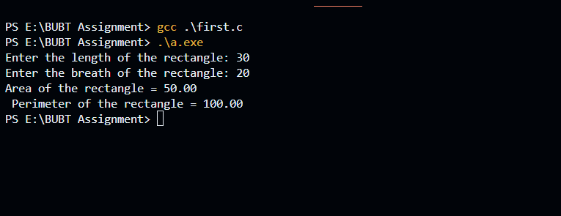

Output Discussion:

The output displays the calculated values based on the input provided by the user. Since the variables are defined as floating-point numbers, the program can handle decimal values accurately. When the user inputs the values 20 and 30 as the length and breadth of the rectangle, the program processes these inputs to perform the required calculations. The perimeter is calculated using the formula 2×(length+breadth)2 \times (length + breadth)2×(length+breadth), which results in a value of 100. The calculated results are then displayed on the screen. Line breaks in the output help maintain clarity and improve the readability of the displayed information.

02. Program Name: Write a C program to enter the radius of a circle and find its diameter.

Circumference and area.

Input:

#include <stdio.h>
int main(){
float radius, diameter, circumference , area;
printf("Enter the radius of the circle : ");
scanf("%f", &radius);
diameter = 2 * radius;
circumference = 2 * 3.1416 * radius;
area = 3.1416 * radius * radius;
printf("Diameter is %.2f\n", diameter);
printf("Circumference is %.2f\n", circumference);
printf("Area is %.2f\n", area);
return 0;
}

Output:
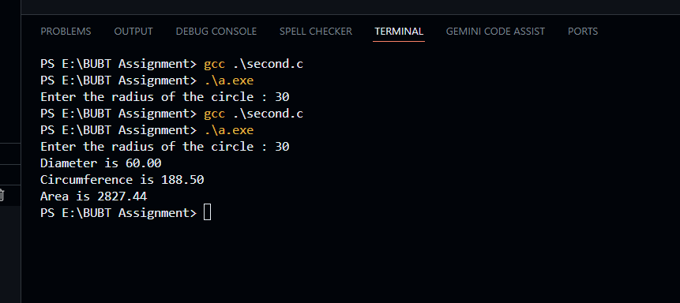

Output Discussion:

The output displays the calculated diameter, circumference, and area of a circle based on the radius entered by the user. Since the variables are declared as floating-point data types, the program can produce accurate results with decimal values. When the user inputs the radius as 30, the program applies standard mathematical formulas to perform the calculations. The diameter is calculated as twice the radius, the circumference is calculated using 2×π×r2 \times \pi \times r2×π×r, and the area is calculated using π×r2\pi \times r^2π×r2. As a result, the program outputs the diameter as 60.00, the circumference as 188.50, and the area as 2827.43. Line breaks are used in the output to present each result on a separate line, ensuring clarity and easy readability.

03. Program Name: Write a C program to enter temperature in °Celsius and convert it into

°Fahrenheit.

Input:

#include <stdio.h>

int main(){
float celsius, fahrenheit;

printf("Enter temperature in Celsius: ");
scanf("%f", &celsius);

fahrenheit = (celsius * 9 / 5) + 32;

printf("Temperature in Fahrenheit : %.2f\n", fahrenheit);
return 0;
}

Output:

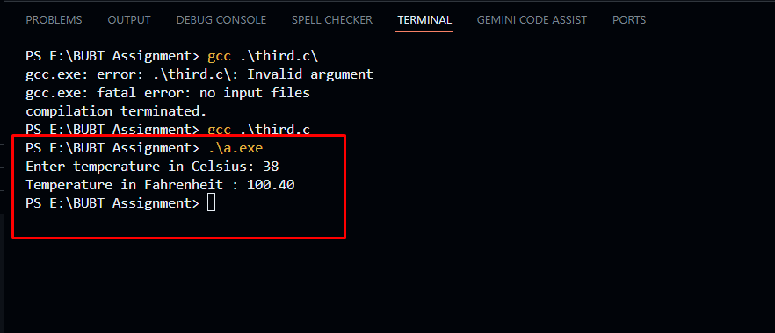

Output Discussion:

The output shows the temperature converted into Fahrenheit based on the Celsius value entered by the user. Since the variables are declared as floating-point numbers, the program can calculate decimal values accurately. When the user enters 38 as the Celsius temperature, the program uses the formula (C×9/5)+32(C × 9 / 5) + 32(C×9/5)+32 to perform the conversion. After calculation, the result is 100.40°F, which is displayed on the screen with two decimal places. The formatted output makes the result clear and easy to understand.

04. Program Name: Write a C program to enter the temperature in Fahrenheit (°F) and convert it into Celsius (°C).

Input:
#include <stdio.h>

int main()
{
float fahrenheit, celsius;

printf("Enter temperature in Fahrenheit: ");
scanf("%f", &fahrenheit);

celsius = (fahrenheit - 32) * 5 / 9;

printf("Temperature in Celsius %.2f\n", celsius);

return 0;
}

Output:

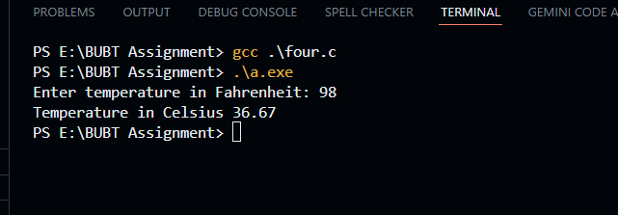

Output Discussion:

The program converts the temperature entered in Fahrenheit into Celsius. When the input value is 98, the program applies the conversion formula to calculate the equivalent Celsius temperature. After calculation, the result is 36.67°C, which is displayed on the screen with two decimal places. The output is shown clearly, making it easy to read and understand.

05. Program Name: Write a C program to enter two angles of a triangle and find the third angle.

Input:

#include <stdio.h>

int main()
{
float angle, angle2, angle3;

printf("Enter the first angle : ");
scanf("%f", &angle);

printf("Enter the second angle : ");
scanf("%f", &angle2);

angle3 = 180 - (angle + angle2);

printf("Third angle of the triangle is: %.2f\n", angle3);

return 0;
}

Output:

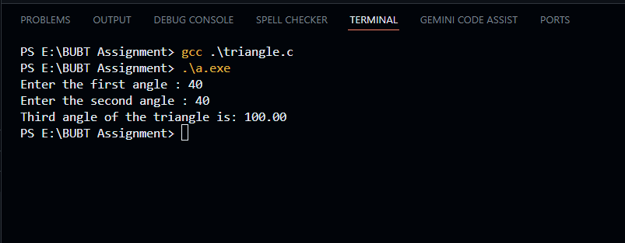

Output Discussion:
The output shows the third angle of a triangle calculated from the two given angles. For the input values 40 and 40, the program subtracts their sum from 180 degrees to determine the remaining angle. As a result, the third angle is calculated as 100.00 degrees and is displayed on the screen in a clear and readable format.

06. Program Name: Write a C program to find the maximum between three numbers.

Input:

#include <stdio.h>
int main(){
int a, b, c;
printf(" Enter the three Number : ");
scanf("%d %d %d", &a, &b, &c);
if (a >= b && a >= c) {
printf("Max number is %d\n", a);
}else if (b >= a && b >= c) {
printf("Max number is %d\n", b);
} else {
printf("Max number is: %d\n", c);
}
return 0;
}

Output:
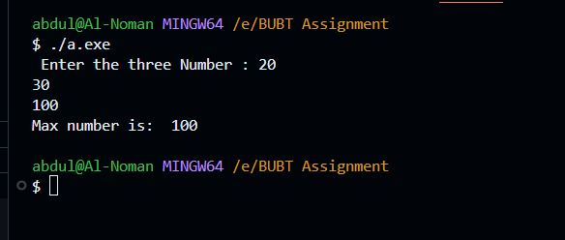

Output Discussion:
The program finds the largest of three numbers entered by the user. When the input values are 20, 30, and 100, the program compares all three numbers using conditional statements. After checking the conditions, it determines that 100 is the maximum value. The result is then displayed clearly on the screen.

07. Program Name: Write a C program to find the minimum between three numbers.

Input:

#include <stdio.h>

int main(){

int a, b, c;

printf("Enter three Number: ");
scanf("%d %d %d", &a, &b, &c);

if( a<= b && a <= c){
printf(" Minimum Number is %d\n", a);
}else if (b <= a && b <= c)
{
printf(" Minimum Number is %d\n", b);
}else
{
printf(" Minimum Number is %d\n", c);
}

return 0;
}

Output:
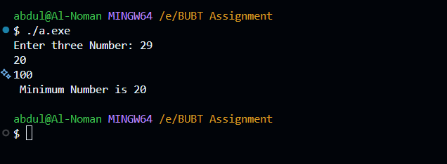

Output Discussion:
The program finds the smallest number among three values entered by the user. For the input 29, 20, and 100, it compares all three numbers and determines that 20 is the minimum. The result is shown clearly on the screen.

08. Program Name: Write a C program to check whether a number is negative, positive, or zero

Input:

#include <stdio.h>

int main()
{
int num;

printf("Enter a Number: ");
scanf("%d", &num);

if (num > 0) {
printf("The number is positive: \n");
}
else if (num < 0) {
printf("The number is Negative: \n");
}
else {
printf("The number is Zero: \n");
}

return 0;
}

Output:
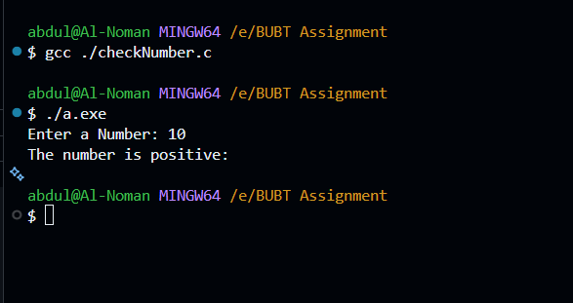

Output Discussion:

The program checks whether a number entered by the user is positive, negative, or zero. When the input value is 10, the program evaluates the conditions and determines that the number is positive. The result is then displayed clearly on the screen.

