
Bangladesh University of Business and Technology

Lab Report

Experiment No : 02 & 03
Course Title : Object-Oriented Programming
Course Code : CSE 111 & 112
Experiment Name : Lab Report-2 & Lab report-3.
Submitted To:

Name: Most. Jannatul Ferdous

Dept. of CSE
Bangladesh University of Business and Technology

Submitted By

Name : Md Abdulla Al Noman
Id No : 20261203021
Intake : 50th
Section : 01
Program : CSE-101

Date of Submission: 16-06-2026
Program No: 01
Program Name: You are required to implement two classes, Varsity and Department. The Varsity class contains a private member ‘name’ and a protected member ‘location’. Implement a default constructor in this class to set the value of name and location. The Department class has a member function ‘Print’, which takes an object of type Varsity as a parameter and is declared as a friend of the Varsity class, allowing it to access the private and protected members of Varsity. In the main function, create an object of Varsity and an object of Department. Use the Print function to output the values of the name and location of the Varsity object.
Source Code:
#include <iostream>
#include <string>
using namespace std;

class Varsity{
string name;

protected:
string location;
public:
Varsity() {
name = "BRAC University";
location = "Bangladesh";
}

friend class Department;
};
class Department{
public:
void Print(Varsity x){
cout << "Varsity Name :" << x.name << "Location :" << x.location<< endl;
}
};
int main(){
Varsity x;
Department y;
y.Print(x);
return 0;
}

Output:
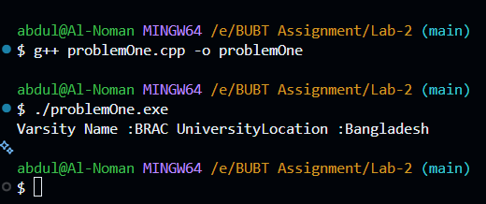
Program No: 02
Program Name: You are required to implement two classes, Student and Faculty. The Student class contains a private member studentID and a protected member name. Implement a parameterized constructor to set the value of studentID and name. The Faculty class has a member function Display, which takes an object of type Student as a parameter and is declared as a friend of the Student class, allowing it to access the private and protected members of Student. In the main function, create an object of Student and an object of Faculty. Use the Display function to output the values of the studentID and name of the Student object.
Source Code:
#include <iostream>
#include <string>
using namespace std;

class Student{
int studentId;

protected:
string name;

public:
Student(int studentId, string name){
this->studentId = studentId;
this->name = name;
}

friend class Faculty;
};

class Faculty{
public:
void Display(Student x){
cout << "Student Id : " << x.studentId << " Name : " << x.name << endl;
}
};
int main(){
Student s1( 202321," MR Nothing ");
Faculty y;
y.Display(s1);
return 0;
}
Output:
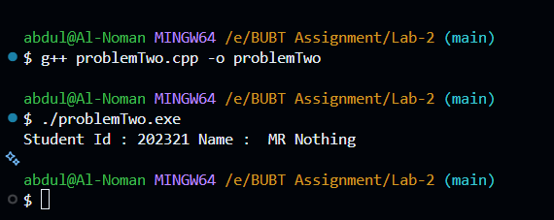

Program No: 03
Program Name: You are required to implement a class, Point2D. The Point2D class contains private members x and y to represent the coordinates of a point. Implement a parameterized constructor to initialize these values. There is a global function calculateDistance(), which takes two Point2D objects as parameters and is declared as a friend of the Point2D class, allowing it to access the private members x and y. The calculateDistance() function calculates the distance between two points in a 2D coordinate system. In the main function, create two Point2D objects, display their coordinates, and use the calculateDistance() function to compute and output the distance between the two points.
Source Code:
#include <iostream>
#include <cmath>
using namespace std;

class Point2D{
double x, y;
public:
Point2D( double x, double y){
this->x = x;
this->y = y;
}
void Display(){
cout << "x = " << x << " Y = " << y << endl;
}
friend double calculateDistance(Point2D a, Point2D b);
};

double calculateDistance(Point2D a,Point2D b){
double dx = a.x - b.x;
double dy = a.y - b.y;

return sqrt(dx * dx + dy * dy);
}
int main(){
Point2D p1(1,2), p2(2, 5);
p1.Display();
p2.Display();
cout << "Distance = " << calculateDistance(p1, p2) << endl;
return 0;
}
Output:
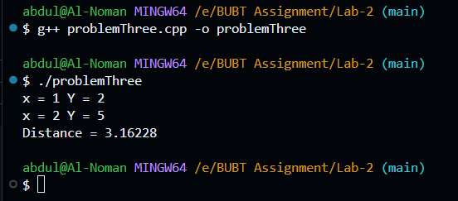

Program No: 04
Program Name: Define a class Person with private members for name and age. Implement a parameterized constructor to initialize name and age. Define a friend function compareAges that takes two Person objects and prints which person is older.
Source Code:
#include <iostream>
#include <string>
using namespace std;

class Person {
private:
string name;
int age;

public:
Person(string n, int a) {
name = n;
age = a;
}

friend void compareAges(Person p1, Person p2);
};

void compareAges(Person p1, Person p2) {
if (p1.age > p2.age) {
cout << p1.name << " is older." << endl;
}
else if (p2.age > p1.age) {
cout << p2.name << " is older." << endl;
}
else {
cout << "Both are same age." << endl;
}
}

int main() {
Person p1("Noman", 22);
Person p2("Maisa", 23);

compareAges(p1, p2);

return 0;
}
Output:
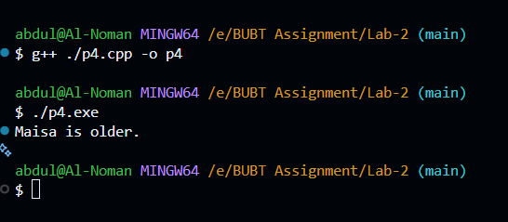

Lab Report -3

Program No: 05
Program Name: Store book title and price in an array of Book objects.
Source Code:
#include <iostream>
#include <string>
using namespace std;

class Book{
public:
string title;
float price;
};

int main(){
Book b[5];

for(int i = 0; i < 5; i++){
cout << "Enter details for book " << i + 1 << endl;

cout << " Title ";
cin >> b[i].title;

cout << " Price ";
cin >> b[i].price;
}

for(int i = 0; i < 5; i++){
cout << "Book " << i + 1 << endl;
cout << " Title: " << b[i].title << " Price: " << b[i].price << endl;
}

int index = 0;

for (int i = 1; i < 5; i++){
if (b[i].price > b[index].price){
index = i;
}
}

cout << "Most expensive books is = " << "Title: " << b[index].title << "Price: " << b[index].price<< endl;

return 0;
}
Output:
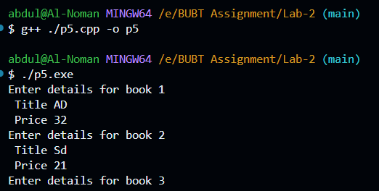
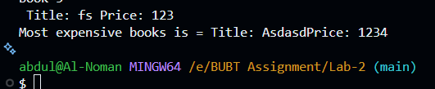

Program No: 06
Program Name: Create an array of Distance objects and calculate the sum of all distances.
Source Code:
#include <iostream>
using namespace std;

class Distance{
public:
double value;

Distance(){
value = 0;
}

void input(){
cout << "Enter Distance: ";
cin >> value;
}

void Display(){
cout << value << endl;
}
};

int main(){
Distance d[2];
double sum = 0;

for (int i = 0; i < 5; i++) {
cout << "Distance " << i + 1 << endl;
d[i].input();
}

for (int i = 0; i < 5; i++) {
d[i].Display();
sum += d[i].value;
}

cout << "\nTotal Sum = " << sum << endl;
return 0;
}
Output:
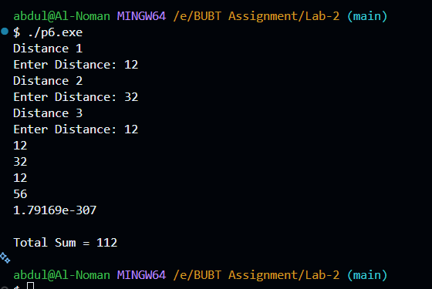

Program No: 07
Program Name: Create an array of Distance objects and calculate the sum of all distances.
Source Code:
#include <iostream>
using namespace std;

class Rectangle{
int width, length;

public:
void areaSetData(int width, int length){
this->width = width;
this->length = length ;
}

int CalculateArea(){
return width * length;
}
};

int main(){
Rectangle r[3];

int width, length;

for (int i = 0; i < 3; i++){
cout << "Enter the width and length of rectangle" << i + 1 << endl;
cin >> width >> length;

r[i].areaSetData(width, length);
};

int maxArea = r[0].CalculateArea();
int maxIndex = 0;

for (int i = 0; i < 3; i++){
int area = r[i].CalculateArea();

cout << "Rectangle " << i + 1 << " Area : " << area << endl;

if(area > maxArea){
maxArea = area;
maxIndex = 1;
}
}

cout << "Rectangle " << maxIndex + 1 << " has the largest area." << endl;

return 0;
}

Output:
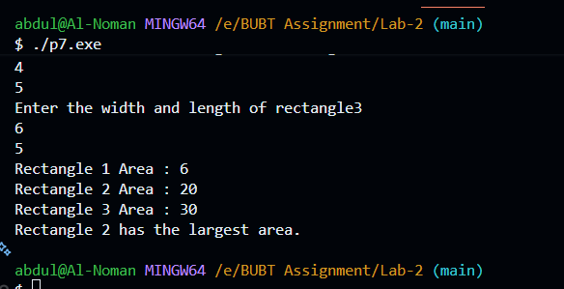

Program No: 08
Program Name: Store account number and balance.
• Create an array of Account objects.
• Display all account details.
• Find accounts having balance less than 1000.
Source Code:
#include <iostream>
using namespace std;

class Account{
int account_Number;
double balance;

public:

void accountDetails(int accountNumber, double balance){
this->account_Number = accountNumber;
this->balance = balance;
}

void showData(){
cout << "Account Number: " << account_Number
<< " Balance: " << balance << endl;
}

double getBalance(){
return balance;
}
};

int main(){
Account a[3];

int accNo;
double bal;

for(int i = 0; i < 3; i++){
cout << "Enter account number and balance for account " << i + 1 << endl;
cin >> accNo >> bal;

a[i].accountDetails(accNo, bal);
}

for(int i = 0; i < 3; i++){
if(a[i].getBalance() < 1000){
a[i].showData();
}
}

return 0;
}

Program No: 09
Program Name: Store product name, quantity, and price.
• Input 10 products.
• Calculate total inventory value.
• Inventory Value=Quantity×Price
• Find the product with maximum inventory value.

Source Code:
#include <iostream>
using namespace std;

class Product
{
string name;
int quantity;
double price;

public:
void ProductInventory(string name, int quantity, double price){
this->name = name;
this->quantity = quantity;
this->price = price;
}

double productValue(){
return quantity * price;
}

void showProduct(){
cout << "Name: " << name << "\n"
<< "Quantity: " << quantity << "\n"
<< "Price: " << price << "\n"
<< "Product value: " << productValue() << endl;
}
};

int main(){
Product p[10];

string name;
int quantity;
double price;

double totalValue = 0;
int maxIndex = 0;
double maxValue = 0;

for (int i = 0; i < 10; i++){
cout << "Enter product name, quantity, price for product " << i + 1 << endl;
cin >> name >> quantity >> price;

p[i].ProductInventory(name, quantity, price);
}

maxValue = p[0].productValue();

for (int i = 0; i < 10; i++){
double v = p[i].productValue();

p[i].showProduct();

totalValue += v;

if (v > maxValue){
maxValue = v;
maxIndex = i;
}
}

cout << "Product with Maximum Value:" << endl;
p[maxIndex].showProduct();

return 0;
}

Output:

