A PROJECT REPORT

on

“Brain Tumor Detection and
Segmentation: Integrating CNN and PSO”

Submitted to

KIIT Deemed to be University

In Partial Fulfilment of the Requirement for the Award of

BACHELOR’S DEGREE IN

COMPUTER SCIENCE

BY

ALOK KUMAR  SURAJ KR. MANDAL  AKSHIT KSHIRSAGAR  AMLAN DAS | 22052879  22051809  22052878  22053749

UNDER THE GUIDANCE OF

Asst. Prof RANJITA KUMARI DASH


SCHOOL OF COMPUTER ENGINEERING

KALINGA INSTITUTE OF INDUSTRIAL TECHNOLOGY

BHUBANESWAR, ODISHA - 751024

April 2025

A PROJECT REPORT

on

“Brain Tumor Detection and Segmentation: Integrating Convolutional Neural Networks and Particle Swarm Optimization”

Submitted to

KIIT Deemed to be University

In Partial Fulfilment of the Requirement for the Award of

BACHELOR’S DEGREE IN COMPUTER SCIENCE

BY

ALOK KUMAR  SURAJ K. MANDAL  AKSHIT KSHIRSAGAR  AMLAN DAS | 22052879  22051809  22052878  22053749

UNDER THE GUIDANCE OF

Asst. Prof (II) RANJITA KUMARI DASH

SCHOOL OF COMPUTER ENGINEERING

KALINGA INSTITUTE OF INDUSTRIAL TECHNOLOGY

BHUBANESWAE, ODISHA -751024

April 2025

KIIT Deemed to be University

School of Computer Engineering
Bhubaneswar, ODISHA 751024

CERTIFICATE

This is certify that the project entitled

“Brain Tumor Detection and Segmentation: Integrating Convolutional Neural Networks and Particle Swarm Optimization”

submitted by

ALOK KUMAR | 22052879
SURAJ KR. MANDAL | 22051809
AKSHIT KSHIRSAGAR | 22052878
AMLAN DAS | 22053749

is a record of bonafide work carried out by them, in the partial fulfilment of the requirement for the award of Degree of Bachelor of Engineering Computer Science & Engineering at KIIT Deemed to be university, Bhubaneswar. This work is done during year 2024-2025, under our guidance.

Date: 28 / 04 / 2025

(Asst. Prof (II) RANJITA KUMARI DASH)
Project Guide

Acknowledgements

We are deeply thankful to Asst. Professor (II) Ranjita Kumari Dash, School of Computer Engineering, KIIT University, Bhubaneswar, for his valuable suggestions and support during this project. His guidance and motivation have contributed to the shaping of our work immensely, and we are deeply thankful to his academic enthusiasm.

A grateful thanks to the Director, School of Computer Engineering, KIIT University, for making available to us the resources needed and creating a conducive environment to make this project become a reality.

This work could not have been accomplished without the combined efforts of all who led, guided, and supported us throughout. Thank you! .....................

ALOK KUMAR
SURAJ KR. MANDAL
AKSHIT KSHIRSAGAR
AMLAN DAS

ABSTRACT

Brain tumor classification and identification are important for early treatment and diagnosis. This work proposes a novel method that integrates Convolutional Neural Networks (CNN) for tumor classification and a hybrid Particle Swarm Optimization-Whale Optimization Algorithm (PSO-WOA) for accurate image segmentation, i.e., tumor identification. The CNN architecture is trained on grayscale MRI scans to classify tumors into four categories: Glioma, Meningioma, Pituitary, and No Tumor. Accuracy and resistance to variations in medical imaging are enhanced by using k-fold cross-validation and data augmentation.

For further tumor detection, the project utilizes a PSO-WOA-based segmentation approach to optimize intensity values, shape parameters, and boundary features to accurately demarcate tumor areas. PSO handles intensive global search, whereas WOA optimizes segmentation with adaptive convergence methods to facilitate the detection of accurate tumor boundary. Scalable efficient and accurate automated brain tumor analysis is enabled using deep learning and evolutionary optimization, which improves radiologists' clinical decision-making and enhances diagnosis accuracy.

Keywords: CNN, PSO, WOA, Image Segmentation

Contents

1 | Introduction |  |  | 1
2 | Basic Concepts/ Literature Review |  |  | 2
 | 2.1 | CNN Based Tumor Classification |  | 2
 | 2.2 | PSO for Image Segmentation |  | 3
 | 2.3 | WOA for Tumor Segmentation |  | 4
 | 2.4 | Skull Stripping in MRI Brain Image |  | 4
3 | Problem Statement / Requirement Specifications |  |  | 5
 | 3.1 | Project Planning |  | 5
 | 3.2 | Project Analysis (SRS) |  | 5
 | 3.3 | System Design |  | 6
 |  | 3.3.1 | Design Constraints | 6
 |  | 3.3.2 | Block Diagram | 7
4 | Implementation |  |  | 8
 | 4.1 | Methodology |  | 8
 | 4.2 | Testing / Verification Plan |  | 10
 | 4.3 | Result Analysis |  | 11
 | 4.4 | Quality Assurance |  | 13
5 | Standard Adopted |  |  | 14
 | 5.1 | Design Standards |  | 14
 | 5.2 | Coding Standards |  | 14
 | 5.3 | Testing Standards |  | 15
6 | Conclusion and Future Scope |  |  | 16
 | 6.1 | Conclusion |  | 16
 | 6.2 | Future Scope |  | 17
References |  |  |  | 18
Individual Contribution |  |  |  | 19
Plagiarism Report |  |  |  | 20

Brain Tumour Detection and Image Segmentation

Chapter 1

Introduction

Brain tumors pose a serious health hazard, and timely and correct diagnosis is essential to enhance the efficacy of treatment. Magnetic Resonance Imaging (MRI) is a common non-invasive method for detecting brain tumors, but manual interpretation is time-consuming and susceptible to human error. Current automated solutions are based on conventional image processing methods or machine learning algorithms that are susceptible to lack of accuracy, generalization, and specific detection of tumor edges. Increasing calls are being made for sophisticated AI-based methods to improve segmentation as well as classification to make more precise diagnoses.

There has been the creation of a specialized CNN model in this project for the classification of the brain tumors into four groups: Glioma, Meningioma, Pituitary, and No Tumor. The model has several convolutional layers, max-pooling layers, and fully connected layers and is thus able to identify major features in MRI scans. We have employed data augmentation and k-fold cross-validation to enhance accuracy and generalization. Tuning the network structure and training it with adequately preprocessed data, our model attains reliable classification outcomes.

To enhance tumor detection further, we have used a hybrid Particle Swarm Optimization-Whale Optimization Algorithm (PSO-WOA) for segmentation. The technique assists in precise detection of tumor regions by optimizing intensity values, shape features, and edge features. The integration of CNN-based classification and PSO-WOA-based segmentation enhances the overall accuracy of the system. This report presents the methodology, implementation, and results, demonstrating how our approach significantly enhances brain tumor analysis.

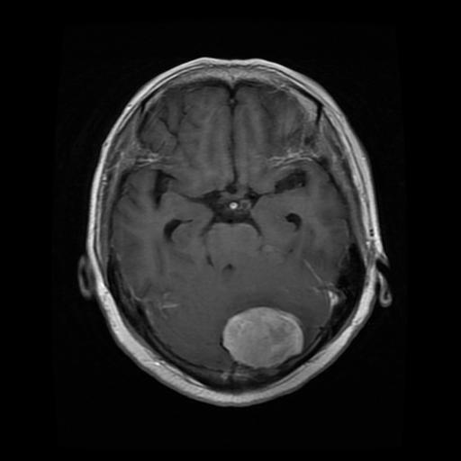
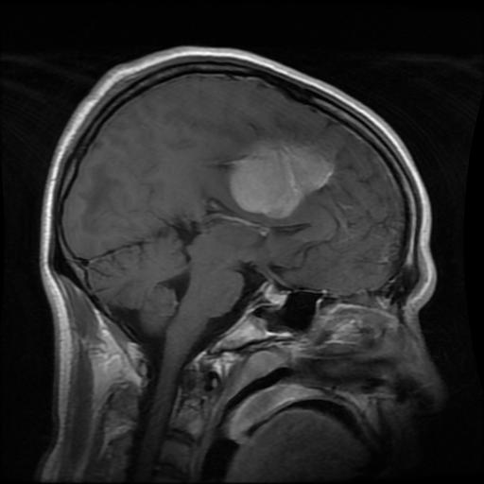

School of Computer Engineering, KIIT, BBSR 1

Brain Tumour Detection and Image Segmentation

Chapter 2

Literature Review

This project utilizes Convolutional Neural Networks (CNN) for brain tumor classification and a hybrid Particle Swarm Optimization-Whale Optimization Algorithm (PSO-WOA) for precise tumor classification and segmentation

2.1 CNN-Based Brain Tumor Classification

(a) Introduction
This project employs Convolutional Neural Networks (CNN) to categorize brain tumors into four types: Glioma, Meningioma, Pituitary, and No Tumor. CNNs are commonly utilized for image classification because they can automatically capture spatial features. In contrast to traditional classification approaches, CNNs minimize the need for manual feature extraction by learning hierarchical patterns directly from the input images. This method is especially effective in medical imaging, where tumor characteristics can differ greatly.

(b) Result
The CNN model developed, which includes several convolutional layers, max-pooling layers, and dense layers, is optimized to achieve high accuracy. By applying data augmentation and k-fold cross-validation, the model enhances its generalization and robustness. As the model identifies unique tumor features from grayscale MRI scans, the classification accuracy improves

(c) Drawbacks
Despite the effectiveness of this approach, CNN-based classification is highly dependent on the quality and amount of the dataset. The model may face challenges with insufficient or unbalanced data, necessitating further augmentation and preprocessing methods. Furthermore, training CNNs demands substantial computational resources, which may restrict their use in real-time medical settings.

School of Computer Engineering, KIIT, BBSR 2

Brain Tumour Detection and Image Segmentation

2.2 Particle Swarm Optimization (PSO) for Image Segmentation

(a) Introduction
Particle Swarm Optimization (PSO) is a nature-inspired optimization method that replicates the collective behavior of birds or fish in search of the best solutions. In this project, PSO is applied for threshold-based image segmentation to identify tumor areas in MRI scans. Conventional segmentation methods, like Otsu’s thresholding and region-growing approaches, are often affected by noise and frequently struggle to accurately delineate tumor edges. PSO enhances segmentation by iteratively fine-tuning thresholds using swarm intelligence, resulting in improved feature extraction from MRI images.

(b) Result
The use of PSO for segmentation significantly improves the identification of tumor areas by dynamically optimizing threshold values. The algorithm successfully distinguishes tumors from adjacent brain tissues, resulting in greater segmentation precision. Experimental findings indicate that PSO outperforms traditional thresholding methods when dealing with intricate tumor shapes.

(c) Drawbacks
A drawback of PSO is its propensity to prematurely converge, which can result in suboptimal segmentation in high-dimensional environments. The algorithm also necessitates careful calibration of hyperparameters, such as inertia weight and cognitive-social coefficients, to prevent getting trapped in local optima. Furthermore, the performance of PSO is influenced by the initial setup of particles, which can impact the consistency of the segmentation outcomes.

2.3 Whale Optimization Algorithm (WOA) for Tumor Segmentation

(a) Introduction
The Whale Optimization Algorithm (WOA) is inspired by the hunting techniques of humpback whales. In this study, WOA is combined with Particle Swarm Optimization (PSO) to enhance tumor segmentation by adaptively modifying threshold values. This hybrid PSO-WOA method strikes a balance between global exploration and local refinement, resulting in more accurate tumor detection than individual segmentation techniques.

(b) Result
WOA improves the accuracy of segmentation by continuously adjusting threshold values, which leads to better detection of tumor boundaries. When compared to PSO on its own, the hybrid PSO-WOA method minimizes sensitivity to noise and enhances precision in segmentation. This approach effectively separates tumor regions with increased accuracy, facilitating improved feature extraction for classification.

School of Computer Engineering, KIIT, BBSR 3

Brain Tumour Detection and Image Segmentation

(c) Drawbacks
Similar to other metaheuristic algorithms, WOA is sensitive to the choice of parameters and requires careful tuning for optimal results. Additionally, due to its iterative process, it may demand greater computational resources, potentially slowing down real-time processing.

2.4 Skull Stripping in MRI Brain Images

(a) Introduction
Skull stripping serves as a preprocessing technique aimed at eliminating non-brain tissues from MRI scans. Conventional approaches, including morphological operations and threshold-based methods, often face difficulties due to variations in skull thickness and differences in image intensity. In this project, a multi-threshold skull stripping method is utilized to improve tumor segmentation.

(b) Result
The skull stripping algorithm implemented successfully eliminates non-brain tissues, improving the visibility of tumors. By refining the initial image, it enhances the effectiveness of classification and segmentation models. This method guarantees that only pertinent brain areas are analyzed, leading to a decrease in computational demands.

(c) Drawbacks
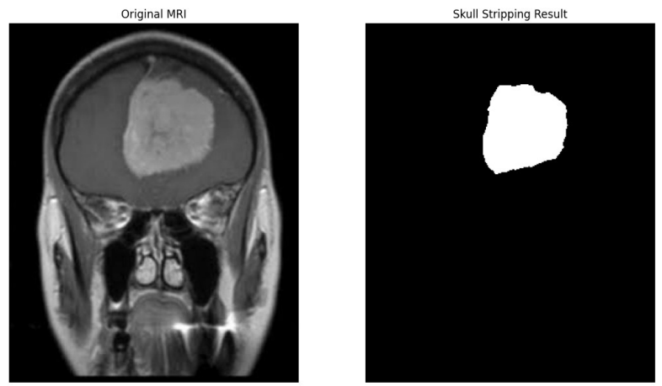
Skull stripping methods can occasionally discard important brain structures if not carefully adjusted. Mistakes in skull stripping may result in imprecise segmentation outcomes, which can adversely impact overall tumor detection efficacy.

Skull Stripping

School of Computer Engineering, KIIT, BBSR 4

Brain Tumour Detection and Image Segmentation

Chapter 3

Problem Statement / Requirement Specifications

Brain tumors are a serious health risk and must be detected early enough so that they can be treated successfully. Manual identification from MRI scans is time-consuming and heavily dependent on radiologists' expertise. The focus of this proposed research is the development of an automatic deep learning method for classifying MRI images with different kinds of tumors and the identification of tumor areas accurately through hybrid optimization techniques. The proposal utilizes convolutional neural networks (CNN) for classification and a Particle Swarm Optimization–Whale Optimization Algorithm (PSO-WOA) to obtain precise tumor segmentation. Overall, the aim is to create accuracy and credibility in the identification of brain tumors through minimizing human effort in intervention and gaining enhanced efficiency for diagnostics.

3.1 Project Planning

The process of ensuring meticulous systematic planning to execute the research project proceeds in a methodological manner. As follows:

(a) Data Collection:
Collect publicly available MRI image datasets with brain tumor scans.
Perform preprocessing methods, such as noise removal, contrast standardization, and resizing, to achieve homogeneity.
Data augmentation methods such as flipping, rotation, and zooming to improve model stability.

(b) CNN Model Development:
Develop and implement a convolutional neural network (CNN) to classify brain tumors. Train the CNN model on labeled MRI images to classify tumors into various classes (e.g., Glioma, Meningioma, Pituitary, and No Tumor).
Try varying network topologies, activation units, and optimization techniques for performance improvement.

(c) Model Evaluation & Optimization:
Use k-fold cross-validation rigorously to confirm the accuracy of the model.
Hyperparameters like learning rate, batch size, and dropout rates should be optimized to reduce overfitting.

School of Computer Engineering, KIIT, BBSR 5
Brain Tumour Detection and Image Segmentation

(d) Image Classification:
Use the trained CNN model to classify the type of tumor from new MRI scans.
Use a feature visualization ability to display confidence scores and misclassification instances.

(e) Segmentation by PSO-WOA:
Use a hybrid optimization method (PSO-WOA) to segment tumor areas from segmented MRI images. Use segmentation methods to divide tumor tissue from non-tumor areas i.e. Skull Stripping. Improve the segmentation process with morphological processing and intensity thresholding.

3.2 Project Analysis

The project focuses on improving brain tumor classification through a CNN model and tumor image segmentation combined with a hybrid optimization technique involving PSO and WOA. The key challenges identified are:

(a) Dataset Limitations
The existing dataset lacks adequately labeled tumor regions, resulting in less precise segmentation. In the absence of pixel-wise labeled masks, segmentation models face difficulties in accurately learning the boundaries of tumors.

(b) Segmentation Accuracy Issues
The PSO-WOA approach depends on intensity thresholding and morphological techniques, which may not perform well without a well-annotated dataset. The current method of segmentation may not consistently identify tumor regions accurately, causing false positives or negatives.

3.3 System Design

(a) Design Constraints
- Software Requirements:
Python Library: TensorFlow, Keras, OpenCV, NumPy, Matplotlib,
Scikit-learn, SciPy, PySwarm for PSO-WOA hybrid optimization

- Development Environment:
Google Colab for cloud training
Jupyter Notebook for local testing and visualization

- Hardware Requirements:
GPU-supported system for training deep models
Minimum 16GB RAM for computation on large MRI data

School of Computer Engineering, KIIT, BBSR 6

Brain Tumour Detection and Image Segmentation

(b) Block Diagram
The process begins with the preprocessing of MRI images, continues with tumor classification via a CNN model, and includes segmentation assisted by a hybrid PSO-WOA optimization method. The end results, which feature both classification and tumor region segmentation, are presented for diagnostic purposes in the medical field.

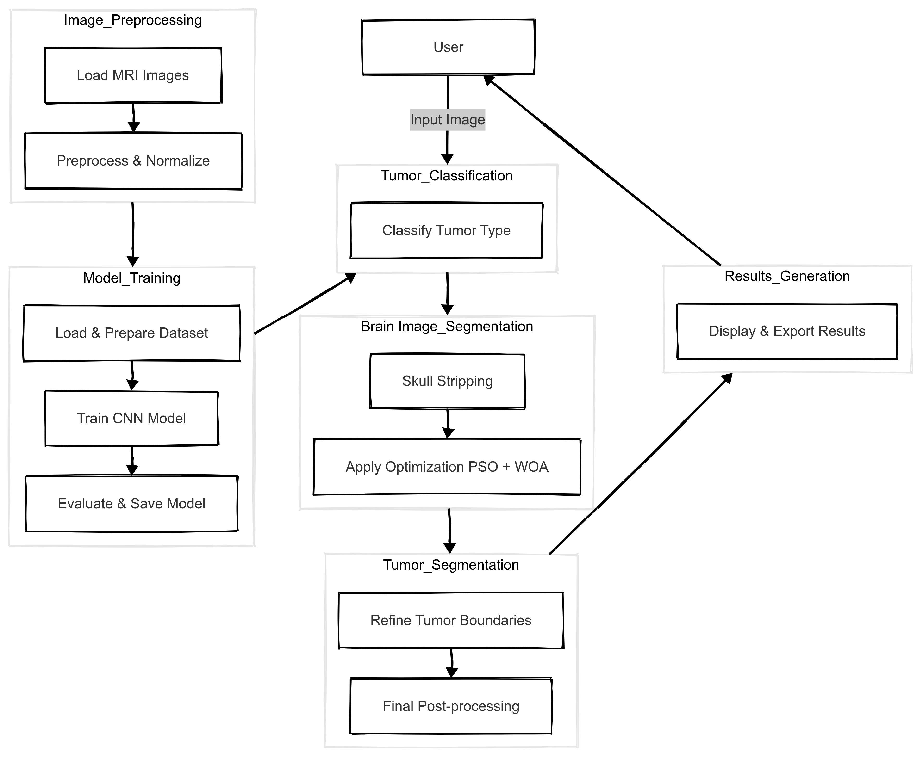

Figure 3.1: Block Diagram of the Brain Tumor
Classification and Segmentation System

School of Computer Engineering, KIIT, BBSR 7

Brain Tumour Detection and Image Segmentation

Chapter 4

Implementation

This chapter outlines the process of implementation, which involves the methodology, test plan, analysis of results, and quality assurance. The suggested system combines Convolutional Neural Networks (CNNs) for classification and a hybrid Particle Swarm Optimization-Whale Optimization Algorithm (PSO-WOA) for segmentation to provide precise tumor detection from MRI images.

4.1 Methodology
The methodology follows a structured pipeline, including data preprocessing, CNN-based classification, and PSO-WOA-based segmentation. The key steps are:

(a) Dataset Structure
Brain tumors are mostly classified into three broad groups: Glioma, Meningioma, and Pituitary tumors. They differ in their locations, aggressiveness, and susceptibility to treatment and therefore accurate categorization of such tumors is critically important for diagnosis.

Tumor Types | Image Qty
Glioma | 1321
Meningioma | 1339
Pituitary | 1457
No Tumor | 1595

(b) Pre-Processing
- Resize images to 128×128 pixels to maintain consistency.
- Normalize pixel values between 0 and 1 using:
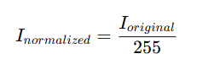
- Apply data augmentation (rotation, zooming, and shifting) to improve model generalization.

School of Computer Engineering, KIIT, BBSR 8

Brain Tumour Detection and Image Segmentation

(c) CNN-Based Tumor Classification
A specialized Convolutional Neural Network (CNN) architecture has been created for the classification of tumors.
- The model features three convolutional layers designed to extract hierarchical characteristics from MRI scans. Max-pooling layers are employed to minimize spatial dimensions while preserving crucial features.
- A Softmax layer is included to categorize the image into one of four types: Glioma, Meningioma, Pituitary, or No Tumor.
- The model undergoes training using k-fold cross-validation to improve generalization and accuracy.

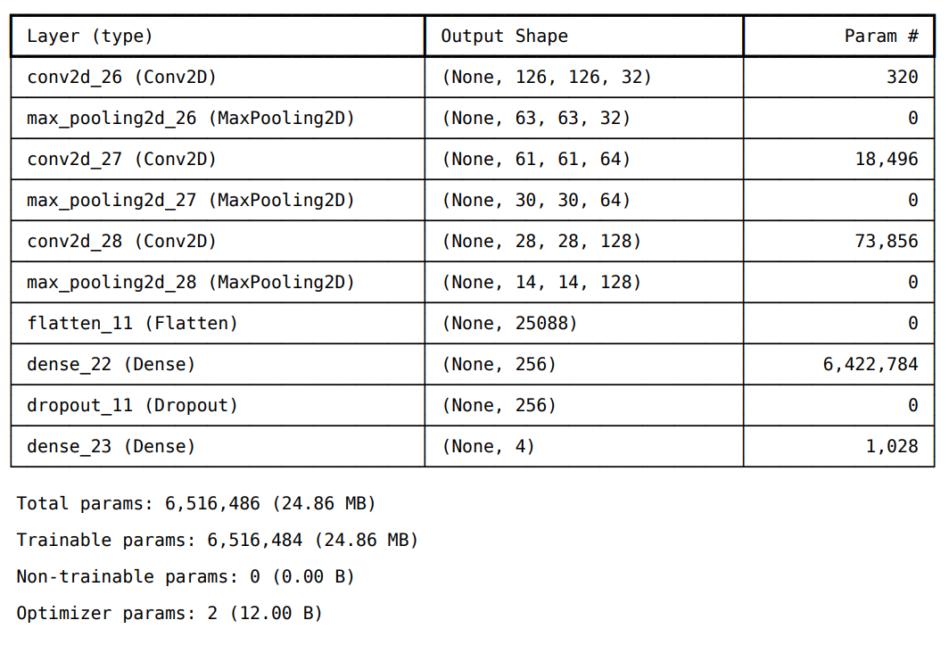

(d) PSO-WOA-Based Tumor Image Segmentation

Segmentation is achieved through a combined approach utilizing Particle Swarm Optimization (PSO) and the Whale Optimization Algorithm (WOA):
- PSO fine-tunes the segmentation thresholds to improve the identification of tumor areas.
- WOA enhances the segmentation by adaptively modifying the boundary values.
- The resulting segmented image accurately emphasizes the tumor region.

School of Computer Engineering, KIIT, BBSR 9
Brain Tumour Detection and Image Segmentation

(e) Model Evaluation
The evaluation of the model’s effectiveness is based on several important metrics, including Accuracy, Precision, Recall, F1-Score, and Loss. The following steps are followed for the evaluation process:

- The Final Training Accuracy is determined by calculating the percentage of correct predictions made on the training data.
- The Final Validation Accuracy is assessed by testing the model on the validation dataset, offering an understanding of how well the model generalizes.
- Training Loss indicates the model’s error on the training data, where lower values suggest improved model performance.
- Validation Loss measures the error on the validation data and helps identify any overfitting issues during training.

The model’s evaluation metrics, such as Accuracy and Loss, are presented for both the training and validation datasets, emphasizing the model’s overall performance.

4.2 Testing OR Verification Plan
For verification of the system, certain test cases are created to compute the accuracy of CNN-based classification. Verification plan includes a main testing:

Classification Testing
The system gives an estimated tumor class from an input MRI as well as a confidence measure. The estimated class is then compared against the actual class.

Test ID | Image Input | Predicted Class | Confidence  Level (%) | Expected Class
1 | Tr-gl 1192.jpg | Glioma | 44.65% | Glioma
2 | Tr-gl 1237.jpg | Glioma | 98.62% | Glioma
3 | Tr-gl_1315.jpg | Glioma | 99.78% | Glioma
4 | Tr-me_0918.jpg | Meningioma | 49.51% | Meningioma
5 | Tr-me_1111.jpg | Meningioma | 84.49% | Meningioma
6 | Tr-me_1189.jpg | Meningioma | 57.24% | Meningioma
7 | Tr-no_1390.jpg | notumor | 99.99% | notumor
8 | Tr-no_1594.jpg | notumor | 100.00% | notumor
9 | Tr-no_1583.jpg | notumor | 99.63% | notumor
10 | Tr-pi_0858.jpg | Pituitary | 99.88% | Pituitary
11 | Tr-pi_0858.jpg | Pituitary | 99.88% | Pituitary
12 | Tr-pi_1113.jpg | Pituitary | 98.46% | Pituitary

School of Computer Engineering, KIIT, BBSR 10
Brain Tumour Detection and Image Segmentation

4.3 Result Analysis
This section shows experimental results, including training performance plots, classification outputs, and PSO-WOA segmentation outputs. The results confirm the efficacy and precision of the proposed method in brain tumor classification and segmentation of tumor regions.

(a) CNN Training Performance
Final Training Accuracy: 87.68% Final Validation Accuracy: 87.89%
Final Training Loss: 0.3365 Final Validation Loss: 0.3744
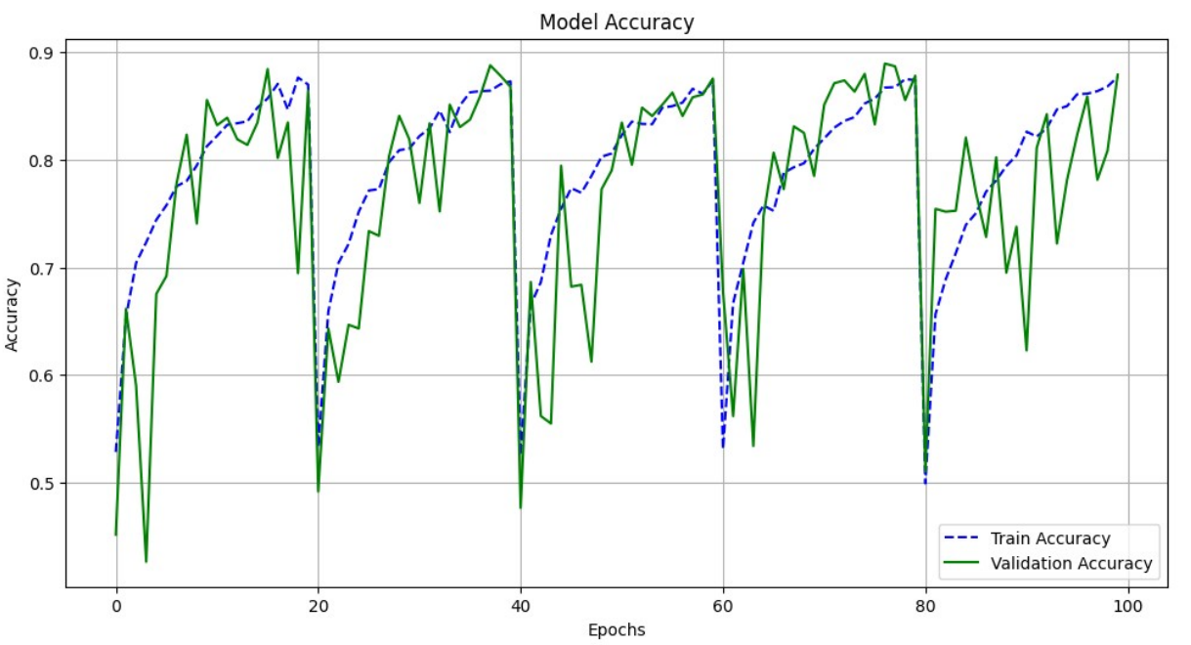

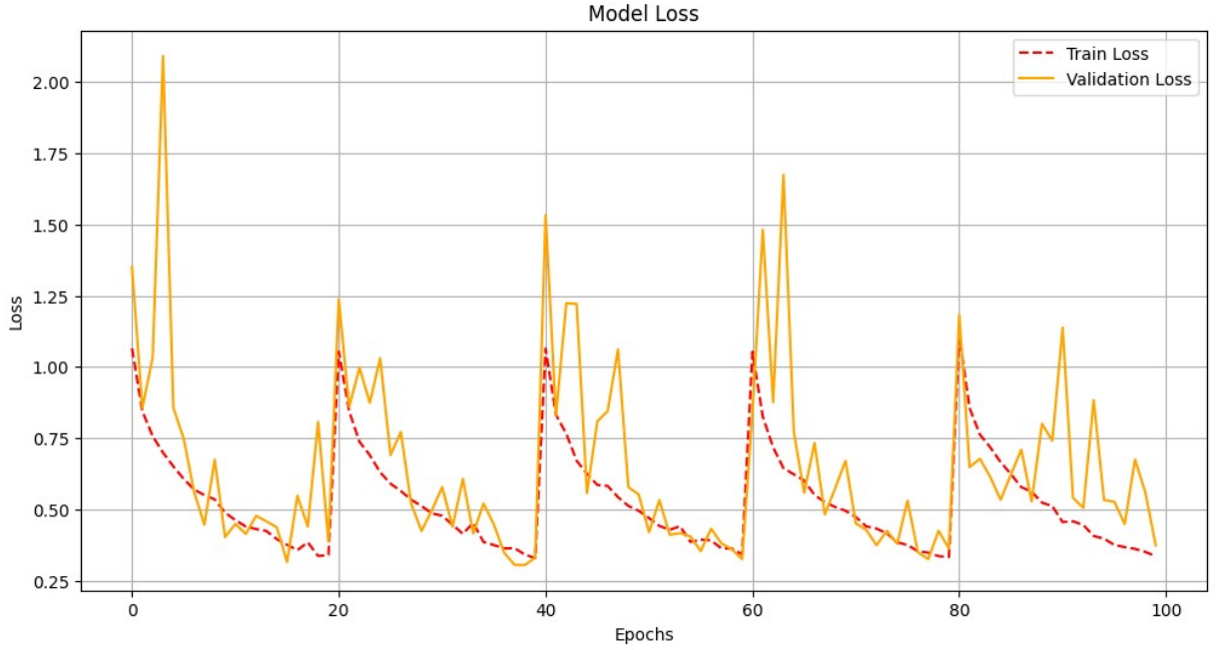

School of Computer Engineering, KIIT, BBSR 11

Brain Tumour Detection and Image Segmentation

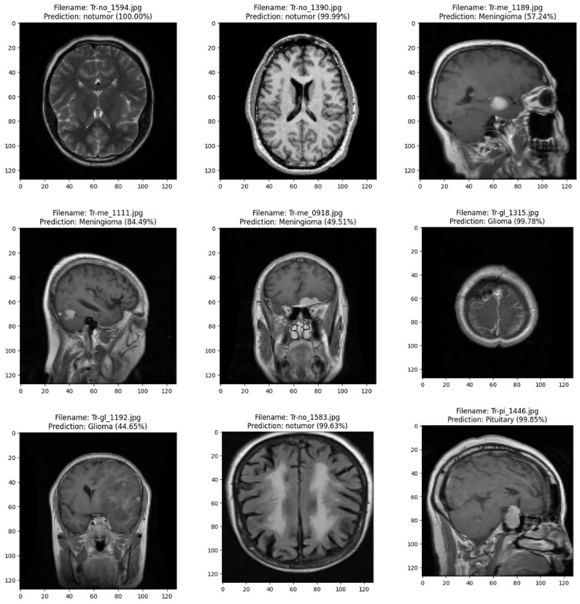

Figure 4.31: Brain Tumor Classification Result

(b) PSO Segmentation Result

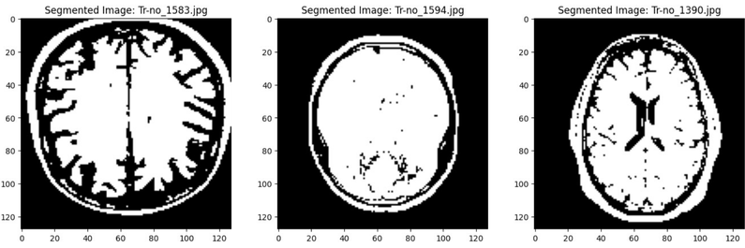

School of Computer Engineering, KIIT, BBSR 12

Brain Tumour Detection and Image Segmentation

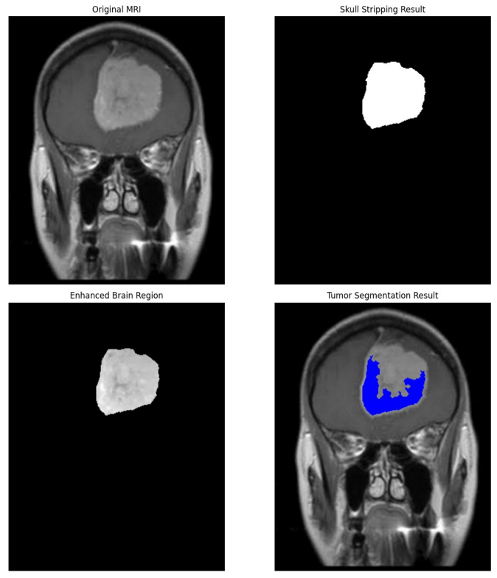
Figure 4.32: Tumor PSO Image Segmentation Result

4.4 Quality Assurance
To ensure project quality, standardized coding, testing, and evaluation practices are followed:
- PEP 8 (Python Coding Standards) ensures clean and structured code.
- IEEE 829-2008 (Software Test Documentation Standard) is used for test planning.
- ISO/IEC 25010 (Software Quality Model) guidelines are followed for software reliability and efficiency.
- k-Fold Cross-Validation improves classification reliability.
- Independent validation of results through dataset testing and comparison with existing methods.

This ensures that the system is efficient, reliable, and meets expected quality standards for brain tumor detection.

School of Computer Engineering, KIIT, BBSR 13

Brain Tumour Detection and Image Segmentation

Chapter 5

Standards Adopted

5.1 Design Standards
The project adheres to well-established software engineering and system design standards to ensure uniformity and adherence to best practices throughout the development process. The principal standards include:

- IEEE 830-1998 – Standard for Software Requirements Specification
- IEEE 1471-2000 – Standard for Software Architecture
- ISO/IEC 9126 – Model for Software Quality (addressing maintainability, reliability, and usability)
- UML (Unified Modeling Language) – Employed for system depiction through block diagrams, activity diagrams, and sequence diagrams
- ISO 25010 – Quality model for software focusing on usability, security, and functionality
- In database design, normalization methods and Entity-Relationship (ER) modeling are utilized to guarantee data consistency and integrity.

5.2 Coding Standards
To ensure readability, reusability, and efficiency, the project complies with established coding standards:
- PEP 8 (Python Enhancement Proposal) – Adopted for styling Python code
- Naming Conventions – Descriptive variable and function names are used (e.g., load_mri_images() rather than func1())
- Code Modularity – Functions and classes are organized so that each function is dedicated to a single responsibility
- Indentation and Formatting – A strict 4-space indentation policy is observed
- Error Handling – Exception management is handled using try-except blocks to avoid runtime failures (try-catch blocks)
- Logging – The logging module in Python is employed instead of print statements for enhanced debugging.

School of Computer Engineering, KIIT, BBSR 14

Brain Tumour Detection and Image Segmentation

5.3 Testing Standards
For the purpose of system validation and verification, IEEE and ISO standards concerning software testing have been utilized:

- IEEE 829 (Test Documentation Standard) – A systematic methodology for test planning and documentation
- IEEE 1012 (Software Verification & Validation Standard) – Ensures the accuracy of model predictions
- ISO/IEC 29119 – Framework for software testing
- k-Fold Cross-Validation – Implemented to evaluate model accuracy
- Unit Testing with PyTest – Each module, including preprocessing, classification, and segmentation, is tested individually.

School of Computer Engineering, KIIT, BBSR 15

Brain Tumour Detection and Image Segmentation

Chapter 6

Conclusion and Future Scope

6.1 Conclusion
The project demonstrates a novel method for brain tumor classification and segmentation based on a combination of Convolutional Neural Networks (CNNs) and a hybrid of Particle Swarm Optimization-Whale Optimization Algorithm (PSO-WOA). The CNN model efficiently classifies MRI scans into four tumor categories: Glioma, Meningioma, Pituitary, and No Tumor with an accuracy of 87.89% using k-fold cross-validation and data augmentation methods.

For improved tumor detection, PSO-WOA-based image segmentation is employed that maximizes tumor region extraction with a blend of global exploration (PSO) and local refinement (WOA). It performs superior to conventional thresholding and clustering-based image segmentation in terms of improved tumor boundary detection.

Experimental findings indicate that the suggested method improves classification accuracy and segmentation accuracy and is a valid and efficient method to automated brain tumor detection. The use of deep learning and evolutionary optimization methods improves diagnosis accuracy and can be a useful tool in the support of medical professionals towards early tumor detection.

School of Computer Engineering, KIIT, BBSR 16
Brain Tumour Detection and Image Segmentation

6.2 Future Scope

Although the current project is promising, several additions and extensions can be explored in the future:

- Integration with 3D MRI Analysis: The model is applied on 2D MRI slices; integration with 3D MRI scans will provide increased diagnostic precision.

- Real-Time Implementation: Modeling via web or mobile application can support radiologists for real-time detection of tumors

- Incorporation of Transfer Learning: Leverage of pre-trained deep neural networks (like ResNet, VGG) can also boost the performance of classification from limited data.

- Multi-Modal MRI Analysis: Combination of different MRI sequences (T1-weighted, T2-weighted, FLAIR) can help in more precise identification of the tumor

- Improved Segmentation Methods: Investigating deep learning-based segmentation methods such as U-Net or Mask R-CNN to further improve tumor extraction.

- Clinical Validation: Clinically validating the system with actual patient data as well as collaboration with healthcare organizations for assessing its usability in real-world scenarios.

By combining all these innovations, the proposed approach can further be optimized to be more accurate, efficient, and helpful in brain tumor detection.

School of Computer Engineering, KIIT, BBSR 17

Brain Tumour Detection and Image Segmentation

References

[1] Ali, M., Shah, J. H., Khan, M. A., Alhaisoni, M., Tariq, U., Akram, T., Kim, Y. J., & Chang, B. (2022). Brain tumor detection and classification using PSO and convolutional neural network. Computers, Materials & Continua, 73(3), 4501–4518.

[2] Bhatt, A., & Nigam, V. S. (2023). Efficient brain tumor detection method using feature optimization and machine learning algorithm. In A. Kumar, S. Senatore, & V. K. Gunjan (Eds.), ICDSMLA 2021. Lecture Notes in Electrical Engineering (Vol. 947). Springer, Singapore.

[3] Ibrahim, R., Ghnemat, R., & Abu Al-Haija, Q. (2023). Improving Alzheimer’s disease and brain tumor detection using deep learning with particle swarm optimization. AI, 4(3), 551–573.

[4] El-Dahshan, E.-S. A., Mohsen, H. M., Revett, K., & Salem, A.-B. M. (2014). Computer-aided diagnosis of human brain tumor through MRI: A survey and a new algorithm. Expert Systems with Applications, 41(11), 5526–5545​

[5] Zhang, Y., Wang, S., Ji, G., & Dong, Z. (2013). An MR brain images classifier system via particle swarm optimization and kernel support vector machine. The Scientific World Journal, 2013, 130134.

[6] Anjali Malik & Ganesh Gopal Devarajan. (2024). Integrated Brain Tumor Detection: PSO-Guided Segmentation with U-Net and CNN Classification,V-235, 3447-3457.

[7] E. B. George and M. Karnan, “Mri brain image enhancement using filtering techniques.”

[8] F. A. E. J. R. M. T. . A. D. W. Scarpace, Lisa, 2015, data from REMBRANDT. The Cancer Imaging Archive. [Online]. Available: http://doi.org/10.7937/K9/TCIA.2015.588OZUZB

[9] K. Clark, B. Vendt, K. Smith, J. Freymann, J. Kirby, P. Koppel, S. Moore, S. Phillips, D. Maffitt, M. Pringle, L. Tarbox, and F. Prior, “The cancer imaging archive (tcia): Maintaining and operating a public information repository,” Journal of Digital Imaging, vol. 26, no. 6, pp. 1045–1057, Dec 2013. [Online]. Available: https://doi.org/10.1007/s10278-013-9622-7

[10] A. Tandan, R. Raja, and Y. Chouhan, “Image segmentation based on particle swarm optimization technique,” Intl J Sci Eng Technol Res, vol. 3, no. 2, pp. 257–260, 2014.

School of Computer Engineering, KIIT, BBSR 18

Brain Tumour Detection and Image Segmentation

INDIVIDUAL CONTRIBUTION REPORT:

BRAIN TUMOR DETECTION AND
SEGMENTATION: INTEGRATING CNN AND PSO

ALOK KUMAR
22052879

Abstract: This study proposes a hybrid approach for brain tumor detection using CNN for classification and PSO-WOA for segmentation. CNN achieves 87.89% accuracy in classifying MRI scans, while PSO-WOA enhances tumor boundary detection. The method outperforms traditional techniques, improving early diagnosis and aiding medical professionals.

Individual contribution and findings: In our project on brain tumor detection using Particle Swarm Optimization (PSO) and Convolutional Neural Networks (CNN), my primary responsibility was focused on implementing and optimizing the CNN model. I played a crucial role in designing the architecture, training the model, and evaluating its performance. My contribution was essential in ensuring that the CNN effectively learned patterns from the medical images and achieved high accuracy in classifying tumors.

Individual contribution to project report preparation: In addition to implementing the CNN model, I contributed significantly to the preparation of the group project report. My primary responsibility was writing the Methodology chapter, where I detailed the CNN architecture, hyperparameter tuning. I also contributed to the Results and Discussion section by analyzing performance metrics, presenting accuracy comparisons, and interpreting misclassification cases. Furthermore, I assisted in formatting the report, ensuring clarity in technical explanations, and reviewing the document for coherence and consistency before final submission.

Individual contribution for project presentation and demonstration: I contributed to the project presentation by preparing slides related to CNN implementation, hyperparameter tuning, and model evaluation. I mentioned the advantages alongwith drawbacks to create an overall understanding and the importance of the CNN model with respect to my project.

Full Signature of Supervisor: Full signature of the student:
……………………………. ……………………………..

School of Computer Engineering, KIIT, BBSR 19

Brain Tumour Detection and Image Segmentation

INDIVIDUAL CONTRIBUTION REPORT:

BRAIN TUMOR DETECTION AND
SEGMENTATION: INTEGRATING CNN AND PSO

SURAJ KR. MANDAL
22051809

Abstract: This study proposes a hybrid approach for brain tumor detection using CNN for classification and PSO-WOA for segmentation. CNN achieves 87.89% accuracy in classifying MRI scans, while PSO-WOA enhances tumor boundary detection. The method outperforms traditional techniques, improving early diagnosis and aiding medical professionals.

Individual contribution and findings: In our project on brain tumor detection using PSO and CNN, my primary responsibility was performing the image segmentation process, including MRI skull stripping, enhancement, and image preparation for PSO-WOA-based tumor extraction. My role involved applying preprocessing techniques to remove non-brain tissues, enhance contrast, and optimize segmentation for improved tumor detection. Through this project, I gained expertise in image preprocessing, optimization techniques, and the functioning of PSO-WOA in enhancing segmentation accuracy.

Individual contribution to project report preparation: Beyond my technical contributions, I played a key role in developing and editing the project report to ensure clarity and coherence. I carefully revised the material, structured the sections logically, and ensured that all technical information was conveyed effectively. Additionally, I was responsible for Chapter 4: Implementation, where I documented the segmentation process while maintaining technical accuracy.

Individual contribution for project presentation and demonstration: For the project presentation, I contributed by explaining the image segmentation process, covering MRI preprocessing, contrast enhancement, and tumor extraction using PSO-WOA. My inputs ensured that the audience understood the significance of segmentation in the overall detection pipeline.

Full Signature of Supervisor: Full signature of the student:
……………………………. ……………………………..

School of Computer Engineering, KIIT, BBSR 20

Brain Tumour Detection and Image Segmentation

INDIVIDUAL CONTRIBUTION REPORT:

BRAIN TUMOR DETECTION AND
SEGMENTATION: INTEGRATING CNN AND PSO

AKSHIT KSHIRSAGAR
22052878

Abstract: This study proposes a hybrid approach for brain tumor detection using CNN for classification and PSO-WOA for segmentation. CNN achieves 87.89% accuracy in classifying MRI scans, while PSO-WOA enhances tumor boundary detection. The method outperforms traditional techniques, improving early diagnosis and aiding medical professionals.

Individual contribution and findings: In our project on brain tumor detection using Particle Swarm Optimization (PSO) and Convolutional Neural Networks (CNN), my primary responsibility was PSO and WOA-based tumor segmentation and visualization design. I focused on optimizing PSO and WOA parameters to maximize tumor extraction accuracy while minimizing segmentation errors. Additionally, I analyzed the results and explored future scope to enhance the impact of our proposed model. Through this project, I gained a deeper understanding of optimization algorithms in medical image processing, particularly hybrid segmentation methods and their role in improving tumor detection accuracy.

Individual contribution to project report preparation: In addition to my technical contributions, I worked on Chapter 6: Conclusion and Future Scope, where I summarized the principal findings and outlined potential future improvements. My role ensured that the report effectively conveyed the significance of our approach and its long-term implications.

Individual contribution for project presentation and demonstration: I contributed to the project presentation by explaining the PSO-WOA segmentation process, parameter optimization, and its impact on tumor detection accuracy. I also highlighted the future scope, emphasizing possible enhancements and applications of our model in medical diagnostics.

Full Signature of Supervisor: Full signature of the student:
……………………………. ……………………………..

School of Computer Engineering, KIIT, BBSR 21

Brain Tumour Detection and Image Segmentation

INDIVIDUAL CONTRIBUTION REPORT:

BRAIN TUMOR DETECTION AND
SEGMENTATION: INTEGRATING CNN AND PSO

AMLAN DAS
22053749

Abstract: This study proposes a hybrid approach for brain tumor detection using CNN for classification and PSO-WOA for segmentation. CNN achieves 87.89% accuracy in classifying MRI scans, while PSO-WOA enhances tumor boundary detection. The method outperforms traditional techniques, improving early diagnosis and aiding medical professionals.

Individual contribution and findings: I contributed to the project by conducting an in-depth literature review, gathering key insights from research papers, and collecting MRI images and datasets. I played a crucial role in the comparative analysis of the model's performance and results, providing valuable suggestions to enhance the project's outcomes. Additionally, I assisted in organizing the dataset and ensuring its quality, which was essential for the project's success. My input in discussing project methodologies and outcomes was invaluable, helping shape the project's direction and improve its overall quality.

Individual contribution to project report preparation: I was responsible for researching and implementing the data preprocessing steps, ensuring that the images were properly resized and normalized for training. My contributions to the report included documenting these preprocessing techniques and their impact on model performance, ensuring clarity and completeness in the methodology section.

Individual contribution for project presentation and demonstration: I contributed to the project presentation by explaining the dataset preparation and preprocessing techniques, highlighting their significance in achieving accurate tumor detection. My efforts focused on ensuring that the project's objectives were met efficiently and effectively.

Full Signature of Supervisor: Full signature of the student:
……………………………. ……………………………..

School of Computer Engineering, KIIT, BBSR 22

