AMERICAN INTERNATIONAL UNIVERSITY-BANGLADESH
Faculty of Science and Technology | Department of Computer Science
PROJECT REPORT
Stone Runner
A 2D Endless-Runner Game Built with OpenGL and GLUT
Course Title: ________________________
Course Code: ________________________
Section: ________________________
Submitted To: ________________________
Group Name: ________________________
Date of Submission: ________________________
Submitted by: group members listed in Section 2

2. Group Member Information
The four members below contributed to two background scenes, two animated characters, and the shared gameplay logic. Every element listed is traceable to a named function in the submitted source file, allInOne.cpp.
Student ID | Name | Primary Module | Assigned Elements
24-56637-1 | Siam Hossain | DreamHell (Desert Scene) | Ground, Cactus, Merge
23-53027-3 | Sumaiya Akter Roshni | DreamWorld (Grass Scene) + Player | Girl, Cloud, Sun, Sky, Mountain, Brick, Coin, Lives
24-56642-1 | Ashraful Islam Siam | DreamHell (Desert Scene) | Sun, Sky, Cloud, Birds, Mountain
24-55989-1 | Sharif Eime Akhter | DreamWorld (Grass Scene) + Dino | Dinosaur, Tree, Grass, Flower, Stone, Score

3. Table of Contents

To fill this table in, open the document in Word, right-click on the table above and choose Update Field → Update entire table. Word takes the section names and page numbers from the headings.

4. Introduction
This project uses C++ and the OpenGL Utility Toolkit (GLUT) to cover the basics of computer graphics programming and event-driven design. No image or texture file is used anywhere in it. The sky, the terrain, the characters, the obstacles and the collectibles are all built from OpenGL immediate-mode primitives (GL_QUADS, GL_TRIANGLES, GL_POLYGON, GL_LINES and GL_LINE_LOOP), and every drawing routine in the program rests on the same three helpers: drawRect(), drawCircle() and drawText().
There were two reasons for taking this approach. The first was to get practice turning plain geometric shapes into a layered animated scene, with backgrounds that scroll at different depths and characters that change pose as they move. The second was to practise building a C++ program around the GLUT callback model (glutDisplayFunc, glutKeyboardFunc, glutTimerFunc), with a state machine handling four game states: start, playing, caught and game over.
The objective was to build a small 2D endless-runner platformer, Stone Runner, with:
- Two animated background scenes the user can switch between: a grass daytime scene (DreamWorld) and a desert scene (DreamHell).
- A playable character who runs without stopping and jumps when the user asks her to.
- An antagonist dinosaur that sprints in and catches the player once all lives are lost.
- A score and lives system built around coins to pick up and stones to avoid, where running speed rises as the score rises.

5. Proposal

5.1 What the Project Does
Stone Runner is a single-executable C++/GLUT application that opens on a menu screen and lets the user choose between four views using the number keys: (1) the DreamWorld grass scene with the runner mini-game active, (2) the DreamHell desert scene with the same mini-game active, (3) a standalone preview of the antagonist Dino character, and (4) a standalone preview of the playable Roshni character. Pressing M returns to the menu from any view, and ESC exits the program.
The mini-game plays the same way in either scene, whichever background is showing. The player runs in place while the world scrolls past her, the user presses SPACE to jump over stones, and coins drift across the screen and are picked up on contact. Colliding with a stone costs one life and two points, followed by a 45-frame invulnerability window so that a single touch cannot drain multiple lives. Collecting a coin adds one point, and running speed rises with score up to a ceiling of 8.0. When lives reach zero the dinosaur sprints toward the player, catches her, and the game switches to a Game Over screen; pressing ENTER restarts the run.

5.2 Scope
The project covers two animated background scenes, two animated characters, one shared system for score, lives and collisions, and the GLUT event-loop wiring that connects menu navigation, keyboard input and per-frame animation. It does not cover external art assets, audio or networking, and nothing is written to disk. High scores are lost when the program closes.

5.3 Problem It Solves
The project shows that a complete, playable 2D game can be written with nothing but OpenGL legacy immediate-mode primitives and modular procedural C++. There is no game engine, no sprite sheet and no texture file anywhere in it. The build still manages scenery that scrolls in layers, characters with more than one running pose, a jump arc integrated with semi-implicit Euler steps, and axis-aligned bounding-box (AABB) collision detection.

6. Schematic Diagram
A single controller section owns the shared game state and drives four self-contained modules. It is the only part of the program that both supplies functions to and calls functions from every other module, so all of the integration happens there.
[ INSERT SCHEMATIC DIAGRAM IMAGE HERE ]
Draw this as a box-and-arrow architecture diagram in draw.io, PowerPoint,
or by hand, then paste the image into this box.
Content: one central Controller block connected to four module blocks.
Structure to reproduce in the diagram
Block | Label inside the block
Controller (centre) | GLUT callbacks: display(), update(), keyboard(), init()  Shared state: selected, gameState, score, lives, stoneX[], coinX[], coinY[]  Shared primitives: drawRect(), drawCircle(), drawText()
DreamWorld | drawBackground(), backgroundAnimate()
DreamHell | drawDreamHell(), dreamHellAnimate()
dragon (Dino) | drawDino(), dinoAnimate(), dinoChase(), dinoReset(), dinoGetX()
roshni_player | drawPlayer(), playerAnimate(), playerJumpStart(), playerJumpUpdate(), playerReset(), playerGetY(), playerIsJumping()
Arrows: draw a two-way arrow from the Controller to each of the four module blocks. The Controller calls every module’s draw and animate functions once a frame, and each module calls back into the Controller’s three shared drawing primitives.
Screens captured from the compiled program
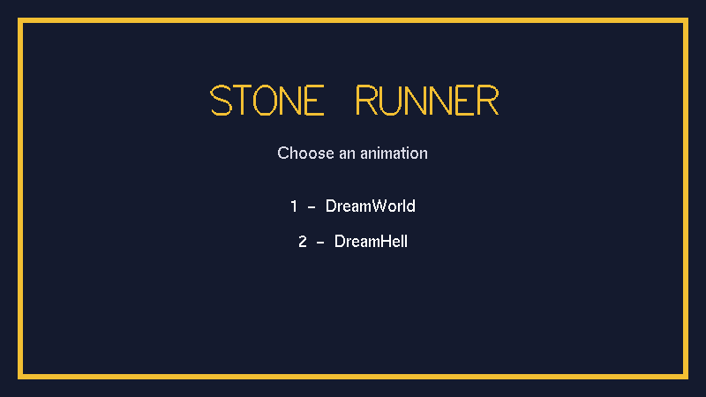
Figure 1: The opening menu (selected = 0), drawn by drawMenu(). This build offers two choices — key 1 for DreamWorld and key 2 for DreamHell. M returns to this screen from either scene, and ESC exits the program.
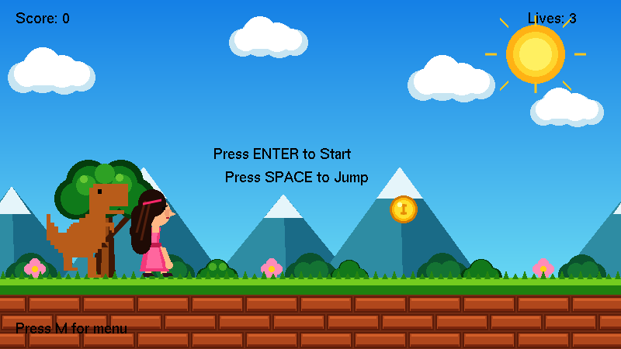
Figure 2: DreamWorld at the start state (gameState = 0). The controller has reset the run — Score: 0, Lives: 3 — and waits for ENTER to begin; SPACE jumps once the run is under way.
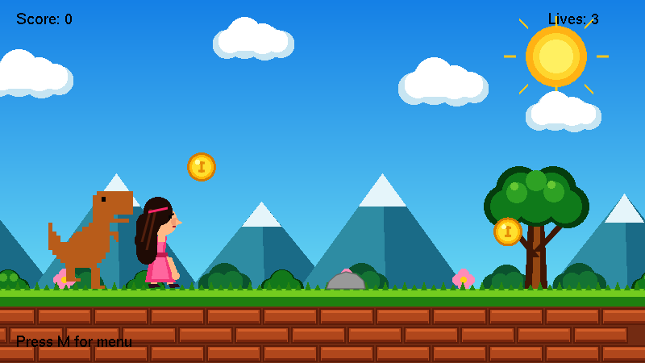
Figure 3: DreamWorld during play (gameState = 1). Three of the four modules are on screen at once — DreamWorld draws the scenery, dragon draws the dino and roshni_player draws the runner — while the controller alone moves the stones and coins and keeps the score and lives.
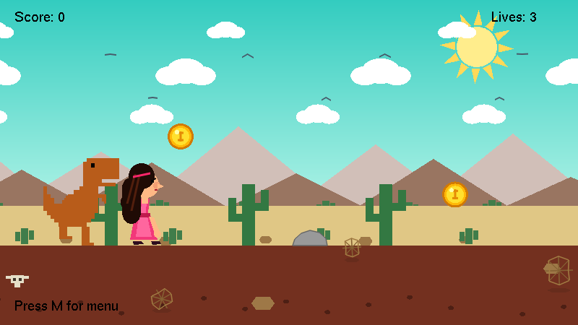
Figure 4: DreamHell during play. Only the scenery module changes: the teal sky, rotating sun, clouds, birds, mountains, cacti, cow skull and tumbleweeds are all drawn by drawDreamHell(), while the same controller keeps running the dino, the runner, the coins and the grey stone obstacle unchanged. The controller sets groundOffset = 18.0f whenever DreamHell is selected, lifting every actor from DreamWorld’s grass line at y = 92 to DreamHell’s sand line at y = 110.
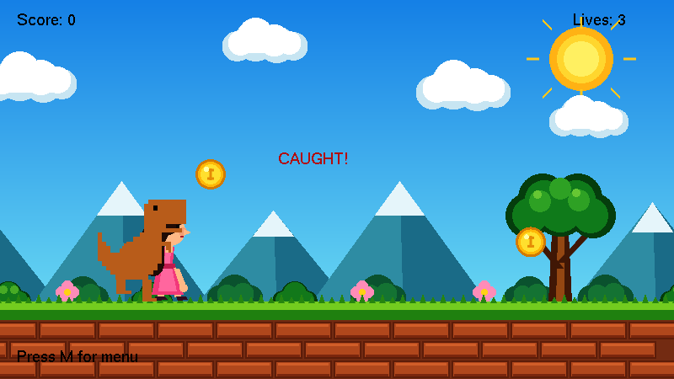
Figure 5: The caught state (gameState = 3) in DreamWorld, marked by the red CAUGHT! banner. Control passes to dinoChase(), which advances the dino 4 px per frame and is captured here mid-sprint; once dinoX reaches 200 the game switches to gameState = 2. In this state the draw order is reversed, so the dino is painted over the player.
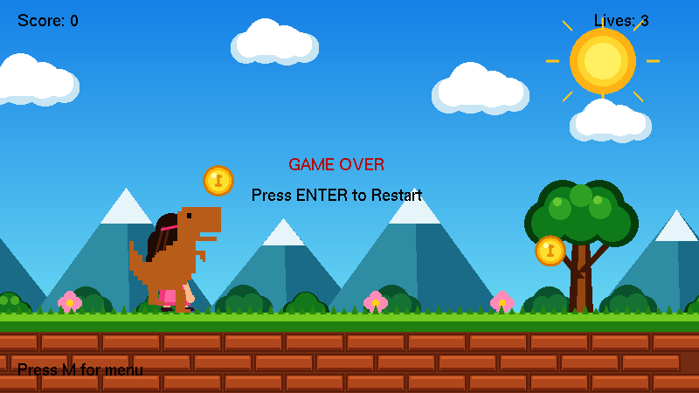
Figure 6: DreamWorld game over (gameState = 2), entered from the caught state once dinoChase() has finished. GAME OVER and Press ENTER to Restart are drawn over the scene. The stones and coins stop and the parallax layers hold still, although the clouds keep drifting; ENTER calls resetRun() to start a fresh run and M returns to the menu.
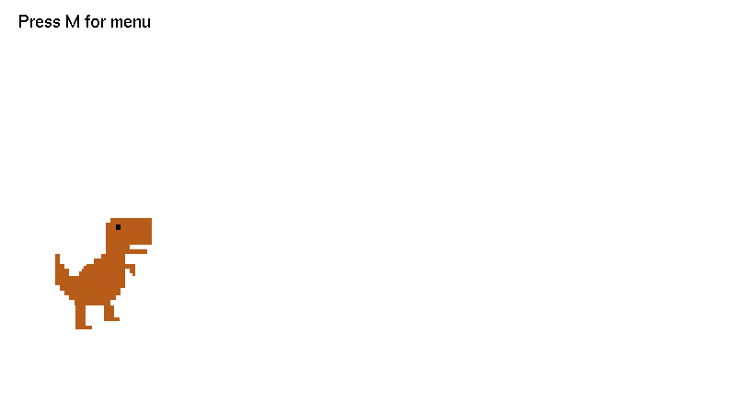
Figure 7: The dragon module drawn on its own, with its running-leg animation active. Previews like this one were used during development to check each character module in isolation before it was wired into the two scenes; the final menu keeps only the DreamWorld and DreamHell entries.

Figure 8: The roshni_player module drawn on its own. Because every module keeps its own state and exposes only its draw and animate functions, the runner can be rendered outside either scene — using the same call the controller makes once per frame in Figures 2 to 6.

7. List of Objects
Note on terminology: the project is written in a procedural, modular style, and the class keyword does not appear anywhere in the source. Each object below is a module that keeps its data in file-scope static variables and exposes a small set of public functions. The effect is the same as an object with private state and public methods, except that the encapsulation comes from the translation unit rather than from a C++ class.
Object (Module) | Location in allInOne.cpp | Purpose
Shared Drawing Primitives | Lines 40-75 | Holds the three low-level shape and text routines (drawRect, drawCircle, drawText) that every other module is built on.
DreamWorld (Grass Scene) | Lines 77-658 | Draws and animates the grass and brick scene: sky, sun, clouds, mountains, bushes, tree, flowers and the scrolling brick-and-grass ground.
DreamHell (Desert Scene) | Lines 660-1154 | Draws and animates the desert scene: sky, spinning sun, clouds, birds, mountains, cacti, rocks, a cow skull and tumbleweeds.
dragon (Dino) | Lines 1156-1272 | Draws and animates the antagonist dinosaur, including its scripted chase sequence.
roshni_player | Lines 1274-1559 | Draws and animates the playable girl character, including her jump physics.
Game Controller | Lines 1561-2098 | Owns the shared score, lives, coin and stone state; the game state machine; collision detection; and the GLUT callback wiring that drives the program.

8. Functions to Represent the Objects
Functions marked [public] are callable from outside their module; those marked static are file-private helpers. DreamWorld and DreamHell had each defined their own private drawSky(), drawMountains() and drawGround(), so combining the modules into one translation unit meant renaming DreamHell’s three to drawHellSky(), drawHellMountains() and drawHellGround(). This report uses the names that appear in the submitted file.

8.1 Shared Drawing Primitives
Function | Explanation
void drawRect(float x1, float y1, float x2, float y2) | Draws an axis-aligned filled rectangle between two corner points using GL_QUADS.
void drawCircle(float cx, float cy, float r) | Draws a filled circle at (cx, cy) with radius r, approximated as a 40-sided polygon.
void drawText(float x, float y, const char *text) | Draws a string of bitmap text at (x, y) using the GLUT Helvetica-18 bitmap font.

8.2 DreamWorld (Grass Scene)
Function | Explanation
void drawBackground() [public] | Draws the whole grass scene back to front, with two tiled copies of each scrolling layer so the wraparound has no seam.
void backgroundAnimate(float speed,  bool running) [public] | Advances all six scroll offsets by one frame. Clouds always scroll; the remaining layers only scroll while running is true.
static void drawSky() | Draws the blue sky gradient.
static void drawSun() | Draws the fixed sun with rays at a set screen position.
static void drawClouds() | Draws four decorative cloud clusters in two shades for depth.
static void drawMountains() | Draws four layered triangular mountains with snow caps.
static void drawBackgroundBushes() | Draws five small background bush clusters.
static void drawTree() | Draws a single large tree: trunk, branches and layered foliage.
static void drawBushes() | Draws three foreground bush clusters.
static void drawFlowers() | Draws three flower clusters.
static void drawBrick() | Draws one brick shape at its own local origin.
static void drawGrassBlades() | Draws one tuft of two grass blades at its own local origin.
static void drawGround() | Draws the dirt path and grass band, tiling drawBrick() and drawGrassBlades() along the scrolling offsets.

8.3 DreamHell (Desert Scene)
Function | Explanation
void drawDreamHell() [public] | Draws the entire desert scene back to front.
void dreamHellAnimate() [public] | Advances the scene clock (gTime) and spins the sun.
static float wrapX(float x0, float speed,  float margin) | Computes a horizontally wrapping x-position for a scrolling element, based on gTime.
static void drawEllipse(float cx, float cy,  float rx, float ry) | Draws a filled ellipse, which is the base shape for the clouds and the sun body.
static void drawHellSky() | Draws the teal-to-white sky gradient.
static void drawSun(float cx, float cy) | Draws the rotating sun with 12 triangular rays at a given position.
static void drawCloud(float x, float y, float size) | Draws one cloud from three overlapping ellipses.
static void drawCloudRow(float y, float size,  float gap, float speed) | Draws a row of clouds that repeats sideways and scrolls without ending.
static void drawBird(float x, float y,  float size, float wing) | Draws one bird as a simple V-shaped wing pair.
static void drawBirdRow(float y, float size,  float gap, float speed) | Draws a scrolling row of birds whose wings flap via a sine function.
static void drawMountain(...) | Draws one triangular mountain at a given position, size and colour.
static void drawHellMountains() | Draws a back row and a front row of mountains using drawMountain().
static void drawHellGround() | Draws the dirt band with scattered pebbles, and the sand band above it.
static void drawRock(float x, float y, float w, float h) | Draws one six-sided rock.
static void drawCactus(float x, float bottom) | Draws one large cactus: a tall body plus two arms.
static void drawSmallCactus(float x, float bottom) | Draws one small cactus.
static void drawTumbleweed(float cx, float groundY,  float r, float speed) | Draws one tumbleweed with a bouncing, spinning motion and a ground shadow.
static void drawSkull(float x, float y) | Draws a cow-skull decoration.

8.4 dragon (Dino)
Function | Explanation
void drawDino() [public] | Draws the dino body plus whichever running-leg pose is current.
float dinoGetX() [public] | Returns the dino’s current world x-position.
void dinoAnimate(float speed) [public] | Advances the leg-pose swap timer; a higher speed swaps legs faster.
bool dinoChase() [public] | Advances the dino 4 units per call during the caught sequence; returns true once dinoX reaches 200.
void dinoReset() [public] | Resets the dino to its starting position and pose.
static void drawDinoBody() | Draws the torso, neck, head, tail and spine spikes as a series of rectangles.
static void drawDinoLegsRun1()  static void drawDinoLegsRun2() | Draw the two alternating running-leg poses.

8.5 roshni_player
Function | Explanation
void drawPlayer() [public] | Draws the current leg pose first, then the body and dress on top.
float playerGetY() [public] | Returns the player’s current vertical position; 92 when grounded.
bool playerIsJumping() [public] | Returns whether the player is currently airborne.
void playerJumpStart() [public] | Begins a jump by setting jumpSpeed to 10; ignored if already jumping.
void playerJumpUpdate() [public] | Integrates one frame of the jump arc and lands the player once playerY falls to 92.
void playerAnimate(float speed) [public] | Advances the leg-pose swap timer while grounded; freezes pose 1 while airborne.
void playerReset() [public] | Resets the player to grounded, not jumping, first running pose.
static void drawPlayerLegs1()  static void drawPlayerLegs2() | Draw the two alternating running-leg poses.
static void drawPlayerBody() | Draws the dress, arms, head, hair and face.

8.6 Game Controller
Function | Explanation
static bool rectHit(...) | Generic axis-aligned rectangle-overlap test used by both collision checks.
static void drawCoin() | Draws one coin from three concentric circles, a dollar-sign cross and a highlight.
static void drawStone() | Draws one stone obstacle as a filled and outlined seven-sided polygon.
static void checkCoins() | Tests the player hitbox against each live coin; on overlap, marks it collected and adds one point.
static void checkStones() | Tests the player hitbox against each stone; on overlap and with no active invulnerability, removes a life, subtracts two points, starts the 45-frame safety timer, and triggers the caught state if lives reach zero.
static void drawGameUI() | Draws the Score and Lives text plus the state-dependent prompts (Start, Caught, Game Over).
static void resetRun() | Seeds the RNG once, resets score, lives and speed, resets the dino and player, and lays out the stones and coins for a new run.
static void drawGame(float groundOffset) | Shared per-frame renderer for both scenes; draws coins, then either the running layout or the caught / game-over layout. groundOffset lifts every game object onto the correct ground height for the active scene.
static void animateGame() | Shared per-frame updater; advances speed, scrolls and wraps stones and coins, drives character animation, runs collision checks, and drives the caught-to-game-over transition.
static void gameKeyPress(unsigned char key) | Handles ENTER (start / restart) and SPACE (jump) while a scene is active.
void drawMenu() | Draws the four-option, number-keyed menu text.
void display() | GLUT display callback; branches on the selected view and renders it.
void update(int value) | GLUT timer callback firing every 16 ms; advances background, game and character animation, then reschedules itself.
void keyboard(unsigned char key, int x, int y) | GLUT keyboard callback; switches views, forwards keys to gameKeyPress(), and handles menu and exit.
void init() | One-time OpenGL setup (clear colour, blending, orthographic projection), then starts the first run.
int main(int argc, char** argv) | Program entry point; creates the GLUT window and registers all callbacks.

9. Interactive Functions
These are the functions that either take user input directly or turn that input into something visible on screen.
Function | Role in Interaction
keyboard(unsigned char key, int x, int y) | The main input handler and GLUT keyboard callback. Number keys 1 to 4 switch between the two scenes and the two character previews, M returns to the menu and ESC exits. While a scene is active it forwards keys to gameKeyPress().
gameKeyPress(unsigned char key) | Reads ENTER (ASCII 13) as start or restart, which calls resetRun() and sets gameState to 1. SPACE means jump, but only while gameState is 1 (playing).
playerJumpStart() | The trigger for a jump. keyboard() calls it directly in the character-preview view, and gameKeyPress() calls it during play. It starts the jump arc only if the player is not already in the air.
display() | Not input-driven itself, but it re-reads the selected variable every frame to decide what to render. That is where the user’s last keypress becomes visible.
update(int value) | The 16 ms timer tick that turns the current interactive state (selected, gameState) into continuous animation and gameplay progression. It reschedules itself through glutTimerFunc, which is what keeps the program moving instead of sitting still.
init() and main() | Not interactive themselves, but they create the window and register display, keyboard and update as GLUT’s callbacks. Nothing above runs without them.

10. Task Assignment and Codes of Functions

10.1 Task Assignment Table
Member | ID | Module | Function(s) | Assigned Element
Ashraful Islam Siam | 24-56642-1 | DreamHell | drawHellSky, drawSun(cx,cy) | Sun, Sky
Ashraful Islam Siam | 24-56642-1 | DreamHell | drawCloud, drawCloudRow | Cloud
Ashraful Islam Siam | 24-56642-1 | DreamHell | drawBird, drawBirdRow | Birds
Ashraful Islam Siam | 24-56642-1 | DreamHell | drawMountain, drawHellMountains | Mountain
Siam Hossain | 24-56637-1 | DreamHell | drawHellGround, drawRock | Ground
Siam Hossain | 24-56637-1 | DreamHell | drawCactus, drawSmallCactus | Cactus
Siam Hossain | 24-56637-1 | DreamHell | drawSkull, drawTumbleweed | Ground clutter
Siam Hossain | 24-56637-1 | Controller | drawGame() | Merge (dino, girl and objects on both scenes)
Sumaiya Akter Roshni | 23-53027-3 | roshni_player | All of the roshni_player module | Girl
Sumaiya Akter Roshni | 23-53027-3 | DreamWorld | drawClouds | Cloud
Sumaiya Akter Roshni | 23-53027-3 | DreamWorld | drawSun, drawSky | Sun, Sky
Sumaiya Akter Roshni | 23-53027-3 | DreamWorld | drawMountains | Mountain
Sumaiya Akter Roshni | 23-53027-3 | DreamWorld | drawBrick | Brick
Sumaiya Akter Roshni | 23-53027-3 | Controller | drawCoin, checkCoins | Coin
Sumaiya Akter Roshni | 23-53027-3 | Controller | checkStones (life deduction), drawGameUI (Lives display) | Lives
Sharif Eime Akhter | 24-55989-1 | dragon | All of the dragon module | Dinosaur
Sharif Eime Akhter | 24-55989-1 | DreamWorld | drawTree | Tree
Sharif Eime Akhter | 24-55989-1 | DreamWorld | drawGrassBlades | Grass
Sharif Eime Akhter | 24-55989-1 | DreamWorld | drawFlowers | Flower
Sharif Eime Akhter | 24-55989-1 | Controller | drawStone, checkStones (collision) | Stone
Sharif Eime Akhter | 24-55989-1 | Controller | checkCoins / checkStones (score maths), drawGameUI (Score display) | Score
Notes on shared work
- checkStones() does the stone-collision test and the life deduction in one function, and drawGameUI() prints Score and Lives in one function. The source never splits these into separate per-feature functions, so the table above lists each one under both members and Section 10.2 prints the code once instead of twice.
- drawGround(), drawSky(), drawBushes() and drawBackgroundBushes() in DreamWorld, together with wrapX() and drawEllipse() in DreamHell, are shared supporting routines. The assigned elements depend on them, so they are not credited to any one member.

10.2 Source Code by Member
The code below is copied unchanged from the submitted file, allInOne.cpp.

A. Ashraful Islam Siam (DreamHell): Sky, Sun, Cloud, Birds, Mountain
Sky
static void drawHellSky()
{
glBegin(GL_QUADS);
glColor3f(0.20f, 0.80f, 0.75f);
glVertex2f(0, 450);
glVertex2f(800, 450);
glColor3f(0.68f, 0.95f, 0.90f);
glVertex2f(800, 165);
glVertex2f(0, 165);
glEnd();
}

Sun
static void drawSun(float cx, float cy)
{
glPushMatrix();

glTranslatef(cx, cy, 0); /* go to where the sun sits point */
glRotatef(sunAngle, 0, 0, 1); /* turn it round */

/* 12 pointy rays. */
glColor3f(1.0f, 0.85f, 0.35f);
for (int i = 0; i < 12; i++)
{
glBegin(GL_TRIANGLES);
glVertex2f(-6, 30);
glVertex2f( 6, 30);
glVertex2f( 0, 52);
glEnd();

glRotatef(30, 0, 0, 1);
}

/* the round body*/
glColor3f(1.0f, 0.93f, 0.55f);
drawEllipse(0, 0, 28, 28);

glPopMatrix();
}

Cloud
static void drawCloud(float x, float y, float size)
{
glPushMatrix();
glTranslatef(x, y, 0);
glScalef(size, size, 1.0f);

glColor3f(1.0f, 1.0f, 1.0f);

drawEllipse(-20, 0, 18, 12);
drawEllipse( 20, 0, 18, 12);
drawEllipse( 0, 6, 24, 16);
glPopMatrix();
}

Cloud row
static void drawCloudRow(float y, float size, float gap, float speed)
{
/* enough clouds to fill the screen, plus a few spare ones*/
int count = 800 / gap + 3;
float rowLength = count * gap;

for (int i = 0; i < count; i++)
{
/* line them up, then left side e jacche */
float x = i * gap - speed * gTime;

/* left side e shesh hole right e anbe*/
while (x < -gap)
x = x + rowLength;

drawCloud(x, y, size);
}
}

Bird
static void drawBird(float x, float y, float size, float wing)
{
glColor3f(0.28f, 0.36f, 0.42f);
glLineWidth(2.0f);

glBegin(GL_LINES);
/* left wing: */
glVertex2f(x - 8 * size, y + wing);
glVertex2f(x,y);

/* right wing:*/
glVertex2f(x, y);
glVertex2f(x + 8 * size, y + wing);
glEnd();
}

Bird row
static void drawBirdRow(float y, float size, float gap, float speed)
{

int count = 800 / gap + 3;
float rowLength = count * gap;

for (int i = 0; i < count; i++)
{
// same time
float x = i * gap - speed * gTime;

while (x < -gap)
x = x + rowLength;

/* the wings up and down */
float wing = 5 * size * sin(gTime * 6 + i);

drawBird(x, y, size, wing);
}
}

Mountain
static void drawMountain(float x, float bottom, float width, float height,
float r, float g, float b)
{
glColor3f(r, g, b);

glBegin(GL_TRIANGLES);
glVertex2f(x - width, bottom); /* left */
glVertex2f(x + width, bottom); /* right */
glVertex2f(x, bottom + height);/* top */
glEnd();
}

Mountain layout
static void drawHellMountains()
{
/*Back Row*/
drawMountain(-40, 160, 120, 100, 0.82f, 0.75f, 0.72f);
drawMountain(140, 160, 130, 80, 0.82f, 0.75f, 0.72f);
drawMountain(330, 160, 140, 115, 0.82f, 0.75f, 0.72f);
drawMountain(520, 160, 120, 90, 0.82f, 0.75f, 0.72f);
drawMountain(710, 160, 130, 105, 0.82f, 0.75f, 0.72f);

/* Front Row */
drawMountain( 30, 160, 100, 55, 0.60f, 0.46f, 0.38f);
drawMountain(210, 160, 110, 65, 0.60f, 0.46f, 0.38f);
drawMountain(410, 160, 100, 50, 0.60f, 0.46f, 0.38f);
drawMountain(600, 160, 110, 70, 0.60f, 0.46f, 0.38f);
drawMountain(790, 160, 100, 45, 0.60f, 0.46f, 0.38f);
}

B. Siam Hossain (DreamHell): Ground, Cactus, Ground Clutter
Ground
static void drawHellGround()
{
glColor3f(0.45f, 0.19f, 0.12f);
drawRect(0, 0, 800, 110);

/* little stones scattered on the dirt */
glColor3f(0.30f, 0.12f, 0.08f);
for (int i = 0; i < 14; i++)
{
float px = wrapX(40 + i * 57.0f, 95.0f, 20.0f);
float py = 15 + 25 * fmod(i * 37, 90) / 90;
drawEllipse(px, py, 4, 3);
}

/* pale sand band the cacti stand on */
glColor3f(0.88f, 0.78f, 0.52f);
drawRect(0, 110, 800, 165);
}

Rock
static void drawRock(float x, float y, float w, float h)
{
glColor3f(0.62f, 0.47f, 0.28f);
glBegin(GL_POLYGON);
glVertex2f(x - w, y);
glVertex2f(x - w * 0.6f, y + h);
glVertex2f(x + w * 0.6f, y + h);
glVertex2f(x + w, y);
glVertex2f(x + w * 0.6f, y - h);
glVertex2f(x - w * 0.6f, y - h);
glEnd();
}

Cactus
static void drawCactus(float x, float bottom)
{
glColor3f(0.20f, 0.47f, 0.26f);

/* the tall middle */
glBegin(GL_QUADS);
glVertex2f(x - 9, bottom);
glVertex2f(x + 9, bottom);
glVertex2f(x + 9, bottom + 85);
glVertex2f(x - 9, bottom + 85);
glEnd();

/* left arm, going across */
glBegin(GL_QUADS);
glVertex2f(x - 28, bottom + 33);
glVertex2f(x - 9, bottom + 33);
glVertex2f(x - 9, bottom + 44);
glVertex2f(x - 28, bottom + 44);
glEnd();

/* left arm, going up */
glBegin(GL_QUADS);
glVertex2f(x - 28, bottom + 33);
glVertex2f(x - 17, bottom + 33);
glVertex2f(x - 17, bottom + 66);
glVertex2f(x - 28, bottom + 66);
glEnd();

/* right arm, going across */
glBegin(GL_QUADS);
glVertex2f(x + 9, bottom + 48);
glVertex2f(x + 28, bottom + 48);
glVertex2f(x + 28, bottom + 59);
glVertex2f(x + 9, bottom + 59);
glEnd();

/* right arm, going up */
glBegin(GL_QUADS);
glVertex2f(x + 17, bottom + 48);
glVertex2f(x + 28, bottom + 48);
glVertex2f(x + 28, bottom + 77);
glVertex2f(x + 17, bottom + 77);
glEnd();
}

Small cactus
static void drawSmallCactus(float x, float bottom)
{
glColor3f(0.25f, 0.49f, 0.29f);

/* the middle */
glBegin(GL_QUADS);
glVertex2f(x - 5, bottom);
glVertex2f(x + 5, bottom);
glVertex2f(x + 5, bottom + 22);
glVertex2f(x - 5, bottom + 22);
glEnd();

/* left arm, standing up */
glBegin(GL_QUADS);
glVertex2f(x - 13, bottom + 4);
glVertex2f(x - 6, bottom + 4);
glVertex2f(x - 6, bottom + 17);
glVertex2f(x - 13, bottom + 17);
glEnd();

/* right arm, standing up */
glBegin(GL_QUADS);
glVertex2f(x + 6, bottom + 6);
glVertex2f(x + 13, bottom + 6);
glVertex2f(x + 13, bottom + 19);
glVertex2f(x + 6, bottom + 19);
glEnd();
}

Tumbleweed
static void drawTumbleweed(float cx, float groundY, float r, float speed)
{
/* how high off the ground it is right now */
float bounce = fabs(sin(gTime * speed / (r * 2.4f))) * (r * 0.7f);
/* how far it has turned, in degrees */
float angle = -(gTime * speed) / r * (180.0f / PI);

float sh = r * (1.0f - bounce / (r * 2.5f)); /* shadow shrinks as it lifts */
float d = r * 0.70f; /* corners, for slanted twigs */
float n = r * 0.46f; /* notches, to look untidy */

/* the shadow stays down on the ground */
glColor4f(0.30f, 0.14f, 0.08f, 0.30f);
glBegin(GL_POLYGON);
glVertex2f(cx - sh, groundY + 2);
glVertex2f(cx - sh * 0.6f, groundY + 5);
glVertex2f(cx + sh * 0.6f, groundY + 5);
glVertex2f(cx + sh, groundY + 2);
glVertex2f(cx + sh * 0.6f, groundY - 1);
glVertex2f(cx - sh * 0.6f, groundY - 1);
glEnd();

glPushMatrix();

glTranslatef(cx, groundY + r + bounce, 0); /* bounce lifts it up */
glRotatef(angle, 0, 0, 1); /* rolling makes it spin */

/* four twigs crossing through the middle */
glColor3f(0.52f, 0.38f, 0.20f);
glLineWidth(1.6f);
glBegin(GL_LINES);
glVertex2f(-r, 0); glVertex2f( r, 0);
glVertex2f( 0, -r); glVertex2f( 0, r);
glVertex2f(-d, -d); glVertex2f( d, d);
glVertex2f(-d, d); glVertex2f( d, -d);
glEnd();

/* the outside edge: eight dots joined in a ring,
two of them pulled inward so it looks tangled */
glColor3f(0.63f, 0.48f, 0.26f);
glBegin(GL_LINE_LOOP);
glVertex2f( r, 0);
glVertex2f( n, n);
glVertex2f( 0, r);
glVertex2f(-d, d);
glVertex2f(-r, 0);
glVertex2f(-n, -n);
glVertex2f( 0, -r);
glVertex2f( d, -d);
glEnd();

glPopMatrix();
}

Skull
static void drawSkull(float x, float y)
{
glColor3f(0.90f, 0.87f, 0.78f);

/* the head */
glBegin(GL_QUADS);
glVertex2f(x - 9, y - 2);
glVertex2f(x + 9, y - 2);
glVertex2f(x + 9, y + 9);
glVertex2f(x - 9, y + 9);
glEnd();

/* the snout hanging down */
glBegin(GL_QUADS);
glVertex2f(x - 4, y - 8);
glVertex2f(x + 4, y - 8);
glVertex2f(x + 4, y - 2);
glVertex2f(x - 4, y - 2);
glEnd();

/* left horn */
glBegin(GL_QUADS);
glVertex2f(x - 16, y + 4);
glVertex2f(x - 9, y + 4);
glVertex2f(x - 9, y + 8);
glVertex2f(x - 16, y + 8);
glEnd();

/* right horn */
glBegin(GL_QUADS);
glVertex2f(x + 9, y + 4);
glVertex2f(x + 16, y + 4);
glVertex2f(x + 16, y + 8);
glVertex2f(x + 9, y + 8);
glEnd();

glColor3f(0.24f, 0.20f, 0.16f);

/* left eye */
glBegin(GL_QUADS);
glVertex2f(x - 6, y + 1);
glVertex2f(x - 2, y + 1);
glVertex2f(x - 2, y + 5);
glVertex2f(x - 6, y + 5);
glEnd();

/* right eye */
glBegin(GL_QUADS);
glVertex2f(x + 2, y + 1);
glVertex2f(x + 6, y + 1);
glVertex2f(x + 6, y + 5);
glVertex2f(x + 2, y + 5);
glEnd();
}

Merge: the girl, the dinosaur, the coins and the stones are merged onto both screens by drawGame(float groundOffset) in the Game Controller. One renderer draws all four on top of whichever background is active, and groundOffset shifts them to the right ground height for that scene: 92 in DreamWorld and 110 in DreamHell. The function is listed in Section 8.6.

C. Sumaiya Akter Roshni: DreamWorld Scenery, Player, Coin and Lives
Sky
static void drawSky()
{
glBegin(GL_QUADS);

glColor3f(0.08f,0.50f,0.90f);
glVertex2f(0,450);
glVertex2f(800,450);

glColor3f(0.40f,0.84f,0.95f);
glVertex2f(800,90);
glVertex2f(0,90);

glEnd();
}

Sun
static void drawSun()
{
glColor3f(1.0f,0.70f,0.08f);
drawCircle(690,380,38);

glColor3f(1.0f,0.84f,0.18f);
drawCircle(690,380,29);

glColor3f(1.0f,0.94f,0.38f);
drawCircle(690,380,21);

glColor3f(1.0f,0.78f,0.10f);
glLineWidth(3);

glBegin(GL_LINES);

glVertex2f(690,430);
glVertex2f(690,416);

glVertex2f(690,344);
glVertex2f(690,330);

glVertex2f(640,380);
glVertex2f(625,380);

glVertex2f(740,380);
glVertex2f(755,380);

glVertex2f(655,415);
glVertex2f(644,426);

glVertex2f(725,415);
glVertex2f(736,426);

glVertex2f(655,345);
glVertex2f(644,334);

glVertex2f(725,345);
glVertex2f(736,334);

glEnd();
}

Clouds
static void drawClouds()
{
glColor3f(0.78f,0.90f,0.95f);

drawCircle(30,350,20);
drawCircle(55,358,28);
drawCircle(83,352,24);
drawCircle(105,350,18);
drawRect(30,335,105,355);

glColor3f(1.0f,1.0f,1.0f);

drawCircle(35,355,17);
drawCircle(55,365,24);
drawCircle(80,358,21);
drawCircle(100,355,16);
drawRect(35,340,100,358);

glColor3f(0.78f,0.90f,0.95f);

drawCircle(313,395,18);
drawCircle(335,402,25);
drawCircle(360,397,22);
drawCircle(380,395,17);
drawRect(313,382,380,400);

glColor3f(1.0f,1.0f,1.0f);

drawCircle(317,399,15);
drawCircle(335,408,21);
drawCircle(357,402,19);
drawCircle(375,399,14);
drawRect(317,387,375,403);

glColor3f(0.78f,0.90f,0.95f);

drawCircle(545,340,20);
drawCircle(570,348,28);
drawCircle(598,342,24);
drawCircle(620,340,18);
drawRect(545,325,620,345);

glColor3f(1.0f,1.0f,1.0f);

drawCircle(550,345,17);
drawCircle(570,355,24);
drawCircle(595,348,21);
drawCircle(615,345,16);
drawRect(550,330,615,348);

glColor3f(0.78f,0.90f,0.95f);

drawCircle(700,305,17);
drawCircle(720,312,24);
drawCircle(744,307,21);
drawCircle(762,305,16);
drawRect(700,293,762,311);

glColor3f(1.0f,1.0f,1.0f);

drawCircle(704,309,14);
drawCircle(720,317,20);
drawCircle(741,312,18);
drawCircle(758,309,13);
drawRect(704,297,758,313);
}

Mountains
static void drawMountains()
{
glColor3f(0.18f,0.55f,0.64f);
glBegin(GL_TRIANGLES);
glVertex2f(-80,90);
glVertex2f(15,210);
glVertex2f(110,90);
glEnd();

glColor3f(0.10f,0.42f,0.53f);
glBegin(GL_TRIANGLES);
glVertex2f(15,210);
glVertex2f(110,90);
glVertex2f(19,90);
glEnd();

glColor3f(0.90f,0.96f,0.98f);
glBegin(GL_TRIANGLES);
glVertex2f(-10,174);
glVertex2f(15,210);
glVertex2f(40,174);
glEnd();

glColor3f(0.18f,0.55f,0.64f);
glBegin(GL_TRIANGLES);
glVertex2f(80,90);
glVertex2f(185,235);
glVertex2f(290,90);
glEnd();

glColor3f(0.10f,0.42f,0.53f);
glBegin(GL_TRIANGLES);
glVertex2f(185,235);
glVertex2f(290,90);
glVertex2f(189,90);
glEnd();

glColor3f(0.90f,0.96f,0.98f);
glBegin(GL_TRIANGLES);
glVertex2f(155,194);
glVertex2f(185,235);
glVertex2f(215,194);
glEnd();

glColor3f(0.18f,0.55f,0.64f);
glBegin(GL_TRIANGLES);
glVertex2f(275,90);
glVertex2f(365,200);
glVertex2f(455,90);
glEnd();

glColor3f(0.10f,0.42f,0.53f);
glBegin(GL_TRIANGLES);
glVertex2f(365,200);
glVertex2f(455,90);
glVertex2f(369,90);
glEnd();

glColor3f(0.90f,0.96f,0.98f);
glBegin(GL_TRIANGLES);
glVertex2f(340,169);
glVertex2f(365,200);
glVertex2f(390,169);
glEnd();

glColor3f(0.18f,0.55f,0.64f);
glBegin(GL_TRIANGLES);
glVertex2f(410,90);
glVertex2f(515,235);
glVertex2f(620,90);
glEnd();

glColor3f(0.10f,0.42f,0.53f);
glBegin(GL_TRIANGLES);
glVertex2f(515,235);
glVertex2f(620,90);
glVertex2f(519,90);
glEnd();

glColor3f(0.90f,0.96f,0.98f);
glBegin(GL_TRIANGLES);
glVertex2f(485,194);
glVertex2f(515,235);
glVertex2f(545,194);
glEnd();
}

Brick
static void drawBrick()
{
glColor3f(0.36f,0.11f,0.035f);
drawRect(0,0,68,21);

glColor3f(0.69f,0.28f,0.11f);
drawRect(2,2,66,19);

glColor3f(0.82f,0.37f,0.16f);
drawRect(4,15,64,18);

glColor3f(0.48f,0.15f,0.05f);
drawRect(3,2,65,5);
}

Player character (roshni_player module)
Running pose 1
static void drawPlayerLegs1()
{
glColor3f(1.0f,0.72f,0.52f); // skin colour

// front leg goes forward
glBegin(GL_QUADS);
glVertex2f(207,97);
glVertex2f(215,97);
glVertex2f(213,130);
glVertex2f(205,130);
glEnd();

// back leg goes backward
glBegin(GL_QUADS);
glVertex2f(187,97);
glVertex2f(195,97);
glVertex2f(199,132);
glVertex2f(191,132);
glEnd();

glColor3f(0.18f,0.05f,0.12f); // shoe colour

// front shoe, standing forward on the ground
glBegin(GL_POLYGON);
glVertex2f(209,98);
glVertex2f(221,98);
glVertex2f(223,94);
glVertex2f(211,93);
glEnd();

// back shoe, standing backward on the ground
glBegin(GL_POLYGON);
glVertex2f(184,98);
glVertex2f(196,98);
glVertex2f(199,94);
glVertex2f(185,93);
glEnd();
}

Running pose 2
static void drawPlayerLegs2()
{
glColor3f(1.0f,0.72f,0.52f); // skin colour

// front leg comes back and lifts a little
glBegin(GL_QUADS);
glVertex2f(199,99);
glVertex2f(207,99);
glVertex2f(213,130);
glVertex2f(205,130);
glEnd();

// back leg stands straight on the ground
glBegin(GL_QUADS);
glVertex2f(193,97);
glVertex2f(201,97);
glVertex2f(199,132);
glVertex2f(191,132);
glEnd();

glColor3f(0.18f,0.05f,0.12f); // shoe colour

// lifted shoe, a little above the ground
glBegin(GL_POLYGON);
glVertex2f(201,101);
glVertex2f(213,101);
glVertex2f(215,97);
glVertex2f(203,96);
glEnd();

// standing shoe
glBegin(GL_POLYGON);
glVertex2f(190,98);
glVertex2f(202,98);
glVertex2f(205,94);
glVertex2f(191,93);
glEnd();
}

Body, dress, head and face
static void drawPlayerBody()
{
glColor3f(0.95f,0.22f,0.48f);

glBegin(GL_POLYGON);
glVertex2f(187,135);
glVertex2f(208,135);
glVertex2f(218,100);
glVertex2f(180,100);
glEnd();

glColor3f(1.0f,0.40f,0.62f);

glBegin(GL_POLYGON);
glVertex2f(192,132);
glVertex2f(204,132);
glVertex2f(210,104);
glVertex2f(188,104);
glEnd();

glColor3f(0.95f,0.22f,0.48f);

glBegin(GL_QUADS);
glVertex2f(192,137);
glVertex2f(205,137);
glVertex2f(207,157);
glVertex2f(194,157);
glEnd();

glColor3f(1.0f,0.40f,0.62f);

glBegin(GL_QUADS);
glVertex2f(195,137);
glVertex2f(202,137);
glVertex2f(203,155);
glVertex2f(196,155);
glEnd();

glColor3f(0.75f,0.10f,0.30f);
drawRect(189,131,208,137);

glColor3f(1.0f,0.72f,0.52f);
drawRect(196,150,205,161);

drawCircle(202,176,18);

glColor3f(0.95f,0.62f,0.45f);
drawCircle(217,175,5);

glColor3f(0.12f,0.045f,0.02f);
drawCircle(196,188,18);
drawCircle(184,172,15);
drawCircle(181,152,14);
drawCircle(182,134,12);
drawRect(169,134,195,172);

glColor3f(0.32f,0.12f,0.05f);
glLineWidth(3);

glBegin(GL_LINES);
glVertex2f(187,191);
glVertex2f(176,150);
glVertex2f(193,190);
glVertex2f(182,140);
glEnd();

glColor3f(1.0f,0.72f,0.52f);

glBegin(GL_TRIANGLES);
glVertex2f(218,178);
glVertex2f(227,174);
glVertex2f(218,170);
glEnd();

glColor3f(0.02f,0.02f,0.02f);
drawCircle(211,181,2.5f);

glLineWidth(2);

glBegin(GL_LINES);
glVertex2f(212,183);
glVertex2f(216,185);
glEnd();

glColor3f(0.65f,0.10f,0.18f);
glLineWidth(2);

glBegin(GL_LINES);
glVertex2f(214,169);
glVertex2f(218,169);
glEnd();

glColor3f(1.0f,0.72f,0.52f);

glBegin(GL_QUADS);
glVertex2f(206,132);
glVertex2f(213,131);
glVertex2f(221,111);
glVertex2f(214,109);
glEnd();

drawCircle(218,108,5);

glColor3f(1.0f,0.15f,0.42f);
glLineWidth(3);

glBegin(GL_LINES);
glVertex2f(184,187);
glVertex2f(208,192);
glEnd();
}

Draw player
void drawPlayer()
{
if (playerPose == 1)
drawPlayerLegs1();
else
drawPlayerLegs2();

drawPlayerBody();
}

Jump start
void playerJumpStart()
{
if (!jumping)
{
jumping = true;
jumpSpeed = 10;
}
}

Jump physics update
void playerJumpUpdate()
{
playerY = playerY + jumpSpeed;
jumpSpeed = jumpSpeed - 0.5f;

if (playerY <= 92)
{
playerY = 92;
jumping = false;
jumpSpeed = 0;
}
}

Leg animation
void playerAnimate(float speed)
{
int legDelay = 8 - (int)speed;

if (legDelay < 2)
legDelay = 2;

if (!jumping)
{
playerCounter++;

if (playerCounter >= legDelay)
{
playerCounter = 0;

if (playerPose == 1)
playerPose = 2;
else
playerPose = 1;
}
}
else
{
playerPose = 1; // in the air her legs stay still
}
}

Reset
void playerReset()
{
playerY = 92;
jumpSpeed = 0;
jumping = false;
playerPose = 1;
playerCounter = 0;
}

Coin and Lives
Coin
static void drawCoin()
{
glColor3f(0.82f,0.48f,0.02f);
drawCircle(0,0,18);

glColor3f(1.0f,0.72f,0.03f);
drawCircle(0,0,15);

glColor3f(1.0f,0.88f,0.18f);
drawCircle(0,0,12);

glColor3f(0.90f,0.55f,0.02f);
glLineWidth(3);

glBegin(GL_LINES);
glVertex2f(0,7);
glVertex2f(0,-7);
glVertex2f(-4,5);
glVertex2f(4,5);
glVertex2f(-4,-5);
glVertex2f(4,-5);
glEnd();

glColor3f(1.0f,1.0f,0.65f);
drawCircle(-5,6,3);
}

Coin collection and score gain
static void checkCoins()
{
float px1=175;
float py1=playerGetY();
float px2=225;
float py2=playerGetY()+100;

for (int i=0; i<4; i++)
{
if (!coinAlive[i])
continue;

if (rectHit(px1,py1,px2,py2,
coinX[i]-18,coinY[i]-18,
coinX[i]+18,coinY[i]+18))
{
coinAlive[i]=false;
score++;
}
}
}

D. Sharif Eime Akhter: Dinosaur, Tree, Grass, Flower, Stone and Score
Tree
static void drawTree()
{
glColor3f(0.25f,0.09f,0.02f);

glBegin(GL_POLYGON);
glVertex2f(121,92);
glVertex2f(149,92);
glVertex2f(145,173);
glVertex2f(125,173);
glEnd();

glColor3f(0.58f,0.28f,0.07f);

glBegin(GL_POLYGON);
glVertex2f(130,92);
glVertex2f(140,92);
glVertex2f(140,169);
glVertex2f(132,169);
glEnd();

glColor3f(0.25f,0.09f,0.02f);
glLineWidth(9);

glBegin(GL_LINES);
glVertex2f(135,131);
glVertex2f(99,176);

glVertex2f(135,138);
glVertex2f(171,176);

glVertex2f(113,162);
glVertex2f(87,190);

glVertex2f(157,162);
glVertex2f(183,190);
glEnd();

glColor3f(0.02f,0.24f,0.05f);
drawCircle(97,194,27);
drawCircle(174,194,27);
drawCircle(114,215,29);
drawCircle(156,215,29);
drawCircle(135,201,32);

glColor3f(0.06f,0.48f,0.10f);
drawCircle(99,194,21);
drawCircle(171,194,21);
drawCircle(116,213,23);
drawCircle(154,213,23);
drawCircle(135,199,25);

glColor3f(0.18f,0.63f,0.14f);
drawCircle(111,211,13);
drawCircle(157,212,13);
drawCircle(135,226,13);

glColor3f(0.40f,0.78f,0.20f);
drawCircle(108,219,5);
drawCircle(154,221,5);
}

Grass blades
static void drawGrassBlades()
{
glColor3f(0.15f,0.52f,0.06f);

glBegin(GL_TRIANGLES);
glVertex2f(0,0);
glVertex2f(4,11);
glVertex2f(8,0);

glVertex2f(12,0);
glVertex2f(16,8);
glVertex2f(20,0);
glEnd();
}

Flowers
static void drawFlowers()
{
glColor3f(1.0f,0.55f,0.72f);
drawCircle(38,103,7);
drawCircle(52,103,7);
drawCircle(45,96,7);
drawCircle(45,110,7);

glColor3f(1.0f,0.82f,0.08f);
drawCircle(45,103,4);

glColor3f(1.0f,0.55f,0.72f);
drawCircle(343,103,7);
drawCircle(357,103,7);
drawCircle(350,96,7);
drawCircle(350,110,7);

glColor3f(1.0f,0.82f,0.08f);
drawCircle(350,103,4);

glColor3f(1.0f,0.55f,0.72f);
drawCircle(693,103,7);
drawCircle(707,103,7);
drawCircle(700,96,7);
drawCircle(700,110,7);

glColor3f(1.0f,0.82f,0.08f);
drawCircle(700,103,4);
}

Dinosaur (dragon module)
Dino body
static void drawDinoBody()
{
glColor3f(0.72f,0.36f,0.10f);

drawRect(5.3f,213.4f,50.2f,208.2f);
drawRect(0.0f,208.2f,50.2f,205.5f);
drawRect(0.0f,205.5f,10.6f,200.2f);
drawRect(15.8f,205.5f,50.2f,200.2f);
drawRect(0.0f,200.2f,50.2f,184.4f);
drawRect(0.0f,184.4f,26.4f,179.1f);
drawRect(0.0f,179.1f,44.9f,173.8f);

drawRect(-55.4f,173.8f,-50.2f,163.3f);
drawRect(-5.3f,173.8f,21.1f,168.6f);
drawRect(-13.2f,168.6f,21.1f,163.3f);
drawRect(-55.4f,163.3f,-44.9f,158.0f);
drawRect(-21.1f,163.3f,31.7f,160.6f);
drawRect(-23.8f,160.6f,31.7f,158.0f);
drawRect(-55.4f,158.0f,-39.6f,150.1f);
drawRect(-26.4f,158.0f,21.1f,155.4f);
drawRect(26.4f,158.0f,31.7f,152.7f);
drawRect(-29.0f,155.4f,21.1f,150.1f);
drawRect(29.0f,152.7f,31.7f,150.1f);
drawRect(-55.4f,150.1f,21.1f,139.5f);
drawRect(-50.2f,139.5f,21.1f,136.9f);
drawRect(-50.2f,136.9f,15.8f,134.2f);
drawRect(-44.9f,134.2f,15.8f,129.0f);
drawRect(-39.6f,129.0f,10.6f,123.7f);
drawRect(-34.3f,123.7f,5.3f,118.4f);

glColor3f(0.0f,0.0f,0.0f);
drawRect(10.6f,205.5f,15.8f,200.2f);
}

Running pose 1
static void drawDinoLegsRun1()
{
glColor3f(0.72f,0.36f,0.10f);

drawRect(-33.0f,118.4f,-22.0f,105.2f);
drawRect(-33.0f,105.2f,-15.4f,100.8f);

drawRect(-2.2f,118.4f,8.8f,96.4f);
drawRect(-2.2f,96.4f,15.4f,92.0f);
}

Running pose 2
static void drawDinoLegsRun2()
{
glColor3f(0.72f,0.36f,0.10f);

drawRect(-33.0f,118.4f,-22.0f,96.4f);
drawRect(-33.0f,96.4f,-15.4f,92.0f);

drawRect(-2.2f,118.4f,8.8f,105.2f);
drawRect(-2.2f,105.2f,15.4f,100.8f);
}

Draw dino
void drawDino()
{
drawDinoBody();

if(dinoPose==1)
drawDinoLegsRun1();
else
drawDinoLegsRun2();
}

Leg animation
void dinoAnimate(float speed)
{
int dinoDelay=8-(int)speed;

if(dinoDelay<2)
dinoDelay=2;

dinoCounter++;

if(dinoCounter>=dinoDelay)
{
dinoCounter=0;

if(dinoPose==1)
dinoPose=2;
else
dinoPose=1;
}
}

Chase sequence
bool dinoChase()
{
dinoX=dinoX+4;

return dinoX>=200;
}

Reset
void dinoReset()
{
dinoX=115;
dinoPose=1;
dinoCounter=0;
}

Stone and Score
Stone
static void drawStone()
{
// ash-grey stone
glColor3f(0.60f,0.60f,0.60f);

glBegin(GL_POLYGON);
glVertex2f(-25.0f,92.0f);
glVertex2f(-22.0f,101.0f);
glVertex2f(-13.0f,109.0f);
glVertex2f(-1.0f,113.0f);
glVertex2f(12.0f,110.0f);
glVertex2f(21.0f,102.0f);
glVertex2f(23.0f,92.0f);
glEnd();

// darker outline
glColor3f(0.40f,0.40f,0.40f);
glLineWidth(1.5f);

glBegin(GL_LINE_LOOP);
glVertex2f(-25.0f,92.0f);
glVertex2f(-22.0f,101.0f);
glVertex2f(-13.0f,109.0f);
glVertex2f(-1.0f,113.0f);
glVertex2f(12.0f,110.0f);
glVertex2f(21.0f,102.0f);
glVertex2f(23.0f,92.0f);
glEnd();
}

Stone collision, life deduction and score penalty (joint)
static void checkStones()
{
// still counting down after the last hit -- skip so one touch
// can't remove more than one life
if (hitTimer>0)
return;

float px1=180;
float py1=playerGetY();
float px2=218;
float py2=playerGetY()+96;

for (int i=0; i<3; i++)
{
if (rectHit(px1,py1,px2,py2,
stoneX[i]-20,92,
stoneX[i]+18,110))
{
lives=lives-1;

// hitting a stone takes away 2 points
score=score-2;

// never let the score go below zero
if (score<0)
score=0;

hitTimer=45; // about 0.75 seconds of safety at 16ms/frame

if (lives<=0)
gameState=3;

return;
}
}
}

E. Joint work: Shared Score and Lives Display
Score and Lives on-screen display
static void drawGameUI()
{
char text[80];

glColor3f(0.0f,0.0f,0.0f);

sprintf(text,"Score: %d",score);
drawText(20,420,text);

sprintf(text,"Lives: %d",lives);
drawText(680,420,text);

if (gameState==0)
{
drawText(275,245,"Press ENTER to Start");
drawText(290,215,"Press SPACE to Jump");
}

if (gameState==3)
{
glColor3f(0.70f,0.05f,0.05f);
drawText(330,255,"CAUGHT!");
}

if (gameState==2)
{
glColor3f(0.70f,0.05f,0.05f);
drawText(330,255,"GAME OVER");

glColor3f(0.0f,0.0f,0.0f);
drawText(288,220,"Press ENTER to Restart");
}
}

Shared AABB overlap test used by both collision checks
static bool rectHit(float a1, float b1, float a2, float b2,
float c1, float d1, float c2, float d2)
{
if (a2 < c1) return false;
if (a1 > c2) return false;
if (b2 < d1) return false;
if (b1 > d2) return false;

return true;
}

Run initialisation for coins, stones, score and lives
static void resetRun()
{
if (!seeded)
{
srand((unsigned)time(NULL));
seeded=true;
}

runSpeed=3.0f;
score=0;

lives=3;
hitTimer=0;

dinoReset();
playerReset();

stoneX[0]=700;
stoneX[1]=1150;
stoneX[2]=1600;

coinX[0]=520;
coinX[1]=900;
coinX[2]=1280;
coinX[3]=1660;

coinY[0]=180;
coinY[1]=220;
coinY[2]=170;
coinY[3]=240;

coinBobDir[0]=0.7f;
coinBobDir[1]=-0.7f;
coinBobDir[2]=0.7f;
coinBobDir[3]=-0.7f;

coinAlive[0]=true;
coinAlive[1]=true;
coinAlive[2]=true;
coinAlive[3]=true;

gameState=0;
}

11. Conclusion

11.1 Summary of What Was Achieved
The team built a working 2D endless-runner game out of OpenGL and GLUT primitive shapes, with no external art assets. The finished build has two animated background scenes that scroll in layers and two animated characters that alternate running poses. One system for score, lives and collisions is shared by both scenes, so the mini-game behaves the same in either one. The menu works, and the GLUT callback wiring lets a single executable switch between four views.
The structure also shows that plain procedural C++ can encapsulate state well enough without classes, using file-scope statics behind a narrow public interface. Each of the four modules exposes only a draw function and an animate or state function. Everything else, helper routines and variables alike, stays private to the module.

11.2 Challenges Faced
- Collision boxes had to be tuned by hand. Every object is drawn from raw vertex coordinates rather than from a sprite, so there is no image size to read a hitbox from. The boxes in checkCoins() and checkStones() were worked out by hand and then adjusted until they lined up with the drawn shapes.
- Getting the parallax layers to keep pace with the game took several passes. The six scroll offsets in backgroundAnimate() each advance at a different multiple of runSpeed. Most of the multipliers we tried either flattened the sense of depth or left one layer stuttering or wrapping early.
- Wraparound with no visible seam. Every scrolling layer is drawn twice, one screen width apart, so no gap shows when a layer wraps. The catch is that each wrap threshold has to match its tile width exactly: 70 for bricks, 24 for grass, 800 for scenery. Those numbers came out of trial and error.
- The two scenes do not share a ground height. DreamWorld’s brick path sits at y = 92 and DreamHell’s sand sits at y = 110. We added a groundOffset parameter to drawGame() so one renderer could place the player, the coins and the stones correctly in both.
- Merging five source files into one translation unit. DreamWorld and DreamHell had each defined private functions under the same names (drawSky, drawMountains, drawGround). That was fine while they were separate files and turned into duplicate-definition errors as soon as they were not. We renamed DreamHell’s three and updated every call site.
- Debugging the timer-driven animation loop. All motion comes from a 16 ms glutTimerFunc callback rather than from measured elapsed time, which ties animation speed to frame count. Every speed value in the project had to be tuned against that fixed tick rate.
Add any other difficulties from development to this list before submitting.

11.3 Possible Future Improvements
These come from reading the current source:
- Correct the collision-hitbox offset in the DreamHell scene. checkCoins() and checkStones() use fixed player coordinates and ignore the scene’s groundOffset, which the matching draw calls in drawGame() do apply. Hit detection is therefore slightly out of line in the desert scene.
- Tie DreamHell’s decorative scroll speed to runSpeed. dreamHellAnimate() advances gTime by a fixed 0.016 whatever the game speed, so the desert scenery falls behind the gameplay once the run gets fast. DreamWorld’s layers already scale with runSpeed.
- Call dinoAnimate() during the caught sequence. In animateGame() the dino’s leg animation runs only while gameState is 1, so the dinosaur’s legs freeze mid-chase as it sprints toward the player.
- Register a glutReshapeFunc so the fixed 800 by 450 orthographic projection stays correct when the window is resized.
- Replace the frame-count timing model with elapsed-time (delta-time) integration, so gameplay speed does not change with the machine’s frame rate.
- Store the high score in a file so it survives between sessions.

