Shashroy Bazar
UML model set
Derived from Software Requirements Specification v0.1

Field | Value
Source document | Shashroy_Bazar_SRS_Requirements_v0_1.docx
Baseline | SRS v0.1 — Product Owner requirements baseline
Models included | Use case diagram, class diagram, sequence diagram
Notation | UML 2.5
Status | Draft — for developer feasibility and QA review

Purpose
This document translates the Shashroy Bazar requirements baseline into three UML views so that the development and QA teams can review behaviour, structure and interaction separately. The use case diagram fixes the boundary of the system and who may cross it. The class diagram fixes the domain vocabulary and the multiplicities that the database and API design must honour. The sequence diagram fixes the order of events in the purchase path, including the failure branch.
Each view traces back to the requirement identifiers used in the SRS, so a reviewer can check that nothing in the model was invented and nothing in the requirements was dropped. Where the model does contain an inference beyond the written requirements, it is listed in section 5.

Use case diagram
Ten use cases sit inside the platform boundary. Every purchase and donation path is gated by identity verification, and product visibility is scoped to a selected zone before any listing is shown. Registration is shared across the customer, merchant and organisation actors because all three pass through a verification gate before restricted functions unlock, though the credentials each submits differ.
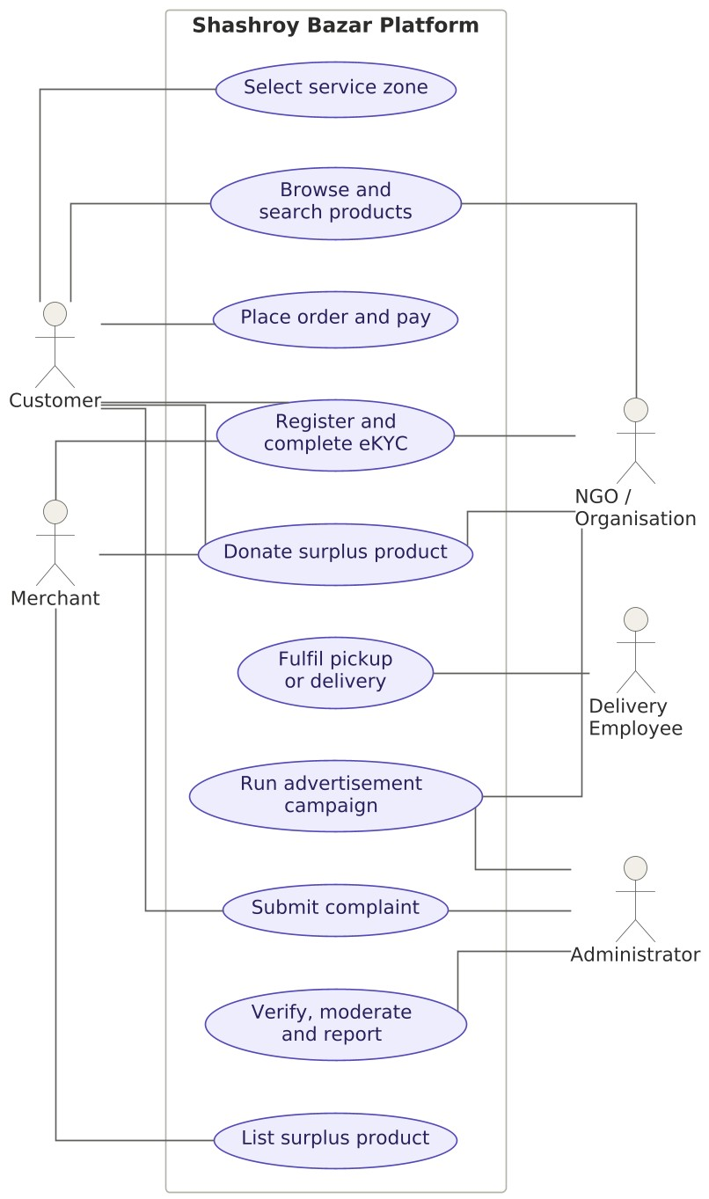
Figure 1 — Use case diagram, Shashroy Bazar platform

Actor summary
Actor | Scope of responsibility | Requirements
Customer | Completes eKYC, selects a zone, browses eligible products, purchases or donates, chooses pickup or delivery, pays, tracks orders and raises complaints. | FR-01 to FR-07,  FR-29 to FR-36,  FR-42, FR-48, FR61
Merchant | Verified business that submits credentials, lists eligible surplus products with expiry evidence, and either sells or donates them. | FR-10 to FR-18,  FR-37, FR-38
NGO / organisation | Verified organisation that may receive donated products, purchase eligible products, and run paid advertising campaigns. | FR-40, FR-55 to FR-60
Delivery employee | Handles assigned delivery orders and updates delivery status through to completion or failure. | FR-44, FR-45, FR47
Administrator | Manages users, verification, merchants, listings, zones, orders, complaints, payments, advertisements, delivery operations and reporting. | FR-08, FR-12, FR-  17, FR-58, FR-62,  FR-64 to FR-70

Use case traceability
Use case | Actors | Requirements
Register and complete eKYC | Customer, merchant, organisation | FR-01 to FR-05, FR-10 to FR-12,  FR-55, FR-56, BR-02
Select service zone | Customer | FR-06, FR-07, BR-01
Browse and search products | Customer, organisation | FR-29, FR-30, FR-31
Place order and pay | Customer | FR-32 to FR-35, FR-42, FR-48 to  FR-54
Donate surplus product | Customer, merchant, organisation | FR-36 to FR-41, BR-09, BR-10
List surplus product | Merchant | FR-13 to FR-18, FR-23 to FR-28, BR-11
Fulfil pickup or delivery | Delivery employee | FR-43 to FR-47, BR-08
Submit complaint | Customer, administrator | FR-61 to FR-63
Run advertisement campaign | Organisation, administrator | FR-57 to FR-60, BR-12
Verify, moderate and report | Administrator | FR-08, FR-64 to FR-70

Class diagram
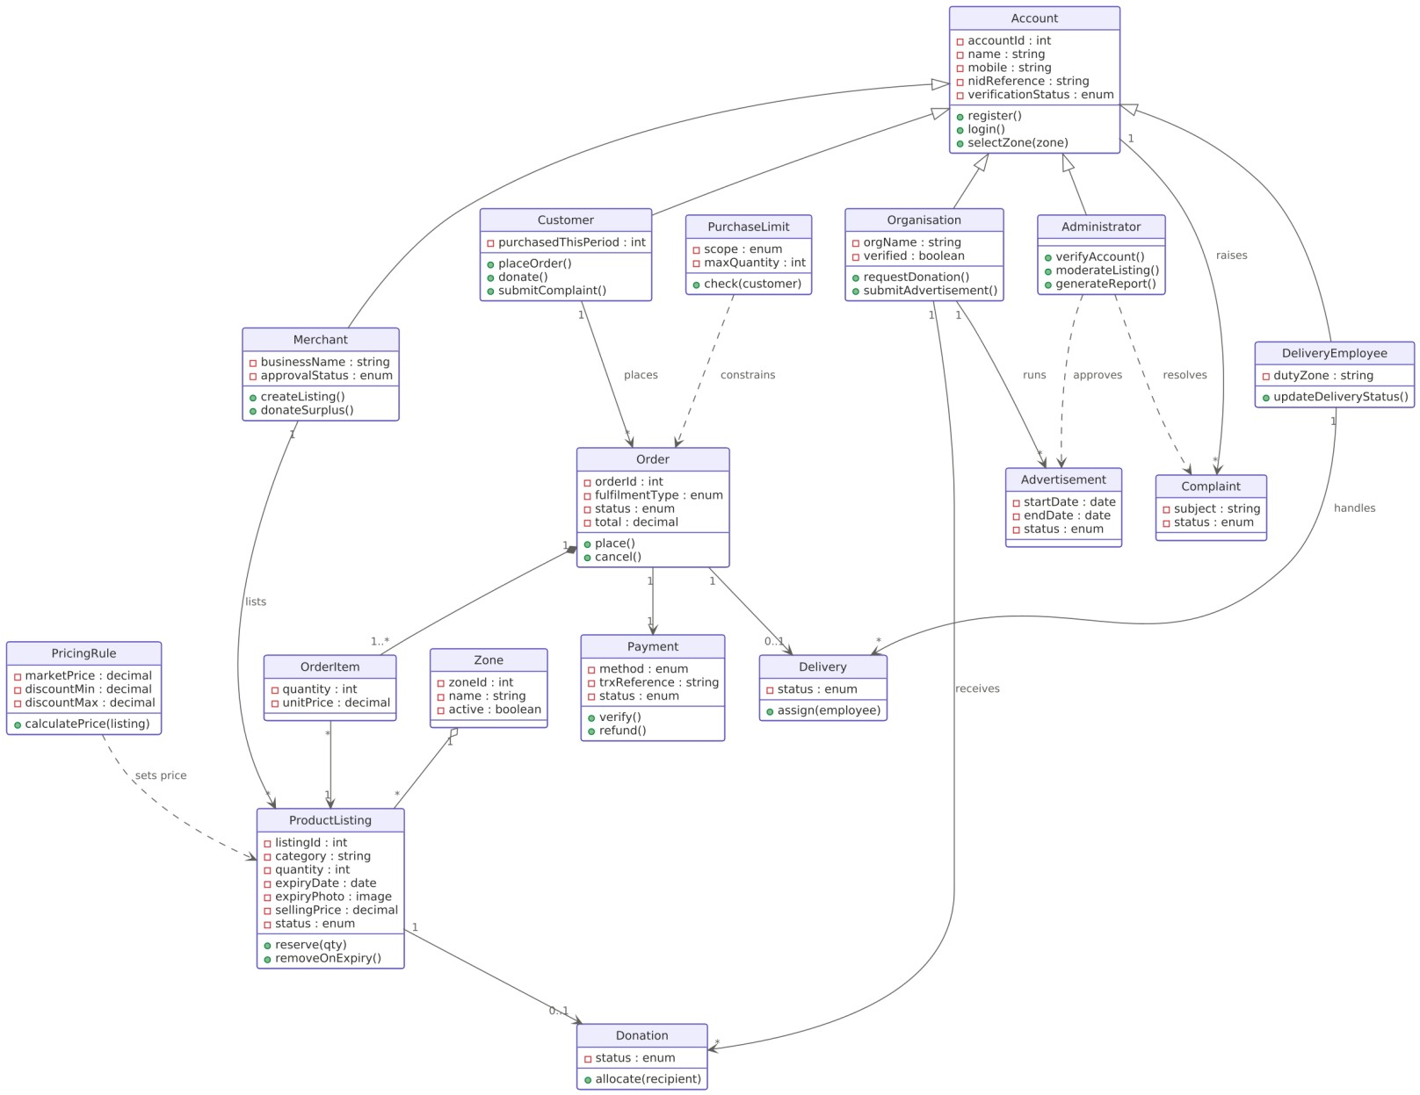
Figure 2 — Domain class diagram
Shashroy Bazar — UML model set — page 4

The domain model separates identity from role, keeps pricing and purchase limits as configurable objects rather than hard-coded attributes, and treats donation as a parallel outcome of a product listing rather than a variant of an order.

Class responsibilities
Class | Responsibility | Requirements
Account | Base identity: name, mobile number, NID reference and verification state shared by all roles. | FR-01 to FR-05
Customer, Merchant,  Organisation,  DeliveryEmployee,  Administrator | Role specialisations of Account, each adding the operations that role is permitted to perform. | SRS section 2
Zone | Service area. Scopes which listings a user can see and which listings a merchant may publish. | FR-06 to FR-09, BR-01
ProductListing | Surplus item with quantity, expiry date, supporting expiry photograph and system-determined selling price. | FR-14 to FR-22, BR-05
PricingRule | Holds the applicable market price and the approved discount band, and computes the customer price. | FR-23 to FR-28, BR-  06, BR-07
PurchaseLimit | Configurable anti-hoarding limit evaluated before an order is accepted. | FR-34, FR-35, BR-03
Order, OrderItem | Customer order and its individual lines, each line pointing at one listing and freezing its unit price. | FR-32, FR-33
Payment | Method, transaction reference, status, retry and refund handling for an order. | FR-48 to FR-54
Delivery | Optional fulfilment record created only for delivery orders, assigned to a delivery employee. | FR-44 to FR-47
Donation | Lifecycle of a donated listing from submission through eligibility check to allocation and collection. | FR-36 to FR-41
Advertisement | Organisation campaign with period, placement, status and payment state. | FR-57 to FR-60
Complaint | Support request raised by any account and worked through to resolution by an administrator. | FR-61 to FR-63

Sequence diagram
This is the purchase and fulfilment path. Two details matter for review. Inventory is reserved before payment is requested, which is what prevents the same stock being allocated to two customers. The alternative fragment shows both outcomes of the payment call, because a failed payment must release the reservation rather than leave it stranded.
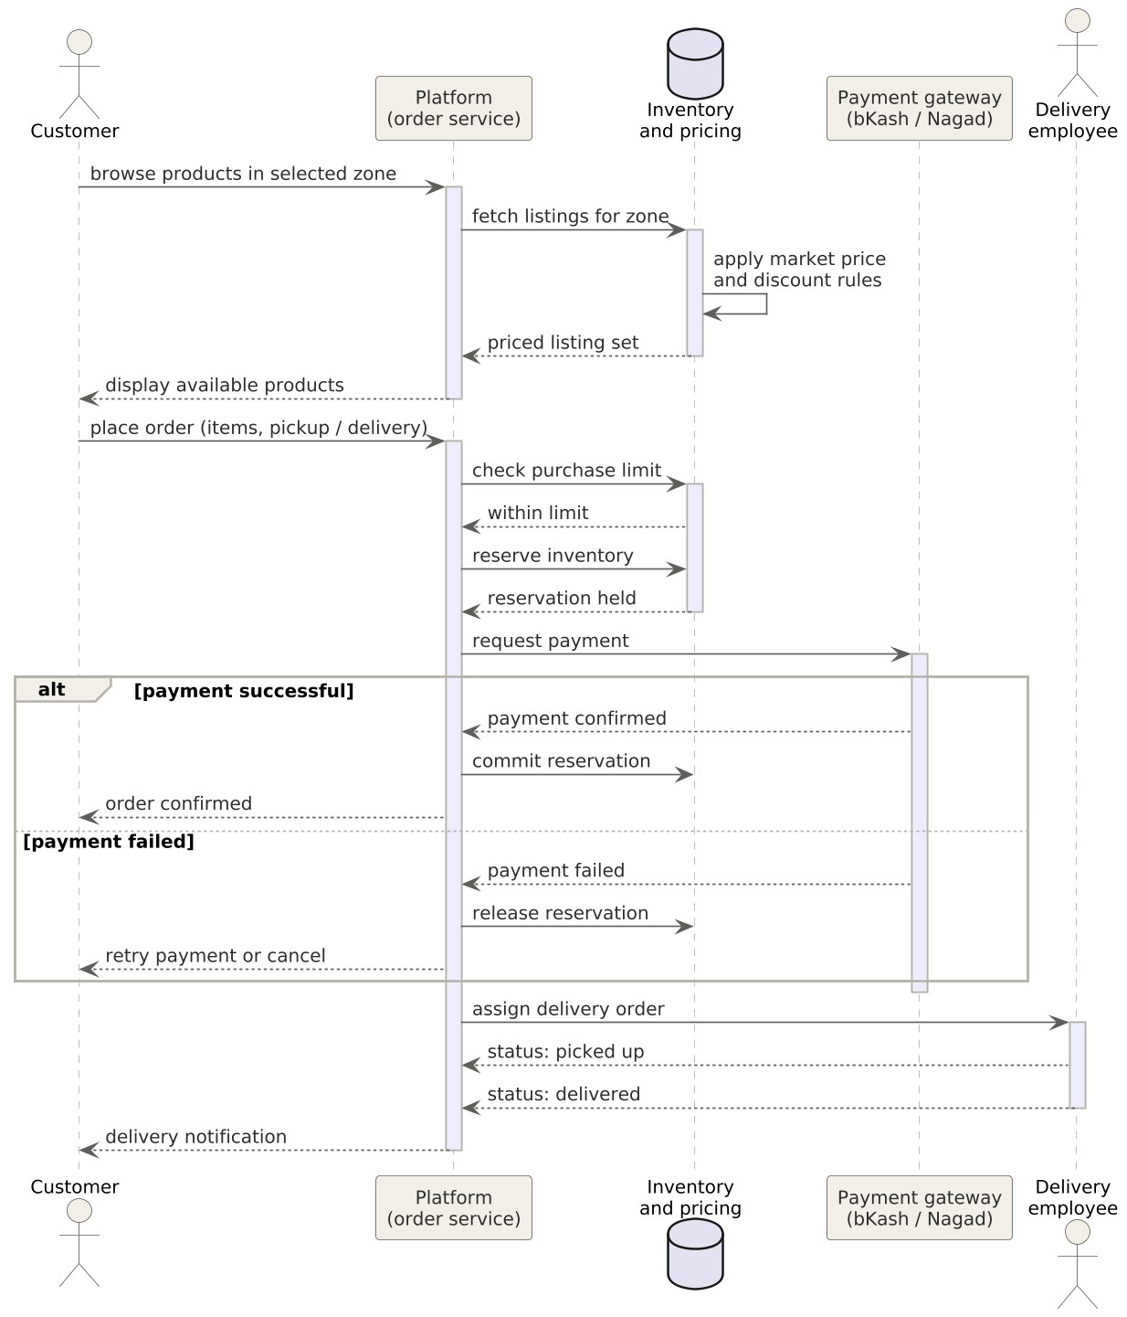
Figure 3 — Sequence diagram, place order through delivery

Step traceability
# | Interaction | Requirements
1 | Customer browses products available in the selected service zone. | FR-06, FR-07, FR-29
2 | Platform retrieves the zone listings; pricing applies the market price and approved discount rules. | FR-09, FR-23 to FR-26
3 | Customer places an order and selects pickup or delivery. | FR-32, FR-42
4 | Platform evaluates the configurable purchase limit for that customer. | FR-34, FR-35
5 | Platform reserves the inventory so it cannot be allocated to another user. | FR-33, NFR-09
6 | Platform requests payment through an approved digital channel. | FR-48, FR-49
7a | On success the reservation is committed, inventory is decremented and the order is confirmed. | FR-18, FR-50, FR-51
7b | On failure the reservation is released and the customer may retry without a duplicate charge. | FR-52
8 | Platform assigns the order to an authorised delivery employee. | FR-44
9 | Delivery employee updates status through picked up, out for delivery and delivered. | FR-45, FR-47
10 | Platform notifies the customer of order and delivery status changes. | FR-71, FR-73

Modelling assumptions
The following are inferences made while modelling. Each needs confirmation before the SRS is frozen at v1.
- Account as a superclass is inferred. The SRS names five actors but does not state whether a merchant or organisation is a user account with additional permissions or a separate entity. This affects the eKYC and duplicate-identity requirements (FR-02, FR-04) directly.
- PricingRule and PurchaseLimit are modelled as first-class objects rather than fields on ProductListing and Customer. FR-25, FR-26 and FR-34 combined with NFR-12 require these values to change without touching unrelated functionality, which embedded constants would not allow.
- The sequence diagram shows inventory and pricing as a logical participant. Section 6 of the SRS deliberately leaves the component and technology breakdown open, so this is a modelling convenience rather than a prescribed service boundary.
- Delivery is optional on Order with multiplicity 0..1, because pickup is an equally valid fulfilment path under FR-42 and creates no delivery record.
- No delivery, service or platform fee appears anywhere in the Order or Payment model. This is deliberate and follows FR-46, FR-54 and BR-08.
- Order carries a status enumeration but the permitted values are not enumerated in the SRS. FR-73 refers to order status changes without defining the state set.

Not covered by these three views
Three areas of the requirements are not adequately expressed by a use case, class or sequence diagram and should be modelled separately.
- Expiry monitoring and the seven-day pre-expiry removal (FR-19 to FR-22, BR-04) is a scheduled background behaviour with no initiating actor. A state machine diagram for ProductListing, covering draft, pending review, active, reserved, expiry-removed and suspended, would express this properly.
- Donation eligibility, allocation and collection (FR-39 to FR-41) involves branching and parallel work across donor, platform and recipient. An activity diagram with partitions would suit this better than the sequence view.
- Administrative reporting (FR-70) spans almost every entity in the class model. It is likely to need its own data or reporting model rather than being derived from the transactional classes shown here.
The open decisions listed as D-01 to D-11 in the SRS may change these models. D-02 on whether a zone can be changed after login, D-03 on the scope of the purchase limit, D-06 on the discount rules and D-08 on the payment commercial model all touch classes shown in figure 2.

