
American International University-Bangladesh (AIUB)
Department of Computer Science
Faculty of Science &Technology (FST)
Summer 25 26
SHASHROY BAZAR
Software Requirement Engineering
Sec: A
Project submitted
By
Israt Jahan Surovy (23-54972-3)
Mishal (24-55979-1)
Siam Hossain (24-56637-1)

Checked By Industry Personnel (Optional)

Name: Md. Shajahan Islam Sani

Designation: Project Manager II

Company: Brain Station 23 PLC.

Sign:

Date:

Table of Contents
Right-click here and choose “Update Field” (or press Ctrl+A then F9) to generate the Table of Contents.

- PROBLEM DOMAIN
  - Background to the Problem
Every day, restaurants, supermarkets, grocery stores, pharmacies, clinics, caterers, and other businesses may have food or medicine that remains unsold even though it is still safe and usable. Food may be close to its best-before or expiry period, while pharmacies and healthcare-related organizations may have sealed and unexpired medicine that is unlikely to be sold within the normal sales period. When there is no proper redistribution mechanism, a significant portion of these products may eventually be discarded.
At the same time, many people, especially low-income individuals and families, struggle to purchase necessary food and healthcare products at regular market prices. NGOs, shelters, and charitable organizations also require affordable or donated products to support vulnerable communities.
Therefore, two problems exist simultaneously: usable products are being wasted while other people are struggling to afford those same types of products.
In Bangladesh, surplus redistribution is often handled through individual donations, NGOs, charitable activities, social-media posts, personal communication, or informal networks. Although these approaches can help people, they may not provide a centralized and structured system for verifying donors and merchants, checking product safety and expiry information, finding nearby products, controlling purchases, processing payments, tracking orders, or measuring the overall social impact.
Root Causes of the Problem:
The major root causes identified for this problem are:
- Lack of an organized redistribution platform: There is no single structured system through which different types of verified businesses can conveniently list their usable surplus products for sale or donation.
- Poor communication between surplus providers and people in need: A business may have surplus products, while people or organizations nearby may need them, but there is no efficient way for them to find each other.
- Dependence on informal channels: Donations and redistribution are frequently arranged through personal contacts or social-media groups, which makes the process difficult to manage and monitor.
- Limited verification and safety control: Informal redistribution methods may not provide proper verification of sellers, donors, products, expiry dates, or recipients.
- Lack of geographical coordination: A product may be available in one area, but potential recipients may not know that the product is available nearby.
- Fear of hoarding or misuse: Extremely discounted or donated products may be purchased in large quantities by a small number of users unless proper quantity restrictions are applied.
- Limited impact tracking: Traditional donation processes often make it difficult to measure how many products have been saved from waste, how many people have benefited, and how much social impact has been created.
  - Solution to the Problem
Shashroy Bazar (সাশ্রয় বাজার) is proposed as a zone-based surplus food and medicine marketplace and redistribution platform that connects verified sellers of near-expiry, safe-to-consume surplus stock with two groups of buyers: price-conscious customers who purchase the surplus at a steep, system-controlled discount, and NGOs, shelters and low-income households who receive eligible surplus as verified donations. Every user and merchant completes mobile-OTP and eKYC identity verification before they can transact, and every listing carries a mandatory expiry-date photograph, so that both sides of a transaction can trust who they are dealing with and what condition the product is in — the two guarantees that informal donation and clearance channels (word-of-mouth networks, unmoderated social media groups, ad hoc merchant clearance sales) cannot currently offer.
The solution is deliberately scoped to be zone-based rather than city-wide: a customer only sees listings available within their own selected zone, which keeps pickup and delivery practical (no delivery fee is charged to the customer) and lets the platform launch and prove itself in a single pilot area before expanding. Pricing is not left to individual merchants — the system benchmarks every discounted listing against a market-price reference and enforces a configured discount band, so the core promise of a trustworthy discount is a platform guarantee rather than a merchant's marketing claim. To prevent the platform from being emptied by bulk buyers rather than the households it is meant to serve, purchase quantities are capped and monitored per user.
This solution is feasible within the constraints of a small, 7-person, 8-month build (see Section 4, Development Plan) because it is built largely on integration rather than invention: identity verification, OTP/SMS, and payment (bKash/Nagad) are provided by established third-party services behind a swappable interface, and engineering effort is concentrated on what is genuinely specific to this problem — the expiry-aware listing and pricing rules, the zone-scoped catalog, and the donation-allocation workflow. Revenue comes from advertising by verified NGOs and organizations rather than a customer-facing service fee, keeping the "save money or give safely" promise to customers and donors intact.
Existing efforts in this space are largely informal: individual restaurants posting last-minute discounts on social media, NGO donation drives coordinated by phone and word of mouth, and general-purpose marketplace or classifieds apps that carry no notion of expiry, no identity verification, and no donation-specific workflow at all. None of these existing channels combine verified identity, an expiry-aware listing model, system-enforced discount pricing, and a first-class donation path in one product — which is the specific gap Shashroy Bazar is designed to fill.

- SOLUTION DESCRIPTION

  - System Features
The full functional specification lives in the project's Software Requirements Specification (SRS v1.0, FR-01–FR-73). The features below condense that specification into the fourteen functional areas it defines; each area cites its FR range for traceability back to the full SRS.
Registration, Authentication and eKYC (FR-01–FR-05)
- Users register and verify their identity via mobile OTP and eKYC (NID-based document verification), including duplicate-identity checks and manual review where needed.
- Verification status is tracked and shown to the applicant throughout the review process.
- Secure login and session authentication is required for every verified account.
Zone-Based Access (FR-06–FR-09)
- Users select a home zone during onboarding and see only products available within that zone.
- Administrators manage zone definitions and boundaries.
- Every product listing is explicitly tied to the zone it is sold in.
Merchant Registration and Verification (FR-10–FR-13)
- Merchants register and submit business credentials for verification.
- Administrators approve or reject merchant applications.
- Approved merchants receive scoped access to listing and inventory tools.
Product Listing and Inventory (FR-14–FR-18)
- Merchants list surplus products with a mandatory expiry-date photograph and expiry metadata.
- Every listing goes through a review step before it becomes visible to customers.
- Inventory quantities are tracked per listing as stock is sold or reserved.
Expiry Management (FR-19–FR-22)
- The system continuously monitors listings for approaching expiry.
- Listings are automatically removed a configured number of days before expiry, with the removal logged.
- Merchants are notified as their listings approach expiry.
Pricing and Discount Management (FR-23–FR-28)
- Prices are benchmarked against a market-price reference and discounted within a system-controlled range — merchants cannot set arbitrary prices.
- Merchants can bundle multiple surplus items into "food bundles" with bundle-level pricing.
Product Discovery and Purchase (FR-29–FR-35)
- Customers browse, search and filter listings within their zone and view full product details.
- Adding an item to cart places a short-lived inventory reservation to prevent overselling.
- Per-user purchase limits are enforced and monitored to discourage hoarding.
Donation (FR-36–FR-41)
- Both individual users and merchants can donate eligible products instead of selling them.
- Donated items are checked against eligibility rules before acceptance.
- Eligible donations are allocated to verified NGOs or recipients, with full custody tracking end to end.
Pickup and Delivery (FR-42–FR-47)
- Customers choose pickup or delivery at checkout, with pickup location and time details shown.
- Delivery orders are assigned to a delivery employee and tracked through to completion, with no separate delivery fee charged to the customer.
Payment (FR-48–FR-54)
- Customers pay digitally through supported methods (e.g. bKash/Nagad), with payment confirmed and recorded as a transaction.
- Failed payments and refunds are handled explicitly, and customers are never charged beyond the product/order price.
Advertising and Revenue (FR-55–FR-60)
- NGOs and organizations register and are verified before they can advertise on the platform.
- Verified advertisers submit campaigns for administrator approval and manage them within an approved window.
- Advertising activity is recorded as the platform's primary revenue stream.
Complaints and Customer Support (FR-61–FR-63)
- Users can submit complaints about orders, listings, or service issues.
- Administrators triage and manage complaints through to resolution, with status visible to the user who raised it.
Administration and Monitoring (FR-64–FR-70)
- Administrators manage users, merchants, and product moderation from a central console.
- Payment activity and payment-gateway health are monitored.
- Delivery operations are managed and reporting is available across the platform.
Notifications (FR-71–FR-73)
- Users receive notifications for account, order, and expiry-related events.

Non-Functional Requirements (Quality Attributes)
The system's quality attributes, as defined in SRS Section 7 (NFR-01–NFR-20):
- Usability (NFR-01): The system shall provide a simple and understandable interface suitable for first-time users and users with limited technical expertise.
- Bangla Language Support (NFR-02): The system shall provide Bangla support for core customer-facing functions, with English available where approved.
- Performance (NFR-03): The system should return normal product browsing, search, and order-status requests within an acceptable response time under expected operating conditions.
- Availability (NFR-04): The platform should remain available during defined service periods with minimal unplanned interruption.
- Security (NFR-05): The system shall protect authentication credentials and restrict functions and data access according to user roles and authorization rules.
- eKYC Data Protection (NFR-06): NID and other identity-verification information shall be protected from unauthorized access and handled only for approved verification purposes.
- Privacy (NFR-07): The system shall protect personally identifiable information and limit access to authorized personnel and processes.
- Data Integrity (NFR-08): The system shall maintain accurate and consistent records for inventory, orders, payments, donations, user verification, and product expiry.
- Transaction Consistency (NFR-09): The system shall prevent the same inventory from being successfully allocated to multiple customers or recipients.
- Reliability (NFR-10): The system shall preserve transaction and order state accurately in the event of recoverable failures.
- Scalability (NFR-11): The system should support growth in users, merchants, zones, listings, orders, and transactions without requiring fundamental redesign.
- Maintainability (NFR-12): The system should allow approved business rules such as purchase limits, expiry thresholds, discount ranges, and zone configurations to be changed without extensive changes to unrelated functions.
- Auditability (NFR-13): The system shall maintain appropriate records of important administrative actions, verification decisions, listing changes, expiry removals, payment events, and complaint resolution actions.
- Interoperability (NFR-14): The system should support integration with approved payment providers and other external services required by the business, subject to provider capabilities and agreements.
- Payment Security (NFR-15): Payment information and transaction processing shall follow applicable payment-provider security requirements and shall avoid storing sensitive payment credentials unless explicitly required and permitted.
- Accessibility (NFR-16): Core user functions should be accessible through clear labels, readable content, and usable navigation on supported devices.
- Mobile Responsiveness (NFR-17): The customer-facing platform should provide a usable experience on common smartphones and desktop/laptop devices.
- Backup and Recovery (NFR-18): The system shall maintain appropriate backup and recovery mechanisms for critical business data.
- Monitoring (NFR-19): The platform shall provide mechanisms for authorized administrators to monitor important operational events and system/service issues.
- Compliance (NFR-20): The platform shall operate subject to applicable Bangladesh laws, regulations, payment-provider requirements, privacy obligations, and approved rules governing food and medicine handling.

  - UML Diagrams
- Use Case Diagram
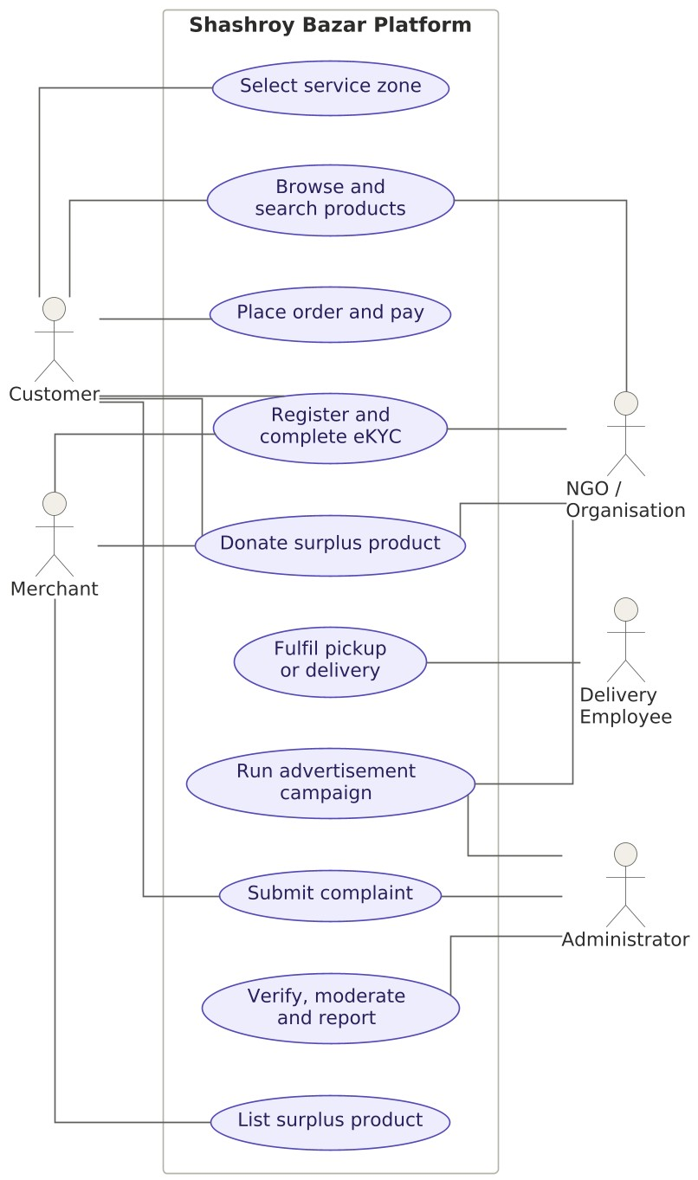
Figure 1 — Use case diagram, Shashroy Bazar
- Class Diagram
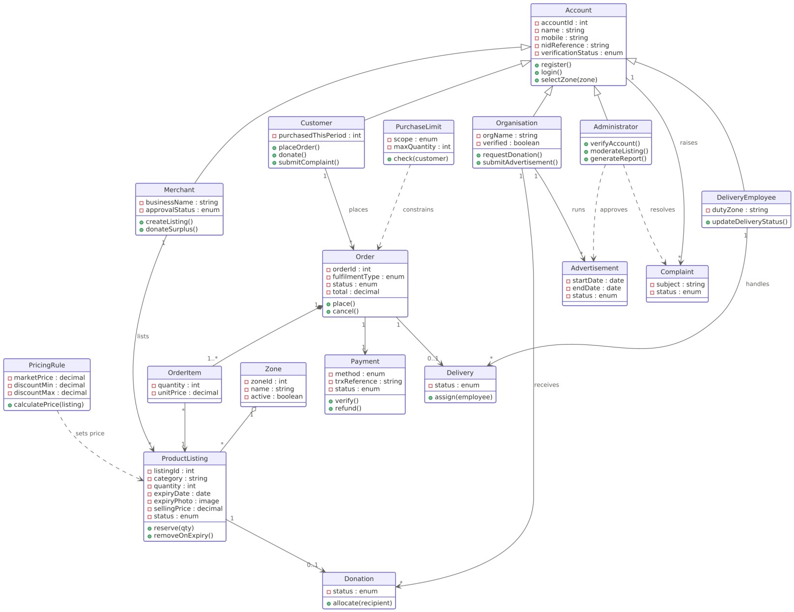
Figure 2 — Class diagram, Shashroy Bazar
- Sequence Diagram
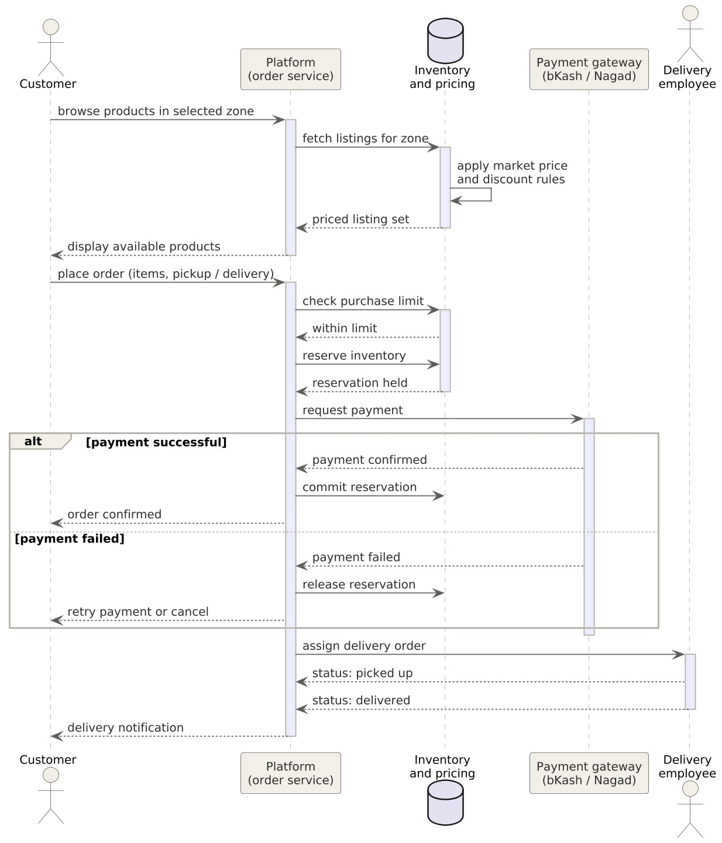

Figure 3 — Sequence diagram, place order through delivery

- Social Impact
Shashroy Bazar's social impact centers on turning food and medicine that would otherwise be discarded into a verified resource for people who need it. By giving merchants a legitimate, trackable channel to donate near-expiry stock — recorded end-to-end from a merchant's donation listing through eligibility screening to allocation and confirmed receipt by a verified NGO or recipient — the platform gives businesses a reason to donate rather than simply discard surplus, and gives NGOs and shelters a more predictable, verifiable supply of donated goods than the informal, word-of-mouth channels they currently rely on.
For price-conscious households, students and low-income communities — including underprivileged groups such as slum residents named explicitly in the platform's problem statement — the discounted marketplace side of the platform provides a second, complementary benefit: legitimate access to safe, still-usable food and medicine at a steep, system-verified discount, rather than at whatever price an informal reseller chooses to charge.
Because every donation and every discounted sale is logged against a verified identity and a specific listing, the platform can measure its own social impact directly — units of food and medicine redirected from waste, weight of surplus redistributed, and number of beneficiaries served — rather than relying on the anecdotal estimates that informal donation drives are limited to today. That measurement is what lets the platform demonstrate, to NGOs, to investors and to the community it serves, that the model is actually reducing waste and reaching the people it is meant to reach, and where it needs to improve zone by zone as it expands beyond the pilot area.

- Development Plan with Project Schedule
2.1 Development Methodology
Given the team size (5–8 people), evolving business rules (pricing, discount bands, purchase limits — see SRS Section 8), and the need to show working increments to stakeholders and prospective investors, an Agile/Scrum approach with two-week sprints is recommended over a strict Waterfall model. Each SDLC phase below is still performed in full, but requirements, design, and testing are revisited each sprint rather than completed once at the start.
- Sprint length: 2 weeks (≈16–17 sprints across an 8-month build).
- A thin vertical slice (registration → one purchase flow) is targeted by Sprint 4 to de-risk integrations (OTP, eKYC, payment) early.
- A releasable MVP (core FRs from SRS Sections 6.1–6.10) is targeted by the end of Month 7, leaving Month 8 for hardening, security review, and launch preparation.
2.2 SDLC Phases and Activities
SDLC Phase | Key Activities | Primary Deliverables | Duration
Requirements | Refine SRS v1.0 into sprint-ready user stories; resolve D-01–D-11 decisions with the PM/stakeholders; prioritize backlog | Product backlog, resolved decision log, acceptance criteria per story | Weeks 1–3 (overlaps with Design)
Design | System architecture, data model, API contracts, UI/UX wireframes and prototypes, third-party integration design (OTP, eKYC/NID, payment gateways, notifications) | Architecture document, ER diagram, API spec, clickable prototype | Weeks 2–5
Implementation | Sprint-based development of registration/eKYC, zones, merchant/listing, pricing engine, discovery/purchase, donation, delivery, payment, advertising, complaints, admin, notifications | Working, demoable increments each sprint; code merged to main branch with CI checks passing | Weeks 4–28 (Months 2–7)
Testing | Unit and integration testing each sprint; end-to-end QA pass per module against SRS acceptance criteria; UAT with a pilot merchant/NGO group; security and payment-flow testing | Test cases mapped to SRS acceptance criteria, defect log, UAT sign-off | Continuous from Week 6; dedicated QA hardening in Month 8
Deployment | Staging environment rollout, production environment setup, phased launch in one pilot zone, app store submission | Deployed staging build, production runbook, pilot-zone go-live | Month 8
Maintenance | Bug fixes, monitoring, incremental feature rollout by zone, quarterly business-rule tuning (discount bands, purchase limits, expiry threshold) | Release notes, monitoring dashboards, quarterly review reports | Month 9 onward (ongoing)

2.3 Project Team Structure
Role | Count | Primary Responsibility
Project Manager / Product Owner | 1 | Backlog ownership, stakeholder/PM liaison, sprint planning, scope and decision tracking (D-01–D-11)
Backend Developer | 2 | Core services: registration/eKYC, pricing engine, inventory, payment and donation logic, admin/reporting APIs
Frontend / Mobile Developer | 2 | Customer, merchant, and admin-facing interfaces; zone-based browsing and checkout flows
QA Engineer | 1 | Test-case design against SRS acceptance criteria, regression and UAT coordination, defect management
UI/UX Designer (part-time) | 1 (50%) | Wireframes, prototypes, Bangla/English UI content, accessibility review (NFR-16)

2.4 Illustrative Technology Stack
Consistent with the SRS's approach of not prescribing technology, the stack below is illustrative for planning and costing purposes only and remains subject to the development team's feasibility review.
- Backend: a mainstream web framework with REST APIs (e.g., Node.js/Express or Django) and a relational database for transactional integrity (NFR-08, NFR-09).
- Frontend/Mobile: a cross-platform mobile framework (e.g., Flutter or React Native) to cover both smartphone users economically, plus a lightweight admin web console.
- Integrations: SMS/OTP gateway, an approved eKYC/NID verification provider, bKash/Nagad/bank-transfer payment gateways, and a push/SMS notification service.
- Infrastructure: cloud hosting with managed database and backups, in line with NFR-04, NFR-11, and NFR-18.
2.5 Project Schedule (8-Month Plan to MVP Launch)
The table below shows each phase's active months (M1–M8). A shaded cell indicates the phase is active in that month.
Phase | M1 | M2 | M3 | M4 | M5 | M6 | M7 | M8
Requirements | ■
Design | ■ | ■
Implementation |  | ■ | ■ | ■ | ■ | ■ | ■
Testing / QA |  |  | ■ | ■ | ■ | ■ | ■ | ■
Deployment / Launch Prep |  |  |  |  |  |  | ■ | ■
Pilot-Zone Go-Live |  |  |  |  |  |  |  | ■

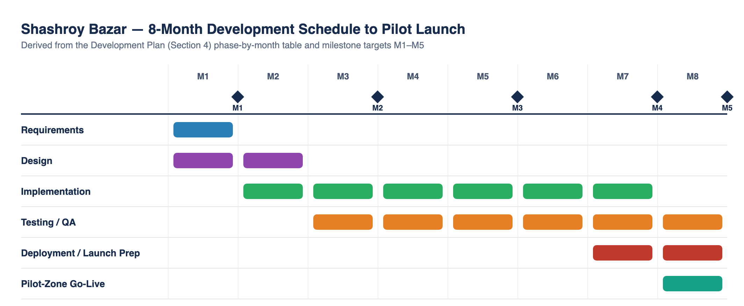
Figure 5 — Gantt chart of the 8-month development schedule, derived from the phase-by-month table above and the M1–M5 milestone targets.
Milestones
Milestone | Target | Exit Criteria
M1 — Backlog & Architecture Baseline | End of Month 1 | Prioritized backlog; architecture and API contracts approved by PM
M2 — Registration/eKYC + Zones Working | End of Month 3 | A user can register, verify via eKYC, and browse zone-filtered listings in staging
M3 — End-to-End Purchase Flow | End of Month 5 | A user can browse, buy at a system-calculated price, pay, and select pickup/delivery
M4 — Donation, Advertising, Admin Complete | End of Month 7 (MVP feature-complete) | All FR-01–FR-73 modules demoable; UAT begins
M5 — Pilot Launch | End of Month 8 | Security review passed; pilot zone live with real merchants and at least one NGO

2.6 Risk Management
Risk | Likelihood | Impact | Mitigation
eKYC/NID verification provider integration delays | Medium | High | Select provider and begin integration in Month 1; keep manual-review fallback (FR-02–FR-04) as a temporary path
Payment gateway (bKash/Nagad) commercial approval takes longer than planned (D-08) | Medium | High | Start commercial discussions in parallel with development; design payment module against an abstraction layer so a provider swap doesn't block launch
Small team stretched across many modules | Medium | Medium | Strict sprint scoping to MVP-critical FRs; defer FR-59/FR-60 advanced ad-analytics and non-critical admin reports to post-MVP
Merchant/NGO adoption slower than expected in pilot zone | Medium | Medium | Recruit pilot merchants and at least one NGO before go-live (see Marketing Plan, Section 3.3)
Discount/pricing rule (D-06) unresolved by build time | Low | High | Build the pricing engine as configurable (NFR-12) so the exact 70–80% band can be tuned without a code change

Project Schedule on Trello
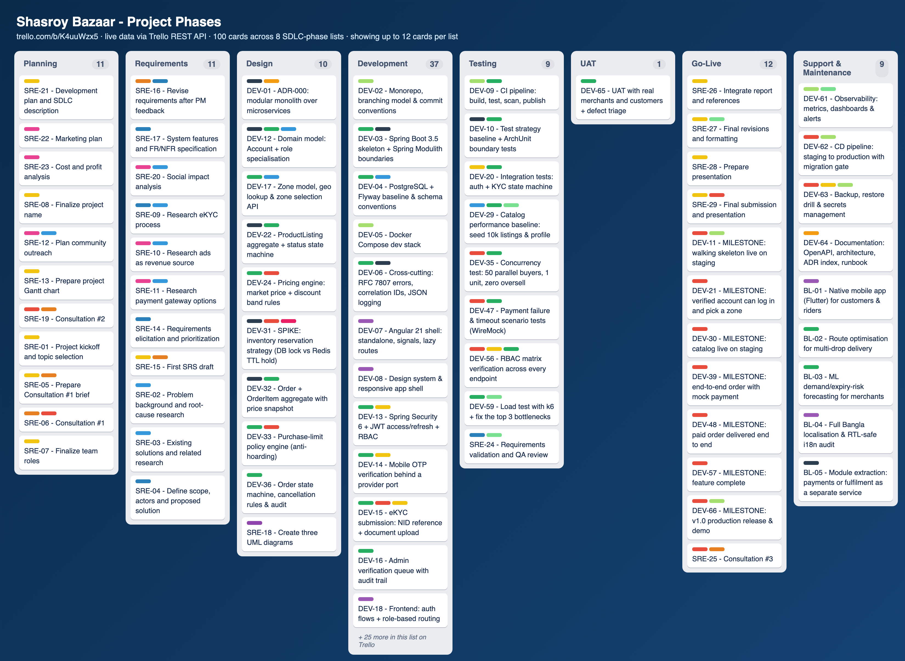
Figure 4 — Project schedule tracked on Trello (“Shasroy Bazaar - Project Phases” board, trello.com/b/K4uuWzx5, 8 SDLC-phase lists, 100 cards), rendered directly from live Trello REST API data as the project's project-management tool for scheduling (per the course requirement not to build the schedule in Word/Excel).

- Marketing Plan
Shashroy Bazar's marketing plan must build trust in a new category of transaction (discounted surplus food/medicine and donation) while growing three distinct audiences at once: paying customers, verified merchants, and verified NGOs/organizations (the platform's primary revenue source through advertising).
3.1 Target Market Segments
Segment | Description | Primary Motivation
Price-conscious households and students | Urban residents in the pilot zone looking for steep discounts on safe surplus food/medicine | Save money (70–80% below market price)
Merchants (restaurants, groceries, pharmacies, clinics, caterers) | Businesses with recurring unsold or near-expiry stock | Recover some value from stock that would otherwise be discarded; positive brand association
NGOs, shelters, and low-income/underprivileged communities | Organizations and individuals who need donated food/medicine | Reliable, verified access to donations
Verified NGOs/organizations as advertisers | Organizations wanting visibility for their own campaigns or causes | Reach an engaged, values-aligned user base (this segment funds the platform)

3.2 Positioning and Value Proposition
Position Shashroy Bazar as “the verified, zone-based way to save money and reduce waste — or to give safely.” The tagline (“সাশ্রয়ী দামে, অপচয় কোই” — roughly, “at a saving price, without waste”) should anchor all messaging around three pillars: verified trust (eKYC, merchant verification), real savings (70–80% off), and measurable social impact (donation tracking and impact metrics per FR-70).
3.3 Short-Term Marketing Plan (Pre-Launch and Launch, Months 6–9)
Runs alongside the Development Plan's testing/deployment phases (Section 2.5), so the platform has both users and supply on day one.
- Pre-launch waitlist and teaser campaign on Facebook and Instagram (dominant platforms for this audience in Bangladesh), building an email/SMS waitlist ahead of the pilot-zone go-live.
- Recruit 15–20 pilot merchants (restaurants, groceries, pharmacies) in the pilot zone directly, offering the first 1–2 months of listing free of any future merchant-facing charges.
- Onboard at least 2–3 verified NGOs in the pilot zone before launch so the donation flow (SRS Section 6.8) has real recipients from day one.
- University and neighborhood “ambassador” program: student or community volunteers who demo the app in exchange for a small referral incentive.
- Local micro-influencer and community-group outreach (Facebook groups, local WhatsApp/Telegram community channels) rather than expensive celebrity endorsements.
- A modest launch event or press outreach in the pilot zone timed to the SRS Section 2.5 M5 milestone, emphasizing the waste-reduction and donation story for media appeal.
- App Store Optimization (ASO): Bangla + English store listing, screenshots emphasizing savings and verified donation impact.
3.4 Long-Term Marketing Plan (6–24 Months Post-Launch)
- Zone-by-zone expansion marketing: replicate the pilot-zone merchant/NGO recruitment playbook in each new service zone as it goes live (paired with SRS FR-08 zone management).
- Formal partnerships with national NGO networks and pharmacy/supermarket chains to onboard merchants at scale rather than one at a time.
- Corporate/CSR partnerships: position advertising packages (SRS Section 6.11) to corporates seeking CSR visibility tied to a concrete, measurable food-waste and donation impact story.
- Referral and loyalty programs once usage data exists: reward both customers and merchants for platform growth and consistent participation.
- Explore co-marketing with mobile financial service providers (bKash/Nagad) once a payment partnership is finalized (D-08), given their large existing user bases.
- Annual “Impact Report” publication (meals saved, donations delivered, waste diverted) as a PR and investor-facing marketing asset, drawing on the reporting module (FR-70).
3.5 Continuous / Ongoing Marketing Activities
- Always-on social media calendar: savings highlights, donation success stories, merchant spotlights, and NGO features (2–4 posts/week).
- Push/SMS notifications for time-sensitive listings and personalized re-engagement, built on the existing Notifications module (SRS Section 6.14).
- Ongoing customer support and review monitoring, feeding directly into the Complaints module (Section 6.12) so service issues are resolved quickly and visibly.
- Search engine and app-store optimization maintained on a rolling basis as keywords and competition evolve.
- Quarterly data-driven review of acquisition channels (which channel brings the most verified, active users per Taka spent) to reallocate the continuous marketing budget.
3.6 Marketing Channels Summary
Channel | Primary Use | Phase
Facebook / Instagram ads and organic content | Awareness, waitlist building, ongoing engagement | Short-term + Continuous
Community ambassadors / word-of-mouth | Trust-building in a new pilot zone | Short-term, repeated per new zone (Long-term)
Direct merchant/NGO outreach and partnerships | Supply-side and donation-recipient onboarding | Short-term + Long-term
App Store / Play Store optimization | Discoverability, conversion from search | Short-term + Continuous
Push/SMS notifications | Retention and time-sensitive conversion | Continuous
PR / local media / annual impact report | Credibility, investor and NGO-partner visibility | Short-term (launch) + Long-term (annual)
Referral and loyalty programs | Retention and low-cost acquisition | Long-term + Continuous

3.7 Marketing KPIs
KPI | Purpose
Verified user sign-ups per month, by zone | Tracks demand-side growth against the zone rollout plan
Verified merchants and NGOs onboarded per zone | Tracks supply-side and donation-recipient growth
Cost per verified, transacting user (by channel) | Guides reallocation of the continuous marketing budget
Repeat purchase/donation rate | Measures retention beyond first use
Advertising campaigns sold and renewed | Directly tracks the platform's primary revenue driver
Donations completed vs. donations submitted | Marketing- and trust-relevant proxy for platform credibility

- Cost and Profit Analysis
4.1 Assumptions and Basis of Estimates
All figures below are planning-stage estimates in BDT, built for a 5–8 person team over an 8-month build (Section 2.5) followed by a pilot-zone launch. They are illustrative — based on typical Bangladeshi early-stage tech-team costs and comparable platform benchmarks — and are not a substitute for a formal costing exercise once the decisions in SRS Section 8 (D-01–D-11) are finalized. Figures should be validated with an accountant or financial advisor before being used in an actual investor pitch or legal fundraising document.
4.2 Development (Labor) Cost Breakdown
Role | Count | Monthly Cost (BDT) | Cost over 8 Months (BDT)
Project Manager / Product Owner | 1 | 80,000 | 640,000
Backend Developer | 2 | 55,000 each (110,000) | 880,000
Frontend / Mobile Developer | 2 | 50,000 each (100,000) | 800,000
QA Engineer | 1 | 40,000 | 320,000
UI/UX Designer (50%) | 1 | 25,000 | 200,000
Subtotal | 7 | 355,000 / month | 2,840,000

4.3 One-Time Setup Costs
Item | Estimated Cost (BDT)
Company registration and legal setup | 50,000
Branding and logo/UI design assets | 30,000
Google Play Store registration (one-time) | 2,750
Apple App Store registration (annual) | 10,900
eKYC/NID and payment-gateway integration setup fees | 100,000
Pre-launch security review / penetration test | 150,000
Total one-time setup costs | 343,650

4.4 Infrastructure and Operational Costs
Item | Monthly Cost — Build Phase (BDT) | Monthly Cost — Post-Launch (BDT)
Cloud hosting and managed database | 10,000 | 20,000
SMS/OTP gateway | 5,000 | 12,000
eKYC/NID verification API (per-verification, estimated volume) | 5,000 | 15,000
Domain, SSL, third-party dev tools, misc. | 5,000 | 5,000
Payment gateway fees (treated as a platform cost per BR-13) | 0 (pre-revenue) | 8,000 (estimated at pilot volume)
Subtotal | 25,000 / month | 60,000 / month

Build-phase infrastructure cost over 8 months: 25,000 × 8 = 200,000 BDT.

4.5 Marketing Cost Breakdown
Marketing Phase | Components | Estimated Cost (BDT)
Short-term (pre-launch + launch, ~3 months, Section 3.3) | Social ads (50,000/mo), ambassador incentives (30,000/mo), launch event, PR, ASO | 395,000 total
Continuous (post-launch, per month, Section 3.5) | Social media management, partnerships, content, referral incentives, scaling paid ads | 120,000 / month

Illustrative Year-1 marketing total (3 months short-term + 3 months continuous after launch): 395,000 + (120,000 × 3) = 755,000 BDT.

4.6 Total Year 1 Cost Summary
Cost Category | Estimated Year 1 Total (BDT)
Development labor (8-month build) | 2,840,000
One-time setup costs | 343,650
Infrastructure — build phase (8 months) | 200,000
Infrastructure/operations — post-launch (4 months) | 240,000
Post-launch maintenance labor (reduced team, 4 months, est. 200,000/mo) | 800,000
Marketing (short-term + partial continuous) | 755,000
Total estimated Year 1 cost | 5,178,650

4.7 Revenue Model and Year 1 Revenue Projection
Per BR-08/BR-13, customers pay only the product price with no added platform fee, so the primary revenue stream is advertising sold to verified NGOs/organizations (SRS Section 6.11), pending the package/pricing decision at D-10. The projection below is illustrative and assumes a slow post-launch ramp as advertisers are onboarded.
Post-Launch Month | Active Advertisers | Avg. Package (BDT/mo) | Monthly Ad Revenue (BDT)
Month 1 (Month 9 overall) | 5 | 5,000 | 25,000
Month 2 (Month 10 overall) | 8 | 5,500 | 44,000
Month 3 (Month 11 overall) | 13 | 5,500 | 71,500
Month 4 (Month 12 overall) | 18 | 6,000 | 108,000
Year 1 total advertising revenue (4 months post-launch) |  |  | 248,500

4.8 Year 1 Profit & Loss Summary
Item | Estimated Amount (BDT)
Total Year 1 revenue (advertising, 4 post-launch months) | 248,500
Total Year 1 cost (Section 4.6) | 5,178,650
Year 1 net result | (4,930,150) — net loss, expected for a pre-profitability Year 1

A Year 1 net loss is normal for a two-sided marketplace still building both its user base and its advertiser base; the figure is presented here specifically so investors can size the funding gap it implies.

4.9 Break-Even Analysis
At the post-launch run rate in Section 4.4 and 4.5 (infrastructure ~60,000/month + a lean post-MVP team + a reduced ongoing marketing spend, roughly 250,000–300,000 BDT/month in steady state), and assuming advertising revenue continues to grow at a similar pace to Month 9–12 (Section 4.7), advertising revenue would need to reach approximately 275,000 BDT/month to cover steady-state operating cost. At the illustrated growth curve (~25,000 to ~30,000 BDT/month of net new advertiser revenue added per month), break-even is estimated in the range of Month 18–24 from initial launch (i.e., roughly 10–16 months after the Month 9 launch point) — a range, not a committed figure, pending real advertiser conversion data.
4.10 Funding Ask and Use of Funds
To carry the project from the current SRS v1.0 stage through Year 1 operations and reach the break-even runway above, an illustrative seed ask is:
Use of Funds | Amount (BDT) | % of Ask
Development labor (8-month build) | 2,840,000 | 44%
One-time setup costs | 343,650 | 5%
Infrastructure (build + Year 1 post-launch) | 440,000 | 7%
Post-launch maintenance labor (Year 1 remainder) | 800,000 | 13%
Marketing (Year 1) | 755,000 | 12%
Contingency buffer (~15%) | 770,000 | 12%
Wind-down/runway extension into Year 2 (partial) | 450,000 | 7%
Total illustrative seed ask | ~6,400,000 BDT (~64 lakh BDT) | 100%

4.11 Caveats and Disclaimer
- These estimates are planning-stage projections prepared to support internal decision-making and an initial investor conversation. They are not audited financial statements and should not be treated as a guarantee of future results.
- Several inputs remain open per SRS Section 8 (advertising pricing D-10, payment-provider commercial terms D-08, purchase-limit and discount-band decisions D-03/D-06), and each will materially affect real costs and revenue once finalized.
- Before presenting these figures to investors or using them for legal/fundraising purposes, they should be reviewed and validated by a qualified accountant or financial advisor familiar with Bangladeshi market conditions.

- Reference
TODO (team to complete before submission): add the specific external sources actually consulted during this project — competitor research, published statistics on food/medicine waste in Bangladesh, or any academic/industry articles referenced above — as a numbered reference list in your course's required citation style.
The following internal project artifacts and named platforms/standards are already referenced throughout this report and are listed here for completeness (not a substitute for the external sources above):
- AIUB Software Requirement Engineering course template and project brief (Summer 25-26)
- Shashroy Bazar Software Requirements Specification, Version 1.0
- Shashroy Bazar UML Models companion document
- Shashroy Bazar Development, Marketing & Cost Plan, Version 1.0
- Trello and the Trello REST API (api.trello.com) — used as the project's project-management tool for scheduling and tracking (see Development Plan, Section 4)
- bKash and Nagad mobile financial services (referenced as candidate payment integrations)
- National ID (NID) verification / eKYC — referenced as the platform's identity-verification approach

