**Analysis**

* Linear Regression Analysis for Predicting Bankruptcy

 Linear regression is a type of prediction analysis. Regression is used to predict if a set of variables do a decent job of predicting outcome and which variables are significant enough to predict the outcome. Regression Analysis has three major uses, those being, forecasting effects, trends, and concluding the strength of predictors.

Regression analysis is useful for predicting future values and trends, which is helpful for those looking to get into, or assess the business in question. Regression analysis is also helpful for deciding which factors have the most impact on the dependent variable. In business linear regression is crucial to predicting sales forecast, which in turn provides information retaining the stability of the business financially.

Linear regression is appropriate for bankruptcy prediction because it will determine the firm’s profitability by comparing the data over the years. Customers will find bankruptcy prediction beneficial because It is a reliable way to determine future investment and assess the company’s ability to pay any debts owed. This will help to analyze the company’s risk of bankruptcy and allow them to possibly avoid bankruptcy. Regression methods can also be applied to help evaluate the debt owed to all creditors resulting in ratios to determine the company’s abilities to pay their debts.

To calculate linear regression the formula: **Y= c+b*x**, where ‘y’ is equal to the estimated dependent, ‘c’ is equal to the constant, ‘b’ is equal to the regression coefficient, and ‘x’ is would be the independent variable.

**Raw Output**

 Here we have raw output showing that a firm’s total debts give insight to predicting bankruptcy.

*using data from R4&R18’

|  |  |  |  |  |  |  |
| --- | --- | --- | --- | --- | --- | --- |
| Variable | B | SE | CI | β | t | p |
| (Intercept) | 0.350 | 0.050 | [0.251, 0.448] | 0.000 | 7.025 | 1.073e-10 |
| R4 | 0.963 | 0.190 | [0.588, 1.339] | 0.407 | 5.076 | 1.306e-06 |

Unstandardized Regression Equation: D = 0.35 + 0.96*R4

|  |  |  |  |  |  |  |
| --- | --- | --- | --- | --- | --- | --- |
| Variable | B | SE | CI | β | t | p |
| (Intercept) | 0.438 | 0.044 | [0.350, 0.526] | 0.000 | 9.835 | 2.102e-17 |
| R18 | 0.298 | 0.076 | [0.146, 0.449] | 0.323 | 3.896 | 1.558e-04 |

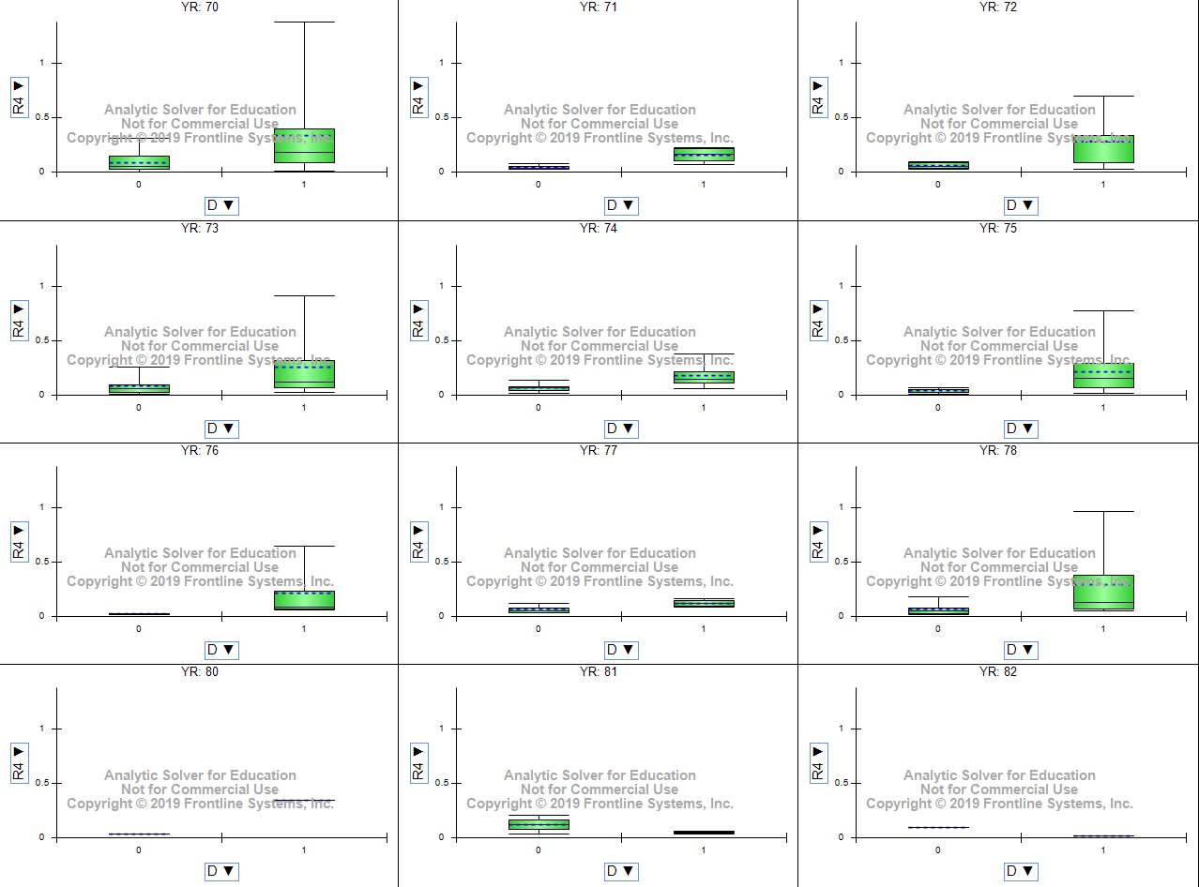

Here we have a box plot showing predictor screening of all variables.



        
        
        
        
        
        
        