RaPId Toolbox User Manual
A Quick start GUIde for the RaPId Toolbox
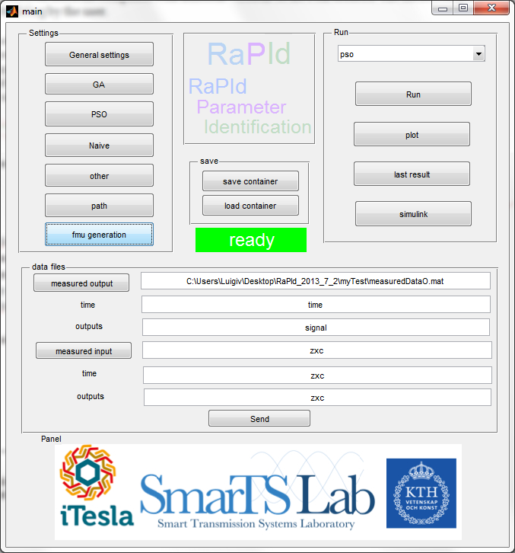

Dissemination level
PU | Public.
TSO | Restricted to consortium members and TSO members of ENTSO-E (including the Commission Services).
RE | Restricted to a group specified by the consortium (including the Commission services).
CO | Confidential, only for members of the consortium (including the Commission services). | X

Document Name: RaPId Toolbox User Manual: Quick start GUIde for the RaPId toolbox
Work Package: WP3
Task: WP3.4
Deliverable: Part of deliverable 3.3 and 3.4
Responsible Partner: KTH

Author |  |  | Approval
Name | Visa |  | Name | Date
[KTH] Achour AMAZOUZ, and Luigi VANFRETTI  luigiv@kth.se | 2013/06/04
DIFFUSION LIST
For action |  | For information
 |  | All partners

DOCUMENT HISTORY
Index | Date | Author(s) | Main modifications
0.1 | 30th May 2013 | AMAZOUZ, Achour | Document creation
0.2 | 4th June 2013 | VANFRETTI, Luigi | Revision and addition of JModelica.org FMU generation
1.0 | 3rd July 2013 | VANFRETTI, Luigi | Added an introduction explaining how RaPId fits in iTesla.  Modified the document including new Automated FMU Generation instructions.

  - Contents

1. RaPId in the iTesla Context 3
1.1. Model Validation in iTesla 3
1.2. RaPId’s software architecture and relation to the overall iTesla toolbox 4
2. An Introduction to Rapid 6
2.1. Goal and restrictions 6
2.2. The way it works 7
2.3. Recommendations 9
3. Setting-up the toolbox 10
3.1. Generating an FMU from a Modelica model 10
3.2. Setting-up the Simulink model 10
3.3. Setting parameters 14
3.4. Containers (setting and results back up) 15
4. Digging Deeper into RaPId: Detailed Specifications and Functionalities 16
4.1. The “settings” struct 16
The following tables specify the contents of the “settings” struct inside of RaPId, this should be consulted only by advanced users. 16
4.2. Optimization Methods and Tools 20
4.3. Command line execution 20
4.4. Important remarks concerning command line execution 21
4.5. Important remarks on file naming and option configuration for MATLAB’s Optimization Toolbox 21
Appendixes 22
1. Advanced FMU Generation 22
1.1. JModelica.org FMU Compilation and Simulation 22
1.2. JModelica for FMU Generation 22
1.2.1. Aims and limitations 22
1.2.2. Enviroment set-up 22
1.2.3. Compilation of FMUs from JModelica 23
1.2.4. FMU Simulation with the FMI Toolbox and JModelica 24
2. RaPId Dependencies 27

RaPId in the iTesla Context

Model Validation in iTesla
The iTesla focuses on developing tools to perform dynamic security assessment of power systems. The quality of the models used by off-line and on-line tools will affect the results of any security assessment computations. A good model approximates the simulated response of the power system as “close” as possible to the “measured” response of the system. A model that is not able to reproduce the response of the power system with a reasonable degree of accuracy is considered as a bad model for the purposes of security assessment. This is illustrated in the figure below.

Fig. 1. Need for model validation using as example the 1996 WECC break-up
WP3 of iTesla focuses on power system model validation. Validating models helps in having models with “good sanity” and “reasonable accuracy” which increases the capability of reproducing actual power system behaviour. As a consequence, the security tools used in iTesla will have a better ability in predicting undesirable dynamic behaviour that could lead to potential instabilities as illustrated in the figure above.

Model validation inherently depends on two main sources of information originating during an “experiment”:
- An assumed model
  - This model includes the details of each dynamic component, controls, protection, etc.
  - The power system topology and any related changes.
- A set of measured data
  - This includes PMU data, fault-recorder data, and any other source of measurements capable of capturing power system dynamics
  - Snapshots from SCADA/EMS indicating the initial condition of the system and providing the status of discrete elements such as breakers.
In this context, an experiment corresponds to either stage tests of a particular “event” that excited power system dynamics (e.g. transient disturbances, blue sky events, etc.).

The model validation loop shown in Fig. 2 combines the two major ingredients listed above. These ingredients need to be combined in a general framework for model validation and appropriate software needs to be design to carry out related model validated tasks. For more details please refer to D.3.1. of iTesla.
Fig. 2. Model Validation Loop

Model validation can be carried out for different levels of a power system. It can be carried out at the component level, for example for a wind turbine or PV panel, for a cluster where the aggregate model of a wind farm or PV farm is validated, or to assess the dynamic performance of the power system as a whole. As illustrated in Fig. 3., WP3 of iTesla is currently carrying out research on these three levels.

RaPId (Rapid Parameter Identification) is software designed for WP3.3 and WP3.4. It allows to carry out most of the steps in the model validation loop and in addition can be used for calibration of the models so that they can meet a specified performance criteria.
Fig. 3. Model Validation Tasks in WP3 of iTesla

RaPId’s software architecture and relation to the overall iTesla toolbox
RaPId is the iTesla Model Validation SW Mock-Up Prototype for WP3.3 and WP3.4 which should be used to develop methods for component level validation and parameter estimation, and to develop methods for aggregate (or cluster) level model validation and parameter estimation.

RaPId has been designed as a completely modular software package that interfaces with the main iTesla toolbox, while at the same time can be used independently to solve problems related to estimation.
However, in the iTesla context, RaPId should be provided by certain inputs, and the results from the execution of the program should be provided back to the iTesla toolbox. This is illustrated in Fig.4 where RaPId corresponds to the “Model Validation Software”. Inputs to RaPId are the harmonized Modelica model containing the dynamic power system model to be validated (.mo files), and the available measurements (.mat files). These inputs are to be downloaded from the main iTesla toolbox into a dedicated computer where RaPId is installed and configured according to the instructions of this manual.

Fig. 4. RaPId’s Modular Software Architecture

RaPId utilizes different simulation technologies to provide a framework for model validation and correction. The foundation of rapid is MATLAB/Simulink which is necessary for processing the available measurements and for the simulation of the Modelica model within the MATLAB/Simulink platform (shown in purple boxes in Fig. 4). Simulation of the Modelica model is carried out using the FMI Toolbox for MATLAB. Within the MATLAB environment, RaPId provides the user with different functionalities, such as the set-up of an optimization problem, access to different solvers to simulate the model, and automates a parameter optimization process (“calibration”) so that the model is not only validated (i.e. satisfies the error allowed in an objective function) but also calibrated (i.e. the error of the objective function is minimized by finding optimal parameters).

The user is provided with a Graphical User Interface (GUI) which he can use to set-up the model validation and calibration problem. More advanced users, such as researchers, can take benefit of the modular design of RaPId which allows for command line execution, the inclusion of dedicated optimization routines, and the formulation of different optimization problems.

RaPId has been designed with the researcher in mind: to give maximum flexibility and efficiency to develop methods and derive tools for model validation, calibration and correction. The spirit of RaPId is that other researchers will use it and contribute to its features – as such, RaPId will be distributed as an Open Source Software at completion of the iTesla project. What RaPId becomes in the future is up to you, the researcher or engineer that needs freedom and flexibility to put your creativity in action, and if RaPId makes this happen, please share it with all of us by sending us your developments!

An Introduction to Rapid

Goal and restrictions
RaPId is a toolbox providing a framework for parameter identification applicable to any dynamic system (not only power systems). A Modelica model of a power system is compiled into a Flexible Mock-Up Unit and made available in the Simulink environment through the FMI Toolbox for MATLAB. The model is characterized by a certain number of parameters whose values can be independently chosen and set-up for an identification process. The model can be simulated and its simulation outputs “measured”. RaPId will attempt to tune the parameters of the model so as to obtain the best curve fitting between the outputs of the simulated and experimentally obtained measurements of the same outputs provided by the user. This is graphically depicted in the figure below.
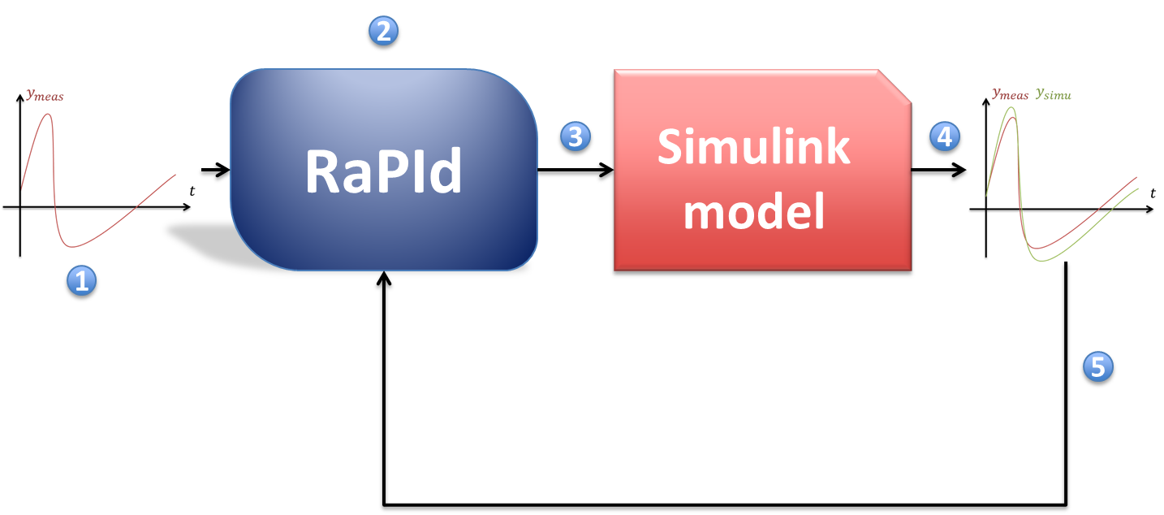
Fig. 5. RaPId’s Iterative Workflow
(1): Output (and optionally input) measurements are provided to RaPId by the user.
(2): At initialization, a set of parameter is generated randomly or preconfigured in RaPId
Iterations:
(3): The model is simulated with the parameter values given by RaPId
(4): The outputs of the model are recorded and compared to the user-provided measurements.
(5): A fitness function is computed to judge how close the measured data and simulated data are to each other
(2): Based on the fitness computed in (5) a new set of parameters is computed by RaPId
The iterations continue as long as a minimal fitness or a maximum number of iterations are reached.

The toolbox requires the users to comply with the following requirements:
- The FMI Toolbox for MATLAB 1.4 or 1.5 and MATLAB R2012b must be installed in their 32bit versions.

- The model to be tuned must be written in Modelica, exported as a *.fmu (Flexible Mock-Up Unit) compatible with Model Exchange (ME). RaPId provides facilities for Automatic FMU generation through its GUI with the restriction that Dymola is installed in the target computer and that the operating system used is Windows 7.

  - The *.fmu files generated through a standard installation of Dymola require:
    - A model compilation license (node-locked or sharable) of Dymola to be used when calling the FMI toolbox
    - A runtime license of Dymola can be used in a computer without a model compilation license for the FMI Toolbox to run FMUs compiled from Dymola by third parties.
    - In order to be free of any Dymola license concern when generating *.fmu files, the computer generating the *.fmu from Dymola needs a “Binary model export license”. The *.fmu will be able to run in any computer with an FMI Toolbox or other FMI-compliant simulation tool.
  - FMU’s can be generated from JModelica.org
    - This requires the user to have expertise in using Python scripting and to set up an environment for loading JModelica and other needed libraries.
    - JModelica does not yet support the complete Modelica Standard definitions (e.g. the reinit function is not supporte, it is used for example in the DFIG Wind Turbine model in the Modelica power systems library).

- Measurements data (and input data if available) should be contained in a MATLAB file (*.mat), the file can include any kind of MATLAB object. The toolbox will let the user specify of to get the appropriate data from a file to be loaded.

- The names of the different blocks in the Simulink model must be given in RaPId or the default names should be used. The Simulink block-diagram cannot be built disregarding this configuration.

- A number of parameters need to be specified for the toolbox to work in a correct way. Any misunderstanding in a parameter’s value will generate exceptions. Minimal exception handling was integrated at this early stage of development.

- Some problems have been experienced when using the Simulink models packaged with the toolbox on different computers with different versions of the FMI toolbox. The models might need rebuilding by the user. This can be done through the Automatic FMU Generation feature in RaPId, provided that Dymola is installed in the target computer and that the operating system is Windows 7.

The toolbox was built as a proof of concept. It can present some instabilities at times. A model simulated several occasions without problem may suddenly provoke bugs. In those cases the toolbox itself complains, errors are displayed in the MATLAB console. A reboot of MATLAB usually fixes the problems related to the toolbox. Similarly, the FMI Toolbox for MATLAB on which the RaPId toolbox relies may cause problems after several iterations of the simulation process which can lead to the following exception:

module = FMICAPI, log level = FATAL: Could not load the DLL: Not enough storage is available to process this command.

A reboot of MATLAB is then needed to use the toolbox.

The way it works
RaPId is a set of MATLAB scripts and a GUI helping towards performing a parameter identification process. All functionalities provided by the GUI can be executed via command line, the GUI is meant to provide user interaction and to help beginning users to get acquainted with the different features of RaPId as quickly as possible, however, and advanced user would prefer the possibility of scripting and adapting RaPId to its own needs.

The main GUI of RaPId is shown in the figure below. The main GUI can be launched by running the run_gui.m file.

Fig. 6. RaPId’s Main GUI
The user has access to measurements. These measurements are given to the toolbox as, a target file and two commands leading to evaluation of a time vector and a signal matrix.

The file should be given as “measured output” and “measured input” in the main window of the user interface. The measured output must be provided as a .mat file containing two elements: time and signal. The elements time and signal are the strings evaluated to load the content of the so-called file. time is a row vector outputs is a matrix whose rows are the different output signals measured. If inputData file contains a struct with time named simout as generated by a to workspace component in Simulink, time will have to be given as transpose(simout.time), outputs will be given transpose(simout.signal.values).

The model representing the system which produced the measurement data is described using the Modelica language and compiled into a *.fmu container. This container can be loaded in the Simulink environment through the FMI Toolbox.

The Modelica model is characterized by a number of parameters and number of variables. Among the variables, a few are the output of the model. They should represent the same physical quantities as found in the measured data. Some of the parameters are known, some are to be identified.

RaPId allows an algorithm to change the value of the parameters to be identified, then triggers the simulation of the Simulink system containing the Modelica model; subsequently, it extracts the output of this simulation and evaluates the fitness of the parameters chosen and feedback this values to the algorithm. Repeating this process iteratively, the algorithm tries to minimize the difference between the measured data and the simulated data.

Different algorithms can be used for this identification process. Different algorithms are tuned differently and yield different results. The toolbox was designed to be easily extended with new algorithms.

Recommendations
After extracting RaPId to the desired location, a folder should be created inside the main folder of the toolbox. In this folder will be placed all the files related to one experience (certain parameter estimation procedure for a certain model).

Depending on your computer hardware and MATLAB installation, Simulink might take a long while to load for the first time. It is recommended to start by typing simulink in the MATLAB console before continuing. The RaPId toolbox adds the FMI Toolbox for MATLAB to your path based on the user-specified location, if a block is tagged with a “bad link” label in the Simulink diagram, this will be fixed later when the toolbox is launched.

Setting-up the toolbox

Generating an FMU from a Modelica model
An FMU file containing the Modelica model is needed by RaPId for the simulation within MATLAB/Simulink using the FMI Toolbox for MATLAB. Although generating an FMU from a Modelica model is not necessarily complex, RaPId provides an Automated FMU generation facility. The user can generate an FMU by clicking on the “fmu generation” button in the main GUI. This will make the window in Fig. 7 to pop-up.

An FMU can be generated by following the steps below:
- The user must click on “Modelica model file” and select the model file to be used.
- The user must type the path within the Modelica package where the specific model to use is located.
- A target folder to place the generated FMU should be selected by the user by clicking on “fmu target folder” and selecting the desired location.
- After completing steps a. through c. the user can click on “Generate fmu”, to obtain the FMU of the selected model.

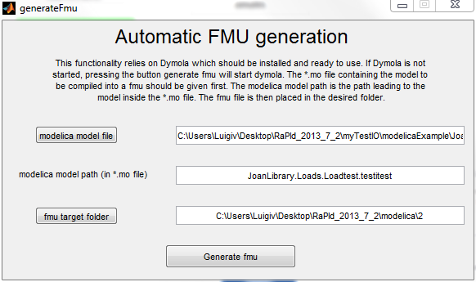
Fig. 7. RaPId’s Automatic FMU generation GUI

Setting-up the Simulink model
The Simulink model given in the folder myTest contains (see Fig. 8):
- The FMU me block where the Modelica model is contained is loaded
- A To Workspace component saving the simulated output. RaPId will fetch the data saved by this component into workspace
- A From Workspace block allowing to include the measured outputs in the model
- Scopes plotting both the measured and simulated output while the computations are running. If the Simulink scopes are open before starting the toolbox every iteration of the optimization will be displayed
- The toolbox always loads in the workspace a struct with time dataMeasuredS based on the data provided by the user. This name should normally not be modified in the From Workspace component. The number of outputs (4 in this example) may vary with the model loaded. It’s for the user to change the settings of the scopes, mux and demux components accordingly.

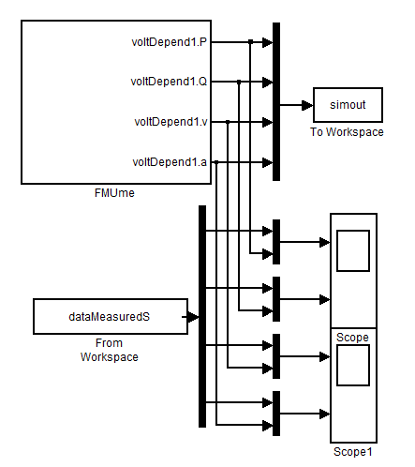
Fig. 8. Simulink model contained in myTest folder
Two kinds of *.fmu files exist. FMUcs (for co-simulation) include binaries for the solvers to be used in simulation. FMUme (for model exchange) only contains a description of the model, when using FMUme, we rely on the solvers embedded in Simulink. RaPId only works with the later.

The choice of the solver and the solver options used in Simulink has to be configured in the toolbox. This implies that the FMU block chosen from the FMI toolbox has to be taken as Model Exchange compatible (ME and CS blocks both exist in the FMI library). Similarly, at creation of the *.fmu file, the user has to make sure that the *.fmu generated will be compatible with the ME standard (see compilation options in Dymola).

Double-clicking on the FMU block in the Simulink model allows the user to select the outputs of the model among all the variables present in the Modelica model (see Fig. 9):
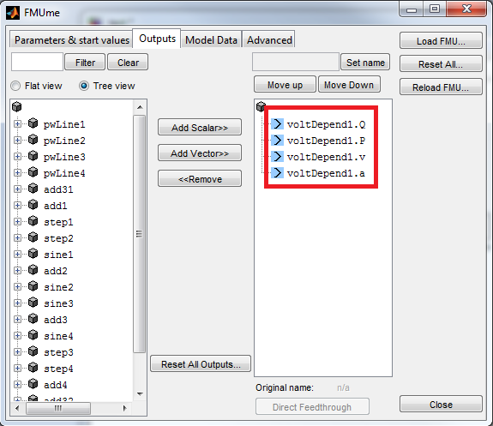
Fig. 9. FMU output selection
The order of appearance of these outputs matters. It should be identical to the order of the outputs in the measurement data provided by the user. The outputs will indeed be compared one by one. If two outputs are switch in the FMU block, the identification will be made more difficult and might never succeed.

Besides, it is recommended to the user to note the complete name of all parameters whose values will be identified by RaPId. The user will indeed have to provide this information to the toolbox.

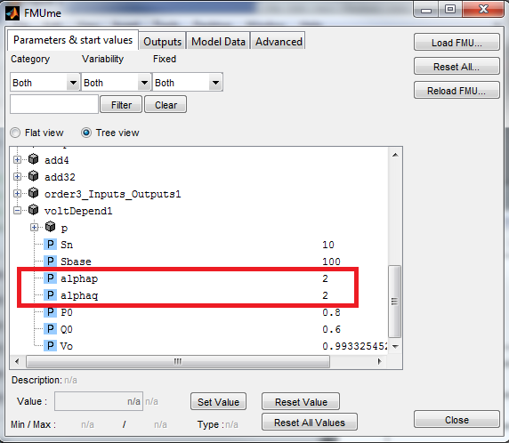
Fig. 9. FMU parameters to be estimated
In this example, we note that the variable to be identified have the complete names voltDepend1.alphap and voltDepend1.alphaq.

If the user desires to use a solver with fixed step (for example ’ode1’), the use of tolerance controlled FMU in the fourth tab of the FMU block needs to be disabled:
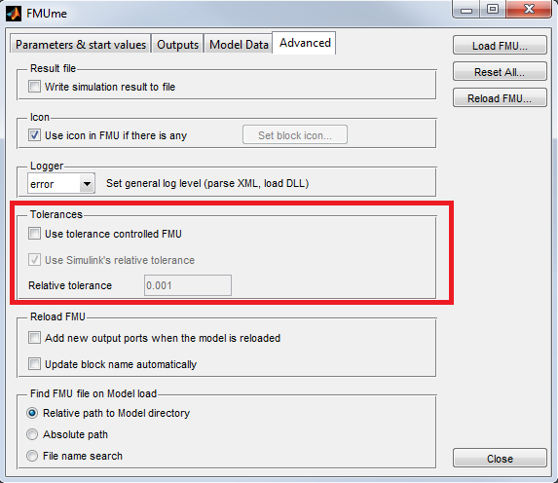
Fig. 9. FMU Tolerance configuration for fixed step solvers

If the Modelica model contains input ports (which must be left unconnected when input measurement signals are available for the model validation process) they will automatically appear as inputs to the FMI block (see Fig. 10).
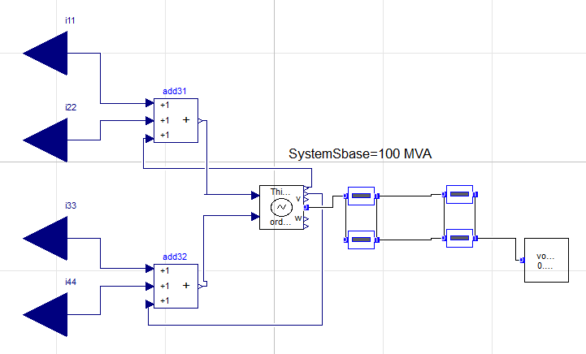
(a) Modelica model expecting input measurements
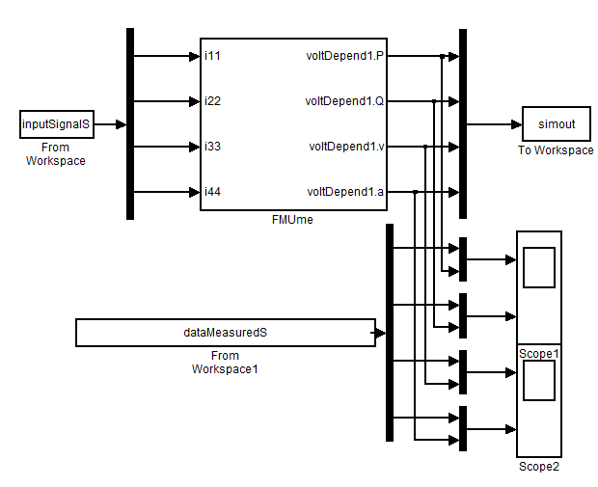
(b) Simulink model with an FMU of the Modelica model in (a) and configuration of input signals
Fig.10. FMU with input signal measurements
The toolbox loads a struct called inputSignalS based on the input data provided by the user. The same happens with the struct called dataMeasuredS which represents the measured outputs. In the GUI, the user provides the path to the MATLAB files containing the input and output measured data and a pair of keywords allowing to evaluate the time vector and signal matrix of the measurement.
The idea is that the toolbox loads the files given as “measured output” and “measured input” into the workspace and evaluates the content of the time and outputs fields (see Fig. 6). The field time should give a row vector containing all the samples at which the outputs were samples. The field outputs should give a matrix whose rows are the output signals themselves. The same can be transposed to the input data. The structs inputSignalS and outputMeasuredS are constructed by the GUI based on the data aforementioned. Thus, the measurement data has to be provided in the “data files” section of the GUI by clicking on “measured output” and “measured output” buttons.

The simulation settings should not be configured in the Configuration Parameters of Simulink. These configuration parameters are overridden by the settings of the toolbox. In the GUI, these settings appear in the generalSettings menu.

Setting parameters
The first time the toolbox is open, the settings pre-defined in the GUI will not be suitable for every user.

They need to be set one after the other.

In the instructions below, the symbol represents the operation to get the toolbox working. Feel free to avoid reading other parts of the text and follow these operations to get the toolbox up and running as quickly as possible.
This section describes the settings to change every time a new model is simulated. They depend on your model and/or on your computer (e.g. path).

cd to the RaPId main directory (the GUI do not run correctly if the currend directory is not the good one)
Start the GUI by running the script run_GUI.m

The script adds the appropriate folders of RaPId in the path.

The main window of the toolbox pops up.
Click on path to set the path to the FMI toolbox main directory, set the path to the Simulink model built at the previous section. Using the button Simulink model path for that purpose will also give the value to the Simulink model name field. FMU block name should be the one given in the Simulink model, the same apply to “To Workspace block name”. Press send
The Simulink button brings up the model if the Simulink model path was given correctly. Looking into the Simulink model allows to take a peek to the different blocks’ names.
Back to the main window. Click on General Settings.
Set the values for solver, Ts, tf just like you would do it in a Simulink model. They are the parameters of the simulation. Do not input this information directly in Simulink, they will be overridden by the settings set in General Settings.
Set the values for output names, parameter, param min, param max, quadratic cost and p0. The field output names correspond to a struct with strings containing the names appearing on the FMU block once the corresponding outputs were selected in the output tab of the FMU ME component. It’s composed the following way: subBlockName.variableName. The field parameter contains the name of all parameters to be identified by the toolbox. The content of these two components should be entered while reading the name of the components inside the Simulink model to minimise the risk of errors. The fields param min, param max and p0 need to be of the appropriate size.
The field quadratic cost represents a vector containing the weights put on the square of the difference of every simulated output when compared to the measured output. If we write the fitness function
fitness = (Ymeas - Ysimu)’ Q (Ymeas - Ysimu)’
quadratic cost represents the diagonal of Q.
Give the path to the *.mat object containing the measurement data in inputData file Give in time and outputs the expression which, if evaluated in the MATLAB command line after loading the data from inputData file, gives the values of the time row vector and the signal array (rows corresponds to different outputs.)
Choose the optimization method to be used via the drop down menu. Warning some methods rely on external methods (it is the case of Knitro, psoExt) be sure to add the path to these toolboxes on the corresponding emplacements in the menu other if you want to use one of these methods. Note that Knitro requires a license.
Press the button send
A press on run will now launch the toolbox and perform multiple iterations of the optimization process
The simulation takes time. An indicator marked running/ready/error helps figuring out if the simulation is still running. An eye should be kept on the console in case an error is detected.
After the computation has finished, plots can be showed and the final solution can be given via pressing the appropriate buttons.

Containers (setting and results back up)
The folder ‘core’ contains the file data.mat. This file contains all the parameters of the toolbox and of the parameter identification method to be used, but also the data generated at the last use of the toolbox.
Initially, the file doesn’t exist. The fields of the GUI are filled with default values that need to be changed, for the most part. A parameter set with an invalid default value will generate errors.
The toolbox contains menus allowing setting the values for every needed parameter. These menus should be closed with the button labelled send, if another method lead to shutting the menu, all change will be discarded. When the button send is pressed, the data is saved in the file data.mat, any former settings are then discarded, only the new parameters will be taken into consideration.
This file may be exported/imported using the save container and load container buttons in the main window of the graphical interface. We advise the user to save a file for every single model on which to perform the system identification. Many of the parameters change when the model to be identified changes.
The file data.mat is a container transferred between the different elements of the toolbox. The user should normally not affect any change on this object outside the toolbox.

Digging Deeper into RaPId: Detailed Specifications and Functionalities

The “settings” struct

The following tables specify the contents of the “settings” struct inside of RaPId, this should be consulted only by advanced users.
Menu in the GUI | Name in the GUI | Name of the field in the settings struct | Functionality | Typical value
General Settings | Ts | settings.Ts | Sampling time for the simulated model whose parameter are tuned, only used if the integration method is a fixed step method. | positive real
 | tf | settings.tf | final time of the simulation | real positive
 | t0 fitness | settings.t0_fitness | start time for the computation of the fitness function (allow to remove the influence of the first second of the simulation on the computation of the cost function) | real positive, by default 0
 | output names | settings.fmuOutData | names of the output measured, should correspond to both the measurement data and the output you set to the FMU block in the Simulink model | struct of strings every string is the name of the output as presented in the FMU block, e.g.:  {‘subbloc.output1’,subbloc.output2}  the order matters, it has to match the order of the signals in the measured data and the order of the outputs in the Simulink model
 | parameter | settings.parameterNames | names of the parameters whose values are going to be identified. | struct of strings, every string should contain the name of the appropriate parameter as stated in the FMU bloc e.g.:  {‘subbloc.parameter1’,’subbloc.parameter2’}
 | param min | settings.p_min | vector containing the min acceptable value for all the parameter to be identified | Depends on the parameter, has to be real though... The order maters, has to match the order specified when you input the parameters’ names
 | param max | settings.p_max | vector containing the min acceptable value for all the parameter to be identified | Depends on the parameter, has to be real though... The order maters, has to match the order specified when you input the parameters’ names
 | verbose | settings.verbose | can trigger more data in the console, used in debugging of the methods | just put it to 0
 | cost | settings.cost | identifiant of the cost function to be used, the function is shipped with only 1 cost function which is quadratic | put 2, might change if you implement new objective functions
 | quadratic cost | settings.objective.vect | weights describing the importance of every single output on the quadratic cost | vector of real positive numers,  each weight corresponds to one output, they must hence be given in the same order as the outputs
 | solver | settings.intMethod | name of the integration method used in Simulink | string given the exact name of the integration method in Simulink, for example ‘ode1’ or ‘ode45’
 | p0 | settings.p0 | initial guess for the vector of parameters to be identified | must be compatible with the upper and lower bounds specified in p_min and p_max. Some methods don’t take into account this parameter.
Nb max |  | settings.nbMaxIterations | Number max of iteration before stopping the algorithm | Must be large, stopping the algorithm that way will not provide an optimal solution. Usefull for debugging purposes.

Menu in the GUI | Name in the GUI | Name of the field in the settings struct | Functionality | Typical value
GA | nbChromosome | settings.ga_options.nbCromosomes | number of vectors of parameters tested at every iteration of the genetic algorithm | natural integer  remark:  nbCrossover1+nbCrossover2+nbMutations+nbReproductions + nbResurrection = nbChromosome
 | nbCrossover1 | settings.ga_options.nbCrossover1 | the crossover is a mean to reach better values for the vectors of parameters searched, here is the number of crossover of first type to be performed at every iteration | natural integer
 | nbCrossover2 | settings.ga_options.nbCrossover2 | the crossover is a mean to reach better values for the vectors of parameters searched, here is the number of crossover of second type to be performed at every iteration | natural integer
 | nbMutations | settings.ga_options.nbMutations | mutations ar a mean to reach better values for the vectors of parameters searched, here is the number of mutations to be performed at every iteration | natural integer
 | nbReproductions | settings.nbReproduction | when you reproduce a chromosome, it just remains the same | natural integer
 | nbGenerations | settings.ga_options.limit | number of iterations of the genetic algorithm | natural integer
 | fitnessStopRatio | settings.ga_options.fitnessStopRatio | the algorithm will stop before nbGenerations if the ratio phy_now/phy_start < fitnessStopRatio  meaning when we consider the fitness sufficiently low (weirdly enough, close match means small fitness index) | very small real positive number
 | headSize1 | settings.ga_options.headSize1 | the crossovers of type 1 are effected on the headSize1 chromosome with best fitness | natural integer < nbChromosome
 | headSize2 | settings.ga_options.headSize2 | the crossovers of type 2 are effected on the headSize2 chromosome with best fitness | natural integer < nbChromosome
 | headSize3 | settings.ga_options.headSize3 | the mutations are effected on the headSize1 chromosome with best fitness | natural integer < nbChromosome
 | nbResurections | settings.ga_options.nbReinjection | number of random chromosomes that should have been deleted given their fitness but that are kept to add a random parameter | natural integer
 | nRandMin | settings.ga_options.nRandMin | the initial set of parameter vectors is determined as a set determined geometrically (vertices of the hypercube + regularly spaced vectors) to which we add a certain number of randomly generated vectors. nRandMin is the minimum number of randomly generated particles desired | natural integer < nbChromosomes
 | p0s | settings.ga_options.p0s | matrix to be used to specify certain initial guesses of the parameters and to include them in the initial cell of chromosomes | matrix whose rows are different initial guesses,  rows should respond to the same requirements as p0 from the general settings
 | storeData | settings.ga_options.storeData | boolean allowing to log data  can break the memory for systems bigger than “tiny” | 0

Menu in the GUI | Name in the GUI | Name of the field in the settings struct | Functionality | Typical value
PSO | alpha1 | settings.pso_options.alpha1 | inertia parameter (used to compute the particle’s speed at next time instant ) | real, alpha1 + alpha2 + alpha3 = 1
 | alpha2 | settings.pso_options.alpha2 | parameter used to compute the speed at the next time instant, relates the component of the speed directed towards the global optimum of the swarm | same as alpha1
 | alpha3 | settings.pso_options.alpha3 | parameter used to compute the speed at the next time instant, relates the component of the speed directed towards the personal optimum of the particle | same as alpha1
 | nbIterations | settings.pso_options.limit | number maximal of iteration for the whole PSO algorithm | natural integer
 | nbParticles | settings.pso_options.nb_particles | number of particles in the swarm | natural integer
 | fitnessStopRatio | settings.pso_options.fitnessStopRatio | see description in the same parameter on GA
 | kickMultiplier | settings.pso_options.kick_multiplier | the speed decreases as the number of iteration increases,when the particle is stuck we give it an impulse to start it back  the kick multiplier helps determining when to consider the particle stuck  it’s the minimum ratio between current speed of the particle and maximum allowed speed of the particle | positive real number smaller than 1
 | nRandMin | settings.pso_options.nRandMin | same as in GA
 | p0s | settings.pso_options.p0s | same as in GA
 | storeData | settings.pso_opt.storeData | same as in GA

Menu in the GUI |  | Name in the GUI | Name of the field in the settings struct | Functionality | Typical value
Naive | tolerance1 |  | settings.naive_options.tolerance1 | at every iteration, the optimization consists of stepping in the opposite direction to the gradient with decreasing steps the tolerance is the smallest size admitted for the step | positive real
 | tolerance2 |  | settings.naive_options.tolerance2 | at every iteration, the optimization consists of stepping in the opposite direction to the gradient with decreasing steps the tolerance is the smallest size admitted for the step | positive real
 | iterations |  | settings.naive_options.iterations | elementary number of optimization in orthogonal directions of the parameter space | natural integer
 | iterations2 |  | settings.naive_options.iterations2 | number of time the elementary iterations are repeated for every orthogonal directions | natural integer
 | iterations3 |  | settings.naive_options.iterations3 | third level of iteration | natural integer

Menu in the GUI | Name in the GUI | Name of the field in the settings struct | Functionality | Typical value
other | gaExtOptions | settings.gaExtOptions | optimset to give the genetic algorithm from MATLAB | see options in  “doc ga”
 | nmOptions | settings.nmOptions | optimset to give the nelder-meade method | see options in “doc fminsearch”
 | cgOptions | settings.cgOptions | optimset to give the conjugate gradient method | see options in “doc fminunc”
 | psoExtPath | settings.psoExtPath | path to the toolbox download here: https://code.google.com/p/psoMATLAB/
 | psoExtOptions | settings.psoExtOptions | optimset for the toolbox psopt | see options in  “doc pso”
 | path2knitro | settings.kn_options.path2Knitro | path to the knitro toolbox  found at: http://www.ziena.com/knitro.htm
 | knitroOptions | settings.kn_options.knOptions | optimset for the knitro toolbox | see options in “doc ktrlink”
 | option file | settings.kn_options.knOptionsFile | path to option file to be given the knitro toolbox | see knitro documentation
 | firstMethod | settings.combiOptions.firstMethod | the method combi executes to methods one after the other this is the name of the first method | see drop down menu
 | secondMethod | settings.combiOptions.secondMethod | name of the second method to be executed in combi | see dropdown menu

Menu in the GUI | Name in the GUI | Name of the field in the settings struct | Functionality | Typical value
Path | FMI toolbox path | settings.path2fmiToolbox | path to the FMI toolbox | C:\Program Files (x86)...
 | Simulink model path | settings.path2fmiToolbox | path to the Simulink model containing the FMU block and the to workspace component
 | FMUme | settings.blockName | name of the FMU block in the Simulink diagram, must be simply “blockname” in the GUI, must be “modelname\blockname” in the command line
 | Simulink model name | settings.modelName | string containing the name of the Simulink model
 | to workspace block name | settings.scopeName | name of the To Workspace component in the Simulink model

Menu in the GUI | Name in the GUI | Name of the field in the settings struct | Functionality | Typical value

main | inputData file | settings.path2data | path to the mat file containing the measurement data, can contain any kind of data handled by MATLAB
 | time | settings.dataT | command to be executed to obtain a row vector containing the time vector of the measurement when the inputData file is loaded in workspace
 | signal | settings.dataY | command to be executed to obtain a matrix whose row vectors contain the output vectors of the measurement when the inputData file is loaded in workspace
 | method | settings.methodName | name of the method to be used in the optimization

Optimization Methods and Tools
pso: particle swarm algorithm, a swarm of particles. The dimension of the vectorial space containing the particles is equal to the number of parameter to identify, a particle is a vector of parameter. The position of the global optimum of the whole swarm and this of every particle are memorized. A speed is given to every particle depending to the distance this particle has to it’s personal optimum and the distance to the global optimum.
ga : A cell contains a number of chromosomes. A chromosome represent a vector of parameters. A certain number of chromosomes will be subject of a crossovers (they exchange part of their genes, a gene is a parameter), other will undergo a mutation (one of their gene is altered randomly). The process is repeated a great number of times, at every iterations we keep the best chromosomes and some random of the not best performing chromosomes.

naive: iteratively solve one-dimensional gradient methods in orthogonal directions taken randomly. Requires an initial guess.

cg: conjugate gradient method from MATLAB (fminunc). Carefull! this method doesn’t take into account the min max for the different parameters, requires an initial guess.

nm: nelder-mead method, lies on fminsearch from MATLAB, requires an initial guess.
combi: choose two methods to apply one after the other, the second one uses the result of the first one as initial guess. The idea is to first use a machine learning based method (less prone to sticking to local minima) and then use an accurate gradient based method: typically NM.
psoExt: like pso but taken from an external toolbox, https://code.google.com/p/psoMATLAB/
gaExt: like ga but using the embedded MATLAB Global Optimization Toolbox function.

knitro: powerful external optimization function, http://www.ziena.com/MATLABknitro.html

Command line execution
The command line execution of the toolbox requires the user to create the settings struct containing all the parameters of the toolbox. A function to rapid call with all the appropriate settings definition for one specific method is rather compact and much easier to comprehend than going through all the menus of the GUI.

Doing things in a command line is also a much less error prone approach.

The advantage of the command line approach is the control given to the user over all the elements coming to and from the toolbox.

The user should refer to the help of the function rapid.m and look into the function run_cmd.m which gives an example of command line definition for every single method included.

The user should only change the settings.methodName flag to switch from one method to the other.
The parameters to be set for every method are the same as in the GUI, the list of parameters given in the present document is then still valid for the command line approach.

Using the run_cmd.m file is pretty easy. The user needs to go through all fields and adapt them to his/her own example. The fields to be changed are in most cases:

- settings.path2SimulinkModel  - settings.modelName  - settings.blockName  - settings.scopeName  - settings.fmuOutData | - settings.p_min  - settings.p_max  - settings.p0  - settings.objective.vect  - settings.path2data  - settings.parameterNames

Important remarks concerning command line execution
The GUI takes care of loading the different toolbox needed to the path from the fields of the struct called settings. Settings is usually built as the users fill the different menus of the GUI.

In command line, the user will then have to include the following lines to reproduce this mechanism.
addpath(genpath(settings.path2fmiToolbox))
addpath(genpath(settings.psoExtPath)) {this only if the external pso toolbox is used}
addpath(genpath(settings.kn_options.path2Knitro)

The array of settings given formerly contains all the data entered by the user in the GUI. When using the toolbox in command line, all these fields need to be input manually by the user. You may however decide not to input the settings relative to an optimization method that you won’t use, which makes the process shorter.
However, the GUI includes in settings some fields that don’t appear in the table here above. These measurement data needs to be included in the settings struct following:

load(settings.path2data)

settings.realData = eval(settings.dataY);
settings.realTime = eval(settings.dataT);

These lines are valid if you filled all the fields of the struct as specified in the table here above.
Otherwise, just arrange yourself to have settings.realData a row vector of time samples, and settings.realTime a matrix whose rows represent the measurement of every output at the corresponding sample times.

Important remarks on file naming and option configuration for MATLAB’s Optimization Toolbox
The core folder contains a file named data.mat that should never be modified by the user. The user also needs to make sure no other file is ever called data.mat within the MATLAB path or the current directory.
The optimsets of the different functions from MATLAB (fmincon, fminsearch, fminunc,ga and so on) can be be generated through the optimization toolbox obtained with the command optimtool.
This tool provides a GUI that allows exporting into the workspace a struct that can then be fed to the toolbox in the appropriate fields of the menu ”other”, see Fig. 6.

Appendixes

Advanced FMU Generation

JModelica.org FMU Compilation and Simulation
This Appendix describes the use of JModelica.org for the generation of Flexible Mock-Up units and to carry out simulation using FMUs both in JModelica.org and with the FMI Toolbox for MATLAB using Simulink blocks.

This is considered an advanced option, and the user should be aware that relevant experience with programming is necessary. If you are not comfortable with working with source code or to program using Python this option is not recommended and instead you should refer to the documentation above regarding the use of Dymola.

JModelica for FMU Generation

Aims and limitations
JModelica.org is an extensible Modelica-based OSS platform, providing facilities for simulation and analysis of Modelica models.

However, it has the following disadvantages for novice users:
- It does not provide a user interface
- It requires some expertise working with Python scripting
- It requires a correct set up of JModelica
- It does not support the complete Modelica standard definition ( e.g. reinit commnad used by the DFIG WT in the iTesla Power System Modelica Library is not support -> no FMU can be generated)
We illustrate one example for FMU here, carried out with JModelica.org-1.8.1.

Enviroment set-up
Follow the next instructions to set-up an environment to compile FMUs with JModelica:
- Download JModelicaorg-1.8.1:
http://www.jModelica.org/downloads/JModelica.org-1.8.1.exe
- Download Python(x,y) – an environment for numerical computations using Python
https://code.google.com/p/pythonxy/
- Python(x,y) will include Spyder, a development environment for the Python language.
- Open the file C:\JModelica.org-1.8.1\Python.bat with Notepad++ or similar. Make sure you have the following statements:
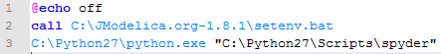
- Create a shortcut for JModelica running in Spyder automatically:
  - Create a shortcut icon in your desktop, and point it to the “C:\JModelica.org-1.8.1\Python.bat” file.
  - Give a name to the shortcut and click on “Finish”
  - You should get a shortcut to launch Spyder with the JModelica libraries loaded and enabled
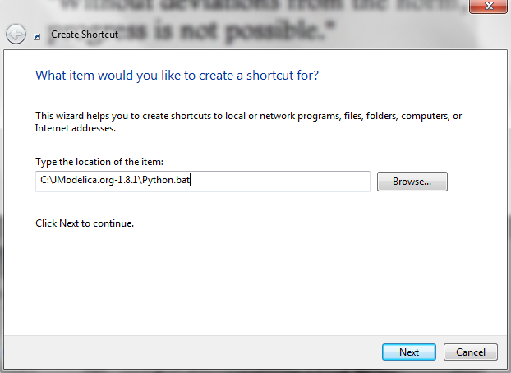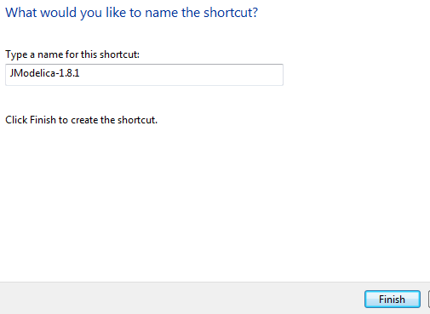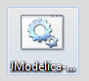

Compilation of FMUs from JModelica
- Go to the directory where you have put the Modelica model you wish to compile through the command prompt in Spyder, and check that you are there:

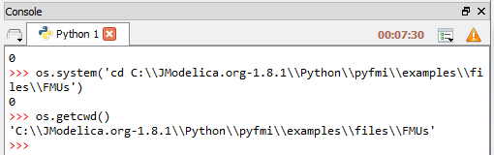

- The following syntax can now be used to compile your FMU, we use it in the next example:

# Import the compiler function
from pyModelica import compile_fmu
# Specify Modelica model and model file (.mo or .mop)
model_name = 'myPackage.myModel'
mo_file = 'myModelFile.mo'
# Compile the model and save the return argument, which is the file name of the FMU
fmu_file = compile_fmu(model_name, mo_file)

- Compile FMUs from JModelica: locating the model name and the file name.
  - We will compile a small test system including a third order generator, lines and a frequency dependent load that can be used for load parameter estimation
  - This model is contained the ‘EPpack.mo’ package, this is the file name.
  - From the hierarchy illustrated in the figure below, one can obtain the model name: EPpack.JoanLibrary.Loads.Loadtest.Loadtestfreq
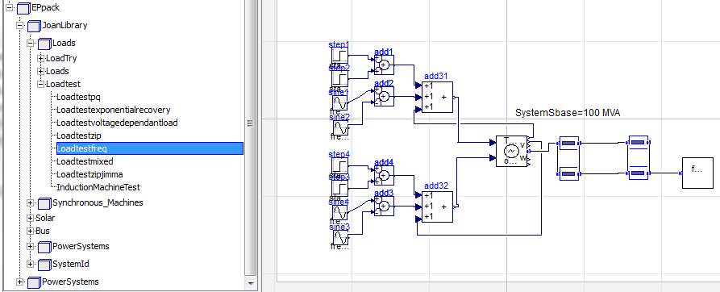

- Go to the console of Syper and type the commands as shown in the screenshot

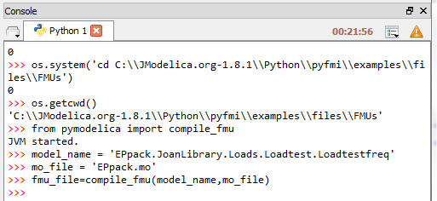

- Browse to your FMU folder and you will find the compiled FMU there!

FMU Simulation with the FMI Toolbox and JModelica

Simulation with the FMI Toolbox
- Create a new Simulink file and load the FMU block for Model Exchange
- Load the FMU and select the outputs to display during simulation
- Put a scope to display the results
- Click on play to see if the FMU is working properly, you should get the results below, the inspected values are at the load bus (V, angle, P and Q):
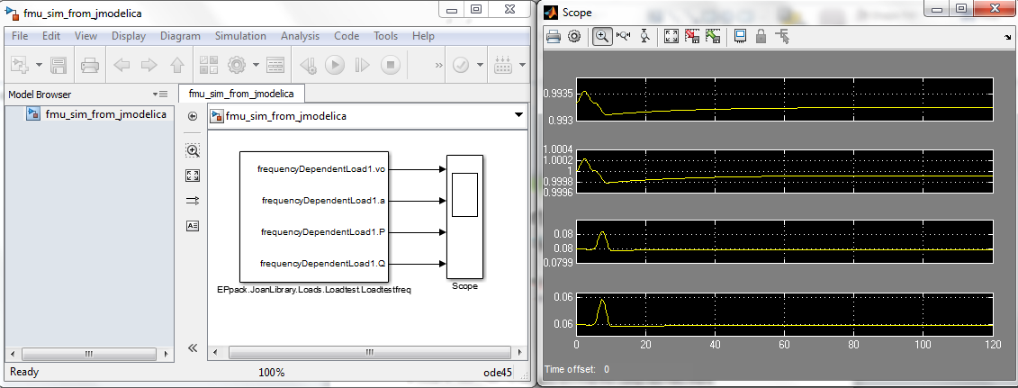

- You might have the situation that the simulation results make no sense. This is not an issue of MATLAB/Simulink nor the FMI Toolbox
- It is simply due to the fact that JModelica does not support the full definition of the Modelica standard, and thus, its compiler may not be able to give a “correct” FMU (or even it may create an error creating the FMU).

Simulation with JModelica
JModelica supports simulation of Modelica models using standard Modelica files, FMUs or JMUs. The script below can be used for simulating the FMU of the example above in JModelica.

# -*- coding: utf-8 -*-
"""
Created on Friday May 31 00:22:56 2013

@author: luigiv
"""

import os as O
import pylab as P
import numpy as N

from pyfmi import FMUModel

curr_dir = O.path.dirname(O.path.abspath(__file__));
path_to_fmus = O.path.join(curr_dir, 'files', 'FMUs')

def run_demo(with_plots=True):
"""
Demonstrates how to use JModelica.org for simulation of FMUs.
"""

fmu_name = O.path.join(path_to_fmus,'EPpack_JoanLibrary_Loads_Loadtest_Loadtestfreq.fmu')
model = FMUModel(fmu_name)

opts = model.simulate_options()
opts['CVode_options']['atol'] = 1.0e-6 # specific tolerance
opts['CVode_options']['atol'] = 1.0e-6 # specific tolerance
opts['ncp'] = 5000 #changing the number of communication points

res = model.simulate(options=opts,final_time=100.)
print("FMU succesfully simulated")

#Retrieve the result for the variables
output_vo_0 = res['frequencyDependentLoad1.vo']
output_vo_1 = res['frequencyDependentLoad1.a']
output_p = res['frequencyDependentLoad1.P']
output_q = res['frequencyDependentLoad1.Q']
t = res['time']

#Plot the solution
if with_plots:
fig = P.figure()
P.clf()
P.subplot(2,1,1)
P.plot(t, output_vo_0)
P.ylabel('Voltage Magnitude at Load (pu)')
P.xlabel('Time (s)')
P.subplot(2,1,2)
P.plot(t, output_vo_1)
P.ylabel('Voltage Angle at Load (rad)')
P.xlabel('Time (s)')
P.suptitle('FMU Simulation using JModelica')
P.show()

fig2 = P.figure()
P.clf()
P.subplot(2,1,1)
P.plot(t, output_p)
P.ylabel('Active Power Response (pu)')
P.xlabel('Time (s)')
P.subplot(2,1,2)
P.plot(t, output_q)
P.ylabel('Reactive Power Response (pu)')
P.xlabel('Time (s)')
P.suptitle('FMU Simulation using JModelica')
P.show()
if __name__ == "__main__":
run_demo()

The results are shown in the plots below, being identical to the results produced with the FMI Toolbox for MATLAB, the inspected values are at the load bus (V, angle, P and Q):
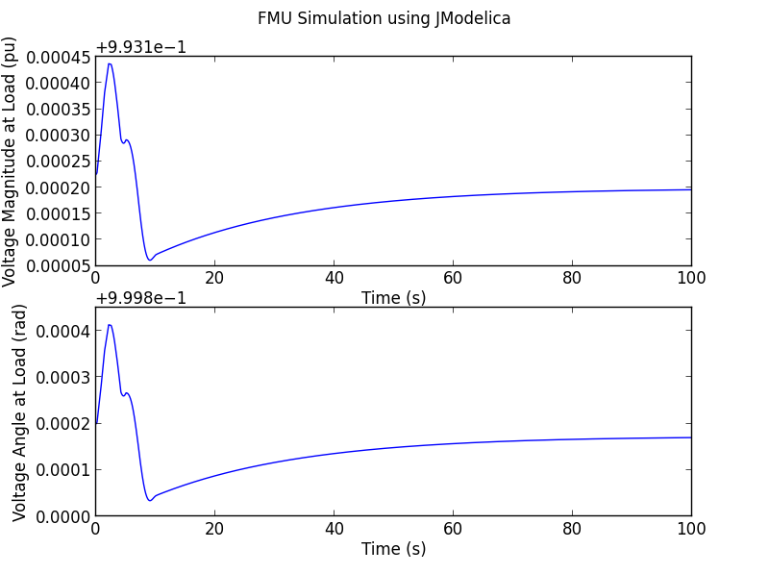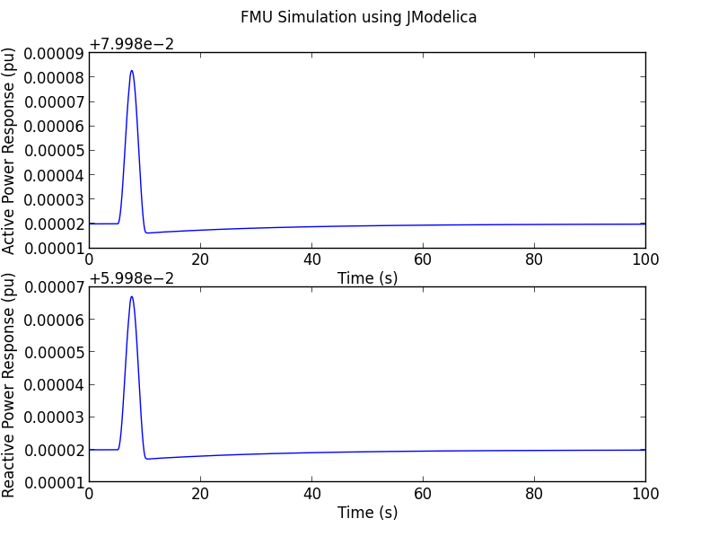

RaPId Dependencies

All software versions are 32bit (64bit versions not tested)

MATLAB/Simulink and Toolboxes:

- MATLAB Version: 8.0.0.783 (R2012b)
- Simulink Version 8.0 (R2012b)
- Optimization Toolbox Version 6.2.1 (R2012b)
- Global Optimization Toolbox Version 3.2.2 (R2012b)
- Signal Processing Toolbox Version 6.18 (R2012b)
- Image Processing Toolbox Version 8.1 (R2012b)
- Statistics Toolbox Version 8.1 (R2012b)

External/Mandatory:
- FMI Toolbox for MATLAB v. 1.5.: http://www.modelon.com/products/fmi-toolbox-for-MATLAB/
- Dymola 2014:
  - A node-locked license with the “binary export” feature enabled will let the FMUs run in any other machine including the one that generated the FMU.
  - The standard license requires that a Dymola license is present in the same machine where the FMU is run.

External/Optional:
- KNITRO http://www.artelys.com/en_EN/optimization_tools/knitro
- PsoMATLAB https://code.google.com/p/psoMATLAB/

See http://www.modelon.com
See https://www.fmi-standard.org
This document provides an example on FMU generation with JModelica, however this should be considered an alternative only for advanced users.

