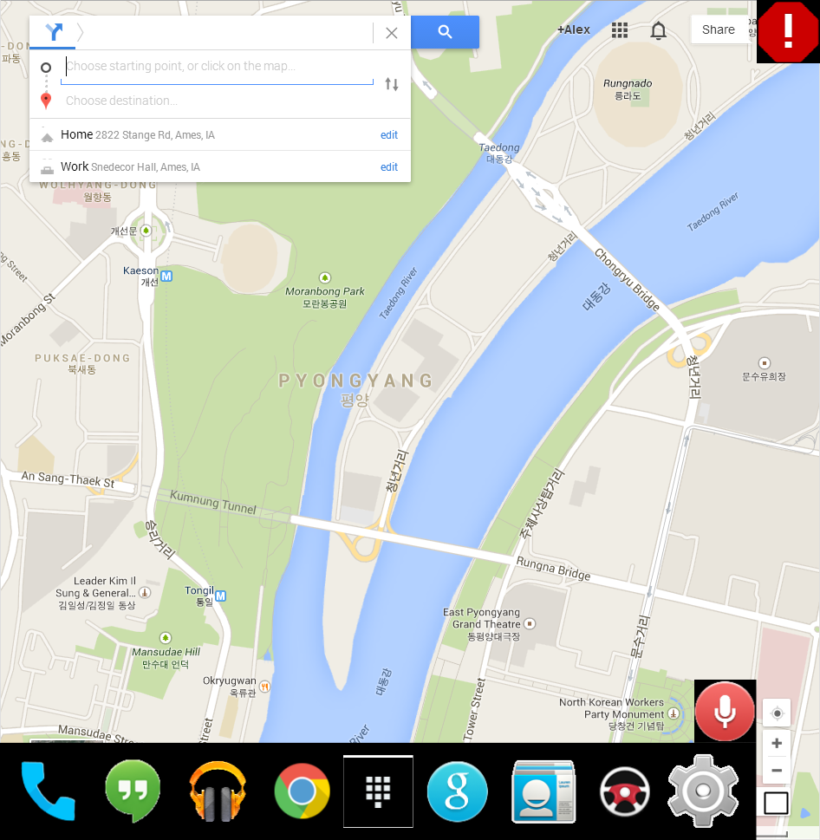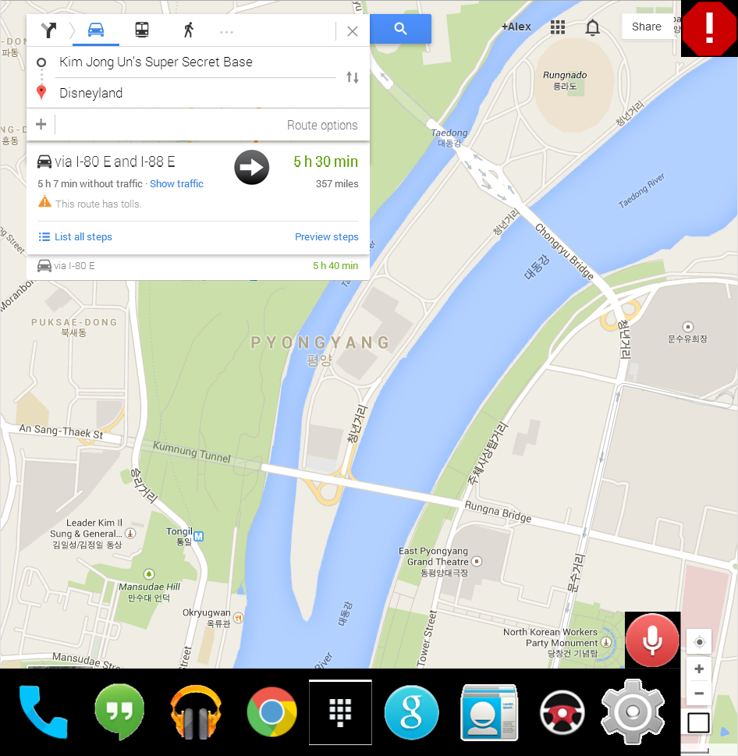

Base UI Screen (with book marked locations) Base UI screen navigation with alternative routes

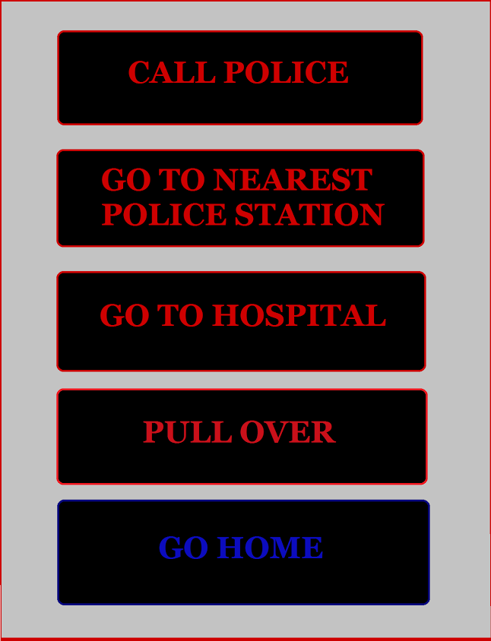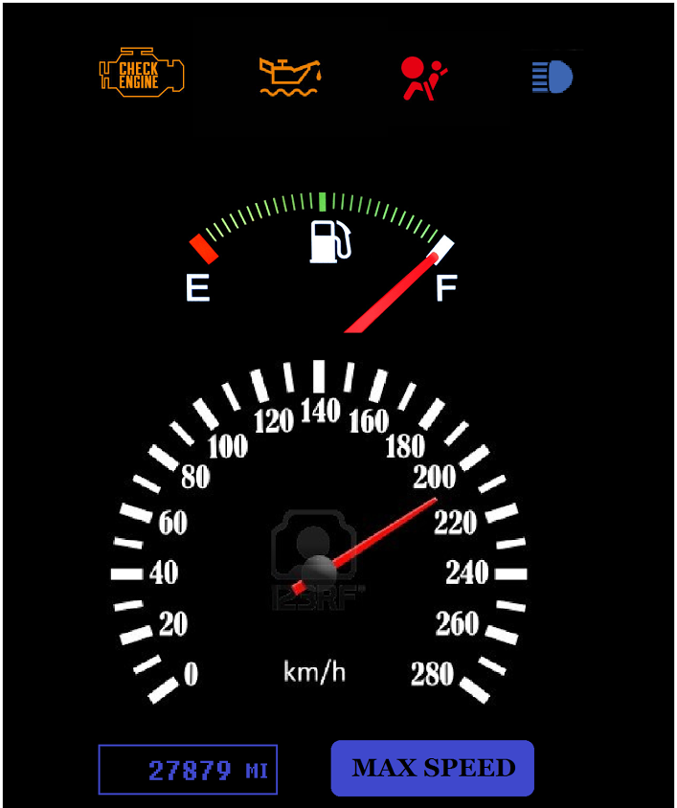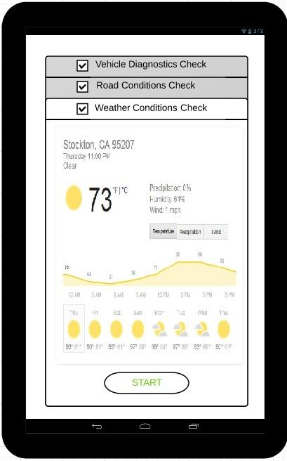

Emergency Screen Car Status screen Car start diagnostics

Please visit <http://github.com/ALShum/uh_stuff/tree/master/new2> for all screenshots of the UI used along with a flow chart to see which screens are connected together.