ALT-F1 We believe in the projects we work on

# WHY ALT-F1?

ALT-F1[1] designs, implements, deploys and supports secure, large-scale software solutions for diverse industries: Manufacturing, MRO, Warehouse, Broadcasting, Bank, Insurance, Defense, Automotive, Law Enforcement, Justice & Serious International Crime

# OUR COMMITMENT

We strive for superior performance, unmatched work ethic, simple and pragmatic approach, jargon-free language and insightful ideas

# ABOUT ALT-F1

ALT-F1 was incorporated in October 2010 after his CEO spent 15 years designing, implementing and supporting mostly public administrations dealing with law enforcement, justice and serious international crime

ALT-F1 are the keys you press to get a support from a software application



The logo represents a round-table around which people participate to bring their experience and knowledge. The innovation created during the conversations is represented by the jet of water on top of the logo.

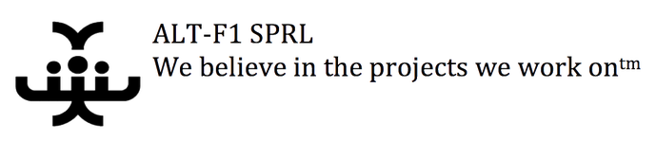

1. ALT-F1 home page : <http://www.alt-f1.be>