|  |
| --- |
| **PART 3 - DOCKER COMPOSE** |

1. Docker compose

This subcommand is used to create and start containers based on the services defined in the Compose file.

**docker compose up -d**

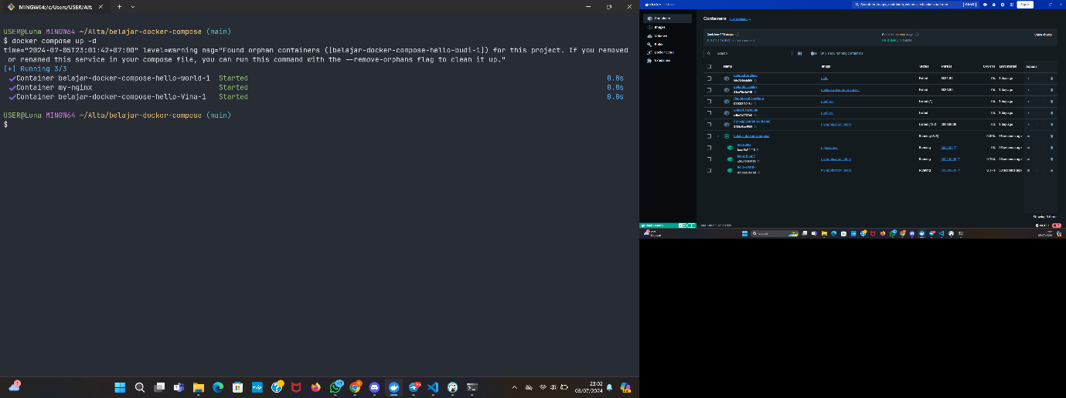

**docker compose down**

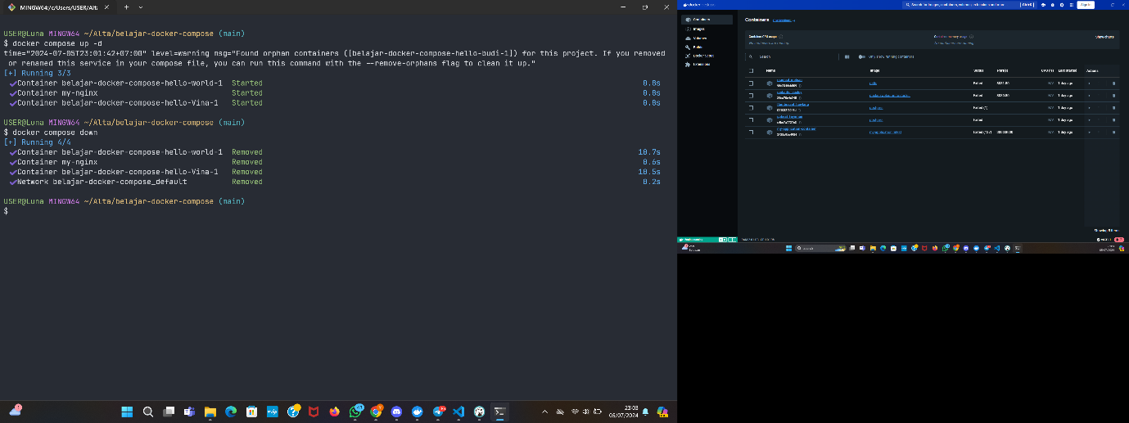

2. Result

localhost:3000

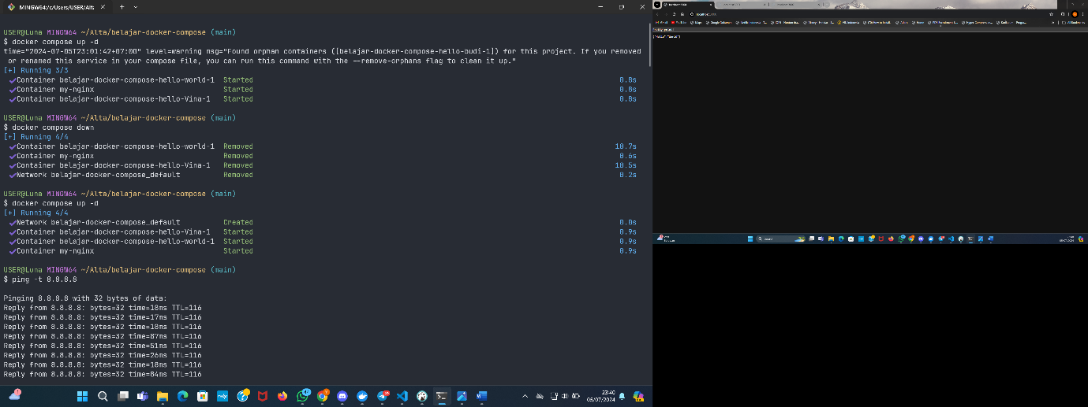

localhost:3001

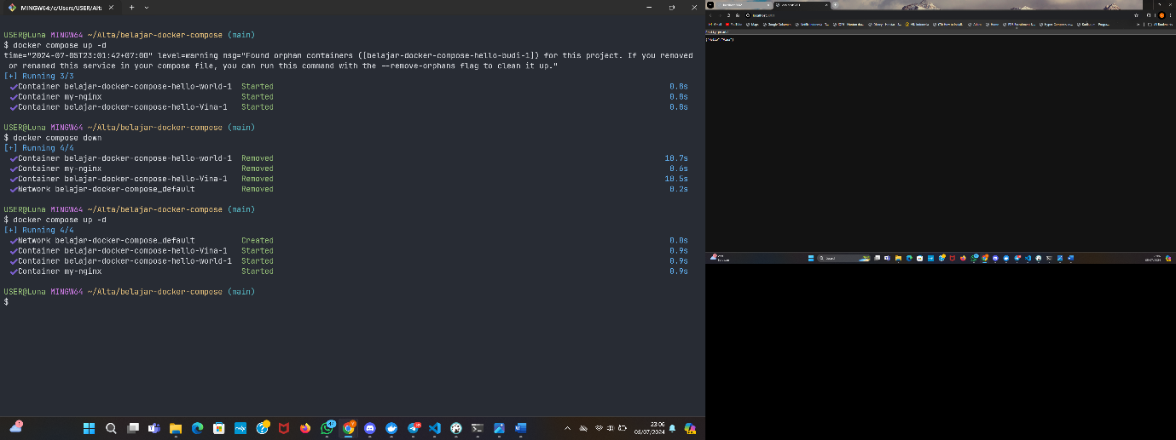

localhost:3002

