**TEACHING A CAR TO DRIVE**

**Key Contributors:**

**Sergio Duran Mata**

**Alvaro Ibarra**

**Cooper Gates**

**October 4th, 2022**

This project and the preparation of this report were funded in part by ….through an agreement with the University of the Incarnate Word.

Cyber Security Systems and the University of the Incarnate Word

**EXECUTIVE SUMMARY**

In this project, we will use deep learning models to determine the best model to teach a car how to drive. In this project, we will use a driving simulation, and each “race” simulation will represent an epoch. Using a loss function, the model will learn the correct way to traverse the track in the most efficient manner possible. After the model has been trained, we will test it using a different track. We will use multiple different learning models on both tracks to determine the best model for this program.

Project Milestones: E.g. Major steps required to complete your project.

Milestone 1: Use the different deep learning models to determine the best one we can use to teach a car how to drive a random track.

Milestone 2: Select the best deep learning model and work on the program to teach the car the best way to learn how to drive.

Milestone 3: Determine the percentage error on how many tries it needs to complete a track.

Materials List:

1. Program with python

2. Simulation for the car and track

3. Item 3 (Qty: #)

Deliverables: E.g. Report, Deployed architecture, other project outcomes etc.

1. A deep learning model that can have a car run through a given track without crashing.

2. Project Report on the best deep learning model for the car simulation.

3. Insight on how deep learning models can “teach” the car, as well as useful real world applications.

Professional Accomplishments: E.g. New skills that you developed

1. Ability to work with deep learning models

2. Accomplishment 2

3. Accomplishment 3

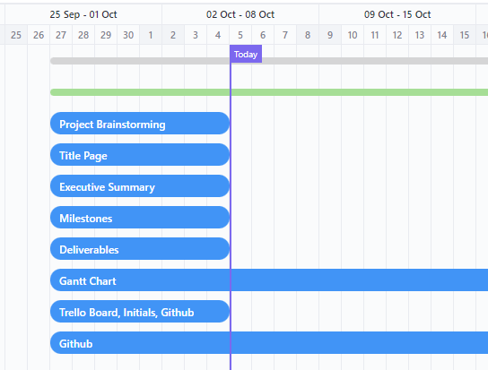

# **PROJECT SCHEDULE MANAGEMENT**

Create a Gantt chart with the application of your choice and replace it with the picture presented below.

IN PROCESS

Project Management Board Link (QR Code Only). Send invite to user: @gdparra

DONE

Create a Github Project Repository and add the user “cyberknowledge” as a contributor.

DONE

<https://github.com/your_username/your_project_repo_name>

**TABLE OF CONTENTS**

[List]

[SECTION HEADER]

[HEADER 1**]**

[Body Text]

[Header 2]

[Body Text]

[Header 3]

[Body Text]

**TITLE PAGE TITLE** (Calibri, 20 R: 0 G: 32 B: 96)

**Authors / Contributors** (Calibri, 20, RGB Hex: cb333b)(Logos can be used)

**Date** (Calibri, 20, RGB Hex: cb333b)

This project and the preparation of this report were funded in part by monies provided by CPS Energy through an agreement with The University of Texas at San Antonio.

ãCPS Energy and the University of Texas at San Antonio

**-----------------------------------------------------------------------------------------------------------------------------**

**EXECUTIVE SUMMARY**(Cambria, 15.5 RGB Hex: 003960)

TEXT (Cambria, 12 Black)

Sub-Text (Calibri, 9.5 Black)

**TABLE OF CONTENTS** (Cambria, 15.5 RGB Hex: 003960

TEXT (Cambria, 12 Black)

Sub-Text (Calibri, 9.5 Black)

**-----------------------------------------------------------------------------------------------------------------------------**

SECTION HEADER

(SECTION HEADER: Cambria, 26 RGB Hex: 003960)

**HEADER 1** (Cambria, 15.5 RGB Hex: 003960)

**Header 2** (Cambria, 14 RGB Hex: 005a98)

Header 3 (Cambria, 13 RGB Hex: cb333b)

Body Text (Calibri, 10.5 Black)

***Boxed Text*** (Calibri, 9.5 Black Bold Italics)

*Letter of Transmittal Sample*

November 23,2021

University of The Incarnate Word

Attention: Dr. Gonzalo. D. Parra

4301 Broadway

San Antonio, TX 78209

Dear Dr. Parra:

With this letter, the team ____________ transmits the following items associated with the **CIS 3353 Final Project**.

**SCOPE OF WORK (dated 11/23/2021): “Title of Your Work”**

· DELIVERABLES related to the _______ sub-task:

Aim 1:

Deliverable 1

Deliverable 2

Aim 2:

Deliverable 1

Deliverable 2

Please share these with your team as appropriate. If you have any questions, please contact ________ at (210) 458-8618 or by email at _________.

Kindest regards,

Team Lead

Student of Cyber Security Systems at the University of the Incarnate Word