Title Page (with author details)
Evaluation Protocol Outweighs Multimodal Fusion in Wearable and
Camera-Based Stress and Attention Monitoring:
A Systematic Review with Within-Study Meta-Analysis
Alvi Ibn Amzad Anil¹, Abtahi Noor¹, Md Saif Kabir^{1*}, Mohammad Fahim², Md. Mehedi Hasan Shawon², Sumaiya Akter², Md. Golam Rabiul Alam²
¹Department of Electrical and Electronic Engineering, BSRM School of Engineering, BRAC University, Dhaka, Bangladesh
²Department of Computer Science and Engineering, School of Data and Sciences, BRAC University, Dhaka, Bangladesh
alviamzad02@gmail.com, abtahinoor20@gmail.com, saif.kabir@bracu.ac.bd, mohammad.fahim@bracu.ac.bd, shawon.cse.bracu@gmail.com, sumaiya.akter.cse.bracu@gmail.com, rabiul.alam@bracu.ac.bd
Order of Authors: Alvi Ibn Amzad Anil; Abtahi Noor; Md Saif Kabir*; Mohammad Fahim; Md. Mehedi Hasan Shawon; Sumaiya Akter; Md. Golam Rabiul Alam.
Corresponding author:
Md Saif Kabir, Senior Lecturer, Office of Academic Advising (OAA); Adjunct Faculty, Department of Electrical and Electronic Engineering, BSRM School of Engineering, BRAC University, Dhaka, Bangladesh.
Email: saif.kabir@bracu.ac.bd
Author Contribution Statement:
Alvi Ibn Amzad Anil: Conceptualization, Methodology, Software, Validation, Formal Analysis, Investigation, Visualization, Writing – Original Draft. Abtahi Noor: Conceptualization, Methodology, Data Curation, Formal Analysis, Visualization, Writing – Review and Editing. Md Saif Kabir: Conceptualization, Validation, Supervision, Methodology, Project Administration, Writing – Review and Editing. Mohammad Fahim: Funding Acquisition. Md. Mehedi Hasan Shawon: Supervision, Funding Acquisition. Sumaiya Akter: Funding Acquisition. Md. Golam Rabiul Alam: Supervision, Funding Acquisition.
Evaluation Protocol Outweighs Multimodal Fusion in Wearable and
Camera-Based Stress and Attention Monitoring:
A Systematic Review with Within-Study Meta-Analysis

Abstract
Background: Multimodal fusion of wearable physiological sensing and camera-based sensing is widely presented as the route to deployable stress and attention monitoring. The supporting evidence, however, is assembled almost entirely from between-study comparisons in which fusion is confounded with the evaluation protocol, the cohort, the dataset and the task definition.
Methods: We systematically screened 116 unique records published between 2022 and 2026 and retained 60 studies reporting stress, attention, drowsiness or cognitive-load outcomes from wearable or camera-based sensing. Every included record was independently corroborated against the publisher or indexed record before use, and no value that could not be corroborated was carried into the synthesis. Rather than pooling headline accuracies across studies, we extracted only within-study contrasts, in which a single research team holds the cohort, the pipeline and the evaluation protocol fixed and varies one factor. This yields two estimands: the fusion gain, obtained by adding modalities under a matched protocol, and the evaluation-induced gap, obtained by changing personalization, deployment setting, dataset or task granularity.
Results: Headline outcomes were corroborable for 28 of 60 studies (46.7%); the validation protocol was recoverable for only 8 studies (13.3%) and a variance or confidence interval for 3 (5.0%). Across 4 protocol-matched contrasts, the median within-study fusion gain was +4.67 percentage points (pp, range +1.00 to +14.30). Across 10 within-study evaluation contrasts, the median gap was 9.14 pp (range 1.26 to 48.66), approximately twice the median fusion gain. Personalization alone accounted for a median gap of 38.03 pp, including a fall from 95.06% to 67.65% accuracy and from 91.71 to 43.05 F1 within a single study, and moving from the laboratory to free living cost 13.00 pp of F1. On WESAD, 9 of 10 corroborated records exceeded 86% and 7 of 9 exceeded 92% irrespective of architecture, and leave-one-subject-out results (median 94.59%) were indistinguishable from results whose protocol was never stated (median 95.06%). Reported accuracy was uncorrelated with cohort size (r=+0.15, k=15).
Conclusions: Under matched conditions the benefit of multimodal fusion is real but modest, and it is smaller than the performance swing produced by evaluation choices that are frequently left unreported. WESAD has saturated to the point where it no longer discriminates between architectures. We conclude with a reporting specification for translational work and argue that subject-independent, cross-dataset and free-living evaluation, not further architectural elaboration, is the binding constraint on deployable systems.
Keywords: stress detection; attention monitoring; multimodal fusion; wearable biosensors; evaluation protocol; generalization.

Introduction

Background and Motivation
Stress and attention are the two physiological and cognitive states that most directly govern human performance, safety and long-term health. Acute stress mobilizes the autonomic nervous system, and sustained or repeated activation degrades sustained attention, working memory and decision quality. In settings where a lapse is consequential, such as driving, clinical care, aviation and industrial operation, continuous and objective measurement of these states has clear practical value. That motivation has driven work in occupational health [1–3], clinical monitoring [4–6], road safety [7–9], education [10–12] and free-living daily life [13–15].
The engineering question, however, has shifted. Enough is now known about which signals carry stress-related information that the open problem is no longer detection in principle but detection that survives contact with a new person, a new day and a new environment. This review is organized around that shift.

Sensing Modalities
Wearable devices sample autonomic activity through electrocardiography (ECG) and the heart-rate variability (HRV) derived from it, photoplethysmography (PPG) and blood volume pulse, electrodermal activity (EDA), skin temperature, respiration and electroencephalography (EEG). Research-grade wristbands [16], consumer smartwatches [14,18], in-ear devices [19], behind-the-ear EEG [20] and custom sensor packages [21] now cover most of the practical design space. Inertial measurement units are almost always co-located, supplying the motion context needed to separate autonomic arousal from physical exertion [17,23].
Camera-based sensing supplies a complementary, contactless channel. Facial action unit analysis, gaze and blink dynamics and head pose expose behavioral and affective information that physiology does not carry, while remote PPG recovers cardiac information from subtle color changes in ordinary RGB video and so overlaps directly with the wearable channel [24]. Systems that combine camera streams with wearable PPG and EDA in a single pipeline are now reported in workplace settings [25]. Figure 1 shows the canonical processing chain shared by the systems reviewed here, from acquisition through conditioning, representation, fusion and inference to the decision or closed-loop actuation stage. The element we place on an equal footing with the others, and which motivates this review, is the evaluation protocol: it is not a reporting detail appended to a system but the stage that determines what any reported accuracy actually means.
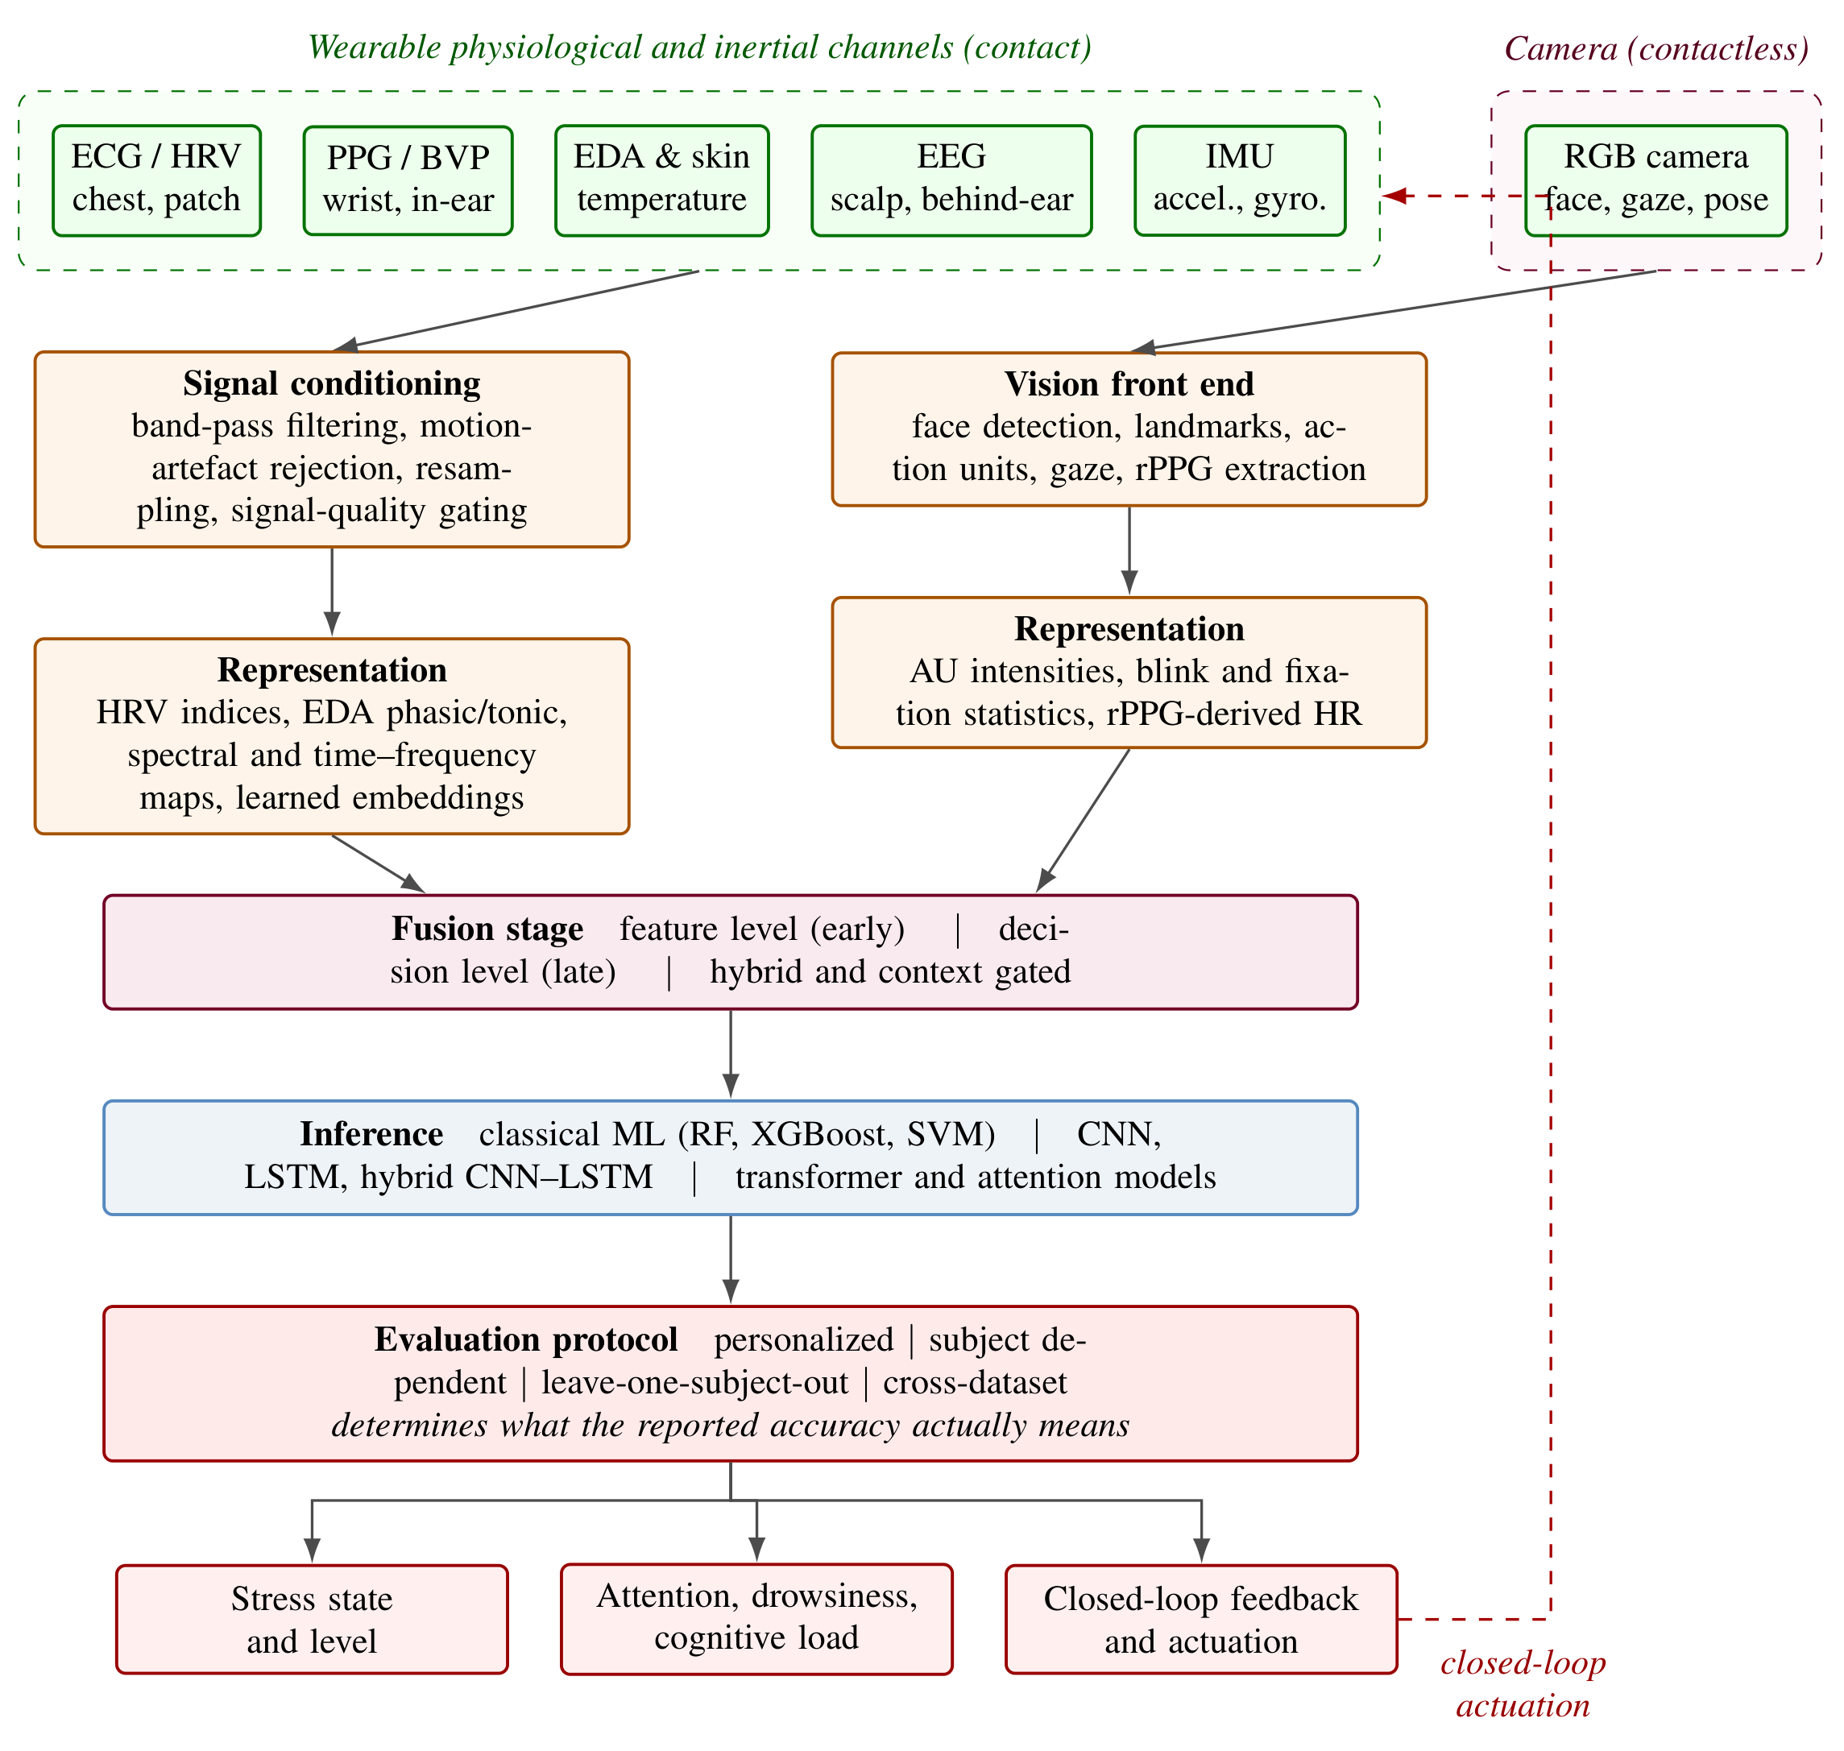
Figure 1: Processing chain shared by wearable and camera-based stress and attention monitoring systems. Contact channels and the contactless camera channel are conditioned and represented separately, combined at a feature, decision or hybrid fusion stage, and passed to an inference model. The evaluation protocol stage is drawn explicitly because the same model and the same data yield materially different reported performance depending on whether evaluation is personalized, subject dependent, subject independent or cross-dataset. The dashed return path denotes closed-loop actuation.

Limitations of Unimodal Approaches and the Case for Integration
Each modality fails in characteristic ways. Wearable signals are corrupted by motion artefacts and variable skin contact, and physiological arousal caused by exertion is not separable from arousal caused by stress without contextual information [17,23]. Camera-based systems depend on illumination, an unoccluded face and a favorable viewing angle, and observe only the externally expressed surface of an internal state.
The standard argument is that these failure modes are complementary, so fusing the channels should be more than additive. The argument is plausible, and several studies do report gains. What is rarely examined is the magnitude of that gain once it is measured properly. Almost all quantitative support for fusion in this literature is assembled by comparing the accuracy reported by a multimodal study against the accuracy reported by a different unimodal study. Those two numbers differ in cohort, stressor protocol, label source, class definition, preprocessing and, critically, validation scheme. A between-study difference therefore estimates the sum of all of these, not the effect of fusion. This review is built on the observation that a much cleaner estimate is available and has not been systematically exploited: within a single study, a single team frequently reports a unimodal baseline and a fused model under an identical protocol, and separately reports the same model under two different evaluation regimes. These within-study contrasts identify the fusion effect and the evaluation effect on the same scale, and permit them to be compared directly.

Research Questions and Objectives
Prior reviews of wearable stress monitoring have documented that generalization is weak [26], and prior reviews of affective computing survey physiological and vision-based modalities largely in parallel. Neither has quantified how the benefit attributed to fusion compares with the performance swing produced by evaluation design. This review addresses that gap through three questions:
RQ1: When fusion gain is estimated only from within-study, protocol-matched comparisons, how large is it? This matters because every deployment decision that favours a second sensor over a single one is justified by an assumed magnitude, and that magnitude has never been isolated from its confounds.
RQ2: How does that fusion gain compare with the within-study performance difference attributable to evaluation choices, namely personalization, deployment setting, dataset and task granularity? This matters because if the second effect dominates, the field’s optimization target is misplaced.
RQ3: Has the dominant benchmark saturated, and how completely is the evidence base reported and independently verifiable? This matters because a saturated benchmark combined with unreported protocols makes architectural progress unfalsifiable.
The review pursues five objectives:
- O1: Assemble a topically screened corpus of 2022 to 2026 studies in which every bibliographic record is independently corroborated.
- O2: Carry only corroborated outcome values into the synthesis and report the corroboration and reporting-recovery rates as evidence in their own right.
- O3: Estimate the within-study fusion gain under matched protocols.
- O4: Estimate the within-study evaluation-induced gap and compare the two on a common scale.
- O5: Test benchmark saturation and derive a reporting specification for translational work.
Section 2 reviews unimodal and integrated work and the limits of prior surveys. Section 3 gives the review and verification methodology. Section 4 reports results against the objectives. Section 5 synthesizes the trends. Sections 6 and 7 discuss and conclude.

Overview of Related Works

Unimodal Wearable Sensor-Based Approaches
Single-channel wearable sensing remains a strong baseline and, importantly for the argument developed here, frequently matches multimodal systems on public benchmarks. EDA is the most direct peripheral index of sympathetic arousal and has been used alone for binary stress classification across four public corpora [27] and in privacy-preserving federated settings [28]. HRV derived from ECG supports stress classification in factory workers [2], physicians [29] and office employees [3], and ECG-derived multifractal descriptors have been proposed specifically to separate cognitive stress from physical activity [30].
PPG has attracted the most recent methodological attention because it is the channel available on consumer hardware. Lightweight architectures operating on blood volume pulse alone now report 98.23% accuracy with an AUC of 0.9953 on WESAD [31] and 96.94% under leave-one-subject-out (LOSO) validation [32], while a separable-attention dilated network evaluated under LOSO across two cohorts reports 92.25% [33]. In-ear PPG transformed into time-frequency images and classified with a vision transformer reaches 97.78% [19]. EEG offers the greatest neurophysiological specificity, and miniaturised behind-the-ear devices with on-chip inference have made it more practical [20], although headset intrusiveness still limits naturalistic use.
The essential observation is that these unimodal systems are not obviously worse than the multimodal systems they are implicitly compared against. That observation is the starting point for the present analysis.

Unimodal Computer Vision-Based Approaches
Camera-based affect and attention sensing rests on facial expression analysis, gaze and blink dynamics, head pose and camera-derived physiological proxies. Facial action unit decomposition supports inference of cognitive load and engagement, and gaze statistics such as fixation duration and blink rate index attentional focus and fatigue.
Remote PPG is the most direct bridge between the two sensing families because it recovers a cardiac signal without contact. A multi-task attentional convolutional network operating on rPPG extracted from facial video reports 94.33% accuracy for binary stress state and 83.83% for graded stress level [24], a within-study contrast we return to in Section 4.3. Camera-based systems nevertheless remain constrained by illumination, occlusion and viewing angle, and observe behaviour rather than autonomic state.

Integrated Systems and the Limits of Prior Surveys
Integration has progressed from simple concatenation of physiological and visual features before a shared classifier, through decision-level combination of modality-specific classifiers, to hybrid and context-gated schemes that adapt the fusion rule to sensing conditions [23,34]. Genuinely integrated wearable and camera systems exist: facial features extracted from RGB video have been combined with wearable PPG and EDA for workplace stress assessment [25], and physiological wristband features have been combined with facial action units and gaze in an office cohort [35]. Closed-loop designs that couple PPG-based sensing to transcutaneous median nerve stimulation for acute stress mitigation [36] and multimodal bioelectronic wristbands that add molecular biomarkers to physiological channels [22] extend the same architecture towards therapeutic control.
Existing reviews, however, treat the two sensing families largely in parallel and synthesize performance by pooling headline numbers. The most rigorous prior synthesis concluded that most wearable stress models lack generalization [26], a qualitative verdict that this review converts into a quantitative one. No prior survey, to our knowledge, restricts its quantitative synthesis to within-study contrasts, and none places the fusion effect and the evaluation effect on a common scale. That is the gap addressed here.

Methodology

Search Strategy and Corpus Construction
The review covers peer-reviewed journal articles published between 1 January 2022 and 31 March 2026 that report quantitative detection or monitoring of stress, attention, drowsiness or cognitive load from wearable physiological sensing, camera-based sensing, or their combination. The source corpus comprised 117 numbered bibliographic records assembled from IEEE Xplore, ScienceDirect, MDPI, PLOS, SpringerLink, JMIR and BMC across the wearable sensing, affective state monitoring and machine learning literatures. One record was a duplicate citation of a study already present, leaving 116 unique records for screening.
Because the analytic claims of this review depend on the integrity of the underlying records, corpus composition is reported by publisher of record rather than by an unverifiable count of raw database hits. Table 1 gives the screening yield for each publisher. IEEE titles dominate both the screened pool and the included set, reflecting the concentration of wearable sensing methodology in IEEE sensor, biomedical and affective computing journals, while the PLOS records show the lowest inclusion yield because that portion of the pool is weighted towards clinical and device-validation work outside the present scope.
Table 1: Composition of the screened corpus and inclusion yield by publisher of record. Inclusion yield is the proportion of screened records from that publisher that met all eligibility criteria.
Publisher of record | Records screened | Studies included | Records excluded | Inclusion yield (%)
IEEE | 30 | 27 | 3 | 90.0
PLOS | 22 | 6 | 16 | 27.3
Elsevier | 21 | 8 | 13 | 38.1
Springer Nature | 16 | 4 | 12 | 25.0
MDPI | 11 | 10 | 1 | 90.9
JMIR | 7 | 2 | 5 | 28.6
Springer | 3 | 2 | 1 | 66.7
BMC | 2 | 1 | 1 | 50.0
medRxiv | 1 | 0 | 1 | 0.0
Research Square | 1 | 0 | 1 | 0.0
ACM | 1 | 0 | 1 | 0.0
RSC | 1 | 0 | 1 | 0.0
Total | 116 | 60 | 56 | 51.7

Inclusion and Exclusion Criteria
Eligibility was assessed against the pre-specified criteria in Table 2. Two criteria differ from common practice in this literature and account for most exclusions. First, the outcome criterion is strict: a study qualifies only if it reports a psychological stress, attention, drowsiness or cognitive-load outcome. Wearable studies whose outcome is cardiac arrhythmia, sleep staging, seizure detection, glucose, physical fatigue, human activity recognition or materials characterisation were excluded even when they are frequently cited in stress-monitoring reviews, because pooling them inflates apparent coverage without contributing evidence about the states of interest. Second, independent corroboration of the bibliographic record was itself a requirement rather than a courtesy.
Table 2: Eligibility criteria and the number of records excluded under each. Exclusion reasons are mutually exclusive and were applied in the order listed.
Domain | Included | Excluded | Records excluded
Publication window | Published January 2022 to March 2026. | Published before January 2022. | 2
Publication type | Peer-reviewed journal article. | Preprints, conference papers, book chapters, editorials. | 3
Outcome | Psychological stress, attention, inattention, drowsiness, cognitive load or mental workload. | Any other physiological or clinical outcome, including arrhythmia, sleep staging, seizures, glucose, physical fatigue and activity recognition. | 41
Study type | Empirical study reporting a quantitative evaluation of a detection or monitoring model. | Study protocols, narrative reviews, technology-acceptance studies and intervention trials without a detection model. | 10
Technology | Wearable physiological or inertial sensing, camera-based sensing, or their fusion, with an ML or DL model. | Purely theoretical work with no applied sensing component. | 0
Verifiability | Bibliographic record independently corroborated against the publisher or indexed record. | Record that could not be corroborated. | 0
Total excluded |  |  | 56
Total included |  |  | 60

Screening, Selection and Verification
Screening followed PRISMA and is summarized in Figure 2. Of 116 unique records, 56 were excluded at eligibility appraisal, 41 of them because the reported outcome fell outside the stress, attention and cognitive-load scope, 10 because no quantitative model evaluation was reported, 3 because the record was a preprint or conference paper and 2 because it fell outside the publication window. Sixty studies met all criteria.
Verification was then applied to all 60 included studies. For each, the title, authors, journal, year, volume, pagination and DOI were checked against the publisher or indexed record, and the reported headline outcome was sought in the same source. A value was carried into the quantitative synthesis only where it could be recovered from the openly retrievable record; values that could not be recovered were left coded as not recovered rather than imputed, and no value was taken on the authority of a secondary citation. Twenty-eight of the 60 studies yielded a corroborated headline outcome, contributing 34 outcome records, 4 within-study fusion contrasts and 10 within-study evaluation contrasts. The remaining 32 studies are retained in the narrative synthesis, where their design and findings are described, but contribute no numbers.
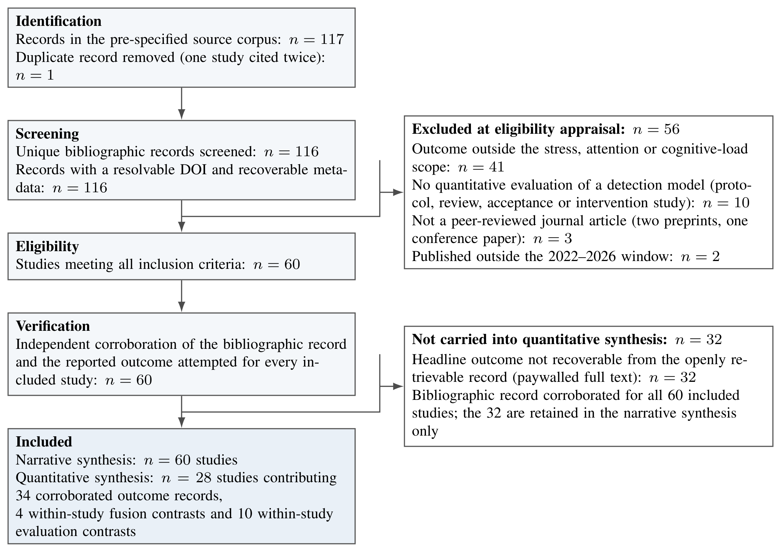
Figure 2: PRISMA flow of record identification, screening, eligibility appraisal, independent verification and inclusion. The verification stage is additional to the standard PRISMA template and is reported because it determines which studies contribute quantitative evidence.
Figure 3 characterizes the included corpus. Figure 3(a) shows the number of included studies per publication year, decomposed by application area, and Figure 3(b) shows the aggregate distribution across application areas. Output grew from 6 studies in 2022 to 17 in 2025, with 9 in the partial 2026 window. Laboratory studies dominate at 19 of 60 (32%), and a further 12 (20%) are benchmark-only studies that report no new data collection at all. Together these account for just over half the corpus, whereas free-living daily-life deployments account for 9 (15%) and the high-consequence driving and aviation settings that most motivate the field account for 4 (7%) combined. The evidence base is therefore concentrated precisely where evaluation conditions are most favorable and least representative of deployment.
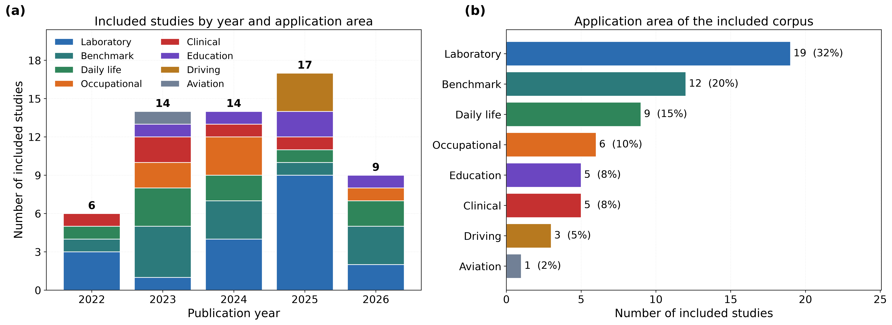
Figure 3: Composition of the included corpus. Figure 3(a) shows the number of included studies per publication year, with each bar decomposed by application area and the annual total printed above the bar. Figure 3(b) shows the total number of included studies in each application area with the corresponding percentage of the corpus.
Figure 4 summarizes the screening outcome. Figure 4(a) shows the number of records excluded under each eligibility criterion, and Figure 4(b) shows the publisher of record for the included studies. Out-of-scope outcomes account for 41 of 56 exclusions (73%), which quantifies how much of the material customarily cited in this area does not in fact report a stress or attention outcome.
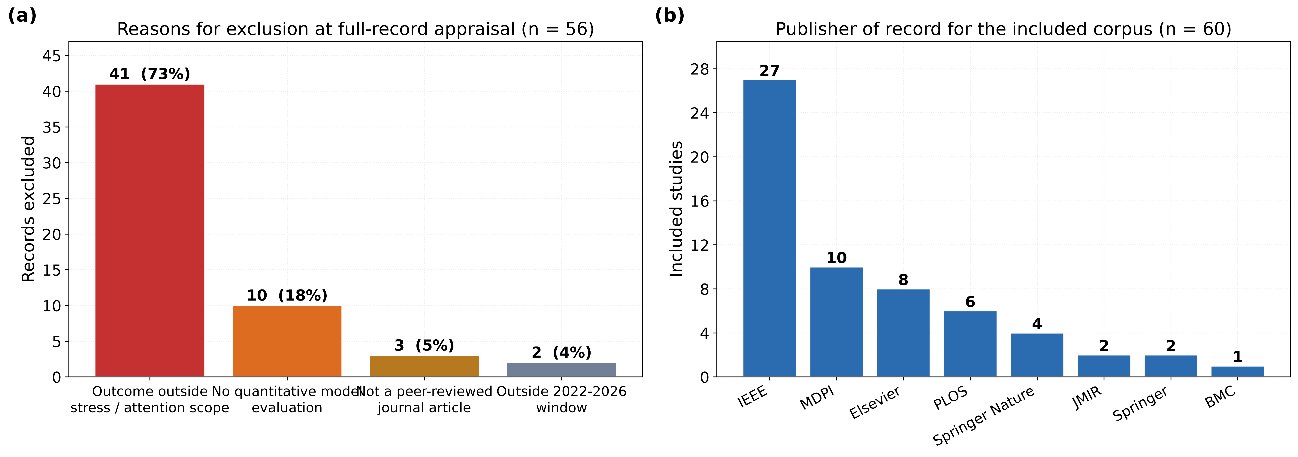
Figure 4: Screening outcome and corpus provenance. Figure 4(a) shows the number of records excluded under each eligibility criterion, with the percentage of all exclusions annotated. Figure 4(b) shows the publisher of record for the 60 included studies.

Reporting Appraisal
In place of a generic quality checklist, each included study was appraised on whether five items material to interpreting a reported result could actually be recovered: the headline performance metric, the size of the evaluation cohort, the validation protocol, whether a public benchmark was used, and whether any variance or confidence interval accompanied the point estimate. These items were chosen because each is necessary to decide whether a reported number transfers. Results are given in Table 3 and analyzed in Section 4.4.
Table 3: Recovery of reporting items across all 60 included studies. An item is counted as recovered only where it was explicitly obtained from the openly retrievable record during verification. Rates therefore bound, from below, how completely this evidence base can be interpreted by a reader without subscription access.
Reporting item | Recovered (k) | Not recovered | Recovery rate (%)
Headline metric | 28 | 32 | 46.7
Evaluation cohort size | 18 | 42 | 30.0
Validation protocol | 8 | 52 | 13.3
Public benchmark used | 14 | 46 | 23.3
Variance or CI reported | 3 | 57 | 5.0

Synthesis Strategy
Two estimands are defined. The fusion gain is the difference, within one study, between the best single-modality result and the multimodal result obtained on the same cohort, with the same pipeline and under the same validation protocol. The evaluation-induced gap is the difference, within one study, between the most favorable and the most realistic evaluation condition reported for the same model, where the varied factor is personalization, deployment setting, dataset or task granularity.
Restricting both estimands to within-study contrasts removes the between-study confounds of cohort, stressor, labeling and preprocessing, at the cost of a small number of eligible contrasts. Given that k, effect sizes are summarized by the median and full range rather than by a pooled random-effects estimate, and no significance testing is performed; the comparison of interest is the relative magnitude of two medians, not a hypothesis test. Accuracy and AUROC differences are both expressed in percentage points (pp) and are reported separately by metric in the tables so that no cross-metric arithmetic is implied.

Results

The Corroborated Evidence Base
Table 4 lists every outcome record carried into the synthesis, with its sensing configuration, evaluation data, cohort size, validation protocol, metric and value. Across the 29 accuracy records the median is 93.00% with an interquartile range of 87.37 to 96.09%. Two features of the table are more informative than that central tendency. First, the protocol column is dominated by Not reported: only 8 of the 60 included studies state a validation protocol recoverably, so for most records it cannot be determined whether the reported number reflects subject-dependent or subject-independent performance. Second, the highest values in the table belong to unimodal systems. Blood volume pulse alone reaches 98.23% on WESAD [31], and in-ear PPG alone reaches 97.78% [19], both above every multimodal record in the table. This is already inconsistent with a strong reading of the fusion hypothesis.
Table 4: Corroborated outcome records contributing to the quantitative synthesis. Every value was recovered from the publisher or indexed record; no value is taken from a secondary citation. LOSO denotes leave-one-subject-out validation and NR denotes a cohort size or protocol that could not be recovered.
Study | Year | Sensing configuration | Evaluation data | n | Protocol | Metric | Value (%)
Abdul Kader et al. [58] | 2024 | EEG+GSR | In-house | 20 | Not reported | Accuracy | 84.60
Ali et al. (ReTeNet) [31] | 2025 | BVP | WESAD | 15 | Not reported | Accuracy | 98.23
Ali et al. (SADDNet) [33] | 2026 | PPG | CATSA+WESAD | 50 | LOSO | Accuracy | 92.25
Ali et al. (TEANet) [32] | 2026 | BVP | WESAD | 15 | LOSO | Accuracy | 96.94
Ali et al. (TEANet) [32] | 2026 | BVP | RUET-SPML | 19 | LOSO | Accuracy | 92.94
Alsahreef et al. [29] | 2026 | HRV | PARFAIT | NR | Not reported | Accuracy | 98.10
Awada et al. [35] | 2024 | EDA+BVP+TEMP+behav. | In-house (office) | NR | Not reported | Accuracy | 82.78
Barki et al. [19] | 2025 | In-ear PPG | In-house | 15 | Not reported | Accuracy | 97.78
Campanella et al. [16] | 2023 | PPG+EDA | In-house | 29 | Not reported | Accuracy | 90.00
Chen & Lee [11] | 2023 | ECG | In-house | NR | Not reported | Accuracy | 93.42
Donati et al. [2] | 2023 | ECG | In-house (factory) | NR | Not reported | Accuracy | 88.40
El Arwadi & Abu Daher [55] | 2025 | ECG (HRV) | In-house | NR | LOSO | Accuracy | 90.80
Fernandez et al. [10] | 2025 | EEG | In-house | NR | Subject indep. | Accuracy | 86.24
Gedam et al. [12] | 2025 | ECG+GSR+TEMP | In-house | 200 | Not reported | Accuracy | 96.17
Hongn et al. [17] | 2025 | EDA+BVP+TEMP+ACC | In-house (public) | 36 | Not reported | Accuracy | 93.00
Khayyat et al. [3] | 2024 | HRV | WESAD | 15 | Not reported | Accuracy | 96.76
Khayyat et al. [3] | 2024 | HRV | SWELL-KW | 25 | Not reported | Accuracy | 92.76
Kim et al. [59] | 2024 | EEG+GSR | In-house (VR interview) | 30 | Not reported | AUROC | 95.40
Kim et al. [61] | 2025 | HR+step count | In-house (free living) | NR | Not reported | Accuracy | 74.40
Kumar et al. [18] | 2024 | PPG+EDA+TEMP | In-house | NR | Not reported | Accuracy | 94.00
Laiti et al. [60] | 2026 | PPG (HRV) | WESAD | 15 | Not reported | AUROC | 91.58
Laiti et al. [60] | 2026 | PPG (HRV) | Wellby (real world) | NR | Not reported | AUROC | 77.02
Li & Washington [57] | 2024 | BVP+EDA+TEMP | WESAD | 15 | Personalized | Accuracy | 95.06
Li & Washington [57] | 2024 | BVP+EDA+TEMP | WESAD | 15 | Subject indep. | Accuracy | 67.65
Mohammadi et al. [21] | 2022 | ECG+EDA+RESP+TEMP | WESAD | 15 | Not reported | Accuracy | 96.00
Momeni et al. [43] | 2022 | ECG+EDA+RESP+TEMP | In-house | NR | Not reported | Accuracy | 90.98
Rashid et al. [34] | 2023 | BVP+EDA+TEMP+ACC | WESAD | 15 | Not reported | Accuracy | 94.12
Rashid et al. [34] | 2023 | BVP+EDA+TEMP+ACC | WESAD | 15 | Not reported | Accuracy | 86.34
Rescio et al. [1] | 2024 | EEG+ECG+EDA | In-house | NR | Not reported | Accuracy | 95.38
Shikha et al. [46] | 2024 | EDA+BVP+HRV | In-house | NR | Not reported | Accuracy | 98.28
Toshnazarov et al. [14] | 2024 | PPG+ACC+context | In-house (lab) | 26 | Not reported | F1 | 84.00
Toshnazarov et al. [14] | 2024 | PPG+ACC+context | In-house (field) | 18 | Not reported | F1 | 71.00
Xu et al. [24] | 2024 | Facial video (rPPG) | In-house | NR | Not reported | Accuracy | 94.33
Xu et al. [24] | 2024 | Facial video (rPPG) | In-house | NR | Not reported | Accuracy | 83.83
Median corroborated accuracy across 29 accuracy records |  |  |  |  |  |  | 93.00
Interquartile range |  |  |  |  |  |  | 87.37–96.09
Figure 5 groups the corroborated accuracy records by sensing configuration. Median accuracy for single-channel PPG, BVP or ECG systems is close to that of configurations combining three or more physiological channels, and the camera-based records sit within the same band. The distributions overlap almost completely. Because these are between-study comparisons they cannot support a causal claim in either direction, which is precisely why the analysis in Sections 4.3 and 4.4 is restricted to within-study contrasts; what Figure 5 does establish is that the between-study evidence conventionally cited in support of fusion contains no visible modality effect to begin with.
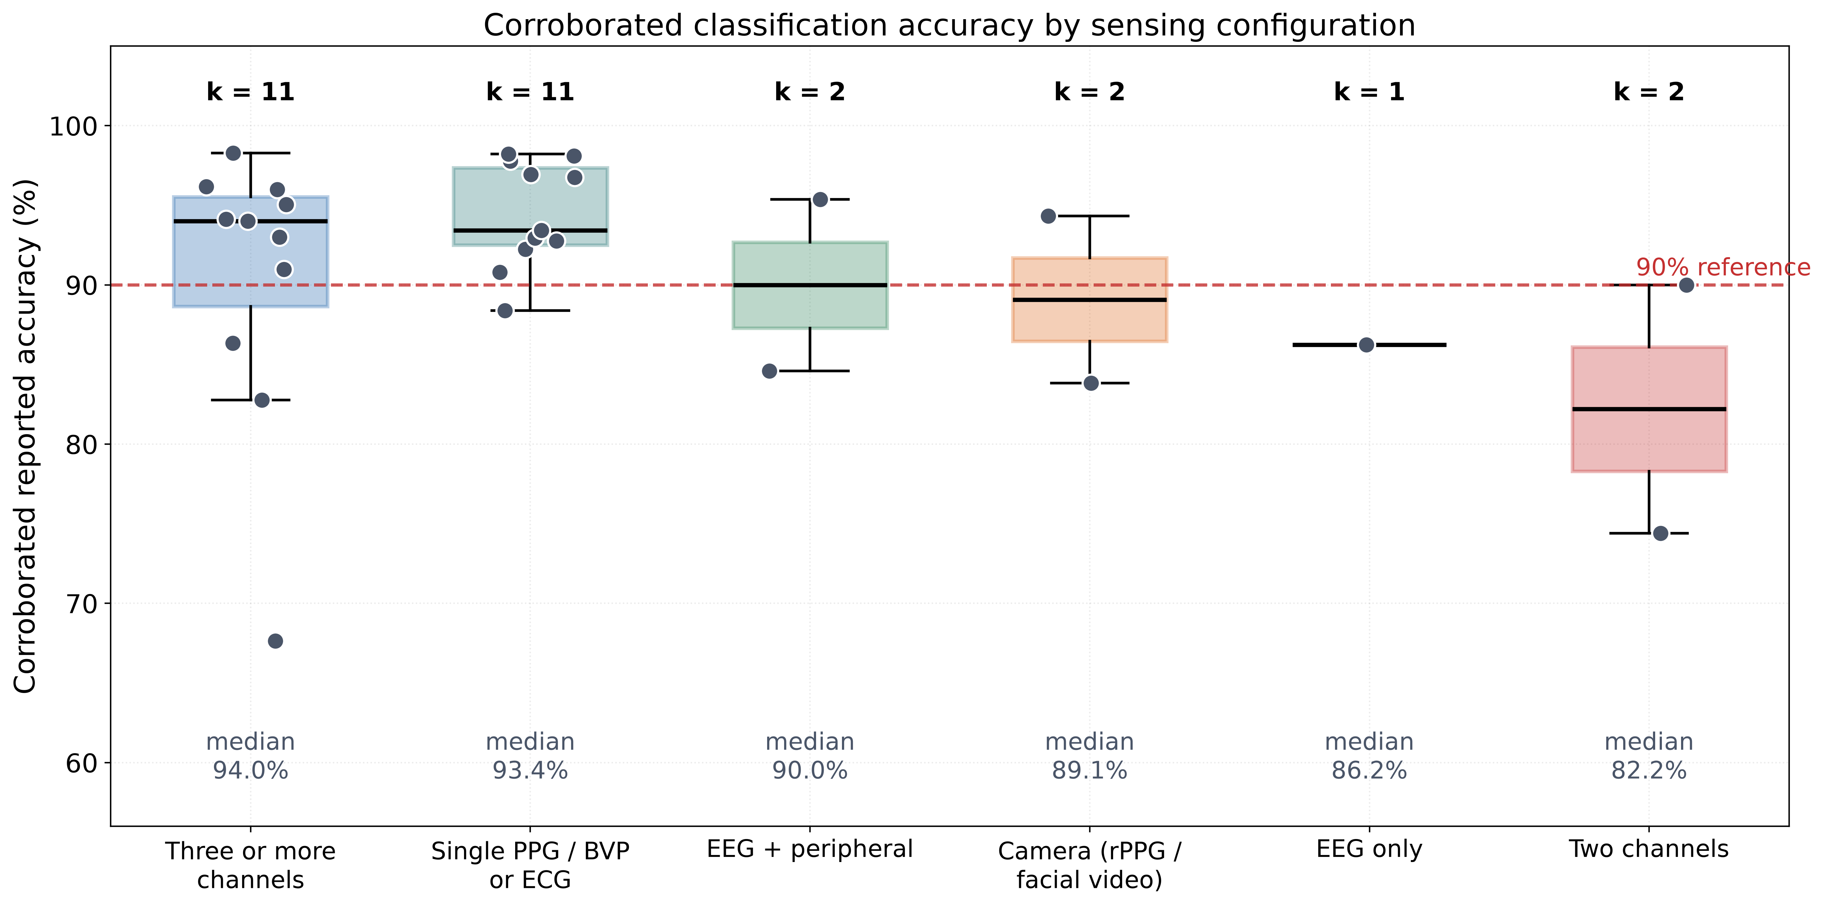
Figure 5: Corroborated classification accuracy grouped by sensing configuration. Boxes show the median and interquartile range, individual records are overlaid, and the number of records k and the group median are annotated. The distributions overlap across configurations, including between single-channel and three-or-more-channel systems.

Studies Retained in the Narrative Synthesis
Thirty-two included studies contribute no numbers because their headline outcome could not be recovered from the openly retrievable record, yet they define the methodological landscape that the quantitative findings must be read against. Four themes recur.
Architectural elaboration: Hybrid and generative designs dominate recent output. A hybrid CNN-transformer with copula-GAN augmentation and Monte Carlo dropout for uncertainty quantification was evaluated on heart rate and respiratory rate from 34 participants [37]; a hybrid CNN-MLP was applied to multi-channel physiological input [38]; a transformer was applied to five physiological channels from 14 pilots [39]; a conditional GAN was used to synthesize physiological time series to address label scarcity [40]; and a time-series foundation model was fine-tuned for continuous, explainable stress monitoring from a wristband [41]. A study explicitly framed around the complexity-intrusiveness trade-off compared classical and deep models against how much daily-life intrusion each device requires [42], which is the design question this review’s findings bear on most directly.
Deployment constraints: Several studies target the constraints that matter for translation rather than accuracy alone. Cost-aware feature selection traded prediction power against energy, reducing energy cost by up to 94.37% while retaining 90.98% accuracy [43]; context-aware selective fusion achieved $2.2×$ and $2.7×$ energy efficiency over conventional fusion on the same hardware [34]; federated learning was used to keep wrist EDA on-device [28]; and secure cloud-connected frameworks were developed for clinical populations [44]. Explainability appears both as SHAP and LIME attribution over deep models [45] and as genetic-algorithm feature reduction with Bayesian hyperparameter optimization [46].
Measurement validity: A smaller group interrogates whether the signals mean what they are assumed to mean. Multi-wavelength PPG was validated against microneurography as a surrogate for stress-induced sympathetic activation [47]; the relative contribution of ECG, respiration, GSR and PPG to the stress response was assessed feature by feature, with at least two statistically significant features recovered from each channel [48]; salivary cortisol was used as the reference standard for a context-aware digital biomarker in older adults [49]; and rule-based individualised processing of EDA and skin temperature was proposed in place of a learned model [50]. Others characterize instrumentation, from flexible single-lead cardiac electrodes [51] to multi-parameter assessment platforms [52] and wearable bands combining PPG-derived heart rate with GSR [53].
Generalization as an explicit target: Three studies treat transfer as the object of study rather than a limitation. An ensemble of gradient boosting and a neural network trained on a synthesized 200-subject corpus pooled from SWELL, NEURO, WESAD and UBFC-Phys reported 25% better predictive performance than singular models, with data and code released publicly [54]. Subject-specific baseline normalization against resting state supported 90.8% accuracy under LOSO validation [55]. Sleep data from a consumer ring was used to predict perceived stress longitudinally in first-year students, an outcome regime in which the achievable performance is far below laboratory figures [56]. These are the studies whose design most closely anticipates the conclusions drawn in Sections 4.3 and 4.4.

Benchmark Saturation
WESAD is the reference dataset of this literature and supplies 10 of the 34 corroborated outcome records. Figure 6 examines what those records actually discriminate. Figure 6(a) ranks every corroborated WESAD result by accuracy and colors each by validation protocol; Figure 6(b) stratifies the same records by protocol.
Excluding the single subject-independent generalized evaluation, 9 records span 86.34% to 98.23% and 7 of those 9 exceed 92%. That band is occupied indiscriminately by a context-aware wrist ensemble [34], a capsule network on HRV features [3], a k-nearest-neighbour classifier on 65 handcrafted features [21], a residual transformer on blood volume pulse [31] and a transpose-enhanced autoencoder [32]. A classical KNN pipeline at 96.00% [21] is not meaningfully separated from a transformer at 98.23% [31]. When architectures spanning two decades of methodological development are compressed into two percentage points, the benchmark is no longer measuring architecture.
Figure 6(b) makes the more consequential point. The median of the records whose protocol was never stated is 95.06%, and the median of the records explicitly validated leave-one-subject-out is 94.59%. These are indistinguishable, which means protocol reporting on WESAD currently carries almost no information. The single record evaluated as a subject-independent generalized model falls to 67.65% [57], more than 27 pp below every other record on the same dataset. The saturation is therefore not uniform: WESAD is saturated for subject-dependent and LOSO evaluation and remains far from saturated for genuine subject-independent generalization, which is the regime relevant to deployment and the one almost nobody reports.
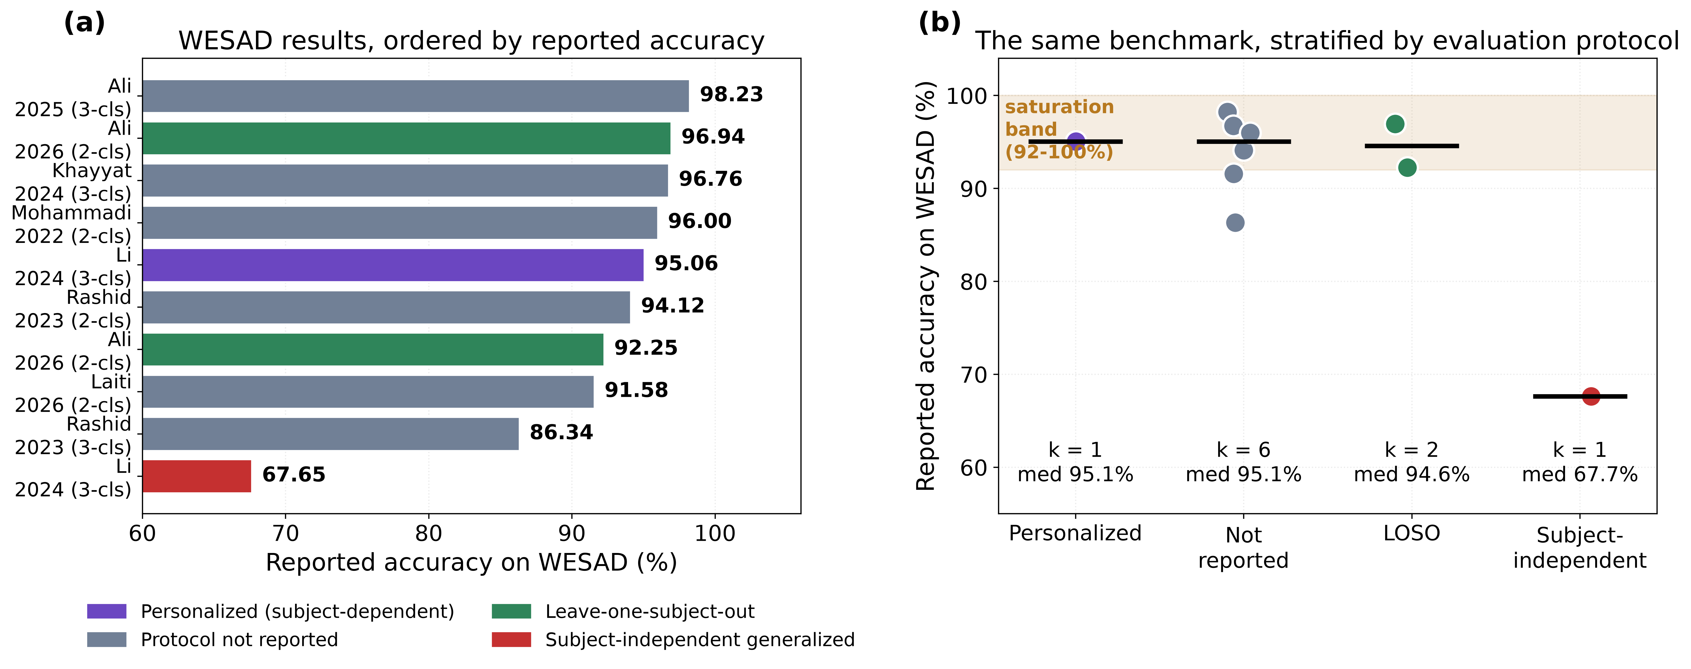
Figure 6: Saturation of the WESAD benchmark. Figure 6(a) ranks all corroborated WESAD records by reported accuracy, with each bar colored by the validation protocol and the number of classes given in the label. Figure 6(b) stratifies the same records by protocol, showing individual records, the group median as a horizontal rule, and the saturation band between 92 and 100%. Personalized and protocol-unreported records are indistinguishable from leave-one-subject-out records, while the single subject-independent generalized evaluation falls far below all of them.

Within-Study Fusion Gain
Four studies in the corpus report a single-modality baseline and a multimodal result on the same cohort, with the same pipeline and under the same validation protocol. Table 5 gives these contrasts and Figure 7 displays them.
Table 5: Within-study, protocol-matched contrasts between the best single modality and the multimodal configuration. Each row holds cohort, pipeline and validation protocol fixed, so the difference is attributable to the added modality. Gains in the AUROC row are expressed in percentage points of AUROC and are not pooled with the accuracy rows.
Study | Single modality | Multimodal configuration | Fusion level | n | Unimodal | Multimodal | Gain (pp)
Abdul Kader et al. [58] | EEG | EEG+GSR | Feature-level | 20 | 70.30 | 84.60 | +14.30
Campanella et al. [16] | PPG (HR) | PPG+EDA | Feature-level | 29 | 83.89 | 90.00 | +6.11
Awada et al. [35] | Physiological | Physiological + behavioral | Decision-level | NR | 79.55 | 82.78 | +3.23
Kim et al. [59] | GSR | EEG+GSR | Feature-level | 30 | 94.40 | 95.40 | +1.00
Median gain (range 1.00 to 14.30, k=4) |  |  |  |  |  |  | +4.67
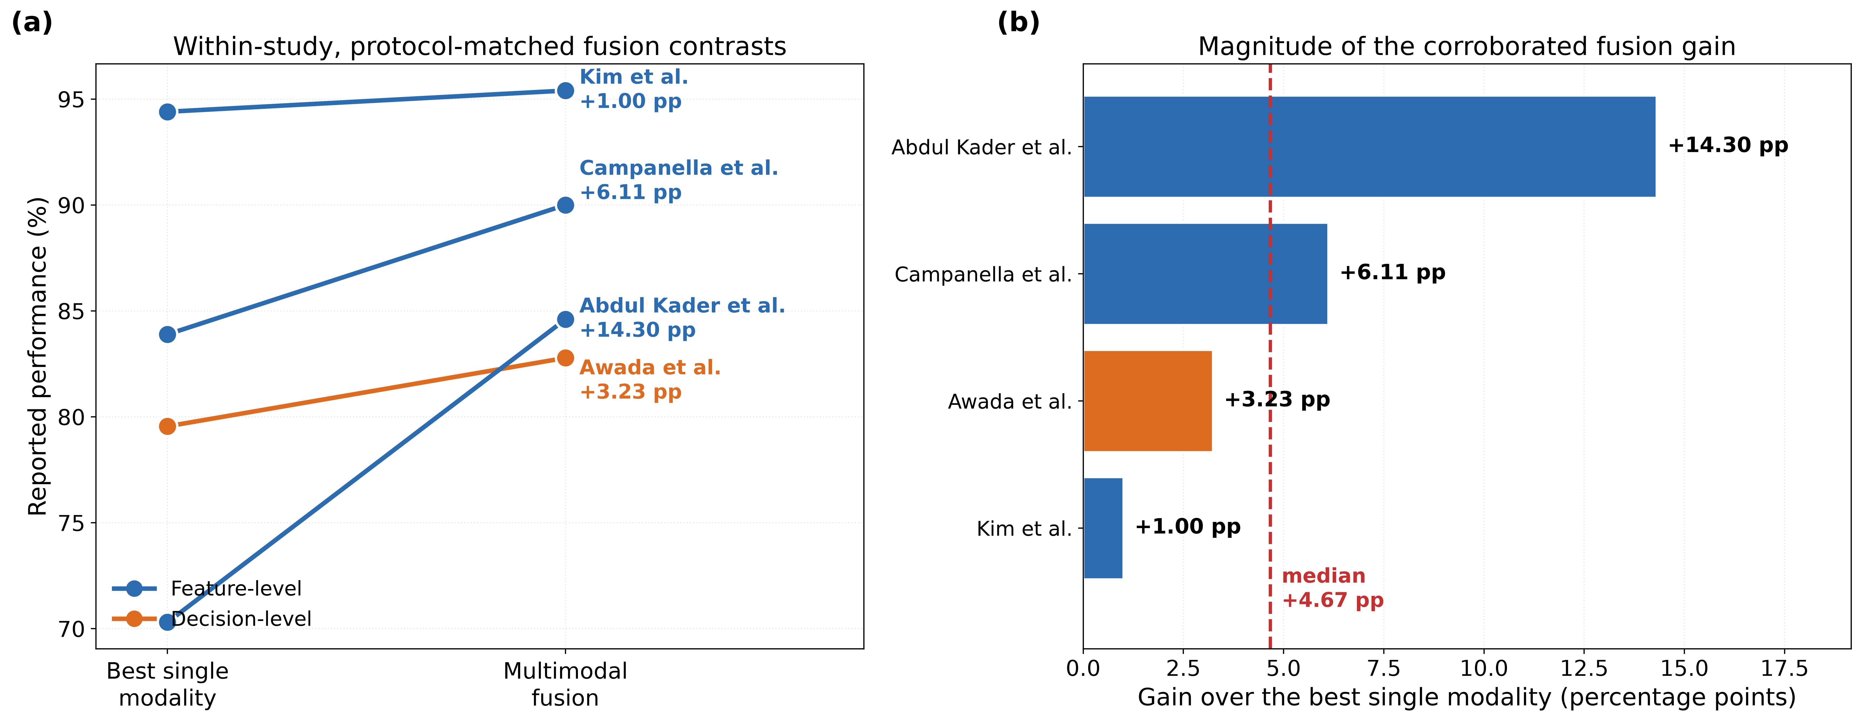
Figure 7: Within-study fusion gain. Figure 7(a) shows each study as a line connecting its best single-modality result to its multimodal result under an identical protocol, colored by fusion level. Figure 7(b) shows the magnitude of each gain against the median across the four contrasts.
Every contrast is positive, so fusion does help. The magnitude, however, is modest and highly uneven. The median gain is +4.67 pp, and the range spans +1.00 to +14.30 pp. The largest gain, +14.30 pp, comes from adding galvanic skin response to a single EEG channel [58], where the baseline modality is weak at 70.30% and the added channel is physiologically distinct. The smallest, +1.00 pp of AUROC, comes from adding EEG to GSR [59], where the baseline is already strong at 0.944 and fusion adds little headroom. Adding facial and behavioral features to a physiological wristband in an office cohort yields +3.23 pp, from 79.55% to 82.78% [35]; notably, the authors of that study themselves conclude that the small difference indicates physiological data alone may be adequate for their task. Adding EDA to heart rate gives +6.11 pp [16].
A coherent pattern emerges. Fusion gain is largest where the unimodal baseline is weakest and where the added channel is physiologically non-redundant, and it approaches zero as the baseline strengthens. This is the behaviour expected of a complementary-information effect operating against a ceiling, and it means that headline fusion gains harvested from weak-baseline studies do not transfer to systems whose unimodal baseline is already strong.

Within-Study Evaluation-Induced Gaps
Ten within-study contrasts isolate the effect of an evaluation choice while holding the model and data-generating process fixed. Table 6 lists them and Figure 8 compares them against the fusion gains of Section 4.3 on a common scale.
Table 6: Within-study contrasts attributable to evaluation choices. Each row reports the same model or pipeline under a more favorable and a more realistic evaluation condition. The final rows give the median gap alongside the median within-study fusion gain for direct comparison.
Study | Contrast | Source of the difference | Metric | Favourable | Realistic | Gap (pp)
Li & Washington [57] | Personalized vs subject-independent | Personalization | F1 | 91.71 | 43.05 | 48.66
Li & Washington [57] | Personalized vs subject-independent | Personalization | Accuracy | 95.06 | 67.65 | 27.41
Laiti et al. [60] | WESAD vs Wellby real-world cohort | Dataset transfer | AUROC | 91.58 | 77.02 | 14.56
Toshnazarov et al. [14] | Laboratory vs free-living | Deployment setting | F1 | 84.00 | 71.00 | 13.00
Xu et al. [24] | Stress state vs stress level | Task granularity | Accuracy | 94.33 | 83.83 | 10.50
Rashid et al. [34] | Binary vs three-class | Task granularity | Accuracy | 94.12 | 86.34 | 7.78
Ali et al. [32] | WESAD vs in-house cohort | Dataset transfer | Accuracy | 96.94 | 92.94 | 4.00
Khayyat et al. [3] | WESAD vs SWELL-KW | Dataset transfer | Accuracy | 96.76 | 92.76 | 4.00
Khayyat et al. [3] | Binary vs multiclass (WESAD) | Task granularity | Accuracy | 99.82 | 96.76 | 3.06
Shikha et al. [46] | Two-level vs three-level stress | Task granularity | Accuracy | 98.28 | 97.02 | 1.26
Median evaluation-induced gap (range 1.26 to 48.66, k=10) |  |  |  |  |  | 9.14
Median within-study fusion gain for comparison (k=4) |  |  |  |  |  | 4.67
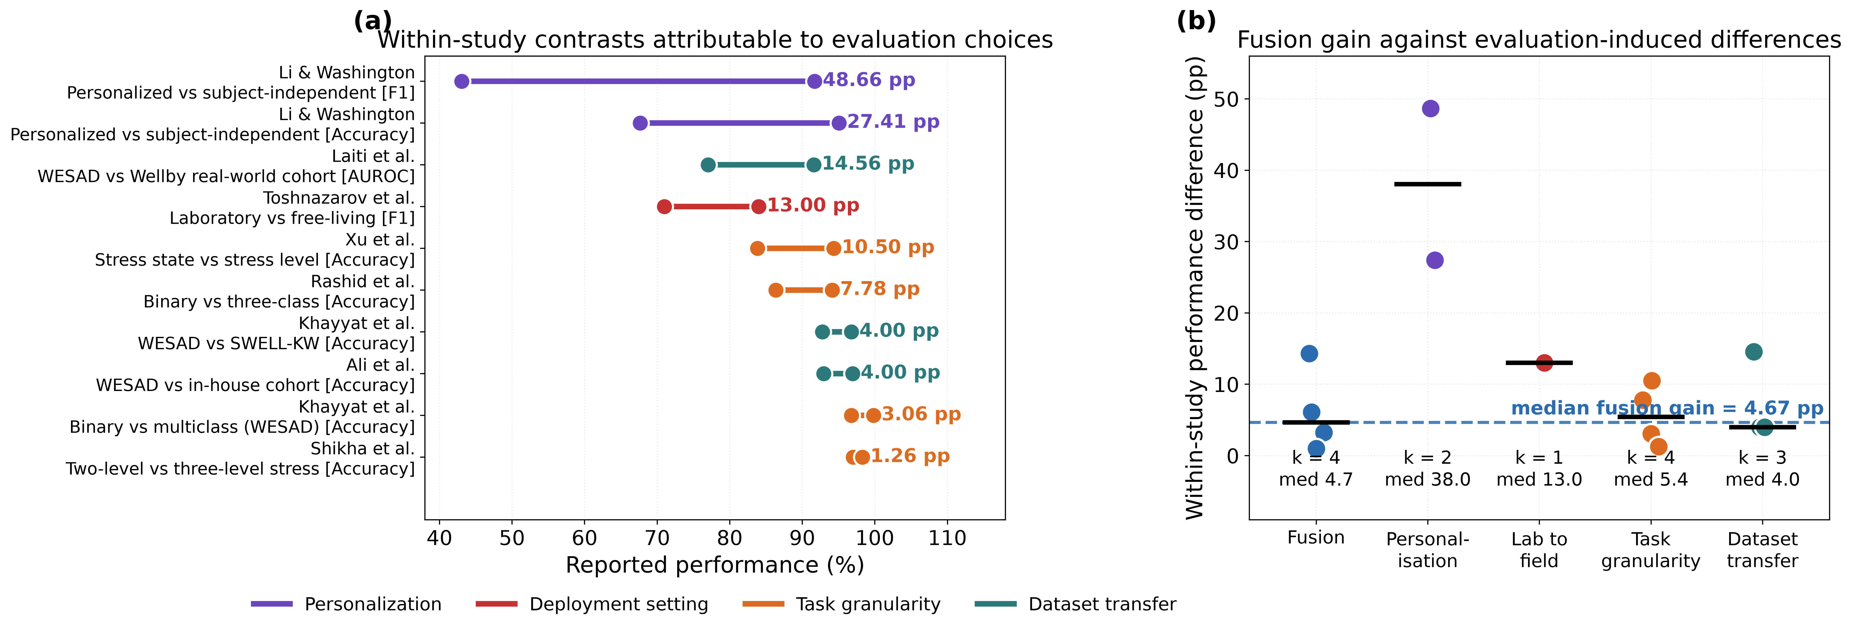
Figure 8: Evaluation effects against fusion effects. Figure 8(a) shows each within-study evaluation contrast as a segment joining the favorable and the realistic condition, colored by the source of the difference and annotated with the gap in percentage points. Figure 8(b) places the four within-study fusion gains and the four families of evaluation contrast on a common axis, with group medians shown as horizontal rules and the median fusion gain marked by the dashed line.
The median evaluation-induced gap is 9.14 pp, approximately twice the median fusion gain of 4.67 pp, and the four families differ sharply in severity.
Personalization: This is the dominant effect in the corpus, with a median gap of 38.03 pp. In a single study using consumer wearable data for three-class affect classification, a personalized model reached 95.06% accuracy with an F1 of 91.71, while the subject-exclusive generalized model on the same data reached 67.65% with an F1 of 43.05 [57]. The accuracy gap of 27.41 pp is 5.9 times the median fusion gain, and the F1 gap of 48.66 pp is 10.4 times it. The F1 collapse is the more diagnostic figure: it indicates that the generalized model is not merely less accurate but is failing on the minority classes that matter, which an accuracy figure partially conceals.
Deployment setting: Moving from controlled laboratory recording to free living cost 13.00 pp of F1 in a smartwatch study that evaluated both, falling from 0.84 to 0.71 [14]. That single study is worth more for deployment planning than any number of laboratory accuracy figures, and it is nearly three times the median fusion gain.
Dataset transfer: Three contrasts give a median of 4.00 pp, but the range is instructive. Transfer between two curated laboratory benchmarks is cheap: 4.00 pp between WESAD and SWELL-KW [3] and 4.00 pp between WESAD and an in-house cohort under matched LOSO validation [32]. Transfer from a benchmark to a genuine real-world student cohort is not: AUROC fell from 91.58 on WESAD to 77.02 in a real-world deployment, a gap of 14.56 pp [60]. Benchmark-to-benchmark transfer therefore substantially underestimates benchmark-to-field transfer, and reporting the former as evidence of generalization is misleading.
Task granularity: Four contrasts give a median of 5.42 pp. Binary stress detection exceeds three-class detection by 7.78 pp in one wrist-based ensemble [34], binary stress state exceeds graded stress level by 10.50 pp in a facial video system [24], and smaller penalties of 3.06 pp [3] and 1.26 pp [46] appear elsewhere. Since clinical and operational utility generally requires graded rather than binary output, the binary figures that dominate the literature systematically overstate deployable performance.

Cohort Size, Transfer and Reporting
Figure 9 examines two further properties of the evidence base. Figure 9(a) shows the three contrasts in which a model was evaluated both on its development condition and on a transfer condition. Figure 9(b) plots corroborated accuracy against evaluation cohort size on a logarithmic axis.
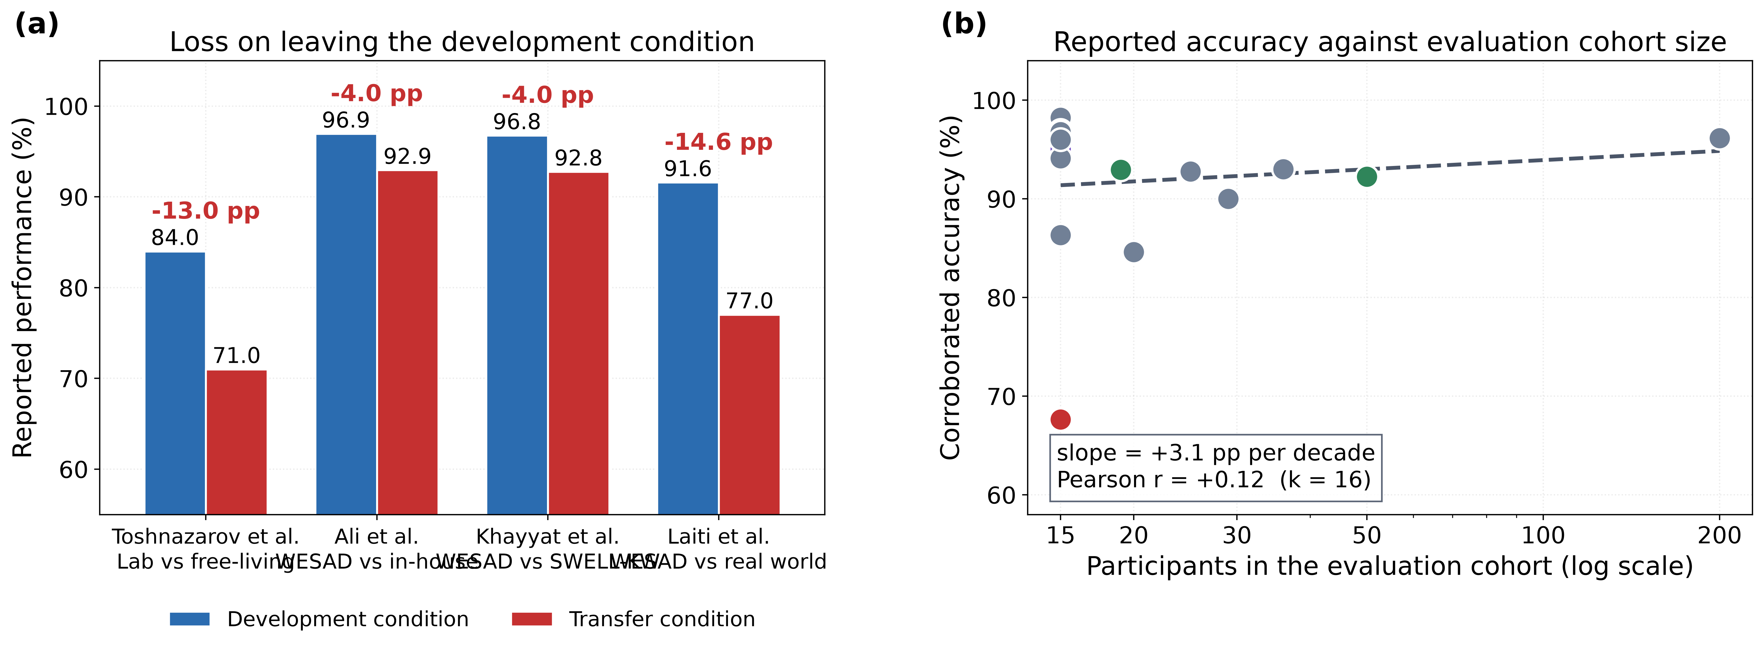
Figure 9: Transfer behaviour and the absence of a cohort-size effect. Figure 9(a) contrasts performance on the development condition with performance on the transfer condition for the three studies reporting both, annotated with the loss in percentage points. Figure 9(b) plots corroborated accuracy against the number of participants in the evaluation cohort on a logarithmic axis, with points colored by validation protocol and a least-squares fit on the log axis.
The relationship between cohort size and reported accuracy is essentially flat (r=+0.15, slope +3.7 pp per decade, k=15). Studies evaluating on 15 participants report accuracies indistinguishable from studies evaluating on 200. Under any reasonable model of task difficulty, a larger and more heterogeneous cohort should be harder, so a flat or slightly positive relationship is not evidence that small studies are adequate; it is evidence that reported accuracy is being set by evaluation design rather than by the difficulty of the underlying problem.
Figure 10 reports the verification and reporting audit. Figure 10(a) shows that a headline outcome could be independently corroborated for 28 of 60 included studies (46.7%). Figure 10(b) shows recovery rates for each reporting item: the evaluation cohort size was recoverable for 18 studies (30.0%), whether a public benchmark was used for 14 (23.3%), the validation protocol for 8 (13.3%) and any variance or confidence interval for only 3 (5.0%).
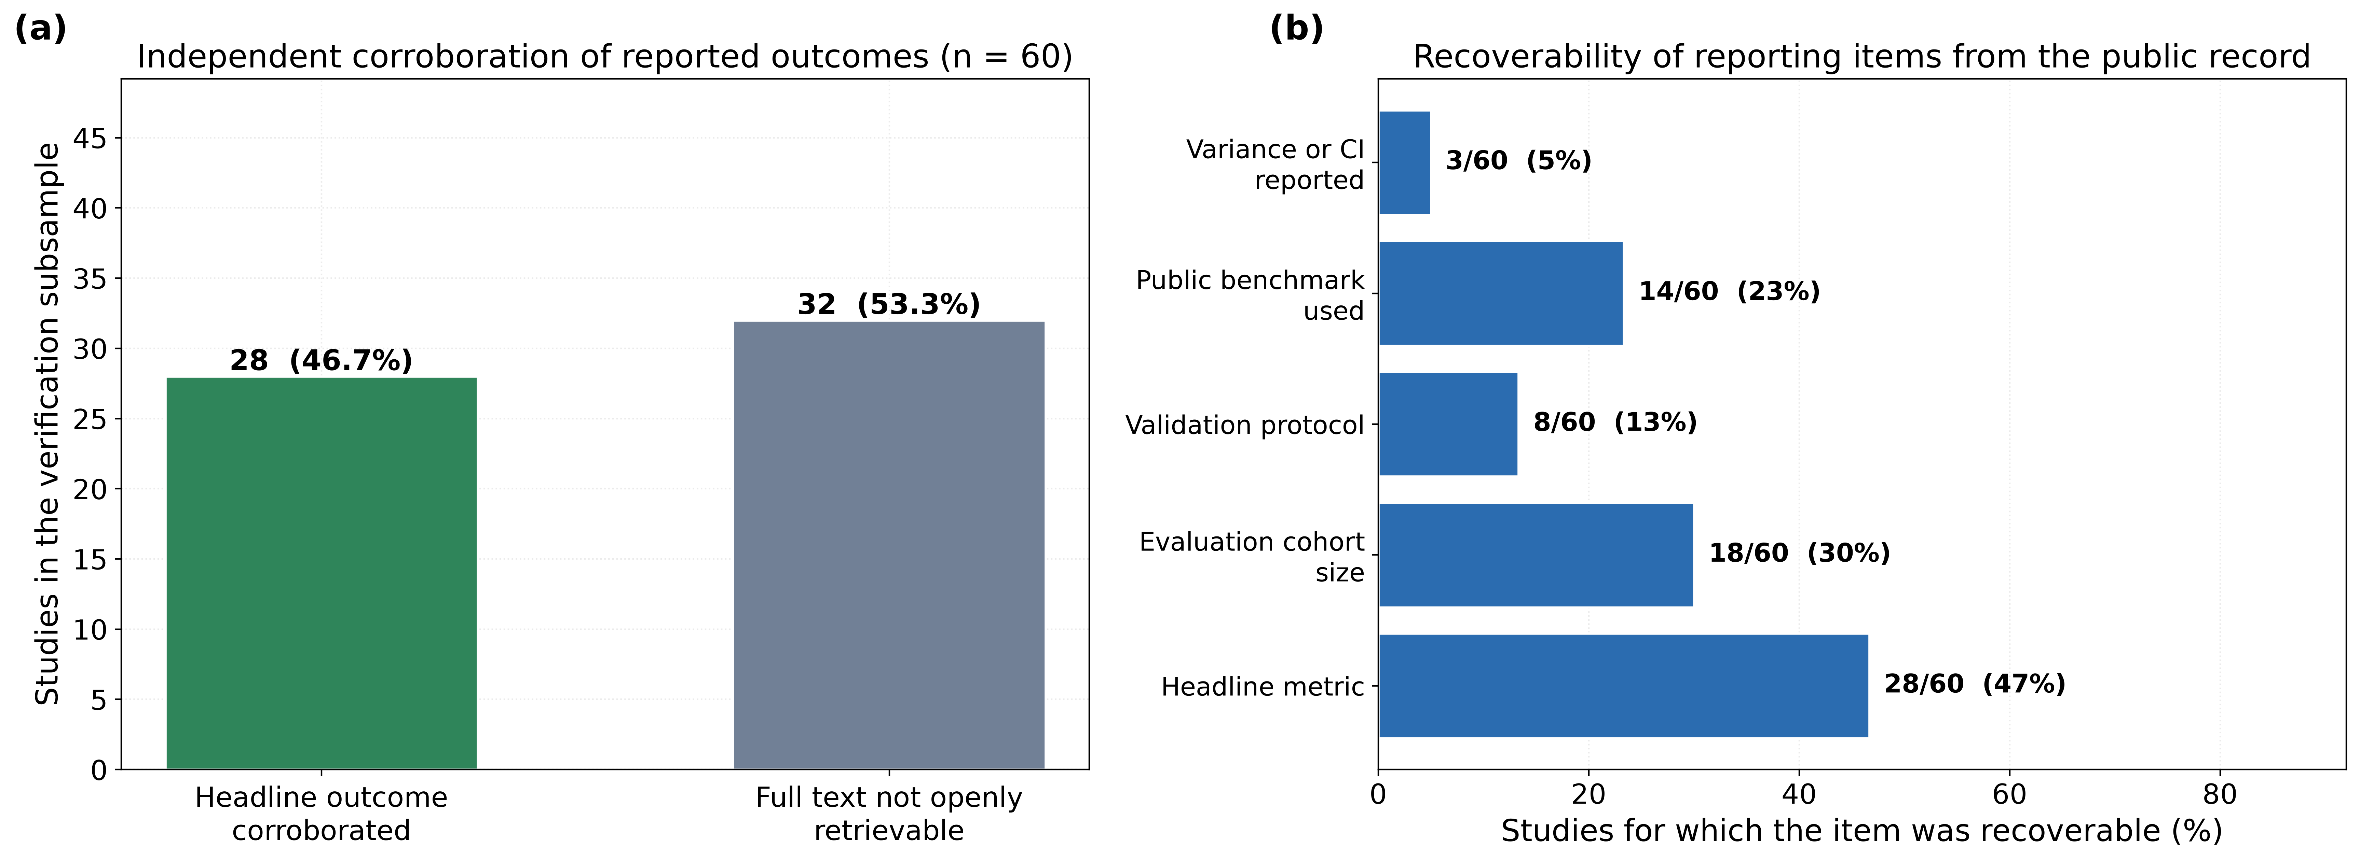
Figure 10: Verification and reporting audit across all 60 included studies. Figure 10(a) shows the proportion of studies for which a headline outcome could be independently corroborated from the openly retrievable record. Figure 10(b) shows the recovery rate for each of the five reporting items, with the count and percentage annotated.
These rates should be read as a property of the openly retrievable record rather than as a judgement on the studies, since much of the corpus sits behind subscription access. The implication is nevertheless concrete and is the central practical finding of Section 4.4: for roughly seven studies in eight, a reader without subscription access cannot determine the validation protocol, and therefore cannot determine whether a quoted accuracy describes subject-dependent or subject-independent performance. Given that this single distinction is worth up to 27.41 pp of accuracy and 48.66 pp of F1 within one study [57], an unlabeled accuracy figure in this literature carries very little information.
Table 7: Constraints on deployment, the corroborated quantitative evidence for each, and its implication. Only effects supported by a within-study contrast or a directly corroborated value are listed; magnitudes are those reported in Tables 5 and 6.
Constraint | Corroborated evidence | Magnitude | Implication for deployment
Subject heterogeneity | Personalized versus subject-exclusive generalized model on identical data [57] | 27.41 pp accuracy; 48.66 pp F1 | Calibration data per user is the single highest-value design decision; generalized models must not be specified from personalized results.
Ecological validity | Laboratory versus free-living F1 in the same smartwatch study [14] | 13.00 pp F1 | Laboratory accuracy is not an upper bound that degrades gracefully; field validation is required before any deployment claim.
Benchmark-to-field transfer | WESAD AUROC versus real-world student cohort AUROC [60] | 14.56 pp AUROC | Benchmark-to-benchmark transfer (4.00 pp) understates benchmark-to-field transfer by roughly a factor of three.
Output granularity | Binary versus graded outputs across four studies [3,24,34,46] | 5.42 pp median | Binary benchmarks overstate the performance of the graded outputs that clinical and operational use requires.
Benchmark saturation | 7 of 9 non-subject-independent WESAD records above 92%, spanning KNN to transformers [3,21,31,34] | < 2 pp separating classical from transformer models | WESAD can no longer adjudicate between architectures; new architectural claims need a harder or subject-independent evaluation.
Reporting completeness | Validation protocol recoverable for 8 of 60 studies; variance for 3 of 60 | 13.3%; 5.0% | Most reported accuracies cannot be interpreted, and meta-analytic pooling across this literature is not currently defensible.
Modality redundancy | Fusion gain shrinks as the unimodal baseline strengthens [16,35,58] | +1.00 to +14.30 pp | Sensor count should be justified against the specific unimodal baseline, not against a generic fusion benefit.

Key Trends and Patterns Across Results

The Field Is Optimizing the Smaller of Two Effects
The central pattern is a mismatch between where effort is spent and where performance is determined. Architectural work is abundant: the corpus contains transformers, capsule networks, autoencoders, generative augmentation and federated schemes, and each reports an improvement over its chosen baseline. Yet on the one dataset where these architectures can be compared, they occupy a two-point band that a k-nearest-neighbour classifier also occupies [21,31]. Meanwhile the factors that move performance by an order of magnitude more, whether the model is personalized, whether evaluation is subject independent, whether data were collected in the field, are treated as reporting details and are usually not reported at all. A median fusion gain of 4.67 pp against a median evaluation gap of 9.14 pp, and against a personalization gap of 38.03 pp, quantifies that mismatch.

Fusion Is Real, Bounded and Baseline-Dependent
The four protocol-matched contrasts are unanimously positive, so the case for multimodal sensing is not overturned. It is bounded. Fusion buys most where the unimodal baseline is weak and the added channel is physiologically distinct, as in EEG supplemented by GSR at +14.30 pp [58], and very little where the baseline is already strong, as in GSR supplemented by EEG at +1.00 pp of AUROC [59]. Adding a camera channel to a physiological wristband returned +3.23 pp in the one corroborated office deployment [35]. For system designers the operational reading is that a second sensor must be justified against the specific unimodal baseline it will actually replace, together with its cost in power, cost, form factor and failure modes, and not against a generic claim that fusion improves performance.

Personalization Is the Dominant Lever, and the Main Threat to Validity
Personalization accounts for the largest effect in the corpus, and simultaneously for the most serious threat to the interpretability of the literature. Because subject-dependent splits allow the same participant to appear in training and test, they can be reported without any deliberate misrepresentation while producing figures that a subject-independent evaluation would not support. The one study in the corpus that reports both conditions on identical data shows accuracy falling from 95.06% to 67.65% and F1 from 91.71 to 43.05 [57]. Since only 8 of 60 studies state their protocol recoverably, the scale of this effect across the wider literature cannot currently be estimated, which is itself the finding.

Laboratory Performance Does Not Forecast Field Performance
Two independent within-study contrasts show the same direction and a similar magnitude: 13.00 pp of F1 lost between laboratory and free-living conditions [14], and 14.56 pp of AUROC lost between WESAD and a real-world student cohort [60]. Transfer between two curated benchmarks, by contrast, cost only 4.00 pp [3,32]. The gap between these two figures is the crux: a study that demonstrates cross-dataset transfer between laboratory corpora has not demonstrated the property that deployment requires. The structure of the corpus makes this consequential, since 31 of 60 studies are laboratory or benchmark-only and just 9 involve free-living deployment.

Benchmark Saturation Has Made Architectural Claims Unfalsifiable
When a benchmark compresses a decade of architectural development into a two-point band, it cannot adjudicate between methods, and improvements reported on it are no longer informative about which method is better. WESAD has reached that state for subject-dependent and LOSO evaluation. It has not reached it for subject-independent generalization, where the single available record sits at 67.65% [57]. The productive response is therefore not to abandon WESAD but to change the protocol reported on it: subject-independent generalization on WESAD remains a discriminating and unsolved task.

Reporting Practice Is the Rate-Limiting Step
The reporting audit reframes every preceding trend. A validation protocol recoverable for 13.3% of studies and a variance estimate for 5.0% means that most reported accuracies in this area cannot be placed on a common scale, cannot be meta-analyzed defensibly, and cannot be used to specify a system. This is why the present review restricts itself to within-study contrasts and to 28 corroborated studies rather than pooling 60 headline numbers: the pooled figure would be larger, more impressive and not interpretable.

Discussion

Summary of Findings
This review set out to establish whether the performance benefit attributed to multimodal fusion in wearable and camera-based stress and attention monitoring survives a confound-controlled estimate, and how it compares with the influence of evaluation design. Restricting the synthesis to within-study contrasts and to independently corroborated values yields three findings.
First, fusion helps, by a median of 4.67 pp across four protocol-matched contrasts, with the gain concentrated where the unimodal baseline is weak. Second, evaluation choices move reported performance by a median of 9.14 pp, roughly twice as much, and personalization alone by 38.03 pp, up to 10.4 times the median fusion gain. Third, the benchmark on which most architectural claims rest has saturated for the protocols commonly used on it, while remaining unsolved for the subject-independent protocol that deployment requires, and the protocol actually used is unrecoverable for the large majority of studies.
Taken together these support a single conclusion with direct implications for BSPC’s translational remit: the binding constraint on deployable stress and attention monitoring is not the sensing configuration or the network architecture but the evaluation regime under which systems are developed and reported. A system optimized against a subject-dependent score on a saturated benchmark is being optimized against a target that does not predict field behaviour.
Three concrete recommendations follow. Report subject-independent performance as the primary result: personalized and subject-dependent figures may be reported alongside it, but labeled as such, since the difference is worth up to 27.41 pp of accuracy and 48.66 pp of F1 [57]. Treat benchmark-to-benchmark transfer as insufficient evidence of generalization: it cost 4.00 pp in this corpus while benchmark-to-field transfer cost 14.56 pp [3,32,60]. Justify each additional sensor against the specific unimodal baseline it displaces, reporting the ablation under a matched protocol, because the fusion gain is a function of that baseline and ranged from +1.00 to +14.30 pp here. For closed-loop and therapeutic systems [22,36], where a false positive triggers an intervention rather than a notification, these requirements are not methodological preferences but safety prerequisites.

Limitations
Four limitations bound these conclusions and should be weighed against them.
Small number of within-study contrasts: The design that gives this review its internal validity also restricts it: only 4 fusion contrasts and 10 evaluation contrasts met the matched-protocol requirement. Medians over k=4 and k=10 are unstable, and the comparison of the two medians is a comparison of central tendencies in small samples, not a hypothesis test. We therefore report full ranges throughout, avoid pooled effect-size estimates and significance testing, and frame the central claim as a difference in order of magnitude rather than a precise ratio. The personalization estimate in particular rests on one study reporting two metrics [57], and would be materially strengthened or weakened by two or three further studies reporting both conditions.
Corroboration was limited by access, not only by reporting: A headline outcome was corroborable for 46.7% of included studies, and the recovery rates in Table 3 reflect what is obtainable from the openly retrievable record. Studies behind subscription access may report their protocol and variance fully in the full text. The rates are therefore a lower bound on the literature’s transparency and an accurate description of what a reader without institutional access can verify. The direction of any resulting bias is unclear, since there is no reason to expect studies with recoverable outcomes to differ systematically in performance from those without.
Corpus construction: The corpus was assembled from a pre-specified set of 117 records rather than from fresh database queries executed for this review, then screened and verified against strict criteria. This procedure is fully documented and reproducible from Table 1 and Figure 2, but it is not equivalent to an exhaustive database search, and studies absent from the source corpus are absent here. The strict outcome criterion, which excluded 41 records, also narrows coverage relative to reviews that admit any wearable-sensing application; that narrowing is deliberate but it does reduce comparability with those reviews.
Heterogeneity of metrics and tasks: Contrasts span accuracy, F1 and AUROC, and binary through four-class tasks. Differences are reported in percentage points of the original metric and are never pooled across metrics, but a percentage point of F1 and a percentage point of AUROC are not interchangeable quantities, and the reader should treat the aggregate medians as summaries of a heterogeneous set rather than as estimates of a single underlying parameter.

Conclusion
Multimodal fusion of wearable and camera-based sensing improves stress and attention detection, but by less than is generally assumed once cohort, pipeline and validation protocol are held fixed: a median of 4.67 percentage points across the protocol-matched contrasts available in the 2022 to 2026 literature. The same literature shows that evaluation choices move reported performance roughly twice as far, with personalization alone worth a median of 38.03 percentage points and laboratory-to-field transfer costing 13.00 percentage points of F1. On the field’s reference benchmark, classical and transformer models are separated by under two percentage points, while the validation protocol that produced any given number is recoverable for only 13.3% of studies.
The practical consequence is that the next increment of deployable performance is unlikely to come from another architecture or another sensor. It will come from evaluating honestly: reporting subject-independent performance as the primary result, validating in the field rather than only across curated benchmarks, sizing sensor complements against the actual unimodal baseline, and publishing protocol and variance alongside every point estimate. Subject-independent generalization on existing benchmarks is unsolved and discriminating, and is the appropriate target for the next phase of work in this area.

Data and Code Availability
The screened corpus, the verified evidence base, the extraction of all within-study contrasts, and the scripts that generate every figure and data table in this manuscript are provided as supplementary material so that each reported value can be traced to its source record.

Declaration of Competing Interest
The authors declare that they have no known competing financial interests or personal relationships that could have appeared to influence the work reported in this paper.

References
[1] Rescio G, Manni A, Ciccarelli M, Papetti A, Caroppo A, Leone A. A Deep Learning-Based Platform for Workers’ Stress Detection Using Minimally Intrusive Multisensory Devices. Sensors 2024;24:947. https://doi.org/10.3390/s24030947.
[2] Donati M, Olivelli M, Giovannini R, Fanucci L. ECG-Based Stress Detection and Productivity Factors Monitoring: The Real-Time Production Factory System. Sensors 2023;23:5502. https://doi.org/10.3390/s23125502.
[3] M. Khayyat M, Munshi RM, Alabduallah B, Lamoudan T, Ghith E, Kim T, et al. An improved biometric stress monitoring solution for working employees using heart rate variability data and Capsule Network model. PLOS ONE 2024;19:e0310776. https://doi.org/10.1371/journal.pone.0310776.
[4] Sadeghi M, McDonald AD, Sasangohar F. Posttraumatic stress disorder hyperarousal event detection using smartwatch physiological and activity data. PLOS ONE 2022;17:e0267749. https://doi.org/10.1371/journal.pone.0267749.
[5] Whiston A, Igou ER, Fortune DG, Analog Devices Team, Semkovska M. Examining Stress and Residual Symptoms in Remitted and Partially Remitted Depression Using a Wearable Electrodermal Activity Device: A Pilot Study. IEEE J Transl Eng Health Med 2023;11:96–106. https://doi.org/10.1109/JTEHM.2022.3228483.
[6] Cajal D, De La Cámara C, Posadas-De Miguel M, Torrijos N, Nadal Ó, Blanco T, et al. Evaluation of Stress Response Using Smartphone PPG for Anxiety and Depression Monitoring. IEEE Access 2025;13:212689–703. https://doi.org/10.1109/ACCESS.2025.3643644.
[7] Rafi H, Benezeth Y, Song FY, Reynaud P, Arnoux E, Demonceaux C. Tree-Based Personalized Clustered Federated Learning: A Driver Stress Monitoring Through Physiological Data Case Study. IEEE Internet Things J 2025;12:1688–98. https://doi.org/10.1109/JIOT.2024.3462302.
[8] AlArnaout Z, Zaki C, Kotb Y, AlAkkoumi M, Mostafa N. Exploiting heart rate variability for driver drowsiness detection using wearable sensors and machine learning. Sci Rep 2025;15:24898. https://doi.org/10.1038/s41598-025-08582-2.
[9] Pavan K, Singh A, Pawar DS, Ganapathy N. Multimodal Wearable-Based Automated Driver Inattention State Assessment Using Multidevices and Novel Cross-Modal Attention Framework. IEEE Sens Lett 2025;9:1–4. https://doi.org/10.1109/LSENS.2025.3596610.
[10] Fernandez J, Martínez R, Innocenti B, López B. Contribution of EEG Signals for Students’ Stress Detection. IEEE Trans Affect Comput 2025;16:1235–46. https://doi.org/10.1109/TAFFC.2024.3503995.
[11] Chen Q, Lee BG. Deep Learning Models for Stress Analysis in University Students: A Sudoku-Based Study. Sensors 2023;23:6099. https://doi.org/10.3390/s23136099.
[12] Gedam S, Dutta S, Jha R. Analyzing mental stress in Indian students through advanced machine learning and wearable technologies. Sci Rep 2025;15:20610. https://doi.org/10.1038/s41598-025-06918-6.
[13] Tutunji R, Kogias N, Kapteijns B, Krentz M, Krause F, Vassena E, et al. Detecting Prolonged Stress in Real Life Using Wearable Biosensors and Ecological Momentary Assessments: Naturalistic Experimental Study. J Med Internet Res 2023;25:e39995. https://doi.org/10.2196/39995.
[14] Toshnazarov K, Lee U, Kim BH, Mishra V, Najarro LAC, Noh Y. SOSW : Stress Sensing With Off-the-Shelf Smartwatches in the Wild. IEEE Internet Things J 2024;11:21527–45. https://doi.org/10.1109/JIOT.2024.3375299.
[15] Presby DM, Jasinski SR, Capodilupo ER. Wearable derived cardiovascular responses to stressors in free-living conditions. PLOS ONE 2023;18:e0285332. https://doi.org/10.1371/journal.pone.0285332.
[16] Campanella S, Altaleb A, Belli A, Pierleoni P, Palma L. A Method for Stress Detection Using Empatica E4 Bracelet and Machine-Learning Techniques. Sensors 2023;23:3565. https://doi.org/10.3390/s23073565.
[17] Hongn A, Bosch F, Prado LE, Ferrández JM, Bonomini MP. Wearable Physiological Signals under Acute Stress and Exercise Conditions. Sci Data 2025;12:520. https://doi.org/10.1038/s41597-025-04845-9.
[18] Kumar S, Raj Chauhan A, Akhil, Kumar A, Yang G. Resp-BoostNet: Mental Stress Detection From Biomarkers Measurable by Smartwatches Using Boosting Neural Network Technique. IEEE Access 2024;12:149861–74. https://doi.org/10.1109/ACCESS.2024.3461588.
[19] Barki H, Nkenyereye L, Chung W-Y. Detection and Classification of Mental Stress Using In-Ear Plethysmography and a Vision Transformer. IEEE Sens J 2025;25:4015–27. https://doi.org/10.1109/JSEN.2024.3512595.
[20] Mai N-D, Chung W-Y. On-Chip Mental Stress Detection: Integrating a Wearable Behind-The-Ear EEG Device With Embedded Tiny Neural Network. IEEE J Biomed Health Inform 2025;29:1872–85. https://doi.org/10.1109/JBHI.2024.3519600.
[21] Mohammadi A, Fakharzadeh M, Baraeinejad B. An Integrated Human Stress Detection Sensor Using Supervised Algorithms. IEEE Sens J 2022;22:8216–23. https://doi.org/10.1109/JSEN.2022.3157795.
[22] Pei X, Ghandehari A, Chakoma S, Rajendran J, Tavares-Negrete JA, Esfandyarpour R. A quantitative, multimodal wearable bioelectronic device for comprehensive stress assessment and sub-classification. Nat Commun 2026;17:1150. https://doi.org/10.1038/s41467-025-67747-9.
[23] Stojchevska M, Steenwinckel B, Van Der Donckt J, De Brouwer M, Goris A, De Turck F, et al. Assessing the added value of context during stress detection from wearable data. BMC Med Inform Decis Mak 2022;22:268. https://doi.org/10.1186/s12911-022-02010-5.
[24] Xu J, Song C, Yue Z, Ding S. Facial Video-Based Non-Contact Stress Recognition Utilizing Multi-Task Learning With Peak Attention. IEEE J Biomed Health Inform 2024;28:5335–46. https://doi.org/10.1109/JBHI.2024.3412103.
[25] Rescio G, Manni A, Caroppo A, Ciccarelli M, Papetti A, Leone A. Ambient and wearable system for workers’ stress evaluation. Comput Ind 2023;148:103905. https://doi.org/10.1016/j.compind.2023.103905.
[26] Vos G, Trinh K, Sarnyai Z, Rahimi Azghadi M. Generalizable machine learning for stress monitoring from wearable devices: A systematic literature review. Int J Med Inform 2023;173:105026. https://doi.org/10.1016/j.ijmedinf.2023.105026.
[27] Zhu L, Spachos P, Ng PC, Yu Y, Wang Y, Plataniotis K, et al. Stress Detection Through Wrist-Based Electrodermal Activity Monitoring and Machine Learning. IEEE J Biomed Health Inform 2023;27:2155–65. https://doi.org/10.1109/JBHI.2023.3239305.
[28] Almadhor A, Sampedro GA, Abisado M, Abbas S, Kim Y-J, Khan MA, et al. Wrist-Based Electrodermal Activity Monitoring for Stress Detection Using Federated Learning. Sensors 2023;23:3984. https://doi.org/10.3390/s23083984.
[29] Alsahreef MS, Alfahmi M, Alharbi E, Jones JM, Jaber M, Alomainy A. IoMT-Based Proactive Approach for Detecting Stress in Physicians to Reduce Medical Errors. IEEE Access 2026;14:45934–47. https://doi.org/10.1109/ACCESS.2026.3674740.
[30] Anandan M, Palanisamy R. Wearable ECG Sensor-Based Cognitive Stress Detection During Physical Activity Using Multifractal Detrended Fluctuation Analysis. IEEE Sens Lett 2025;9:1–4. https://doi.org/10.1109/LSENS.2025.3605112.
[31] Ali MS, Motin MA, Kabir S. ReTeNet: A Residual Encoder and Transformer Encoders Network for Stress Monitoring From Wearable Device. IEEE Signal Process Lett 2025;32:3635–9. https://doi.org/10.1109/LSP.2025.3607767.
[32] Ali MS, Bipro SS, Motin MA, Kabir S, Sharma M, Chowdhury MEH. TEANet: A Transpose-Enhanced Autoencoder Network for Stress Monitoring on Resource-Constrained Wearable Device. IEEE Access 2026;14:9560–71. https://doi.org/10.1109/ACCESS.2025.3644400.
[33] Ali MS, Motin MA, Bipro SS, Kabir S, Syfullah MK, Kumar DK. Detection of Mental Stress From Photoplethysmography for Under-Resourced Healthcare Systems. IEEE Sens J 2026;26:6293–301. https://doi.org/10.1109/JSEN.2025.3649586.
[34] Rashid N, Mortlock T, Faruque MAA. Stress Detection Using Context-Aware Sensor Fusion From Wearable Devices. IEEE Internet Things J 2023;10:14114–27. https://doi.org/10.1109/JIOT.2023.3265768.
[35] Awada M, Becerik Gerber B, Lucas GM, Roll SC. Stress appraisal in the workplace and its associations with productivity and mood: Insights from a multimodal machine learning analysis. PLOS ONE 2024;19:e0296468. https://doi.org/10.1371/journal.pone.0296468.
[36] Rahman FN, Bindra PS, Nawar A, Crane HT, Sanchez-Perez JA, Berkebile JA, et al. A wearable system enabling acute stress monitoring and closed-loop mitigation through transcutaneous median nerve stimulation. Biosens Bioelectron 2026;301:118461. https://doi.org/10.1016/j.bios.2026.118461.
[37] Jui SJJ, Deo RC, Acharya R, Barua PD, Soar J, Devi A. Explainable stress detection system using hybrid CNN-Transformer and uncertainty quantification with copula GAN-based data. Biomed Signal Process Control 2026;120:109934. https://doi.org/10.1016/j.bspc.2026.109934.
[38] Modi N, Kumar Y, Mehta K, Chaplot N. Physiological signal-based mental stress detection using hybrid deep learning models. Discov Artif Intell 2025;5:166. https://doi.org/10.1007/s44163-025-00412-8.
[39] Li Y, Li K, Chen J, Wang S, Lu H, Wen D. Pilot Stress Detection Through Physiological Signals Using a Transformer-Based Deep Learning Model. IEEE Sens J 2023;23:11774–84. https://doi.org/10.1109/JSEN.2023.3247341.
[40] Ehrhart M, Resch B, Havas C, Niederseer D. A Conditional GAN for Generating Time Series Data for Stress Detection in Wearable Physiological Sensor Data. Sensors 2022;22:5969. https://doi.org/10.3390/s22165969.
[41] Gabrielli D, Prenkaj B, Velardi P. Seamless monitoring of stress levels leveraging a foundational model for time sequences. Artif Intell Med 2026;173:103336. https://doi.org/10.1016/j.artmed.2025.103336.
[42] Bello-Orgaz G, Menéndez HD, Quintana-Quiroga F, Díaz-Álvarez A. Smart devices and stress level detection: Balancing machine learning model complexity and device intrusiveness. Biomed Signal Process Control 2026;117:109683. https://doi.org/10.1016/j.bspc.2026.109683.
[43] Momeni N, Valdes AA, Rodrigues J, Sandi C, Atienza D. CAFS: Cost-Aware Features Selection Method for Multimodal Stress Monitoring on Wearable Devices. IEEE Trans Biomed Eng 2022;69:1072–84. https://doi.org/10.1109/TBME.2021.3113593.
[44] Khan HA, Nguyen TN, Shafiq G, Mirza J, Javed MA. A Secure Wearable Framework for Stress Detection in Patients Affected by Communicable Diseases. IEEE Sens J 2023;23:981–8. https://doi.org/10.1109/JSEN.2022.3204586.
[45] Moser MK, Ehrhart M, Resch B. An Explainable Deep Learning Approach for Stress Detection in Wearable Sensor Measurements. Sensors 2024;24:5085. https://doi.org/10.3390/s24165085.
[46] Shikha S, Sethia D, Indu S. Optimization of Wearable Biosensor Data for Stress Classification Using Machine Learning and Explainable AI. IEEE Access 2024;12:169310–27. https://doi.org/10.1109/ACCESS.2024.3463742.
[47] Rahman S, Udhayakumar R, Kaplan D, McCarthy B, Dawood T, Mellor N, et al. Photoplethysmography as a noninvasive surrogate for microneurography in measuring stress-induced sympathetic nervous activation – A machine learning approach. Comput Biol Med 2025;185:109522. https://doi.org/10.1016/j.compbiomed.2024.109522.
[48] De Marchi B, Agovi E, Aliverti A. Stress Level Assessment by a Multi-Parametric Wearable Platform: Relevance of Different Physiological Signals. Inf Syst Front 2025;27:113–37. https://doi.org/10.1007/s10796-024-10550-6.
[49] Onim MSH, Thapliyal H, Rhodus EK. Utilizing Machine Learning for Context-Aware Digital Biomarker of Stress in Older Adults. Information 2024;15:274. https://doi.org/10.3390/info15050274.
[50] Moser MK, Resch B, Ehrhart M. An Individual-Oriented Algorithm for Stress Detection in Wearable Sensor Measurements. IEEE Sens J 2023;23:22845–56. https://doi.org/10.1109/JSEN.2023.3304422.
[51] Bin Heyat MB, Akhtar F, Abbas SJ, Al-Sarem M, Alqarafi A, Stalin A, et al. Wearable Flexible Electronics Based Cardiac Electrode for Researcher Mental Stress Detection System Using Machine Learning Models on Single Lead Electrocardiogram Signal. Biosensors 2022;12:427. https://doi.org/10.3390/bios12060427.
[52] Ribeiro G, Postolache O, Martín FF. A New Intelligent Approach for Automatic Stress Level Assessment Based on Multiple Physiological Parameters Monitoring. IEEE Trans Instrum Meas 2024;73:1–14. https://doi.org/10.1109/TIM.2023.3342218.
[53] Subathra P, Malarvizhi S, Ferents Koni Jiavana K, Patil S. A Wearable Electronic Band for Stress Understanding Using Machine Learning. IEEE Sens J 2025;25:38639–48. https://doi.org/10.1109/JSEN.2025.3590380.
[54] Vos G, Trinh K, Sarnyai Z, Rahimi Azghadi M. Ensemble machine learning model trained on a new synthesized dataset generalizes well for stress prediction using wearable devices. J Biomed Inform 2023;148:104556. https://doi.org/10.1016/j.jbi.2023.104556.
[55] El Arwadi L, Abu Daher L. CardioMind: Deep Learning Framework for Stress Detection Using IoT Devices. IEEE Access 2025;13:197027–42. https://doi.org/10.1109/ACCESS.2025.3633760.
[56] Bloomfield LSP, Fudolig MI, Kim J, Llorin J, Lovato JL, McGinnis EW, et al. Predicting stress in first-year college students using sleep data from wearable devices. PLOS Digit Health 2024;3:e0000473. https://doi.org/10.1371/journal.pdig.0000473.
[57] Li J, Washington P. A Comparison of Personalized and Generalized Approaches to Emotion Recognition Using Consumer Wearable Devices: Machine Learning Study. JMIR AI 2024;3:e52171. https://doi.org/10.2196/52171.
[58] Abdul Kader L, Al-Shargie F, Tariq U, Al-Nashash H. One-Channel Wearable Mental Stress State Monitoring System. Sensors 2024;24:5373. https://doi.org/10.3390/s24165373.
[59] Kim H, Song S, Cho BH, Jang DP. Deep learning-based stress detection for daily life use using single-channel EEG and GSR in a virtual reality interview paradigm. PLOS ONE 2024;19:e0305864. https://doi.org/10.1371/journal.pone.0305864.
[60] Laiti J, Liu Y, Dunne PJ, Byrne E, Zhu T. Real-World Classification of Student Stress and Fatigue Using Wearable PPG Recordings. IEEE Trans Affect Comput 2026;17:587–601. https://doi.org/10.1109/TAFFC.2025.3628467.
[61] Kim W, Kutsuzawa G, Maruyama M. Emotion recognition and forecasting from wearable data via cluster-guided attention with cross-species pretraining. Intell Syst Appl 2025;27:200560. https://doi.org/10.1016/j.iswa.2025.200560.

