KSC System Update

* Message with private own buy number. \*\* Still under maintain \*\*
* Kscretails.com is available.

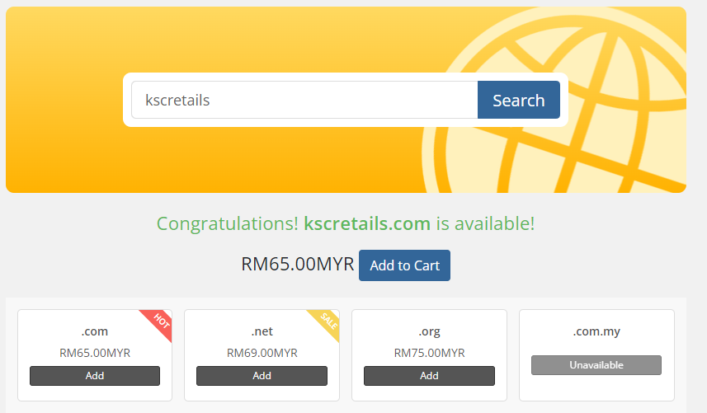

* WhatsApp OTP are still using free version account.
* Panda Cost (\*\* Will revert today \*\*)
* 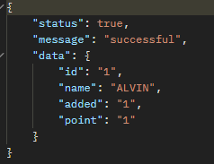Receipt Information :

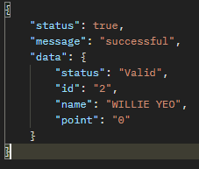

* Payment method Everrise and Emart use:

