APPLICATION DEVELOPMENT ON CLOUD

NAME: ADARI LEELA VENKATA SANDEEP

REGNO:2000031853

SECTION:01

ASSIGNMENT 2: Assume a company is running with the AWS services in their main branch. They are now opening the new branch for the increased customers. Due to this, they need to create new set of AWS services which are similar to the existing main branch is having. Luckily, they Create Cloud formation template which can act as a Infrastructure as Code. Now, you are the administrator for the new branch, who need to create the AWS services. Create those services and show the output.

Ans:

AWS CloudFormation simplifies provisioning and management on AWS. I can create templates for the service or application architectures you want and have AWS CloudFormation use those templates for quick and reliable provisioning of the services or applications (called “stacks”)

Step 1: Create Stack and choose the option Create template in Designer.

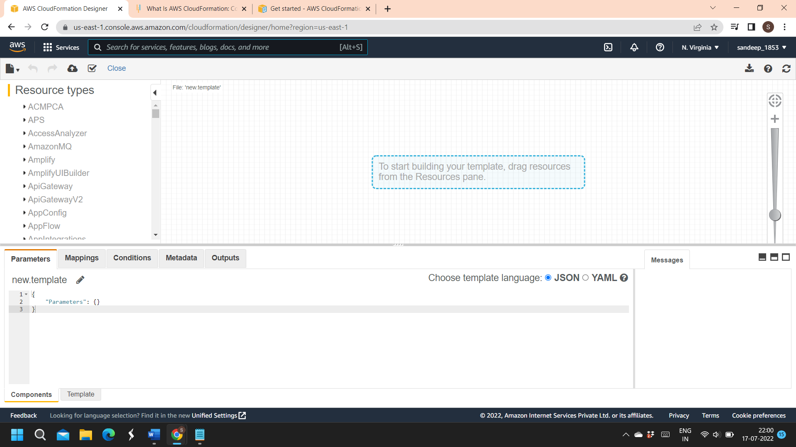

Step 2: Paste the JSON code in “Template” tab i.e..

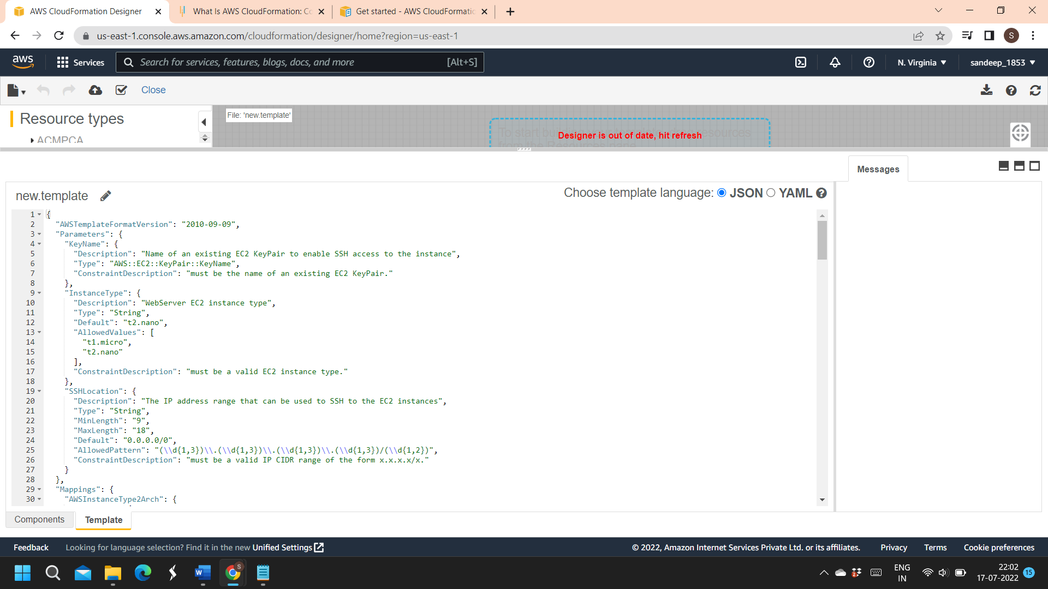

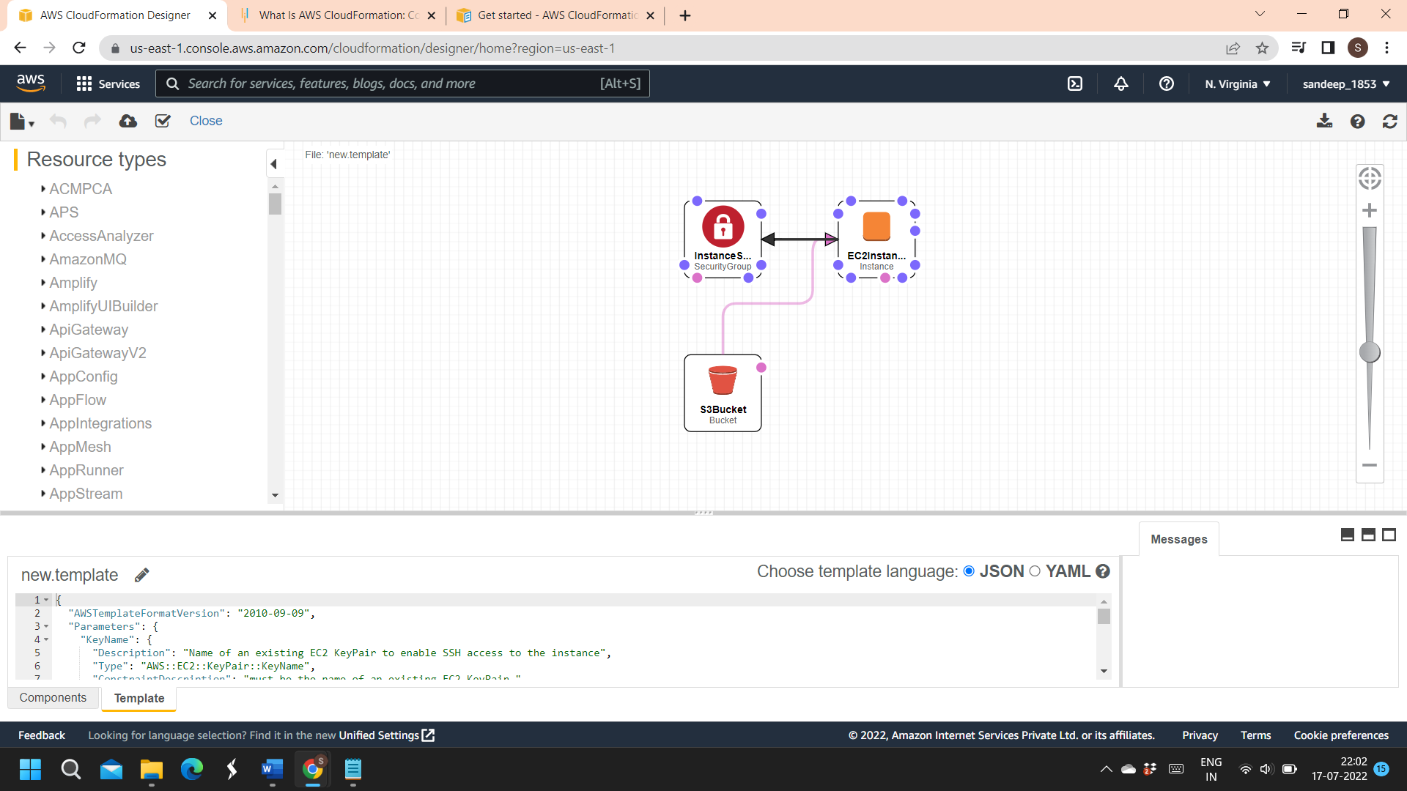

Step 3: Create a stack that at top left button and already file location is updated-->next-->S3-EC2-SecurityGroup(stack name)

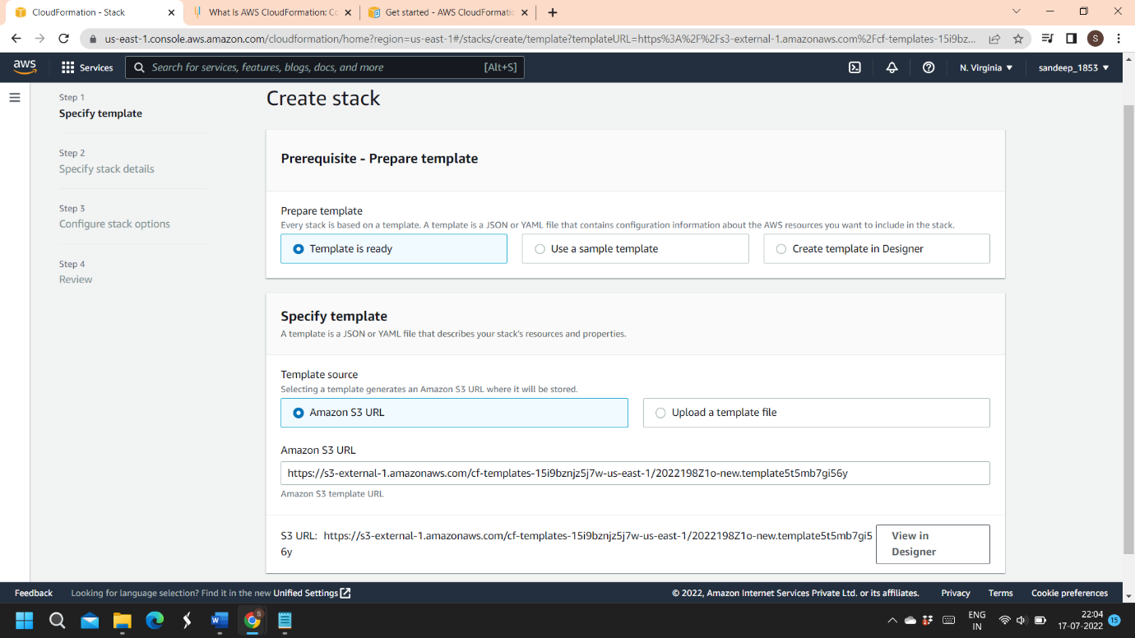

🡪I had created keypair already from ec2 instances i.e..” projectkey”

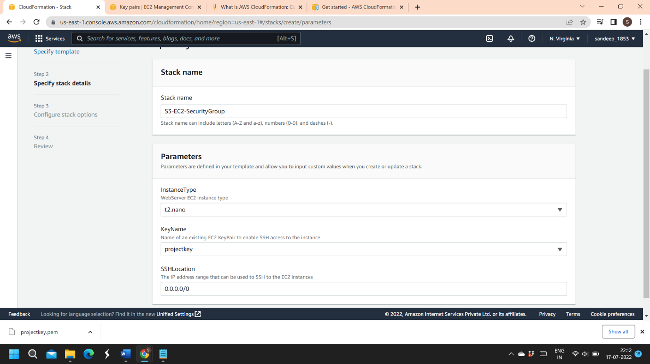

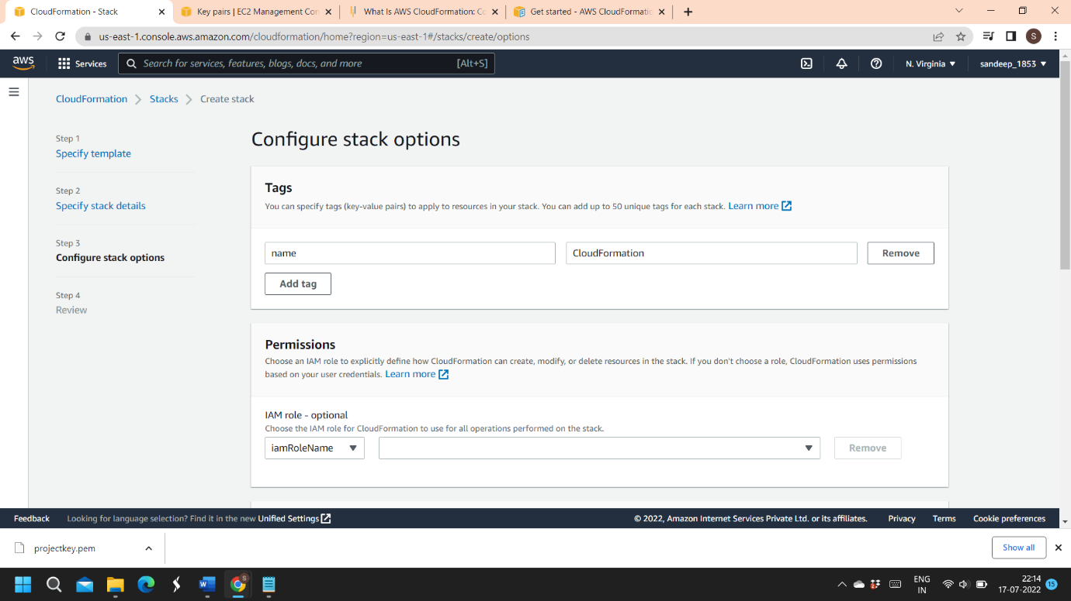

Click ->Create Stack

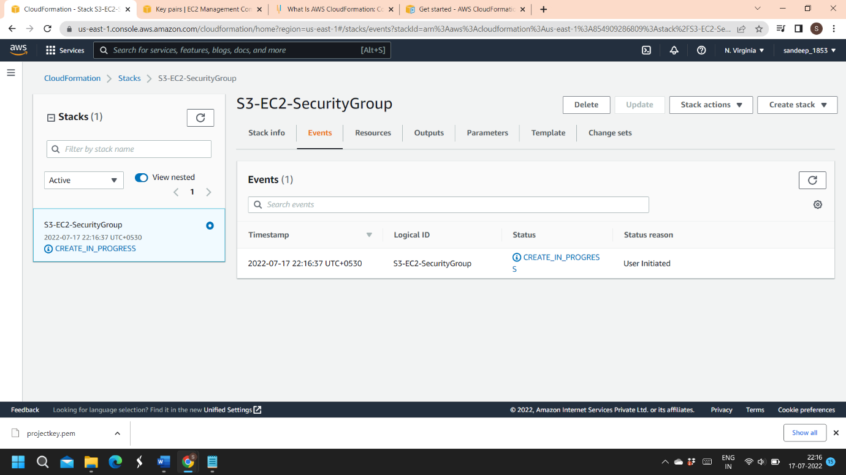

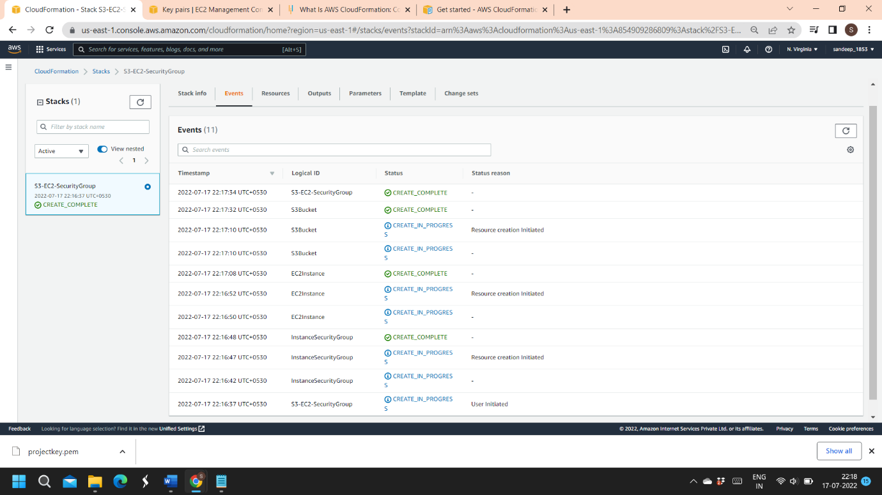

Step 4: Check EC2, S3 bucket and Security group created or not..

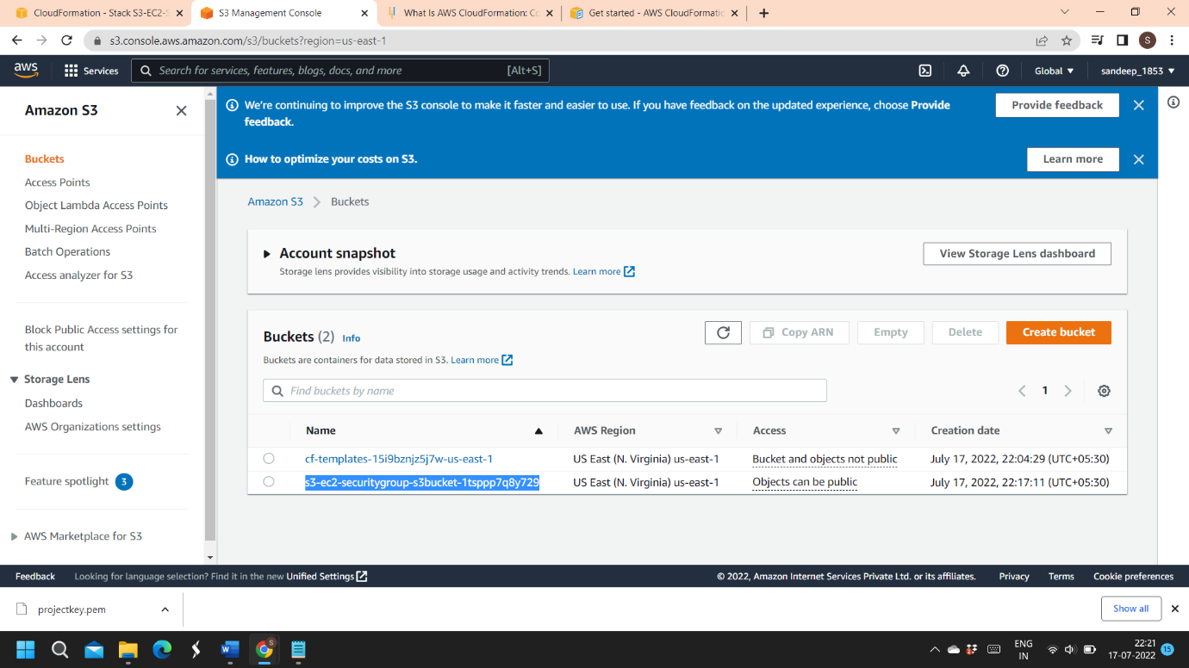

Outputs:

