ALWIN TOMY (2347207)

C-ASSIGNMENT

1. Write a program in C to display n terms of natural numbers and their sum.

#include<stdio.h> void main()

{

int n,i,sum=0;

printf("Enter the Max limit : "); scanf("%d",&n);

printf("The First %d Natural Numbers is ",n); for (i=1;i<=n;i++)

{

printf("%d\t",i); sum=sum+i;

}

printf("\n The Sum of natural Numbers upto %d is %d",n,sum);

}

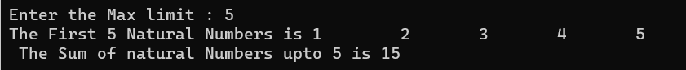

1. Write a program in C to display the cube of the number up to an integer.

#include<stdio.h> void main()

{

int i,n=0;

printf("Input number of terms : "); scanf("%d",&n); for(i=1;i<=n;i++)

{

printf("\nNumber is : %d and cube of the %d is :%d",i,i,(i*i*i));

}

}

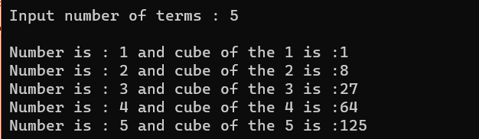

1. Write a program in C to display the multiplier table vertically from 1 to n.

#include<stdio.h> void main()

{

int n=0,x=0,i;

printf("Enter the Multiplier : "); scanf("%d",&n);

printf("Enter the count :"); scanf("%d",&x);

printf("Multiplication table from 1 to %d is \n",x); for(i=1;i<=x;i++)

{

printf("%d * %d = %d\n",i,n,(i*n));

}

}

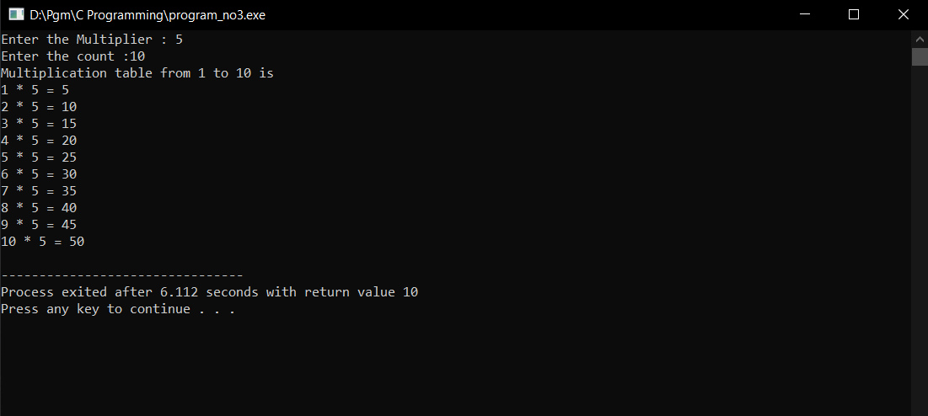

1. Write a program in C to display the n terms of a harmonic series and their sum.

#include<stdio.h> void main()

{

int n,i;

float sum=0.0;

printf("Enter the number of terms : "); scanf("%d",&n);

printf("1 "); for(i=2;i<=n;i++)

{

printf("+ 1/%d ",i); sum+=1.0/i;

}

printf("\nSum of Series upto %d is %f",n,sum+1.0);

}

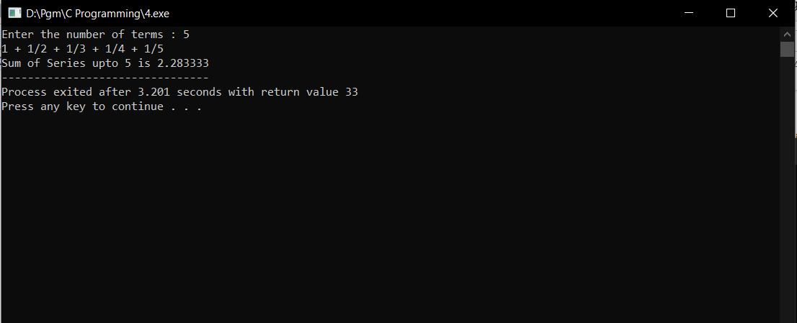

1. Write a program in C to display the sum of the series [ 9 + 99 + 999 + 9999

...]

#include<stdio.h> int main()

{

int i,n;

long int num=9,sum=0; printf("Enter the input :"); scanf("%d",&n); for(i=0;i<n;i++)

{

printf("%ld\t",num); sum=sum+num; num=(num*10)+9;

}

printf("\nThe sum of series is %ld",sum);

}

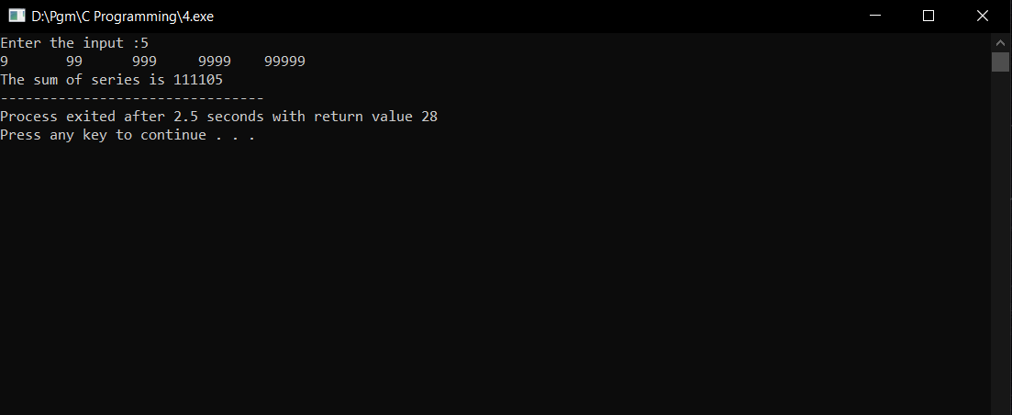

1. Write a program in C to find the sum of the series [x - x^3 + x^5 + ]

#include <stdio.h>

#include <math.h>

void main() {

int i, value, limit;

double sum = 0;

printf("Enter Value of X: ");

scanf("%d", &value);

printf("Enter Limit: ");

scanf("%d", &limit);

for (i = 0; i < limit; i++)

{

if (i % 2 == 0) {

sum += pow(value, 2 * i + 1);

}

else {

sum -= pow(value, 2 * i + 1);

}

}

printf("\nSum Of Series is %lf",sum);

}

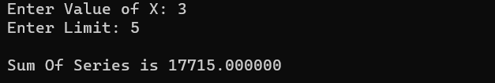

1. Write a C program that displays the n terms of square natural numbers and their sum.1 4 9 16 ... n Terms

#include<stdio.h> void main()

{

int i,n,max,square,sum=0; printf("Enter the number of terms : "); scanf("%d",&max);

printf("The square of Natural numbers upto %d is",max); for(i=1;i<=max;i++)

{

square=i*i;

printf(" %d",square); sum=sum+square;

}

printf("\nSum of square of natural number upto %d is %d",max,sum);

}

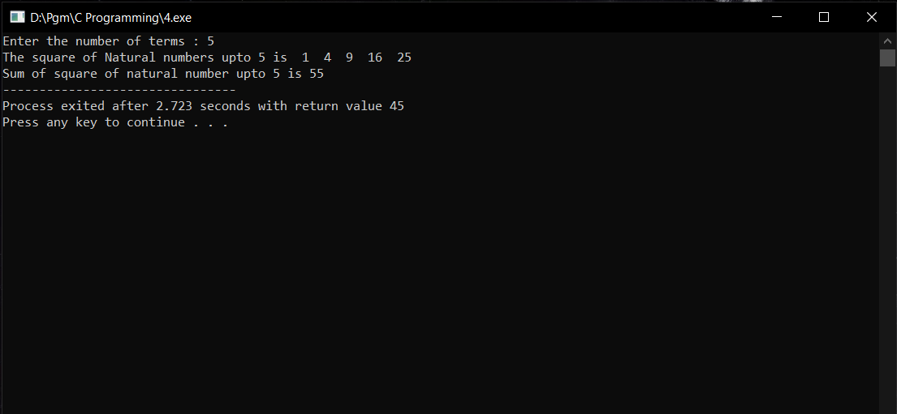

1. Write a C program to read temperature in centigrade and display a suitable message according to the temperature state below:

Temp < 0 then Freezing weather, Temp 0-10 then Very Cold weather, Temp 10-20 then Cold weather, Temp 20-30 then Normal in Temp,

Temp 30-40 then Its Hot, Temp >=40 then Its Very Hot

#include <stdio.h> int main()

{

float temp;

printf("Input temperature in centigrade: "); scanf("%f", &temp);

if (temp < 0)

printf("Freezing weather\n"); else if (temp >= 0 && temp < 10)

printf("Very Cold weather\n"); else if (temp >= 10 && temp < 20)

printf("Cold weather\n");

else if (temp >= 20 && temp < 30) printf("Normal in Temp\n");

else if (temp >= 30 && temp < 40) printf("Its Hot\n");

else

printf("Its Very Hot\n"); return 0;

}

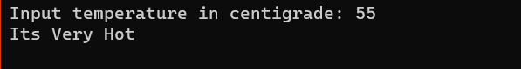

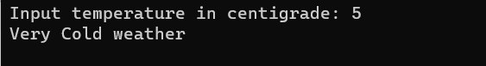

1. Write a program in C to calculate and print the electricity bill of a given customer. The customer ID, name, and unit consumed by the user should be captured from the keyboard to display the total amount to be paid to the customer.The charge are as follow :

Unit Charge/unit upto 199 @1.20

200 and above but less than 400 @1.50 400 and above but less than 600 @1.80

600 and above @2.00 If bill exceeds Rs. 400 then a surcharge of 15% will be charged and the minimum bill should be of Rs. 100/-

#include <stdio.h> int main()

{

int customerID, unitConsumed; char customerName[50];

float charges = 0, surcharge = 0, totalAmount; printf("Enter Customer ID: ");

scanf("%d", &customerID); printf("Enter Customer Name: "); scanf("%s", customerName); printf("Enter Unit Consumed: "); scanf("%d", &unitConsumed);

if (unitConsumed <= 199)

charges = unitConsumed * 1.20;

else if (unitConsumed >= 200 && unitConsumed < 400) charges = unitConsumed * 1.50;

else if (unitConsumed >= 400 && unitConsumed < 600) charges = unitConsumed * 1.80;

else if (unitConsumed >= 600) charges = unitConsumed * 2.00;

if (charges > 400)

surcharge = charges * 0.15; totalAmount = charges + surcharge; if (totalAmount < 100)

totalAmount = 100;

printf("Customer IDNO: %d\n", customerID); printf("Customer Name: %s\n", customerName);

printf("Unit Consumed: %d\n", unitConsumed);

printf("Amount Charges @ Rs. %.2f per unit: %.2f\n", charges, charges); printf("Surchage Amount: %.2f\n", surcharge);

printf("Net Amount Paid By the Customer: %.2f\n", totalAmount);

return 0;

}

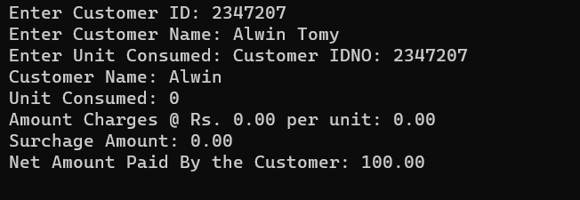

1. Write a program in C to read any digit and display it in the word.

#include <stdio.h> int main()

{

int digit;

printf("Enter a digit: "); scanf("%d", &digit); switch (digit) {

case 0:

printf("Zero\n"); break;

case 1:

printf("One\n"); break;

case 2:

printf("Two\n"); break;

case 3:

printf("Three\n"); break;

case 4:

printf("Four\n"); break;

case 5:

printf("Five\n"); break;

case 6:

printf("Six\n"); break;

case 7:

printf("Seven\n"); break;

case 8:

printf("Eight\n"); break;

case 9:

printf("Nine\n"); break;

default:

printf("Invalid input\n");

}

return 0;

}

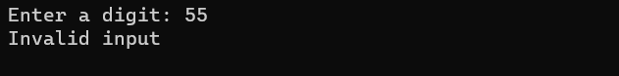



1. Write a C program for reading any Month Number and displaying the Month name as a word.

#include <stdio.h> int main() {

int monthNumber;

printf("Enter the month number: "); scanf("%d", &monthNumber); switch (monthNumber) {

case 1:

printf("January\n"); break;

case 2:

printf("February\n"); break;

case 3:

printf("March\n"); break;

case 4:

printf("April\n"); break;

case 5:

printf("May\n"); break;

case 6:

printf("June\n"); break;

case 7:

printf("July\n"); break;

case 8:

printf("August\n"); break;

case 9:

printf("September\n"); break;

case 10:

printf("October\n"); break;

case 11:

printf("November\n"); break;

case 12:

printf("December\n"); break;

default:

printf("Invalid month number\n");

}

return 0;}

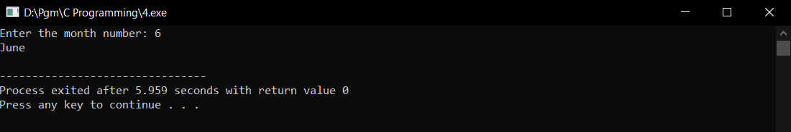

1. Write a program in C which is a Menu-Driven Program to perform a simple calculation. (1. Area of Circle 2. Area of Triangle 3. Area of Rectangle)

#include <stdio.h> #include <math.h> void main()

{

int choice; float result;

printf("Menu:\n");

printf("1. Area of Circle\n"); printf("2. Area of Triangle\n"); printf("3. Area of Rectangle\n"); printf("4. Exit\n");

printf("Enter your choice: "); scanf("%d", &choice); switch (choice) {

case 1: {

float radius;

printf("Enter radius of the circle: "); scanf("%f", &radius);

result = M_PI * radius * radius; printf("Area of the circle: %f\n", result); break;

}

case 2: {

float base, height;

printf("Enter base length of the triangle: "); scanf("%f", &base);

printf("Enter height of the triangle: "); scanf("%f", &height);

result = 0.5 * base * height;

printf("Area of the triangle: %f\n", result); break;

}

case 3: {

float length, width;

printf("Enter length of the rectangle: "); scanf("%f", &length);

printf("Enter width of the rectangle: "); scanf("%f", &width);

result = length * width;

printf("Area of the rectangle: %f\n", result); break;

}

case 4:

printf("Exiting the program.\n"); break;

default:

printf("Invalid choice\n");

}

}

