Queries:

1. 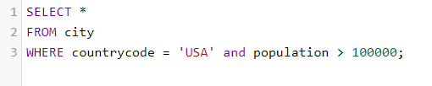
2. 
3. 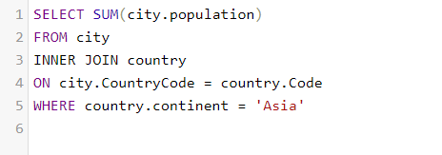
4. 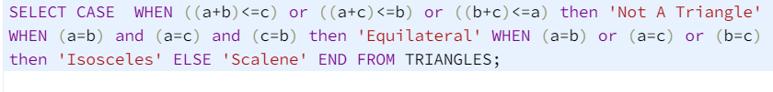
5. 

Problem1: