commerce- الطالبتين :

نوره خالد الزبيد ي وجدان عطيه الزهراني

software

Requirements:

User, Product, Inventory and Order Management.

Main Tasks the Software Can Do:

*1.* Manage Products and Inventory *(Add, update, and delete products and set alerts for low stock).* :

Add/Update/Delete Products: Admins can add new products, edit product details (e.g., name, price, description, category), and remove products.

Inventory Management: Track stock levels in real-time. Adjust stock when products are sold or returned.

Low Stock Alerts: Notify admins when stock levels fall below a certain threshold.

Product Categorization: Organize products by categories, tags, or brands for easy browsing.

Product Attributes:

* Name
* Description
* Price
* SKU (Stock Keeping Unit)
* Images
* Category (electronics, clothing)
* Stock quantity
* Status (in stock/out of stock)

*2.* Process Orders and Payments *(Handle customer orders, process payments securely, and manage the checkout process efficiently). :*

Shopping Cart: Customers can add/remove products and update quantities before checkout.

Checkout Process: Secure, multi-step checkout process for reviewing orders, selecting shipping options, and entering payment details.

Order Management: Admins can view and update order statuses (e.g., processing, shipped, delivered, canceled).

Payment Gateway Integration: Integration with payment gateways like PayPal, Stripe, or credit card processors for secure payment handling.

Order Tracking: Customers can track the progress of their orders.

Invoice Generation: Automatically generate invoices after successful transactions.

1. Facilitate Customer Interaction *(Enable customers to browse products, add them to the cart, and complete purchases while providing support when needed). :*

Product Browsing: Customers can browse products by category, search for specific items, and use filters (price, brand, rating).

Customer Reviews & Ratings: Customers can leave reviews and rate products they have purchased.

Live Chat Support: Optional integration with live chat to assist customers with their queries in real-time.

Wishlist: Allow customers to save products for future purchases.

1. generate Reports *(Create detailed reports on sales, customer behavior, and inventory, helping businesses make data-driven decisions). :*

Sales Reports: Generate daily, weekly, and monthly sales reports, including product-wise and category-wise breakdowns.

Inventory Reports: Monitor stock levels and predict replenishment needs. Identify fast- and slow-moving items.

Customer Behavior Reports: Track purchase history, preferences, and site interactions to inform marketing strategies.

Revenue Reports: Track revenue, profits, and margins over time.

Homework 2

The problems that an e-commerce store solves:

1. Reduces costs: Such as expenses for employees and rent.

2. Overcomes time constraints: Allows customers to shop at any time.

3. Ease of finding products: Some products are available only on online stores.

4. Solves congestion and queuing issues: Avoids crowded stores and long lines.

Needs Met by an e-commerce Store:

1. Convenience and ease of shopping: Allows customers to shop easily from

home or anywhere.

2. Secure payment: Provides safe and reliable payment options.

3. Delivery service: Orders are delivered to the doorstep, saving time and effort.

4. Communication tools: Offers customer service and instant inquiry options.

Survey about NAMSHI app:

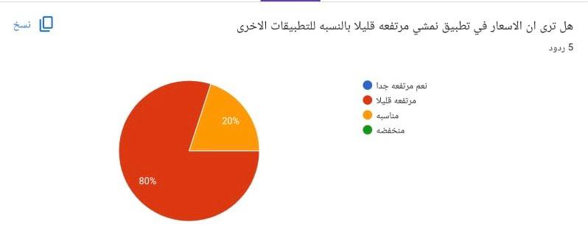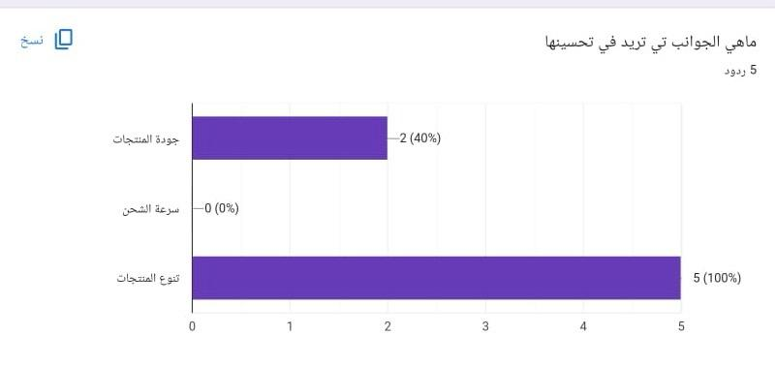

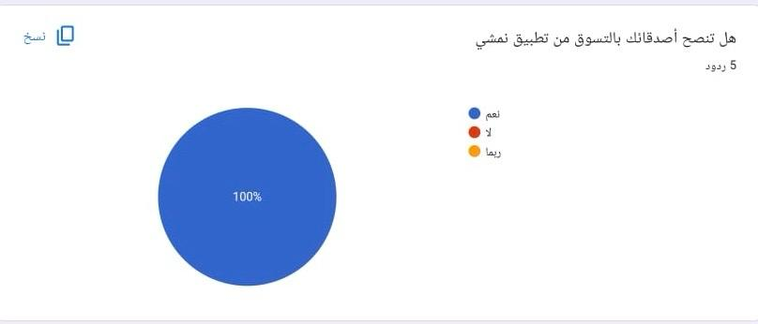

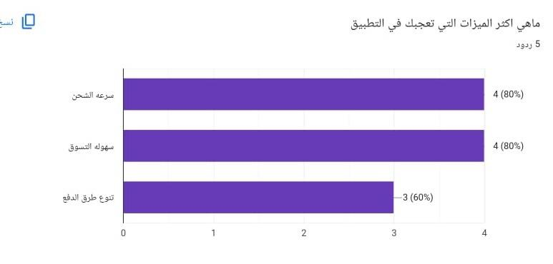

Based on the survey results we can

1. Improving Quality:

* Adding a return policy.
* Choosing reliable suppliers.
* Inspecting product quality
* 2. Improving Product Diversity:
* Expanding categories by adding new ones.
* Checking market trends.
* Offering seasonal products.

3. Improving Prices:

* Offering discounts and promotions.
* Offering flexible payment options.

|  |  |  |
| --- | --- | --- |
| App: | Advantages | Disadvantages |
| NAMSHI | Fast shipping and  delivery. Multiple payment  methods. | Variable product quality.  Slightly unaffordable  prices.  The app focuses mainly  on fashion, so there is not  much variety in products. |
| Noon | Fast shipping and  delivery.  Variety of products.  Multiple payment  methods | Inconsistent product  quality.  Price variations. |
| SHEIN | Competitive prices. Variety of products. Multiple payment  options. | Slow shipping and  delivery.  Inconsistent product  quality |

Comparison Between NAMSHI and Similar Apps