AD6 Results

1. In silico

1.1 Sequence analysis and conservation

Fig Xa is showing the multiple sequence alignment of several glycoprotein B sequences from 4 animal CMVs and one HCMV. While the whole alignment is fairly heterogeneous, the region where AD-6 is located is one of the few spots with clear similarity. The same BLAH can be deduced from comparing the phylogenetic trees of glycoprotein B sequences and just the AD-6 segment [make the trees!!!! On the same scale] . As expected, there is a high sequence similariy when aligned with the sequences from same virus (Fig Xb).

[seq figure + Phylo tree]

And THEN put them on structure – all similar

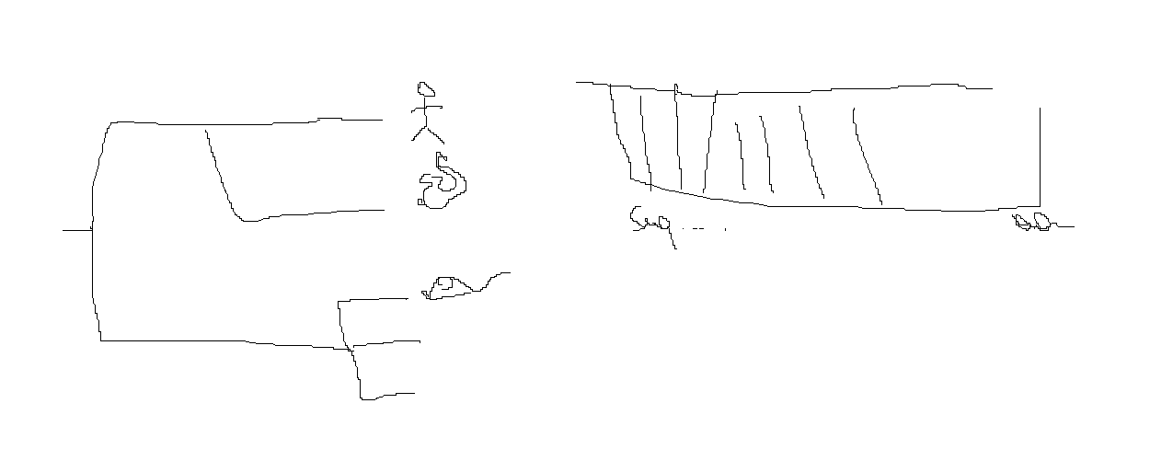

1.2 Structural conservation – figure

While the direct sequence alignment worked with hman and animal CMV sequences, I have come across an issue of gB sequences from other herpesviruses being too heterogeneous. Many methods [ref?????] recommend the lowest possible level of sequence similarity being 40% for a sensible alignment. Table Y outlines residue similarity among HHV gB sequences

[make the sequence similarity somparisons – how? Blast? Write your own code?? ] BLAST p-p – spend a few days working on this.

|  |  |  |  |
| --- | --- | --- | --- |
|  |  |  |  |
|  |  |  |  |
|  |  |  |  |
|  |  |  |  |

Thus, an approach not relying on sequence similarity was needed. I instead mirrored the previously analsyis in reverse, first starting with the structural similarity of gB. Figure X describes the identification of AD-6 analogues from aligning published PDB structures of 4 HHV. Moreover, a curious pattern emerged once the AD-6 and its analogues’ sequences aligned. Although the overall sequence conservation was consitently poor, a pattern of a repeating same or similar amino acid at a regular interval of 3 or 4 residues was noted, concocrdant with a step of an alpha-helical curve (ref). Thus there was a possiblilty of a conserved conformational epitope (fig X d) where matching amino acids would be presented in a simliar way on the same side of the alpha-helix. However, as the protein structure in vivo is not rigid and AD-6 undergoes a variety of conformational changes, the latter can not be valued as a definitive proof of epitope conservation. (then do i even need to include it rly?? )

[remove self-alignment in here – that'll be in the table earlier ]

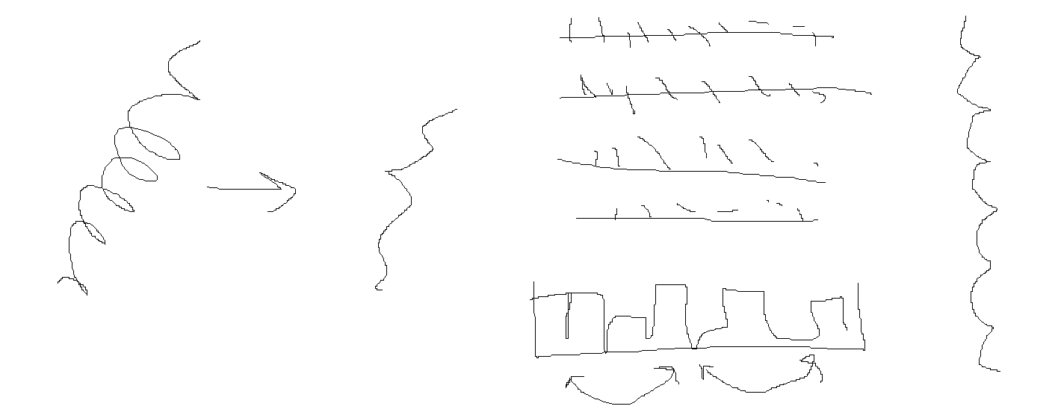

Make a separate figure for HVS – that one was alphafolded

And add phylo trees!! For just AD-6 of HHV + add the scale.

1.3 Immunogenicity prediction and database matching

To support the hypothesis of conserved immunogenicity I performed a B cell epitope prediction analysis on all 4 gB sequences.

[figre with the profiles compared – AD6 everywhere has a 3 peak profile]

[another figure for the alignment with epitopes]

when browsed through the database – the 3 epitopes match up, with the last one probably being the most real one, consistent with the data from the AD-6 paper [ask matt if it ever made to the publication].

Another result of the aforementioned epitope database matching exercise is a comprehensive epitope map of the Merlin gB amino acid sequence. The corresponding alignment and epitope metadata can be found on (github). While that alignment was obtained using the methods described in [], I had a chance to modify the process and compile a script that simplifies and streamlines the database search process. The epitope mapping tool can now be used publicly, is applicable for any protein sequence of interest, and outputs the same kind of alignment that was used in this analysis.

1.4 Molecular frustration

Molecular frustration can be used to measure the internal energy stored within an amino acid residue as part of a bigger protein structure. In lay terms, high level of molecular frustration corresponds to a high amount of “jigglyness” within a given reside. Highly frustrated parts of the protein (red in figure X) are not favourable from entropy point of view – they jiggle a lot - thus suggesting an evolutionary pressure other than convenience of folding. High frustration is usually clustered at the functional /catalytic/reactive parts of proteins [towers review?? ]. Minimally frustrated parts of the protein (green in figure X) are very stable from entropy point of view – they barely jiggle. Most proteins in nature would try to achieve a state where most of the structure is minimally frustrated. Neutral regions (grey in figure X) are inconsequential – they jiggle a little bit, like any molecule would.

Highly frustrated domains are not favourable from entropy point of view

– trimer and not, HSV1 and not, pre post fusion etc

[are 4 HHV possible here? ]

[ Figures and graphs from frustratometer with the coordinates altered ]

High level of molecular frustration often correlates with domain’s function [Greg Towers review] - reword this

parts of the protein are not favourable from entropy point of view – they jiggle a lot. This suggests an evolutionary pressure other than convenience of folding. High frustration is clustered at the functional /catalytic/reactive parts of proteins.

1.5 Oligomerisation prediction

One of the natural follow-up questions to the frustratometer results was whether AD-6 function lies in assisting the trimerisation of gB molecule. Additionally, the outlook of an AD-6 specific vaccine was outlining whether an abundance of AD-6 peptide can exist in an immunologically favourable state. I ran multiple Alphafold models with a varying number of constituent AD-6 “monomers”, first, to observe if trimerisation would occur resembling the gB homotrimer. Then as the number of monomers increased, I asked a question whether the oligomerisation would interfere with optimal epitope presentation.

Polymerisation of AD6

Optimal N – fence, then donut then falls apart

[figures for increasing N, maybe a graph for how much frustration in the PDB? Or accessibility]

1.6 Binding partner prediction

High level of molecular frustration of AD-6 in pre-fusion state

AD6 vs other glycoproteins.

Maybe try other cellular proteins

Run through a few options - figures and a table mb

gH maybe binds

1. In vitro

2.1 Mab purification

Table for nanodrop

See if plain media can be used as a blank instead of PBS

|  |  |  |
| --- | --- | --- |
|  | 12b2 | 14f7 |
| Media with igG-free FCS |  |  |
| harvest | 1.646 | 1.722 |
| Overnight fraction | 1.607 | 1.690 |
| PBS wash | 0 | 0 |
| Eluate (Glycine + Tris-Base) | 0 | 0 |
| Concentrator flow through | 0 | 0 |
| Final retainant | 0 | 0 |

Decision to not purify for some experiments as preliminary ELISA has shown a reasonable level of binding and difficulty to purify.

2.1 ELISA

2.1.1

AD6 pab

On CMVs, on HHVs

2.1.2

AD6 mabs

unpurified

On CMVs, on HHVs

Compare the two, one is rly good one is broad

2.2 Virus spread assay

2.2.1 Viral spread vs AD-6 pab

HCMV

HSV1

HVS

VZV

In conclusion, HCMV AD-6 polyclonal antibody seems to exhibit a protective effect against HSV-1 and HVS cell-to-cell spread.

2.2.2 Viral spread vs AD-6 mab

HCMV AD6 mab – Mara's data, my own data (? )

HSV1 – preliminary data with the undiluted antibody

2.3 Neutralisations

2.2.1 HCMV

Peptides and cell types

2.2.1 HSV1

Peptides and cell types

Preliminary data

[Als data ? ] Mebe discuss with him – read through his report

2.4 Binding assay

Preliminary data

Check if His6-AD6 has the same structure as regular AD6 – atlas

Infection % and PCR

Infection 20 times higher

Bound

No infection from eluate – probably imidazole concentration too high