1.bug:

java.lang.ClassNotFoundException: com.mysql.jdbc.Driver

solve：数据库驱动包没有加载到项目中，让该数据包能在工作区看到就没问题了

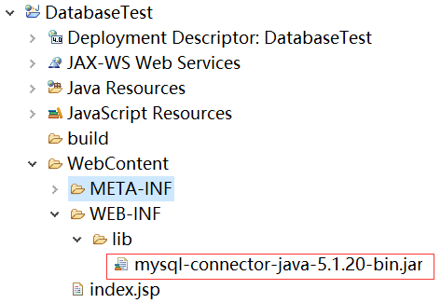

2.bug:

java.sql.SQLException: java.lang.ClassCastException: java.math.BigInteger cannot be cast to java.lang.Long

solve:换个jar包就好了,换成mysql-connector-java-8.0.12.jar

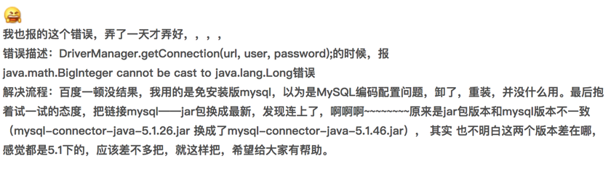

3.bug:

java.sql.SQLException: The server time zone value '???ú±ê×??±??' is unrecognized or represents more than one time zone. You must configure either the server or JDBC driver (via the serverTimezone configuration property) to use a more specifc time zone value if you want to utilize time zone support.

solve: 其实这个不是spring boot + mybatis的问题， 其实是为了使MySQL JDBC驱动程序的8.0.12版本与UTC时区配合使用，必须在连接字符串中明确指定serverTimezone。

也就是：

String url = "jdbc:mysql://localhost:3306/world?serverTimezone=UTC";

4.bug:

WARN: Establishing SSL connection without server's identity verification is not recommended. According to MySQL 5.5.45+, 5.6.26+ and 5.7.6+ requirements SSL connection must be established by default if explicit option isn't set. For compliance with existing applications not using SSL the verifyServerCertificate property is set to 'false'. You need either to explicitly disable SSL by setting useSSL=false, or set useSSL=true and provide truststore for server certificate verification.

翻译如下：

不推荐服务器身份验证，不需要建立SSL连接。根据MySQL 5.5.45 +，+，+ 5.6.26 5.7.6要求SSL连接必须建立明确的选项默认情况下如果不设置。符合现有的应用程序不使用SSL的verifyservercertificate属性设置为“false”。你需要显式禁用SSL设置usessl = false，或设置usessl =真实提供服务器证书验证信任库

solve:在URL中加入useSSL=false即可

String url = "jdbc:mysql://localhost:3306/world?useSSL=false&serverTimezone=UTC";