

Qassim university

College of Computer

CS214 Data Structures

This project submitted as part of this course requirement.

November 21,2018

Index

Introduction-------------------------------------------------[3]

Algorithm---------------------------------------------------[4-8]

Code---------------------------------------------------------[9-16]

Output-----------------------------------------------------[17-21]

Introduction

Book store management program

This program will have the following Features:

1-Add a new Book to your store, when you want add a new one you most enter the ISBN of the Book ,and the Book name also most enter the Author name Which has specific rules, (for more information see point 5),then enter the category of the Book (Which is mentioned in the INFO function see point 5),and you most enter the price of the book which most be floating point .

2- Delete a Book from your store, you can delete a Book by entering the ISBN of the Book if it is found it in the first location in the list than well delete from there ,if not found in the beginning it well continue until the last location if it not found ,than well go out of the function.

3-Search for a book, you can search for a book in your store using the ISBN of the book and by the Frist Letter of the Author name, also you can search by the Category of the book.

4-INFO, you can see the info of what you should enter in the ISBN and in the author name also which category we have in our store, (go to the Algorithm of info function for extra information).

5- Save book list, you can save the book list if a specific file in your device, so you can access the data in another time (Load list).

6- Print the book list, you can print the book list continue the page number and the ISBN of the books and the books name, also print the category of the books, and the price of each book separately.

Algorithm

Add Book () [To add a new Book in the store]

This function well Add a new book to your store:

1-create New Node in memory [Node Comp].

2.get the ISBN of the book from the user.

2-get the book name from the user.

3-get the author name from the user.

4-get the category of the book from the user.

5-get the price of the book from the user.

6- if (Head = NULL) then: Head = new node and Return.

7- if (new node ->ISBN <Head->ISBN) then: Set New node ->Head and Head = new node, Return.

8-Set Prev node = NULL and CurrNode =NULL.

9-Repeat for (Curr=Head; Curr! =NULL; Curr=Curr->next)

{

If (new node->ISBN <Curr->ISBN) {break the loop}.

Set Prev node = Curr.

}

10-Set new node->next = Prev->next and prev->next=newnode.

11-Exit.

Info () [to get some information]

This function well helps the user to inter an allowed input.

1-write” The ISBN at least more than 4 digits”.

2-write” For the author name should contain first letter of first name and all the last name”.

3-write “For the Category of Books most be one of the following, [1]-Drama [2]-Math [3]-Art [4]-Science [5]-Comics”.

4-write” The price should be floating point, note that the price is (Includes VAT)”.

5-Exit.

Space(s) [to add a space to the output]

This function definite just for adding a space in the output

1-set coun =0 and set I = 0

2-Repeat steps 3 and 4 while (s! =0)

3-appliy [count++]

4appply[++i]

5-set sp =20-coun

6-Repeat for sp until (sp >0; sp---;)

{write: “”;}

7-Exit

Delete Book () [To Delete a book] [using data variable]

This function well deletes a book to your store:

1-Create New Node in memory [Node Comp].

2-if (Head =NULL) then: write:” Sorry, but your shop is empty”, Return.

3-get the ISBN of the book from the user to delete.

4-if (data =Head ->ISBN) then:

Set head = head->next and Return.

5-Repeat for (Scan->Head; Scan! =NULL; Scan=scan->next)

{

If(scan->ISBN=data) {

break;

}

Set prev =scan;

}

6-if(scan==NULL) then

Write: "Sorry, but the ISBN of this Book not found in the list!”

Else {

Write: “The Book has been deleted”

Set prev->next = curr->next.

}

7-Exit

Search_for_Book()[to search for a book in the store] [using Look and fname variable]

1-Dsplay optional for user to Choose.

2-get choice from user.

3[case1] Repeat -for (Curr=Head; Curr! =NULL;Curr = Curr->next )

{if (Curr-> ISBN = look) then:

Display ISBN.

}

4-if(look<1) then: write: “not found!”. Break;

5-[case2] Repeat for (Curr=Head; Curr! =NULL;Curr = Curr->next ){

If(curr->author [0] =fname)then:write”found” . Break;

6- [case3 Repeat] for (Curr=Head; Curr! =NULL;Curr = Curr->next ){

If (strcmp (curr->category = look) then: write”found” .

7-Exit

Save List () [to save the list in a file]

1-if (Pfile=NULL) then:

Write: cannot open the file, and Return.

2-repeat step 3 until 7 for (Curr = Head; Curr! = NULL; Curr = Curr -> next)

3- set NF. ISBN = Curr->ISBN;

4-set (NF.Book_name, Curr -> Book_name)

5-set NF.author, Curr->author)

6-set NF.category, Curr->category);

7-set NF.price = Curr->price;

8-Exit

LoadList()[to load the list form the file]

1-if(pfile=NULL) then:

Write: File not Exist, and Return.

2-repeat step 3 until 9 while (pifile).

3-create a new node

4- Set NewNode->ISBN = NF. ISBN;

5- Set NewNode -> Book_name, NF.Book_name

6- Set NewNode->author, NF.author

7- Set NewNode->category, NF.category

8- Set NewNode->price = NF.price;

9- Set NewNode -> next = NULL;

10- if (head= NULL) then:

Set head= newnode , and tail = newnode;

Else {

Tail->next = newnode , and tail = newnode.

Return.

}

11-Exit

DisplayList_of_Books()[This function well prints all the Book in the store!]

1-set i=0

1-if (Head= NULL) then: write” Sorry,but your store is empty”

2-Repeat steps 3 and 4 for (Curr = Head; Curr! = NULL; Curr = Curr -> next)

3- if (i % 20 == 0 && i! = 0) then:write:” Press a key for next Page:”

4 call Heading ();

5-print record.

7-Exit

Code

# The include libraries and Global Structure with Variables and Functions Prototypes.

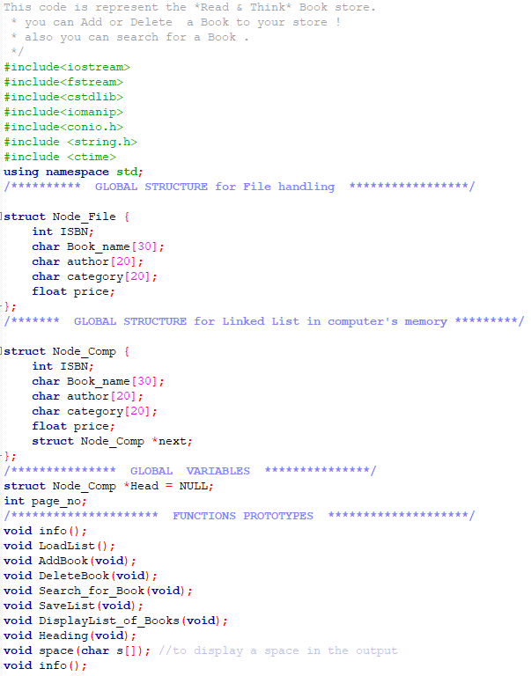

#The main Functions:

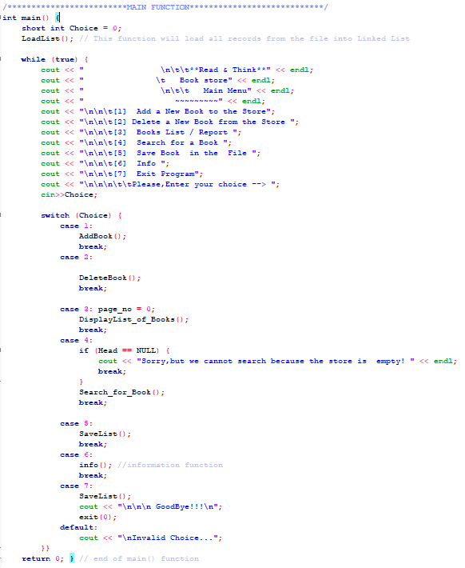

# The Add Book Functions:

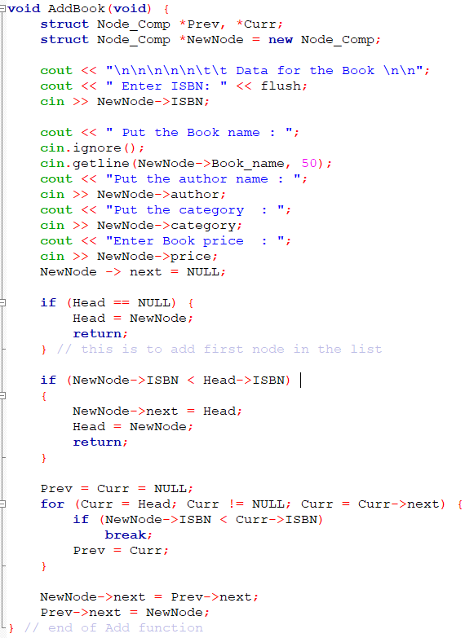

#The Space Functions:

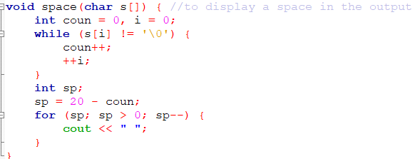

#The Delete Functions:

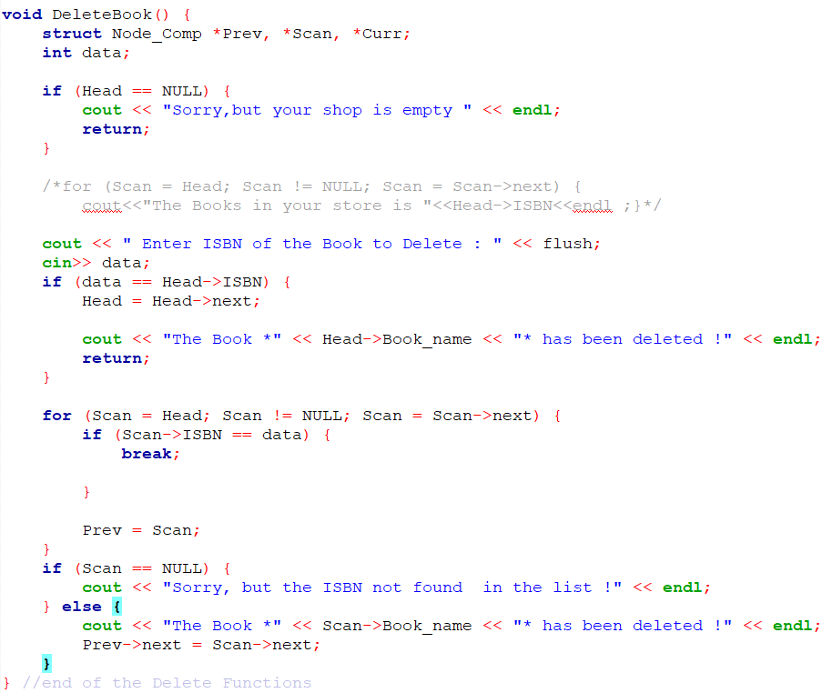

#The info Function:

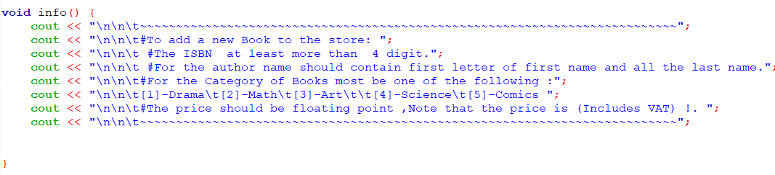

#The Search Function:

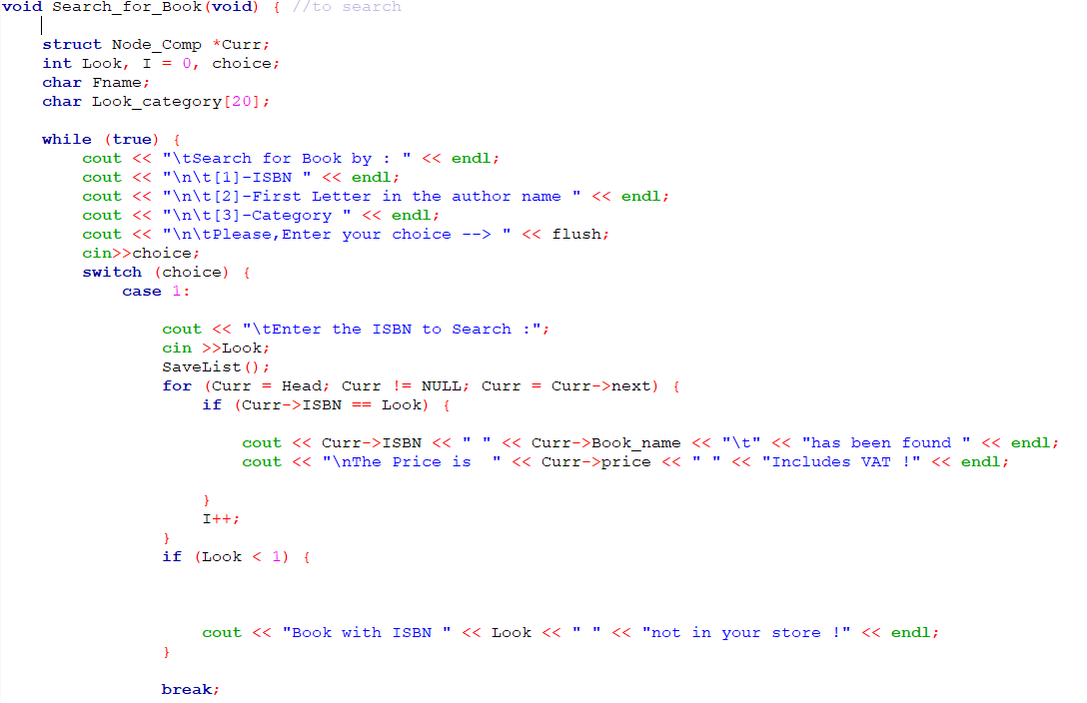

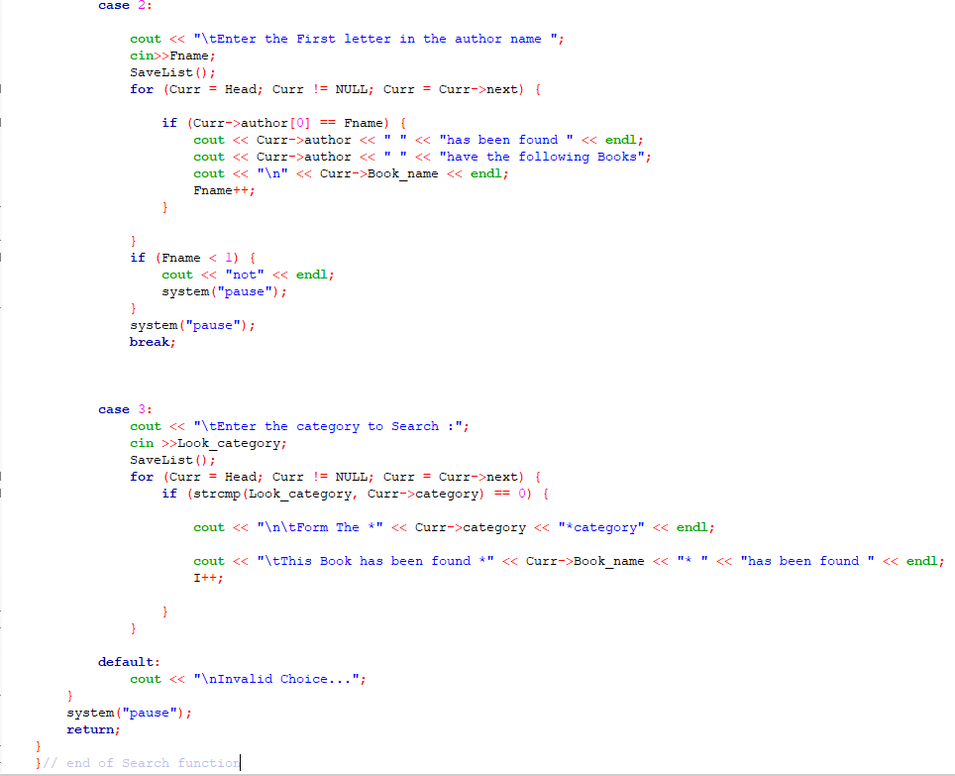

#The Save Function:

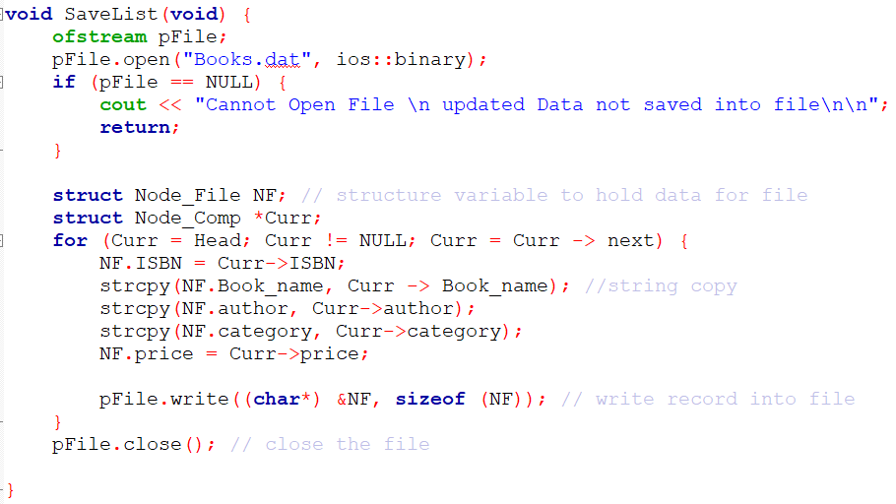

#The Load Function:

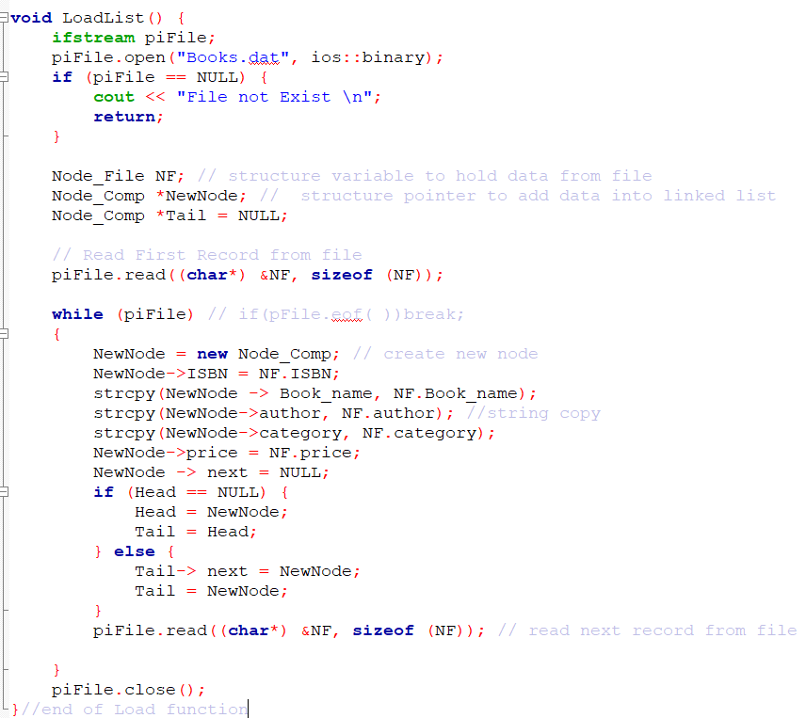

#The Display Function:

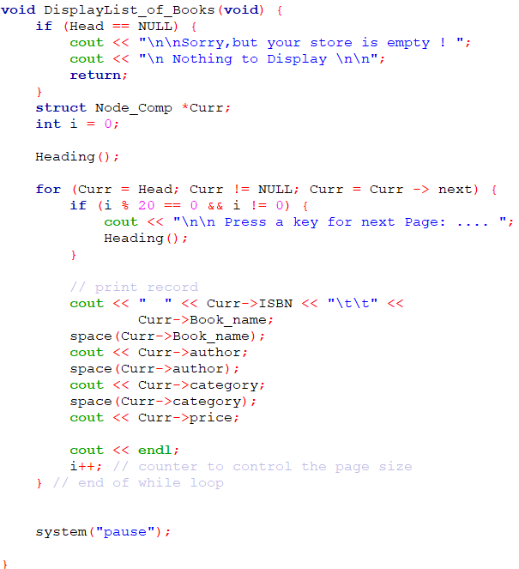

#The Heading Function:

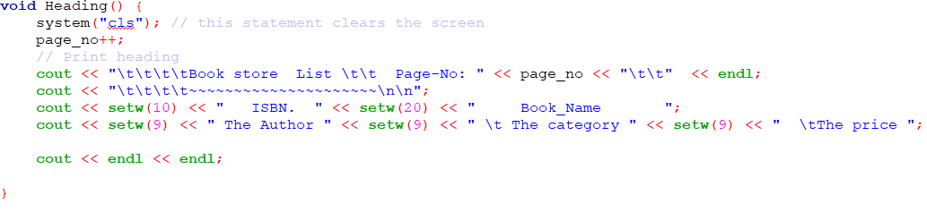

Output

Test the Add Book Function:

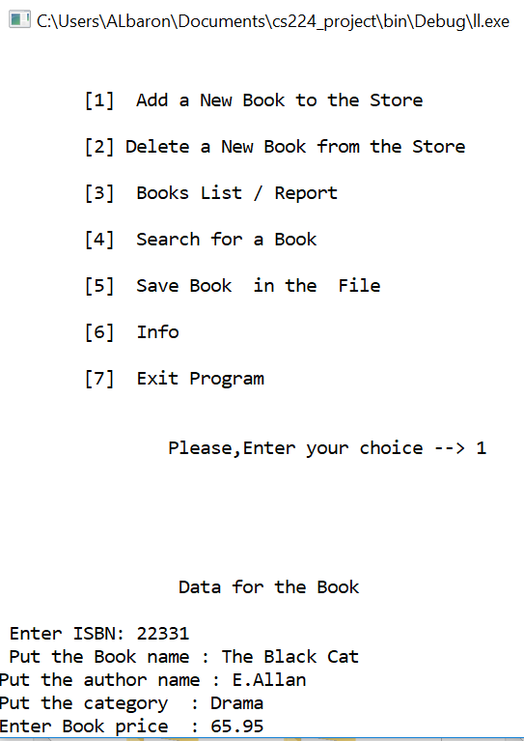

Test the Book list printing:

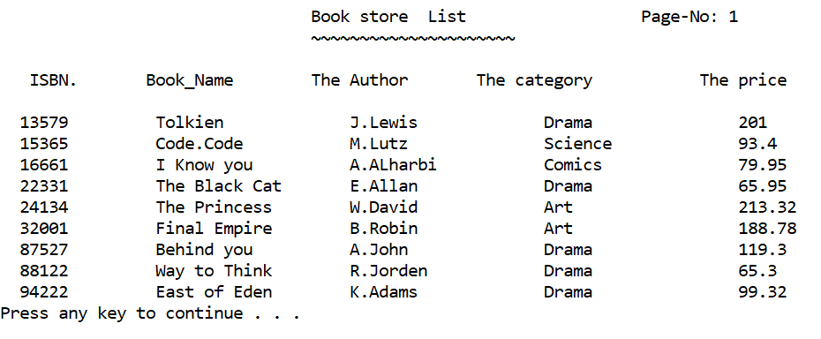

Test the Delete Function:

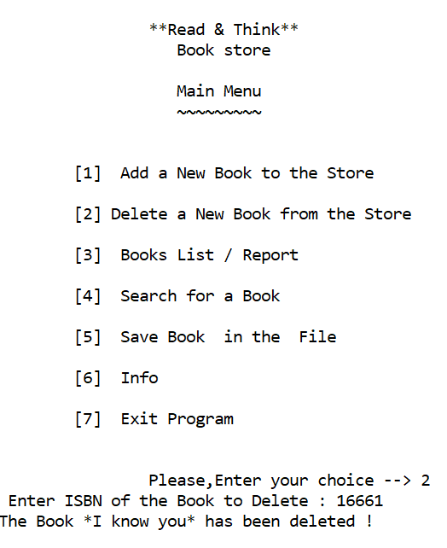

Test after Deleting a Book!

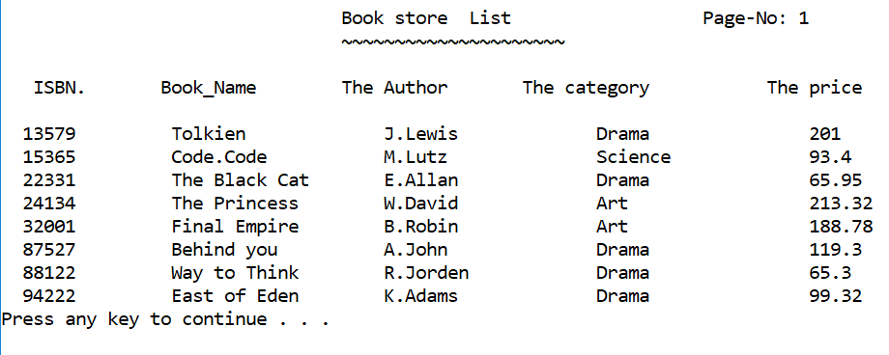

Test the Search Function:

1- (search by the ISBN):

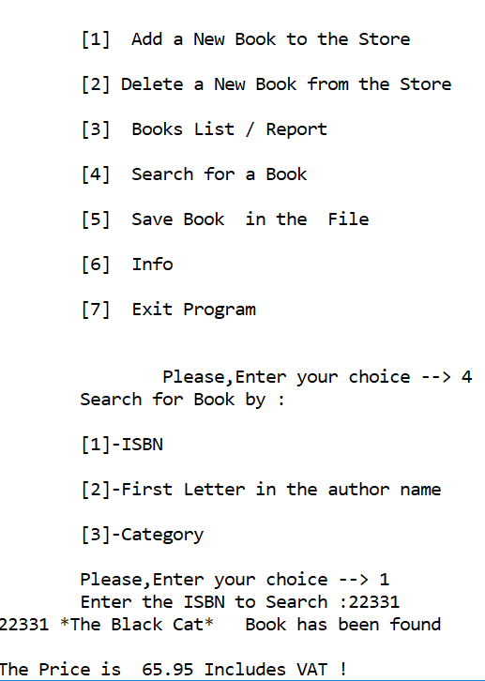

Test the Search Function:

2- (search by the Frist Letter in the author name):

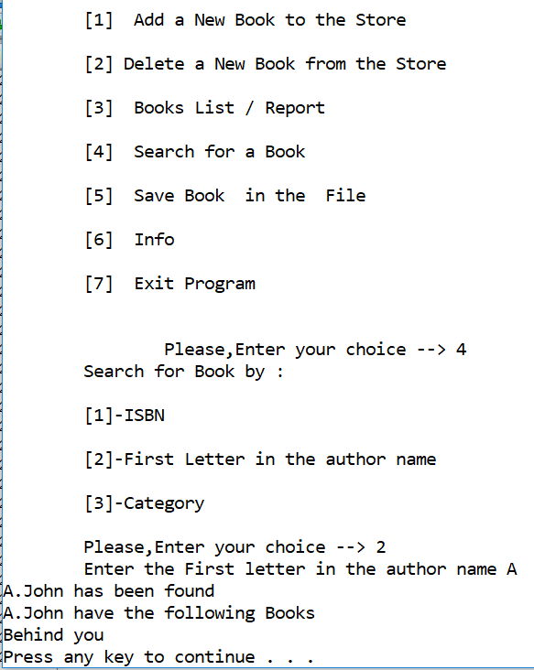

Test the Search Function:

3- (search by the category).

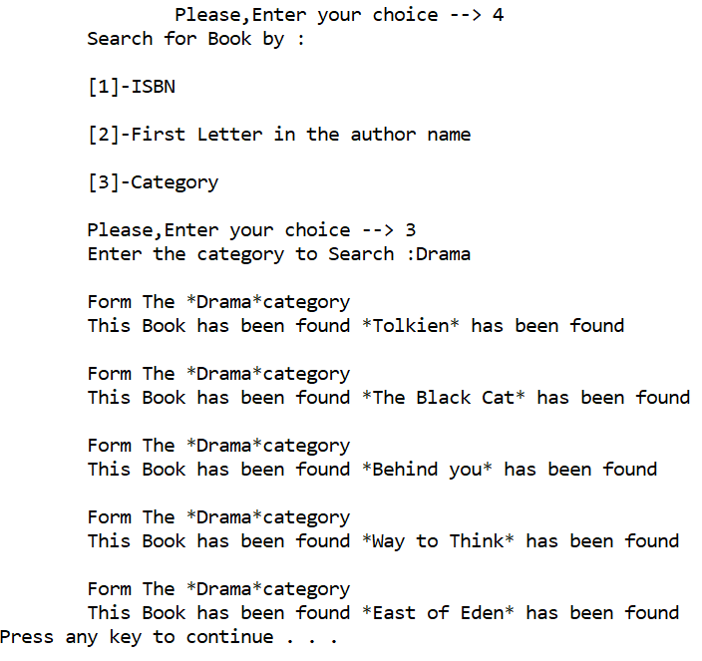

Test The info Function:  
