Alexandra Ledgerwood

Data Visualization

Final Project

February 21, 2024

**Section 1. Introduction**

This report explores a dataset of Data Science roles. The purpose of the report is to draw insights about salaries related to job titles, location, experience, and work setting among other features. Such insights can be useful to both job seekers and employers. In a relatively new field with a multitude of job titles and specialties, a dashboard is a useful tool to make sense of this information.

**Section 2. Data Description**

The dataset is employment information from 2020-2023 related to roles in Data Science. It includes 12 columns and 9355 rows of data. It is a csv file titles Jobs and Salaries in Data Science sourced from Kaggle. ([Jobs and Salaries in Data Science (kaggle.com)](https://www.kaggle.com/datasets/hummaamqaasim/jobs-in-data)). The data comes from [The Global AI, ML, Data Science Salary Index for 2023 | ai-jobs.net](https://ai-jobs.net/salaries/2023/) which invites analysts to submit their own employment information and allows some interesting exploration of the data.

**Section 3. Data Cleaning Strategies**

The dataset was prepared for use in research and visualization and required no cleaning. Only slight transformations were required in Excel, such as adding a calculated benchmark column for comparison purposes.

**Section 4. Clean Dataset**

The features include:

work_year: date. Year.

job_title: string. The title of the job/position.

job_category: string. Category of job/position.

salary_currency: string. The currency of the annual salary.

salary: int. Amount of annual salary for the job.

salary_in_usd: int. Conversion of annual salaries, as needed, into American dollars.

employee_residence: string. The country in which the employee lives.

experience_level: string. Four levels of experience.

employment_type: string. If the position is fulltime or not.

work_setting: string. The location of the work being done (hybrid, remote, in-person).

company_location: string. The country of the company.

company_size: string. S, M, L.

Data Extract:

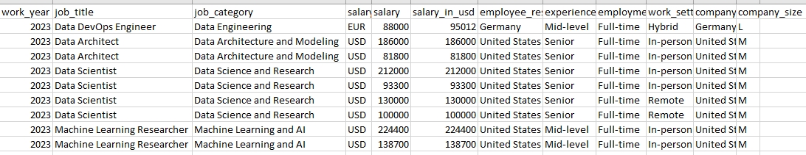

**Section 5. Visualization Tools**

I used Microsoft Excel as a tool for my initial data exploration for ease of use. It was also the best tool for creating a benchmark chart. I used Tableau to create the charts for a dashboard with stories which is something Excel does not have the ability to create.

Tableau Public Link

<https://public.tableau.com/views/Ledgerwood_FinalProject/Goal3Story?:language=en-US&:sid=&:display_count=n&:origin=viz_share_link>

Github Link

[Data-Science-Jobs-Visualizations/ at main · ALedgerwood/Data-Science-Jobs-Visualizations (github.com)](https://github.com/ALedgerwood/Data-Science-Jobs-Visualizations/tree/main)

**Section 6. Visualizations and Stories**

**Goal 1 –** Compare average salaries by job category and an industry benchmark.

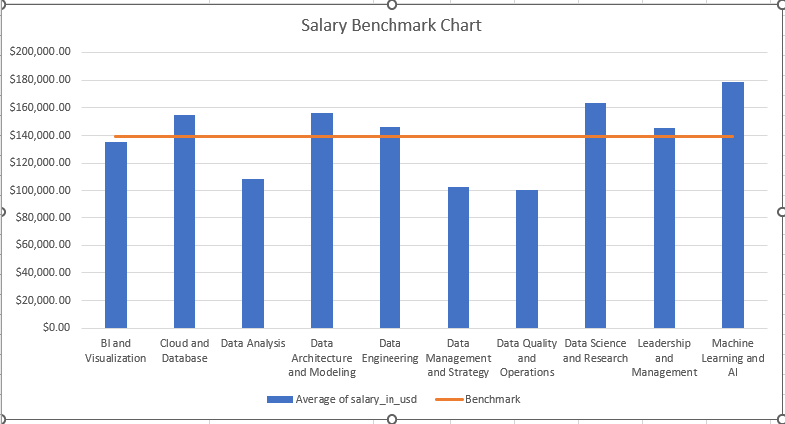

**Goal 1 Story** – This chart reveals that six of the ten broad categories of jobs in data science exceed the industry benchmark salary of just under $140,000. The categories with the top three highest average salaries, exceeding the benchmark, are Machine Learning and AI, followed by Data Science and Research and Data Architecture and Modeling. What may be even more interesting is the three which fall farthest below the industry benchmark salary: Data Analysis, Data Management and Strategy, and Data Quality and Operations. This benchmark insight would be useful to students in data analytics programs as they consider which specialties to pursue. It is also useful to employers as they set salaries for various positions. Job seekers should also consider the category of job they are seeking when setting their salary expectations.

**Goal 2** – Find the distribution of jobs counts by category and company location, as well as salaries trends, using a dashboard.

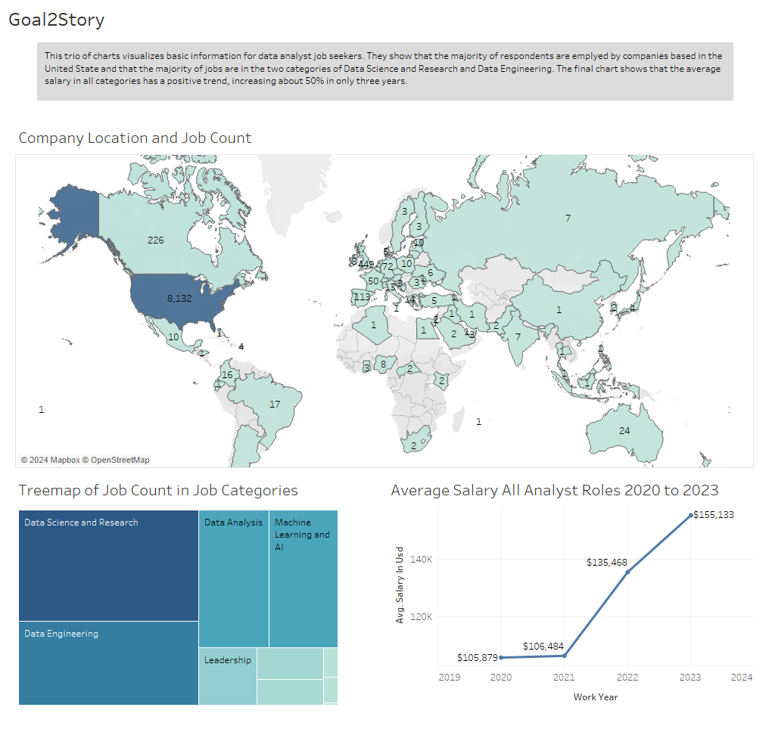

**Goal 2 Story** - This goal is designed to give job seekers a very general overview of the number of jobs by category, location of employers, and basic salary trends over time. The charts show that the majority of respondents are employed by companies based in the United State and that the majority of jobs are in the two categories of Data Science and Research and Data Engineering. The final chart shows that the average salary in all categories has a positive trend, increasing about 50% in only three years.

**Goal 3** – Compare average salary by category and experience level.

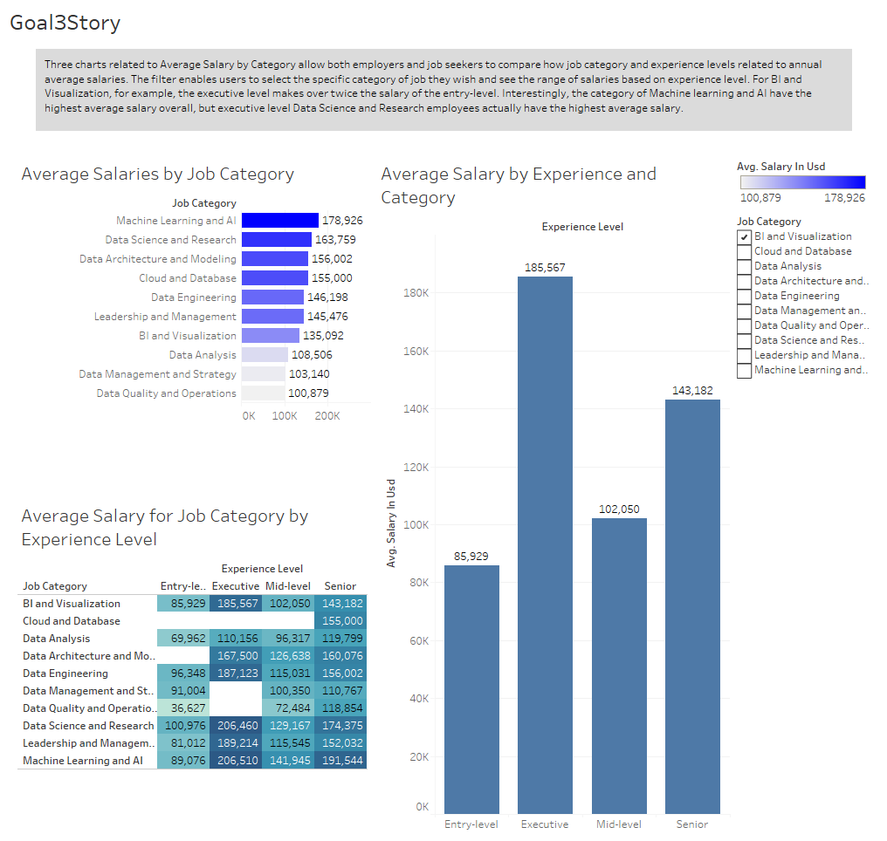

**Goal 3 Story** - The filter on the right enables users to select the specific category of job they wish and see the range of salaries based on experience level. For BI and Visualization, for example, the executive level makes over twice the salary of the entry-level. The two charts on the left allows users to see the average salaries by category in general and then drill down by experience. Interestingly, the category of Machine learning and AI have the highest average salary overall, but executive level Data Science and Research employees actually have the highest average salary.

**Goal 4** – Compare average salary based on experience and company location.

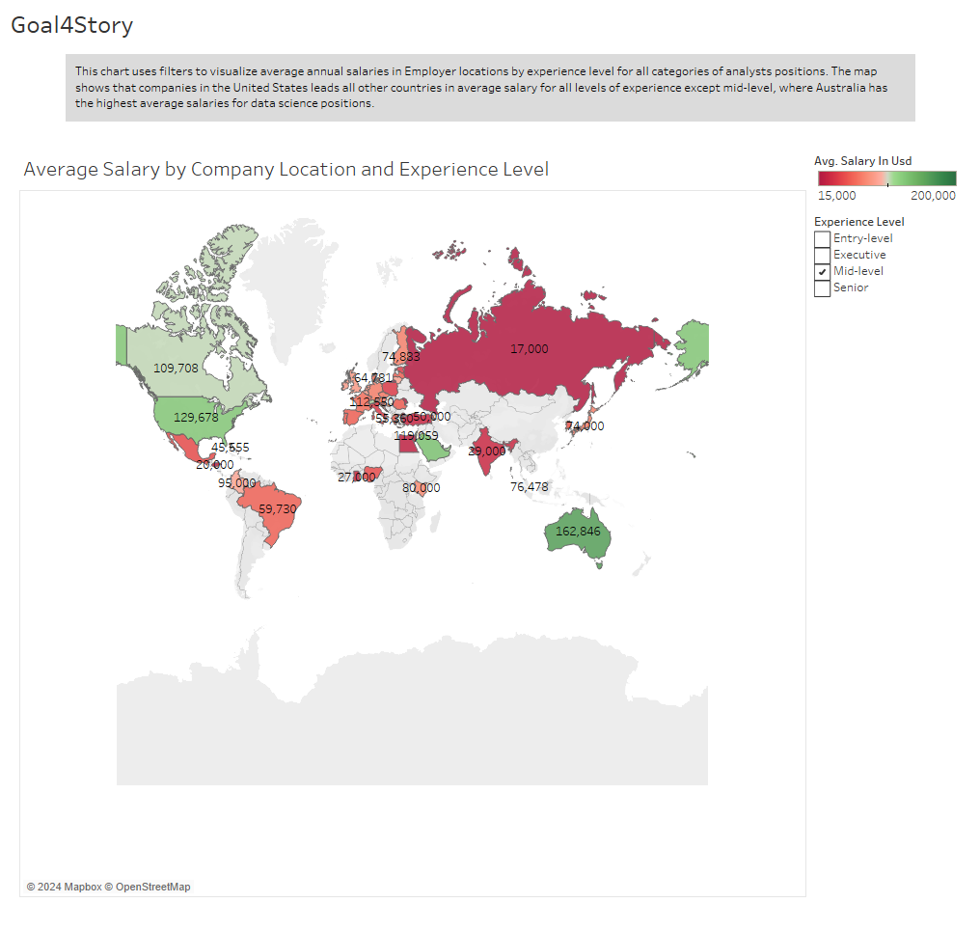

**Goal 4 Story** - This chart uses filters to allow users to visualize average annual salaries by Employer Locations and Experience level for all categories of analyst positions. The map shows that companies in the United States lead all other countries in average salary for all levels of experience except mid-level, where Australia has the highest average salaries for data science positions.

**Goal 5** – Compare average salaries by job title, specifically the top and bottom N.

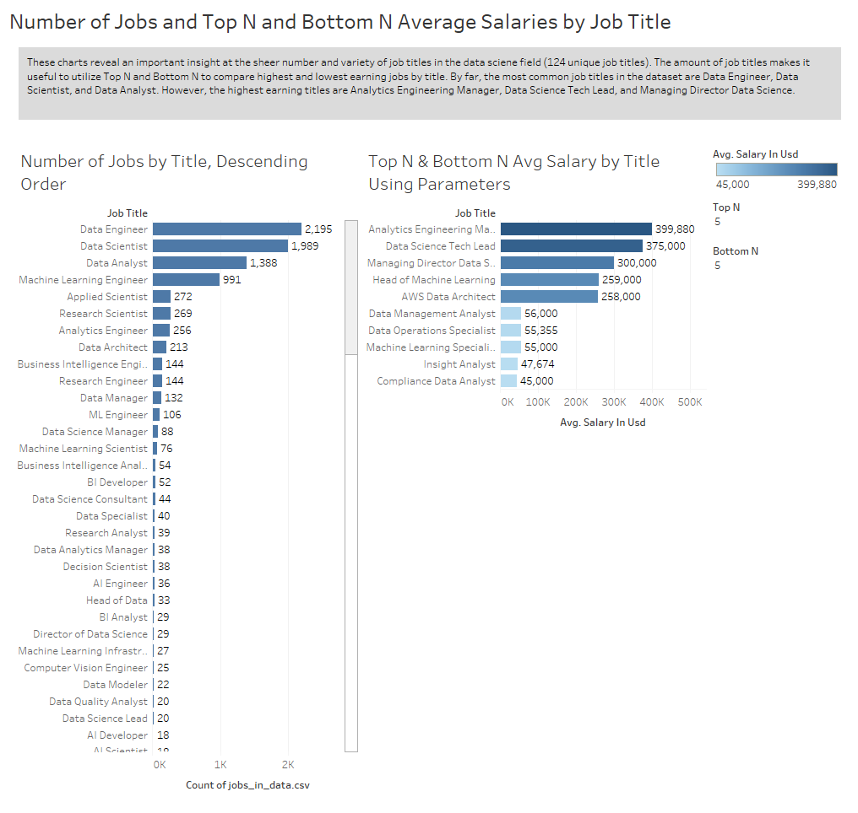

**Goal 5 Story** - These charts reveal an important insight at the sheer number and variety of job titles in the data science field (124 unique job titles). The large number of titles makes it useful to utilize Top N and Bottom N to compare highest and lowest earning jobs by title. By far, the most common job titles in the dataset are Data Engineer, Data Scientist, and Data Analyst. However, the highest earning titles are Analytics Engineering Manager, Data Science Tech Lead, and Managing Director Data Science.

**Goal 6** – Compare average salaries by company size and experience level.

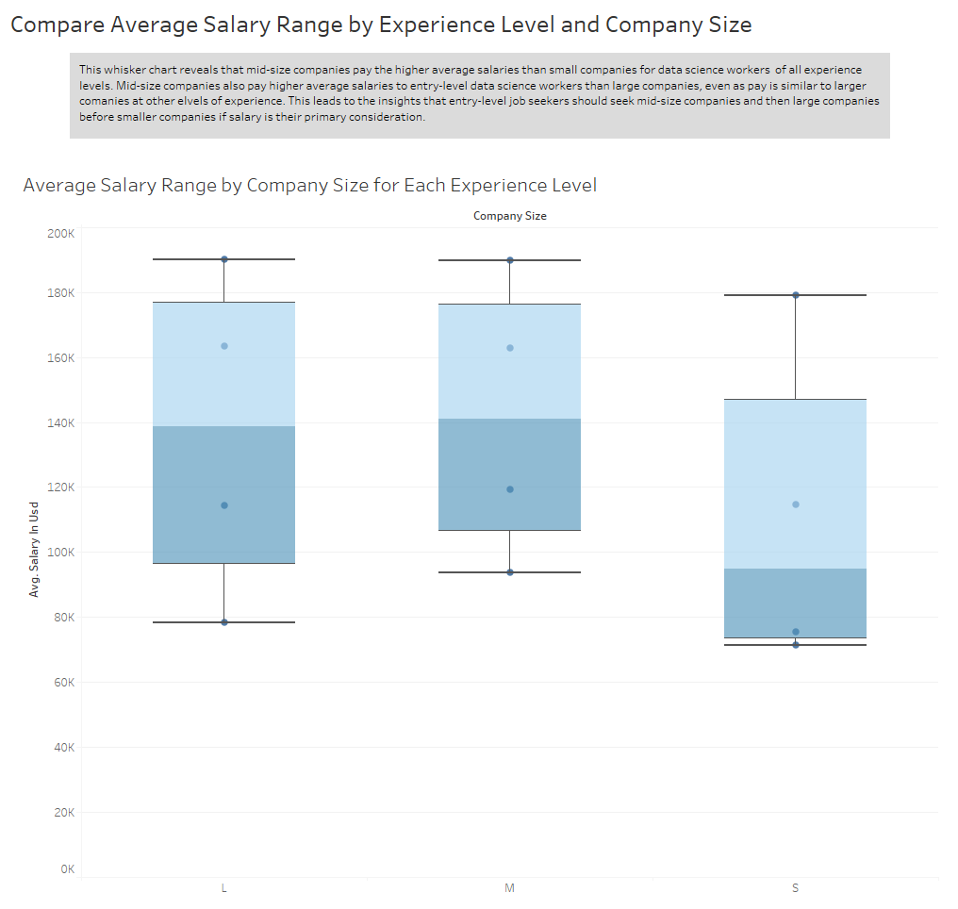

**Goal 6 Story** - This whisker chart reveals that mid-size companies pay the higher average salaries than small companies for data science workers of all experience levels. Mid-size companies also pay higher average salaries to entry-level data science workers than large companies, even as pay is similar to larger companies at other levels of experience. This leads to the insight that entry-level job seekers should seek mid-size companies and then large companies before smaller companies if salary is their primary consideration.

**Section 7. Conclusions** – The dataset reveals that jobs in Data Science vary widely in salary depending on a variety of factors that impact any job (such as company location and experience level). Interestingly, unlike many other fields, jobs in Data Science have a wide array of titles, making it a challenge for both job seekers and employers to draw and conclusions about salaries. Rather than make decisions based on a single job title (the most common being Data Engineer) they would do better to consider a whole category. As my Stories reveal, using job categories as filters and top and bottom N for job titles lead to the most useful insights and comparisons for determining appropriate salary ranges.

Average salaries reveal the top paying job category is Machine Learning and AI, but experience greatly impact average salary as well since executives in Data Science and Research employees actually have the highest average salary. Entry level data scientists would do well to consider mid-size companies as they pay the highest salaries to lower-level data scientists on average. Companies in America tend to pay the highest salaries, although mid-level data scientists could make higher average salaries with companies based in Australia. The dashboards created in this project make the data easier to navigate and lead to insights helpful to both employers and data scientists as they consider appropriate salary ranges for various roles and experience levels in this vast field.