1. Для дерева категорий я выбираю подход Closure Table.

Для того чтобы предусмотреть возможность делать заказы из разного набора товаров заведена отдельная таблица Order Items.

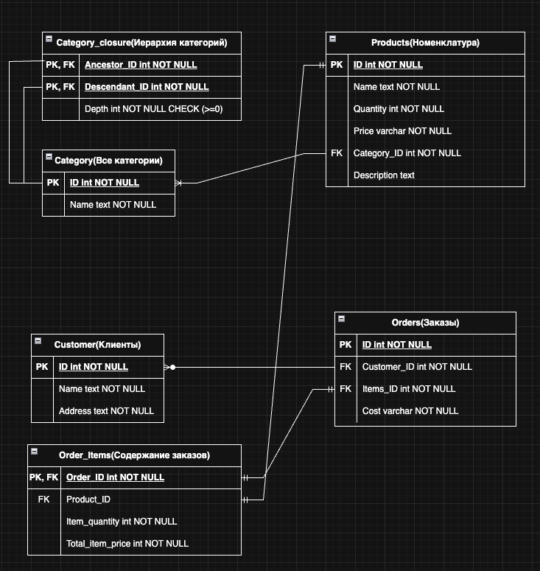

2. 1

SELECT

c.id as customer_id,

c.first_name || ' ' || c.last_name as customer_name,

c.email,

COUNT(DISTINCT o.id) as total_orders,

COUNT(oi.id) as total_items,

SUM(oi.quantity) as total_quantity,

SUM(oi.total_price) as total_amount,

AVG(oi.total_price) as avg_order_amount,

FROM customer c

LEFT JOIN orders o ON c.id = o.customer_id

LEFT JOIN order_items oi ON o.id = oi.order_id

GROUP BY c.id, c.first_name, c.last_name, c.email

ORDER BY total_amount DESC NULLS LAST;

2.2

SELECT

parent.id as category_id,

parent.name as category_name,

COUNT(child.id) as direct_children_count

FROM category parent

LEFT JOIN category_closure cc ON parent.id = cc.ancestor_id

LEFT JOIN category child ON cc.descendant_id = child.id

WHERE cc.depth = 1 -- Прямые потомки (первый уровень вложенности)

GROUP BY parent.id, parent.name

ORDER BY direct_children_count DESC;

2.3.1

CREATE OR REPLACE VIEW top_5_products_last_month_optimized AS

WITH last_month AS (

SELECT

DATE_TRUNC('month', CURRENT_DATE - INTERVAL '1 month') as start_date,

DATE_TRUNC('month', CURRENT_DATE) as end_date

),

product_sales AS (

SELECT

oi.product_id,

SUM(oi.quantity) as total_quantity,

COUNT(DISTINCT oi.order_id) as orders_count,

SUM(oi.total_price) as total_revenue

FROM order_items oi

JOIN orders o ON oi.order_id = o.id

CROSS JOIN last_month lm

WHERE o.order_date >= lm.start_date

AND o.order_date < lm.end_date

AND o.status IN ('confirmed', 'processing', 'shipped', 'delivered')

GROUP BY oi.product_id

),

category_mapping AS (

SELECT

cc.descendant_id as category_id,

c.name as first_level_name

FROM category_closure cc

JOIN category c ON cc.ancestor_id = c.id

WHERE cc.depth = 1

)

SELECT

p.id as product_id,

p.name as product_name,

COALESCE(cm.first_level_name, 'Без категории') as first_level_category,

ps.total_quantity as total_quantity_sold,

ps.orders_count,

ps.total_revenue,

RANK() OVER (ORDER BY ps.total_quantity DESC) as rank_by_quantity

FROM product_sales ps

JOIN product p ON ps.product_id = p.id

LEFT JOIN category_mapping cm ON p.category_id = cm.category_id

ORDER BY ps.total_quantity DESC

LIMIT 5;

2.3.2

Для оптимизации можно использовать такие инструменты как партиции(например по месяцам или дням, для этого нужно добавить даты в заказы).

Можно сделать дополнительную витрину или таблицу с нужными метриками по товарам чтобы делать запросы не напрямую в базу.

Если запросов очень много нужно масштабировать базу, то есть использовать шардирование(Легко делается в Greenplum например)

mount,