

**Department of Software Engineering Engineering**

**Mehran University of Engineering Technology**

**CEP-MAD- Report [Country Craze]**

**SUBJECT: Mobile Application Development(MAD)**

**ASSIGNED BY: Maa’m Mariam Jawed**

**PREPARED BY:**

* Ali Mehran **20sw008**
* Ali Haider **20sw040**

**SECTION: “2”**

**PROJECT Title:**

**Country CRAZE**

**TABLE OF THE CONTENTS:**

* **Real World Problem Identification**
* **Proposed Solution (our APP)**
* **Responsive User Interfaces (Screenshots of Country Craze app on different screens & platforms)**
* **Data Storage (Used Shared preferences)**
* **[Optional Section]**

**APIs/Packages/Plug-ins (if used with justifications for using**

* **Issues and Bugs Encountered and Resolved during Development**

1. **Real World Problem Identification:**

The real-world problem we tackled was the absence of engaging and educational quiz apps related to world geography. This gap was evident, with few interactive ways available for individuals to test and enhance their knowledge of countries and flags. Users lacked accessible and enjoyable platforms to improve their global awareness.

1. **Proposed Solution:**

To address this problem, our team proposed the development of an educational quiz app called 'Country Craze.' Our aim was to create an engaging experience where users could test and improve their knowledge of countries from different continents. Our solution involved combining entertainment with education to make learning about countries fun and interactive.

1. **Responsive User Interfaces:**

* 'Country Craze' is meticulously designed with responsiveness in mind. Our group ensured that the user interface provides a consistent and engaging experience across various devices and orientations.
* Our app includes three class:

1. Home_screen class
2. Game_screen Class
3. Records class

* Assets folder for storing images
* The app seamlessly adapts to different screen sizes, including smartphones and tablets, and orientations, such as portrait and landscape.

**Home Screen UI [chrome]:**

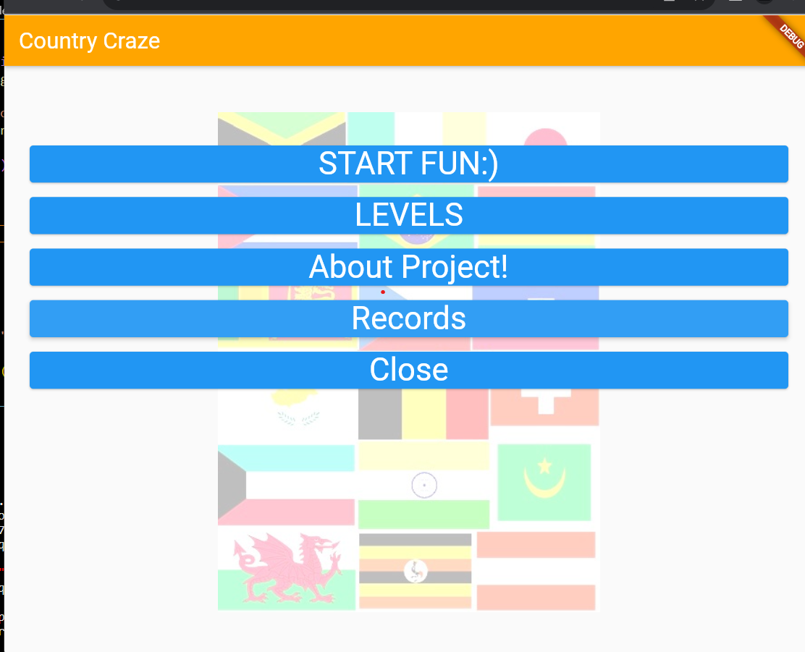

**Home Screen UI [APP:**

**Game Screen UI [chrome]:**

**Game Screen UI [APP]:**

**Records UI [chrome]:**

**Records UI [APP]:**

1. **Data Storage:**

For data storage, we selected local storage using the 'shared preferences' package.

This choice allowed us to offer a seamless user experience without relying on internet connectivity.

It also simplified data management for our small-scale app, 'Country Craze.' Users can access their quiz progress and preferences even when offline

1. **Packages/Plug-ins:**

During development, external tools were integrated to enhance our app's functionality.

One notable tool utilized is:

The **'cached_network_image'** package. This package significantly improved image loading performance by caching images locally on the user's device.

The decision to use this package was based on the need for smooth and efficient loading of flag images from different continents.

1. **Issues and Bugs Encountered and Resolved during Development:**

Throughout our development journey, we encountered a minor challenge related to image loading. Some flags weren't displayed correctly due to variations in image file naming conventions.

However, we promptly addressed this issue by standardizing the naming format for flag images, guaranteeing their accurate display.

1. **Conclusion:**

In brief, 'Country Craze' is an educational quiz app that fills the gap in geography-related applications. It combines fun and learning, offering users an engaging way to enhance their knowledge of countries and flags. With responsive interfaces, offline access, and optimized image loading, 'Country Craze' is an accessible platform for geography enthusiasts.

Our commitment to resolving minor challenges during development underscores our dedication to delivering a valuable educational tool that makes learning enjoyable.

**-THANK YOU- :)**