LayerForge-X Final Report

Project status
LayerForge-X is a modular single-image layer decomposition system that exports ordered RGBA layers, amodal masks, intrinsic albedo/shading approximations, graph metadata, and edit-oriented artifacts. The current repo state also includes:
- a hybrid Qwen + LayerForge graph path;
- graph-guided recursive peeling;
- heuristic associated-effect layers;
- submission-safe report artifacts and figure manifests.
Primary source files for the report narrative:
- 01_LITERATURE_REVIEW_ADVANCED.md
- 02_BENCHMARKING_PROTOCOL.md
- 03_NOVELTY_AND_METHOD.md
- 04_ABLATIONS_AND_TABLES.md
- ../RESULTS_SUMMARY_2026_04_19.md
- ../QWEN_IMAGE_LAYERED_COMPARISON.md

Figures

Truck recomposition comparison
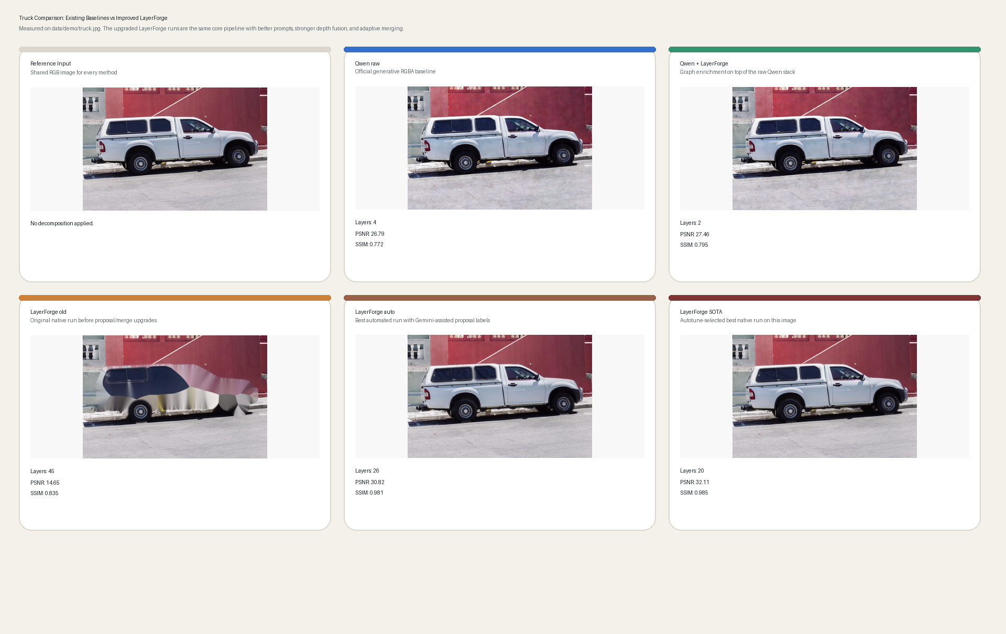
Truck recomposition comparison

Truck layer stack comparison
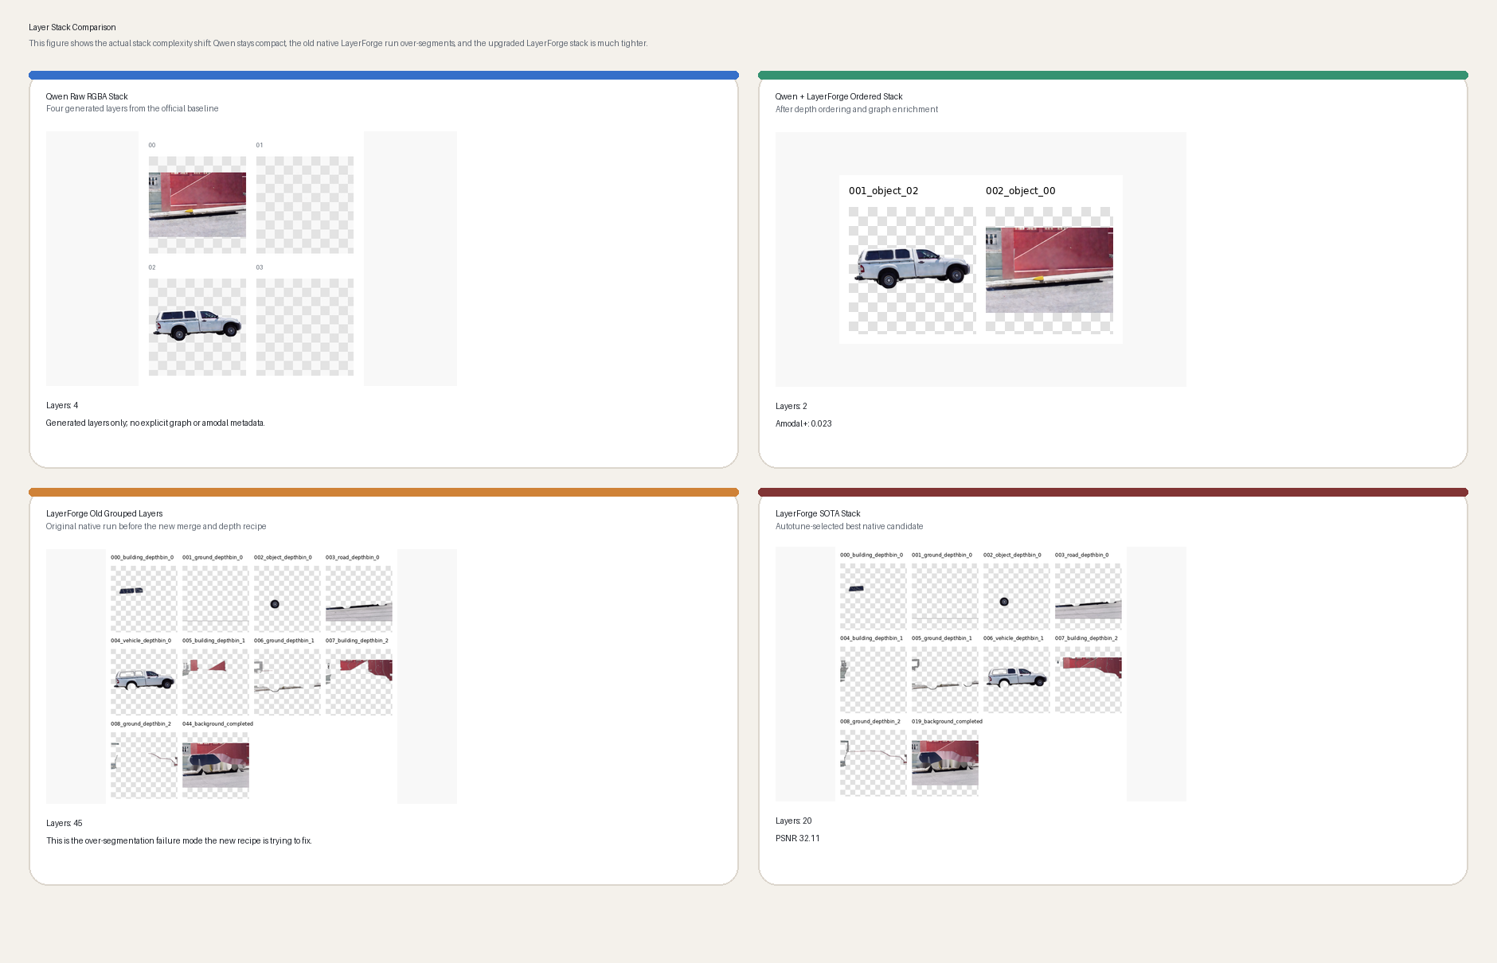
Truck layer stack comparison

Truck metrics comparison
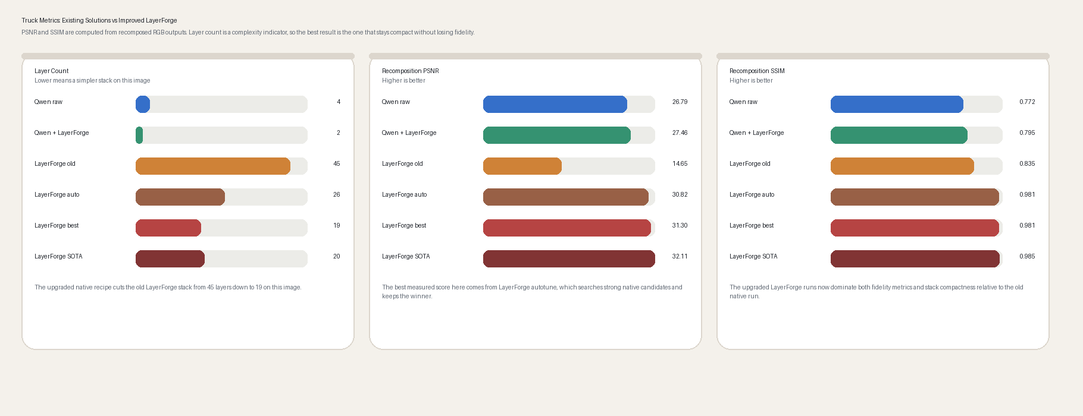
Truck metrics comparison

Prompt ablation
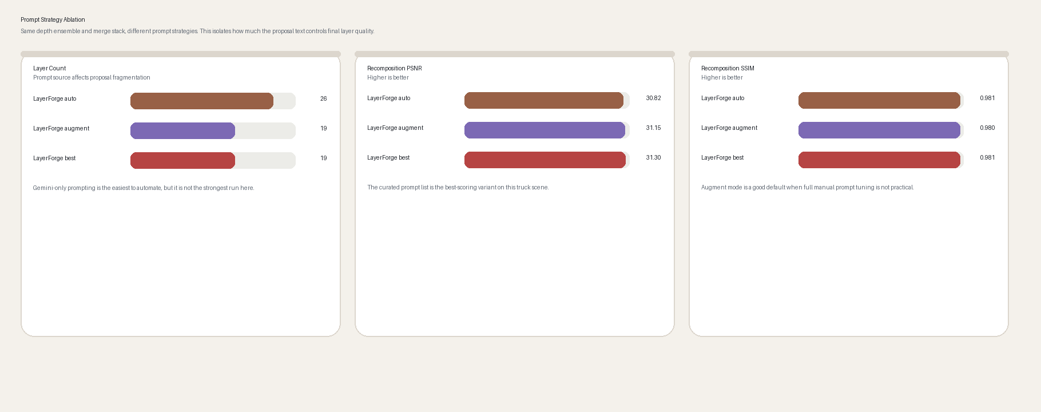
Truck prompt ablation

Synthetic ordering ablation
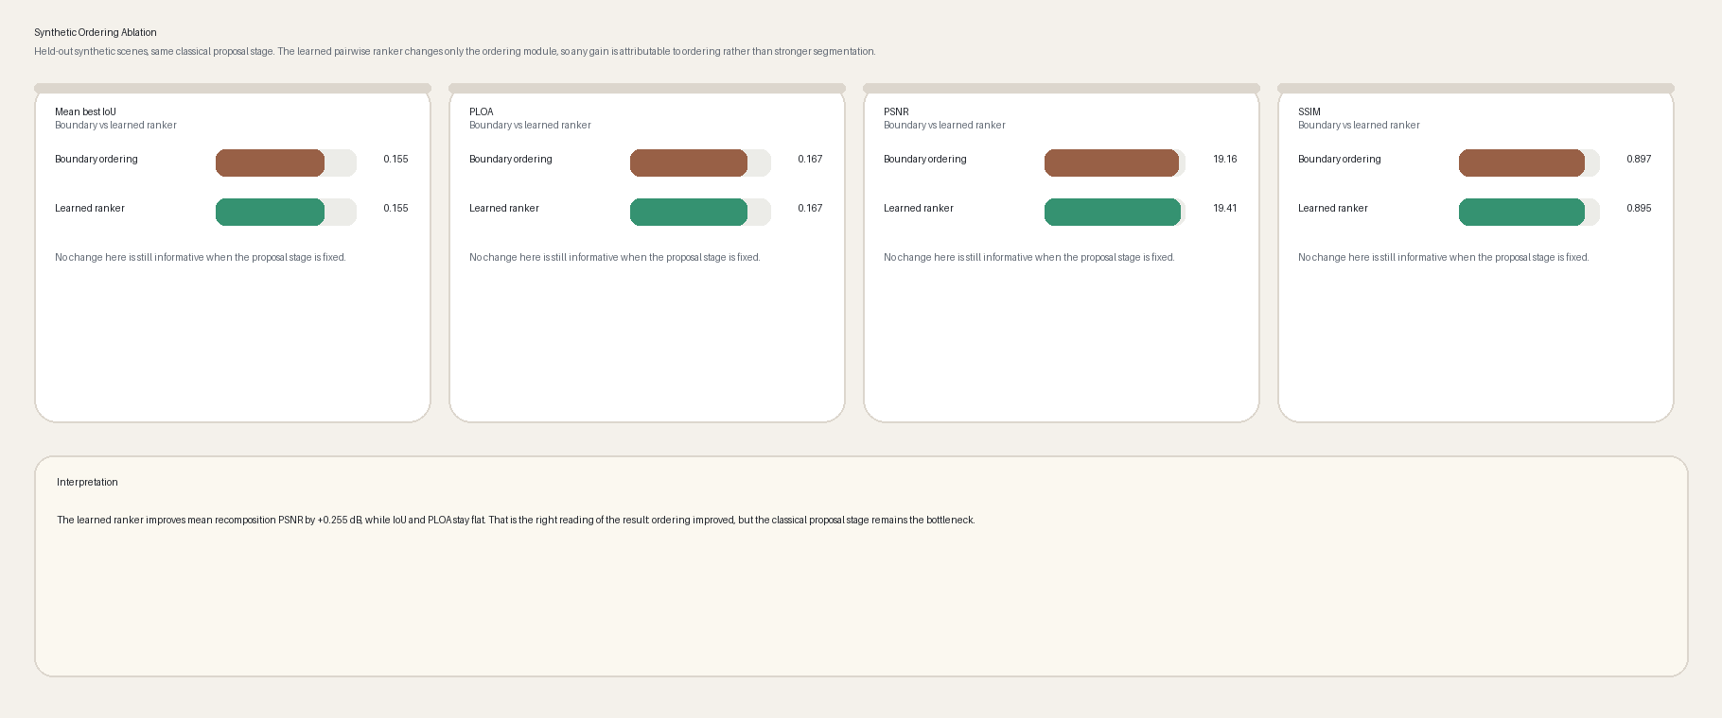
Synthetic ordering ablation

Qualitative gallery
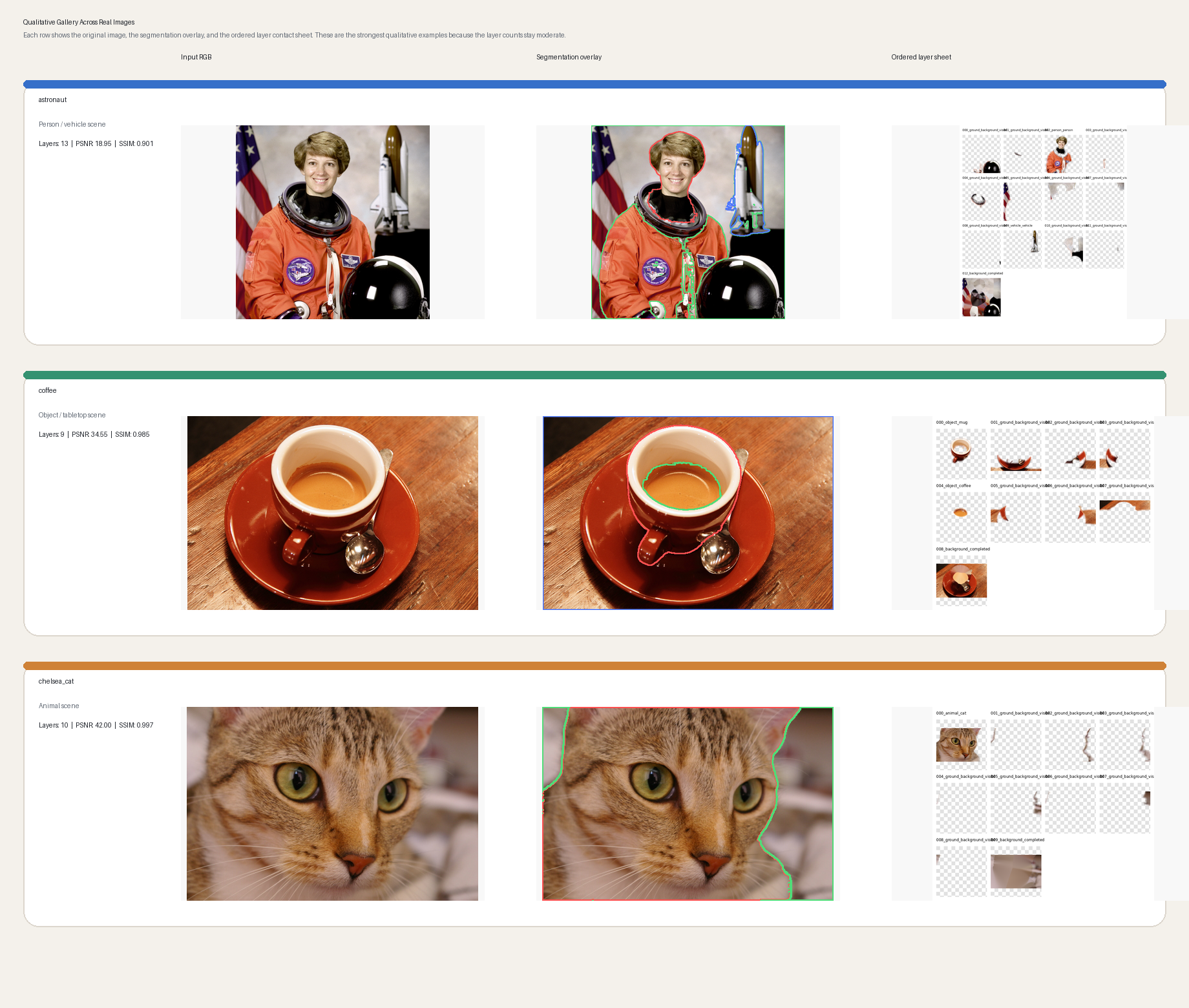
Qualitative gallery

Associated-effect demo
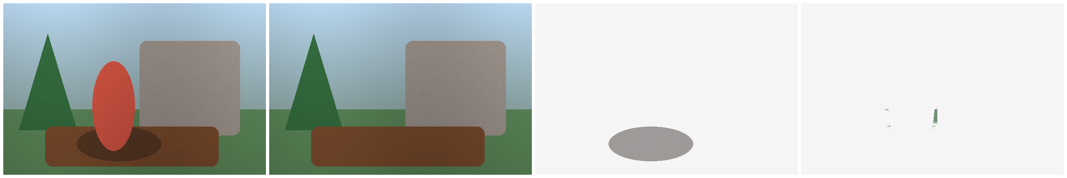
Associated-effect demo

Public visible-group benchmark comparison
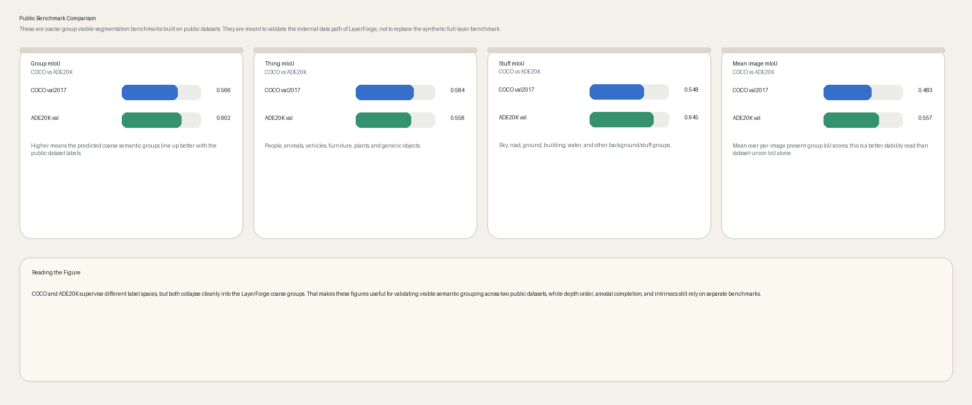
Public benchmark comparison

Public depth benchmark comparison
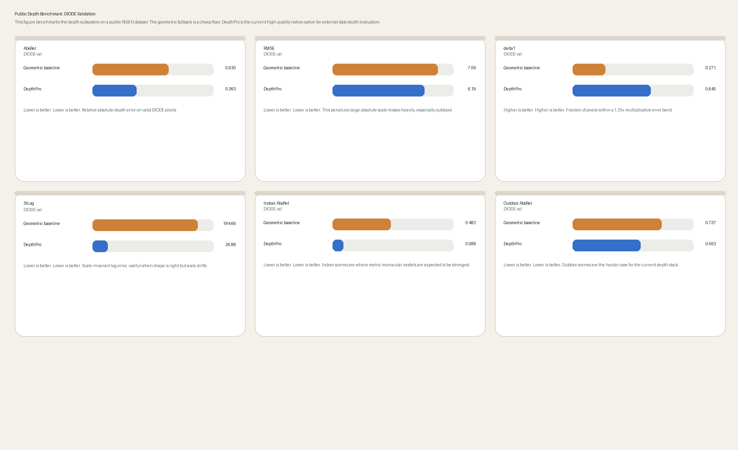
Public depth comparison

Tables and benchmark notes

Report tables snapshot
The current table templates and measured cells live in ../REPORT_TABLES.md.

Current measured-results snapshot
The current measured-results narrative lives in ../RESULTS_SUMMARY_2026_04_19.md.

Qwen comparison notes
The direct Qwen baseline and hybrid positioning live in ../QWEN_IMAGE_LAYERED_COMPARISON.md.

Final measured additions (2026-04-22)
Five-image Qwen raw versus hybrid review:
Method | Images | Graph | Mean PSNR | Mean SSIM
Qwen raw (4) | 5 | no | 29.0757 | 0.8850
Qwen + LayerForge graph (4) | 5 | yes | 28.5408 | 0.8637
Associated-effect demo:
Artifact | Effect detected | Predicted effect px | Ground-truth effect px | Effect IoU
runs/effects_groundtruth_demo_cutting_edge | yes | 411 | 13750 | 0.0006
Interpretation:
- raw Qwen remains the stronger pure pixel-fidelity baseline on the measured five-image sweep;
- the hybrid row should be presented as a structured-representation complement that adds graphs, ordering, and amodal metadata;
- the associated-effect path now has a real exported demo artifact, but the measured IoU is still weak, so it must be framed as an early heuristic rather than a solved component.

Remaining review checklist
The repo-level acceptance checklist lives in ../NEXT_REVIEW_CHECKLIST_2026_04_22.md.

Failure cases
Failure taxonomy and future-work framing are documented in 04_ABLATIONS_AND_TABLES.md and 02_BENCHMARKING_PROTOCOL.md. The report should explicitly keep:
- wrong semantic grouping;
- wrong depth order;
- jagged alpha boundaries;
- missing shadow/effect layers;
- bad inpainting in large unseen regions;
- bad amodal continuation under heavy occlusion;
- intrinsic split errors.

Appendix: full source sections
The following sections are appended verbatim so the DOCX contains the current report text even if markdown files continue evolving independently.

Literature Review: LayerForge-X

Project framing
The project looks at single-image layered scene decomposition: given one RGB bitmap, infer a set of re-composable RGBA layers that are semantically meaningful, ordered by depth and occlusion, and — as a stretch goal — decomposed into albedo and shading. The fundamental difficulty is that a raster image collapses a lot of scene factors into one 2D array: object identity, transparency, shadows, reflections, illumination, camera projection, and occlusion. Any strong layered representation therefore has to borrow from several different sub-fields at once: scene understanding, monocular geometry, matting, completion, and appearance decomposition.
LayerForge-X positions itself as a Depth-Aware Amodal Layer Graph (DALG) rather than a plain segmentation exporter. Every layer is a graph node that carries a visible mask, a soft alpha, a semantic label, depth statistics, an estimated amodal extent, completed hidden or background content, and optional intrinsic appearance. Graph edges encode near/far and occludes/occluded-by relations. The intent is that the output is useful for editing, parallax, object removal, relighting-style operations, and general downstream analysis — not just “a folder of PNGs.”

1. Layered depth and image-based rendering
The oldest directly relevant representation is the Layered Depth Image (LDI). Shade et al. introduced LDIs as an image-based rendering structure where a single camera view can store multiple samples along one line of sight instead of just the first visible surface. That’s the right historical starting point because the present project also needs more than a flat visible mask: it needs depth ordering and some notion of hidden-region reasoning.
LDIs work well for novel-view rendering because disocclusions can be handled more gracefully than with a flat depth map. They were not, however, designed to be editable semantic layers. A classical LDI doesn’t really tell you which layer is “person,” “chair,” “sky,” or “road,” and it doesn’t separate albedo from shading or split foreground effects from object cores.
Use in this project: DALG borrows the idea of storing layered samples along viewing rays, but makes the layers semantic, alpha-composited, and editable.

2. 3D photography and depth inpainting
Shih et al.’s 3D Photography using Context-Aware Layered Depth Inpainting converts an RGB-D image into a multi-layer representation aimed at parallax rendering. Their system uses an LDI with explicit pixel connectivity and performs colour-and-depth inpainting in occluded regions. The paper is directly relevant because it stitches together layered depth, inpainting, and interactive view synthesis in one pipeline — exactly the kind of integration this project is trying to do, just for a different target task.
The catch is that 3D Photography assumes RGB-D input or externally supplied depth, and the target is novel-view synthesis rather than semantic object editing. It doesn’t output object-level semantic RGBA layers like “people,” “vehicles,” “furniture,” and “background stuff.”
Use in this project: LayerForge-X treats context-aware hidden-region completion as one stage inside a semantic layer graph. The output can drive parallax, but its primary purpose is object editing.

3. Scene decomposition, object layers, and completed occluded content
A few older works sit closer to the full scene-decomposition goal. Dhamo et al.’s Object-Driven Multi-Layer Scene Decomposition From a Single Image builds an LDI from a single RGB image and uses object information to infer occluded intermediate layers. Zheng et al.’s Layer-by-Layer Completed Scene Decomposition studies decomposition into individual objects, occlusion relationships, amodal masks, and content completion — a list that could honestly serve as the target for this project.
These works matter because they make the case that correct layering requires more than visible segmentation. Occluded regions are part of the representation. If a person is standing in front of a car, a practical layer representation should estimate the hidden continuation of the car, at least enough to support removal or parallax.
Use in this project: LayerForge-X follows this line but modernises the toolchain: foundation segmentation models, current monocular geometry, promptable / open-vocabulary controls, and explicit evaluation of recomposition and editability.

4. Video layer decomposition and omnimattes
Layered decomposition has also been studied heavily in video. Omnimatte decomposes a video into object-associated RGBA layers that can include not only the object but also related visual effects — shadows, smoke, reflections. That’s conceptually important, because a clean object cutout is frequently not enough for editing: moving a person without their shadow immediately looks fake.
Generative Omnimatte and a handful of follow-ups push this idea further with stronger generative priors. But video methods have a free lunch that single-image methods don’t: motion and temporal consistency. Without optical flow or multiple frames, the task is genuinely more ambiguous.
Use in this project: LayerForge-X can optionally export associated-effect layers (object core, shadow / reflection / effect region, clean background). Even a simple shadow-layer heuristic makes the output read as serious layer decomposition rather than plain segmentation.

5. Modern generative layer decomposition
This is the corner of the field that makes the project topic especially timely. LayerDecomp targets image layer decomposition with visual effects, producing a clean background and a transparent foreground while preserving effects like shadows and reflections. DiffDecompose studies layer-wise decomposition of alpha-composited images, particularly transparent and semi-transparent cases. Qwen-Image-Layered proposes an end-to-end diffusion model that decomposes one RGB image into multiple semantically disentangled RGBA layers. Referring Layer Decomposition frames the task as prompt-conditioned RGBA layer extraction.
All four sit very close to the project statement, and the report should cite them specifically to show awareness of the frontier. The important boundary to draw is that LayerForge-X should not claim to beat these large generative systems on raw image quality — it almost certainly can’t, and claiming otherwise would be unconvincing. The claim is a different one: a transparent, modular, geometry-aware layer graph that can be benchmarked component-by-component instead of only eyeballed.
Use in this project: These works define the current research frontier. LayerForge-X positions itself as a practical, inspectable alternative that fuses segmentation, geometry, amodal reasoning, alpha refinement, inpainting, and intrinsic decomposition.

6. Panoptic and open-vocabulary segmentation
Layered decomposition needs both object and stuff regions. Panoptic segmentation is a natural fit because it unifies instance-level things (people, animals, vehicles) with amorphous stuff (sky, road, wall, grass, water). The panoptic segmentation paper also gave us the unified Panoptic Quality (PQ) metric.
Mask2Former is the closed-set baseline of choice — it’s a universal segmentation architecture that handles semantic, instance, and panoptic segmentation with a single head. Its obvious limitation is that it’s bounded by the training label vocabulary.
Open-vocabulary models cover that gap. GroundingDINO detects objects specified by free-form text (either category names or referring expressions), and SAM / SAM2 produces promptable segmentation masks. Stitching these together allows prompts like “left chair,” “red car,” “window,” or “foreground person” — exactly the kind of control a layer editor actually wants.
Use in this project: The report should compare closed-set panoptic segmentation and open-vocabulary grounded segmentation side by side. The second is more exciting, but the first has the advantage of being trivial to benchmark with standard PQ / mIoU.

7. Monocular depth and geometry
Depth ordering is central, and the obvious first heuristic — sort by average object depth — is often wrong. Large regions such as walls, floors, tables, and roads span a wide depth range, so their “average depth” doesn’t correspond to where they actually sit relative to neighbours.
Modern monocular geometry models provide strong priors that make depth-based ordering viable at all. Depth Anything V2 improves robustness and detail over older monocular depth models using synthetic labelled data plus large-scale pseudo-labelled real data. Depth Pro produces sharp metric depth from a single image without camera intrinsics. Marigold repurposes diffusion priors for affine-invariant depth estimation. MoGe goes further and predicts a fuller monocular geometry package — point maps, depth, normals, camera field of view.
Use in this project: Rather than sorting layers by global median depth, LayerForge-X infers pairwise ordering from boundary-local depth evidence. That’s more robust when objects overlap and when background regions cover both near and far pixels.

8. Amodal segmentation and occlusion reasoning
Visible (modal) masks describe only what can be seen. Amodal segmentation estimates the full object extent, including the invisible occluded parts. KINS is a key amodal instance segmentation benchmark, and newer foundation-model-based work such as SAMEO adapts Segment Anything-style mask decoders to occluded objects.
Amodal reasoning matters because editing demands it. If a user removes a foreground object, the background has to be completed. If a user moves a partially occluded object, its hidden parts may need to be hallucinated. This is inherently ambiguous, so completion outputs should be treated as plausible rather than ground-truth-accurate on real images.
Use in this project: LayerForge-X reports modal visible masks separately from amodal masks. That avoids over-claiming and makes the representation honest.

9. Alpha matting and edge quality
Hard segmentation masks make jagged cutouts. Real layers need soft alpha around hair, fur, glass, motion blur, antialiased vector edges, smoke, and any semi-transparent object. Matting methods estimate a fractional alpha matte directly.
Matting Anything is a relevant reference because it combines SAM features with a lightweight mask-to-matte module and supports visual or linguistic prompts — which plays well with this project’s open-vocabulary layer extraction direction.
Use in this project: Even if the implementation uses a simple boundary-feathering fallback, the report should explicitly compare hard alpha to soft alpha. The visual difference is usually obvious even at thumbnail size.

10. Inpainting and hidden-region completion
Editing layered content requires plausible content behind removed or moved objects. LaMa is the reliable baseline here: it was explicitly designed for large masks and high-resolution generalisation, using Fourier convolutions and large-mask training.
Inpainting should not be framed as “ground truth recovery” on real images. For a real photograph the method cannot know what’s behind the object; it can only produce a plausible completion. For synthetic composites where the hidden background is genuinely known, inpainting is quantifiable.
Use in this project: Use synthetic data to score background completion with PSNR / SSIM / LPIPS inside removed-object regions. Use real images for qualitative object-removal and parallax demos.

11. Intrinsic images: albedo and shading
Intrinsic image decomposition splits an image into reflectance / albedo and illumination / shading. The problem is badly under-constrained from a single image — one image, two unknowns per pixel. Intrinsic Images in the Wild (IIW) introduced a large in-the-wild benchmark using human reflectance judgments and WHDR. Recent diffusion-based intrinsic methods (Marigold-IID and friends) give stronger modern baselines.
For this project, intrinsic decomposition should be framed as a stretch module rather than the core contribution. A Retinex-style fallback is fine, but the report should be honest about the fact that physical correctness is limited.
Use in this project: Export per-layer albedo and shading as useful editing approximations. Evaluate with IIW/WHDR when possible; otherwise fall back to synthetic scenes with known albedo and shading.

Gap summary
A compact view of what each prior area covers, where it stops, and how LayerForge-X uses it:
Prior area | What it solves | What it misses for this project | How LayerForge-X uses it
LDI / image-based rendering | Multi-depth samples for novel views | No semantic/editable object layers | Use layered depth idea as representation backbone
3D photo inpainting | Parallax and hidden-region completion | Usually not semantic object/stuff editing | Add semantic graph nodes and RGBA export
Panoptic segmentation | Things + stuff parsing | No depth, alpha, hidden content | Provides layer proposals
Open-vocabulary segmentation | User-specified object masks | No ordering/completion by itself | Enables promptable layer extraction
Monocular depth | Per-pixel relative/metric depth | No object graph or masks | Supplies geometry for ordering
Amodal segmentation | Full object extent under occlusion | Does not complete appearance alone | Supplies hidden masks
Matting | Soft alpha boundaries | Usually foreground/background only | Refines layer alpha
Inpainting | Plausible missing content | No semantic/depth ordering | Completes background/hidden regions
Intrinsic images | Albedo/shading factors | Highly ambiguous; not layer-aware | Optional per-layer appearance split
Generative layer decomposition | End-to-end RGBA layers | Often black-box and hard to benchmark component-wise | Used as frontier comparison and motivation

Report-ready related-work paragraph
This is the paragraph-length version suitable for dropping straight into the report:
Single-image layered scene decomposition sits at the intersection of image-based rendering, scene parsing, monocular geometry, amodal perception, matting, inpainting, and intrinsic image decomposition. Classical Layered Depth Images show why a single visible surface per pixel is insufficient for view synthesis, since disoccluded content requires multiple depth and colour samples along camera rays. Modern 3D-photo methods extend this with learned colour-and-depth inpainting, but primarily target parallax rather than semantic object editing. Panoptic segmentation provides a natural source of object and stuff proposals, while open-vocabulary detectors and promptable segmenters allow user-specified layer extraction beyond fixed label sets. Recent monocular depth and geometry models improve the reliability of depth ordering, but depth alone does not produce editable layers. Amodal segmentation and inpainting address the invisible portions of occluded objects and backgrounds, while matting improves layer boundaries. Recent generative layer-decomposition systems demonstrate the importance of RGBA layers for editing, but their end-to-end nature makes component-wise analysis difficult. Our work therefore proposes an inspectable Depth-Aware Amodal Layer Graph that combines semantic masks, depth ordering, soft alpha, amodal extent, completion, and optional intrinsic decomposition into a re-composable representation.

Benchmarking Protocol for LayerForge-X

Goal
The project shouldn’t be evaluated with one vague “looks good” comparison. A layered representation has several measurable properties, each of which can fail independently:
- Are the layer regions semantically correct?
- Is the near-to-far depth and occlusion order correct?
- Do the layers recompose back into the original image?
- Are alpha boundaries usable for editing?
- Are hidden and background regions completed plausibly?
- Does the intrinsic split behave sensibly?
- Does the representation actually support edits better than baselines?
Because any of those can be wrong while the others look fine, the benchmark runs on multiple tracks.
For the current repository state, the completed quantitative runs are summarised in docs/RESULTS_SUMMARY_2026_04_19.md. That file should be treated as the source of truth for reported numbers.

Track A: Modal semantic / panoptic segmentation

Datasets
- COCO Panoptic for common objects and stuff.
- ADE20K for dense scene parsing and a broader set of stuff classes.
- Optional: a small hand-labelled project test set for whichever domains the demos lean on.

Metrics

Panoptic Quality
When ground-truth panoptic annotations are available, report PQ:
PQ = sum_{(p,g) in TP} IoU(p,g) / (|TP| + 0.5|FP| + 0.5|FN|)
Also report the two components:
SQ = segmentation quality over matched segments
RQ = recognition quality

Semantic mIoU
For semantic-only labels, the standard per-class IoU averaged over classes:
IoU_c = TP_c / (TP_c + FP_c + FN_c)
mIoU = mean_c IoU_c

Baselines
Baseline | Purpose
SLIC / classical connected components | Low-level non-semantic baseline
Mask2Former panoptic | strong closed-set panoptic baseline
GroundingDINO + SAM2 | open-vocabulary promptable baseline
Florence-2 + SAM2, optional | prompt-conditioned alternative

Report table
Method | Dataset | group mIoU ↑ | thing mIoU ↑ | stuff mIoU ↑ | mean image mIoU ↑ | Avg layers | Runtime
Classical | COCO-val subset
Mask2Former | COCO-val subset
Grounded-SAM2 | curated prompts
LayerForge-X | mixed
For the current repo state, note the distinction clearly:
- the implemented COCO and ADE20K evaluators are coarse-group IoU benchmarks rather than official PQ pipelines;
- PQ/SQ/RQ stay as the report-template target if a full panoptic evaluator is added later;
- do not relabel the current JSON summaries as PQ.

Track B: Depth-order and occlusion-graph quality

Why this matters
The output is a stack, so order is as important as mask quality. Get the ordering wrong and recomposition breaks, parallax looks incoherent, and the whole representation stops being useful even if each individual mask is perfect. Global average-depth sorting fails when objects are large, slanted, or span multiple depth planes — exactly the cases most scenes contain — so evaluation has to measure pairwise ordering, not just a global ranking.

Datasets
- Synthetic-LayerBench: generated composites with known z-order.
- NYU Depth V2: indoor RGB-D scenes with object and instance labels.
- DIODE: indoor / outdoor RGB-D for generalisation.
- Optional: KITTI for outdoor road scenes if vehicles and roads are a focus.

Ground-truth pair construction
For each image, define a ground-truth depth value per layer using median ground-truth depth inside the visible mask:
z_i = median(Depth_GT[p] for p in visible_mask_i)
Then, for each candidate pair (i, j), include it only if:
|z_i - z_j| > tau_depth
That threshold rejects near-ties, which otherwise get penalised as “wrong” even when the order is genuinely ambiguous.

Metrics

Pairwise Layer Order Accuracy (PLOA)
PLOA = (# correctly ordered valid pairs) / (# valid pairs)
A pair is correct if:
sign(pred_depth_i - pred_depth_j) == sign(gt_depth_i - gt_depth_j)
Stick to one depth convention consistently: here, smaller depth means nearer when using metric depth.

Boundary-Weighted PLOA (BW-PLOA)
Weight pairs by shared boundary length or adjacency confidence, so pairs that actually touch count more than pairs sitting in different corners of the image:
BW-PLOA = sum_{i,j} w_ij * correct_ij / sum_{i,j} w_ij
Recommended weight:
w_ij = shared_boundary_length(i,j) * min(area_i, area_j)^0.5

Occlusion Edge F1
Build a ground-truth occlusion graph from synthetic z-order or RGB-D boundary reasoning. Then compare predicted graph edges as a set:
Precision = correct_pred_edges / pred_edges
Recall = correct_pred_edges / gt_edges
F1 = 2PR / (P + R)

Kendall tau / inversion count
For images with a total ground-truth layer order, also report Kendall tau or the normalised inversion count — it’s a cleaner single number than PLOA when the order is fully defined.

Report table
Method | Depth source | Ordering rule | PLOA ↑ | BW-PLOA ↑ | Occlusion F1 ↑ | Kendall τ ↑
No depth | none | layer area / heuristic
Luminance depth | grayscale | global median
Depth Anything V2 | monocular | global median
Depth Pro | metric mono | global median
LayerForge-X | ensemble | boundary graph

Track C: RGBA recomposition fidelity

Why this matters
If the exported layers are correct, alpha-compositing them in predicted order should recover the input image closely. This track is essentially a sanity check on the representation as a whole.

Rendering equation
For layers composited far-to-near:
C_out = alpha_over(L_1, L_2, ..., L_K)
Equivalently: start from the farthest layer and alpha-over each nearer layer on top.

Metrics

Pixel reconstruction
MAE = mean(|I - I_hat|)
MSE = mean((I - I_hat)^2)
PSNR = 20 log10(MAX_I / sqrt(MSE))

Structural similarity
SSIM or MS-SSIM.

Perceptual similarity
LPIPS if it’s available. Lower is better.

Alpha coverage error
Compare the summed alpha against the valid image area. For opaque natural images, summed alpha should cover the whole scene:
coverage_error = mean(|clip(sum_k alpha_k, 0, 1) - 1|)

Report table
Method | Hard/soft alpha | PSNR ↑ | SSIM ↑ | LPIPS ↓ | Alpha coverage err ↓ | Edge artifacts ↓
Hard masks | hard
Feathered masks | soft
Depth-aware alpha | soft
Matting backend | soft

Track D: Amodal mask and hidden-region completion

Datasets
- Synthetic-LayerBench: exact full masks and hidden pixels are known.
- KINS: driving-scene amodal instance segmentation.
- COCOA / COCO-A: amodal object annotations where available.
- MP3D-Amodal, if accessible, for real indoor amodal masks from 3D data.

Metrics

Modal IoU — visible mask quality
IoU_visible = |M_pred_visible ∩ M_gt_visible| / |M_pred_visible ∪ M_gt_visible|

Amodal IoU — full object extent quality
IoU_amodal = |M_pred_amodal ∩ M_gt_amodal| / |M_pred_amodal ∪ M_gt_amodal|

Invisible-region IoU
The hardest and most informative of the three, because it isolates just the hidden portion:
M_invisible = M_amodal - M_visible
IoU_invisible = IoU(M_pred_invisible, M_gt_invisible)

Background-completion quality
On synthetic composites where the clean background is known:
PSNR_masked, SSIM_masked, LPIPS_masked
These are computed only inside the removed or hidden region.

Report table
Method | Amodal module | Inpaint module | Visible IoU ↑ | Amodal IoU ↑ | Invisible IoU ↑ | Masked LPIPS ↓
Visible masks only | none | none
Heuristic expansion | shape prior | OpenCV
SAMEO-style | amodal model | OpenCV
Full LayerForge-X | amodal + depth | LaMa/diffusion

Track E: Intrinsic albedo/shading split

Datasets
- IIW for reflectance-order judgments and WHDR.
- Synthetic-LayerBench-Intrinsic with known albedo and shading.
- Optional: MIT Intrinsic Images if a small controlled set is enough.

Metrics

WHDR on IIW
WHDR measures whether predicted reflectance comparisons agree with human judgments. Lower is better.

Synthetic intrinsic metrics
If ground-truth albedo A and shading S are available:
MSE_albedo
MSE_shading
Scale-invariant MSE
Layer-local color constancy error

Recomposition consistency
Per layer:
I_layer ≈ A_layer * S_layer + residual_layer
Scored as:
intrinsic_recompose_error = mean(|I_layer - A_layer * S_layer| inside alpha > 0)

Report table
Method | WHDR ↓ | Albedo MSE ↓ | Shading MSE ↓ | Recompose error ↓ | Notes
Retinex fallback |  |  |  |  | fast but approximate
Marigold-IID |  |  |  |  | stronger external backend
LayerForge-X per-layer |  |  |  |  | mask-aware export

Track F: Editability evaluation

Why this matters
The whole point of layers is editing. The most compelling final section should demonstrate that the representation supports practical operations, not just that it scores well on segmentation benchmarks.

Edits to evaluate
- Object removal — remove one foreground layer and show the completed background.
- Object translation — move one layer sideways and see whether background holes stay plausible.
- Parallax preview — shift layers according to depth to simulate viewpoint change.
- Depth-of-field edit — blur far layers more than near layers.
- Albedo recolour — recolour an object through its albedo while preserving shading.
- Relighting-lite — scale or alter the shading layer.

Metrics

Non-edited region preservation
Outside the edit mask, the image should remain unchanged:
preservation_MAE = mean(|I_original - I_edited| outside affected_region)

Hole artifact ratio
After movement or removal, count transparent or invalid pixels:
hole_ratio = invalid_pixels / image_pixels

User preference study
A small study is plenty:
- 10 to 20 images.
- 3 methods: baseline, depth-aware only, full method.
- Question: “Which edit looks more plausible?”
- Report preference percentage.
Even a dozen people can surface systematic differences.

Report table
Method | Removal preference ↑ | Move preference ↑ | Parallax artifacts ↓ | Preservation MAE ↓ | Notes
Hard segmentation |  |  |  |  | jagged edges
Soft alpha only |  |  |  |  | better boundaries
Depth-aware + inpaint |  |  |  |  | fewer holes
Full LayerForge-X |  |  |  |  | best editability

Synthetic-LayerBench design
This is the easiest path to strong, defensible numbers, precisely because ground truth is known by construction.

Data generation
Composite scenes from known layers:
background B
for each layer k from far to near:
choose object sprite / shape / cutout
assign z_k
assign semantic class
assign alpha matte
optionally assign albedo and shading
composite using alpha-over
save:
final RGB image
each GT RGBA layer
modal mask
amodal/full mask
alpha matte
depth order
clean background
albedo and shading if available
optional associated-effect layer

Domains
At least three domains to avoid overfitting the benchmark to one look:
Domain | Why it matters
Flat/vector graphics | crisp shapes, clear order
Photographic cutouts | realistic textures and boundaries
Stylized/anime | line art and cel shading

Recommended split
train/dev for order ranker: 300 images
validation: 100 images
test: 100 images
If time is genuinely short:
30 synthetic images + 20 real qualitative images
Even that is a big improvement over hand-picked demos alone.

Rich synthetic export now implemented
The repo now supports:
python scripts/make_synthetic_dataset.py \
--output data/synthetic_layerbench_pp \
--count 20 \
--output-format layerbench_pp \
--with-effects
Per scene, layerbench_pp writes:
image.png
layers_near_to_far/
visible_masks/
amodal_masks/
alpha_mattes/
layers_effects_rgba/
intrinsics/albedo.png
intrinsics/shading.png
depth.png
depth.npy
occlusion_graph.json
scene_metadata.json
That format is the right one to use for recursive-peeling and effect-layer evaluation because it preserves both the visible scene and the hidden/effect supervision.

Ablation protocol
Run a controlled set where one component changes at a time. The reason to do this rather than one giant comparison is simple: only this kind of diff can attribute credit to an individual component.
ID | Segmentation | Depth | Ordering | Alpha | Amodal | Inpaint | Intrinsics
A | SLIC | luminance | global median | hard | off | off | off
B | Mask2Former | none | heuristic | hard | off | off | off
C | Mask2Former | Depth Anything V2 | global median | hard | off | off | off
D | Mask2Former | Depth Anything V2 | boundary graph | hard | off | off | off
E | Grounded-SAM2 | Depth Anything V2 | boundary graph | soft | off | off | off
F | Grounded-SAM2 | Depth Pro/MoGe | boundary graph | soft | heuristic | OpenCV | off
G | Grounded-SAM2 | ensemble | learned edge ranker | soft/matting | amodal | LaMa | off
H | full | ensemble | learned edge ranker | soft/matting | amodal | LaMa | Retinex/Marigold-IID
I | full + peel | ensemble | graph-guided peeling | soft/matting | amodal | iterative completion | Retinex/Marigold-IID

Expected interpretation
- A → B measures the semantic segmentation benefit.
- B → C measures the depth benefit.
- C → D measures the boundary graph benefit on top of depth.
- D → E measures open-vocabulary plus soft alpha.
- E → F measures amodal and inpaint.
- G → H measures intrinsic split usefulness.
- H → I measures whether recursive peeling improves editability or hidden-region completion beyond the one-shot stack.

Minimum result set for best marks
Figures that should be in the final report, in roughly this order:
- Input image.
- Semantic overlay.
- Depth map.
- Layer graph visualization.
- Ordered RGBA contact sheet.
- Hard-mask baseline vs soft-alpha result.
- Global-depth ordering vs boundary-graph ordering.
- Visible mask vs amodal mask.
- Object removal with background completion.
- Recursive peeling storyboard.
- Parallax GIF or frame strip.
- Albedo/shading layer visualisation.
- Failure cases.
Tables:
- Literature comparison table.
- Benchmark/dataset table.
- Ablation metrics table.
- Runtime/memory table.
- Failure-case taxonomy.

Failure-case taxonomy
Failures are part of the contribution, not a thing to hide. Classifying them makes the report read as mature rather than salesy:
Failure | Cause | Example | Fix / future work
Wrong semantic grouping | segmenter misses object or merges stuff | chair merged with table | better prompts / panoptic model
Wrong depth order | monocular depth ambiguity | mirror/window/flat poster | boundary ranker + uncertainty
Jagged edge | hard mask or bad matting | hair/fur | matting backend
Missing shadow/effect | object-only mask | person moved without shadow | associated-effect layer
Bad inpainting | large unseen region | removed foreground person | diffusion/LaMa inpaint
Bad amodal shape | heavy occlusion | hidden car side | amodal model/SAMEO
Intrinsic artifacts | single-image ambiguity | texture mistaken as shading | stronger IID model
Too many layers | oversegmentation | background split into fragments | graph merging
Too few layers | undersegmentation | person + bicycle merged | prompt refinement

Recommended final benchmark narrative
If the report needs one paragraph summarising the whole evaluation, this is the one:
We evaluate LayerForge-X across four axes: segmentation quality, layer-order correctness, recomposition fidelity, and editability. Standard panoptic metrics measure visible semantic grouping, while a synthetic layer benchmark and RGB-D datasets measure pairwise depth-order accuracy. Recomposition metrics verify that the exported RGBA stack preserves the original image. Finally, object removal, object movement, parallax, and intrinsic recolouring demonstrate that the representation is genuinely useful for editing rather than being a segmentation visualisation in disguise.

Novelty and Method: LayerForge-X

Core idea
LayerForge-X is best described as a Depth-Aware Amodal Layer Graph, or DALG when that phrase gets tiring.
The output isn’t:
image → segmentation masks → PNG files
It’s:
image → graph of editable scene layers
Each graph node is a layer. Each graph edge is an ordering or occlusion relation. The renderer walks the graph and produces a depth-ordered RGBA stack on demand.

1. Representation: Depth-Aware Amodal Layer Graph
The graph itself:
G = (V, E)
Each node v_i ∈ V is one semantic layer:
v_i = {
label_i, semantic label
group_i, person / animal / vehicle / furniture / stuff / background
M_i^vis, visible/modal binary mask
A_i, soft alpha matte
M_i^amo, amodal/full mask
C_i, visible RGBA color layer
H_i, hidden/completed content, optional
D_i, depth statistics
R_i, S_i, albedo and shading, optional
bbox_i, area_i, geometry metadata
u_i uncertainty score
}
Each edge e_ij ∈ E encodes one relation between two nodes:
v_i occludes v_j
v_i is in front of v_j
v_i is behind v_j
v_i is adjacent to v_j
v_i belongs with v_j as an associated effect
Final RGBA layers come out of a topological sort of the graph, in either near-to-far or far-to-near order depending on what the renderer wants.

Why this is novel enough for a project
Most baselines export independent masks and call it a day. DALG explicitly stores seven things a segmentation mask doesn’t:
- semantic identity,
- depth order,
- soft alpha,
- amodal extent,
- completion information,
- intrinsic appearance,
- graph relations and confidence.
That combination is what makes the output a scene representation rather than a flat output.

2. Novel component A: Boundary-Weighted Occlusion Graph

Problem
Sorting layers by global mean or median depth is where most first-attempt pipelines quietly fall over. The failure mode is easy to describe: a large floor region might have near pixels at the bottom of the image and far pixels at the top. Its median depth ends up somewhere in the middle, and that median can rank the floor incorrectly against a person actually standing on it.

Proposed solution
Instead of sorting by global statistics, infer pairwise ordering from local depth near shared boundaries.
For each adjacent pair of masks (i, j):
- Find the boundary pixels of M_i and M_j.
- Find the shared / contact boundary region.
- Sample predicted depth near that boundary.
- Compute robust local depth statistics.
- Add a directed edge from the near layer to the far layer, annotated with confidence.

Formula
Let B_ij be pixels near the boundary between layers i and j:
z_i^B = median(D[p] for p in dilate(M_i) ∩ B_ij)
z_j^B = median(D[p] for p in dilate(M_j) ∩ B_ij)
With the convention that smaller depth means nearer:
score(i in front of j) = sigmoid((z_j^B - z_i^B) / sigma)
Edge decision:
if score > theta:
i → j
else if score < 1 - theta:
j → i
else:
ambiguous edge
Confidence weight:
w_ij = |z_i^B - z_j^B| * shared_boundary_length(i,j) * alpha_boundary_confidence

Cycle resolution
Depth predictions aren’t internally consistent, and they do produce cycles:
person in front of chair
chair in front of table
table in front of person
The resolution objective is the obvious one — find an order that maximises satisfied weighted edges:
argmax_order sum_{i,j} w_ij * 1[order_i before order_j]
In practice the approximation used is much cheaper:
rank_i = weighted_out_degree_i - weighted_in_degree_i
sort by rank_i
Alternatively, iteratively drop the lowest-confidence cycle edge until the graph becomes a DAG.

Claim
We replace global depth sorting with a boundary-weighted occlusion graph, improving ordering for large background stuff regions and partially overlapping objects.
This is a genuine, small algorithmic contribution — not a world-shaking one, but it’s real and it can be isolated in the ablations.

3. Novel component B: Lightweight Layer Order Ranker
This is the easiest way to make the project feel experimental rather than just engineering, and it is now implemented in the repo as src/layerforge/ranker.py.

Idea
Train a small model to predict whether layer i is in front of layer j. No giant neural network needed — the implemented version uses a lightweight logistic model trained in NumPy on the synthetic benchmark scenes.

Input features
For each candidate pair (i, j):
Δ median depth
Δ boundary median depth
Δ minimum depth
Δ vertical centroid
Δ area
bbox overlap
shared boundary length
semantic pair features
T-junction heuristic count
alpha boundary confidence
is_thing_i, is_thing_j
is_stuff_i, is_stuff_j

Label
From synthetic composites or RGB-D data:
y_ij = 1 if i is nearer than j else 0

Training data
The implemented source is:
- Synthetic-LayerBench, which gives exact z-order by construction.
RGB-D supervision remains future work, not a claimed completed result.

Model
Implemented option:
lightweight logistic model with pairwise depth / geometry / boundary features

Evaluation
The completed ablation in the repo compares:
Global median depth sorting
Boundary depth sorting
Learned pairwise ranker
Using:
mean best IoU
PLOA
recomposition PSNR / SSIM

Claim
We introduce a lightweight pairwise layer-order ranker trained on synthetic layered composites, and on the held-out synthetic split it improves recomposition PSNR over the boundary-only ordering baseline.
Compact, doable, and — compared to “we trained a massive model” — easy to defend.

4. Novel component C: Visible-vs-amodal dual masks

Problem
A visible (modal) mask only contains observed pixels. Editing needs the hidden extent too.

Proposed representation
For every object layer, store two masks:
M_visible: what is currently visible
M_amodal: estimated full object extent
The hidden region is the difference:
M_hidden = M_amodal - M_visible
And export all three as separate files:
layer_007_visible_rgba.png
layer_007_amodal_mask.png
layer_007_hidden_completion_rgba.png

Fallback method
If no amodal model is used at all, there’s a usable geometric fallback:
- Detect occlusion boundaries using nearby layers and depth discontinuities.
- Expand the mask only behind closer occluders.
- Apply class-dependent expansion limits (e.g. don’t let a person’s amodal mask grow indefinitely).
- Smooth the resulting amodal mask.
- Inpaint hidden colour inside M_hidden.

Strong method
Plug in SAMEO or another amodal-SAM-style backend when compute and weights are available.

Claim
We distinguish visible support from estimated amodal support, allowing the exported layers to represent both observed content and plausible hidden continuation.

5. Novel component D: Graph-guided recursive semantic peeling

Problem
One-shot decomposition freezes the full scene in place before any hidden content has been revealed. That forces ordering, hidden support, and background completion to compete inside a single pass.

Proposed method
Instead of extracting every layer once, iterate:
I_0 = input RGB
for t in 1..T:
propose layers on I_{t-1}
choose the frontmost editable entity from the current graph
export RGBA_t
inpaint the residual canvas to obtain I_t
repeat until only background remains
At each iteration, store:
iteration_t/input.png
iteration_t/selected_mask.png
iteration_t/selected_layer.png
iteration_t/residual_inpainted.png

Why it matters
This reformulates the pipeline from:
segment once -> sort once -> export once
to:
extract front layer -> reveal residual -> repeat
That makes the next layer and the completed background explicit rather than implied.

Claim
We add a graph-guided recursive peeling mode that repeatedly extracts the current frontmost editable layer, inpaints the residual canvas, and updates the ordered scene representation.
This is the strongest “frontier” addition in the current repo state because it changes the decomposition formulation rather than only tuning a component.

6. Novel component E: Associated-effect layers

Problem
Moving an object without its shadow or reflection looks fake. Standard segmentation ignores these effects entirely.

Proposed representation
For selected foreground objects, estimate an effect mask:
M_effect_i = soft region near object boundary with low-frequency intensity/color change
Common examples:
person_shadow
car_reflection
smoke_or_transparency
contact_shadow
Two possible representations:
same object layer with extended alpha
or:
separate associated effect layer linked by graph edge
Graph relation:
person_core --associated_effect--> person_shadow

Simple heuristic
A basic shadow heuristic that works surprisingly often:
- Find pixels near the bottom or contact region of the object mask.
- Look for connected darkened regions relative to local background.
- Restrict the expansion by direction and distance from the object.
- Export as a low-alpha effect layer.

Claim
We add optional associated-effect layers so that object edits can preserve shadows or other local visual effects.
This one is best framed as exploratory unless the results turn out to be very clean.

7. Novel component F: Layer-local intrinsic decomposition

Problem
Intrinsic image methods generally operate on full images, but editing happens per layer. A naive approach — run intrinsic separately per masked layer — creates obvious artifacts at mask boundaries.

Proposed method
Run intrinsic decomposition globally first, then mask afterwards:
I ≈ A * S + residual
Apply each layer’s alpha:
A_i = A ⊙ alpha_i
S_i = S ⊙ alpha_i
And enforce visible-recomposition consistency per layer:
I_i ≈ A_i * S_i
Export alongside the normal RGBA:
layer_i_rgba.png
layer_i_albedo_rgba.png
layer_i_shading_rgba.png

Claim
We expose per-layer albedo and shading controls, enabling recoloring and shading edits while preserving the original layer alpha.
Useful, but stretch — keep it in the report as a bonus contribution rather than a central claim.

8. Full pipeline

Step 1: Layer proposal
Choose one:
classical components
Mask2Former panoptic
GroundingDINO + SAM2
Florence-2 + SAM2
Output:
visible masks + labels + confidence

Step 2: Semantic merging
Collapse fragments into higher-level semantic groups:
person
animal
vehicle
furniture
plant
background-stuff
text/graphic
effect/unknown

Step 3: Depth / geometry
Pick one, or ensemble several:
Depth Anything V2
Depth Pro
Marigold
MoGe
Output:
depth map
optional normals / point map
confidence map

Step 4: Soft alpha
Refine the masks using:
mask confidence
image gradients
boundary blur
matting backend if available

Step 5: Boundary-weighted occlusion graph
Build graph edges from local depth evidence around shared boundaries (see §2 above).

Step 6: Amodal expansion
Estimate full object masks and identify hidden regions.

Step 7: Completion / recursive residual update
Inpaint background and hidden regions using one of:
OpenCV Telea fallback
LaMa backend
Diffusion inpainting backend

Step 8: Intrinsic split
Run the Retinex fallback or a Marigold-IID-style model.

Step 9: Export
Write out:
ordered individual RGBA layers
grouped semantic RGBA layers
visible and amodal masks
background completion
layer graph JSON
albedo/shading RGBA layers
iteration artifacts for recursive peeling
optional associated-effect RGBA layers
parallax preview
metrics report

9. Main contributions section
A clean version of the contributions bullet list suitable for the report:

Contributions
- Depth-Aware Amodal Layer Graph. We formulate single-image layer extraction as a graph representation in which nodes store semantic RGBA layers, visible and amodal masks, depth statistics, soft alpha, completion state, and optional intrinsic appearance, while edges encode occlusion and depth relations.
- Boundary-weighted layer ordering. We infer occlusion order using boundary-local depth evidence rather than only global mean or median depth, improving cases involving large stuff regions, slanted surfaces, and partially overlapping objects.
- Promptable semantic layer extraction. The system supports both closed-set panoptic segmentation and open-vocabulary grounded segmentation, enabling user-controllable extraction of layers such as “person,” “window,” “left chair,” or “red car.”
- Recursive peeling and completion-aware editing. The system supports both one-shot layer export and graph-guided recursive peeling, where a frontmost layer is extracted, the residual scene is completed, and the graph is updated for the next iteration.
- Amodal and effect-aware layers. The system separates visible masks from estimated amodal masks and can optionally export associated-effect layers so that edits preserve shadows or other local visual effects.
- Multi-axis benchmark. We evaluate not only segmentation, but also depth-order accuracy, recomposition fidelity, amodal completion, intrinsic decomposition, and editability.

10. Safe novelty claims
These are the phrasings I’d recommend — strong enough to mean something, soft enough to survive scrutiny:
We propose a modular framework for converting a single RGB image into a depth-aware amodal layer graph rather than a set of independent visible segmentation masks.
We introduce boundary-weighted occlusion graph construction for more reliable near-to-far layer ordering than global depth statistics.
We evaluate layered image decomposition across segmentation, depth ordering, recomposition, completion, intrinsic decomposition, and editing tasks.
We provide a synthetic layered benchmark with ground-truth RGBA layers, depth order, modal/amodal masks, and clean backgrounds for controlled ablation.

11. Claims to avoid
And the phrasings to steer clear of, each paired with a defensible substitute:
Don’t write:
Our method solves single-image layered decomposition.
Do write:
Our method provides a practical and inspectable approximation to single-image layered decomposition.
Don’t write:
Our method recovers true hidden object appearance.
Do write:
Our method synthesizes plausible hidden/background content for editing; quantitative evaluation is performed where ground truth is available.
Don’t write:
Our method produces physically correct albedo and shading.
Do write:
Our intrinsic split is intended as an editable appearance factorization and is evaluated as an approximation.

12. Best title and abstract

Title
LayerForge-X: Depth-Aware Amodal Layer Graphs from a Single RGB Image

Abstract
Single RGB images collapse object identity, occlusion, transparency, illumination, and depth into a single raster canvas, making local editing and parallax manipulation difficult. We present LayerForge-X, a modular system that converts one RGB image into a depth-aware amodal layer graph. Each graph node stores a semantic RGBA layer with a visible mask, a soft alpha matte, an estimated amodal extent, depth statistics, optional completed content, and optional intrinsic albedo and shading factors. Graph edges encode occlusion and near-to-far ordering inferred from boundary-local monocular depth evidence. The graph is exported as ordered RGBA layers, semantic group layers, completed background, intrinsic appearance layers, and editing previews. We evaluate the representation using visible-grouping metrics on public datasets, pairwise depth-order accuracy, recomposition fidelity, amodal mask and completion metrics, and editing demonstrations including object removal, movement, parallax, and recolouring. The results indicate that combining semantic proposals, monocular geometry, soft alpha refinement, amodal reasoning, and completion yields more editable and interpretable layers than visible-mask baselines.

13. Method section skeleton

4.1 Problem definition
Given an input image:
I ∈ [0,1]^{H×W×3}
infer K layers:
L_k = (C_k, A_k, y_k, z_k, M_k^vis, M_k^amo)
where:
C_k ∈ [0,1]^{H×W×3}
A_k ∈ [0,1]^{H×W}
y_k is semantic label
z_k is depth/order score
M_k^vis is visible mask
M_k^amo is amodal mask
The layers should satisfy approximate recomposition:
I ≈ Render(L_1, ..., L_K, order)

4.2 Layer proposal
Panoptic segmentation and open-vocabulary alternatives; pick per-config.

4.3 Depth and geometry
Monocular depth estimation and its normalisation.

4.4 Occlusion graph
Boundary-weighted edge construction; the key algorithmic section.

4.5 Alpha refinement
Hard masks, feathering, gradient-aware alpha, and an optional matting backend.

4.6 Amodal masks and completion
Visible / amodal distinction, hidden-region definition, and inpainting.

4.7 Recursive peeling and completion
Iterative extraction of frontmost layers with residual inpainting.

4.8 Intrinsic decomposition
Albedo and shading export, per layer.

4.9 Rendering and export
Alpha compositing and the set of output files.

Ablations, Tables, and Figures for LayerForge-X
This document collects every planned ablation, every table the report needs, every figure the report needs, and the slide sequence for the presentation. It is the working document — fill values in as runs complete.

Completed runs snapshot
The rows below are no longer placeholders; they correspond to runs already present in the repo:
Variant | Segmentation | Depth | Ordering | Split | Mean best IoU | PLOA | Recompose PSNR
A1 | classical | geometric luminance | boundary | synthetic fast | 0.1549 | 0.1667 | 19.1360
A2 | classical | geometric luminance | boundary | synth test | 0.1549 | 0.1667 | 19.1589
A3 | classical | geometric luminance | learned ranker | synth test | 0.1549 | 0.1667 | 19.4138
Interpretation:
- A2 → A3 gives a real learned-ordering result worth reporting.
- the current bottleneck is proposal quality, because the fast classical segmenter still produces about 65 predicted layers for 5 ground-truth layers.
- therefore the strongest next qualitative row is the real-image grounded_sam2 + depth_pro system, not more tuning on the classical baseline.

Main ablation matrix
The core sweep. Each row changes exactly one axis relative to the next so the contribution of each component is readable off the table:
Variant | Segmentation | Depth | Ordering | Alpha | Amodal | Inpaint | Intrinsic | Purpose
A | SLIC/classical | luminance | global median | hard | no | no | no | weak baseline
B | Mask2Former | none | area/heuristic | hard | no | no | no | semantic-only baseline
C | Mask2Former | Depth Anything V2 | global median | hard | no | no | no | tests depth addition
D | Mask2Former | Depth Anything V2 | boundary graph | hard | no | no | no | tests graph ordering
E | Grounded-SAM2 | Depth Anything V2 | boundary graph | soft | no | no | no | tests promptable masks + alpha
F | Grounded-SAM2 | Depth Pro / MoGe | boundary graph | soft | heuristic | OpenCV | no | tests amodal + completion
G | Grounded-SAM2 | ensemble | learned edge ranker | soft/matting | amodal | LaMa | no | strong non-intrinsic system
H | full | ensemble | learned edge ranker | soft/matting | amodal | LaMa | Retinex / Marigold-IID | full LayerForge-X
I | full + peel | ensemble | graph-guided peeling | soft/matting | amodal | iterative completion | Retinex / Marigold-IID | recursive peeling variant

Table 1: Literature comparison
A gap analysis across the most relevant families of prior work. The LayerForge-X row is intentionally the most densely populated — that’s the point:
Method family | Semantic layers | Depth order | Amodal hidden parts | Soft alpha | Inpainting | Intrinsics | Single image | Notes
LDI | no | yes | partial | no | no | no | yes/varies | rendering representation
3D photo inpainting | no/limited | yes | yes | no | yes | no | RGB-D/depth | parallax focus
Panoptic segmentation | yes | no | no | no | no | no | yes | visible masks only
Grounded-SAM | yes/open vocab | no | no | no | no | no | yes | promptable visible masks
Matting | foreground only | no | no | yes | no | no | yes | excellent alpha boundaries
Amodal segmentation | object masks | limited | yes | no | sometimes | no | yes | hidden shape, not full layer stack
LayerDecomp-style | foreground/background | partial | yes | yes | yes | no | yes | strong generative editing baseline
Qwen-Image-Layered-style | yes | implicit | yes | yes | yes | no/limited | yes | end-to-end generative RGBA layers
LayerForge-X | yes | explicit graph | yes | yes | yes | optional | yes | modular and benchmarkable

Table 2: Dataset plan
Which dataset gets used for which track, with the available ground truth in each:
Dataset | Used for | Ground truth available | Metrics
Synthetic-LayerBench / layerbench_pp | full pipeline | RGBA layers, z-order, masks, clean background, optional albedo/shading, optional effects | PLOA, PSNR, SSIM, LPIPS, alpha MAE, amodal IoU
COCO Panoptic | visible semantic grouping | panoptic masks | coarse-group mIoU, thing/stuff mIoU
ADE20K | scene/stuff parsing | semantic masks | coarse-group mIoU, pixel accuracy
NYU Depth V2 | indoor depth order | RGB-D, labels | AbsRel, RMSE, PLOA
DIODE | indoor/outdoor depth | RGB-D | AbsRel, RMSE, PLOA
KINS / COCOA | amodal segmentation | amodal masks | modal IoU, amodal IoU, invisible IoU
IIW | intrinsic decomposition | reflectance comparisons | WHDR
Real curated set | qualitative editing | no full GT | visual comparison, user preference

Table 3: Main quantitative results template
Method | group mIoU ↑ | PLOA ↑ | BW-PLOA ↑ | Recon PSNR ↑ | Recon SSIM ↑ | LPIPS ↓ | Amodal IoU ↑ | Runtime ↓
Classical baseline
Panoptic only
Panoptic + depth
Panoptic + depth + graph
Open-vocab + depth + graph
Full LayerForge-X

Table 4: Component ablation template
A leave-one-out table. For each row, the expected-damage column says what I think should break, and the observed-result column is what the numbers actually say. If the observed column doesn’t match the expected column, that’s interesting and deserves a paragraph in the discussion.
Removed component | Expected damage | Metric most affected | Observed result
remove semantic segmenter | no meaningful object layers | group mIoU
remove depth | wrong near/far order | PLOA/BW-PLOA
remove boundary graph | large stuff/object order errors | BW-PLOA/Occlusion F1
remove soft alpha | jagged boundaries | alpha MAE/recomposition edge error
remove amodal masks | no hidden object support | amodal IoU/editing score
remove inpainting | holes after edits | masked LPIPS/hole ratio
remove intrinsic split | no recoloring/shading control | WHDR/edit demo
remove recursive peeling | weaker hidden-region recovery in iterative scenes | edit demo / masked LPIPS

Table 5: Failure analysis template
One row per failure example. Talking about failures explicitly is one of the easiest ways to make the report read as mature rather than salesy:
Image | Failure type | Cause | Visible symptom | Fix/future work
image_01 | depth ambiguity | mirror/glass | wrong order | uncertainty + user correction
image_02 | mask merge | same-colored objects | two objects in one layer | prompt refinement
image_03 | alpha failure | hair/fur | jagged edge | matting backend
image_04 | inpaint failure | large hidden background | blurry fill | stronger diffusion inpaint
image_05 | amodal failure | extreme occlusion | wrong hidden shape | SAMEO/amodal backend

Required figures

Figure 1: Pipeline diagram
A flow diagram in the order the pipeline runs:
RGB input
→ semantic proposals
→ monocular depth
→ soft alpha
→ amodal masks
→ occlusion graph
→ completion
→ intrinsic split
→ RGBA layer stack

Figure 2: DALG representation
A graph drawing. Nodes are layers; arrows are “occludes” edges. Use colour to distinguish semantic groups.

Figure 3: Ordered layer contact sheet
All layers for a single scene, laid out near → far. This one sells the project visually better than any table.
Measured file available now:
docs/figures/truck_layer_stack_comparison.png

Figure 4: Baseline vs full
A comparison grid. Columns step through the key ablations:
Input | hard masks | semantic only | depth-aware | full LayerForge-X
Rows cover a mix of domains so no single content type dominates:
person street
indoor furniture
vehicle scene
animal scene
anime/vector scene
Measured file available now:
docs/figures/truck_recomposition_comparison.png

Figure 5: Occlusion graph improvement
Pick a single scene where the global-median-depth ordering fails and the boundary graph gets it right. Highlight the contested edge.

Figure 6: Editing demo
Rows:
object removal
object movement
parallax
albedo recolor
background blur

Figure 7: Failure cases
Do not skip this. A report without a failure-cases figure looks like the author hid the hard examples.
Additional measured figure files already generated:
docs/figures/truck_metrics_comparison.png
docs/figures/synthetic_ordering_ablation.png
docs/figures/qualitative_gallery.png

Presentation pitch
Slide sequence for the talk:
- Problem — raster images are entangled.
- Motivation — editing needs layers.
- Related work map — LDI → 3D photo → panoptic / open-vocab → modern layer decomposition.
- Key idea — Depth-Aware Amodal Layer Graph.
- Pipeline.
- Boundary-weighted occlusion graph (the algorithmic contribution slide).
- Outputs.
- Benchmark tracks.
- Quantitative results.
- Qualitative edits.
- Ablations.
- Failure cases.
- Conclusion.

One-minute oral explanation
The short script if someone asks “what’s your project?” at a poster session:
Single images are hard to edit because every scene element gets fused into one RGB canvas. My system converts that canvas into a structured layer graph. Each node is a semantic RGBA layer with a visible mask, a soft alpha, depth statistics, an estimated amodal extent, and optional albedo and shading. The edges record which layers occlude which. Instead of sorting masks by average depth, I build a boundary-weighted occlusion graph from local depth evidence near object contacts. That yields a near-to-far stack you can recompose, edit, inpaint, and animate. The evaluation doesn’t stop at segmentation metrics — it also covers layer-order accuracy, recomposition error, amodal completion quality, and actual editing demonstrations.

