
aSSIGNMENT - cLOUD eCONOMICS
Timothy Victori

April 6, 2025
IFT320 Spring B
Timothy Victori

What we need:
Server Farm 1: 8 Servers
Dual 4 CPU Core Processors (8 processors per server)
64GB RAM
Linux
250GB SSD
Server Farm 2: 12 Servers
Dual 8 CPU Core processors (16 processors per server)
256GB RAM
Windows
1TB SSD
Cost Comparison
Server Farm 1:
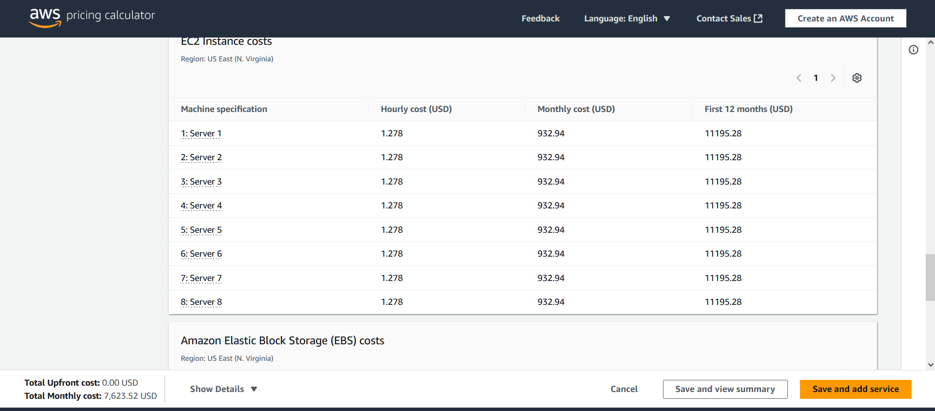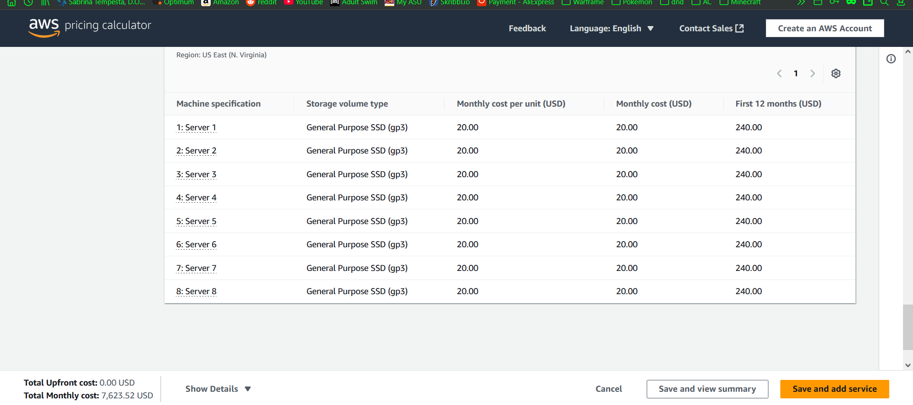
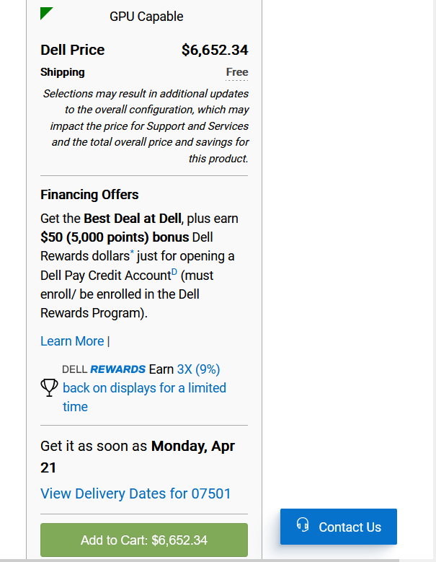PER physical server

Server Farm 2
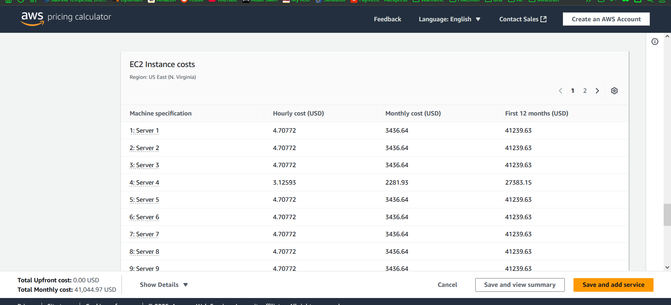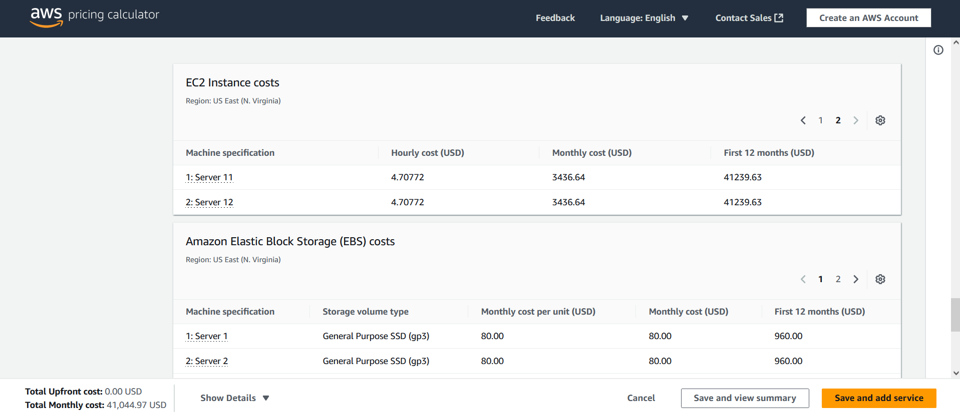
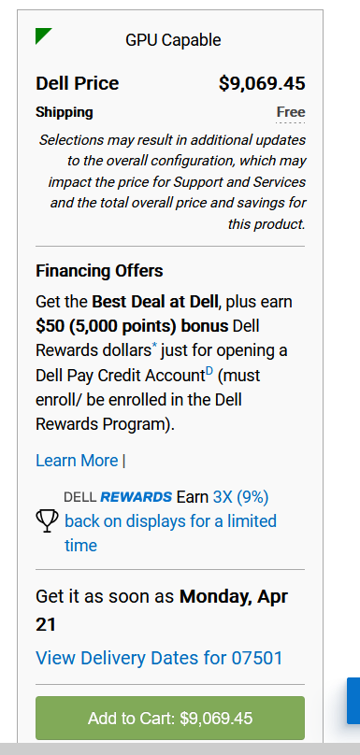
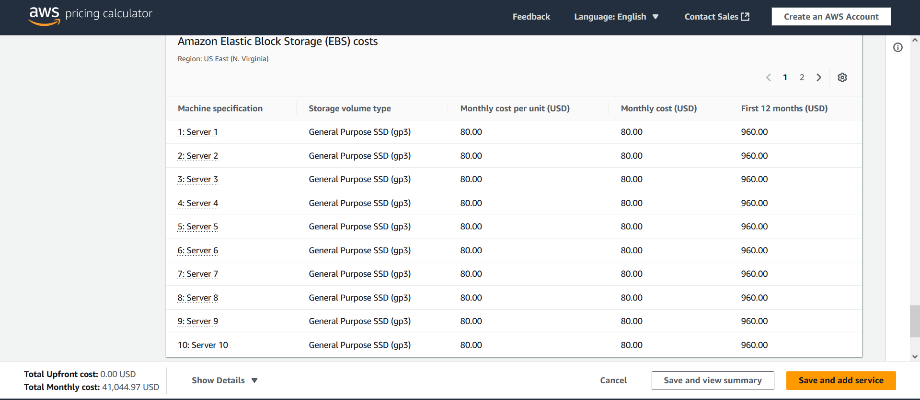
Server Farm | Traditional Costs | AWS Cloud Costs
Server Farm 1 Purchase | $53,218.72 | $7,623.52/month
Server Farm 2 Purchase | $108,833.40 | $41,044.97/month
Yearly Server Farm Upkeep 5 years | $1,834,452.12 + internet Fees + site related costs | $2,920,109.40
AWS costs based on AWS calculator (Amazon).
Traditional costs based on the PowerEdge R360 Rack Server model from Dell with the lowest possible specifications based on requirements.
Upkeep costs based on estimates from ServerMania (Cameron Downs 2025) which estimates power cost for a server to be around $60 a month. Does not take into account cooling fees or internet expenses. (Comes out to $14400 yearly for power) Cooling fees add about $1000-$2000 peer Kilowatt cooled we will go with a rough estimate of $100,000 a month being conservative. This can add a lot based on server load. For a higher server load you will be paying significantly higher cooling costs
Uses Administration costs based on New Jersey’s average annual salary for a server manager $44,924 (ZipRecruiter 2025).
Uses a janitor’s average salary of $34k a year
Totals made with a 5 year plan in mind
Cost Analysis:
Keeping in mind that we are renting a building to hold the physical servers and that the costs estimated for the physical servers are minimums and that cooling costs may be severely underrepresented depending on network traffic the physical servers would cost approximately $1.8 million. The Linux based servers would cost approximately $6,652 each and we would need 8 of them meaning the cost for the servers alone comes out to $53,218.72 for the Linux servers. The Windows servers would be slightly more expensive (due to license fees and higher specs) at $9,065.45 per server or $108,833.40 for all 12. You then add on the cost to have a building to physically house servers as well as the power costs (estimated to be 14,400 a year for the server rack and $1000-$2000 per Kilowatt hour) this can account for on average 40% of the energy costs(Liquori, T. 2025). Additionally on site locations will likely require both physical personnel and janitorial staff. The AWS costs come up to about $2,920,109.40 total over the 5 year period and can be more efficiently and more cost effectively be expanded and maintained as there is less need for a physical location to host these servers and you would not have to pay for hundreds of thousands in energy costs for cooling alone. The cost for a AWS server is less expensive in the long term than a physical server due to the ability to handle more traffic without racking up expensive cooling fees. A company may use traditional infrastructure for better security as you do not have to rely on a cloud computing company to handle your data allowing more sensitive data to not be accessible outside of the organization by bad actors. Cloud computing is more scalable and cost-effective than traditional computing however.

Sources:
Amazon. (n.d.). AWS Pricing Calculator. https://calculator.aws/#/
Cameron Downs (2025). How much does a server cost for a small business in 2025?. What’s the Cost of a Server for Small Business. https://www.servermania.com/kb/articles/how-much-does-a-server-cost-for-a-small-business
ZipRecruiter What is the average server manager salary by state in 2025? (2025.). https://www.ziprecruiter.com/Salaries/What-Is-the-Average-Server-Manager-Salary-by-State
Liquori, T. (2025, March 28). Cooling costs - data center energy efficiency. Dataspan. https://dataspan.com/blog/data-center-cooling-costs/

