**DATA 557**

**Winter 2019**

**Homework Assignment 4**

**Will Wright**

**Instructions**

Submit your solutions **in pdf format** to the dropbox on the canvas page by **5:00PM, Wednesday February 6**.

This homework is not a group project. However, you may work together to help each other identify articles and to solve problems, but you should do all the work, create your own solutions, and hand in your own work without copying others’ work. You should not purposefully use the same article as a classmate.

*Your assignment for this homework is to identify a published article (in any field) that makes use of t-tests and to describe and critique the use of the t-test in the article using the outline below. (Note: it is not necessary to critique other aspects of the article besides the use of the t-test.) Your article should be available on-line (either publicly available or available through the UW libraries electronic journals). Provide a link to the article in your solution. Avoid articles that are very long or excessively technical. If you have trouble finding a suitable article, email me for suggestions.*

For this assignment, I was interested to see what studies the anti-vaxxers think support their claims that vaccines cause autism. I went to [a prominent anti-vax site](http://avoiceforchoice.org/issues/pharmaceuticals-and-vaccines/24-studies/) and found the first study that mentioned a t-test.

**Link to paper:** <https://www.ncbi.nlm.nih.gov/pmc/articles/PMC3697751/>

**Paper Title:** B-Lymphocytes from a Population of Children with Autism Spectrum Disorder and Their Unaffected Siblings Exhibit Hypersensitivity to Thimerosal

1. How many t-tests were reported in the article? For this question, include all types of “t-tests” including 1-sample or 2-sample t-tests, equal-variance, Welch t-test, large-sample t-test, etc. In some papers it is not clear how many tests were reported, in which case, you can give an answer of the form “at least...”.

A total of 15 t-tests were reported:

* 3 One-tailed t-test of mean differences of LDH-G50 in ASD, twin, and sibling groups vs control
* 2 One-tailed t-test of mean differences of LDH-G50 between the hyper- and hypo-sensitive groups compared to their control-counterparts
* 3 One-tailed t-test of the mean differences of XTT-G50 in ASD, twin, and sibling groups vs control
* 1 One-tailed t-test of the mean differences of XTT-G50 between the 8 cells deemed hypersensitive to thimerosal in the LDH-G50 analysis
* 2 One-tailed t-tests of the mean difference of LDH-G50 in families A-D vs their controls and families E-K vs their controls
* 4 One-tailed t-tests of the mean difference of LDH-G50 in the hypersensitive groups vs hyposensitive groups, cut by type (i.e. ASD, twin, sibling, or control)

Additionally, 32 other mean differences were put in a table with no description of the test-type that resulted in statements of “statistically significant”.

2. If there was more than one t-test reported was there one test that was reported as the primary hypothesis test? If the authors did not designate one test as primary, choose one of the t-tests reported that you believe to be the most important test. (Look for one that is described in the abstract of the article or is used as a basis for a conclusion described in the abstract.)

The authors did not designate one test as primary, but I believe the goal of the authors is to show that those with ASD exhibit a higher likelihood of being hypersensitive to thimerosal (implying that thimerosal could be an environmental cause). This being the case, I’ll designate the one-tailed t-test of the mean difference of thimerosal that induced LDH-G50 in the ASD group vs the control as the primary test.

*For all remaining questions answer with respect to the t-test that the authors declared as primary or the one that you selected as most important. For all questions, if the authors did not provide clear information to allow you to answer the question, point out what information was lacking.*

3. Which type of t-test was performed, e.g., 1-sample, 2-sample, equal-variance, Welch, etc. Was the test 1-sided or 2-sided?

A 2-sample, 1-sided t-test. Whether the variance was assumed equal was not specified.

4. Did the authors give a statement of statistical significance or lack of statistical significance? If so, what significance level did they use?

They indicated that there is a statistically significant difference at P=0.004***. They clarify that, “The P values indicate the results from a one-tailed t-test, n = 11, with, (*) indicating <0.05, and (***) indicating <0.005.”

5. List all the following elements that were reported for the test: sample means in the two groups, difference between sample means, SDs in each group, SE of the difference between sample means, test statistic, p-value.

Only the p-values and a chart of the mean differences were included, but supplemental data provided some of the other values (my calculations indicated with ‘*’):

|  |  |  |
| --- | --- | --- |
| Metric | ASD group | Control Group |
| Sample Mean | 688* | 1026* |
| Difference Between Sample means | 338.5* | 0 |
| SD | 328* | 281* |
| SE | 99* | 85* |
| Test-statistic | Unknown | unknown |
| p-value | 0.004 | NA |

6. Did the authors report a confidence interval corresponding to their test?

No confidence interval was stated, but their chart had lines which *may* indicate confidence intervals.

7. Did the authors provide a sample size justification or power calculation for the test?

No sample size justification was provided. Ostensibly, only 11 families were included (and 11 other control-counterparts) due to the rarity/difficulty of obtaining samples from families that had met the condition of having a child with ASD, a twin without ASD, and another sibling.

8. Do the assumptions of the test appear to be met? Answer as well as you can given the information provided by the authors. (Also see the next question.)

No. Given the low sample size at n=11, the assumption of normality is not at all tested. Additionally, no mention of the difference in variance is discussed. Finally, we have no idea if the samples collected are independent (i.e. they could be from families who all live close to the collection center).

9. Did the authors provide enough information for you to assess the assumptions? If not, what additional information would you have needed to properly assess the assumptions?

No. They should have clearly demonstrated that the distribution seems normal, whether or not equal variance was assumed, and how the samples were collected.

10. What was the conclusion from the test. (You can include a short quotation of the statement of their conclusion.) Do you think their conclusion was justified? Why or why not?

The test shows a significant difference in the thimerosal concentrations which cause LDH-G50 between the B-cells in 11 people with ASD vs their control counterparts. I do not think their conclusion was justified for several reasons:

1. Unaware of how samples were obtained from the Autism Genetic Resource Exchange collection—possibly biased by availability of samples
2. Control samples were only controlled for age/sex, but it’s likely that factors such as race, BMI, etc. could have an impact on the results. I don’t know, for instance, if the ASD group was all white with high BMI and the control group was all-Asian with low-BMI.
3. The data could easily be uniform or exponential and not follow a t-distribution:  
   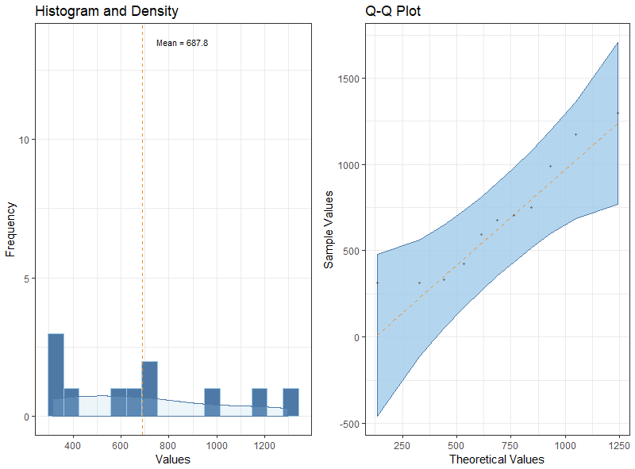
4. Unaware of how they dealt with the variance in their tests (i.e. did they assume equal? Incomplete information provided).
5. There was a spelling mistake in their supplemental data file (“twim” vs “twin”) and several of their data points were mysteriously exact at 314, 675, and 750, while the rest were out to 4 decimal places. This leads me to believe they possibly manipulated the data.